SCHUR_DECOMP PROJECT BRIEF
Methods, rationale, current outputs, and advisor discussion points
Project: schur_decomp
Prepared for: Advisor review
Prepared by: [Name]
Date: August 24, 2026
Primary matrix: matrices/mij_matrix.csv
Primary outputs: outputs/schur_modes, outputs/schur_mode_greedy_trees, outputs/network_linear_systems, outputs/inhibitory_schur_modulation

Executive Summary
The schur_decomp project analyzes a signed, directed hippocampal-entorhinal connectivity matrix as a linear dynamical system. Its central purpose is to move from a dense source-to-receiver connectivity table to interpretable modes, propagation routes, and candidate circuit mechanisms.
The project uses Schur decomposition because Schur vectors provide an orthonormal, numerically stable modal basis while the upper-triangular Schur matrix preserves directional coupling between modes. This makes it possible to study both what the dominant activity patterns are and how upstream modes drive downstream modes.
- The primary matrix contains 85 cell classes, 1,641 nonzero directed entries, and 22.7% density.
- The netlist labels 32 excitatory and 53 inhibitory cell classes across regions including CA1, CA3, DG, MEC, EC, CA2, LEC, and SUB.
- Major analysis branches include Schur/eigenmode characterization, signal propagation, self-connection comparison, greedy subnetwork reconstruction, linear systems metrics, and inhibitory Schur-complement modulation.
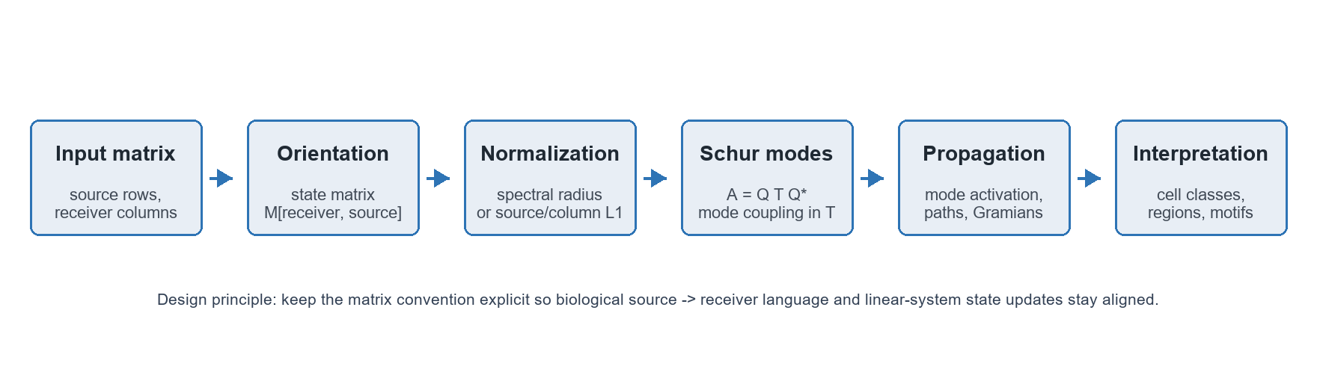
Figure 1. High-level workflow used throughout the schur_decomp project.

Project Structure
File or module | Role in the project
schur_analysis_utils_script.py | Core Schur/eigenmode utilities: matrix loading, normalization, Schur decomposition, mode summaries, E/I routing ratios, spectra, heatmaps, dominant-mode comparisons, and validation checks.
schur_signal_propagation_script.py | Prepares a Schur propagation model, creates initial activity signals, propagates cell-type and Schur-mode activations, summarizes mode and region loadings, and saves reusable Schur-mode outputs.
schur_mode_greedy_trees_script.py | Extracts the top cell-type contributors for each Schur mode and reconstructs compact source-to-receiver subnetworks using greedy directed trees.
network_linear_systems_tools_script.py | Provides path-power, controllability, Gramian, and frequency-response tools for asking how activity can move through the network as a linear system.
inhibitory_schur_modulation_script.py | Specialized branch for partitioning E/I blocks, Schur-eliminating inhibitory nodes, testing perturbations, motif enrichment, and disinhibitory path ranking.

Data and Matrix Convention
The raw M_ij CSV is treated as a source-by-receiver table: rows are outgoing source cell classes and columns are receiver cell classes. For the column-vector state update x[t + 1] = M x[t], the project transposes the raw table into M[receiver, source]. This convention is used consistently in the Schur, propagation, path, and inhibitory-modulation analyses.
Dataset fact | Value
Cell classes | 85
Nonzero directed weights | 1,641
Matrix density | 22.7%
Excitatory classes | 32
Inhibitory classes | 53
Largest region counts | CA1: 28, CA3: 14, DG: 14, MEC: 11, EC: 9

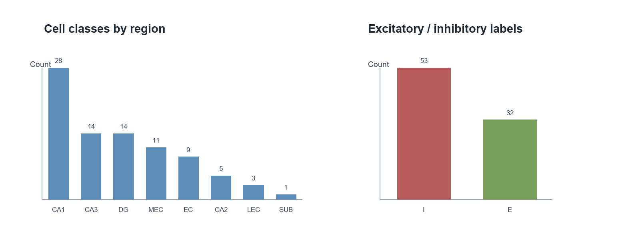
Figure 2. Composition of the primary connectivity matrix by region and E/I label.

Methods Used and Why
Method | What was done | Why it was used
Orientation correction | The raw source-row matrix is transposed into M[receiver, source]. | This aligns biological source -> receiver language with the standard linear update x[t + 1] = M x[t].
Spectral-radius normalization | Most analyses scale the matrix to a target spectral radius, commonly 0.95. | This prevents trivial blow-up in discrete propagation and allows comparisons across with-self and no-self variants.
Schur decomposition | The project computes A = Q T Q* in complex or real Schur form. | Schur vectors are orthonormal and numerically stable; T preserves upper-triangular mode-to-mode coupling.
Eigenvalue and dominant-mode analysis | Eigenvalues, dominant eigenvectors, and Schur-vector loadings are ranked and summarized by cell type and region. | Eigenvalues describe growth/decay and oscillation, while loadings connect abstract modes back to biological cell classes.
Left-action/readout analysis | Several notebooks distinguish Schur vectors from true eigenvectors and left eigenvector action/readout directions. | This avoids overinterpreting Schur vectors as eigenvectors and improves interpretation of mode sensitivity.
E/I routing ratios and regimes | Active edges within high-loading mode contributors are classified by E/E, E/I, I/E, and I/I routing. | The goal is to describe whether a mode behaves like excitatory recurrence, inhibitory feedback, disinhibition, or mixed routing.
Signal propagation in Schur coordinates | Initial activity in selected cell classes is mapped into Schur coordinates and advanced by T. | This shows how a perturbation spreads through the modal coupling hierarchy rather than only through raw edges.
Path-power analysis | The project computes M^k and cumulative weighted path matrices. | Powers of M aggregate all length-k walks from source to receiver, revealing indirect propagation channels.
Controllability and frequency response | Discrete Gramians, continuous-time shifted systems, and transfer-function gains are computed. | These methods ask which nodes are influential drivers and which frequencies produce large network responses.
Greedy mode trees | Top contributors to each Schur mode are reduced to compact source-to-receiver trees. | This turns dense modal loadings into inspectable candidate subnetworks for advisor discussion.
Inhibitory Schur complement | The inhibitory block is eliminated to form an effective excitatory matrix. | This separates direct excitatory recurrence from inhibitory feedback and chained disinhibitory effects.

Current Outputs and Interpretation

Schur modes
The saved Schur archive contains 85 modes from the normalized state matrix. The output tables summarize each mode by eigenvalue, dominant region, dominant cell type, loading magnitude, and the number of high-loading excitatory/inhibitory contributors.
Mode | |lambda| | Dominant cell type | Region | E/I | Tree edges
0 | 0.950 | MEC LIII Superficial Multipolar Interneuron | MEC | I | 5
1 | 0.370 | MEC LIII Superficial Multipolar Interneuron | MEC | I | 4
2 | 0.311 | DG AIPRIM | DG | I | 4
3 | 0.311 | CA1 Trilaminar | CA1 | I | 6
4 | 0.310 | DG HICAP | DG | I | 5
5 | 0.182 | CA1 Perforant Path Associated | CA1 | I | 4

A recurring pattern in the saved summaries is that many high-loading modes are dominated by CA1 and inhibitory cell classes. That does not mean the network is purely inhibitory; rather, inhibitory classes often have large modal participation in the normalized dynamics.

Self-connection comparison
Variant | Raw spectral radius | Achieved radius | Frobenius norm | Non-normality
with_self | 26,213.1 | 0.95 | 77.2 | 5,869.9
no_self | 14,837.9 | 0.95 | 136.3 | 18,319.8

The no-self variant reaches the same target spectral radius but has larger Frobenius norm and substantially higher non-normality. This matters because non-normal matrices can show strong transient amplification even when eigenvalues are kept inside a stable radius.
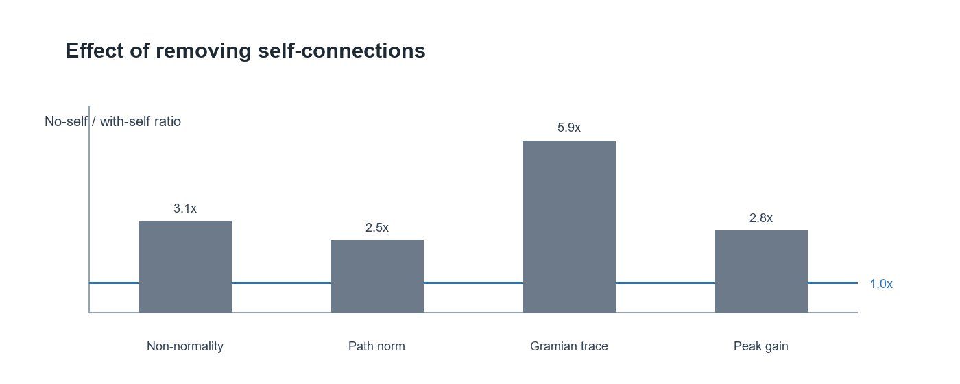
Figure 3. No-self to with-self ratios for selected linear-systems summaries.

Linear systems branch
Variant | Cumulative path norm | Gramian trace | Gramian condition | Peak gain
with_self | 132.0 | 9,546.6 | 5,767.2 | 69.4
no_self | 323.9 | 56,245.6 | 42,740.4 | 193.4

The linear-systems outputs suggest that removing self-connections increases indirect path strength, controllability energy, and low-frequency gain. This makes the self/no-self comparison a genuine modeling decision rather than a cosmetic preprocessing step.

Inhibitory modulation branch
Variant | Effective E radius | Feedback radius | Selected I-I order | alpha rho(M_II)
with_self | 1.000 | 0.116 | 2 | 0.155
no_self | 1.000 | 0.365 | 1 | 0.116

The inhibitory branch should be presented as a focused extension of the main Schur project. It uses the same state convention but partitions the matrix into E and I blocks, then asks how inhibitory feedback reshapes effective excitatory dynamics.

Interpretive Value for Advisor Discussion
- The project provides a consistent mathematical convention for a biologically directed matrix, reducing ambiguity about source and receiver roles.
- Schur decomposition gives a stable modal coordinate system that supports both eigenvalue interpretation and directed mode-coupling traces.
- Self/no-self comparisons show that diagonal entries materially affect spectral scale, non-normality, and propagation strength.
- Greedy trees and top-contributor tables translate high-dimensional modes into cell-class hypotheses that can be checked against neuroanatomy.
- The inhibitory Schur-complement branch connects broad linear algebra results to mechanistic questions about feedback and disinhibition.

Limitations
- The model is linear and static; it does not include spiking dynamics, nonlinear activation, synaptic delays, or state-dependent gain changes.
- Some E/I labels are inferred by string patterns or netlist metadata, so final biological claims should verify labels against the source dataset.
- Schur vectors are orthonormal modal coordinates, not ordinary eigenvectors; interpretation should preserve that distinction.
- Spectral-radius normalization is useful for comparison and stability, but normalized values should not be read as direct physiological magnitudes.
- Greedy trees are interpretive summaries of high-loading subnetworks, not guaranteed optimal circuit reconstructions.

Recommended Next Steps
- Choose a primary matrix convention and include a short convention statement in every notebook and figure caption.
- Decide whether the advisor-facing analysis should prioritize with-self, no-self, or a formal side-by-side treatment.
- Validate the top Schur-mode and greedy-tree cell classes against known hippocampal-entorhinal pathways.
- Add a constrained null model for motif and path analyses that preserves region and E/I block structure.
- Package the most important outputs into a compact figure panel: spectrum, Schur T heatmap, mode contributors, self/no-self comparison, and inhibitory feedback summary.

Source Files Used
- eigenmode_analysis_mij_schur_corrected_left_action.ipynb and related notebooks: exploratory analysis and interpretive notes.
- schur_analysis_utils_script.py: reusable Schur decomposition and modal interpretation functions.
- schur_signal_propagation_script.py: propagation and saved Schur-mode outputs.
- schur_mode_greedy_trees_script.py: mode contributor subnetworks and greedy tree summaries.
- network_linear_systems_tools_script.py: path powers, controllability, and frequency-response summaries.
- inhibitory_schur_modulation_script.py: E/I block analysis and inhibitory Schur-complement branch.
- outputs/schur_modes, outputs/schur_mode_greedy_trees, outputs/network_linear_systems, and outputs/inhibitory_schur_modulation: generated result tables used in this brief.

