METHOD BRIEF
E-to-E Backbone Method Comparison
Advisor submission summary for the notebook, data scope, optimization methods, and current results
Prepared for: Advisor review
Prepared from: ee_backbone_method_comparison.ipynb
Primary input: matrices/mij_EE_matrix.csv
Date: August 20, 2026

Bottom line
The notebook compares six approaches for extracting excitatory-to-excitatory backbone paths from the E-only matrix. The unconstrained MILP with subtour elimination is the exact maximizing benchmark for the current objective: all 32 seed solves returned Optimal, and it produced the highest mean summed path weight. The Hamiltonian MILP also solved optimally for all seeds, but it answers a stricter complete-ordering question because every excitatory node must be visited exactly once.

1. Purpose of the notebook
The notebook evaluates alternative ways to build directed E-to-E backbone paths from the matrix representation of connectivity weights. Each method starts from every excitatory seed node and produces a directed path scored by the sum of selected positive transition weights between distinct excitatory nodes. The purpose is methodological comparison: which search formulation best captures high-weight directed structure under the same preprocessing and scoring rules?
The current analysis uses `mij_EE_matrix.csv` as the input. That file contains the 32 excitatory rows and columns extracted from `mij_matrix.csv`. The notebook treats all row and column labels in this restricted matrix as excitatory nodes, clips negative weights out of the candidate transition graph, and sets the diagonal to zero before path search.

2. Data scope and graph assumptions
Item | Current setting
Input matrix | matrices/mij_EE_matrix.csv
Nodes | 32 excitatory nodes
Candidate directed E-to-E edges | 355 positive off-diagonal transitions
Self-connections | 27 nonzero diagonal entries; 27 are positive
Diagonal handling | Excluded from all current path-scoring methods
Graph structure | Directed and cyclic; not a DAG
The cyclic structure is important. A DAG longest-path algorithm would not apply, and allowing repeated nodes would make a positive cycle reusable. For that reason, the exact and heuristic path methods enforce simple paths: once a node is used, it cannot be revisited.

3. Methods compared
The methods are intentionally diverse. Some are fast heuristics, some are bounded searches, and the MILP variants are solver-backed formulations that can certify optimality when the solver status is Optimal.
Method | Why included | How to interpret it
Greedy tree/path | Fast local baseline. | Shows what is recovered by repeatedly taking the strongest available outgoing edge.
Maximum spanning tree path | Sparse structural skeleton. | Collapses the graph into high-weight non-cycling undirected structure, then scores directed paths through it.
Branch-and-bound | Bounded exhaustive search. | Prunes partial paths whose optimistic upper bound cannot beat the current best path.
Dynamic programming / beam DP | Subset-state search or approximation. | Exact only when the node set is small enough; beam mode keeps the strongest states for tractability.
MILP, maximum simple path | Exact maximizing benchmark. | Uses binary edge/node variables and MTZ order constraints to optimize a single simple path from each seed.
Maximum-weight asymmetric Hamiltonian path | Complete directed ordering. | Forces all 32 excitatory nodes to appear exactly once, preserving directed edge asymmetry.

4. Current results
Both solver-backed methods completed successfully: the unconstrained MILP returned `Optimal` for all 32 seed nodes, and the Hamiltonian MILP returned `Optimal` for all 32 seed nodes. Hamiltonian paths contain 31 edges for every seed, as expected for a 32-node path.
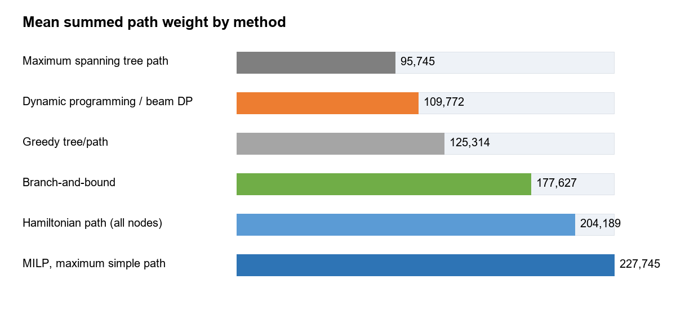
Figure 1. Mean summed path weight by method.
Method | Mean weight | Median weight | Mean edges | Max weight
MILP, maximum simple path | 227,745 | 241,065 | 28.5 | 241,901
Hamiltonian path (all nodes) | 204,189 | 222,249 | 31.0 | 223,059
Branch-and-bound | 177,627 | 171,725 | 25.7 | 232,244
Greedy tree/path | 125,314 | 121,527 | 16.7 | 195,127
Dynamic programming / beam DP | 109,772 | 105,454 | 4.5 | 150,350
Maximum spanning tree path | 95,745 | 109,051 | 5.5 | 114,610

5. Interpretation
The unconstrained MILP is the strongest benchmark for the stated objective because it maximizes summed path weight over simple directed paths while preventing subtours. Its higher mean score indicates that the earlier heuristic and bounded methods often stop short of the best available combination of directed transitions.
The Hamiltonian path is useful for a different scientific question: it gives a complete ordering through all excitatory nodes. Its mean path weight is lower than the unconstrained MILP because it is forced to include every node, even when a complete traversal requires weaker connecting edges. That difference should be interpreted as the cost of complete coverage, not as solver failure.
Dynamic programming is retained as a useful conceptual comparison, but at 32 nodes the notebook uses beam-limited DP rather than full bitmask DP. Beam pruning explains why dynamic programming can appear weak in the current results: it is not proving the global maximum at this graph size.

6. Caveats and recommended next checks
- The current objective uses positive off-diagonal E-to-E transition weights only. Negative transitions and diagonal self-connections are excluded from path scoring.
- Because 27 E-only nodes have positive diagonal entries, a separate self-connection sensitivity analysis may be warranted if self-effects are biologically meaningful.
- The unconstrained MILP and Hamiltonian MILP are exact only for rows whose solver status is Optimal. In the current run, all relevant rows are Optimal.
- If the advisor wants a complete ordered sequence of all excitatory nodes, use the Hamiltonian path output. If the advisor wants the highest-weight simple backbone of any length, use the unconstrained MILP output.

7. Output files
Artifact | Path
Notebook | ee_backbone_method_comparison.ipynb
Input matrix | matrices/mij_EE_matrix.csv
Long comparison table | ee_backbone_comparison_outputs/method_comparison_long.csv
Wide comparison table | ee_backbone_comparison_outputs/method_comparison_wide.csv
Selected path edges | ee_backbone_comparison_outputs/all_methods_edges.csv
Method summary | ee_backbone_comparison_outputs/method_summary.csv
MILP benchmark gaps | ee_backbone_comparison_outputs/milp_benchmark_gaps.csv

References
Held, M., & Karp, R. M. (1962). A dynamic programming approach to sequencing problems. Journal of the Society for Industrial and Applied Mathematics, 10(1), 196-210. https://doi.org/10.1137/0110015.
Miller, C. E., Tucker, A. W., & Zemlin, R. A. (1960). Integer Programming Formulation of Traveling Salesman Problems. Journal of the ACM, 7(4), 326-329. https://doi.org/10.1145/321043.321046.

