ITC320 – Web Applications Client-Side Scripting
Group Project 2
Chess Game State, with player moves
Due on the Course Web Server (project2) folder
by Nov. 21, 2013 by 9:00 pm

Using a Two-dimensional Array in JavaScript
DOM Scripting via user supplied commands
to cause piece relocation

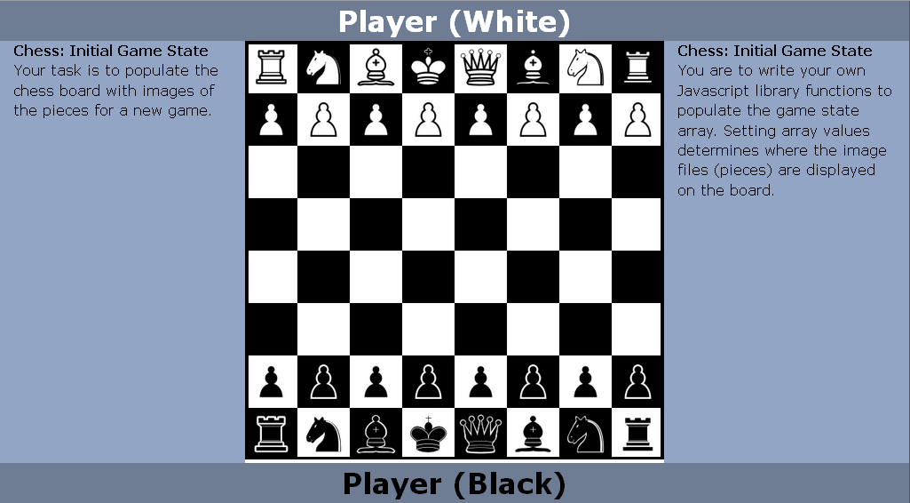

The Model: Maintain the following values
Game status: 0 = Beginning, 1 = Continue
Player Turn: 0=White, 1=Black
Player check status: 0=no, 1=yes
Overall game state:
Includes the above properties and the Board State.
Board_State:
(piece positions)
Be able to identify:
player/piece at a particular position on the board.
The board model should be implemented as a 2-D array of piece objects.
8 rows by 8 columns
Piece object:
piece id: numeric values translatable to/from corresponding letter values (K,Q,R,B,N,P) for King, Queen, Rook, Bishop, Knight and Pawn)
piece color: 0=White 1=Black

The model and view should be able to interpret move commands and carry out piece moves.

View: HTML page: The game board should consist of at least 64 divs with square dimensions, sized relative to a parent container. Your game board container should be set initially to 700px by 700px.
The game board should re-size proportionally if the game board container is set to a minimum size of 500px by 500px.
Test these size setting and square sizes in between. Image files should fill the container and re-size relative to their container size.
Max size 700px X 700px
Min size 500px X 500px
Image files for individual pieces should can either be jpg or png file format.
Implement the game board and piece coloring in a way that the square's background color is complemented with the coloring of the piece. Maintain a high contrast. Ex: a white rook can land
on a light background, or dark background.
MOVE command notation:
Move commands: reflect a from/to notation, consult board state to look-up the piece in the from location and enforce valid moves. Determine of target move is even valid and display a message somewhere on the margin of the game-board if it is not.
Ex. A knight can jump pieces but other pieces need a clear path to move to a destination.
A valid destination is one that is empty.

We will not concern ourselves with having to “take” pieces.
Example of move commands after a new game is initialized:
Start of game: initialize board. Both players' pieces set in starting positions.
Test these move commands:

Turn: 0 e2e4 (should advance the white pawn 2 places)
Turn: 1 e7e5 (should advance the black pawn 2 places)
Turn: 0 g1f3 (should move white knight in g1 to f3)
Turn: 1 b8c6 (should move black knight at b8 to c6)
Turn: 0 f1c4 (should move white bishop at f1 to c4)
Turn: 1 f8c5 (should move black bishop at f8 to c5)

Provide an input box and submit mechanism for the commands on the margin of the game board.

