Virtual Environment Set Up
VirtualBox Download and Configuration
- Go to https://www.virtualbox.org/wiki/Downloads
  - click on “VirtualBox 6.0 builds”.
  - For this case I choose 6.0.18 version - Windows hosts.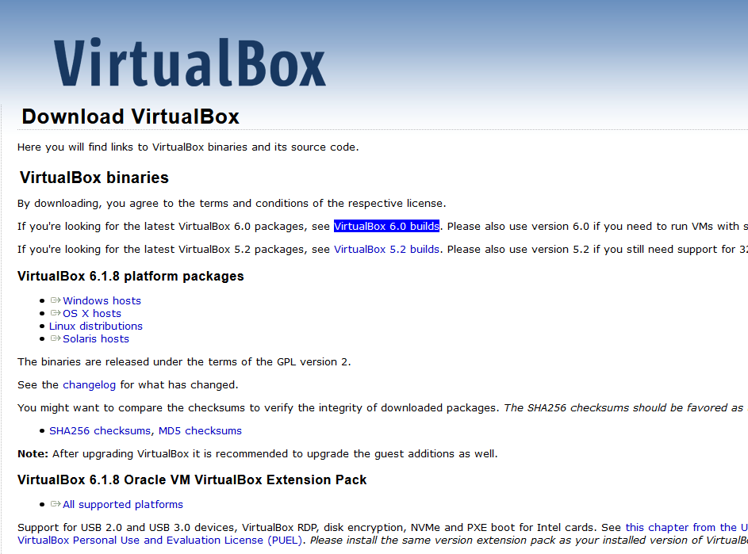
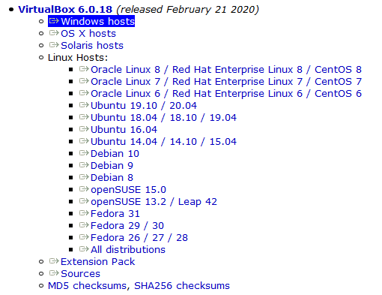

  - Once “Windows hosts” clicked a download window will appear, then Save File.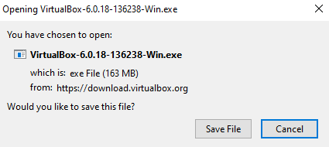
- Go to Downloads folder (or where VirtualBox was downloaded) and open downloaded file. Then click on “Execute” option. This will open the installer.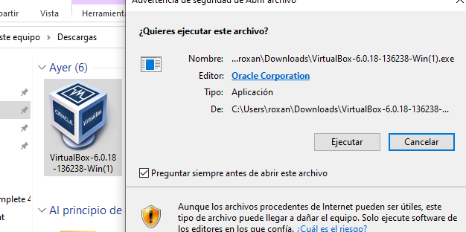
- Click on “Next”.
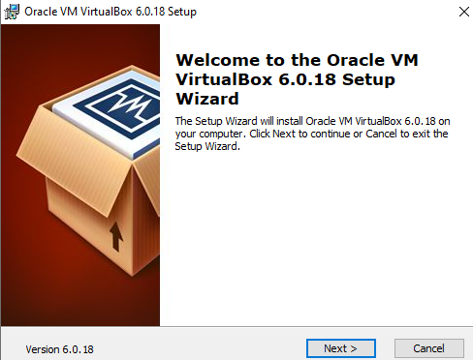
- Custom installation. I choose default. Then click “Next”.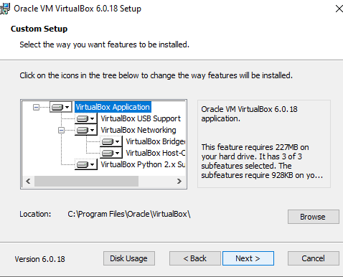
- Select installation preferences and click “Next”.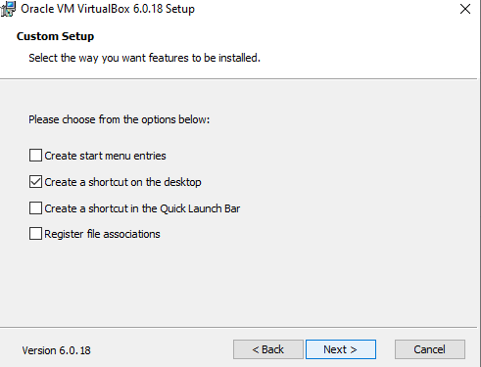
- Network Warning will appear. It’s necessary click “Yes” to continue.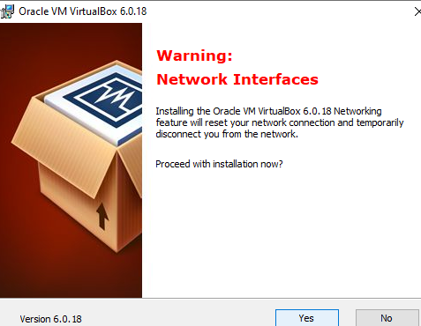
- Finally, click on “Install”.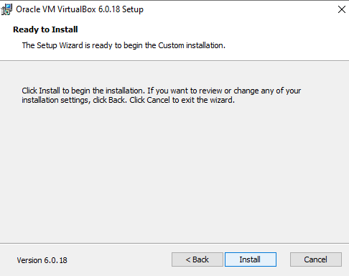

- Installation process will begin, and then a window informing installation has been completed will appear. Click “Finish”.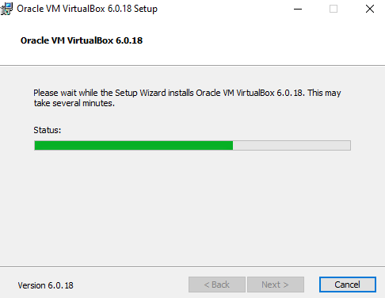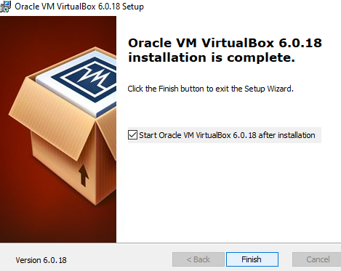

Ubuntu 20.04 Installation on VirtualBox
- Go to https://ubuntu.com/download/desktop and click con “Download”.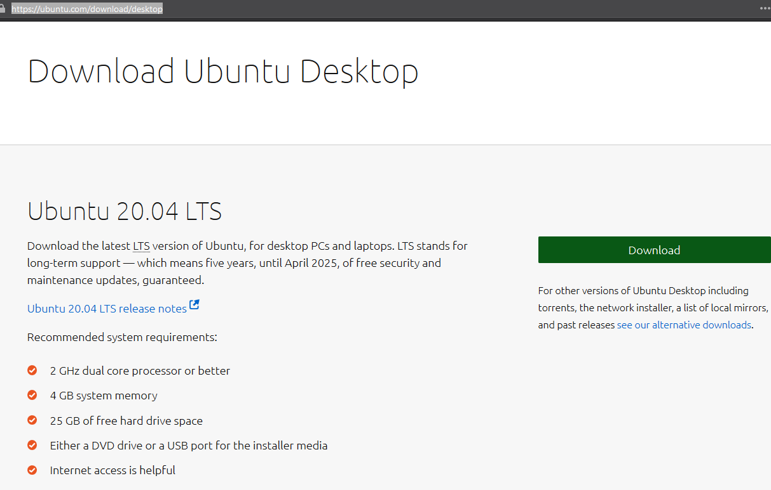
- This will lead to or file to be downloaded. It has to start download automatically, if no click on the option to start download. Save File.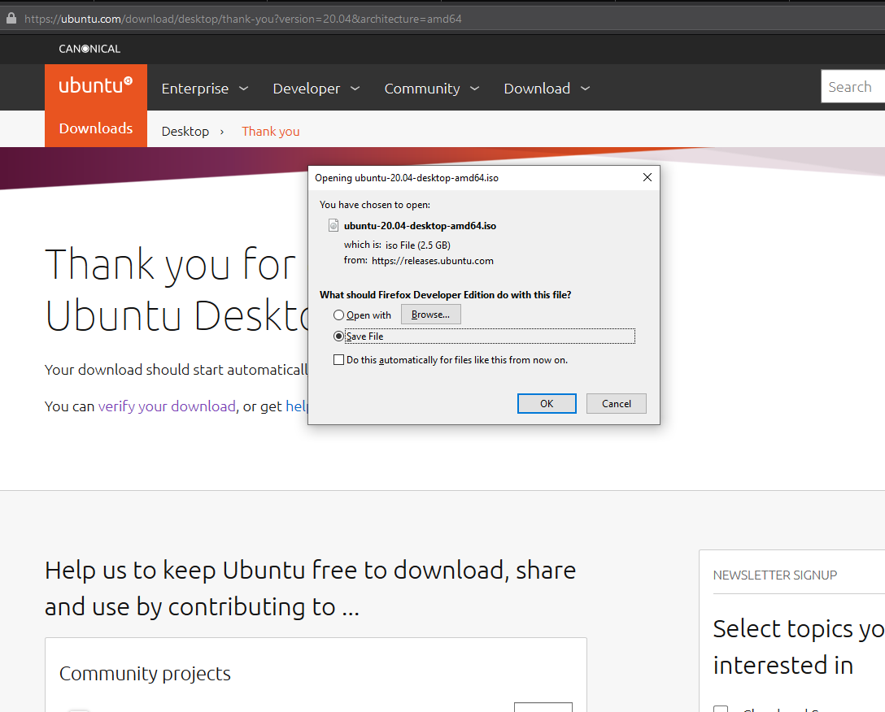

- Open Virtual Box. Click on “Machine”, and select “New”. Or directly press Ctrl+N.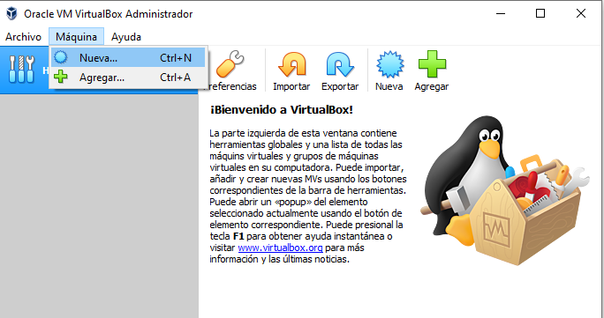
- Type virtual machine’s name, choose location, OS Type and version. Once I typed “ubuntu_lts”, VirtualBox automatically gave me type and version. Click “Next”.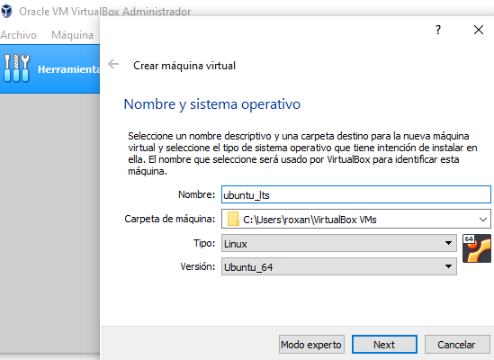

- Set memory size (for Ubuntu Desktop 20.04 it should be at least 2048 MB). Click “Next”.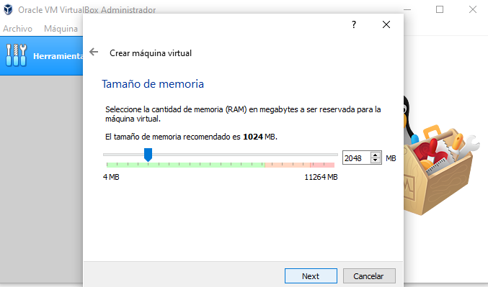
- Choose “Create a virtual hard disk now”. Click on “Create”.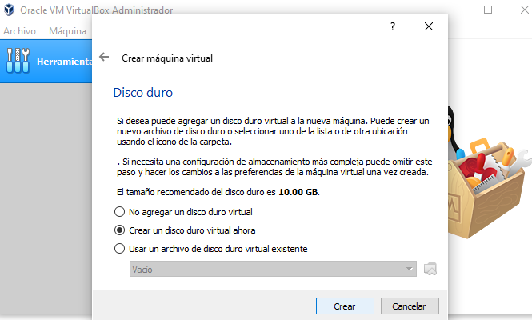

- Choose “VDI(VirtualBox Disk Image)”. Click “Next”.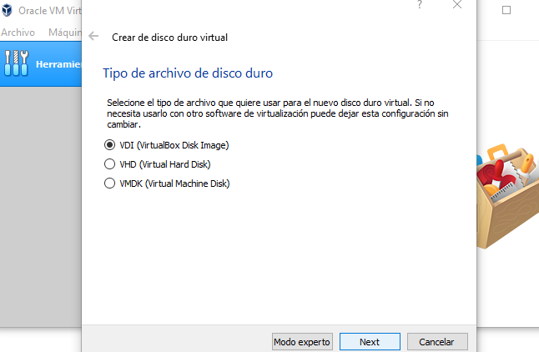
- Select “Dynamically allocated”. Click “Next”.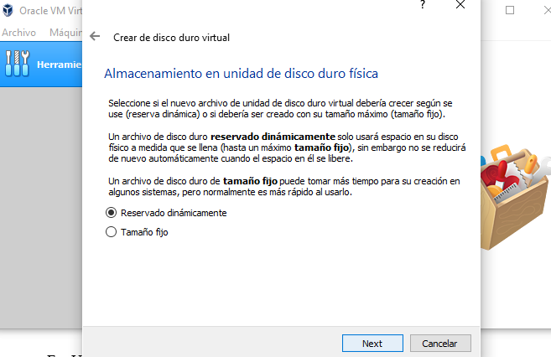

- Set virtual hard disk size (at least 20.0 GB for Ubuntu 20.04). Click “Create”.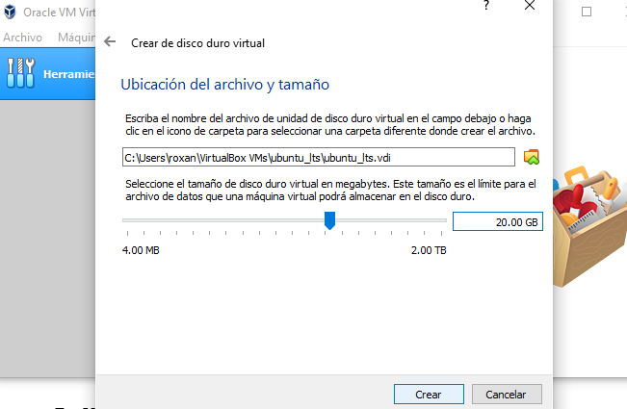
- This will return us to “main” VirtualBox. Select the virtual machine and click on “Settings.”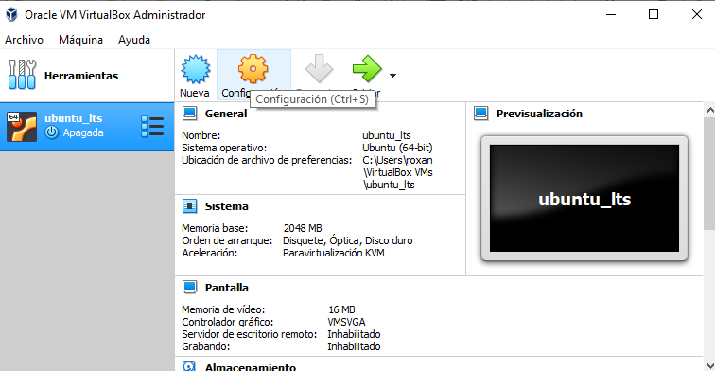
- Now click on “Storage”. Choose “Empty” controller and look for “Choose Virtual Optical Disk File…”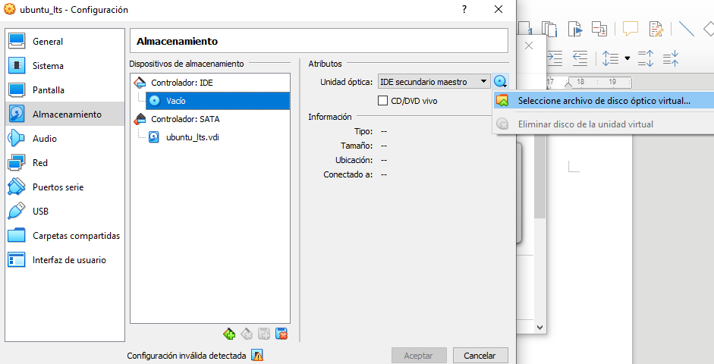
- Open the Ubuntu Desktop ISO. And click on “Accept”.
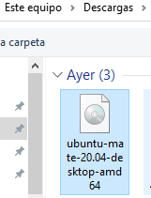
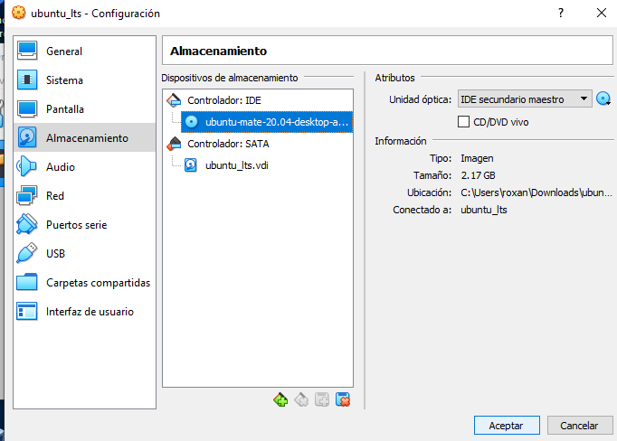
NOTE:It might happen that one of these error appears. If so it means Virtualization is not available and BIOS change has to be done. Following this link instructions, problem will be solved.
https://support.bluestacks.com/hc/en-us/articles/115003174386-How-can-I-enable-virtualization-VT-on-my-PC-?flash_digest=3bc1a112ea56fcd696dc2abf845388e6ba0dcb2b#%E2%80%9C3%E2%80%9D

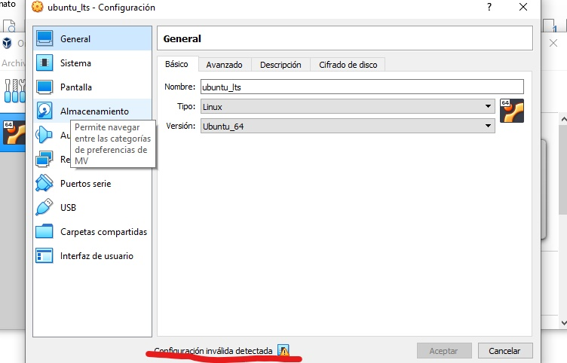
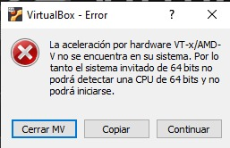
- Now select virtual machine and click on “Start”.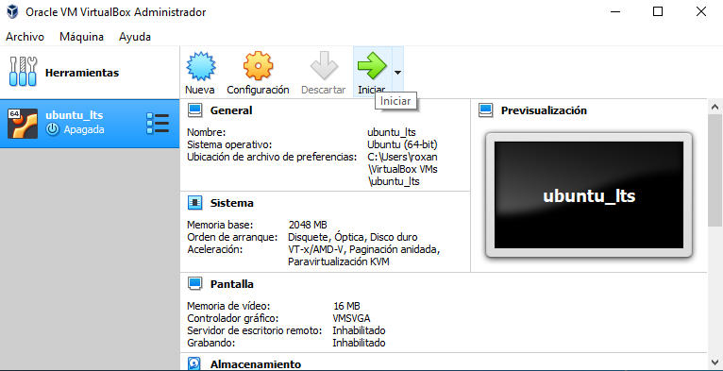
- Ubuntu Installer should start. Choose main language and click on “Install Ubuntu”. 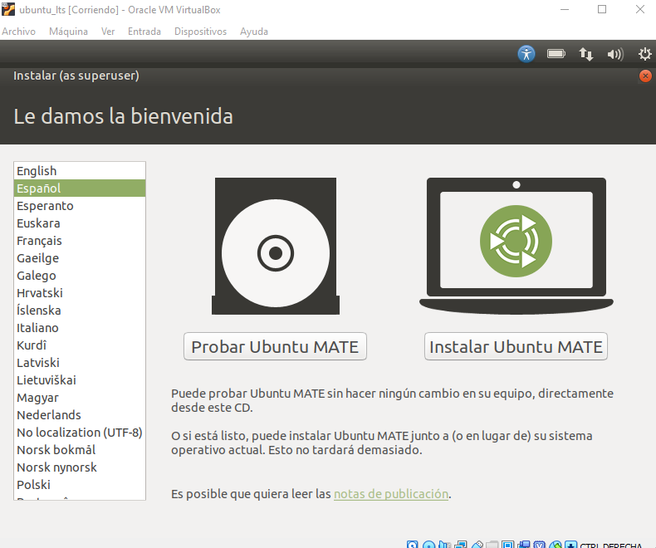
- Select Keyboard Layout and click on “Continue”.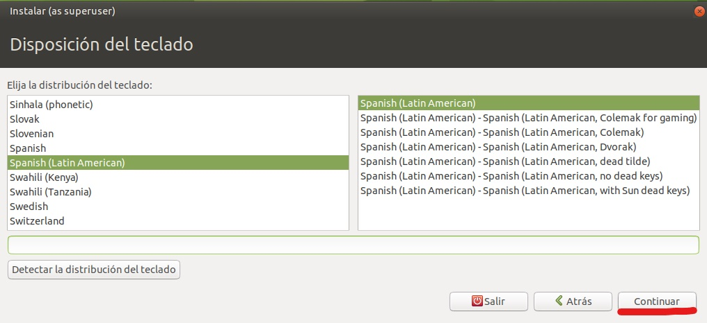
- Select “Normal Installation”. Click on “Continue”.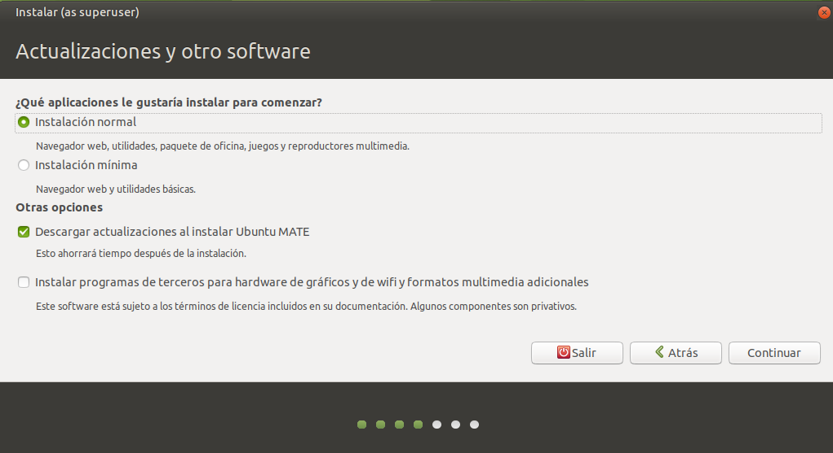
- As this is a virtual machine just select “Erase disk and install Ubuntu”. Click on “Install Now”.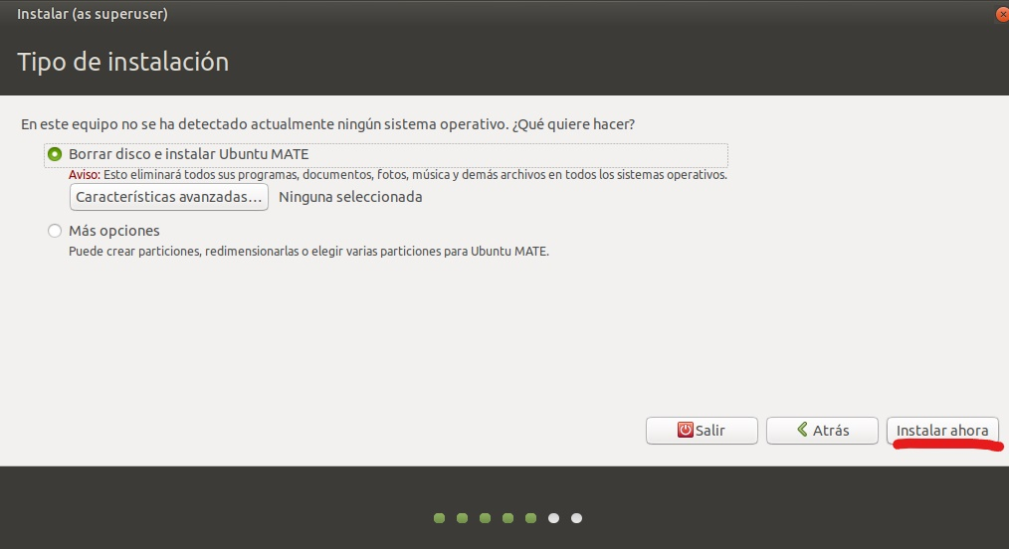
- Click “Continue”.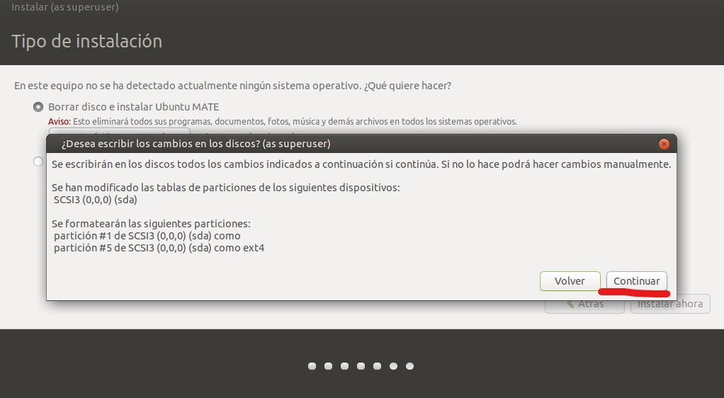
- Select Time Zone and click “Continue”.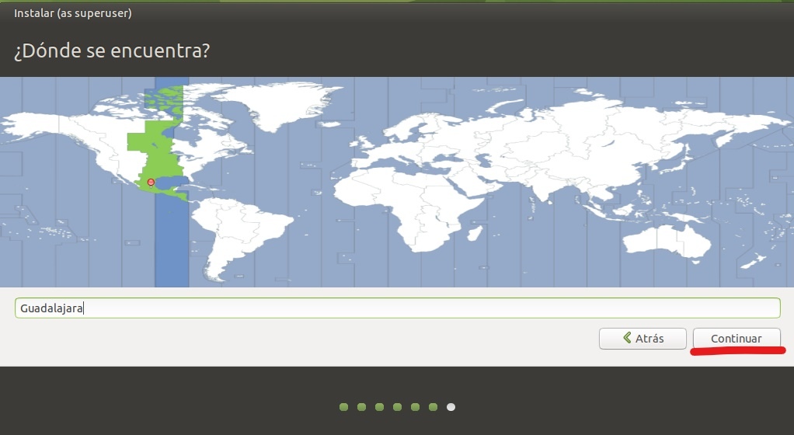
- Type required information and click “Continue”.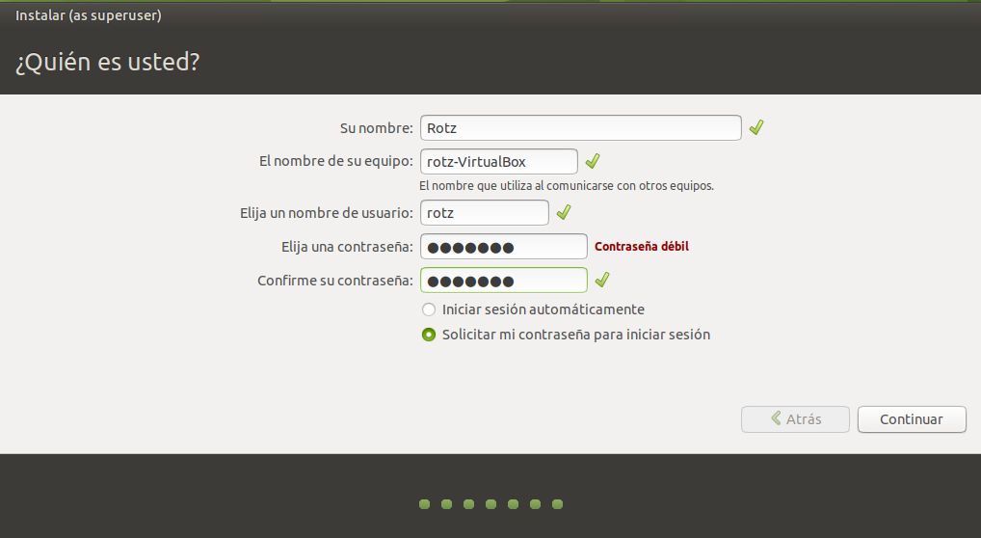
- Necessary files will be copied and installed.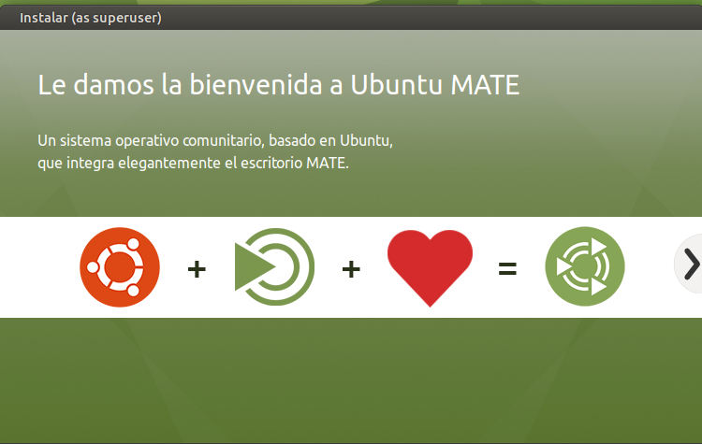
- Once installation is completed. Restart the Virtual Machine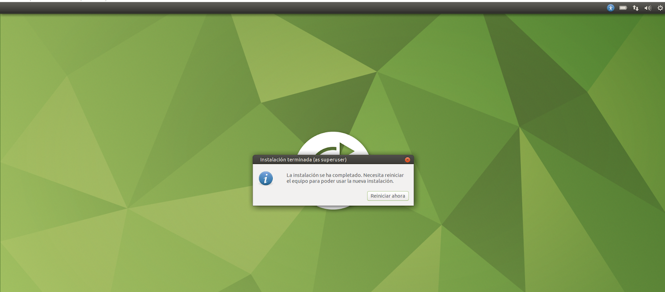

- Ubuntu log in will appear. Enter password.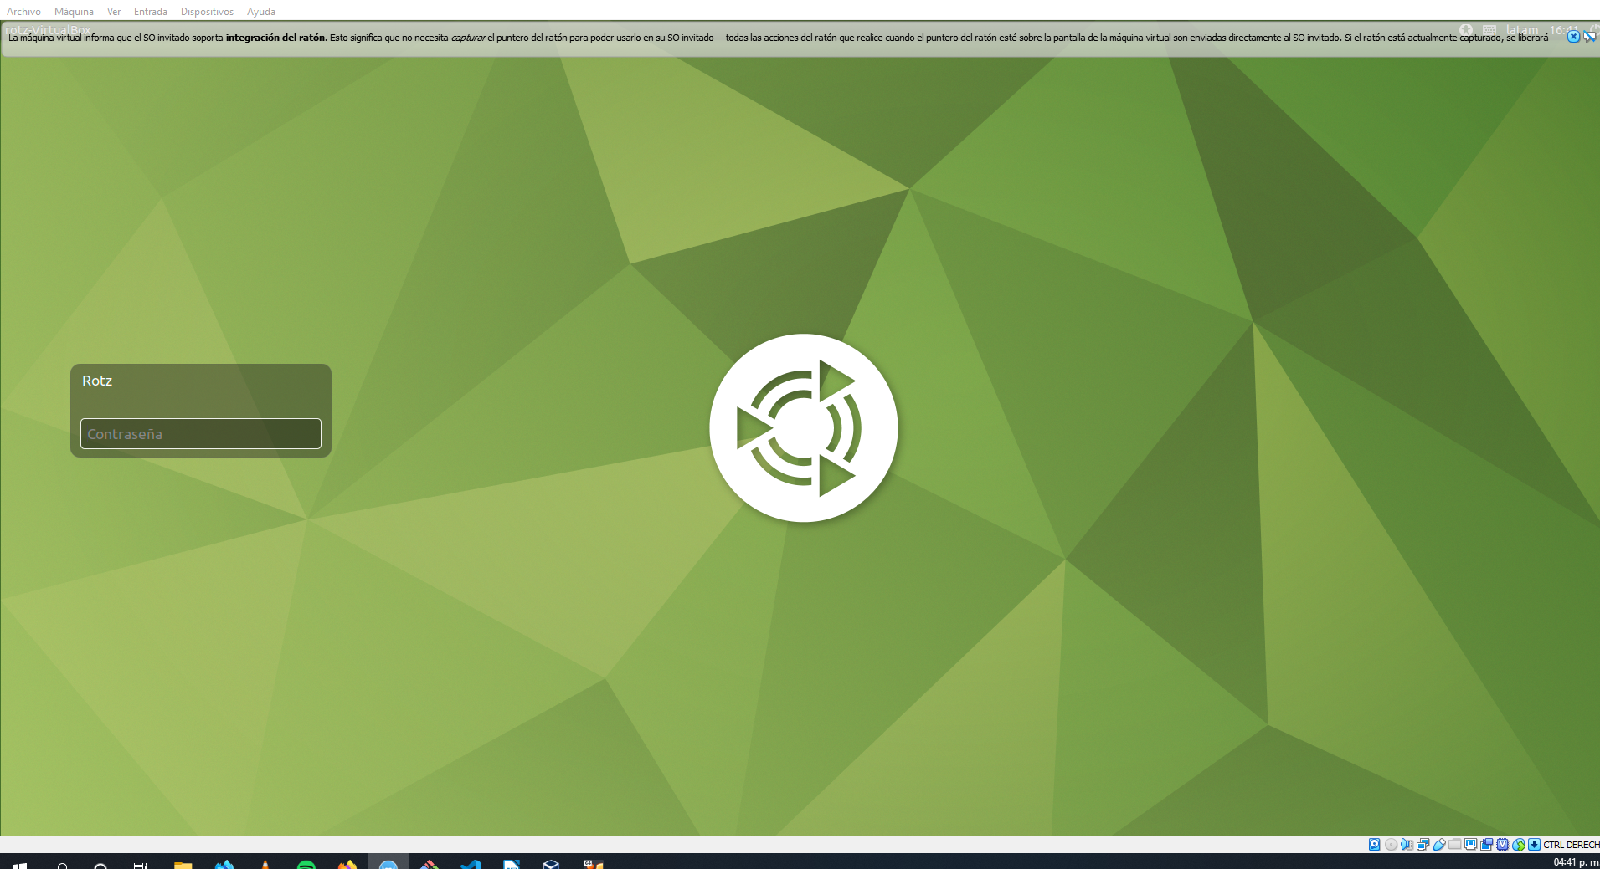
- Go to terminal to update APT package repository.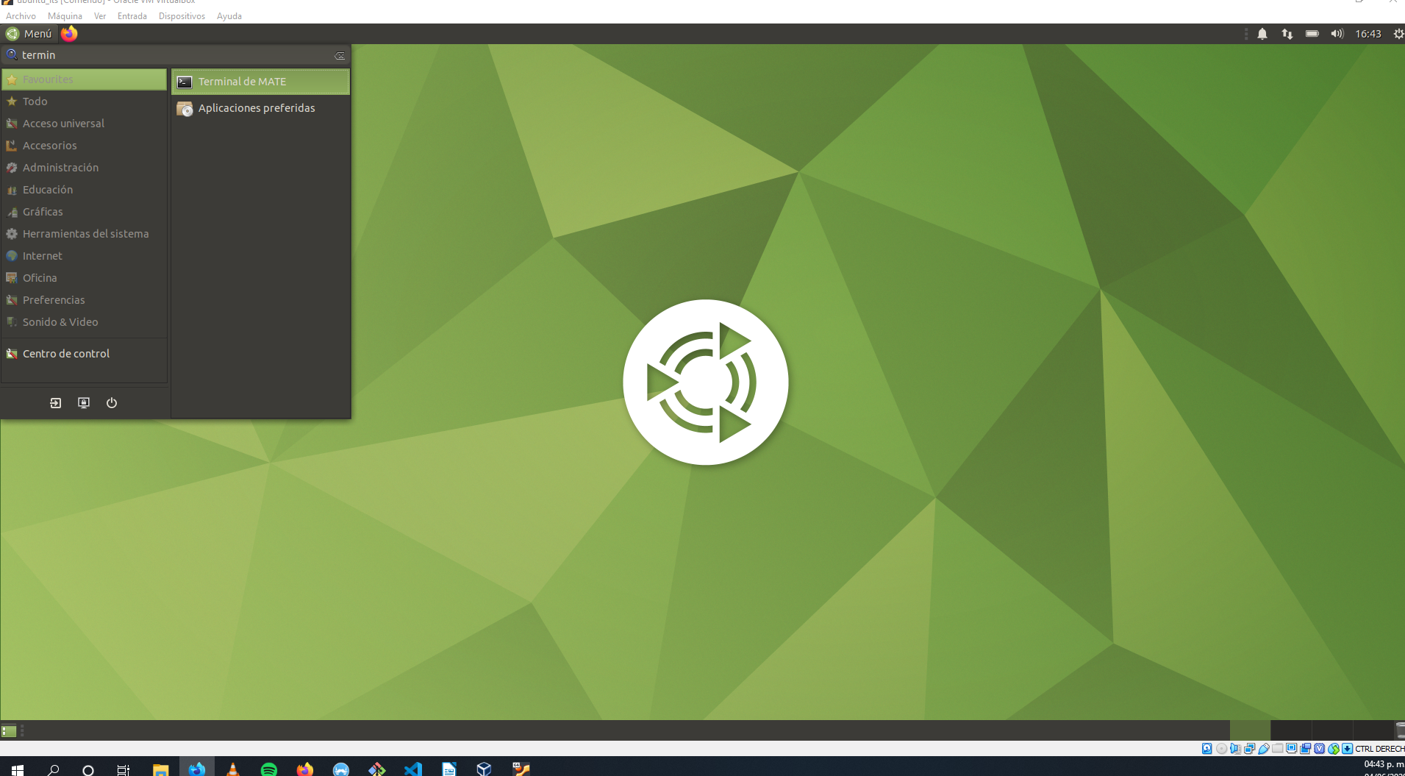
- Type “sudo apt update”. This action will require password, type it (characters won’t be showed).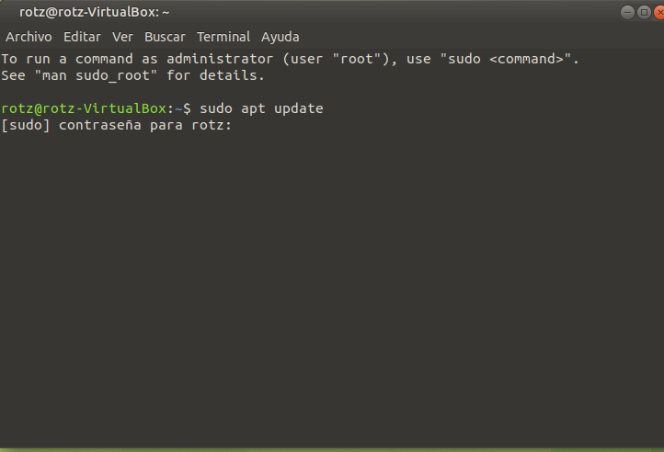
- Install Guest Additions with following command “sudo apt install virtualbox-guest-dkms virtualbox-guest-x11 virtualbox-guest-utils”. Then type “Y” or “S” (depends on the language) to confirm installation.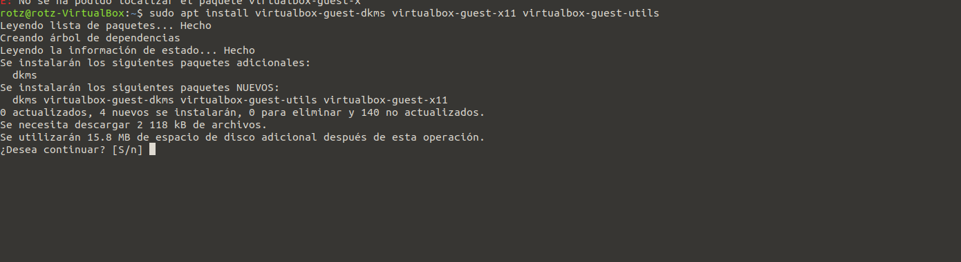
- This installation allows to resize the Virtual Machine freely and display size would automatically adjust itself and also Guest Additions are designed to be installed inside a virtual machine after the guest operating system has been installed. They consist of device drivers and system applications that optimize the guest operating system for better performance and usability.

Setting Guest Additions for Sharing Folders
- Go to Devices on virtual machine and click on “Guest Additions CD Image”.
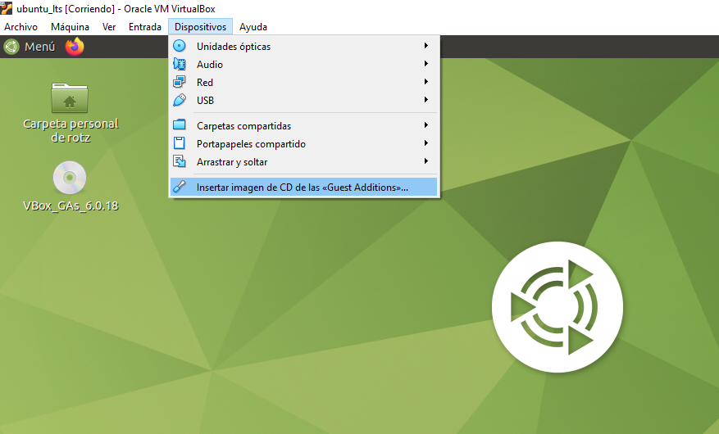
- Is necessary to select how to run image. Click on “OK”
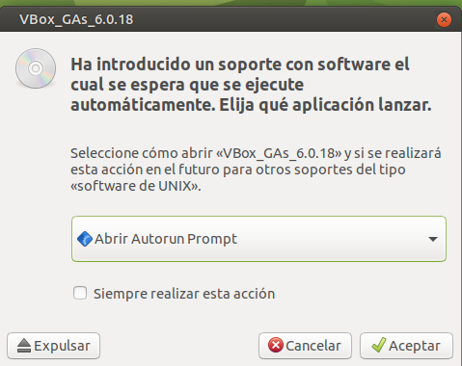

- Warning will appear. Click on “Execute”.
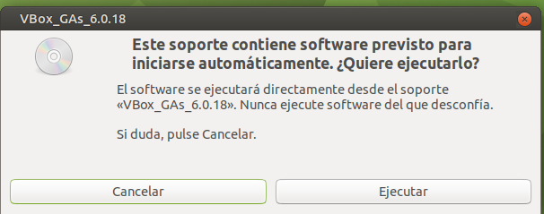
- We have to insert our sudo password to start installation
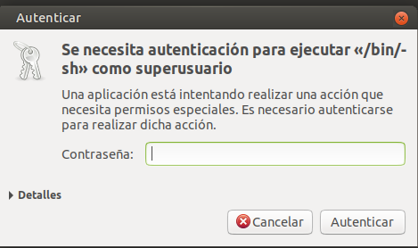
- As we made a previous Guest Additions Installation, it will appear a message type “S” or “Y”, depending on system language.
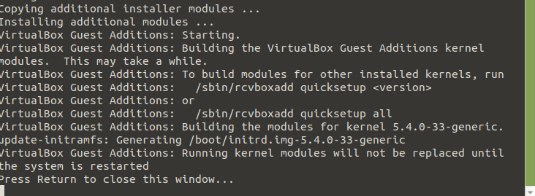

- Close terminal and reboot Ubuntu. Is necessary to ensure Guest Addition has all the necessary base packages (gcc, make and perl). Install them by terminal “sudo apt install gcc make perl”. Enter password.
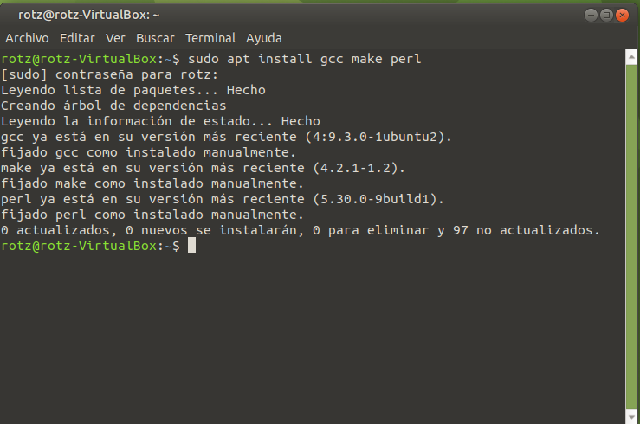
- Files shared by VirtualBox can only be access by members of vboxsf group created by the earlier by the autorun.sh script. To make them accessible account needs to be a member of the vboxsf group. Run “sudo add user <username> vboxsf”.
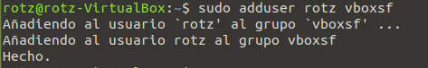

Adding Shared Folder
- Now go to Devices-Shared Folder - Shared Folder Settings
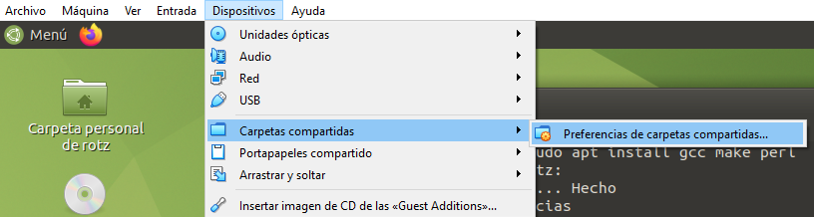

- Following window will appear, click on first folder icon (on the right) to define where Shared Folder will be in host operating system.
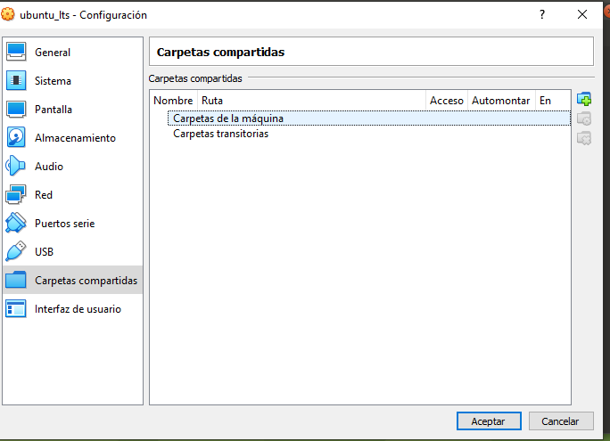

- For this case. I created a folder named “VboxSharedFolder” in C: drive. And selected “automount” for folder to be mounted without manual intervention and “make permanent” to enable sharing every time virtual machine is booted.
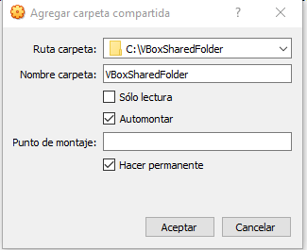

- Rebooting virtual machine is necessary so changes would show up as a Shared Folder on our User’s desktop (or at /media/<sf_VBoxShare)
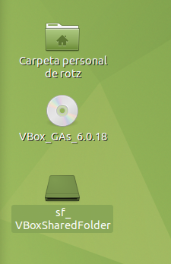
- To test if folders can share files I created a new file called Hello.txt on host side.
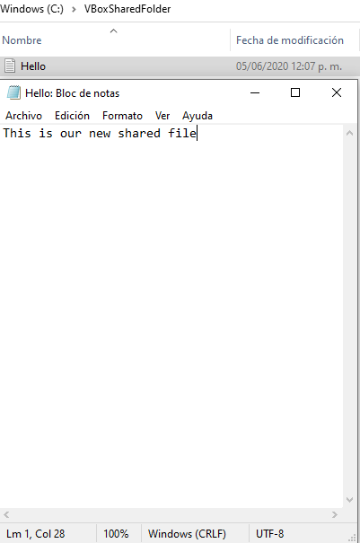

- So, now on virtual machine we can see the new file.
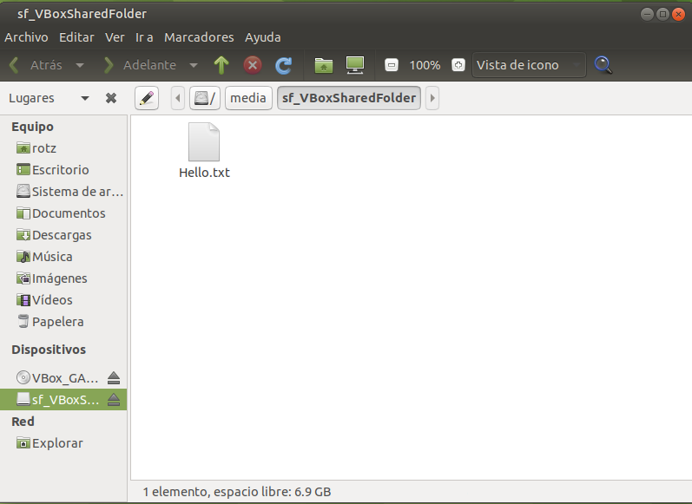

Ping between Guest and Host
- Ping was succesfull at firts attemp.
  - I opened cmd on Host Machine and type ipconfig. It gave me host IP (192.168.100.97) and guest IP (192.168.56.1).
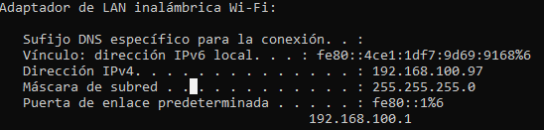
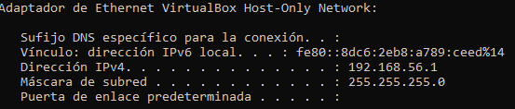
  - I made a ping to guest ip through CMD
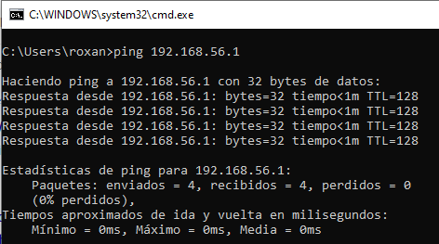
  - Then a ping to host machine through Terminal
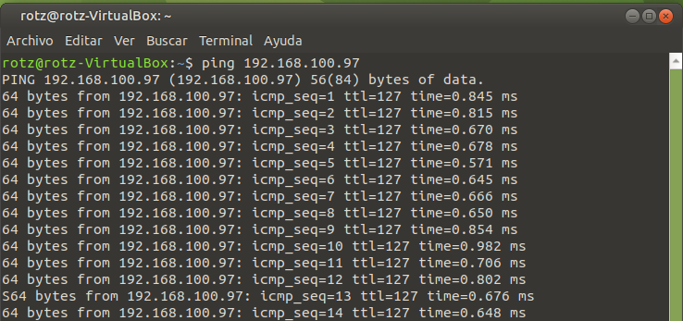

- But, for learning purposes I find how to set network through VirtualBox setting 2 network adapters. For this: virtual machine should be shutted down first. Go to Settings on VirtualBox Administrator.
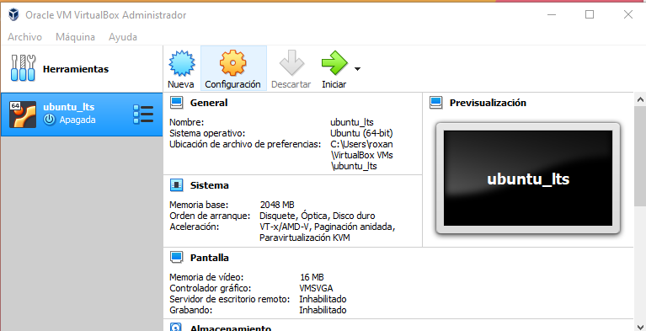
- Go to Network Option and enable adapter and select NAT on dropdown.
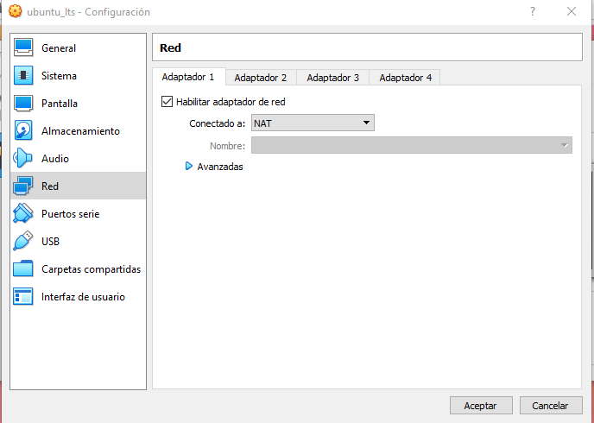

- Now open Adapter 2 TAB.
  - Enable adapter and select “host-Only Adapter”
  - Name: “VirtualBox Host-only Ethernet Adapter”
  - Click “Extended”
  - Adapter Type: “Intel PRO/1000 MT Desktop…”
  - Modus: “Allow all”
  - Save settings.
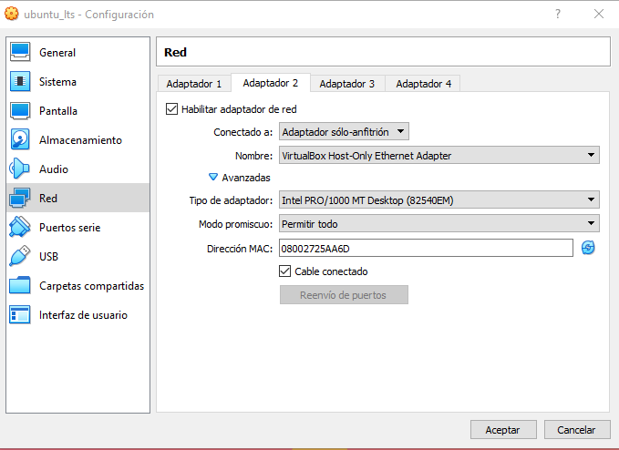
- Start virtual machine and enter ifconfig on Terminal. By now ip address is 192.168.56.101
NOTE: I needed to install net-tools first by “sudo apt install net-tools”. Is necessary give our password
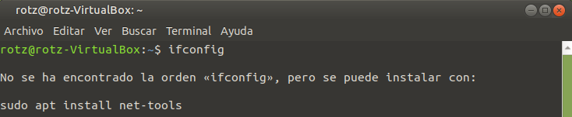
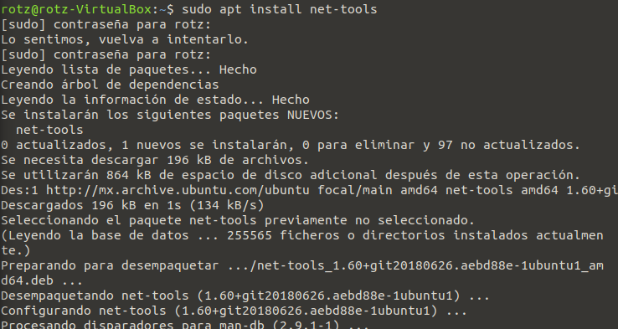
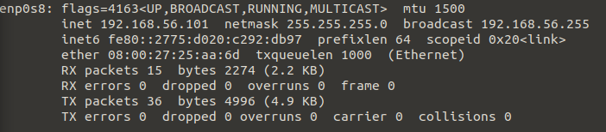
- Now for testing. On host machine open cmd and ping virtual machine ip address. “ip config 192.168.56.101”
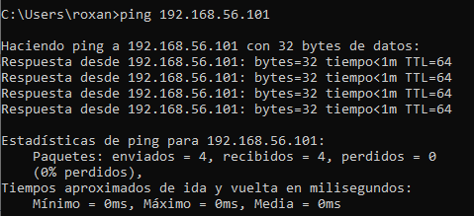
- Now type “ipconfig” on host machine CMD to know ip address and be able to ping from virtual machine. 192.168.100.97
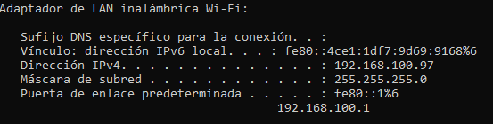

- Now on virtual machine type “ping 192.168.100.97”


