Extra Exercises

Contenido
SSH SESSION FROM WINDOWS TO UBUNTU (PUTTY) 3
COPYING FILES (WinSCP) 7

SSH SESSION FROM WINDOWS TO UBUNTU (PUTTY)
- Go to https://www.putty.org/
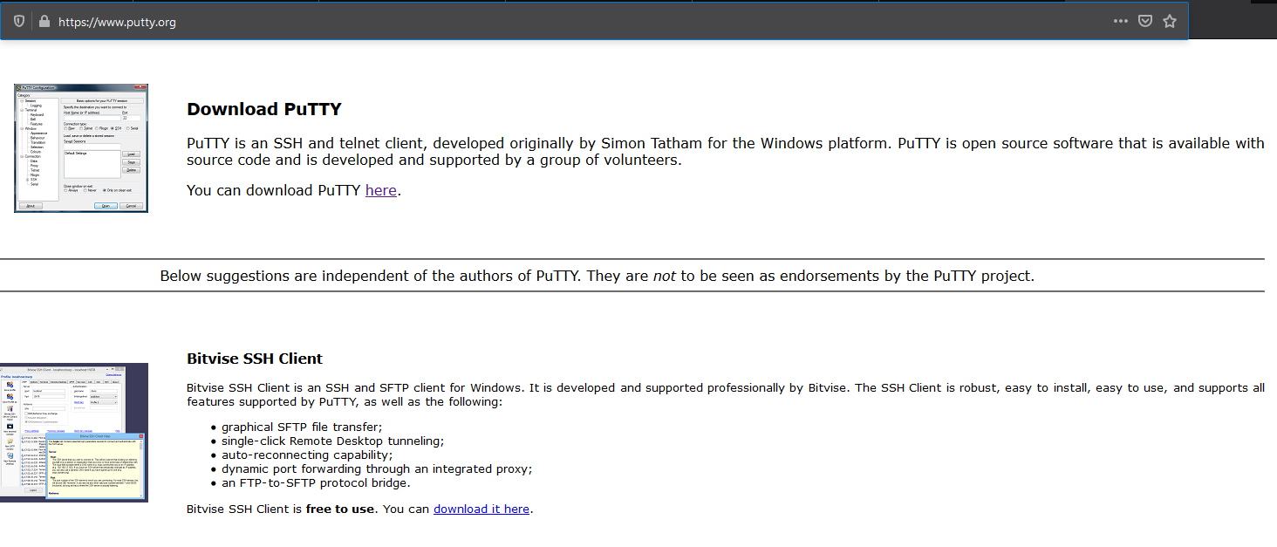
- Click on download option and then select necessary version (I choose 64 bits)
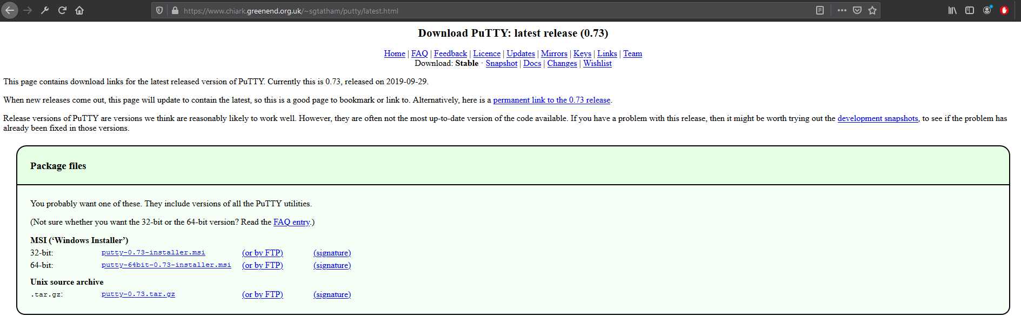
- Go where installer is allocated and execute it.
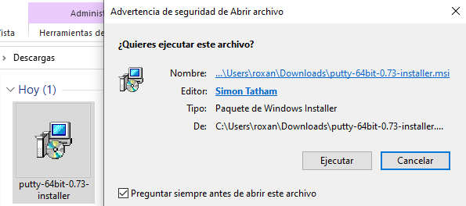

- Once PuTTY is installed. Open VM and is necessary to check if ssh service is available by “sudo systemctl status ssh”.
- By now service is not available, type “sudo apt-get install ssh” (most of the times ssh-client is installed by default and ssh-server is not). Then, type “s” or “y” (depending on language) to download ssh-server
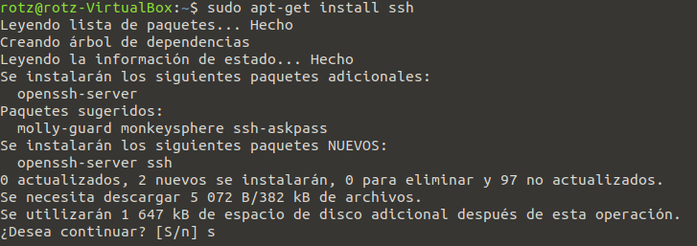
- Now if we run “sudo systemctl status ssh” we can see the following
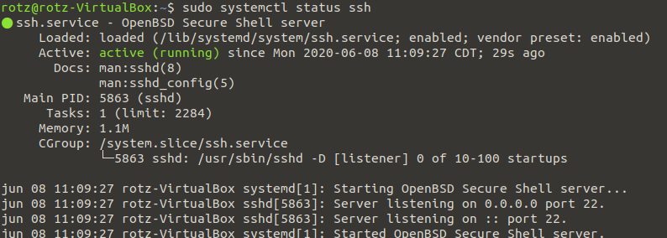
- With “netstat -tpln” we can see the needed port (22) to ssh session
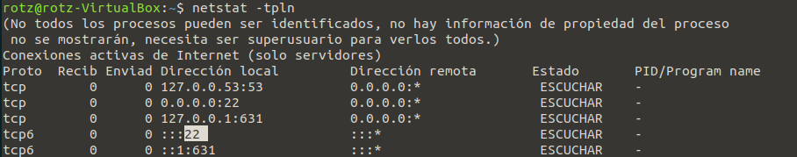
- Run “ifconfig” to get VM IP address in order to establish ssh session on Host side. (192.168.56.101)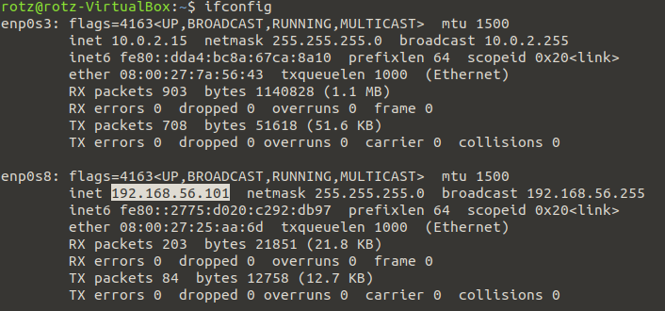
- Open PuTTY on Windows and type guest IP address (192.168.56.101), port (22), select on SSH and click “Open”
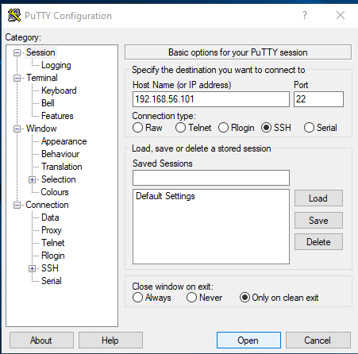

- Warning will appear, click “Yes” to continue.
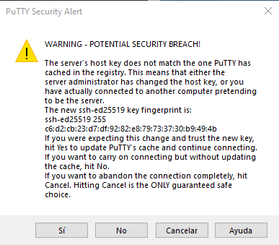
- A console will open type user and password (from Ubuntu VM) for session to be opened.
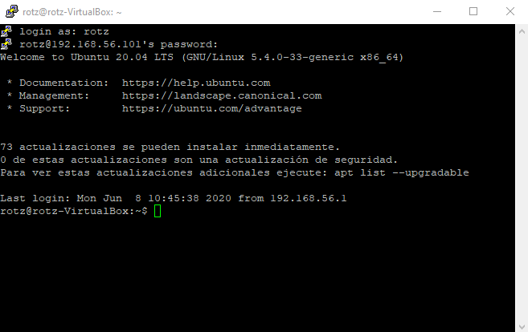

COPYING FILES (WinSCP)
- With open ssh session, download WinSCP on Windows Machine going to https://winscp.net/eng/download.php
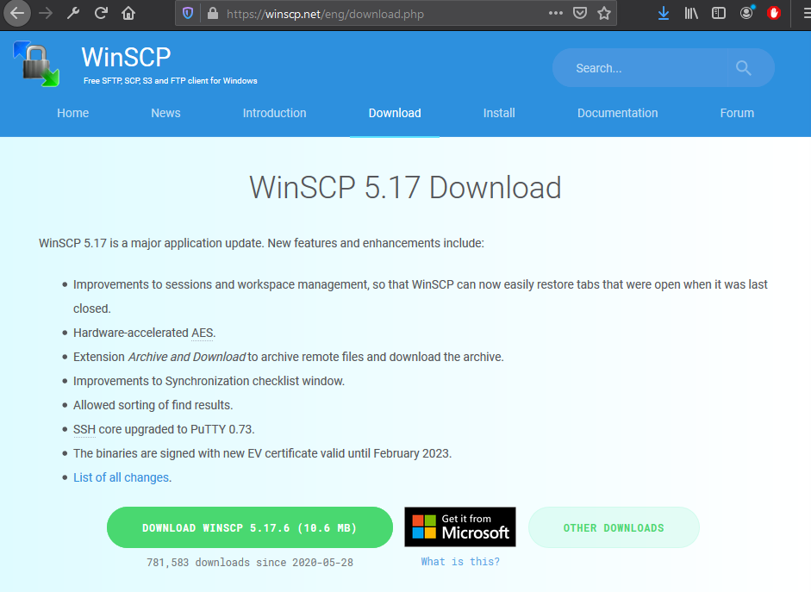
- Once installer is downloaded. Execute it
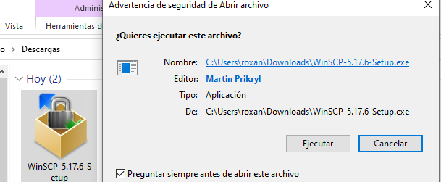

- With WinSCP credentials should be supplied to connect Virtual Machine.
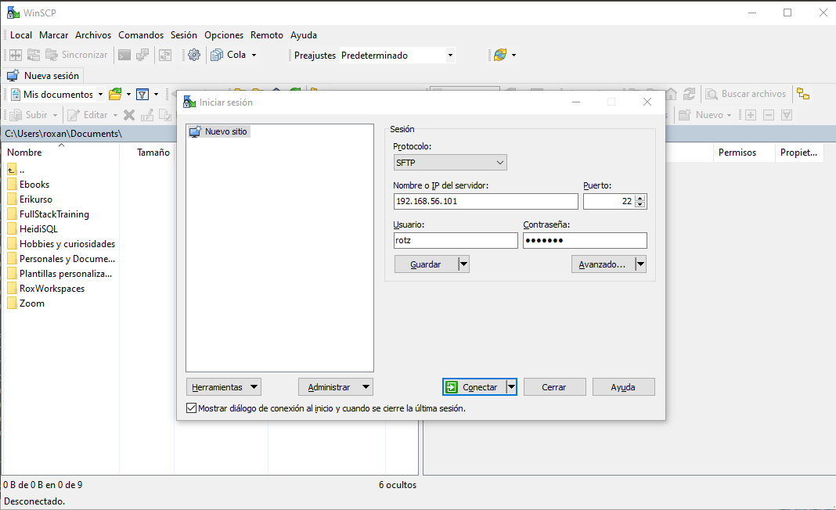
- Click “Yes”
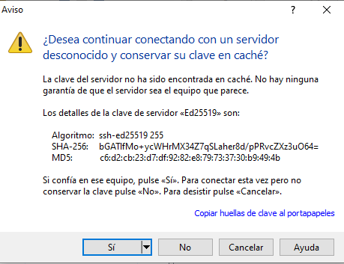

- Windows and ubuntu screens will be displayed
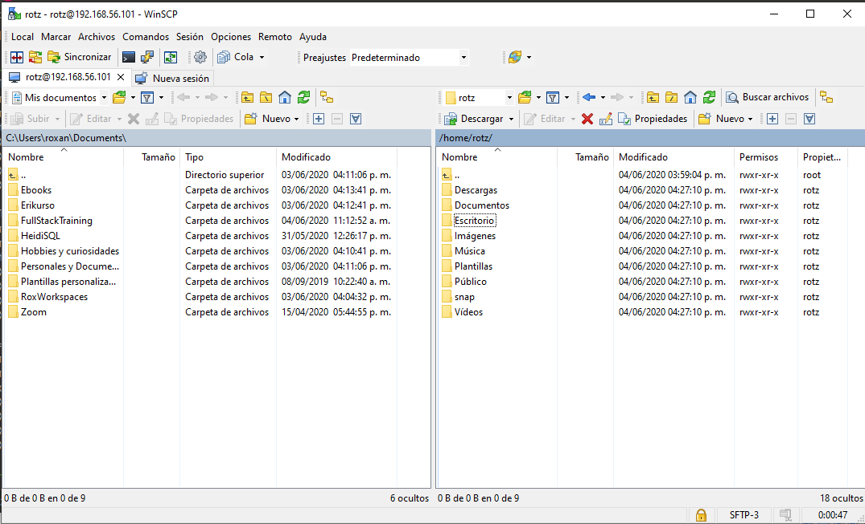
- Now just drag file from one screen to the other
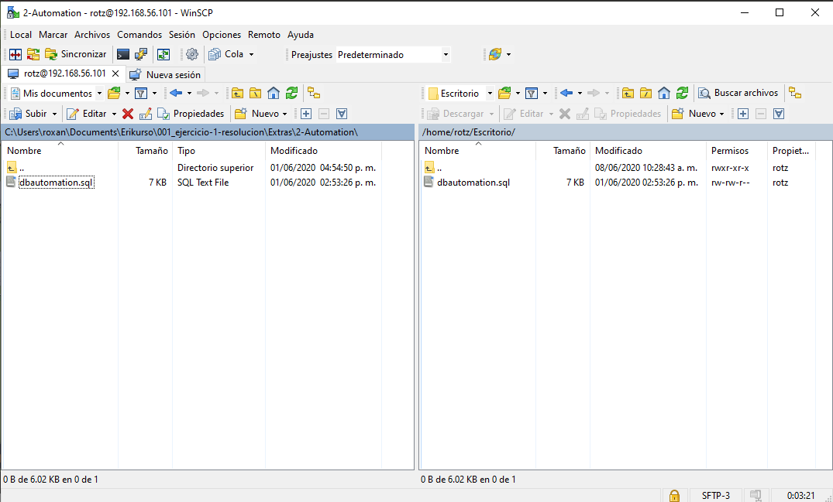

- Back to virtual machine, we can see file on Desktop.
