NORMAL FORMS IN DBMS

Content
NORMALIZATION OF DATABASE 3
FIRST NORMAL FORM (1NF) 3
SECOND NORMAL FORM (1NF) 4
THIRD NORMAL FORM (1NF) 5

NORMALIZATION OF DATABASE
Normalization is used for mainly two purposes,
- Eliminating redundant(useless) data.
- Ensuring data dependencies make sense

FIRST NORMAL FORM (1NF)
For a table to be in the First Normal Form, it should follow the following 4 rules:
- It should only have single(atomic) valued attributes/columns.
- Values stored in a column should be of the same domain
- All the columns in a table should have unique names.
- And the order in which data is stored, does not matter.
Example:
The following table has two different values on Department Column
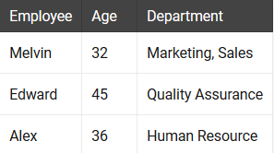
To be in 1NF department values have to be single
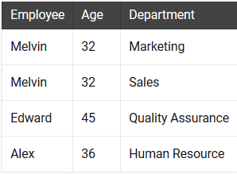

SECOND NORMAL FORM (1NF)
For a table to be in the Second Normal Form,
- It should be in the First Normal form.
- And, it should not have Partial Dependency.
Example:
Following table has to be divided in two different categories.
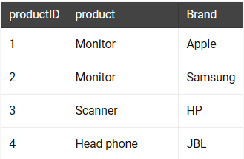
These have to be the new tables following 2NF
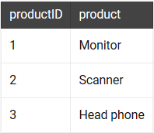
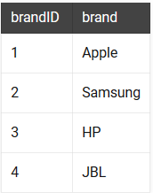

THIRD NORMAL FORM (1NF)
A table is said to be in the Third Normal Form when,
- It is in the Second Normal form.
- And, it doesn't have Transitive Dependency.
Example:
Following table has transitive dependency.

These have to be the new tables following 3NF



