PROJECT REPORT

TOUR AND TRAVEL

Priyanka Kumari

ABSTRACT

Here I have developed a project on Tour and Travel. Online Tour and Travel Booking is a system that gives you the facility of booking any type of packages (Summer special packages, Manali tour packages, Shimla special packages, adventures etc ). This system is made, so that customer can easily book ticket for all packages of tourist place such as hills, trekking, adventures, spirituals and user can also register for hotels for different types of room.

The project ‘Tours and Travels’ is developed to replace the currently existing system, which helps in keeping records of the customer, details of destination as well as payment received. It saves the precious asset that is time, and also accuracy, reliability and uniformity can be maintained. This project is useful for the manager of the company as it helps them to search the data faster than existing system, to get customer record easily and report of the customer payment, etc are generated as per requirement.

Details of different types of tours which include tours like family tours, couple tours, general tours, date and time of departure and the fair of the tours etc are maintained. Through this site we can provide different types of travel packages to the customers. This sites provide everything related to it itineraries.

This site gives new packages on flexible price, so that user can book easily. According to season admin can change packages. We revise our itineraries regularly. Vacation-O-City offers a large range of travel opportunities. Tours and Travels Project is designed in asp.net programming language, and SQL server used for this site.

In this site, Admin can add packages, add destinations (adventures, spirituals), add hotels details, and delete hotel details. Admin can also add different types of rooms.

ii
TABLE OF CONTENTS

PAGE
ACKNOWLEDGEMENTS……………………………………………………………… i

ABSTRACT……………………………………………………………………………… ii
LIST OF TABLE………………………………………………………………………………..v
LIST OF FIGURE……………………………………………………………………………....vi

1 INTRODUCTION

1.1 General Introduction …………………………………………………………………. | 1
1.2 Area of computer science……………………………………………………………... | 2
1.3 Hardware and Software Requirements………………………………………………... | 3

2 PROBLEM DEFINITION AND OBJECTIVE 4

3 BACKGROUND 6

4 DESIGN

4.1 Working of Website on .net platform………………………………………………… |  | 7
4.2 Database Design………………………………………………………………………… |  | 7
4.3 Database Schema………………………………………………………………………….. |  | 8
4.4 Dataflow Diagram……………………………………………………………………… 14
5 METHODOLGY
5.1 | Methodology………………………………………………………………………… | 18

6 IMPLEMENTATION DETAILS 19

6.1 Screenshot of Website………………………………………………………………….......19

CONCLUSION 35

REFERENCES ……………………………………………………………………………..36

LIST OF TABLES

Page

4.1 User Register…………………………………………………………………..........08

4.2 Add Package……………. ……………………………………………………….…09
4.3 Add Source ……………………….………………………………………… ..…....09
4.4 Add Destination…………………………………………….. ……………………...10
4.5 Package Description………………………………………………. ………………..10
4.6 Package Booking and Payment………………………………………………...........11
4.7Add Hotel Details……………………………………………………………….…...12
4.8 Add Room Type……………………………………………………………………..12
4.9 Hotel Booking …………………………………………………….………….……...13
4.10Payment…………………………….………………………………………………..14
4.11Add Adventure……………………………………………………………………...14
4.12Destination of Adventure……………………………………………………………15
4.13 Booking Adventure and Payment…………………………………………………..15

iii
LIST OF FIGURES

4.1 Level 0 Data Flow Diagram……………………………………………………16
4.1 Level 1 Data Flow Diagram……………………………………………………17
6.1 Add Package……………. ……………………………………………………...20
6.2 Delete Package………………………………………………………….....…......21
6.3 Add Source …………………………………………….. ………………………21
6.4 Add Destination………………………………………………………………….22
6.5 Add Package Description……….………………………………………………..22
6.6 Add Hotel Details………………………………………………….………….….23
6.7 User Registration…………………………………………………………………24
6.8 User Login………………….…………………………………………………….24
6.9 Change Password………………………………………………….………….…..25
6.10 Package Demo…………………………………………………………………...25
6.11 Book Package……….…………………………………………………………...29
6.12 payment for package………………………………………………….………….29
6.13 List of Hotels……….………………………………………………………….....30
6.14 Book Hotel………………………………………………….……………………31
6.15 Payment Hotel………………………………………………….………………...33
6.16 Add Adventure………………………………………………….……………….33
6.17 Book Adventure………………………………………………….………………34
6.18 Payment Adventure………………………………………………………………34
iv

CHAPTER 1
INTRODUCTION

  - General Introduction

Online Tour and Travel is a very user friendly project. In this project user can easily understand and book all packages and also register for hotel. In this project there are various types of forms, like all types of packages, book for package and Room Registration Page in which user can insert his personal needs & facilities then upload his form by which user can register in the web site. In this website user can also pay money through credit card.

This site provides different tour packages, hotel booking and summer special tour packages. Through this site, user can book different types of room such as deluxe room, ac room etc on flexible price.

This site provides different packages, destination, and hotel booking services in one particular state of India. Himachal Pradesh is very popular hill station of north India. Visitors enjoy snow covered mountain peaks and adventure sports like trekking, mountaineering and skiing.

In this website, according to the tour packages it provides services like online booking facilities for all packages and hotels registration to the customer. In this project user can easily understand and fill up the Room Reservation form. User can search for various types of rooms.

Online Tour and Travel is a web based application made in Asp.Net. So with the help of this project user can apply for packages of tour and room reservation.
1

In this project, Admin can add travel packages and all details of hotels which is located in Himachal Pradesh and also add all details of bus for this particular city.

Organization

HCL Company is multinational IT Services Company, headquartered in Noida, Uttar Pradesh, India. It is a subsidiary of HCL Enterprise. Originally the research and development division of HCL Limited, it emerged as an independent company in 1991 when HCL Limited ventured into the software services business. HCL Technologies (often called Hindustan Computer Limited) offers services including IT consulting, enterprise transformation, remote infrastructure management, engineering and R&D, and business process outsourcing.

HCL Company has offices in 32 countries and operates across a number of verticals industry including aerospace and defense, automotive, consumer electronics, energy.

1.2 Area of Computer Science

Web Development is a broad term for the work involved in developing a web site for the internet or an Intranet (a private network). Web development can range from developing the simplest static single page of plain text to the most complex web based internet applications, electronic businesses, and social network services.

Using Web development we can design different types of websites and the web application. A more comprehensive list of tasks to which web development commonly refers, may include web engineering, web design, web content development, client liaison, e-commerce development. Among web professionals, "web development" usually refers to the main non-design aspects of building web sites: writing markup and coding.

1.3 HARDWARE AND SOFTWARE REQUIREMENTS

1.3.1 Software Requirements:
- Operating System: Windows 7/8/10
- Application: ASP.Net using C#
- Database: SQL SERVER
- Software: Internet Explorer/Google Chrome

1.3.2 Hardware Requirements:
- Processor: Preferably 1.0 GHz or Greater.
- RAM : 1GB or Greater.

3
CHAPTER 2

PROBLEM DEFINITION AND OBJECTIVES

The purpose of tour and travel is mainly to provide online booking services for the user. This statement describes the problem definition of the proposed system. The purpose of this site is to book online ticket for hotels and all tourist places of Himachal Pradesh.

The problem definition of the vacation-o-city is to book online ticket for hotel and tourist place where user wants to visit. It is a Web Based Application to develop website in which end user interact with the web-app easily. In this website, Customer or User can search and book all tourist places and all hill stations and all hotels of Himachal Pradesh.

The problem is that we although have many websites but they offer a different kinds of services. The customers are enjoying a lot but there is a lack of relationship between travel agency and customers and hence we are establishing that relationship by carrying and servicing all customers in the same manner that we wish to serve.

OBJECTIVES

This system provides Online Registration, Tour Package Information, Bus ticket booking and all other destinations. The purpose of this project is very clear that user can find room facilities easily & hotel service providers also get good customers very easily. Customer can register in the website & can create his own registration then he can receive email for his room status related to his reservation and book all packages. User can register hotel for different types of room what they want.
4

The Main Goal of this project is to provide a very faster room reservation services and also booking services for different types of packages so any user can get this service very easily.

- Our objective is to make strong relationship with customers so that they can enjoy the holiday of their dreams.

- It saves lots of time , now a days there is a fast process world any one can work quickly so, this project helps that people who are searching for reservation in organization, so they can easily fill up the form and search rooms and different tourist place.

- Possess complete back up services.

.

5
CHAPTER 3
BACKGROUND

People wish to see the website in an even better and organized form always. The use of this website is to book online packages and online hotel reservation etc. for fun have become a favorite pass time of the people. Features vary from website to website. Usually this website focuses on the different types of packages, adventure and destination, what they want.

This tour and travel website is based on .net 4.5 platform. Along with several architecture domains, Applications Architecture from the pillars of an solution architecture. Application architecture is used for an internal structure of an application. These apps have become common trend now.

Online Tour and Travel is a web based application made in the Asp.Net. So with the help of this project user can apply for packages of tour and room reservation. All details of packages, adventure, destination and hotels are added by Admin on the Admin panel. User can search more attractive packages, destination etc. you will create web pages that visitors can interact with in wonderful way.

6
CHAPTER 4
DESIGN

4.1 Working of .Net Website

Website Tour and Travel is used to book online ticket for different packages and hotels, adventures and different destinations of Himachal Pradesh. The main page of this website has Home page which contains Register for new account, Login for account.

The user can choose different packages, destinations and hotels from gallery. The user also has the option of changing the password for security purpose and new user must have to create the account to book the packages and hotels. The first option in the navigation drawer is Home, Packages, Hotel, and Destinations (Adventures, Spirituals). Online payment option is also available on this website.

  - DATABASE DESIGN / DATA STRUCTURE DESIGN
Tables and Relationship

- In my Project Tour and travel, I used VISUAL STUDIO 2008 as a front end and use SQL server 2008 as a backend.

- Front end is mainly used for the designing purpose or designing the various kinds of forms and implement the logic and the backend is mainly used for, to store the data, records, or the information.

- I make all the tables in the SQL Server 2008. My tables name are Add package, add package description, add source, add destination, add hotels, Hotel Rooms, Hotel Info., add adventures, delete and update adventure and city. These are the tables to store the records, data, and information in the back end means in the SQL Server 2008.
7

- All the tables are used to store the records, and administrator is able to watch all the data. Now we talk about the tables and how this tables work in a back end that we can know but the main thing is the relationship of the tables.

- That’s the most important thing for the back end. In my project there is a relationship between the tables means all the tables are connected with each other so all the records or the data or the information can easily stored and there is a no chance of the mistakes in the tables.

- The Relationship between the tables is also considered as a security part if the records are not stored properly so candidate can not able to work further so it can avoid the chance of the dummy records.

  - Database Schema

User Register: This is the schema of User.

Fields | Type | Constraint
UserID | int | Auto Incre.(Primary Key)
UserName | nvarchar(max)
Password | nvarchar(max)
UserEmailAddress | Text
UserPhoneNumber | nvarchar(10)
Address | nvarchar(max)
Table 4.1 User Register
8

Add package: By this admin can add all details of packages. In this table PackageID is auto incremented and unique. Image will be upload by FileUpload control.

Fields | Type | Constraint
PackageID | int | Auto Incre.(Primary Key)
HotelName | nvarchar(max)
Image | Nvarchar(max)
Duration1 | Text
Duration2 | nvarchar(10)
Duration3 | nvarchar(10)
Duration4 | Nvarchar(10)
Image1 | nvarchar(100)
Image2 | nvarchar(max)
PackageAmount | Nvarchar(max)
Table 4.2 Add package

Add Source: On the behalf of this table admin will add the source in database. Here SourceId is primary key and auto Incremented.
Fields Name | Type | Constraint
SourceId | Int | Auto Incre  (Primary Key)
SourceName | nvarchar(50)
Table 4.3 Add Source

9
Add Destination: By this admin will add all Destination name and DestinationID will auto Incremented. DestinationID is primary key.
Fields Name | Type | Constraint
DestinationId | Int | Auto Increment (Primary Key)
DestinationName | nvarchar(50)
Table 4.4 Add Destination

Package Description: By this Admin can add package Name, days number, source and destination and details of particular package.
Fields | Type | Constraint
Package_desID | Int | Auto Incre (Primary Key)
packageID | Int | (foreignkey)
PackageName | nvarchar(200)
Days Number | nvarchar(max)
Source | nvarchar(max)
Destination | nvarchar(max)
Package_Details | Nvarchar(max)
Table 4.5 Package Description

Package Booking and Payment : In this schema, BookingID is auto Incremented and primary key. BookingID will Auto Increment and packageId, packageName, packageAmount all will come on the behalf of add package table. UserID, UserName, UserPhoneNumber, UserAddress will fill on the behalf of User_Register Schema.
10
Fields | Type | Constraint
BookingID |  | Auto Incre.(Primary Key)
PackageID | int
PackageName | nvarchar(max)
PackageAmount | nvarchar(max)
UserID | int
UserName | nvarchar(max)
UserPhoneNumber | nvarchar(max))
UserAddress | nvarchar(max)
CardNumber | nvarchar(100)
CVVNumber | nvarchar(3)
ExpiryDate | nvarchar(max)
NameOnCard | Nvarchar(max)
BookingDate | Nvarchar(max)
Table 4.6 Package Booking and Payment

11
Add Hotels : In this table Admin will add HotelName, CityName, Amount of Room, Room Type, hotel details and admin can also upload hotel image and HotelID is primary key and it will auto increment.
Fields | Type | Constraint
HotelID | int | Auto Incre.(Primary Key)
HotelName | nvarchar(max)
CityName | nvarchar(max)
Amount | nvarchar(max)  11
HotelImage | nvarchar(max)
HotelDetails | nvarchar(max)
RoomType | Nvarchar(max)
Table 4.7 Add Hotel Details

Room Type: In this schema admin will add different types of room of hotel.
Fields Name | Type | Constraint
RoomTypeId | Int | Auto Incre  (Primary Key)
RoomTypeName | nvarchar(50)
Table 4.7 Room Type

Hotel Booking: In this schema, BookingID is auto Incremented and primary key. BookingID will Auto Increment and HotelID, HotelName, Amount, Room Type all will come on the behalf of User Booking. UserID, UserName, UserPhoneNumber, UserAddress will fill on the behalf of User_Register Schema. Dateof Booking is selected date of user.
12
Fields | Type | Constraint
BookingID | int | Auto Incre (Primary Key)
HotelID | int
HoteName | nvarchar(max)
UserID | int
UserName | nvarchar(max)
RoomType | nvarchar(max)
Adults | int
Child | int
DateOFBooking | nvarchar(max)
UserEmailAddress | nvarchar(max)
Table 4.8 Hotel Booking

Hotel Payment: When user will book for particular hotel room, that details of user and hotel will come. BookingID will Auto Increment.

13
Fields | Type | Constraint
BookingID | int | Auto Incre (Primary Key)
HotelID | int
HoteName | nvarchar(max)
UserID | int
UserName | nvarchar(max)
CardNumber | nvarchar(16)
cvvnumber | int
expirydate | nvarchar(max)
Amount | nvarchar(max)
Booking Date | nvarchar(max)
Table 4.9 Payment

Add Adventures: Admin will add details of adventure and AdventureID will auto Increment.
Fields | Type | Constraint
AdventureID | int | Auto Incre.(Primary Key)
AdventureName | nvarchar(max)
Amount | nvarchar(max)
Duration | nvarchar(max)
AddImage | nvarchar(max)
Destination | nvarchar(max)
Details | nvarchar(max)
Table 4.10 Add Adventure
14

Destination of Adventure: Admin will add CityName of Adventure and CityID will auto Increment.
Fields Name | Type | Constraint
CityID | int | Auto Incre  (Primary Key)
CityName | nvarchar(50)
Table 4.11 Destination of Adventure

Book Adventure and Payment: Details of booking and details of user will come in this schema.
Fields | Type | Constraint
BookingID | int | Auto Incre (Primary Key)
AdventureID | int
AdventureName | nvarchar(max)
Amount | nvarchar(max)
UserID | int
UserName | Nvarchar(max)
UserPhoneNumber | nvarchar(max)
Address | nvarchar(max)
CardNumber | int
cvvnumber | int
expirydate | nvarchar(max)
Booking Date | nvarchar(max)
Table 4.12 Booking and Payment for Adventure
15

4.4 Data Flow Diagram
LEVEL 0

System
Register

User

Login

Book Package/Hotel
Payment
Add
Packages/Hotel/ Adventures/Temples
Add

Hotel
Modify (Search/Update/Delete)
Packages/Hotel/Adventure/Temples

Admin

Figure 4.1 Data Flow Level 0

16

LEVEL 1:

Manage Packages/ Hotels/Adventures

Register User

System

Login

Search Packages

Display Packages/Hotels/Destination

Output

Input

Figure 4.2 Dataflow Level 1

17
CHAPTER 5

Methodology

Front end design and tour booking
Front end refers to the visual layer of website and applications. The UI, layout, images and other visual elements and their styling comprises of:
- Developing visual standards.
- Handling site accessibility.
- Page layout
- Form design

It is very helpful in business applications. Since, it is web based it gives online booking facility for packages, destinations i.e adventures, spirituals and hotels and customer can also payment by card. Vacation-o-city is to book online ticket for hotel and tourist place. It is a Web Based Application to develop website in which end user interact with the webapp easily. In this website, Customer or User can search and book all tourist places and all hill station, adventures, spirituals and all hotels of Himachal Pradesh.

  - Choose working page.

1. This is the home screen that contains the title in the toolbar and has four links which takes the user to four different features.
2. On the top right corner of title bar is a button which on clicking opens the navigation, on which user will click.
3. In the navigation drawer, the user can choose package from package link, destination from destination link, or hotels from hotels link. The user also has the option of changing the user password which in return changes it to your password in the database.
18

4. User has also option for payment after the booking of package, hotels and destinations which includes adventures, spirituals.

19
CHAPTER 6

IMPLEMENTATION DETAILS

6.1 Admin Panel
Step 1: Add packages: In this step admin added package name and also uploaded image. When package added successfully it will show Inserted successfully in label.
Admin can add package, delete package, modify package and admin can also add all description of packages and add duration.

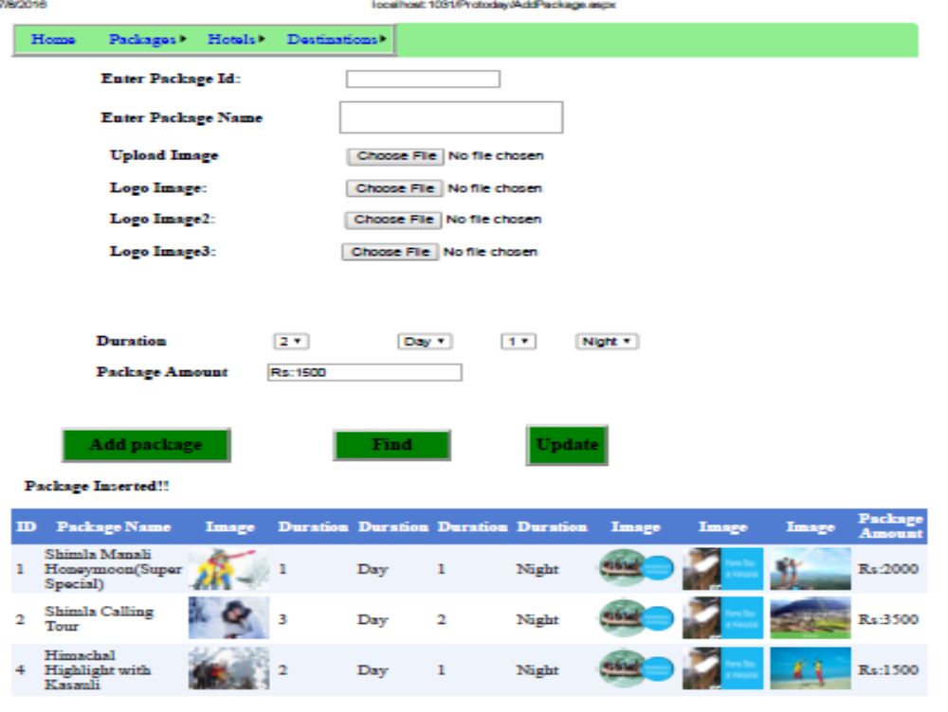
Figure 6.1 Add package

20

Step 2: Delete Package: By the following Edit button and Delete button Admin can update and delete details particular package.

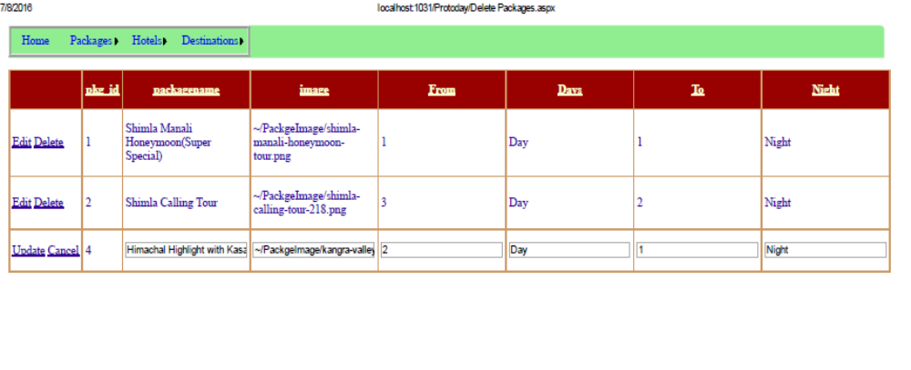

Figure 6.2 Delete Package

Step 3: Add Source: Admin are adding Source.

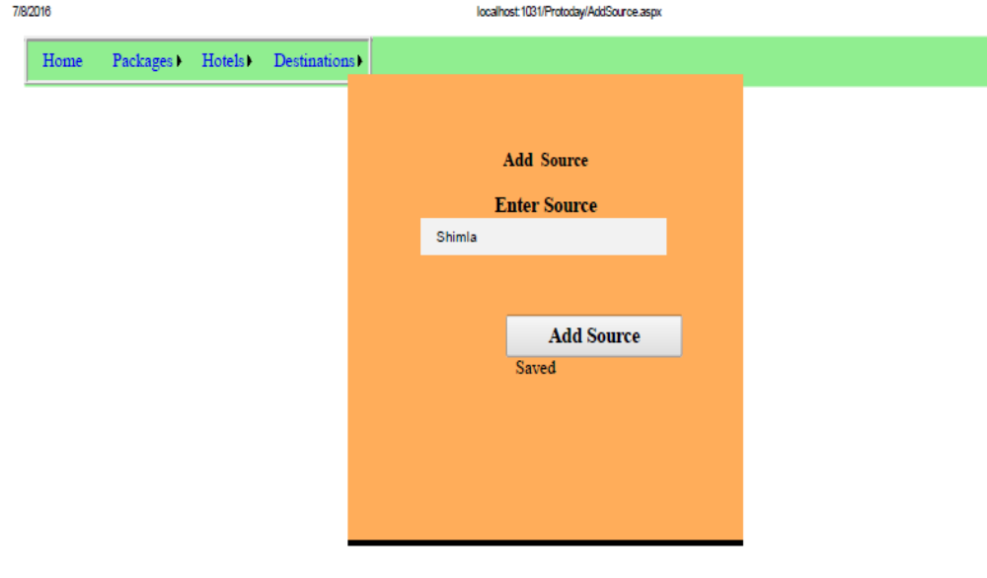
Figure 6.3 Add Source

21

Step 4: Add Destination: Admin can add destination name. If Destination name will add in the database, it will show Saved in label

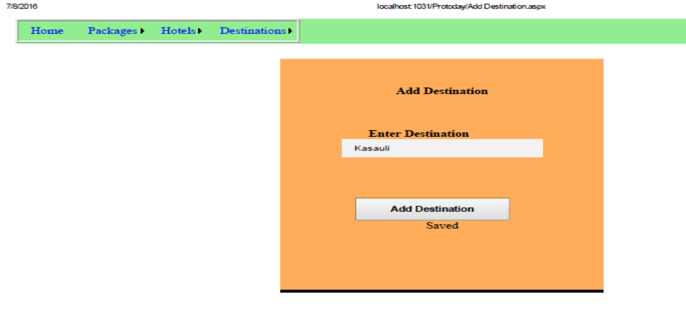
Figure 6.4

Step 5: Add Package Description: Admin added all the details of package and package name will select from Dropdown list which referred from the database.

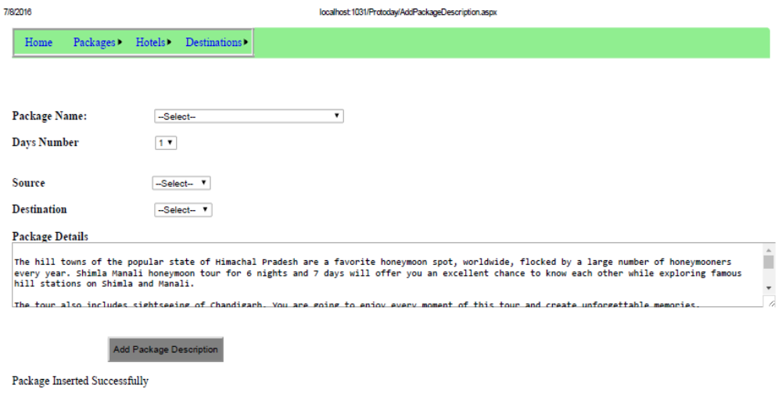
Figure 6.5 Package Description

22
Step6 Add Hotel Details

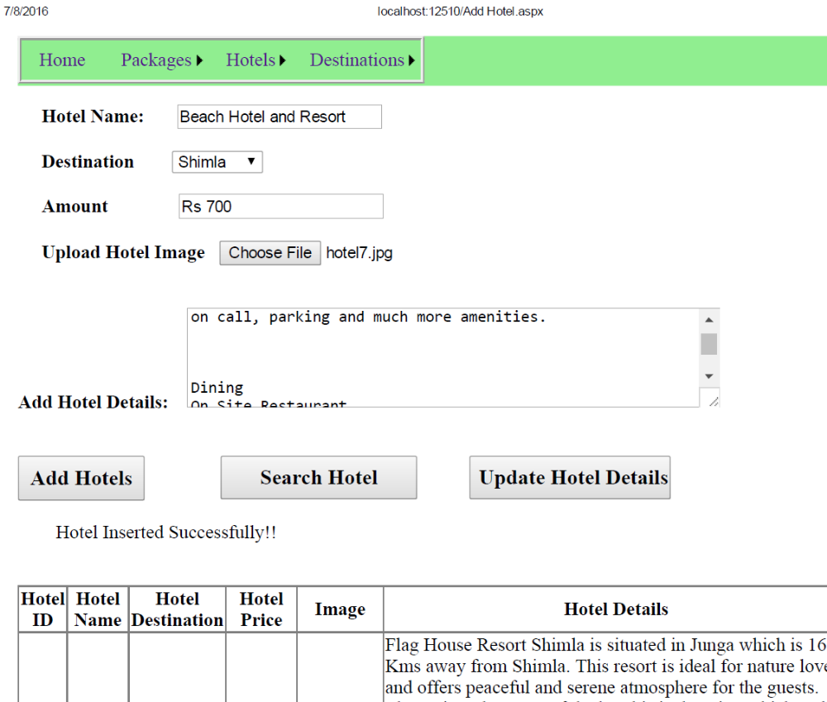

Figure 6.6 Add Hotel Details

User Panel:

User Register: In this step new user must have to create account. Login is possible only after the registration. User can also change his/her password.

23
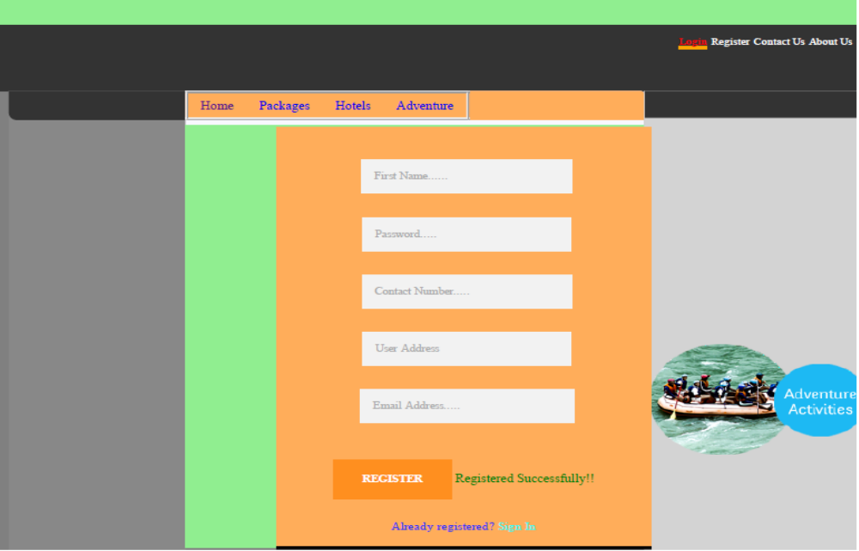
Figure 6.7 User Registration

Step: 2 User Login: In this step registered customer can login/signin the account. Login is possible only after the registration. User can also change his/her password.

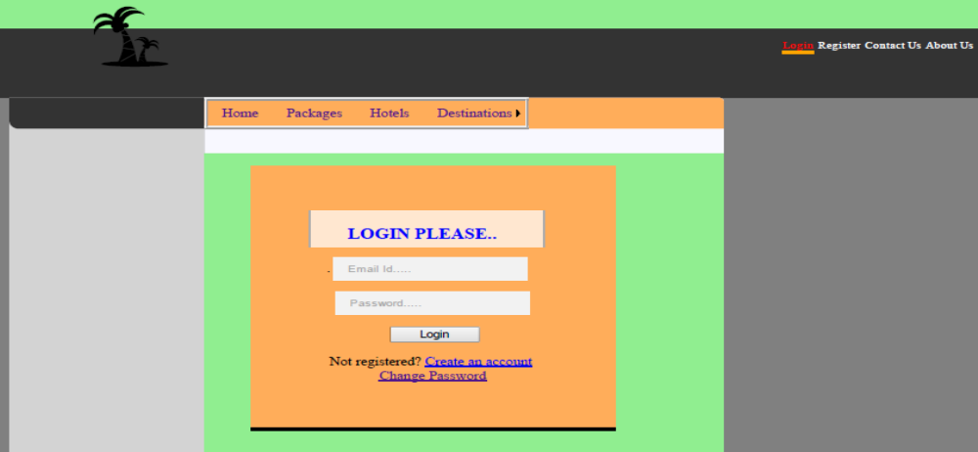
Figure 6.8 User Login
24

Step 3: Change password: By this page user can change own password.

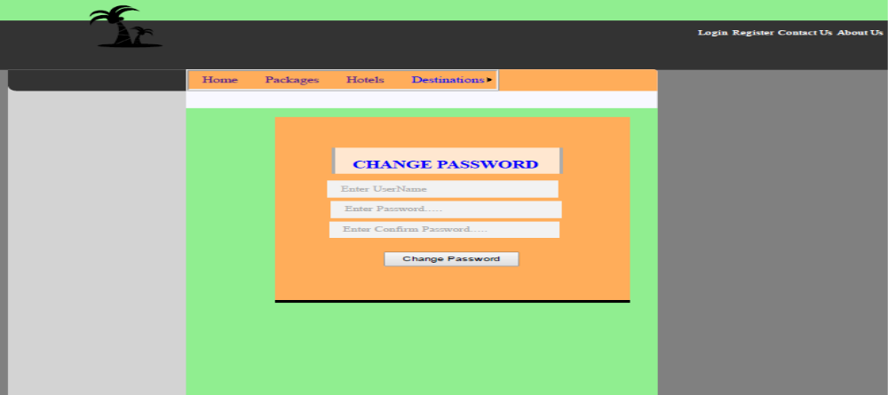
Figure 6.9 Change Password

Step4: For booking, User will first login after login user can go to package panel this page will open. By this user can know details of package.

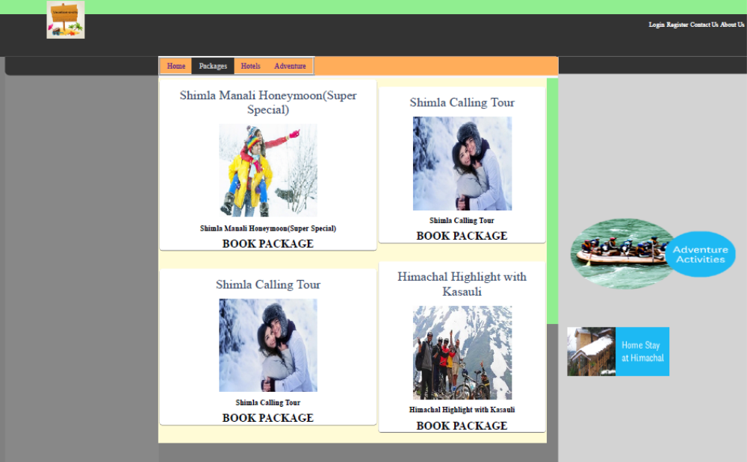
25
Figure 6.10 Package demo
Step 5: Booking Package: When user will click on booking package button, user will go to the Payment.

Code snippet for Book Package and Payment for package

protected void Page_Load(object sender, EventArgs e)
{
this.UnobtrusiveValidationMode = System.Web.UI.UnobtrusiveValidationMode.None;

try
{
if (!IsPostBack)
{
if (Session["username"] != null)
{
DataTable _Dt1 = mydbconnection.CreateInstance().GetSingleTable("select * from User_Registers where UserEmailAddress='" + Session["userName"].ToString() + "'");

if (_Dt1 != null && _Dt1.Rows.Count > 0)
{
txtTotalAmount.Text = Session["PackageAmount"].ToString();

Session["UId"] = _Dt1.Rows[0]["UserID"].ToString();
UserID = _Dt1.Rows[0]["UserID"].ToString();
Username = _Dt1.Rows[0]["UserName"].ToString();
txtAddress.Text = _Dt1.Rows[0]["UserAddress"].ToString();

btnSaveandBuy.Enabled = true;
if (txtAddress.Text != "")
{
Label14.Visible = btnUpdateAddress.Visible = false;
txtAddress.ReadOnly = true;
}
else
{
Label14.Visible = btnUpdateAddress.Visible = true;
}

txtPhoneNo.Text = _Dt1.Rows[0]["UserPhoneNumber"].ToString();
if (txtPhoneNo.Text != "")
{
Label14.Visible = btnUpdatePhone.Visible = false;
txtPhoneNo.ReadOnly = true;
}
else
{
Label14.Visible = btnUpdatePhone.Visible = true;
}

DataTable dt2 = mydbconnection.CreateInstance().GetSingleTable("select * from pkg join package_detail on pkg. pkg_id=package_detail.pkg_id where pkg.pkg_id='" + Session["pkg_id"].ToString() + "'");
if (dt2 != null && dt2.Rows.Count > 0)
26
{
packageid = dt2.Rows[dt2.Rows.Count - 1]["pkg_id"].ToString();
packageName = dt2.Rows[dt2.Rows.Count - 1]["packagename"].ToString();
PackageAmount = dt2.Rows[dt2.Rows.Count - 1]["PackageAmount"].ToString();
DataList1.DataSource = dt2;
DataList1.DataBind();
}
}
}
else
{
Label14.Visible = false;
btnSaveandBuy.Enabled = false;
}
}
}
catch (Exception ex)
{
Label14.Text = ex.Message;
}
}

protected void btnUpdateAddress_Click(object sender, EventArgs e)
{
try
{
SqlConnection conn = new SqlConnection("Data Source=.; Initial Catalog=vacation;Integrated Security=true;");

string Qry = "update User_Registers set UserAddress='" + txtAddress.Text + "' where UserID='" + UserID + "'";
SqlCommand comm = new SqlCommand(Qry, conn);
conn.Open();

int i = comm.ExecuteNonQuery();
conn.Close();
if (i > 0)
{
Label14.Visible = btnUpdateAddress.Visible = false;
txtAddress.ReadOnly = true;
}
}
catch (Exception ex)
{ }
}

protected void btnUpdatePhone_Click(object sender, EventArgs e)
{
try
{
SqlConnection conn = new SqlConnection("Data Source=.; Initial Catalog=vacation;Integrated Security=true;");

string Qry = "update User_Registers set UserPhoneNumber='" + txtPhoneNo.Text + "' where UserID='" + UserID + "'";

27
SqlCommand comm = new SqlCommand(Qry, conn);
conn.Open();
int i = comm.ExecuteNonQuery();
conn.Close();
if (i > 0)
{
Label14.Visible = btnUpdatePhone.Visible = false;
txtPhoneNo.ReadOnly = true;
}
}
catch (Exception ex)
{ }
}
static string UserID = "";
static string Username = "";
static string Address = "";
static string phoneno = "";
static string packageid = "";
static string packageName = "";
static string PackageAmount = "";

protected void btnSaveandBuy_Click(object sender, EventArgs e)
{
try
{
Address = txtAddress.Text; phoneno = txtPhoneNo.Text;
SqlConnection conn = new SqlConnection("Data Source=.; Initial Catalog=vacation;Integrated Security=true;");
SqlCommand comm;
string exp = ddlExpireMonth.SelectedValue + "/" + ddlExpireYear.SelectedValue;
string Qry = "Insert into Booking values ('" + packageid + "','" + packageName + "','" + PackageAmount + "','" + UserID + "','" + Username + "','" + phoneno + "','" + Address + "','" + txtCardNumber.Text + "','" + txtCvv.Text + "','" + exp + "','" + txtNameonCard.Text + "','" + DateTime.Now.ToString() + "')";
comm = new SqlCommand(Qry, conn);
conn.Open();
int i = comm.ExecuteNonQuery();
conn.Close();
Label7.Text = "Payment Successfully.";
}
catch (Exception ex)
{ }

}
28
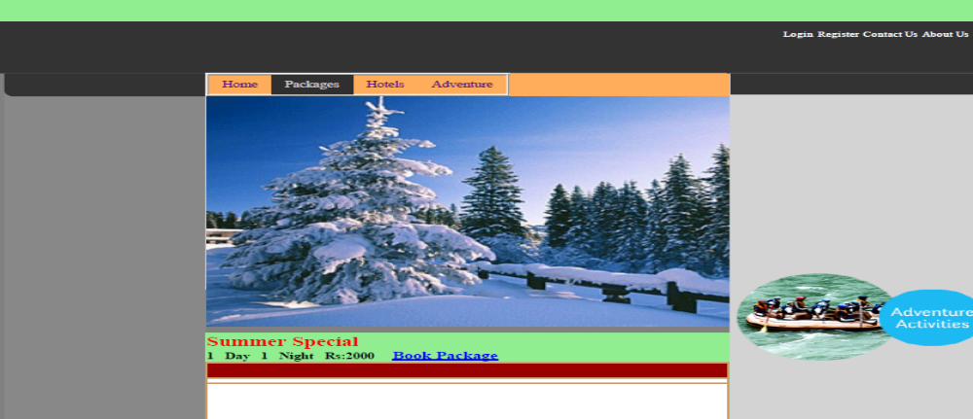

Figure 6.11 Book Package

Step 6: Payment: In this step user will payment for package.

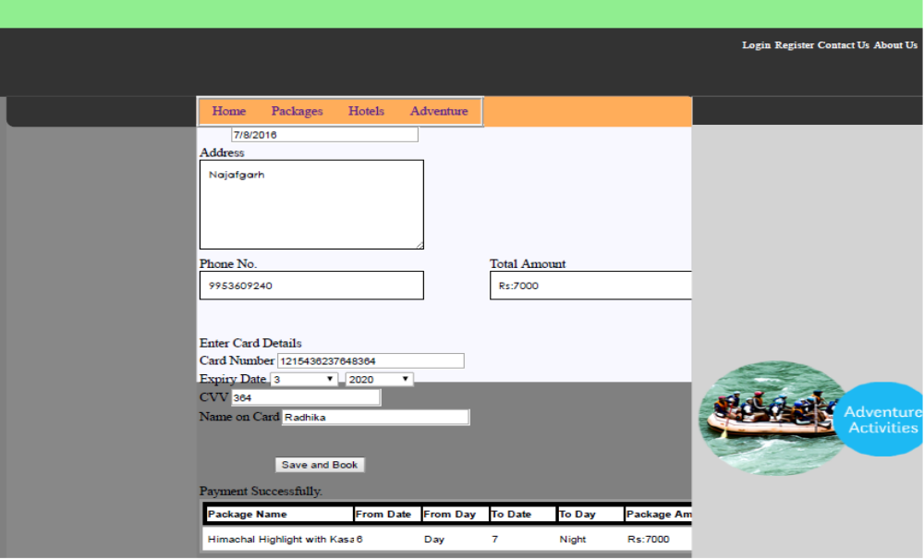

Figure 6.12 Payment for package
29

Hotel:

Step1: List of Hotels

When User will click on Hotel link, this page will open and when user will click Book Hotel button, user will go to hotel details page and on the last user will go to payment page, on which user can pay for hotel.

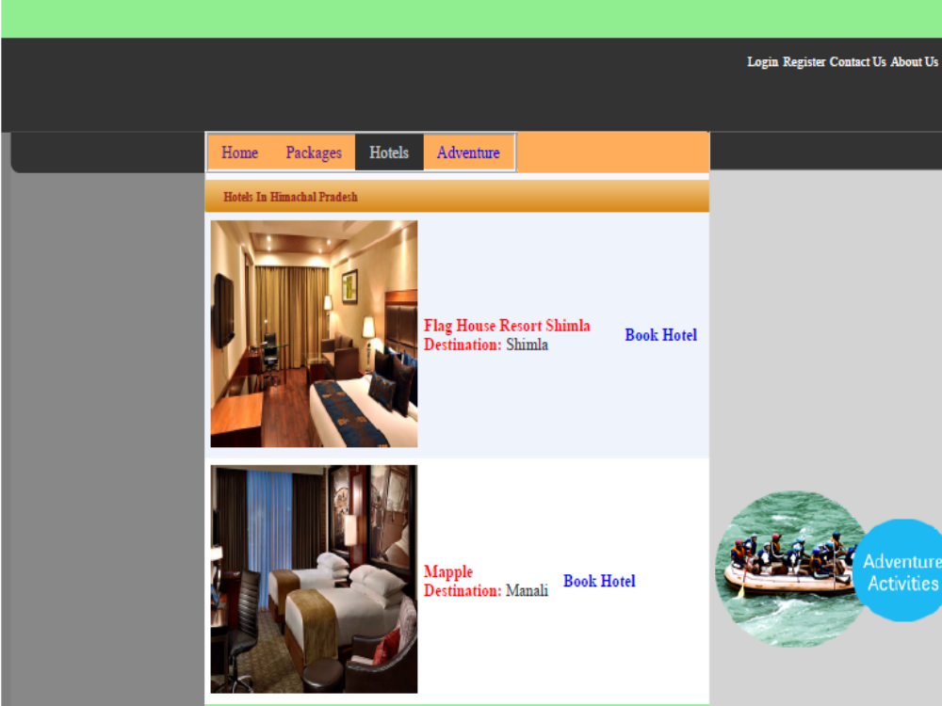
Figure 6.13 List of Hotels

Step 2: User can see Hotels Details and they can register for hotel and choose different types of rooms from the dropdown list.
30
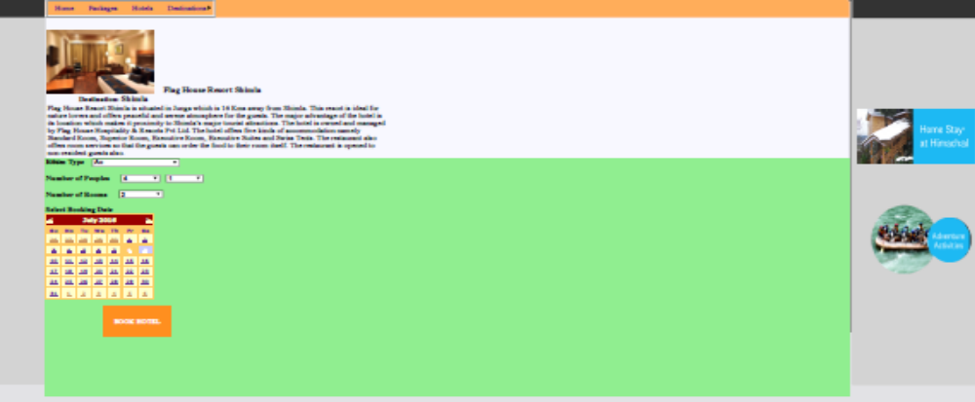
Figure 6.14 Book Hotel

Step 3: Payment Gateway for Hotel.

Code Snippet for Payment of Hotel

protected void btnSaveandBuy_Click(object sender, EventArgs e)
{
try
{

if (Session["HotelID"] != null)
{

DataTable _Dt1 = mydbconnection.CreateInstance().GetSingleTable("select * from AddHotel where AddHotel.HotelID='" + Session["HotelID"].ToString() + "'");
if (_Dt1 != null && _Dt1.Rows.Count > 0)
{
Session["hotelId"] = _Dt1.Rows[0]["HotelID"].ToString();
hotelid = _Dt1.Rows[0]["HotelID"].ToString();

Session["HotelName"] = _Dt1.Rows[0]["HotelName"].ToString();
hotelname = _Dt1.Rows[0]["HotelName"].ToString();

Session["amount"] = _Dt1.Rows[0]["Amount"].ToString();
amount = _Dt1.Rows[0]["Amount"].ToString();
}
}

if (Session["UserName"] != null)
{
DataTable _Dt2 = mydbconnection.CreateInstance().GetSingleTable("select * from User_Registers where UserEmailAddress='" + Session["UserName"].ToString() + "'");
if (_Dt2 != null && _Dt2.Rows.Count > 0)
31
{
Session["Userid"] = _Dt2.Rows[0]["UserID"].ToString();
Userid = _Dt2.Rows[0]["UserID"].ToString();

Session["Username"] = _Dt2.Rows[0]["UserName"].ToString();
Username = _Dt2.Rows[0]["UserName"].ToString();
}
}

SqlConnection conn = new SqlConnection("Data Source=.; Initial Catalog=vacation;Integrated Security=true;");
SqlCommand comm;
string exp = ddlExpireMonth.SelectedValue + "/" + ddlExpireYear.SelectedValue;
string Qry = "Insert into Payment values ('" + bookingId + "','" + hotelid + "','" + hotelname + "','" + Userid + "','" + Username + "','" + txtNameonCard.Text + "','" + txtCardNumber.Text + "','" + txtCvv.Text + "','" + exp + "','" + amount + "','" + DateTime.Now.ToString() + "')";
comm = new SqlCommand(Qry, conn);
conn.Open();
int i = comm.ExecuteNonQuery();
conn.Close();

Label1.Text = "Payment Successfully!";
}

catch (Exception ex)
{
Label1.Text = ex.Message;

}
32
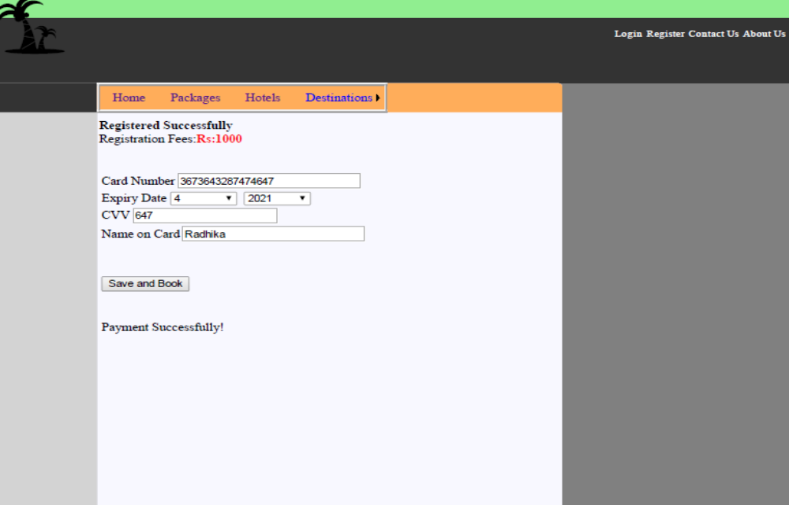
Figure 6.15 Payment for hotel

Adventures:

Admin Panel of Adventures: Admin can add adventures, Modify adventures (ie. Delete,
Update details.

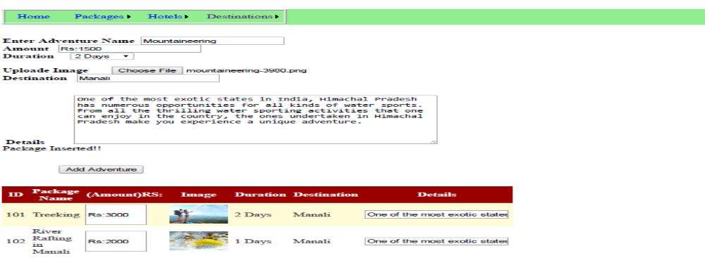
Figure 6.16 Add Adventure
33

Book Adventure: when user will click on Book Adventure Button, it will go to the
payment gateway.

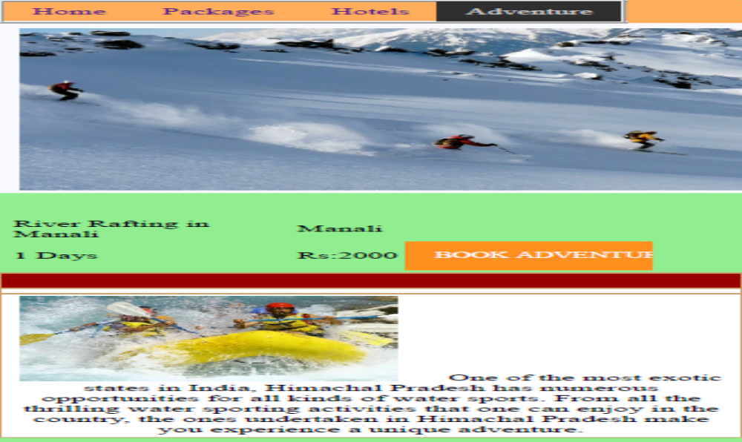
Figure 6.17 Book Adventure

Pyment for Adventure: User can pay online for Adventure, and all details of logged in user will update automatically. Address, phone number of logged in people will showing.

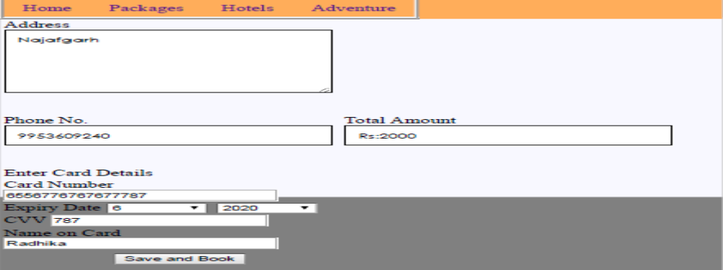
Figure 6.18 Payments for Adventure

34

CONCLUSION

This web application provides easy way to book tickets online. This application developed is designed in such a way that any further enhancements can be done with ease.

Through this website user can book all packages of tourist places and hotels. By using this site we can save our time.

35
REFERENCES

[1] Mathew Macdonald, Apress Beginning ASP.net 4.5 in C#

[2] Tutorialspoint.com for searching for new options and features to add in the application

[3] Thenewboston.com for basic application development learning.

36

