# StructuredStreaming整合Kafka

## 官网说明

http://spark.apache.org/docs/latest/structured-streaming-kafka-integration.html

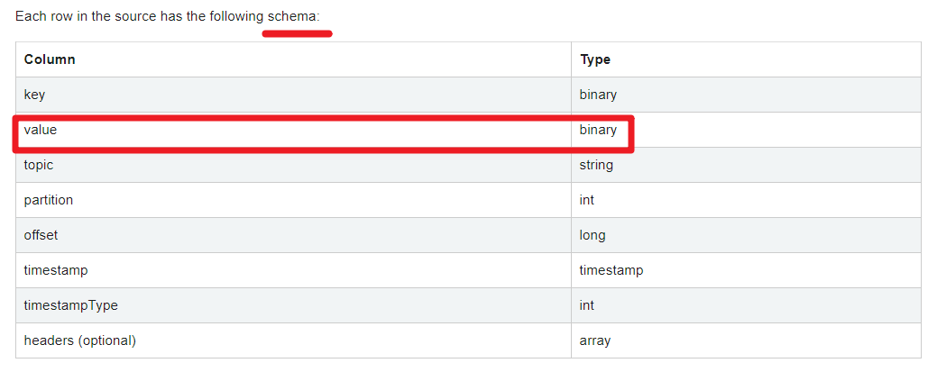

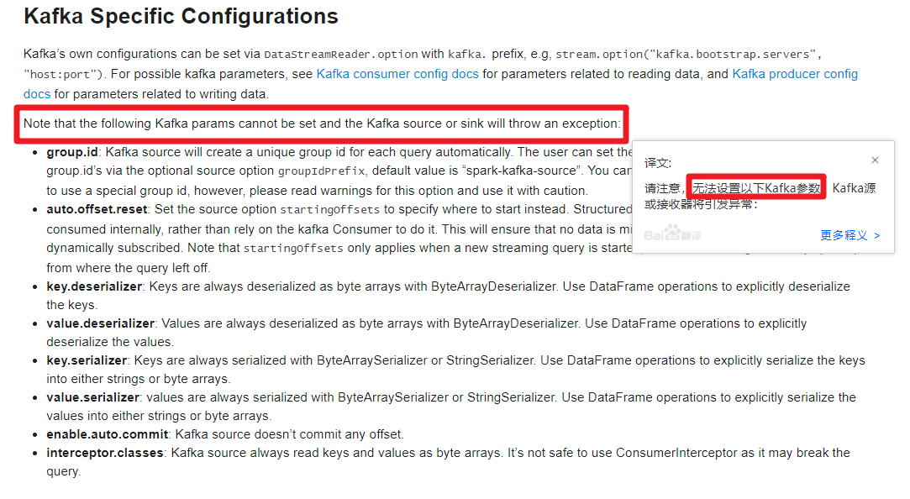

## API使用

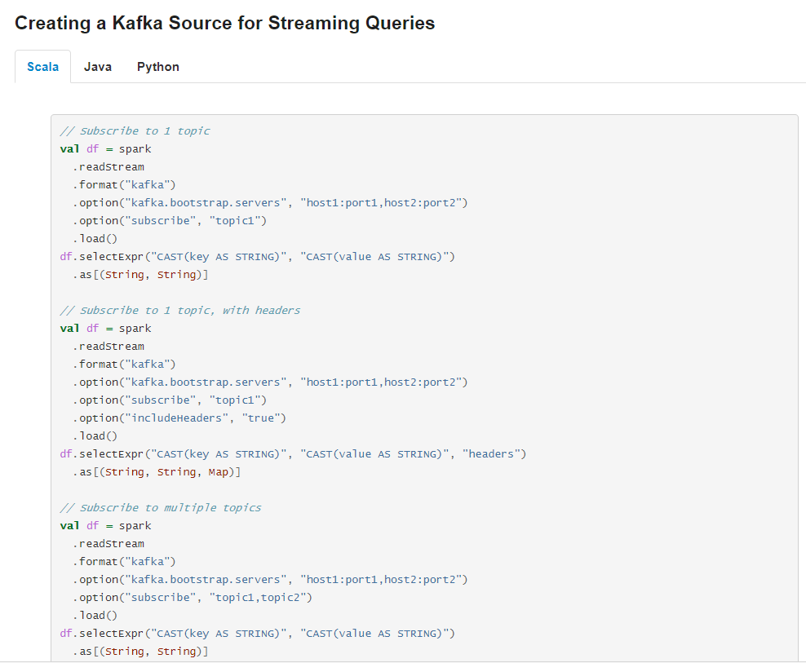

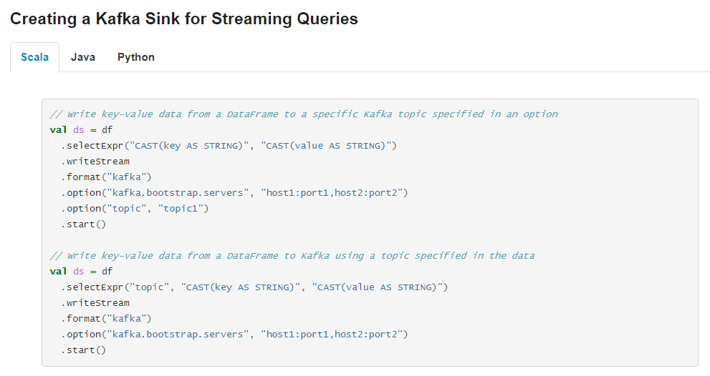

## 案例1-实时ETL

### 需求

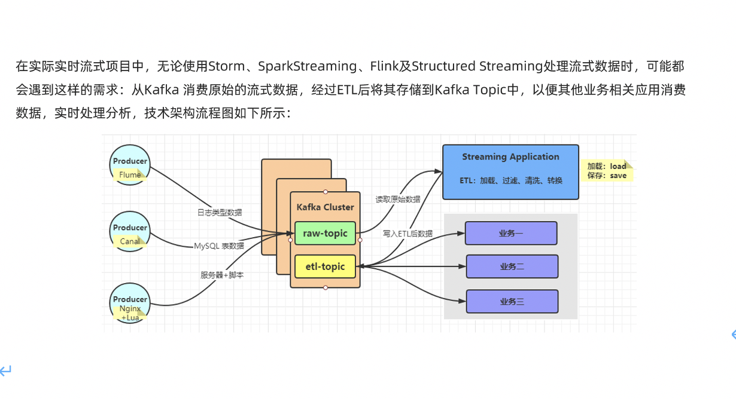

### 准备数据-直接用

package com.as.structured  
  
import java.util.Properties  
  
import org.apache.kafka.clients.producer.{KafkaProducer, ProducerRecord}  
import org.apache.kafka.common.serialization.StringSerializer  
  
import scala.util.Random  
  
/**  
 * 模拟产生基站日志数据，实时发送Kafka Topic中  
 * 数据字段信息：  
 * 基站标识符ID, 主叫号码, 被叫号码, 通话状态, 通话时间，通话时长  
 */  
object MockStationLog {  
 def main(args: Array[String]): Unit = {  
 // 发送Kafka Topic  
 val props = new Properties()  
 props.put("bootstrap.servers", "node1:9092")  
 props.put("acks", "1")  
 props.put("retries", "3")  
 props.put("key.serializer", classOf[StringSerializer].getName)  
 props.put("value.serializer", classOf[StringSerializer].getName)  
 val producer = new KafkaProducer[String, String](props)  
  
 val random = new Random()  
 val allStatus = Array(  
 "fail", "busy", "barring", "success", "success", "success",  
 "success", "success", "success", "success", "success", "success"  
 )  
  
 while (true) {  
 val callOut: String = "1860000%04d".format(random.nextInt(10000))  
 val callIn: String = "1890000%04d".format(random.nextInt(10000))  
 val callStatus: String = allStatus(random.nextInt(allStatus.length))  
 val callDuration = if ("success".equals(callStatus)) (1 + random.nextInt(10)) * 1000L else 0L  
  
 // 随机产生一条基站日志数据  
 val stationLog: StationLog = StationLog(  
 "station_" + random.nextInt(10),  
 callOut,  
 callIn,  
 callStatus,  
 System.currentTimeMillis(),  
 callDuration  
 )  
 println(stationLog.toString)  
 Thread.sleep(100 + random.nextInt(100))  
  
 val record = new ProducerRecord[String, String]("stationTopic", stationLog.toString)  
 producer.send(record)  
 }  
  
 producer.close() // 关闭连接  
 }  
  
 /**  
 * 基站通话日志数据  
 */  
 case class StationLog(  
 stationId: String, //基站标识符ID  
 callOut: String, //主叫号码  
 callIn: String, //被叫号码  
 callStatus: String, //通话状态  
 callTime: Long, //通话时间  
 duration: Long //通话时长  
 ) {  
 override def toString: String = {  
 s"$stationId,$callOut,$callIn,$callStatus,$callTime,$duration"  
 }  
 }  
  
}

### 准备主题

#查看topic信息  
/export/server/kafka/bin/kafka-topics.sh --list --zookeeper node1:2181  
#删除topic  
/export/server/kafka/bin/kafka-topics.sh --delete --zookeeper node1:2181 --topic stationTopic  
/export/server/kafka/bin/kafka-topics.sh --delete --zookeeper node1:2181 --topic etlTopic  
  
#创建topic  
/export/server/kafka/bin/kafka-topics.sh --create --zookeeper node1:2181 --replication-factor 1 --partitions 3 --topic stationTopic  
/export/server/kafka/bin/kafka-topics.sh --create --zookeeper node1:2181 --replication-factor 1 --partitions 3 --topic etlTopic  
  
#模拟生产者  
/export/server/kafka/bin/kafka-console-producer.sh --broker-list node1:9092 --topic stationTopic  
/export/server/kafka/bin/kafka-console-producer.sh --broker-list node1:9092 --topic etlTopic  
  
#模拟消费者  
/export/server/kafka/bin/kafka-console-consumer.sh --bootstrap-server node1:9092 --topic stationTopic --from-beginning  
/export/server/kafka/bin/kafka-console-consumer.sh --bootstrap-server node1:9092 --topic etlTopic --from-beginning

### 代码实现

stationTopic -->StructuredStreaming-->etlTopic

package com.as.structured  
  
import org.apache.spark.SparkContext  
import org.apache.spark.sql.streaming.Trigger  
import org.apache.spark.sql.{DataFrame, Dataset, Row, SparkSession}  
  
/**  
 * Author roy  
 * Desc 演示StructuredStreaming整合Kafka,  
 * 从stationTopic消费数据 -->使用StructuredStreaming进行ETL-->将ETL的结果写入到etlTopic  
 */  
object Demo09_Kafka_ETL {  
 def main(args: Array[String]): Unit = {  
 //TODO 0.创建环境  
 //因为StructuredStreaming基于SparkSQL的且编程API/数据抽象是DataFrame/DataSet,所以这里创建SparkSession即可  
 val spark: SparkSession = SparkSession.builder().appName("sparksql").master("local[*]")  
 .config("spark.sql.shuffle.partitions", "4") //本次测试时将分区数设置小一点,实际开发中可以根据集群规模调整大小,默认200  
 .getOrCreate()  
 val sc: SparkContext = spark.sparkContext  
 sc.setLogLevel("WARN")  
 import spark.implicits._  
  
 //TODO 1.加载数据-kafka-stationTopic  
 val kafkaDF: DataFrame = spark.readStream  
 .format("kafka")  
 .option("kafka.bootstrap.servers", "node1:9092")  
 .option("subscribe", "stationTopic")  
 .load()  
 val valueDS: Dataset[String] = kafkaDF.selectExpr("CAST(value AS STRING)").as[String]  
  
 //TODO 2.处理数据-ETL-过滤出success的数据  
 val etlResult: Dataset[String] = valueDS.filter(_.contains("success"))  
  
 //TODO 3.输出结果-kafka-etlTopic  
 etlResult.writeStream  
 .format("kafka")  
 .option("kafka.bootstrap.servers", "node1:9092")  
 .option("topic", "etlTopic")  
 .option("checkpointLocation", "./ckp")  
 //TODO 4.启动并等待结束  
 .start()  
 .awaitTermination()  
  
  
 //TODO 5.关闭资源  
 spark.stop()  
 }  
}  
//0.kafka准备好  
//1.启动数据模拟程序  
//2.启动控制台消费者方便观察  
//3.启动Demo09_Kafka_ETL

## 案例2-物联网设备数据实时分析

### 需求

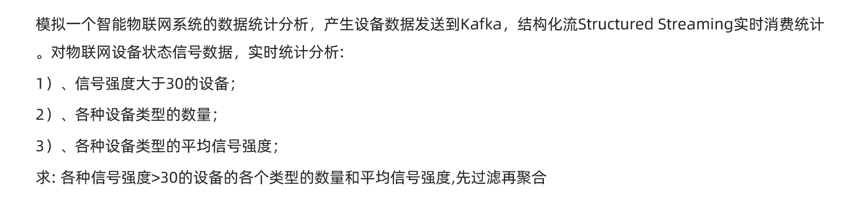

### 准备数据-直接用

package com.as.structured  
  
import java.util.Properties  
  
import org.apache.kafka.clients.producer.{KafkaProducer, ProducerRecord}  
import org.apache.kafka.common.serialization.StringSerializer  
import org.json4s.jackson.Json  
  
import scala.util.Random  
  
object MockIotDatas {  
 def main(args: Array[String]): Unit = {  
 // 发送Kafka Topic  
 val props = new Properties()  
 props.put("bootstrap.servers", "node1:9092")  
 props.put("acks", "1")  
 props.put("retries", "3")  
 props.put("key.serializer", classOf[StringSerializer].getName)  
 props.put("value.serializer", classOf[StringSerializer].getName)  
 val producer = new KafkaProducer[String, String](props)  
  
 val deviceTypes = Array(  
 "db", "bigdata", "kafka", "route", "bigdata", "db", "bigdata", "bigdata", "bigdata"  
 )  
  
 val random: Random = new Random()  
 while (true) {  
 val index: Int = random.nextInt(deviceTypes.length)  
 val deviceId: String = s"device_${(index + 1) * 10 + random.nextInt(index + 1)}"  
 val deviceType: String = deviceTypes(index)  
 val deviceSignal: Int = 10 + random.nextInt(90)  
 // 模拟构造设备数据  
 val deviceData = DeviceData(deviceId, deviceType, deviceSignal, System.currentTimeMillis())  
 // 转换为JSON字符串  
 val deviceJson: String = new Json(org.json4s.DefaultFormats).write(deviceData)  
 println(deviceJson)  
 Thread.sleep(100 + random.nextInt(500))  
  
 val record = new ProducerRecord[String, String]("iotTopic", deviceJson)  
 producer.send(record)  
 }  
  
 // 关闭连接  
 producer.close()  
 }  
  
 /**  
 * 物联网设备发送状态数据  
 */  
 case class DeviceData(  
 device: String, //设备标识符ID  
 deviceType: String, //设备类型，如服务器mysql, redis, kafka或路由器route  
 signal: Double, //设备信号  
 time: Long //发送数据时间  
 )  
  
}

### 准备主题

#查看topic信息  
/export/server/kafka/bin/kafka-topics.sh --list --zookeeper node1:2181  
#删除topic  
/export/server/kafka/bin/kafka-topics.sh --delete --zookeeper node1:2181 --topic iotTopic  
  
  
#创建topic  
/export/server/kafka/bin/kafka-topics.sh --create --zookeeper node1:2181 --replication-factor 1 --partitions 3 --topic iotTopic  
  
  
#模拟消费者  
/export/server/kafka/bin/kafka-console-consumer.sh --bootstrap-server node1:9092 --topic iotTopic --from-beginning

### 代码实现

iotTopic --->StructuredStreaming-->控制台

package com.as.structured  
  
import org.apache.commons.lang3.StringUtils  
import org.apache.spark.SparkContext  
import org.apache.spark.sql.streaming.Trigger  
import org.apache.spark.sql.types.DoubleType  
import org.apache.spark.sql.{DataFrame, Dataset, SparkSession}  
  
/**  
 * Author roy  
 * Desc 演示StructuredStreaming整合Kafka,  
 * 从iotTopic消费数据 -->使用StructuredStreaming进行实时分析-->将结果写到控制台  
 */  
object Demo10_Kafka_IOT {  
 def main(args: Array[String]): Unit = {  
 //TODO 0.创建环境  
 //因为StructuredStreaming基于SparkSQL的且编程API/数据抽象是DataFrame/DataSet,所以这里创建SparkSession即可  
 val spark: SparkSession = SparkSession.builder().appName("sparksql").master("local[*]")  
 .config("spark.sql.shuffle.partitions", "4") //本次测试时将分区数设置小一点,实际开发中可以根据集群规模调整大小,默认200  
 .getOrCreate()  
 val sc: SparkContext = spark.sparkContext  
 sc.setLogLevel("WARN")  
 import spark.implicits._  
 import org.apache.spark.sql.functions._  
  
 //TODO 1.加载数据-kafka-iotTopic  
 val kafkaDF: DataFrame = spark.readStream  
 .format("kafka")  
 .option("kafka.bootstrap.servers", "node1:9092")  
 .option("subscribe", "iotTopic")  
 .load()  
 val valueDS: Dataset[String] = kafkaDF.selectExpr("CAST(value AS STRING)").as[String]  
 //{"device":"device_30","deviceType":"kafka","signal":77.0,"time":1610158709534}  
  
 //TODO 2.处理数据  
 //需求:统计信号强度>30的各种设备类型对应的数量和平均信号强度  
 //解析json(也就是增加schema:字段名和类型)  
 //方式1:fastJson/Gson等工具包,后续案例中使用  
 //方式2:使用SparkSQL的内置函数,当前案例使用  
 val schemaDF: DataFrame = valueDS.filter(StringUtils.isNotBlank(_))  
 .select(  
 get_json_object($"value", "$.device").as("device_id"),  
 get_json_object($"value", "$.deviceType").as("deviceType"),  
 get_json_object($"value", "$.signal").cast(DoubleType).as("signal")  
 )  
  
 //需求:统计信号强度>30的各种设备类型对应的数量和平均信号强度  
 //TODO ====SQL  
 schemaDF.createOrReplaceTempView("t_iot")  
 val sql: String =  
 """  
 |select deviceType,count(*) as counts,avg(signal) as avgsignal  
 |from t_iot  
 |where signal > 30  
 |group by deviceType  
 |""".stripMargin  
 val result1: DataFrame = spark.sql(sql)  
  
 //TODO ====DSL  
 val result2: DataFrame = schemaDF.filter('signal > 30)  
 .groupBy('deviceType)  
 .agg(  
 count('device_id) as "counts",  
 avg('signal) as "avgsignal"  
 )  
  
  
 //TODO 3.输出结果-控制台  
 result1.writeStream  
 .format("console")  
 .outputMode("complete")  
 //.option("truncate", false)  
 .start()  
 //.awaitTermination()  
  
 //TODO 4.启动并等待结束  
 result2.writeStream  
 .format("console")  
 .outputMode("complete")  
 //.trigger(Trigger.ProcessingTime(0))  
 //.option("truncate", false)  
 .start()  
 .awaitTermination()  
  
 //TODO 5.关闭资源  
 spark.stop()  
 }  
}  
  
//0.kafka准备好  
//1.启动数据模拟程序  
//2.启动Demo10_Kafka_IOT

# 基于事件时间的窗口计算

## 时间分类

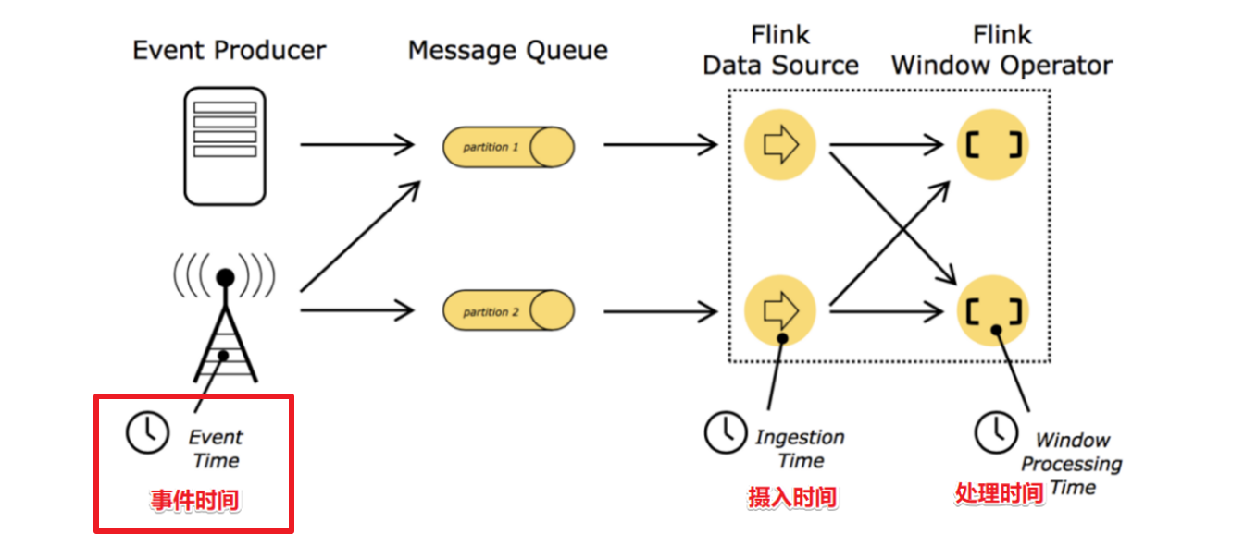

注意: 在实际开发中一般都要基于事件时间进行窗口计算, 因为事件时间更能代表事件的本质

如: 10-1 23:59:50的订单, 到10-2 00:00:10才被系统处理,如果不支持事件时间那么会出现统计错误

而在StructuredStreaming中就支持事件时间

## API

* 基于事件时间进行窗口计算

import spark.implicits._  
  
val words = ... // streaming DataFrame of schema { timestamp: Timestamp, word: String }  
  
// Group the data by window and word and compute the count of each group  
val windowedCounts = words.groupBy(  
 window($"timestamp", "10 minutes", "5 minutes"),  
 $"word"  
).count()

* 基于事件时间进行窗口计算-容易出现以下问题:

数据迟到--到底计算还是不计算?----得设置一个阈值! ---Watermaker水位线/水印

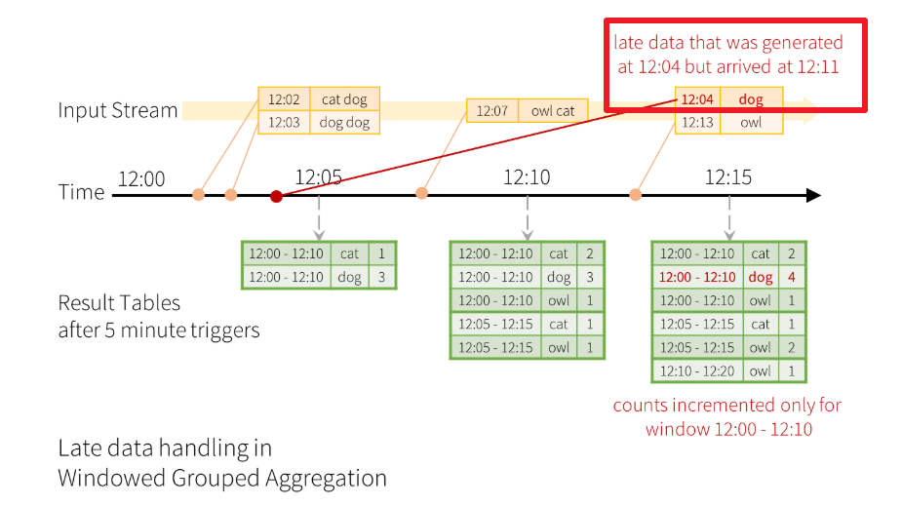

* 基于事件时间进行窗口计算+ Watermaker水位线/水印解决数据延迟到达问题

import spark.implicits._  
  
val words = ... // streaming DataFrame of schema { timestamp: Timestamp, word: String }  
  
// Group the data by window and word and compute the count of each group  
val windowedCounts = words  
 .withWatermark("timestamp", "10 minutes")  
 .groupBy(  
 window($"timestamp", "10 minutes", "5 minutes"),  
 $"word")  
 .count()

## 需求

官网案例该开窗窗口长度为10 min，滑动间隔5 min，水印为eventtime-10 min，trigger为Trigger.ProcessingTime("5 minutes")，但是测试的时候用秒  
  
每隔5s计算最近10s的数据,withWatermark设置为10s  
  
2019-10-10 12:00:07,dog  
2019-10-10 12:00:08,owl  
  
2019-10-10 12:00:14,dog  
2019-10-10 12:00:09,cat  
  
2019-10-10 12:00:15,cat  
2019-10-10 12:00:08,dog --迟到不严重,会被计算,控制台会输出  
2019-10-10 12:00:13,owl  
2019-10-10 12:00:21,owl  
  
2019-10-10 12:00:04,donkey --迟到严重,不会被计算,控制台不会输出  
2019-10-10 12:00:17,owl --影响结果

## 代码演示

package com.as.structured  
  
import java.sql.Timestamp  
  
import org.apache.commons.lang3.StringUtils  
import org.apache.spark.SparkContext  
import org.apache.spark.sql.streaming.{OutputMode, StreamingQuery, Trigger}  
import org.apache.spark.sql.types.DoubleType  
import org.apache.spark.sql.{DataFrame, Dataset, SparkSession}  
  
/**  
 * Author roy  
 * Desc 演示StructuredStreaming  
 * 基于事件时间的窗口计算+水位线/水印解决数据延迟到达(能够容忍一定程度上的延迟,迟到严重的还是会被丢弃)  
 * 每隔5s计算最近10s的数据,withWatermark设置为10s  
 *  
 * 2019-10-10 12:00:07,dog  
 * 2019-10-10 12:00:08,owl  
 *  
 * 2019-10-10 12:00:14,dog  
 * 2019-10-10 12:00:09,cat  
 *  
 * 2019-10-10 12:00:15,cat  
 * 2019-10-10 12:00:08,dog --迟到不严重,会被计算,影响最后的统计结果  
 * 2019-10-10 12:00:13,owl  
 * 2019-10-10 12:00:21,owl  
 *  
 * 2019-10-10 12:00:04,donkey --迟到严重,不会被计算,不影响最后的统计结果  
 * 2019-10-10 12:00:17,owl --影响结果  
 */  
object Demo11_Eventtime_Window_Watermark {  
 def main(args: Array[String]): Unit = {  
 //TODO 0.创建环境  
 //因为StructuredStreaming基于SparkSQL的且编程API/数据抽象是DataFrame/DataSet,所以这里创建SparkSession即可  
 val spark: SparkSession = SparkSession.builder().appName("sparksql").master("local[*]")  
 .config("spark.sql.shuffle.partitions", "4") //本次测试时将分区数设置小一点,实际开发中可以根据集群规模调整大小,默认200  
 .getOrCreate()  
 val sc: SparkContext = spark.sparkContext  
 sc.setLogLevel("WARN")  
 import org.apache.spark.sql.functions._  
 import spark.implicits._  
  
 //TODO 1.加载数据  
 val socketDF: DataFrame = spark.readStream  
 .format("socket")  
 .option("host", "node1")  
 .option("port", 9999)  
 .load()  
  
 //TODO 2.处理数据:添加schema  
 val wordDF = socketDF  
 .as[String]  
 .filter(StringUtils.isNotBlank(_))  
 // 将每行数据进行分割: 2019-10-12 09:00:02,cat  
 .map(line => {  
 val arr = line.trim.split(",")  
 val timestampStr: String = arr(0)  
 val word: String = arr(1)  
 (Timestamp.valueOf(timestampStr), word)  
 })  
 // 设置列的名称  
 .toDF("timestamp", "word")  
 //需求:每隔5s计算最近10s的数据,withWatermark设置为10s  
 val resultDF = wordDF  
 //withWatermark(指定事件时间是哪一列,指定时间阈值)  
 .withWatermark("timestamp", "10 seconds")  
 .groupBy(  
 //指定基于事件时间做窗口聚合计算:WordCount  
 //window(指定事件时间是哪一列,窗口长度,滑动间隔)  
 window($"timestamp", "10 seconds", "5 seconds"),  
 $"word")  
 .count()  
  
  
 //TODO 3.输出结果-控制台  
 resultDF.writeStream  
 .outputMode(OutputMode.Update()) //为了方便观察只输出有变化的数据  
 .format("console")  
 .option("truncate", "false")  
 .trigger(Trigger.ProcessingTime("5 seconds"))  
 //TODO 4.启动并等待结束  
 .start()  
 .awaitTermination()  
  
 spark.stop()  
  
 //TODO 5.关闭资源  
 spark.stop()  
 }  
}  
  
//0.kafka准备好  
//1.启动数据模拟程序  
//2.启动Demo10_Kafka_IOT

# 流数据去重

## 说明

Spark中的批数据去重很简单,直接对所有数据进行

df.dropDuplicates("列名1","列名2")

流式数据去重需要保存历史数据的状态才可以做的去重,而StructuredStreaming的状态管理是自动的

所以StructuredStreaming的流式数据去重和批处理一样

df.dropDuplicates("列名1","列名2")

## 需求

对网站用户日志数据，按照userId和eventTime、eventType去重统计  
数据如下：

{"eventTime": "2016-01-10 10:01:50","eventType": "browse","userID":"1"}  
{"eventTime": "2016-01-10 10:01:50","eventType": "click","userID":"1"}  
{"eventTime": "2016-01-10 10:01:50","eventType": "click","userID":"1"}  
{"eventTime": "2016-01-10 10:01:50","eventType": "slide","userID":"1"}  
{"eventTime": "2016-01-10 10:01:50","eventType": "browse","userID":"1"}  
{"eventTime": "2016-01-10 10:01:50","eventType": "click","userID":"1"}  
{"eventTime": "2016-01-10 10:01:50","eventType": "slide","userID":"1"}

## 代码实现

package com.as.structured  
  
import java.sql.Timestamp  
  
import org.apache.commons.lang3.StringUtils  
import org.apache.spark.SparkContext  
import org.apache.spark.sql.streaming.{OutputMode, StreamingQuery, Trigger}  
import org.apache.spark.sql.{DataFrame, Dataset, Row, SparkSession}  
  
/**  
 * Author roy  
 * Desc 演示StructuredStreaming  
 */  
object Demo12_Deduplication {  
 def main(args: Array[String]): Unit = {  
 //TODO 0.创建环境  
 //因为StructuredStreaming基于SparkSQL的且编程API/数据抽象是DataFrame/DataSet,所以这里创建SparkSession即可  
 val spark: SparkSession = SparkSession.builder().appName("sparksql").master("local[*]")  
 .config("spark.sql.shuffle.partitions", "4") //本次测试时将分区数设置小一点,实际开发中可以根据集群规模调整大小,默认200  
 .getOrCreate()  
 val sc: SparkContext = spark.sparkContext  
 sc.setLogLevel("WARN")  
 import org.apache.spark.sql.functions._  
 import spark.implicits._  
  
 //TODO 1.加载数据  
 val socketDF: DataFrame = spark.readStream  
 .format("socket")  
 .option("host", "node1")  
 .option("port", 9999)  
 .load()  
  
 //TODO 2.处理数据:添加schema  
 //{"eventTime": "2016-01-10 10:01:50","eventType": "browse","userID":"1"}  
 //{"eventTime": "2016-01-10 10:01:50","eventType": "click","userID":"1"}  
 val schemaDF: DataFrame = socketDF  
 .as[String]  
 .filter(StringUtils.isNotBlank(_))  
 .select(  
 get_json_object($"value", "$.eventTime").as("eventTime"),  
 get_json_object($"value", "$.eventType").as("eventType"),  
 get_json_object($"value", "$.userID").as("userID")  
 )  
  
 //TODO 3.数据处理  
 //对网站用户日志数据，按照userId和eventTime、eventType去重统计  
 val result: Dataset[Row] = schemaDF  
 .dropDuplicates("userID","eventTime","eventType")  
 .groupBy("userID")  
 .count()  
  
  
 result.writeStream  
 .outputMode(OutputMode.Complete())  
 .format("console")  
 .start()  
 .awaitTermination()  
  
 //TODO 5.关闭资源  
 spark.stop()  
 }  
}  
  
//0.kafka准备好  
//1.启动数据模拟程序  
//2.启动Demo10_Kafka_IOT