# SparkSQL实战

## 实战1-加载数据成为分布式表

package com.as.sql  
  
import org.apache.spark.SparkContext  
import org.apache.spark.sql.{DataFrame, Dataset, SparkSession}  
  
/**  
 * Author roy  
 * Desc 演示SparkSQL初体验  
 */  
object Demo01 {  
 def main(args: Array[String]): Unit = {  
 //TODO 0.准备环境  
 val spark: SparkSession = SparkSession.builder().appName("sparksql").master("local[*]").getOrCreate()  
 val sc: SparkContext = spark.sparkContext  
 sc.setLogLevel("WARN")  
  
 //TODO 1.加载数据  
 val df1: DataFrame = spark.read.text("data/input/text")  
 val df2: DataFrame = spark.read.json("data/input/json")  
 val df3: DataFrame = spark.read.csv("data/input/csv")  
  
 //TODO 2.处理数据  
  
 //TODO 3.输出结果  
 df1.printSchema()  
 df2.printSchema()  
 df3.printSchema()  
 df1.show()  
 df2.show()  
 df3.show()  
  
 //TODO 4.关闭资源  
 spark.stop()  
 }  
}

## 案例2-将RDD转为DataFrame

### 使用样例类

package com.as.sql  
  
import org.apache.spark  
import org.apache.spark.SparkContext  
import org.apache.spark.rdd.RDD  
import org.apache.spark.sql.{DataFrame, SparkSession}  
  
/**  
 * Author roy  
 * Desc 演示SparkSQL-RDD2DataFrame  
 */  
object Demo02_RDD2DataFrame1 {  
 def main(args: Array[String]): Unit = {  
 //TODO 0.准备环境  
 val spark: SparkSession = SparkSession.builder().appName("sparksql").master("local[*]").getOrCreate()  
 val sc: SparkContext = spark.sparkContext  
 sc.setLogLevel("WARN")  
  
 //TODO 1.加载数据  
 val lines: RDD[String] = sc.textFile("data/input/person.txt")  
  
 //TODO 2.处理数据  
 val personRDD: RDD[Person] = lines.map(line => {  
 val arr: Array[String] = line.split(" ")  
 Person(arr(0).toInt, arr(1), arr(2).toInt)  
 })  
  
 //RDD-->DF  
 import spark.implicits._  
 val personDF: DataFrame = personRDD.toDF()  
  
 //TODO 3.输出结果  
 personDF.printSchema()  
 personDF.show()  
  
 //TODO 4.关闭资源  
 spark.stop()  
 }  
 case class Person(id:Int,name:String,age:Int)  
}

### 指定类型+列名

package com.as.sql  
  
import com.as.sql.Demo02_RDD2DataFrame1.Person  
import org.apache.spark.SparkContext  
import org.apache.spark.rdd.RDD  
import org.apache.spark.sql.{DataFrame, SparkSession}  
  
/**  
 * Author roy  
 * Desc 演示SparkSQL-RDD2DataFrame-指定类型和列名  
 */  
object Demo02_RDD2DataFrame2 {  
 def main(args: Array[String]): Unit = {  
 //TODO 0.准备环境  
 val spark: SparkSession = SparkSession.builder().appName("sparksql").master("local[*]").getOrCreate()  
 val sc: SparkContext = spark.sparkContext  
 sc.setLogLevel("WARN")  
  
 //TODO 1.加载数据  
 val lines: RDD[String] = sc.textFile("data/input/person.txt")  
  
 //TODO 2.处理数据  
 val tupleRDD: RDD[(Int, String, Int)] = lines.map(line => {  
 val arr: Array[String] = line.split(" ")  
 (arr(0).toInt, arr(1), arr(2).toInt)  
 })  
  
 //RDD-->DF  
 import spark.implicits._  
 val personDF: DataFrame = tupleRDD.toDF("id","name","age")  
  
 //TODO 3.输出结果  
 personDF.printSchema()  
 personDF.show()  
  
 //TODO 4.关闭资源  
 spark.stop()  
 }  
  
}

### 自定义Schema

package com.as.sql  
  
import org.apache.spark.SparkContext  
import org.apache.spark.rdd.RDD  
import org.apache.spark.sql.types.{IntegerType, StringType, StructField, StructType}  
import org.apache.spark.sql.{DataFrame, Row, SparkSession}  
  
/**  
 * Author roy  
 * Desc 演示SparkSQL-RDD2DataFrame-自定义Schema  
 */  
object Demo02_RDD2DataFrame3 {  
 def main(args: Array[String]): Unit = {  
 //TODO 0.准备环境  
 val spark: SparkSession = SparkSession.builder().appName("sparksql").master("local[*]").getOrCreate()  
 val sc: SparkContext = spark.sparkContext  
 sc.setLogLevel("WARN")  
  
 //TODO 1.加载数据  
 val lines: RDD[String] = sc.textFile("data/input/person.txt")  
  
 //TODO 2.处理数据  
 val rowRDD: RDD[Row] = lines.map(line => {  
 val arr: Array[String] = line.split(" ")  
 Row(arr(0).toInt, arr(1), arr(2).toInt)  
 })  
  
 //RDD-->DF  
 import spark.implicits._  
 /*val schema: StructType = StructType(  
 StructField("id", IntegerType, false) ::  
 StructField("name", StringType, false) ::  
 StructField("age", IntegerType, false) :: Nil)*/  
 val schema: StructType = StructType(List(  
 StructField("id", IntegerType, false),  
 StructField("name", StringType, false),  
 StructField("age", IntegerType, false)  
 ))  
  
 val personDF: DataFrame = spark.createDataFrame(rowRDD, schema)  
  
 //TODO 3.输出结果  
 personDF.printSchema()  
 personDF.show()  
  
 //TODO 4.关闭资源  
 spark.stop()  
 }  
  
}

## 案例3-RDD-DF-DS相互转换

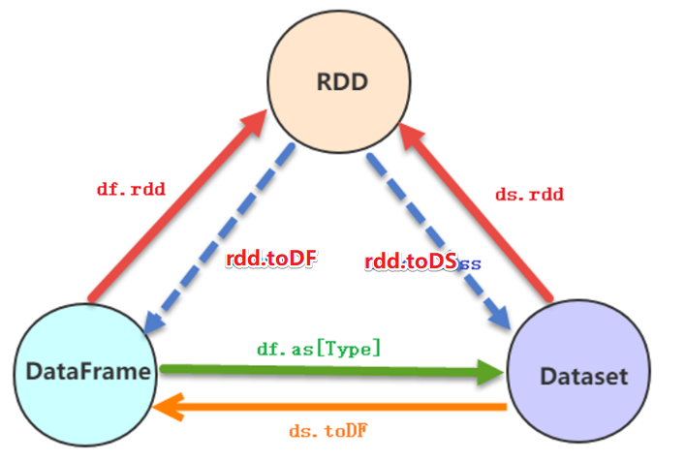

package com.as.sql  
  
import org.apache.spark.SparkContext  
import org.apache.spark.rdd.RDD  
import org.apache.spark.sql.{DataFrame, Dataset, Row, SparkSession}  
  
/**  
 * Author roy  
 * Desc 演示SparkSQL-RDD_DF_DS相互转换  
 */  
object Demo03_RDD_DF_DS {  
 def main(args: Array[String]): Unit = {  
 //TODO 0.准备环境  
 val spark: SparkSession = SparkSession.builder().appName("sparksql").master("local[*]").getOrCreate()  
 val sc: SparkContext = spark.sparkContext  
 sc.setLogLevel("WARN")  
  
 //TODO 1.加载数据  
 val lines: RDD[String] = sc.textFile("data/input/person.txt")  
  
 //TODO 2.处理数据  
 val personRDD: RDD[Person] = lines.map(line => {  
 val arr: Array[String] = line.split(" ")  
 Person(arr(0).toInt, arr(1), arr(2).toInt)  
 })  
  
 //转换1:RDD-->DF  
 import spark.implicits._  
 val personDF: DataFrame = personRDD.toDF()  
 //转换2:RDD-->DS  
 val personDS: Dataset[Person] = personRDD.toDS()  
 //转换3:DF-->RDD,注意:DF没有泛型,转为RDD时使用的是Row  
 val rdd: RDD[Row] = personDF.rdd  
 //转换4:DS-->RDD  
 val rdd1: RDD[Person] = personDS.rdd  
 //转换5:DF-->DS  
 val ds: Dataset[Person] = personDF.as[Person]  
 //转换6:DS-->DF  
 val df: DataFrame = personDS.toDF()  
  
  
  
 //TODO 3.输出结果  
 personDF.printSchema()  
 personDF.show()  
 personDS.printSchema()  
 personDS.show()  
 rdd.foreach(println)  
 rdd1.foreach(println)  
  
 //TODO 4.关闭资源  
 spark.stop()  
 }  
 case class Person(id:Int,name:String,age:Int)  
}

## 案例4-SparkSQL花式查询

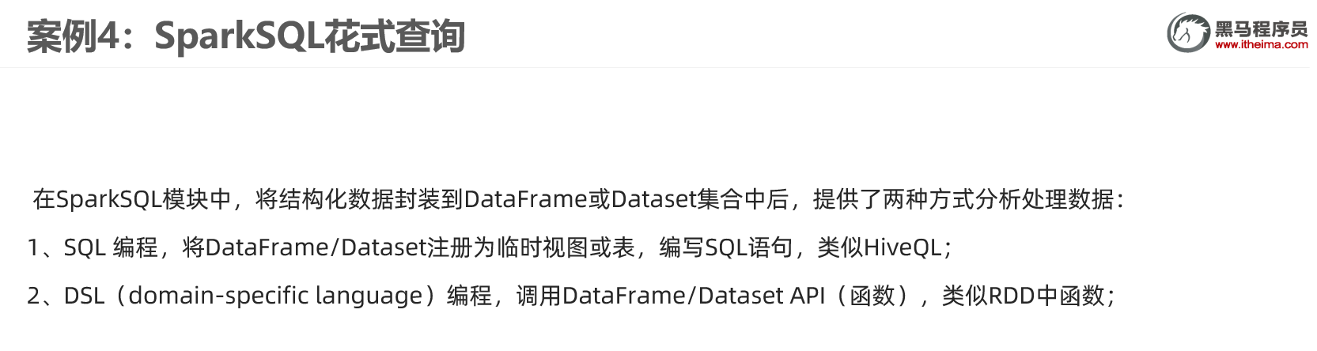

需求:针对personDF中的数据使用SQL和DSL两种方式进行各种查询

package com.as.sql  
  
import org.apache.spark.SparkContext  
import org.apache.spark.rdd.RDD  
import org.apache.spark.sql.{DataFrame, SparkSession}  
  
/**  
 * Author roy  
 * Desc 演示SparkSQL-SQL和DSL两种方式实现各种查询  
 */  
object Demo04_Query {  
 def main(args: Array[String]): Unit = {  
 //TODO 0.准备环境  
 val spark: SparkSession = SparkSession.builder().appName("sparksql").master("local[*]").getOrCreate()  
 val sc: SparkContext = spark.sparkContext  
 sc.setLogLevel("WARN")  
  
 //TODO 1.加载数据  
 val lines: RDD[String] = sc.textFile("data/input/person.txt")  
  
 //TODO 2.处理数据  
 val personRDD: RDD[Person] = lines.map(line => {  
 val arr: Array[String] = line.split(" ")  
 Person(arr(0).toInt, arr(1), arr(2).toInt)  
 })  
  
 //RDD-->DF  
 import spark.implicits._  
 val personDF: DataFrame = personRDD.toDF()  
 personDF.printSchema()  
 personDF.show()  
 /*  
root  
 |-- id: integer (nullable = false)  
 |-- name: string (nullable = true)  
 |-- age: integer (nullable = false)  
  
+---+--------+---+  
| id| name|age|  
+---+--------+---+  
| 1|zhangsan| 20|  
| 2| lisi| 29|  
| 3| wangwu| 25|  
| 4| zhaoliu| 30|  
| 5| tianqi| 35|  
| 6| kobe| 40|  
+---+--------+---+  
 */  
  
 //TODO ===========SQL==============  
 //注册表名  
 //personDF.registerTempTable("")//过期的  
 //personDF.createOrReplaceGlobalTempView("")//创建全局的,夸SparkSession也可以用,但是生命周期太长!  
 personDF.createOrReplaceTempView("t_person")//创建临时的,当前SparkSession也可以用  
  
 //=1.查看name字段的数据  
 spark.sql("select name from t_person").show()  
 //=2.查看 name 和age字段数据  
 spark.sql("select name,age from t_person").show()  
 //=3.查询所有的name和age，并将age+1  
 spark.sql("select name,age,age+1 from t_person").show()  
 //=4.过滤age大于等于25的  
 spark.sql("select name,age from t_person where age >= 25").show()  
 //=5.统计年龄大于30的人数  
 spark.sql("select count(*) from t_person where age > 30").show()  
 //=6.按年龄进行分组并统计相同年龄的人数  
 spark.sql("select age,count(*) from t_person group by age").show()  
 //=7.查询姓名=张三的  
 spark.sql("select name from t_person where name = 'zhangsan'").show()  
  
 //TODO ===========DSL:面向对象的SQL==============  
 //=1.查看name字段的数据  
 //personDF.select(personDF.col("name"))  
 personDF.select("name").show()  
 //=2.查看 name 和age字段数据  
 personDF.select("name","age").show()  
 //=3.查询所有的name和age，并将age+1  
 //personDF.select("name","age","age+1").show()//错误的:cannot resolve '`age+1`' given input columns: [age, id, name];;  
 //注意$是把字符串转为了Column列对象  
 personDF.select($"name",$"age",$"age" + 1).show()  
 //注意'是把列名转为了Column列对象  
 personDF.select('name,'age,'age + 1).show()  
 //=4.过滤age大于等于25的  
 personDF.filter("age >= 25").show()  
 personDF.filter($"age" >= 25).show()  
 personDF.filter('age >= 25).show()  
 //=5.统计年龄大于30的人数  
 val count: Long = personDF.where('age > 30).count() //where底层filter  
 println("年龄大于30的人数为:"+count)  
 //=6.按年龄进行分组并统计相同年龄的人数  
 personDF.groupBy('age).count().show()  
 //=7.查询姓名=张三的  
 personDF.filter("name = 'zhangsan'").show()  
 personDF.filter($"name"==="zhangsan").show()  
 personDF.filter('name ==="zhangsan").show()  
 personDF.filter('name =!="zhangsan").show()  
  
 //TODO 3.输出结果  
 //TODO 4.关闭资源  
 spark.stop()  
 }  
 case class Person(id:Int,name:String,age:Int)  
}

## 案例5-WordCount

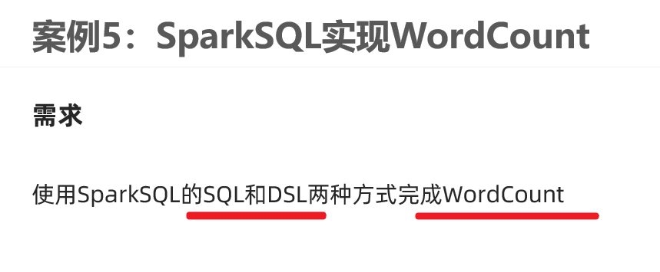

package com.as.sql  
  
import org.apache.spark.SparkContext  
import org.apache.spark.sql.{DataFrame, Dataset, SparkSession}  
  
/**  
 * Author roy  
 * Desc 演示SparkSQL-SQL和DSL两种方式实现WordCount  
 */  
object Demo05_WordCount {  
 def main(args: Array[String]): Unit = {  
 //TODO 0.准备环境  
 val spark: SparkSession = SparkSession.builder().appName("sparksql").master("local[*]").getOrCreate()  
 val sc: SparkContext = spark.sparkContext  
 sc.setLogLevel("WARN")  
 import spark.implicits._  
  
  
 //TODO 1.加载数据  
 val df: DataFrame = spark.read.text("data/input/words.txt")  
 val ds: Dataset[String] = spark.read.textFile("data/input/words.txt")  
 df.printSchema()  
 df.show()  
 ds.printSchema()  
 ds.show()  
 /*  
root  
 |-- value: string (nullable = true)  
  
+----------------+  
| value|  
+----------------+  
|hello me you her|  
| hello you her|  
| hello her|  
| hello|  
+----------------+  
 */  
 //TODO 2.处理数据  
 //df.flatMap(_.split(" "))//注意:df没有泛型,不能直接使用split  
 val words: Dataset[String] = ds.flatMap(_.split(" "))  
 words.printSchema()  
 words.show()  
 /*  
 root  
 |-- value: string (nullable = true)  
  
+-----+  
|value|  
+-----+  
|hello|  
| me|  
| you|  
| her|  
|hello|  
| you|  
| her|  
|hello|  
| her|  
|hello|  
+-----+  
 */  
 //TODO ===SQL===  
 words.createOrReplaceTempView("t_words")  
 val sql:String =  
 """  
 |select value,count(*) as counts  
 |from t_words  
 |group by value  
 |order by counts desc  
 |""".stripMargin  
 spark.sql(sql).show()  
  
 //TODO ===DSL===  
 words.groupBy('value)  
 .count()  
 .orderBy('count.desc)  
 .show()  
  
 //TODO 3.输出结果  
 //TODO 4.关闭资源  
 spark.stop()  
 }  
}

## 案例6-多数据源支持

读:spark.read.格式(路径) //底层 spark.read.format("格式").load(路径)

写:df.writer..格式(路径) //底层 df.writer.format("格式").save(路径)

package com.as.sql  
  
import java.util.Properties  
  
import org.apache.spark.SparkContext  
import org.apache.spark.sql.{DataFrame, Dataset, SaveMode, SparkSession}  
  
/**  
 * Author roy  
 * Desc 演示SparkSQL-支持的外部数据源  
 * 支持的文件格式:text/json/csv/parquet/orc....  
 * 支持文件系统/数据库  
 */  
object Demo06_DataSource {  
 def main(args: Array[String]): Unit = {  
 //TODO 0.准备环境  
 val spark: SparkSession = SparkSession.builder().appName("sparksql").master("local[*]").getOrCreate()  
 val sc: SparkContext = spark.sparkContext  
 sc.setLogLevel("WARN")  
 import spark.implicits._  
  
 //TODO 1.加载数据  
 val df: DataFrame = spark.read.json("data/input/json")//底层format("json").load(paths : _*)  
 //val df: DataFrame = spark.read.csv("data/input/csv")//底层format("csv").load(paths : _*)  
 df.printSchema()  
 df.show()  
 //TODO 2.处理数据  
 //TODO 3.输出结果  
 df.coalesce(1).write.mode(SaveMode.Overwrite).json("data/output/json")//底层 format("json").save(path)  
 df.coalesce(1).write.mode(SaveMode.Overwrite).csv("data/output/csv")  
 df.coalesce(1).write.mode(SaveMode.Overwrite).parquet("data/output/parquet")  
 df.coalesce(1).write.mode(SaveMode.Overwrite).orc("data/output/orc")  
 val prop = new Properties()  
 prop.setProperty("user","root")  
 prop.setProperty("password","root")  
 df.coalesce(1).write.mode(SaveMode.Overwrite).jdbc("jdbc:mysql://localhost:3306/bigdata?characterEncoding=UTF-8","person",prop)//表会自动创建  
  
 //TODO 4.关闭资源  
 spark.stop()  
 }  
}

## 案例7-电影数据分析

https://github.com/apache/spark/tree/master/examples/src/main/scala/org/apache/spark/examples

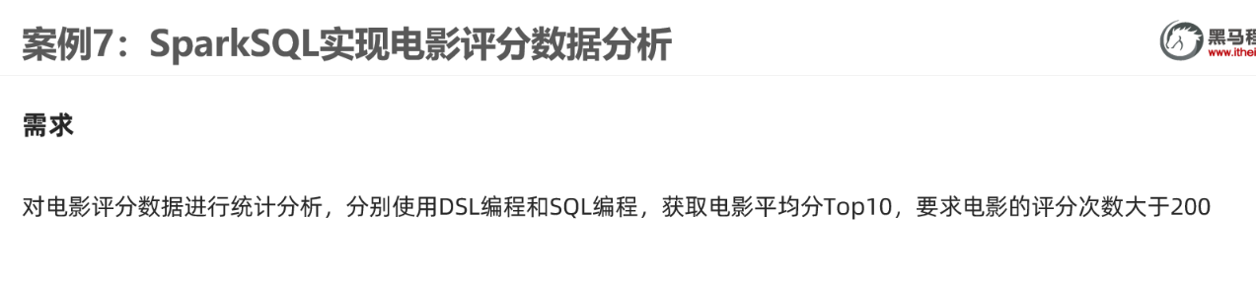

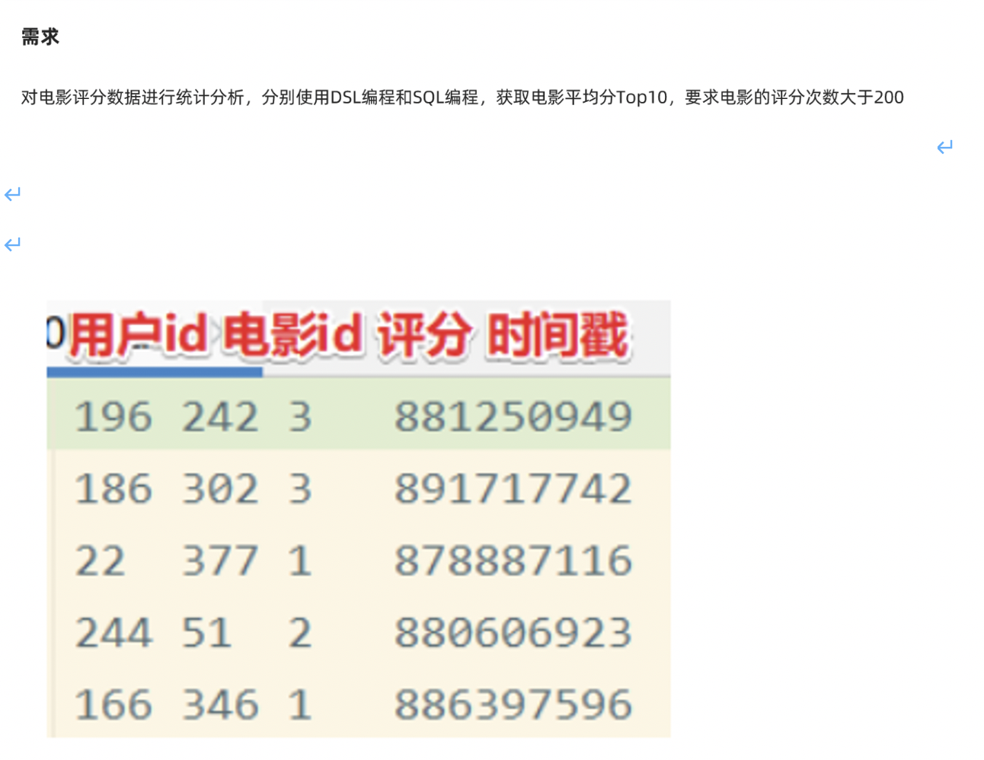

package com.as.sql  
  
  
import org.apache.spark.SparkContext  
import org.apache.spark.sql.{DataFrame, Dataset, SparkSession}  
  
/**  
 * Author roy  
 * Desc 演示SparkSQL-完成电影数据分析  
 */  
object Demo07_MovieDataAnalysis {  
 def main(args: Array[String]): Unit = {  
 //TODO 0.准备环境  
 val spark: SparkSession = SparkSession.builder().appName("sparksql").master("local[*]")  
 .config("spark.sql.shuffle.partitions", "4")//本次测试时将分区数设置小一点,实际开发中可以根据集群规模调整大小,默认200  
 .getOrCreate()  
 val sc: SparkContext = spark.sparkContext  
 sc.setLogLevel("WARN")  
 import spark.implicits._  
  
 //TODO 1.加载数据  
 val ds: Dataset[String] = spark.read.textFile("data/input/rating_100k.data")  
  
 //TODO 2.处理数据  
 val movieDF: DataFrame = ds.map(line => {  
 val arr: Array[String] = line.split("\t")  
 (arr(1), arr(2).toInt)  
 }).toDF("movieId", "score")  
 movieDF.printSchema()  
 movieDF.show()  
 /*  
 +-------+-----+  
 |movieId|score|  
 +-------+-----+  
 | 242| 3|  
 | 302| 3|  
 */  
  
 //需求:统计评分次数>200的电影平均分Top10  
  
 //TODO ======SQL  
 //注册表  
 movieDF.createOrReplaceTempView("t_movies")  
 val sql: String =  
 """  
 |select movieId,avg(score) as avgscore,count(*) as counts  
 |from t_movies  
 |group by movieId  
 |having counts > 200  
 |order by avgscore desc  
 |limit 10  
 |""".stripMargin  
 spark.sql(sql).show()  
 /*  
 +-------+------------------+------+  
 |movieId| avgscore|counts|  
 +-------+------------------+------+  
 | 318| 4.466442953020135| 298|  
 | 483| 4.45679012345679| 243|  
 | 64| 4.445229681978798| 283|  
 | 603|4.3875598086124405| 209|  
 .....  
 */  
  
  
 //TODO ======DSL  
 import org.apache.spark.sql.functions._  
 movieDF.groupBy('movieId)  
 .agg(  
 avg('score) as "avgscore",  
 count("movieId") as "counts"  
 ).filter('counts > 200)  
 .orderBy('avgscore.desc)  
 .limit(10)  
 .show()  
  
 //TODO 3.输出结果  
 //TODO 4.关闭资源  
 spark.stop()  
 }  
}

## 案例8-SparkSQL-UDF

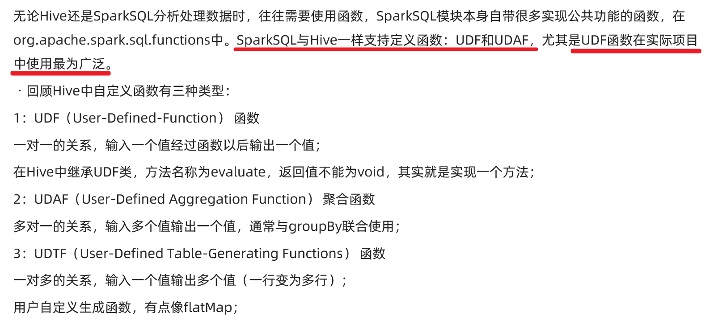

需求: 加载文件中的数据并使用SparkSQL-UDF将数据转为大写

package com.as.sql  
  
import org.apache.spark.SparkContext  
import org.apache.spark.sql.expressions.UserDefinedFunction  
import org.apache.spark.sql.{DataFrame, Dataset, SparkSession}  
  
/**  
 * Author roy  
 * Desc 演示SparkSQL-使用SparkSQL-UDF将数据转为大写  
 */  
object Demo08_UDF {  
 def main(args: Array[String]): Unit = {  
 //TODO 0.准备环境  
 val spark: SparkSession = SparkSession.builder().appName("sparksql").master("local[*]")  
 .config("spark.sql.shuffle.partitions", "4")//本次测试时将分区数设置小一点,实际开发中可以根据集群规模调整大小,默认200  
 .getOrCreate()  
 val sc: SparkContext = spark.sparkContext  
 sc.setLogLevel("WARN")  
 import spark.implicits._  
  
 //TODO 1.加载数据  
 val ds: Dataset[String] = spark.read.textFile("data/input/udf.txt")  
 ds.printSchema()  
 ds.show()  
 /*  
+-----+  
|value|  
+-----+  
|hello|  
| haha|  
| hehe|  
| xixi|  
+-----`  
 */  
 //TODO 2.处理数据  
 //需求:使用SparkSQL-UDF将数据转为大写  
 //TODO ======SQL  
 //TODO 自定义UDF函数  
 spark.udf.register("small2big",(value:String)=>{  
 value.toUpperCase()  
 })  
 ds.createOrReplaceTempView("t_word")  
 val sql:String =  
 """  
 |select value,small2big(value) as bigValue  
 |from t_word  
 |""".stripMargin  
 spark.sql(sql).show()  
 /*  
 +-----+--------+  
 |value|bigValue|  
 +-----+--------+  
 |hello| HELLO|  
 | haha| HAHA|  
 | hehe| HEHE|  
 | xixi| XIXI|  
 +-----+--------+  
 */  
  
 //TODO ======DSL  
 //TODO 自定义UDF函数  
 import org.apache.spark.sql.functions._  
 val small2big2: UserDefinedFunction = udf((value:String)=>{  
 value.toUpperCase()  
 })  
 ds.select('value,small2big2('value).as("bigValue")).show()  
 /*  
 +-----+--------+  
 |value|bigValue|  
 +-----+--------+  
 |hello| HELLO|  
 | haha| HAHA|  
 | hehe| HEHE|  
 | xixi| XIXI|  
 +-----+--------+  
 */  
  
 //TODO 3.输出结果  
 //TODO 4.关闭资源  
 spark.stop()  
 }  
}

# SparkOnHive-掌握

## 前置说明

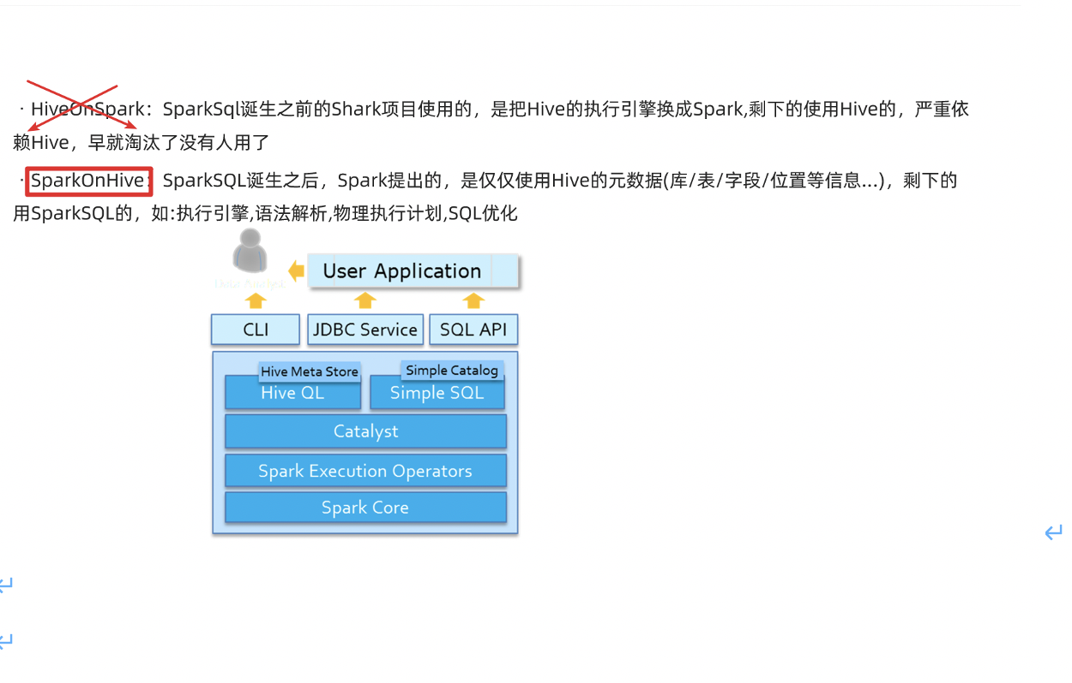

注意:需要先启动Hive的metastore

nohup /export/server/hive/bin/hive --service metastore &

## SparkSQL命令行中整合Hive

0.注意:spark3.0.1整合hive要求hive版本>=2.3.7

1.注意:需要先启动Hive的metastore ----node2

nohup /export/server/hive/bin/hive --service metastore &

2.把hive的配置文件hive-site.xml拷贝到spark/conf目录,把mysql驱动上传到spark/jars里面--node1 (也可以把配置文件和jar分发到其他机器,在其他机器使用SparkSQL操作hive)

3.启动spark/bin下的spark-sql命令行--node1

/export/server/spark/bin/spark-sql

4.执行sql语句--node1

show databases;  
show tables;  
CREATE TABLE person (id int, name string, age int) row format delimited fields terminated by ' ';  
LOAD DATA LOCAL INPATH 'file:///root/person.txt' INTO TABLE person;  
show tables;  
select * from person;

vim /root/person.txt

1 zhangsan 20  
2 lisi 29  
3 wangwu 25  
4 zhaoliu 30  
5 tianqi 35  
6 kobe 40

## SparkSQL代码中整合Hive

0.导入依赖

<dependency>  
 <groupId>org.apache.spark</groupId>  
 <artifactId>spark-hive_2.12</artifactId>  
 <version>${spark.version}</version>  
</dependency>

1.注意:需要先启动Hive的metastore

nohup /export/server/hive/bin/hive --service metastore &

2.编写代码

package com.as.sql  
  
import org.apache.spark.SparkContext  
import org.apache.spark.sql.expressions.UserDefinedFunction  
import org.apache.spark.sql.{Dataset, SparkSession}  
  
/**  
 * Author roy  
 * Desc 演示SparkSQL-使用SparkSQL-UDF将数据转为大写  
 */  
object Demo09_Hive {  
 def main(args: Array[String]): Unit = {  
 //TODO 0.准备环境---需要增加参数配置和开启hivesql语法支持  
 val spark: SparkSession = SparkSession.builder().appName("sparksql").master("local[*]")  
 .config("spark.sql.shuffle.partitions", "4")//本次测试时将分区数设置小一点,实际开发中可以根据集群规模调整大小,默认200  
 .config("spark.sql.warehouse.dir", "hdfs://node1:8020/user/hive/warehouse")//指定Hive数据库在HDFS上的位置  
 .config("hive.metastore.uris", "thrift://node2:9083")  
 .enableHiveSupport()//开启对hive语法的支持  
 .getOrCreate()  
 val sc: SparkContext = spark.sparkContext  
 sc.setLogLevel("WARN")  
 import spark.implicits._  
  
 //TODO 1.操作Hive  
 spark.sql("show databases").show(false)  
 spark.sql("show tables").show(false)  
 spark.sql("CREATE TABLE person4 (id int, name string, age int) row format delimited fields terminated by ' '")  
 spark.sql("LOAD DATA LOCAL INPATH 'file:///D:/person.txt' INTO TABLE person4")  
 spark.sql("show tables").show(false)  
 spark.sql("select * from person4").show(false)  
  
 spark.stop()  
 }  
}

# Spark分布式SQL引擎

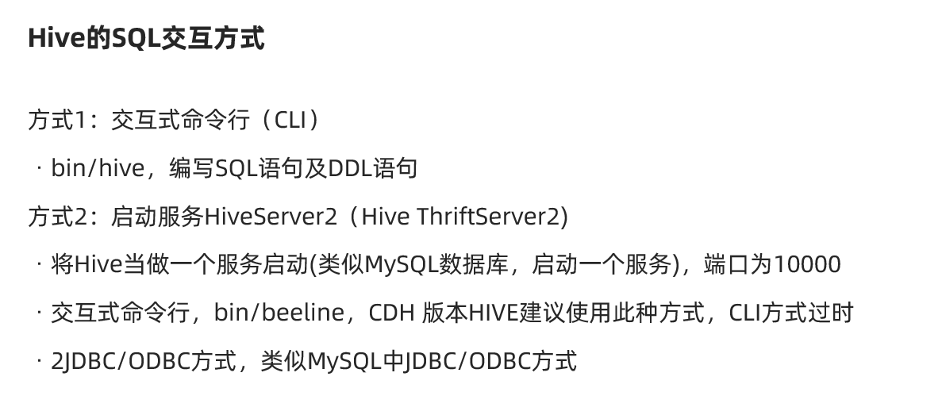

同样的SparkSQL也支持这样的访问方式:

1.SparkSQL的命令行

2.在某一台机器启动SparkSQL的ThriftServer,然后可以在其他机器使用beeline访问

## 使用beeline 客户端连接

0.hive的元数据库服务metastore 保持启动状态---node2启动

nohup /export/server/hive/bin/hive --service metastore &

1.启动SparkSQL的ThriftServer--类似于HiveServer2 ------node2启动

/export/server/spark/sbin/start-thriftserver.sh \  
--hiveconf hive.server2.thrift.port=10000 \  
--hiveconf hive.server2.thrift.bind.host=node2 \  
--master local[2]

http://node2:4040/jobs/

2.在其他机器使用beeline连接sparkSQL的thriftserver

/export/server/spark/bin/beeline  
!connect jdbc:hive2://node2:10000  
root  
123456

3.执行sql

show databases;  
show tables;  
select * from person;

## 使用代码访问

0.导入依赖

<dependency>  
 <groupId>org.apache.spark</groupId>  
 <artifactId>spark-hive-thriftserver_2.12</artifactId>  
 <version>${spark.version}</version>  
</dependency>

1.使用jdbc代码访问SparkSQL-thriftserver_2

package com.as.sql  
  
import java.sql.{Connection, DriverManager, PreparedStatement, ResultSet}  
  
/**  
 * Author roy  
 * Desc 演示使用jdbc访问SparkSQL的ThriftServer  
 */  
object Demo10_ThriftServer{  
 def main(args: Array[String]): Unit = {  
 //0.加载驱动  
 Class.forName("org.apache.hive.jdbc.HiveDriver")  
  
 //1.获取连接  
 val conn: Connection = DriverManager.getConnection(  
 "jdbc:hive2://node2:10000/default", //看上去像是在使用Hive的server2,本质上使用Spark的ThriftServer  
 "root",  
 "123456"  
 )  
  
 //2.编写sql  
 val sql = """select id,name,age from person"""  
  
 //3.获取预编译语句对象  
 val ps: PreparedStatement = conn.prepareStatement(sql)  
  
 //4.执行sql  
 val rs: ResultSet = ps.executeQuery()  
  
 //5.处理结果  
 while (rs.next()){  
 val id: Int = rs.getInt("id")  
 val name: String = rs.getString("name")  
 val age: Int = rs.getInt("age")  
 println(s"id=${id},name=${name},age=${age}")  
 }  
  
 //6.关闭资源  
 if(rs != null) rs.close()  
 if(ps != null) ps.close()  
 if(conn != null) conn.close()  
 }  
}

# StructuredStreaming概述

## SparkStreaming的不足

1.基于微批,延迟高不能做到真正的实时

2.DStream基于RDD,不直接支持SQL

3.流批处理的API应用层不统一,(流用的DStream-底层是RDD,批用的DF/DS/RDD)

4.不支持EventTime事件时间

* 注:
* EventTime事件时间 :事件真正发生的事件
* PorcessingTime处理时间:事件被流系统处理的时间
* IngestionTime摄入时间:事件到底流系统的时间
* 如: 一条错误日志10月1日,23:59:00秒产生的(事件时间),因为网路延迟,到10月2日 00:00:10到达日志处理系统(摄入时间),10月2日 00:00:20被流系统处理(处理时间)
* 如果要统计10月1日的系统bug数量,那么SparkStreaming不能正确统计,因为它不支持事件时间

5.数据的Exactly-Once(恰好一次语义)需要手动实现

* 注: 数据的一致性语义
* 最多一次
* 恰好一次--是我们的目标,SparkStreaming如果要实现恰好一次,需要手动维护偏移量+其他操作
* 最少一次

## StructuredStreaming介绍

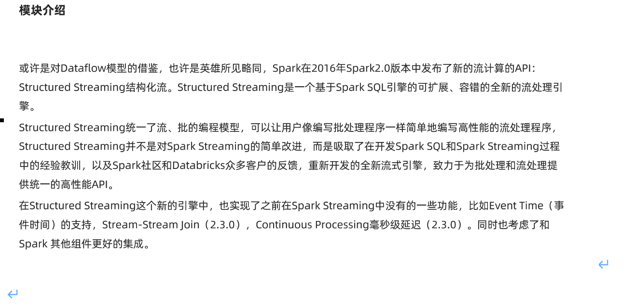

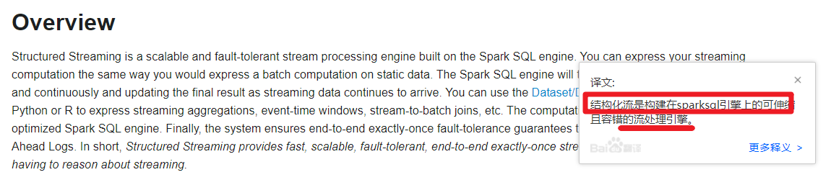

http://spark.apache.org/docs/latest/structured-streaming-programming-guide.html

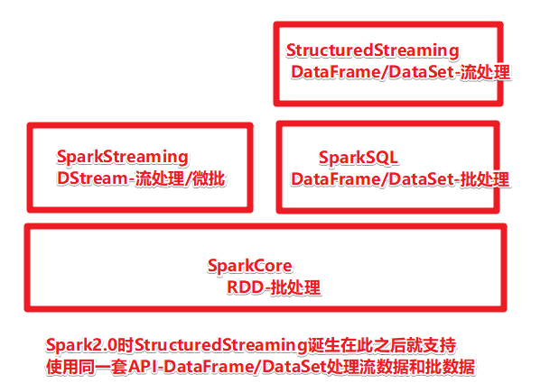

## 编程模型和数据抽象

编程模型 :无界表/动态表格

数据抽象: DataFrame/DataSet

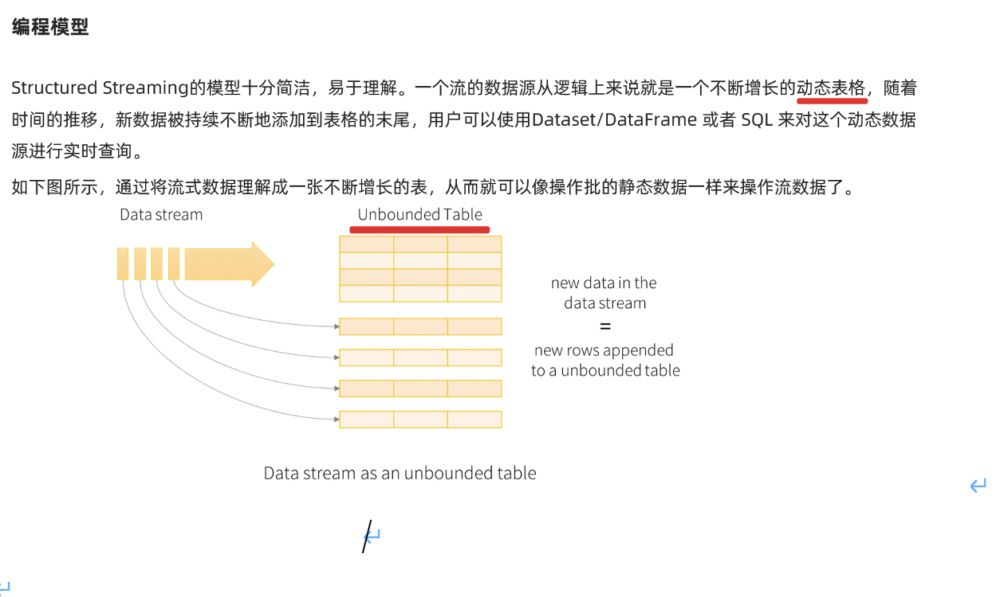

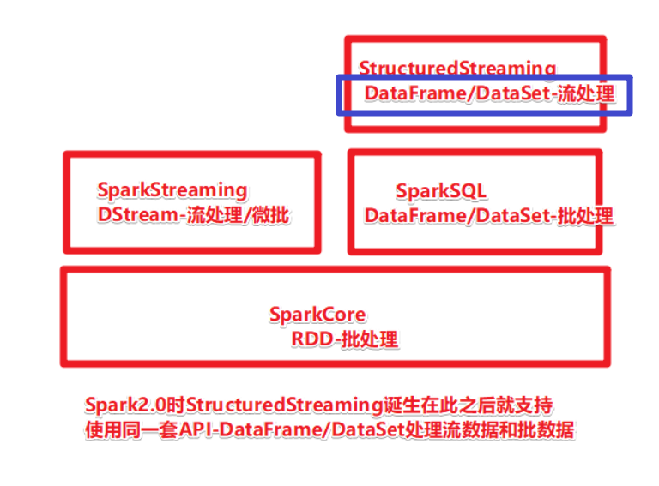

# StructuredStreaming-Source

http://spark.apache.org/docs/latest/structured-streaming-programming-guide.html

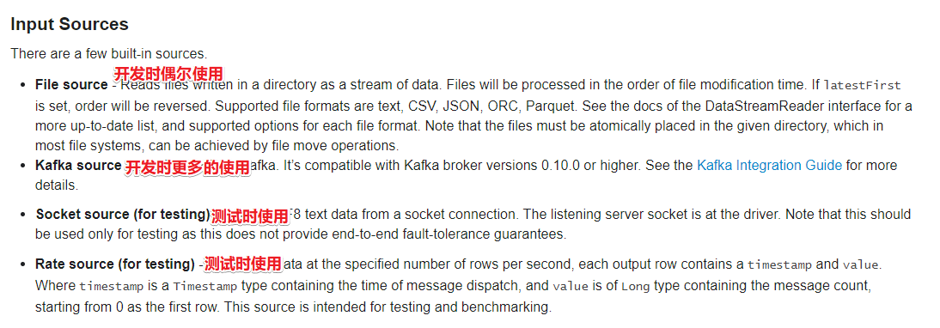

## 代码演示-1-Socket

package com.as.structured  
  
import org.apache.spark.SparkContext  
import org.apache.spark.sql.{DataFrame, Dataset, Row, SparkSession}  
  
/**  
 * Author roy  
 * Desc 演示StructuredStreaming的Source-Socket  
 */  
object Demo01_Source_Socket {  
 def main(args: Array[String]): Unit = {  
 //TODO 0.创建环境  
 //因为StructuredStreaming基于SparkSQL的且编程API/数据抽象是DataFrame/DataSet,所以这里创建SparkSession即可  
 val spark: SparkSession = SparkSession.builder().appName("sparksql").master("local[*]")  
 .config("spark.sql.shuffle.partitions", "4")//本次测试时将分区数设置小一点,实际开发中可以根据集群规模调整大小,默认200  
 .getOrCreate()  
 val sc: SparkContext = spark.sparkContext  
 sc.setLogLevel("WARN")  
 import spark.implicits._  
 import org.apache.spark.sql.functions._  
  
 //TODO 1.加载数据  
 val df: DataFrame = spark.readStream  
 .format("socket")  
 .option("host", "node1")  
 .option("port", 9999)  
 .load()  
  
 df.printSchema()  
 /*  
 root  
 |-- value: string (nullable = true)  
 */  
 //df.show()// Queries with streaming sources must be executed with writeStream.start();  
  
 //TODO 2.处理数据  
 val ds: Dataset[String] = df.as[String]  
 val result: Dataset[Row] = ds.flatMap(_.split(" "))  
 .groupBy('value)  
 .count()  
 .orderBy('count.desc)  
  
 //TODO 3.输出结果  
 result.writeStream  
 .format("console")  
 .outputMode("complete")  
 //TODO 4.启动并等待结束  
 .start()  
 .awaitTermination()  
  
 //TODO 5.关闭资源  
 spark.stop()  
 }  
}

## 代码演示-2-Rate

package com.as.structured  
  
import org.apache.spark.SparkContext  
import org.apache.spark.sql.{DataFrame, Dataset, Row, SparkSession}  
  
/**  
 * Author roy  
 * Desc 演示StructuredStreaming的Source-Rate  
 */  
object Demo02_Source_Rate {  
 def main(args: Array[String]): Unit = {  
 //TODO 0.创建环境  
 //因为StructuredStreaming基于SparkSQL的且编程API/数据抽象是DataFrame/DataSet,所以这里创建SparkSession即可  
 val spark: SparkSession = SparkSession.builder().appName("sparksql").master("local[*]")  
 .config("spark.sql.shuffle.partitions", "4")//本次测试时将分区数设置小一点,实际开发中可以根据集群规模调整大小,默认200  
 .getOrCreate()  
 val sc: SparkContext = spark.sparkContext  
 sc.setLogLevel("WARN")  
 import spark.implicits._  
  
 //TODO 1.加载数据  
 val df: DataFrame = spark.readStream  
 .format("rate")  
 .option("rowsPerSecond", "10") //每秒生成数据条数  
 .option("rampUpTime", "0s") //每条数据生成间隔时间  
 .option("numPartitions", "2") //分区数目  
 .load()  
  
  
 //TODO 2.处理数据  
  
  
 //TODO 3.输出结果  
 df.writeStream  
 .format("console")  
 //Complete output mode not supported when there are no streaming aggregations  
 //.outputMode("complete")  
 .outputMode("append")  
 .option("truncate",false)//表示对列不进行截断,也就是对列内容全部展示  
 //TODO 4.启动并等待结束  
 .start()  
 .awaitTermination()  
  
 //TODO 5.关闭资源  
 spark.stop()  
 }  
}

## 代码演示-3-File

package com.as.structured  
  
import org.apache.spark.SparkContext  
import org.apache.spark.sql.types.{IntegerType, StringType, StructType}  
import org.apache.spark.sql.{DataFrame, SparkSession}  
  
/**  
 * Author roy  
 * Desc 演示StructuredStreaming的Source-File  
 */  
object Demo03_Source_File {  
 def main(args: Array[String]): Unit = {  
 //TODO 0.创建环境  
 //因为StructuredStreaming基于SparkSQL的且编程API/数据抽象是DataFrame/DataSet,所以这里创建SparkSession即可  
 val spark: SparkSession = SparkSession.builder().appName("sparksql").master("local[*]")  
 .config("spark.sql.shuffle.partitions", "4")//本次测试时将分区数设置小一点,实际开发中可以根据集群规模调整大小,默认200  
 .getOrCreate()  
 val sc: SparkContext = spark.sparkContext  
 sc.setLogLevel("WARN")  
  
 val csvSchema: StructType = new StructType()  
 .add("name", StringType, nullable = true)  
 .add("age", IntegerType, nullable = true)  
 .add("hobby", StringType, nullable = true)  
  
  
 //TODO 1.加载数据  
 val df: DataFrame = spark.readStream  
 .option("sep", ";")  
 .option("header", "false")  
 .schema(csvSchema)//注意:流式处理对于结构化数据哪怕是有约束也需要单独指定  
 .format("csv").load("data/input/persons") //.csv("data/input/persons")  
  
 //TODO 2.处理数据  
  
  
 //TODO 3.输出结果  
 df.writeStream  
 .format("console")  
 //Complete output mode not supported when there are no streaming aggregations  
 //.outputMode("complete")  
 .outputMode("append")  
 .option("truncate",false)//表示对列不进行截断,也就是对列内容全部展示  
 //TODO 4.启动并等待结束  
 .start()  
 .awaitTermination()  
  
 //TODO 5.关闭资源  
 spark.stop()  
 }  
}

# StructuredStreaming-Operation

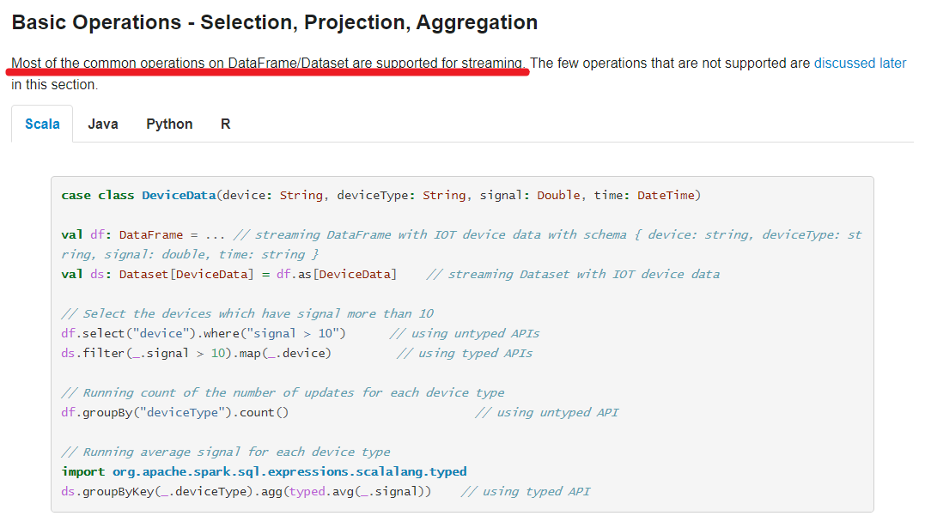

package com.as.structured  
  
import org.apache.spark.SparkContext  
import org.apache.spark.sql.{DataFrame, Dataset, Row, SparkSession}  
  
/**  
 * Author roy  
 * Desc 演示StructuredStreaming的Operation  
 */  
object Demo04_Operation {  
 def main(args: Array[String]): Unit = {  
 //TODO 0.创建环境  
 //因为StructuredStreaming基于SparkSQL的且编程API/数据抽象是DataFrame/DataSet,所以这里创建SparkSession即可  
 val spark: SparkSession = SparkSession.builder().appName("sparksql").master("local[*]")  
 .config("spark.sql.shuffle.partitions", "4")//本次测试时将分区数设置小一点,实际开发中可以根据集群规模调整大小,默认200  
 .getOrCreate()  
 val sc: SparkContext = spark.sparkContext  
 sc.setLogLevel("WARN")  
 import spark.implicits._  
  
 //TODO 1.加载数据  
 val df: DataFrame = spark.readStream  
 .format("socket")  
 .option("host", "node1")  
 .option("port", 9999)  
 .load()  
  
 df.printSchema()  
 /*  
 root  
 |-- value: string (nullable = true)  
 */  
 //df.show()// Queries with streaming sources must be executed with writeStream.start();  
  
 //TODO 2.处理数据  
 //TODO ====DSL  
 val ds: Dataset[String] = df.as[String]  
 val wordsDS: Dataset[String] = ds.flatMap(_.split(" "))  
 val result1: Dataset[Row] = wordsDS  
 .groupBy('value)  
 .count()  
 .orderBy('count.desc)  
  
  
 //TODO ====SQL  
 wordsDS.createOrReplaceTempView("t_words")  
 val sql:String =  
 """  
 |select value,count(*) as counts  
 |from t_words  
 |group by value  
 |order by counts desc  
 |""".stripMargin  
 val result2: DataFrame = spark.sql(sql)  
  
 //TODO 3.输出结果  
 result1.writeStream  
 .format("console")  
 .outputMode("complete")  
 //TODO 4.启动  
 .start()  
 //.awaitTermination()//注意:后面还有代码要执行,所以这里需要注释掉  
  
 result2.writeStream  
 .format("console")  
 .outputMode("complete")  
 //TODO 4.启动并等待结束  
 .start()  
 .awaitTermination()  
  
 //TODO 5.关闭资源  
 spark.stop()  
 }  
}

# StructuredStreaming-Sink

## Output Modes

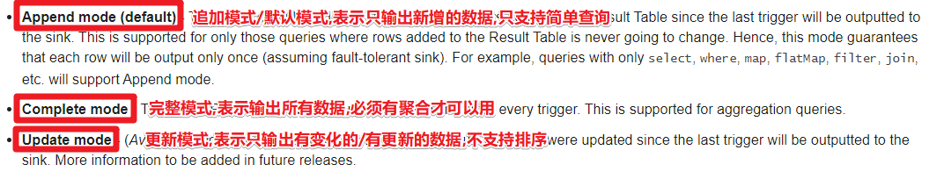

package com.as.structured  
  
import org.apache.spark.SparkContext  
import org.apache.spark.sql.{DataFrame, Dataset, Row, SparkSession}  
  
/**  
 * Author roy  
 * Desc 演示StructuredStreaming的Sink_OutPutMode  
 */  
object Demo05_Sink_OutPutMode {  
 def main(args: Array[String]): Unit = {  
 //TODO 0.创建环境  
 //因为StructuredStreaming基于SparkSQL的且编程API/数据抽象是DataFrame/DataSet,所以这里创建SparkSession即可  
 val spark: SparkSession = SparkSession.builder().appName("sparksql").master("local[*]")  
 .config("spark.sql.shuffle.partitions", "4")//本次测试时将分区数设置小一点,实际开发中可以根据集群规模调整大小,默认200  
 .getOrCreate()  
 val sc: SparkContext = spark.sparkContext  
 sc.setLogLevel("WARN")  
 import spark.implicits._  
  
 //TODO 1.加载数据  
 val df: DataFrame = spark.readStream  
 .format("socket")  
 .option("host", "node1")  
 .option("port", 9999)  
 .load()  
  
 df.printSchema()  
  
 //TODO 2.处理数据  
 val ds: Dataset[String] = df.as[String]  
 val result1: Dataset[Row] = ds.flatMap(_.split(" "))  
 .groupBy('value)  
 .count()  
 .orderBy('count.desc)  
  
 val result2: Dataset[Row] = ds.flatMap(_.split(" "))  
 .groupBy('value)  
 .count()  
  
 val result3: Dataset[String] = ds.flatMap(_.split(" "))  
  
  
 //TODO 3.输出结果  
 /*result1.writeStream  
 .format("console")  
 //.outputMode("append")//Append output mode not supported  
 //.outputMode("update")//Sorting is not supported  
 .outputMode("complete")  
 .start()  
 .awaitTermination()*/  
  
 /*result2.writeStream  
 .format("console")  
 .outputMode("update")  
 .start()  
 .awaitTermination()*/  
  
 result3.writeStream  
 .format("console")  
 .outputMode("append")  
 //TODO 4.启动并等待结束  
 .start()  
 .awaitTermination()  
  
 //TODO 5.关闭资源  
 spark.stop()  
 }  
}

## Sink位置

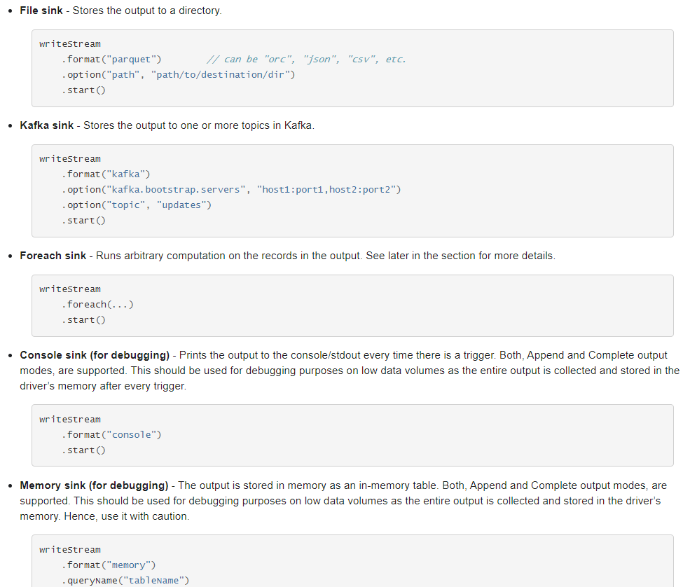

package com.as.structured  
  
import org.apache.spark.SparkContext  
import org.apache.spark.sql.streaming.StreamingQuery  
import org.apache.spark.sql.{DataFrame, Dataset, Row, SparkSession}  
  
/**  
 * Author roy  
 * Desc 演示StructuredStreaming的Sink_Location  
 */  
object Demo06_Sink_Location {  
 def main(args: Array[String]): Unit = {  
 //TODO 0.创建环境  
 //因为StructuredStreaming基于SparkSQL的且编程API/数据抽象是DataFrame/DataSet,所以这里创建SparkSession即可  
 val spark: SparkSession = SparkSession.builder().appName("sparksql").master("local[*]")  
 .config("spark.sql.shuffle.partitions", "4")//本次测试时将分区数设置小一点,实际开发中可以根据集群规模调整大小,默认200  
 .getOrCreate()  
 val sc: SparkContext = spark.sparkContext  
 sc.setLogLevel("WARN")  
 import spark.implicits._  
  
 //TODO 1.加载数据  
 val df: DataFrame = spark.readStream  
 .format("socket")  
 .option("host", "node1")  
 .option("port", 9999)  
 .load()  
  
 df.printSchema()  
  
 //TODO 2.处理数据  
 val ds: Dataset[String] = df.as[String]  
 val result: Dataset[Row] = ds.flatMap(_.split(" "))  
 .groupBy('value)  
 .count()  
 .orderBy('count.desc)  
  
 //TODO 3.输出结果  
 /*result.writeStream  
 .format("console")  
 .outputMode("complete")  
 .start()  
 .awaitTermination()*/  
  
 val query: StreamingQuery = result.writeStream  
 .format("memory")  
 .queryName("t_result")  
 .outputMode("complete")  
 //TODO 4.启动并等待结束  
 .start()  
 //.awaitTermination()  
 while(true){  
 spark.sql("select * from t_result").show  
 Thread.sleep(3000)  
 }  
  
 //query.awaitTermination()  
  
 //TODO 5.关闭资源  
 spark.stop()  
 }  
}

## ForeachBatch Sink

package com.as.structured  
  
import org.apache.spark.SparkContext  
import org.apache.spark.sql._  
  
/**  
 * Author roy  
 * Desc 演示StructuredStreaming的Sink_ForeachBatch  
 */  
object Demo07_Sink_ForeachBatch {  
 def main(args: Array[String]): Unit = {  
 //TODO 0.创建环境  
 //因为StructuredStreaming基于SparkSQL的且编程API/数据抽象是DataFrame/DataSet,所以这里创建SparkSession即可  
 val spark: SparkSession = SparkSession.builder().appName("sparksql").master("local[*]")  
 .config("spark.sql.shuffle.partitions", "4") //本次测试时将分区数设置小一点,实际开发中可以根据集群规模调整大小,默认200  
 .getOrCreate()  
 val sc: SparkContext = spark.sparkContext  
 sc.setLogLevel("WARN")  
 import spark.implicits._  
  
 //TODO 1.加载数据  
 val df: DataFrame = spark.readStream  
 .format("socket")  
 .option("host", "node1")  
 .option("port", 9999)  
 .load()  
  
 df.printSchema()  
  
 //TODO 2.处理数据  
 val ds: Dataset[String] = df.as[String]  
 val result: Dataset[Row] = ds.flatMap(_.split(" "))  
 .groupBy('value)  
 .count()  
 .orderBy('count.desc)  
  
 //TODO 3.输出结果  
 /*result.writeStream  
 .format("console")  
 .outputMode("complete")  
 .start()  
 .awaitTermination()*/  
 result.writeStream  
 .foreachBatch((ds: Dataset[Row], batchId:Long) => {  
 //自定义输出到控制台  
 println("-------------")  
 println(s"batchId:${batchId}")  
 println("-------------")  
 ds.show()  
 //自定义输出到MySQL  
 ds.coalesce(1)  
 .write  
 .mode(SaveMode.Overwrite)  
 .format("jdbc")  
 //.option("driver", "com.mysql.cj.jdbc.Driver")//MySQL-8  
 //.option("url", "jdbc:mysql://localhost:3306/?serverTimezone=UTC&characterEncoding=utf8&useUnicode=true")//MySQL-8  
 .option("url", "jdbc:mysql://localhost:3306/bigdata?characterEncoding=UTF-8")  
 .option("user", "root")  
 .option("password", "root")  
 .option("dbtable", "bigdata.t_struct_words")  
 .save()  
 })  
 .outputMode("complete")  
 //TODO 4.启动并等待结束  
 .start()  
 .awaitTermination()  
  
  
 //TODO 5.关闭资源  
 spark.stop()  
 }  
}

## 触发间隔

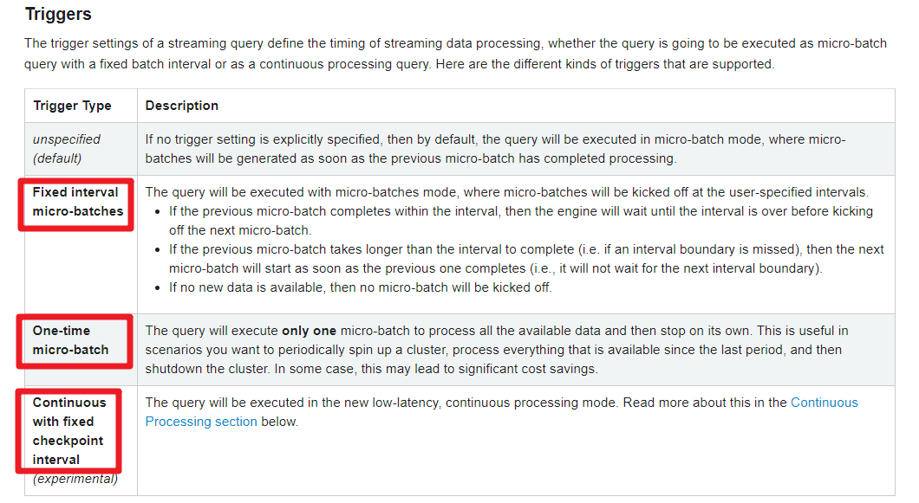

注意:

微批处理的时候每个批次可以做Checkpoint,容错/保持状态

那么在做连续处理的时候也需要做Checkpoint,什么时候做?--需要指定时间

package com.as.structured  
  
import org.apache.spark.SparkContext  
import org.apache.spark.sql.streaming.Trigger  
import org.apache.spark.sql.{DataFrame, Dataset, Row, SparkSession}  
  
/**  
 * Author roy  
 * Desc 演示StructuredStreaming的Source-Socket  
 */  
object Demo08_Sink_Trigger_Checkpoint {  
 def main(args: Array[String]): Unit = {  
 //TODO 0.创建环境  
 //因为StructuredStreaming基于SparkSQL的且编程API/数据抽象是DataFrame/DataSet,所以这里创建SparkSession即可  
 val spark: SparkSession = SparkSession.builder().appName("sparksql").master("local[*]")  
 .config("spark.sql.shuffle.partitions", "4")//本次测试时将分区数设置小一点,实际开发中可以根据集群规模调整大小,默认200  
 .getOrCreate()  
 val sc: SparkContext = spark.sparkContext  
 sc.setLogLevel("WARN")  
 import spark.implicits._  
  
 //TODO 1.加载数据  
 val df: DataFrame = spark.readStream  
 .format("socket")  
 .option("host", "node1")  
 .option("port", 9999)  
 .load()  
  
 df.printSchema()  
  
 //TODO 2.处理数据  
 val ds: Dataset[String] = df.as[String]  
 val result: Dataset[Row] = ds.coalesce(1).flatMap(_.split(" "))  
 .groupBy('value)  
 .count()  
 //.orderBy('count.desc)  
  
 //TODO 3.输出结果  
 result.writeStream  
 .format("console")  
 .outputMode("complete")  
 //触发间隔:  
 //1.默认的不写就是:尽可能快的运行微批,Default trigger (runs micro-batch as soon as it can)  
 //2.指定0也是尽可能快的运行  
 // .trigger(Trigger.ProcessingTime("0 seconds"))  
 //3.指定时间间隔  
 //.trigger(Trigger.ProcessingTime("5 seconds"))  
 //4.触发1次  
 //.trigger(Trigger.Once())  
 //5.连续处理并指定Checkpoint时间间隔,实验的  
 .trigger(Trigger.Continuous("1 second"))  
 .option("checkpointLocation", "./ckp"+System.currentTimeMillis())  
 //TODO 4.启动并等待结束  
 .start()  
 .awaitTermination()  
  
 //TODO 5.关闭资源  
 spark.stop()  
 }  
}