**Bonus**

**Bonus(1)**

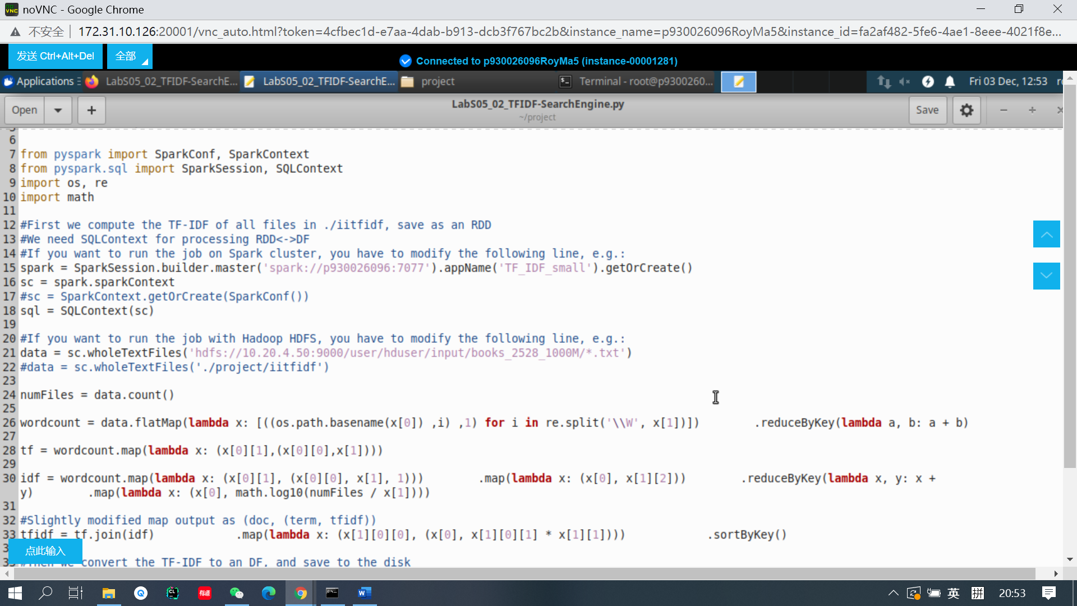

**Run a large file (1G) from our HDFS, since there was an error when I ran the code in Jupyter notebook, so, I submit the task from the console.**

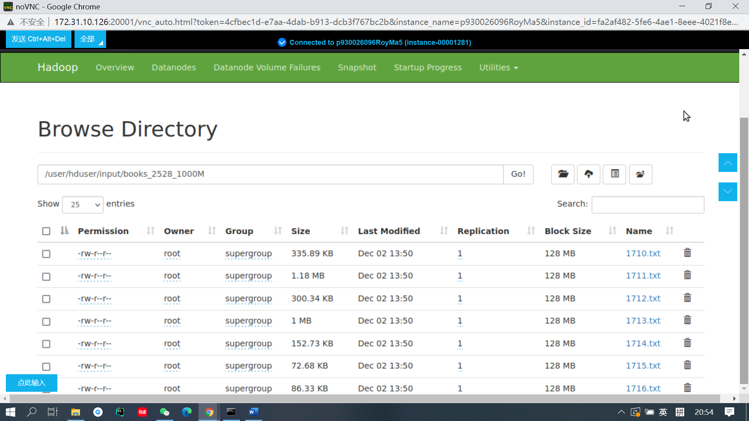

**Here is a screen shout of my file directory in HDFS which contains more than 1G.**

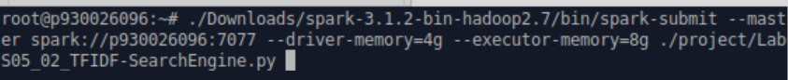

**Submit the file in the console by setting the driver memory and executor memory.**

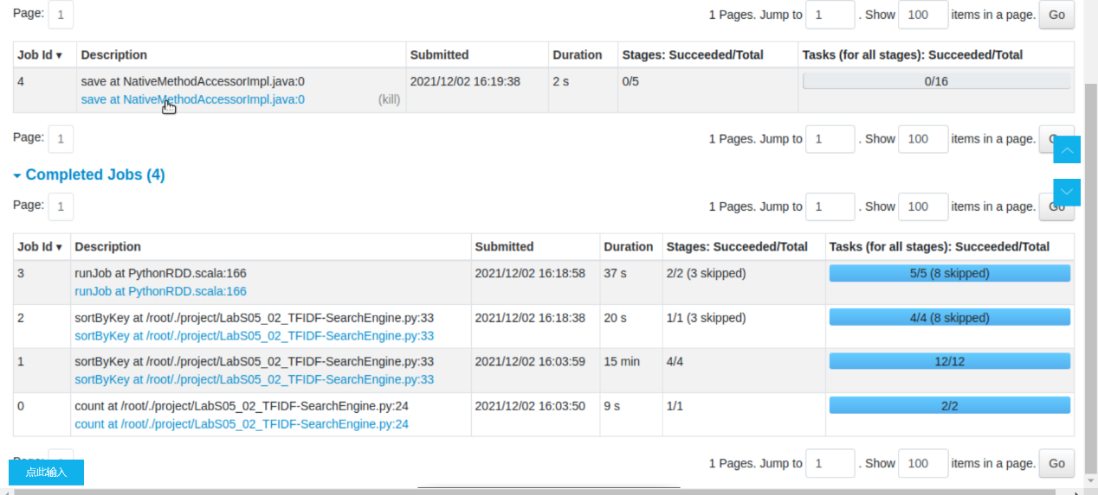

**The result of task. It takes approximately 16 mins.**

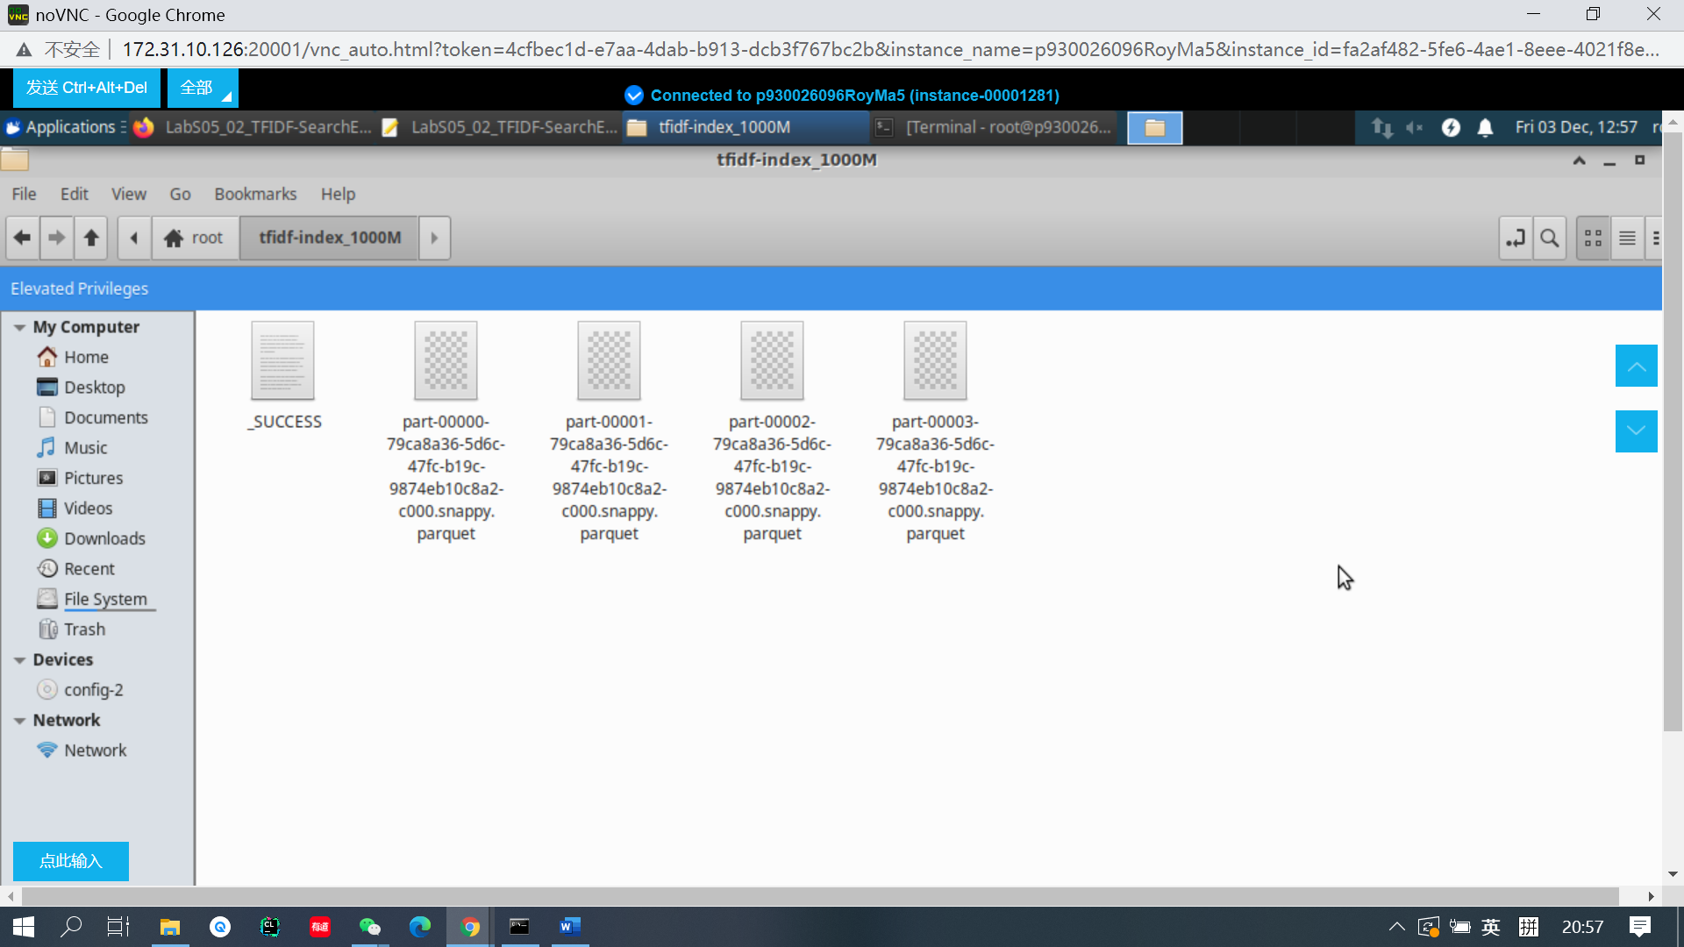

**Here is the output files of the codes.**

**Bonus（2）**

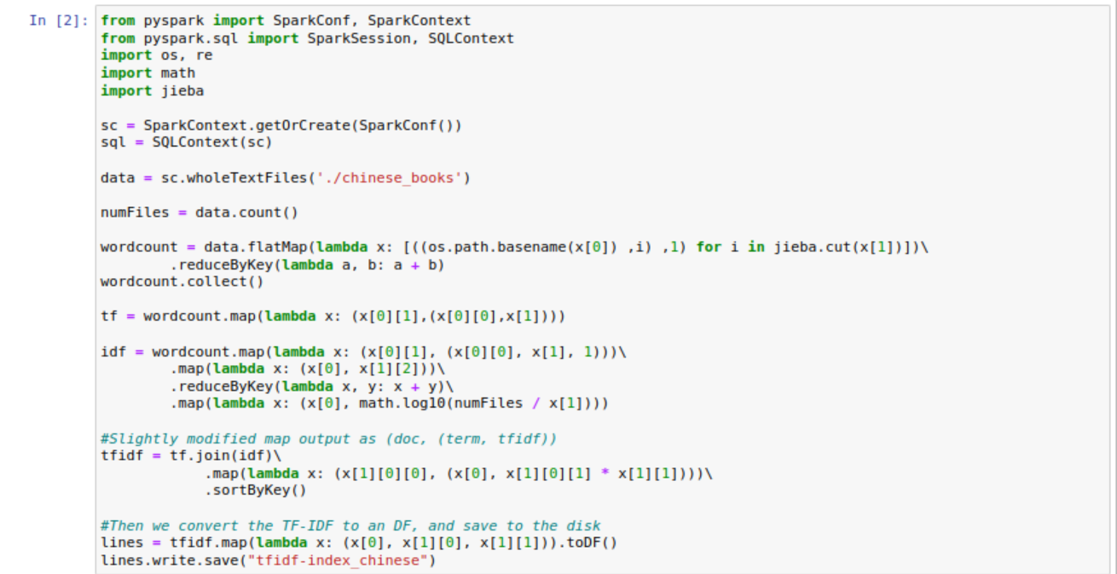

**Run the code based on some Chinese books by using the package jieba.**

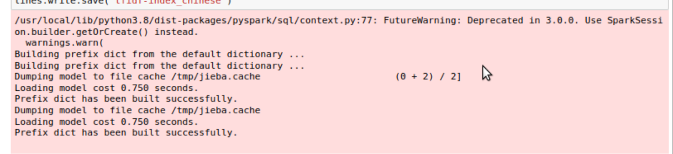

**The program is running.**

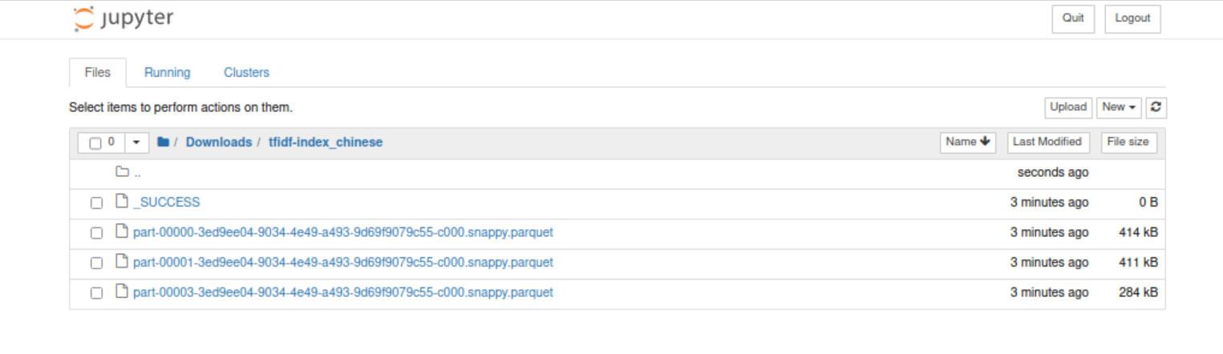

**The files that generate by the codes.**