Intermediate

1）



The command should be ls -m

2)

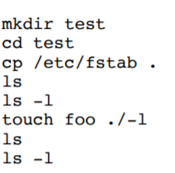

Command mkdir test make a directory named “test”.

Command cd test enter the directory called “test”.

Command cp /etc/fstab . copy the file ‘fstab’ in /etc directory to the current directory.

Command ls list all the directory contents.

Command ls -l long list all the directory contents in detail.

Command touch foo ./-l create two empty files named “foo” and “-l”. Using “./” to state “-l” is not an option.

Command ls list all the directory contents.

Command ls -l long list all the directory contents in detail.

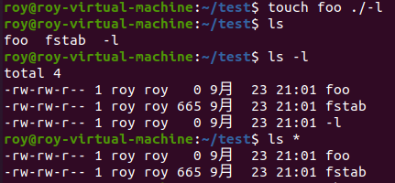

Problem: after execute ls \*, the file “-l” is not on the list.

Explain: the option \* will print all the matched file on the screen. While, the file “-l” starts with the character “-”, which does not match the pattern in “\*”. Thus, it omits this file in “ls -l” command output.

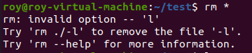

Problem: It cannot remove the file “-l” in the directory.

Explain: the option \* will print all the matched file on the screen. While, the file “-l” starts with the character “-”, which does not match the pattern in “\*”. Thus, it omits this file in “ls -l” command output.

Modified command: rm ./-l && rm \*



Explain: First remove “-l”, by specified it using “./”. And then remove the rest two file files.

3)

Result:

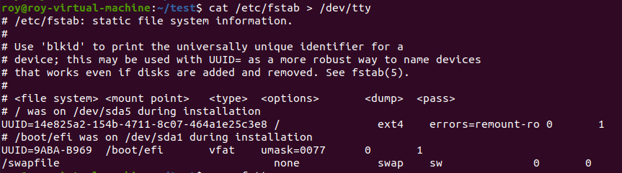

Explain: The result display on the standard output (terminal) instead of rewriting in the file “/dev/tty”. Normally, if the place of output is a file, then the redirection will work, and there would not nothing on the terminal. However, the redirection had been truncated since “/dev/tty” is not a file. Thus, the output has to being shown on the standard place (terminal). In this case, the real core is that the redirection fails.

4)

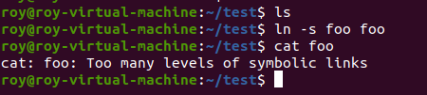

Explain: In this case, we create s soft link “foo” (in fact, an image file) in the directory “test”. However, In such directory, there is no file named “foo”, so when I “cat” soft link “foo”, it does not know where to link.

5)



The command that can only find files in the /run directory is: find -type f 2> /dev/null

Here is the result:

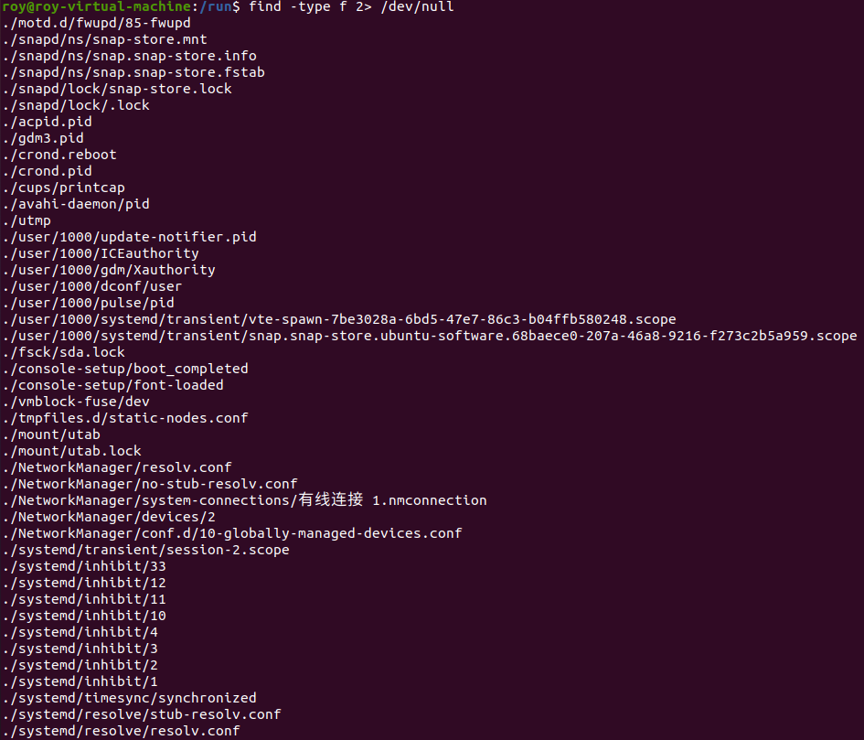

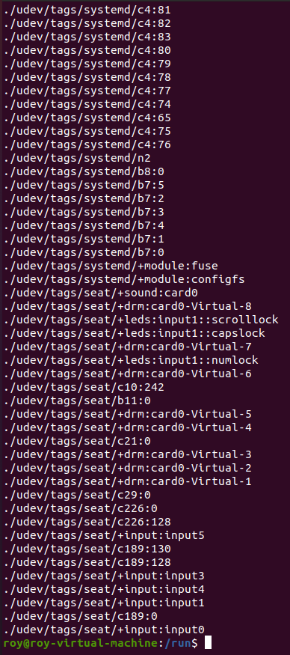

6)

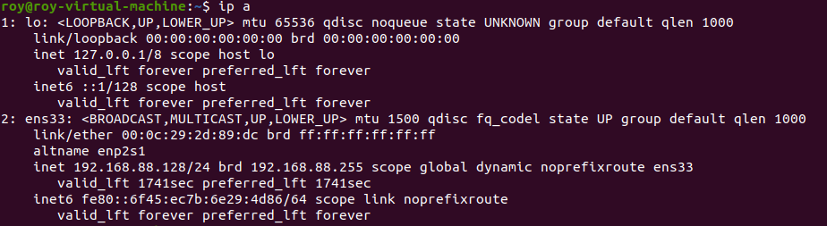

Use ip. Command “ip a” gives all the network interfaces. Here are two interfaces, and the first one is the loopback interface which is a virtual interface. The second one is what I want. The name is “ens33”. The MAC address is “192.168.88.128”

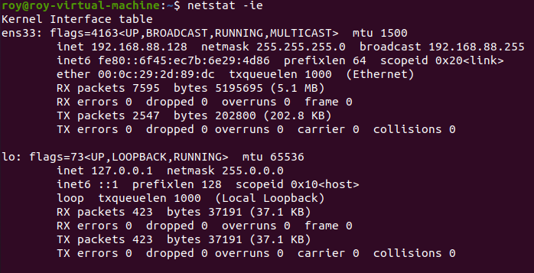

Use netstat. Command “netstat ie” can check network interfaces in the system. It result is similar to the above.

7)

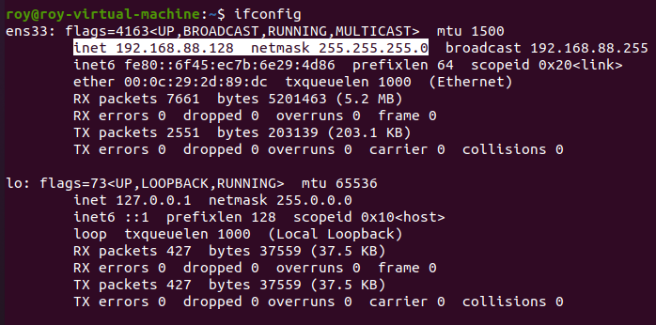

Here is the IP address and netmask for my own Ubuntu machine. It is similar to the above two commands. The IP address is “192.168.88.128”. The netmask is “255.255.255.0”

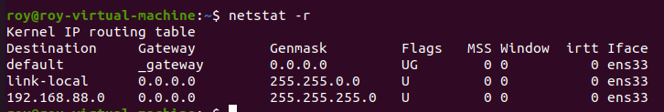

Here is the IP address for the machine router. Command “netstat -r” can show the kernel network router table. The IP address is “192.168.88.0”.

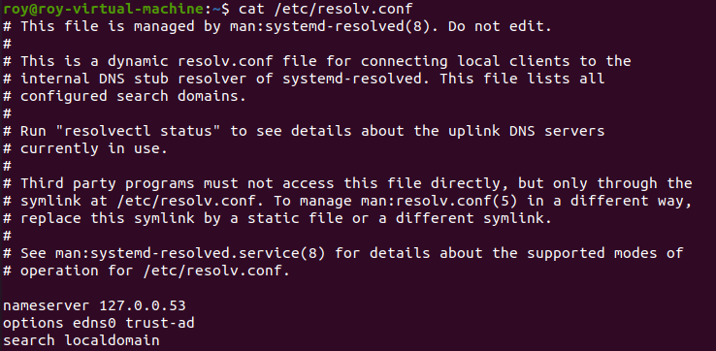

Here is the IP address for the DNS server. In Linux, IP address of DNS server is stored in “/etc/resolv.conf”. Thus, we can open and search this file by command “cat”. The IP address is “127.0.0.53”.

8)

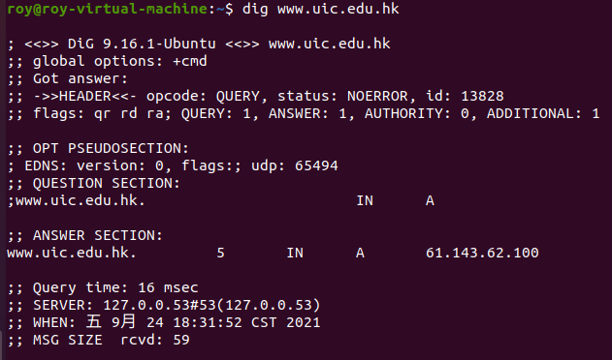

Command: “dig www.uic.edu.hk”. The command dig performs DNS searching. It provides information about the server by giving the domain name. The IP address “61.143.62.100” is shown on the screenshot.