**Bonus build a docker image from scratch for a web**



**Create a virtual network by docker**



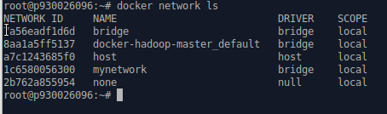

**list the network information**



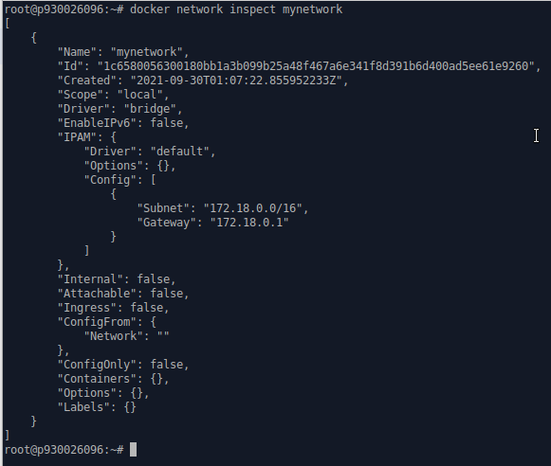

**Inspect mynetwork that you just created**

**Start a MySQL database by connecting to the virtual network, mapping the port 3306, setting the root password, and set a user and its password. Finally, state the MySQL version.**

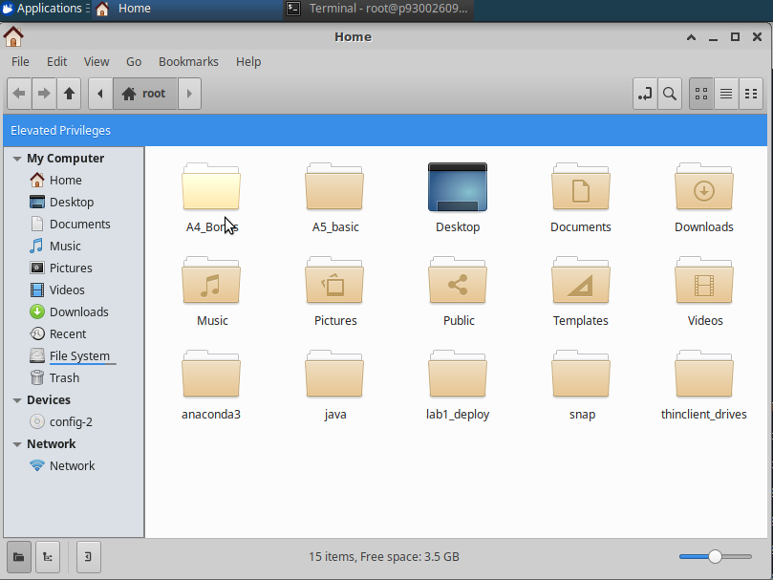

**Download the configure file under the root directory**

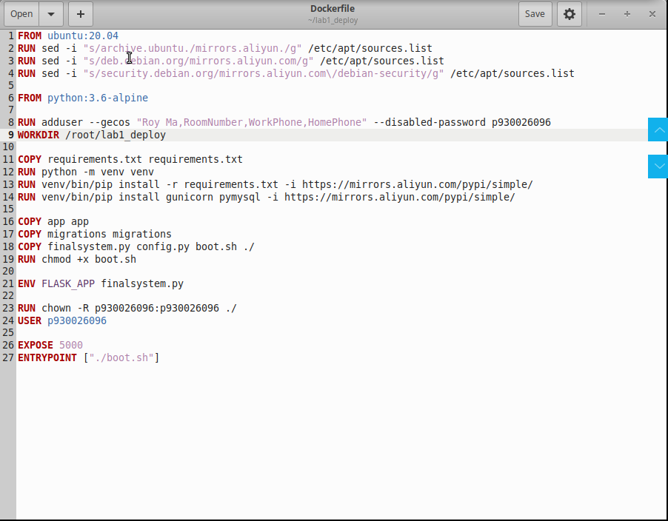

**Modify the Dockerfile.**

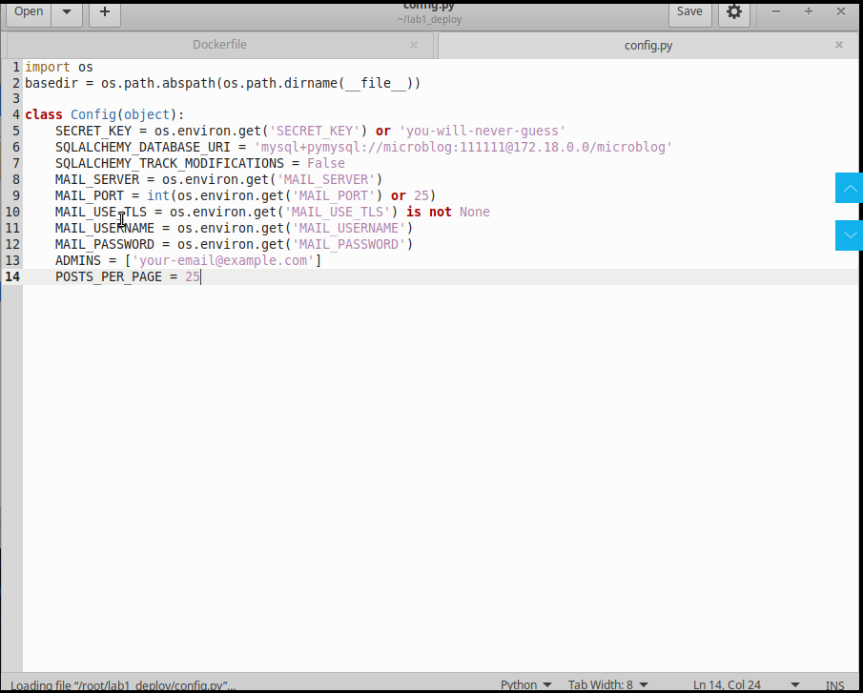

**Modify the config.py file.**



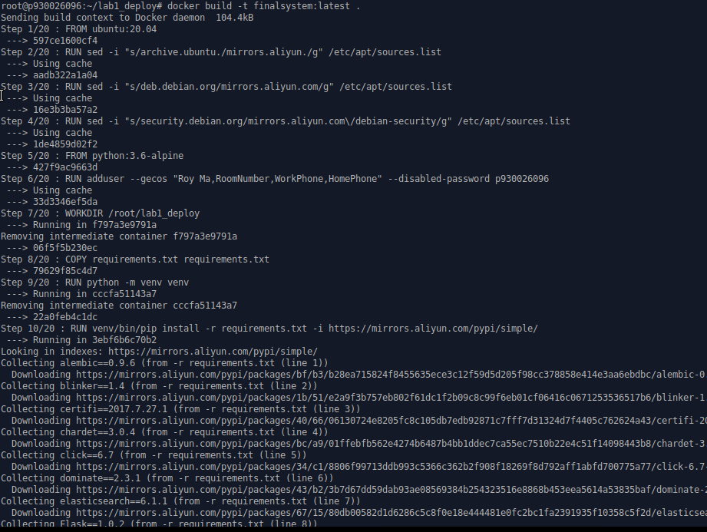

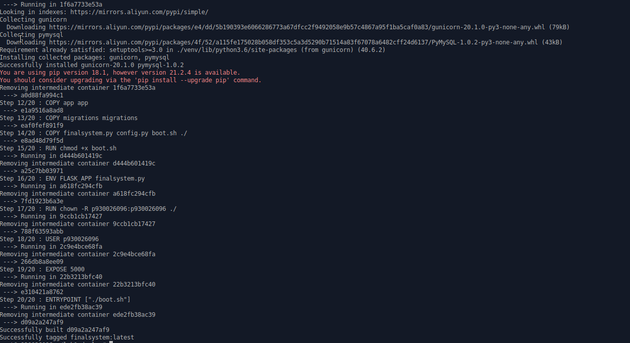

**Enter the directory that contains all the configure files. And build a container for web server.**



**Start the web server.**



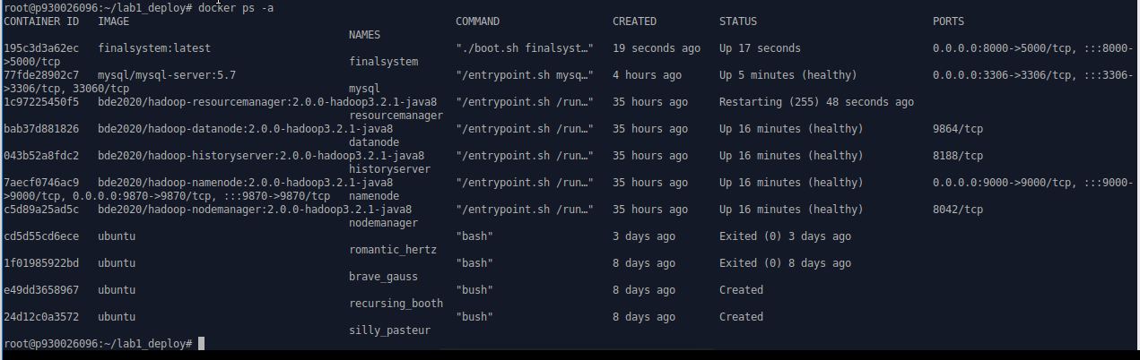

**MySQL and web server are both on.**

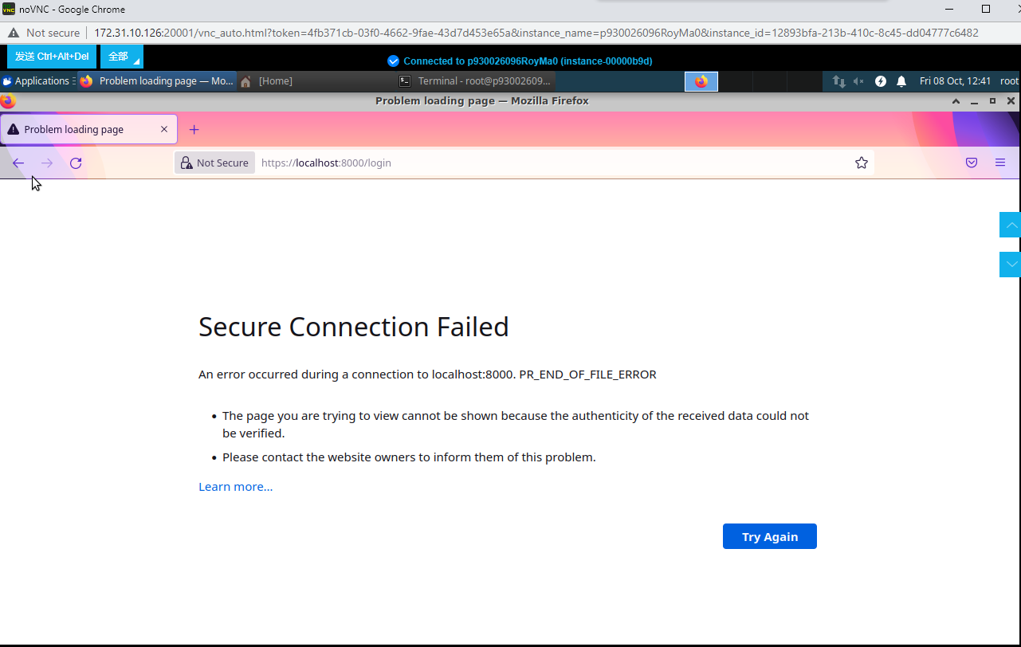

**However, due to some problems, my webpage failed to open.**

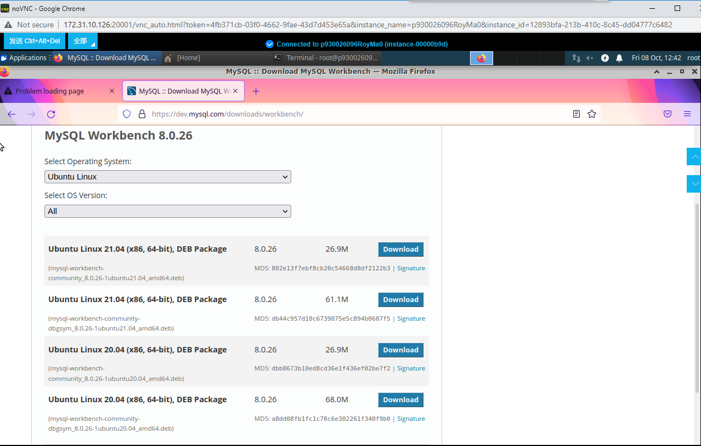

**Download MySQL Workbench for Linux in official platform.**

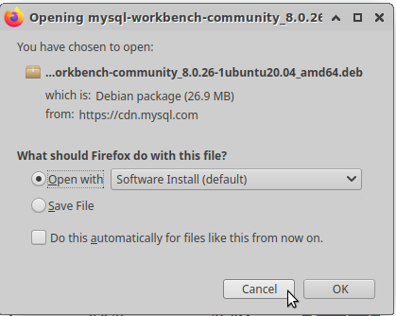

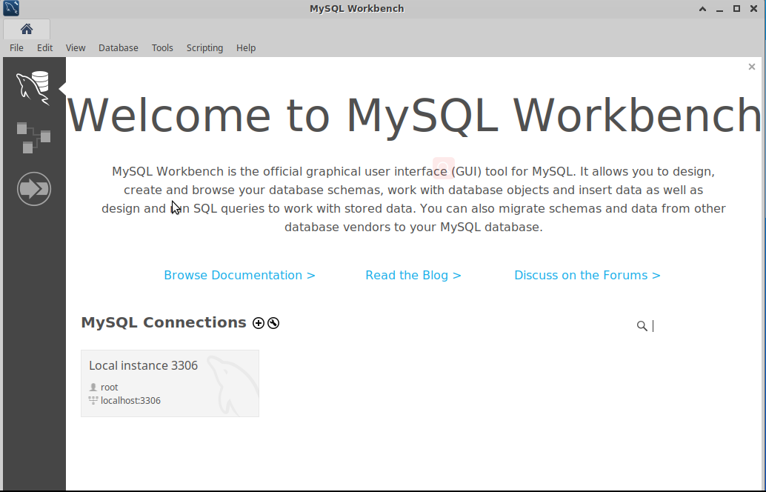

**Download Workbench successfully.**

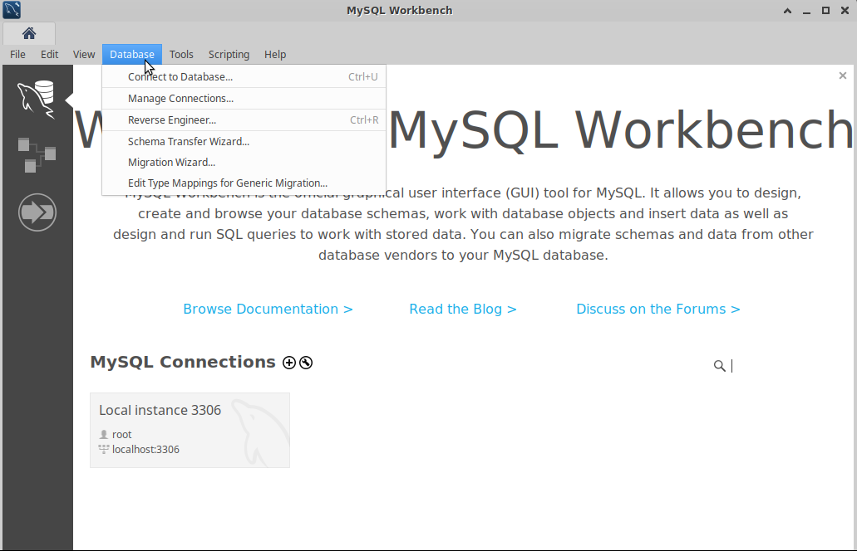

**Connect to Database(microblog)**

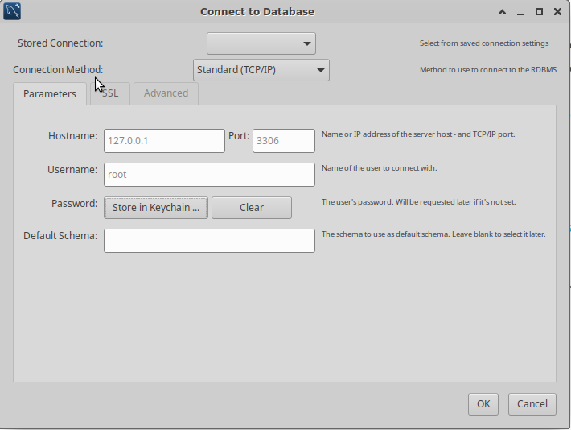

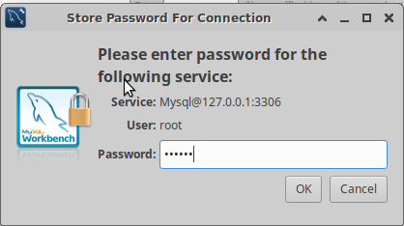

**Login use username and password.**