Install any 3 docker images from docker hub.

1. Install Ubuntu

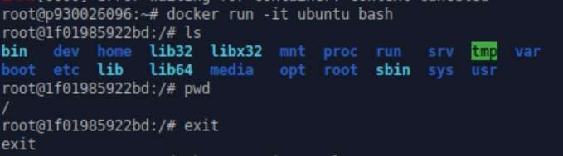

Install Ubuntu and run an Ubuntu container inside docker. It is successful because the CLI prompt changed.

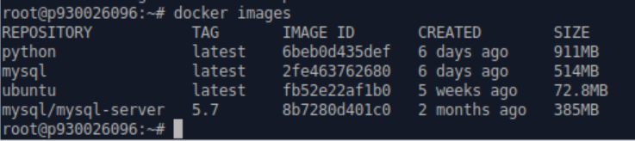

Check docker images, ubuntu has already been installed.

1. Install mysql

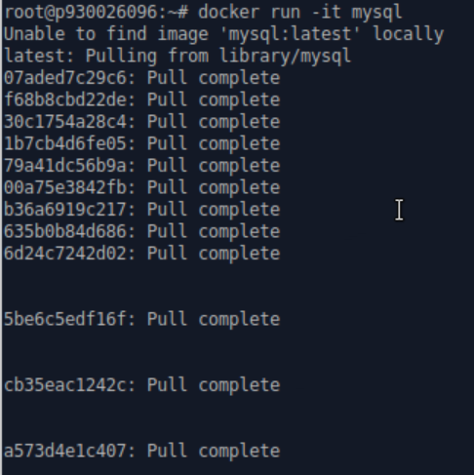

Install MySQL

Check docker images, mysql has already been installed.

1. Install python

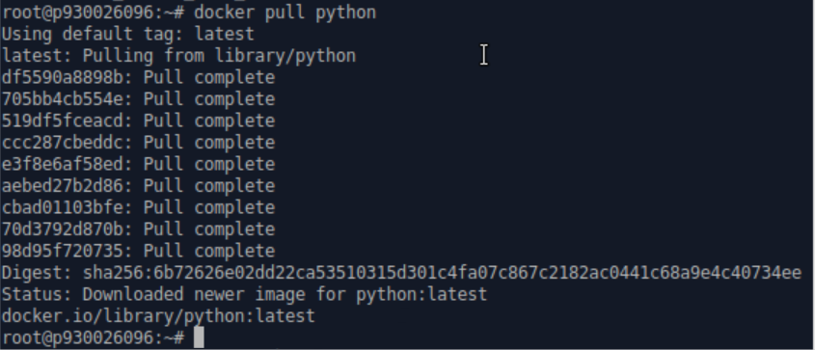

Install python



Check docker images, python has already been installed.