Install JDK & Download and install Hadoop on Ubuntu



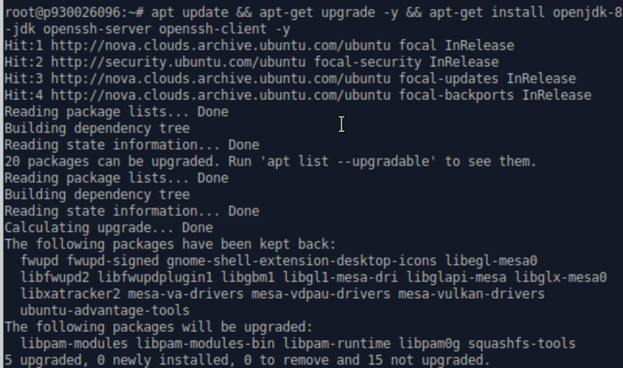

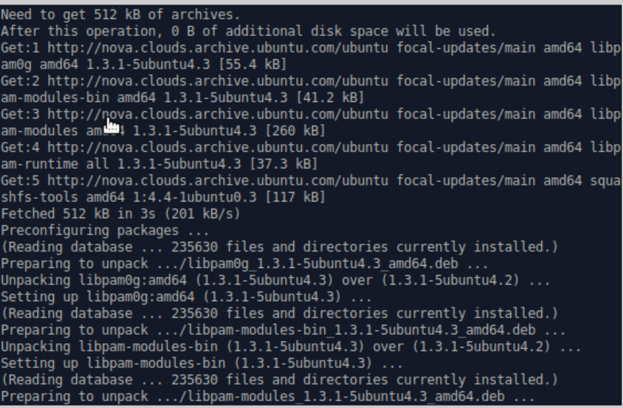

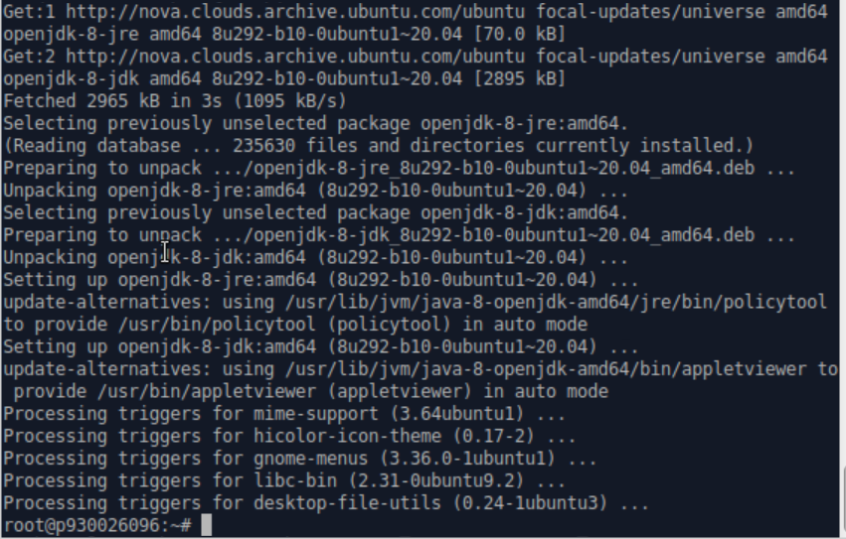

Update the system and install JRE and JDK.



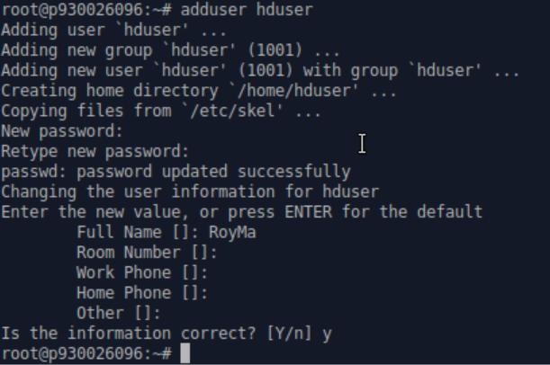

Create a Hadoop user. The username is RoyMa with no room number, work phoe and home phone and others.



SSH the localhost.



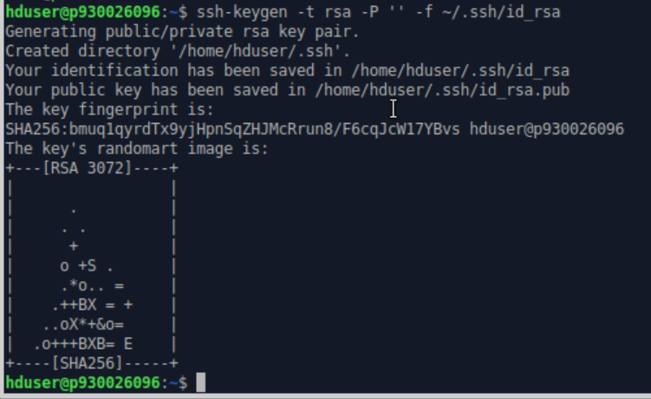

Generate an SSH key pair and define the storage location.



“cat” to move public key as authorized_keys to the ssh directory.

Set the permissions by “chmod” command.



Establish SSH connection to the localhost.



Download the Hadoop 3.2.2 mirrors.

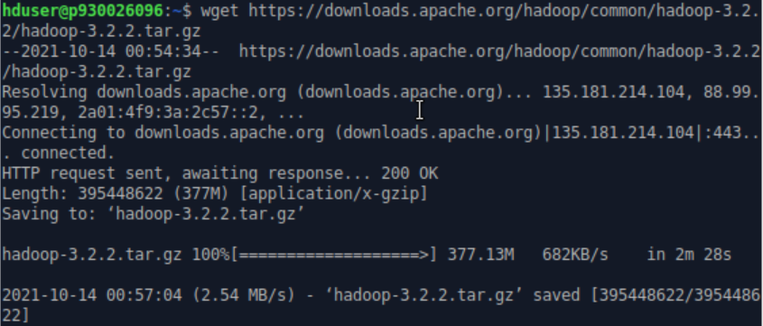



Extract the zip files.



Edit .bashrc file, adding some environment variables as follow.

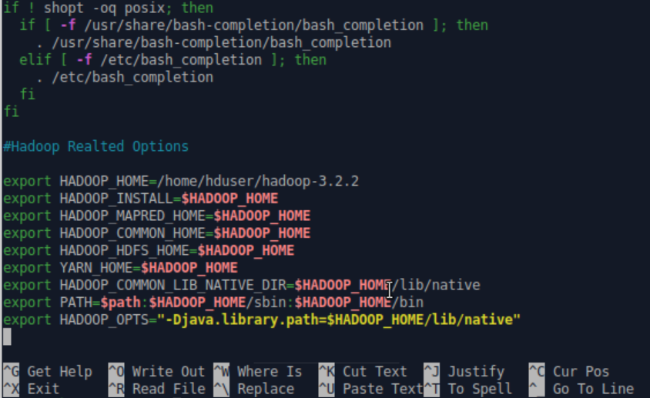



Apply the changes of .bashrc.



Edit Hadoop-env.sh file as follow.

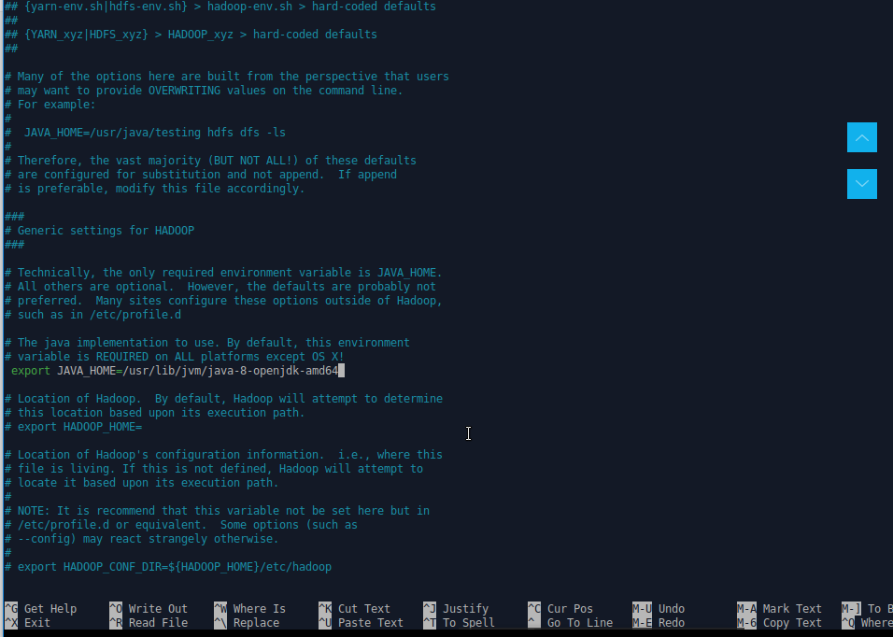



Edit core-site.xml file as follow. Hostname is localhost.

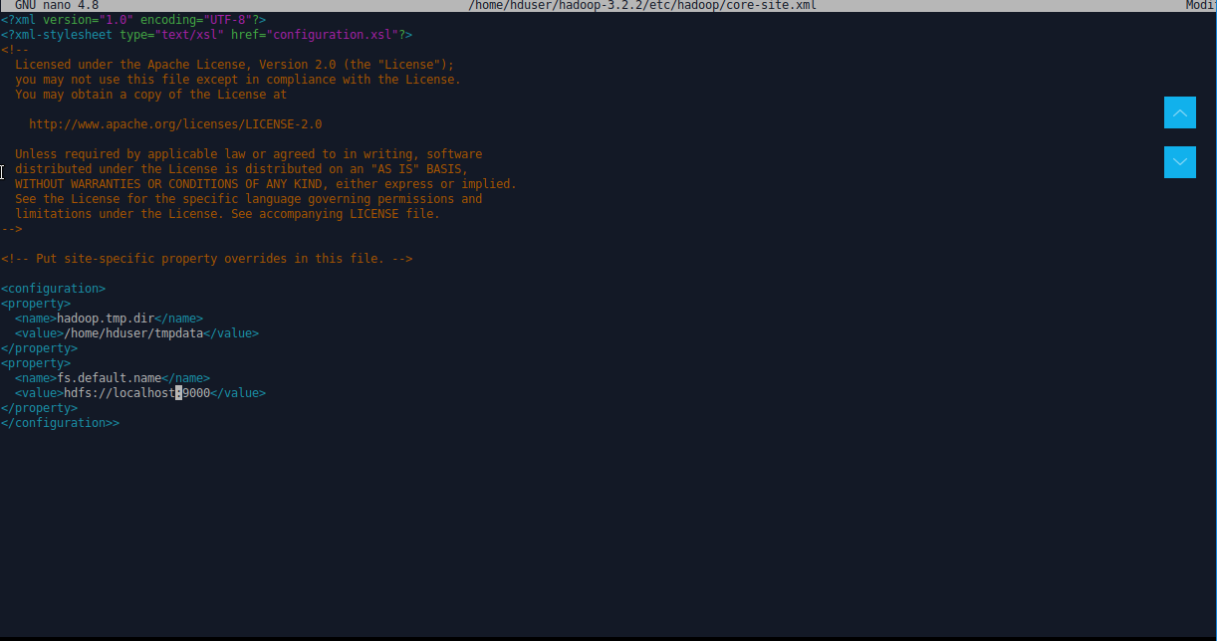



Edit hdfs-site.xml file as follow.

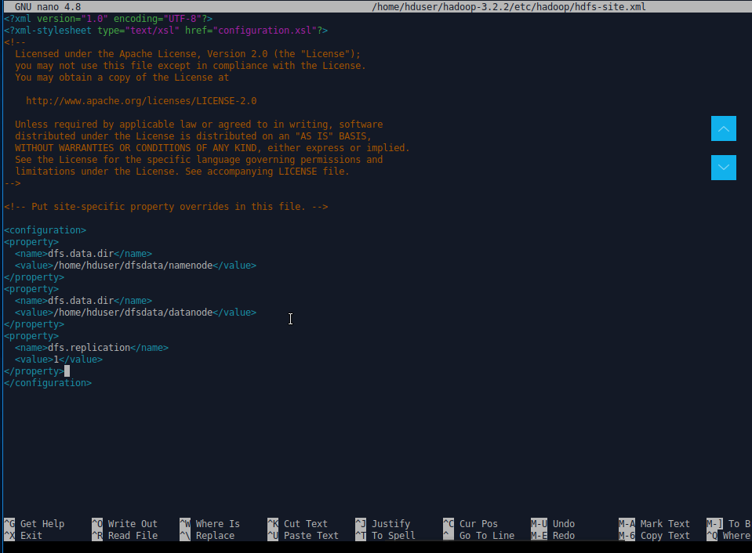



Edit mapred-site.xml as follow.

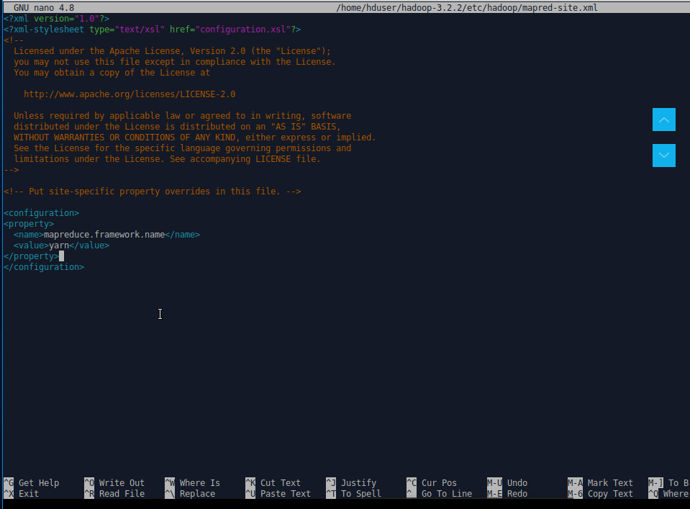



Edit yarn-site.xml file as follow. Hostname is localhost.

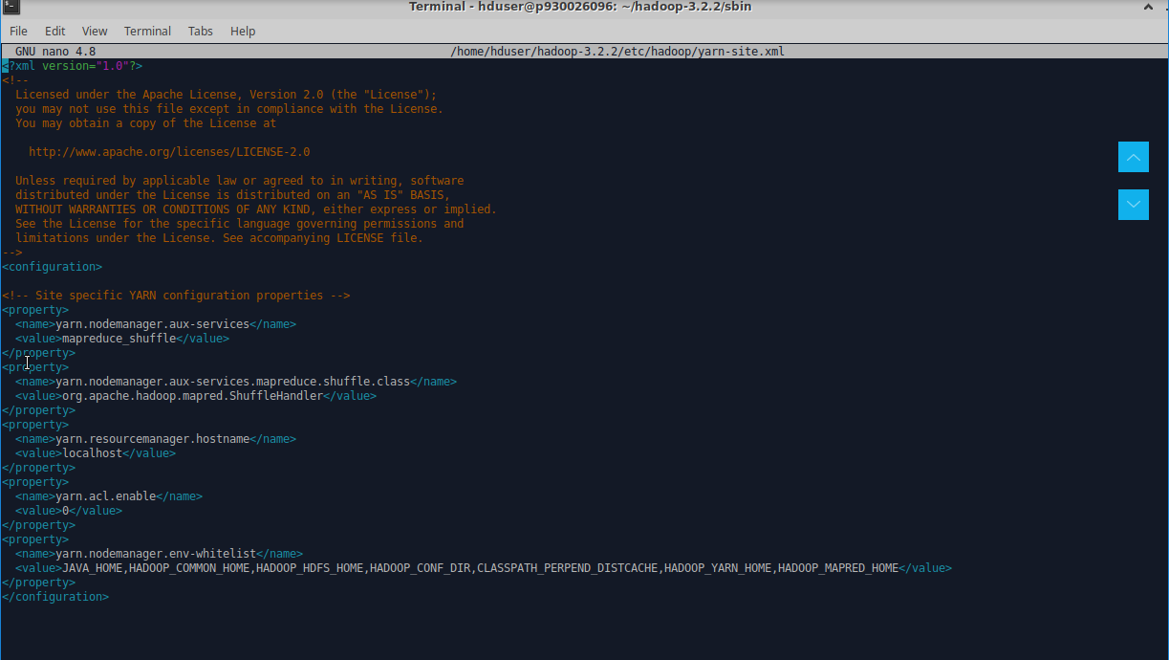



Format the namenode at the first time starting Hadoop services.

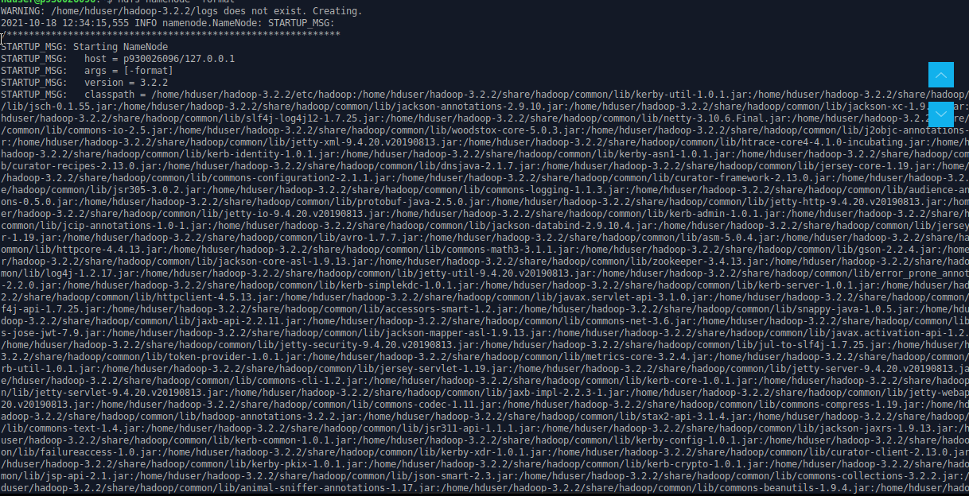

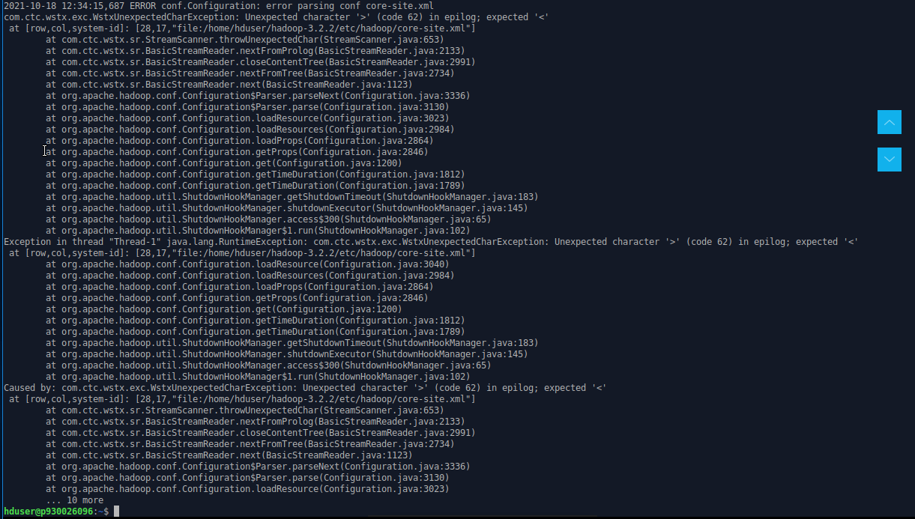

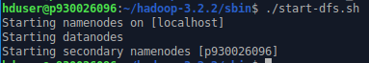

Go to the directory “~/Hadoop-3..2.2.sbin”, and start the namenode and datanode.



Start the yarn resource and nodemanagers

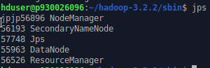

Check if all the daemons are active and running as java processes.

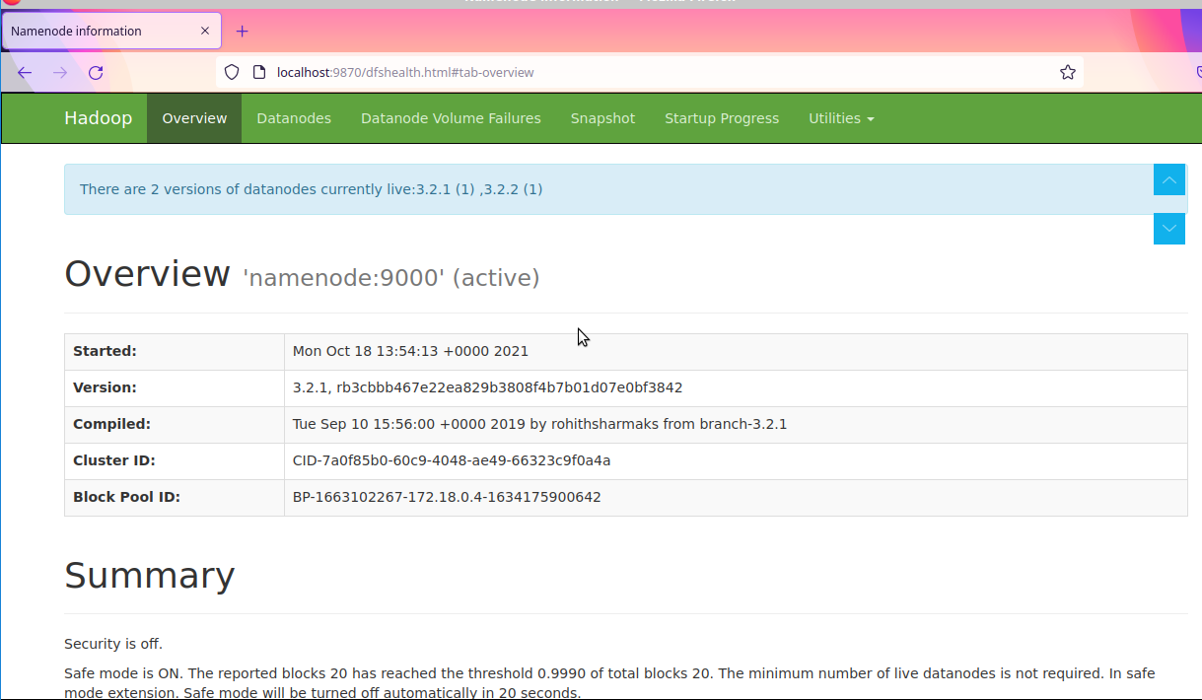

Access the Hadoop namenode UI by port 9870.

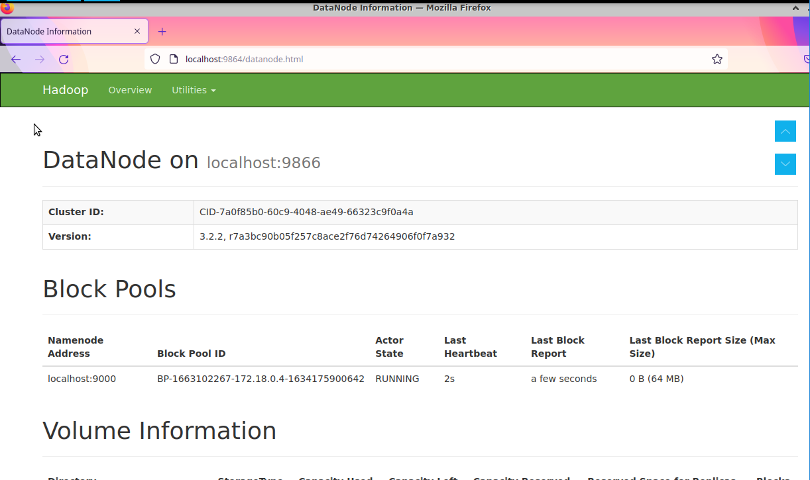

Access individual datanode by port 9864.

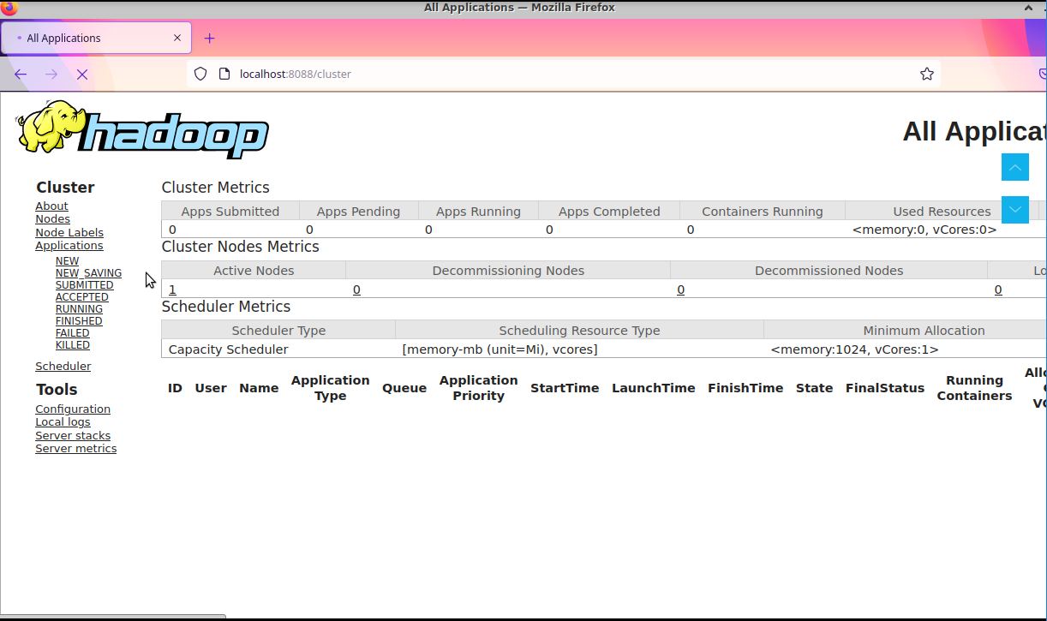

Access yarn resource manager by port 8088.

Successfully installed Hadoop on Ubuntu!