Testing the Hadoop Cluster



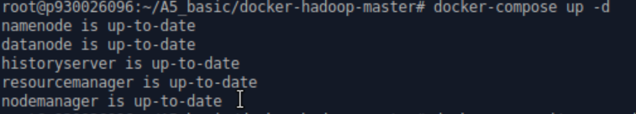

To deploy an HDFS cluster



Enter the namenode container

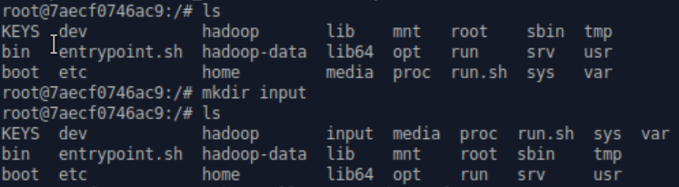

List the file under namenode container. And make a directory called input.





Create two .txt files under input directory.



Create the input-royma directory on HDFS.



Put the all files under input into datanode on HDFS. However, it showed Name node is in safe mode. I first restart the Hadoop, but it didn’t work.

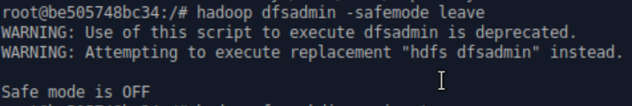

To leave safemode.

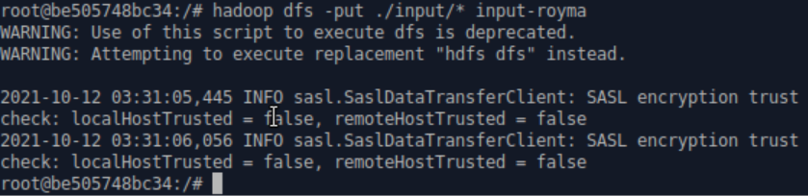

Try the command again to all files under input to the datanodes on HDFS.

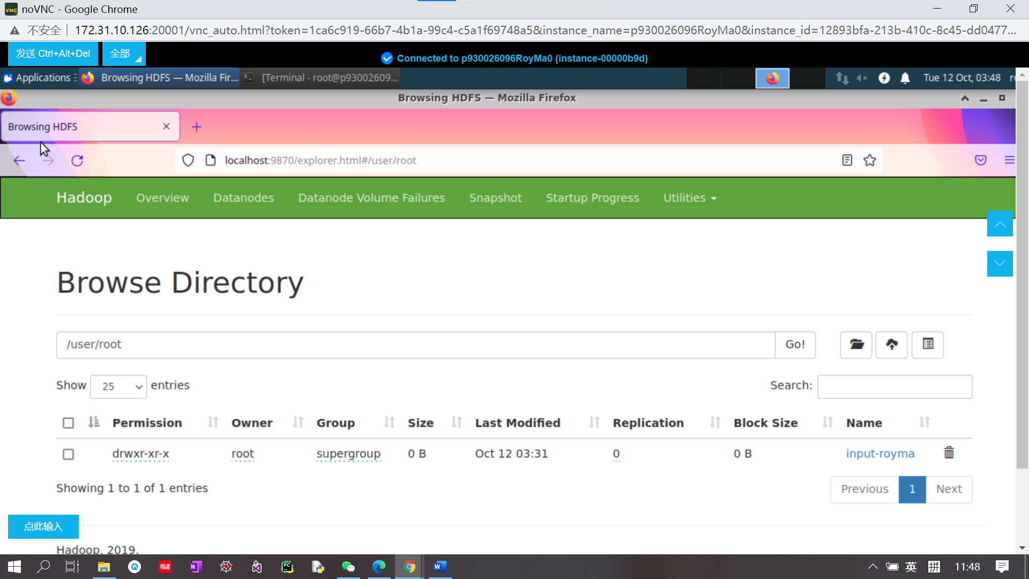

Enter localhost:9870, and successfully move my local files to HDFS datanodes.



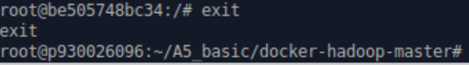

Exit the container.