**Basic**

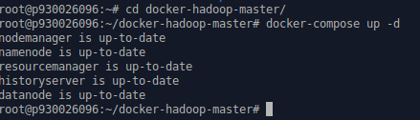

**Start the docker. Here docker already started.**

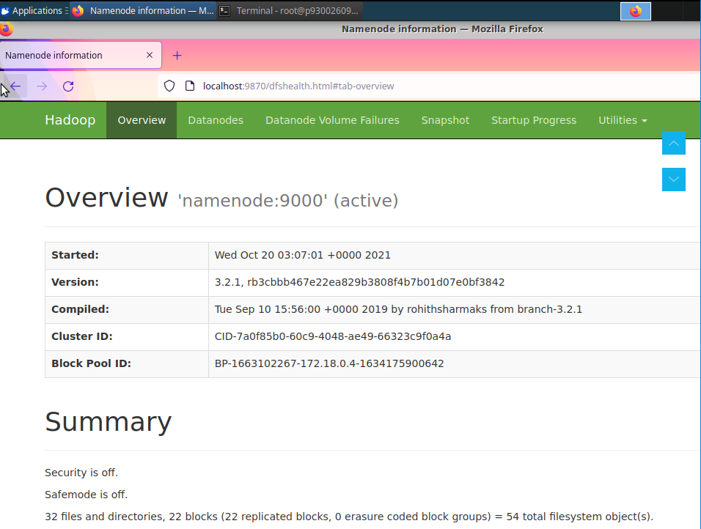

**Make sure the namenode is running by checking the port 9870.**

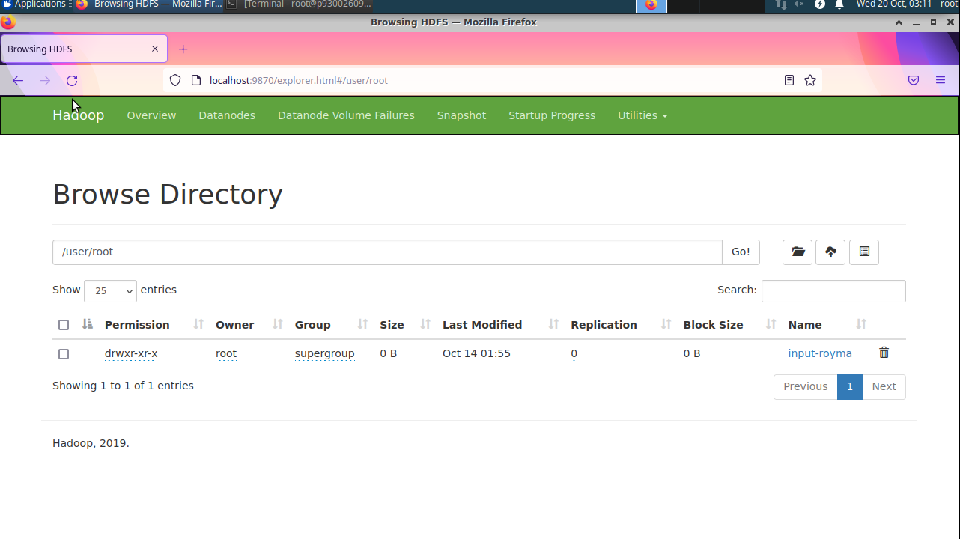

**The directory input-royma exists. For storing two .txt file (f1.txt & f2.txt).**



**Download WordCount.java under “~/Downloads/”**

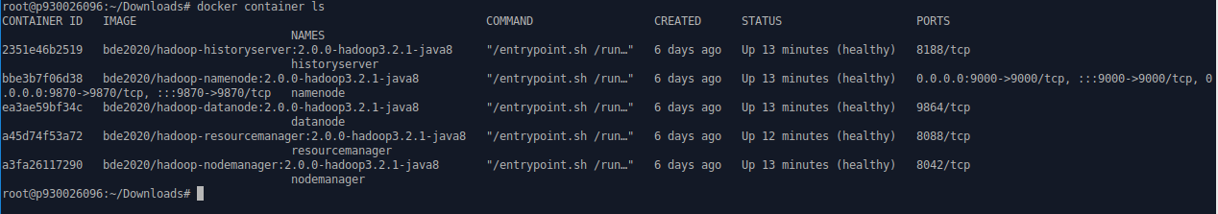

**Find out the ID of my own namenode container.**



**Copy the WordCount.java file from ~/Downloads to my docker Hadoop cluster.**



**Start and enter namenode.**



**Create a jar**





**“wc.jar” file is under current working directory and ready to run the Java program.**





**Run the WordCount.java program and count the word in two files.**

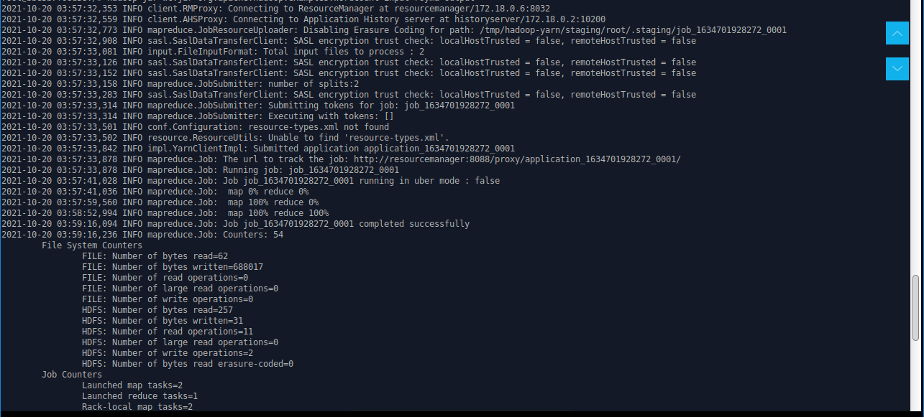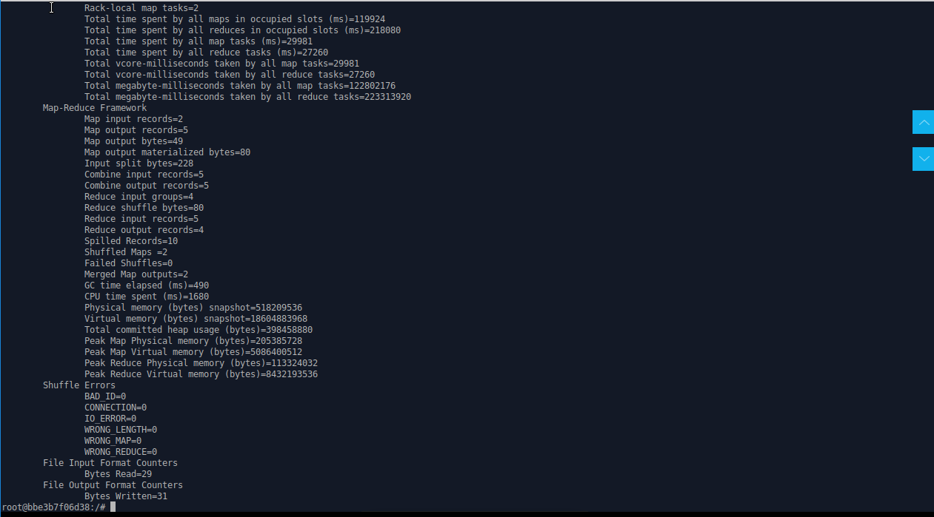

**It takes few minutes to finish map-reduce process. It will show the message, “map 100% reduce 100%”, if it runs well.**

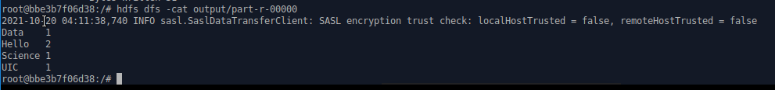

**To print out the result of WordCount.java program.**



**Leave the container.**

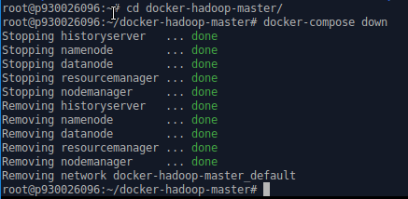

**Safely shut down the cluster.**