**Intermediate**

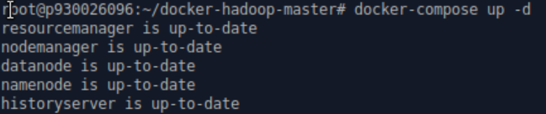

**Start the docker container. Here the docker is ready.**

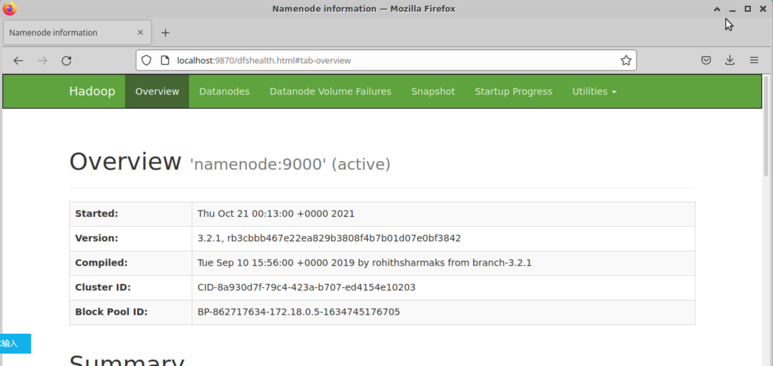

**Namenode is running by checking the port 9870.**

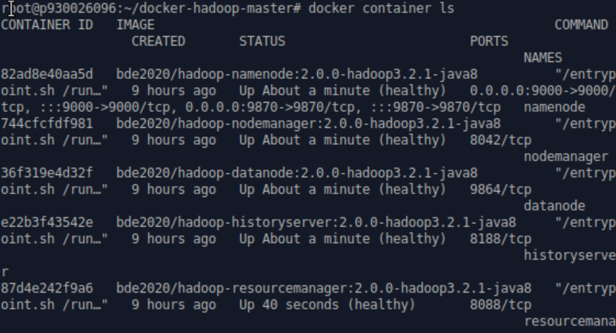

**Find out the ID of my own namenode.**



**Copy the downloaded .txt file from books to the docker Hadoop cluster.**



**Execute the namenode bash.**



**Put all the .txt file under the directory, inpyt-royma. Here you can check whether all the .txt files had been copied to the right path by checking the file information on the port 9870.**



**Run the WordCount.java file to do the map reduce.**

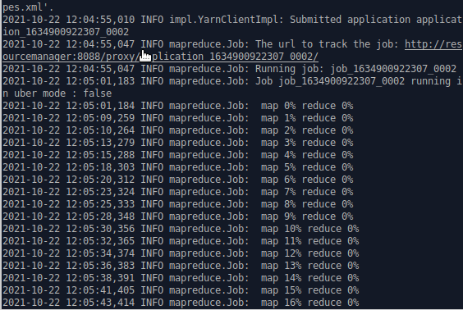

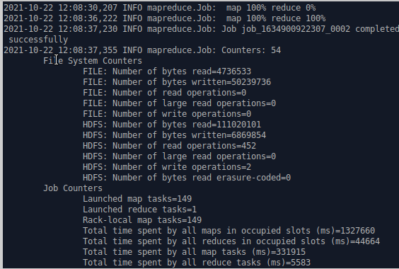

**It takes about 3-5 minutes, since the data is huge. The message continuously shows the progress of map reduce.**

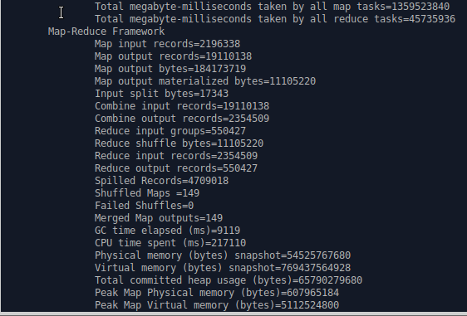

**Finish map reduce.**

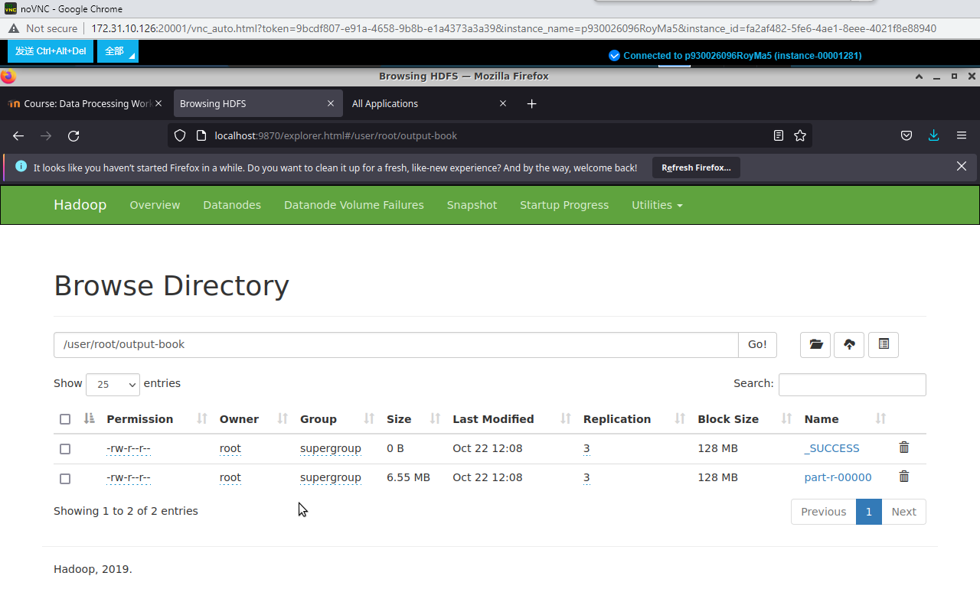

**By checking port 9870, output files are under output-book directory.**

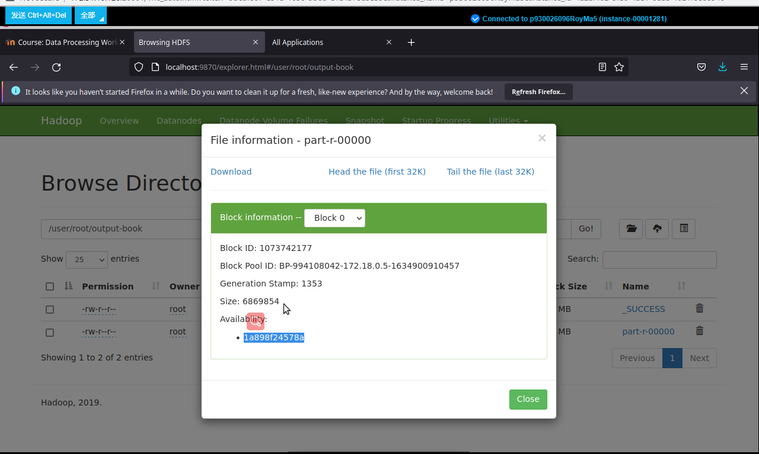

**Also download to your host computer.**

**Finally, use the “exit” and “docker-compose down” commands to leave the container and shut down the cluster safely as the last two steps in basic.**