Basic



Open the command in your own computer. And install pyspark using “conda install”.

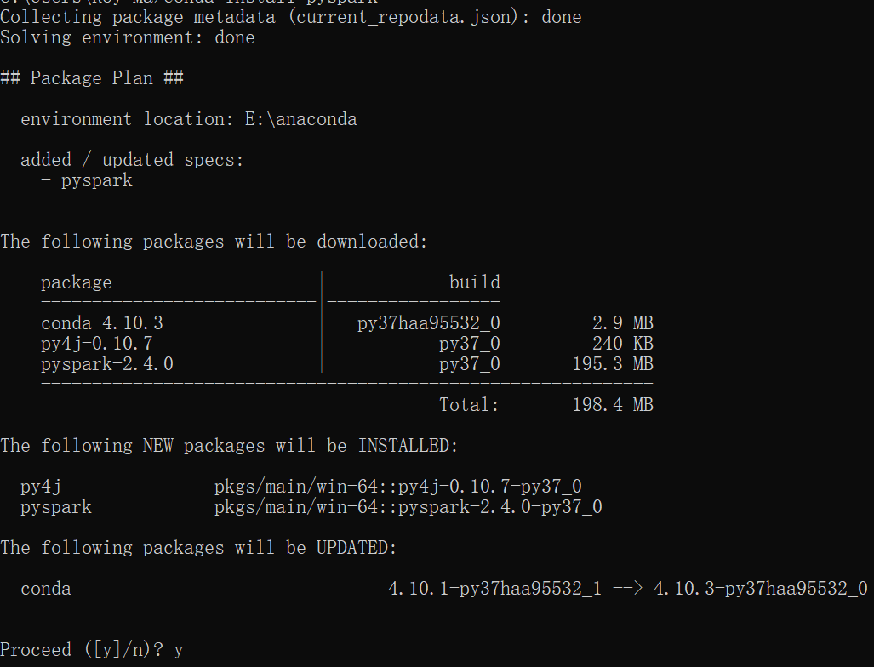

Type “y” on the command.

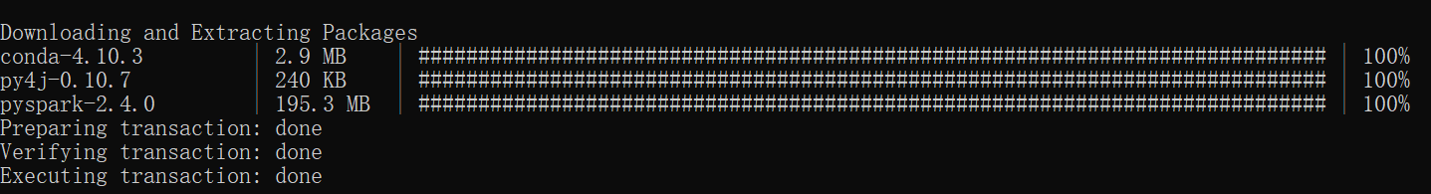

The download is finished.

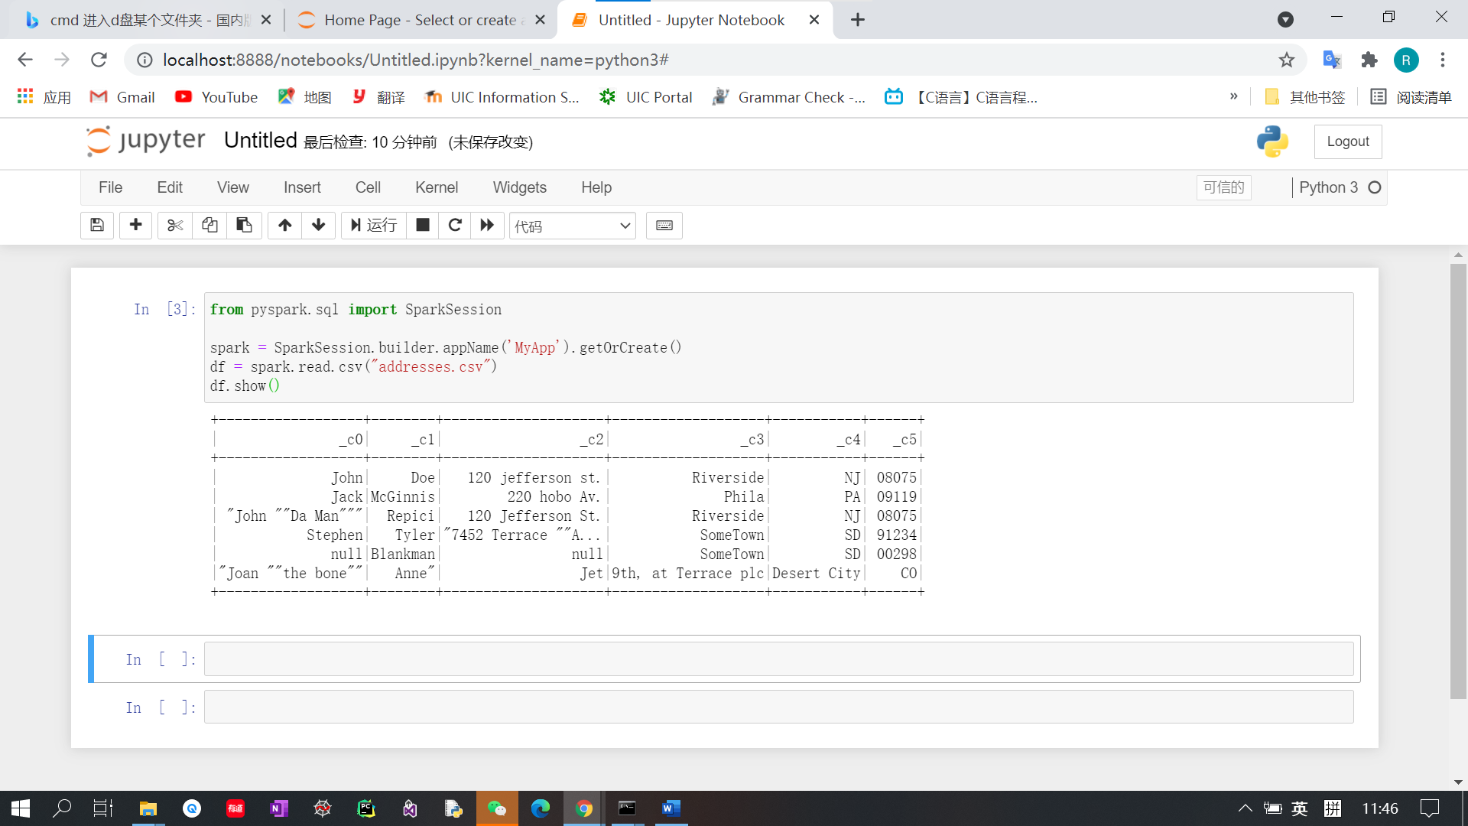

Open the Jupyter notebook and then type the sample codes.