Bonus



Run a docker container by specific ports

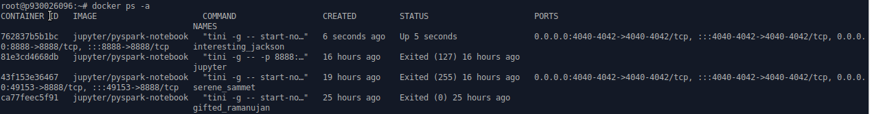

Check the container status, the first container is what we ran.



Copy the container ID and execute the container command line.



Type the command “jupyter notebook list” and it will show a series of token of website “http://0.0.0.0:8888/”

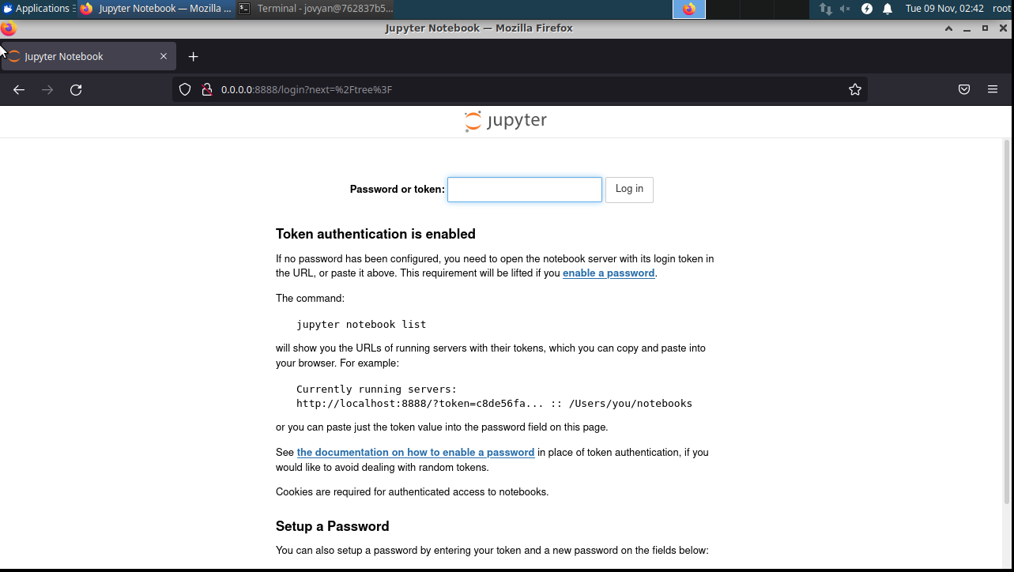

Open the website by web browser and copy the token to log in the jupyter notebook.

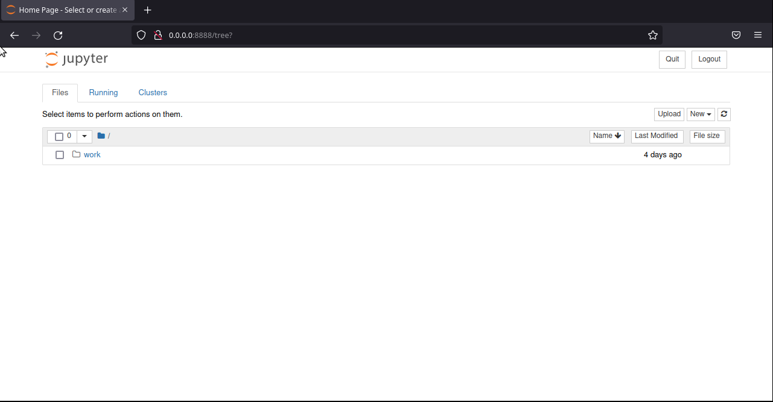

We found that currently we can create a python file but we didn’t have the .csv file.



Suppose we download the .csv file in our local root directory. And we use docker cp command to copy the file to the current container’s working directory.

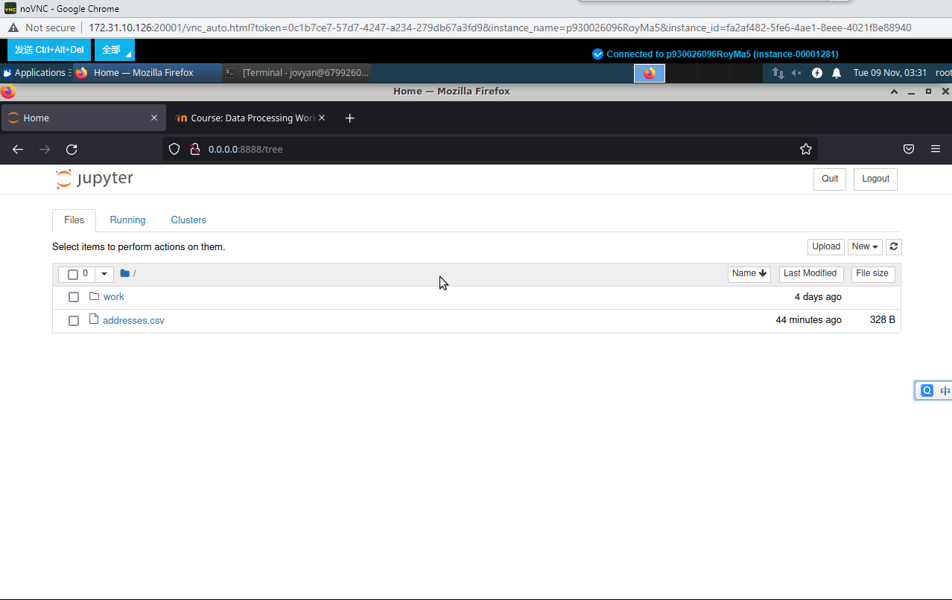

Now the .csv file had already under the jupyter notebook working directory.

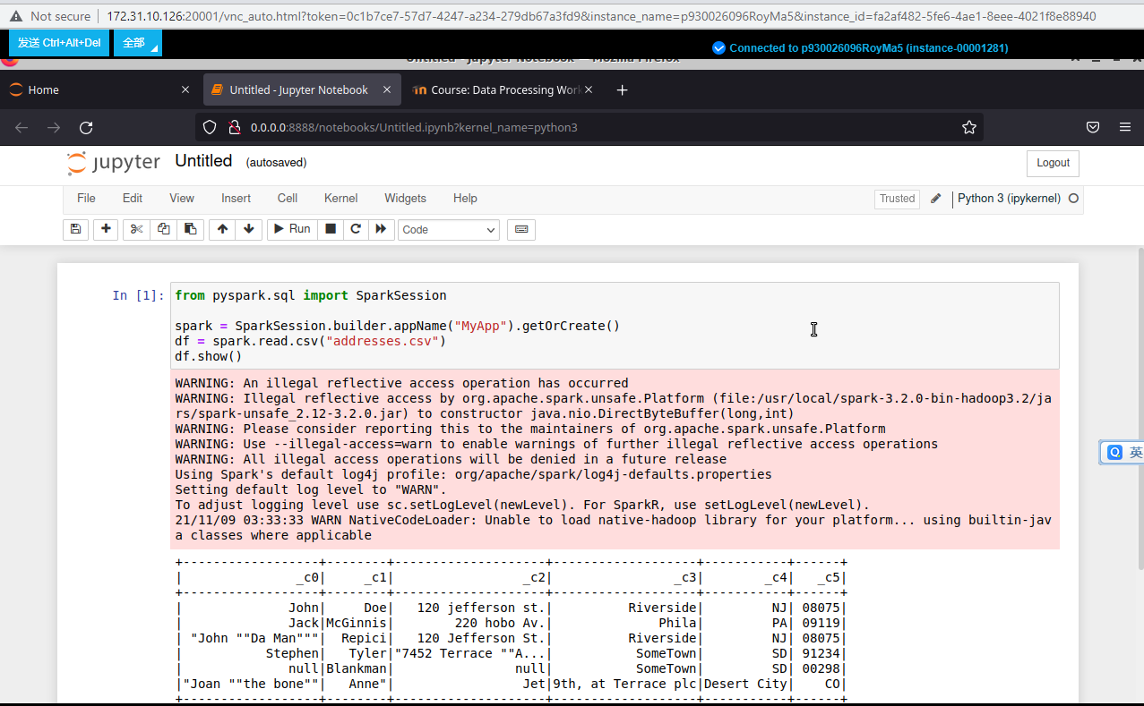

Create a python3 file. Type the sample code and run it. The result is shown on the above graph.