**Intermediate**

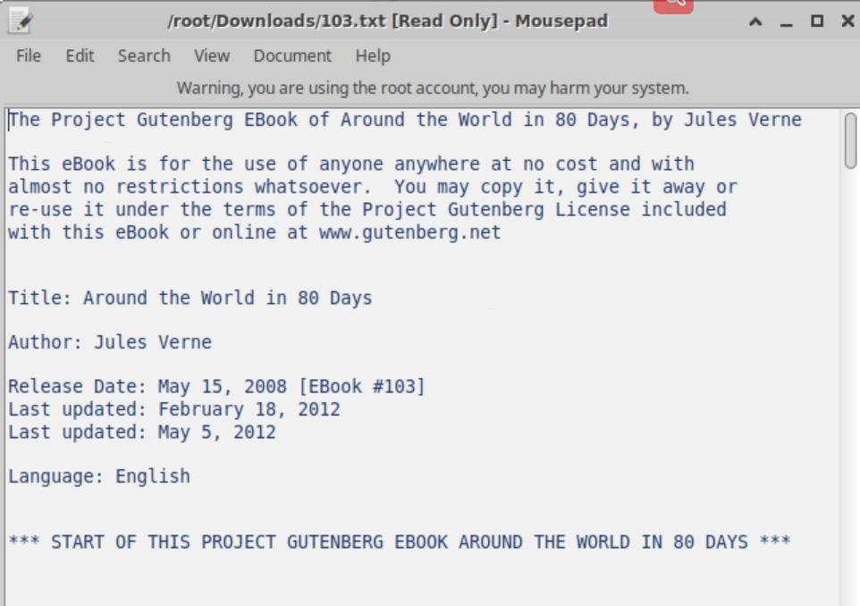

Find an English text book on Gutenberg. (Around the world in 80 days)

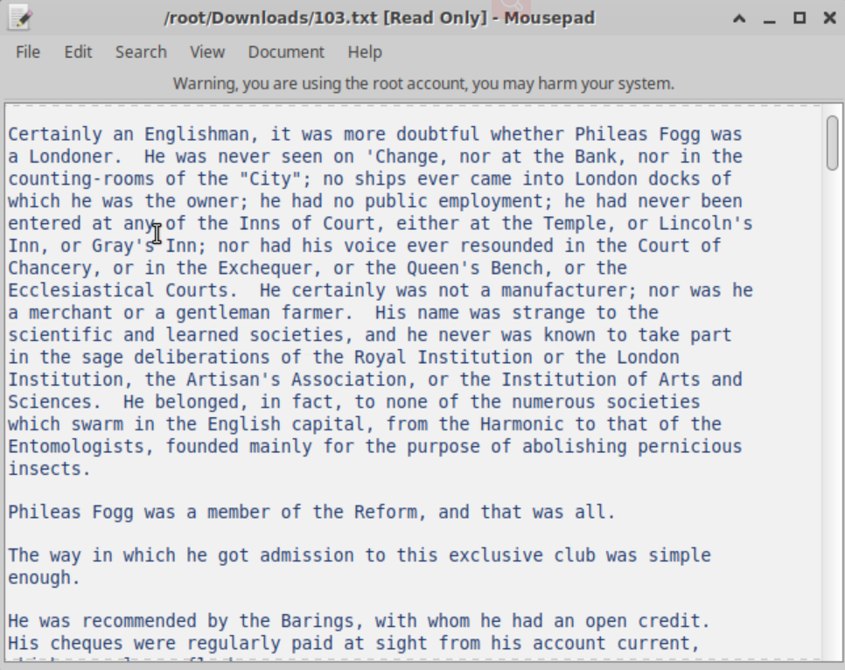

Here is the partial content of the text file

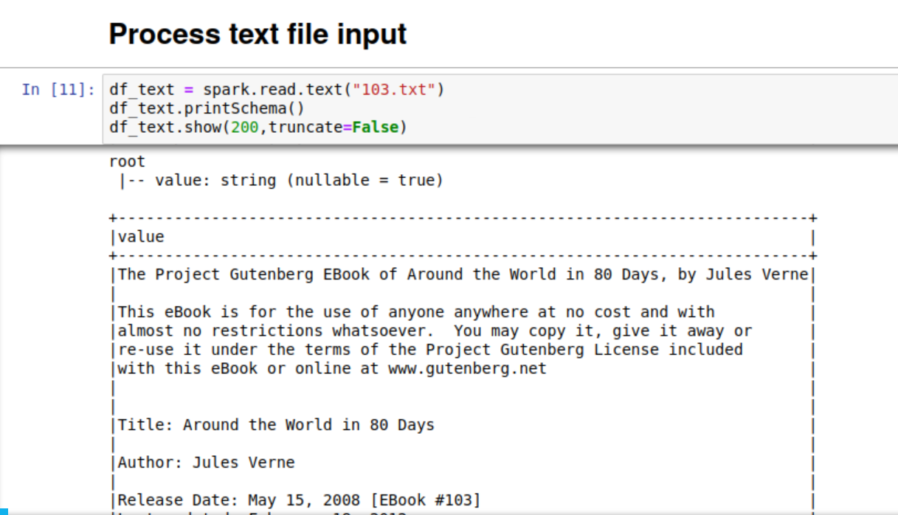

Input such text file as a dataframe in spark

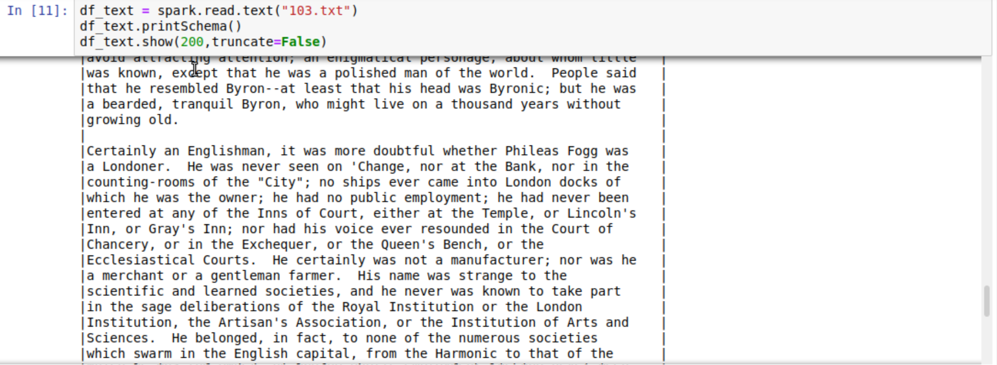

Here is the dataframe content.

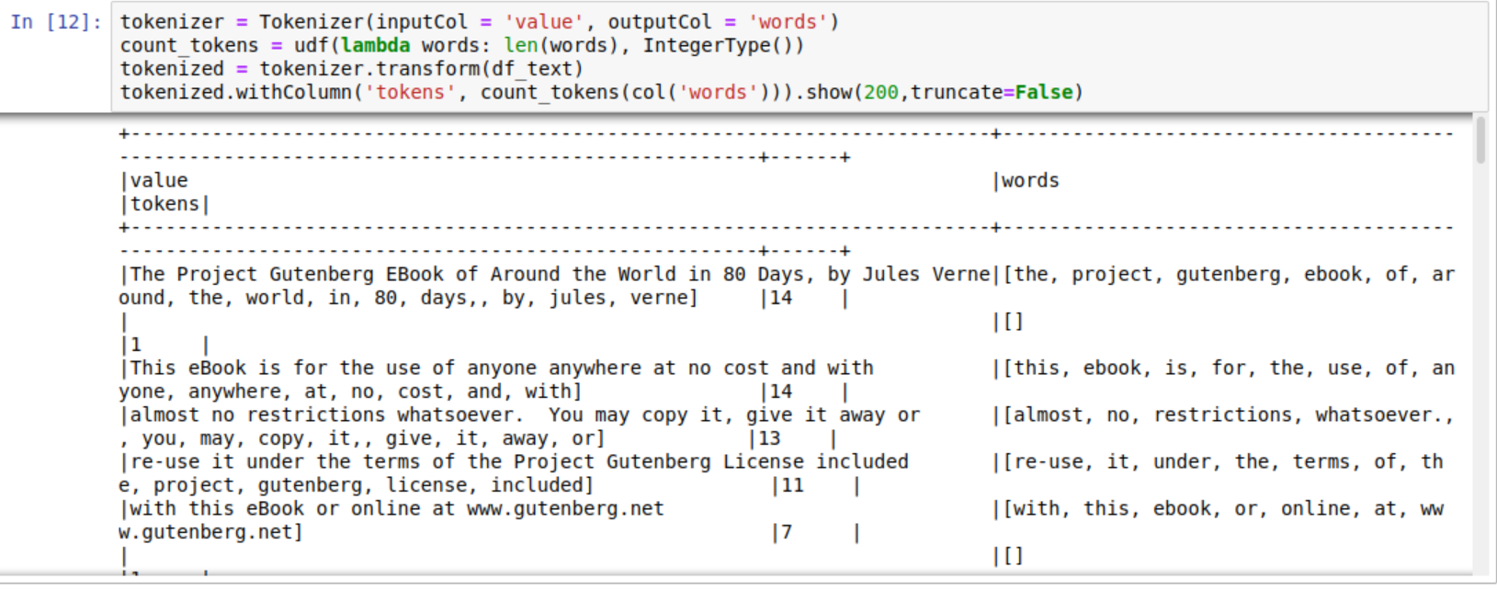

First apply tokenization.

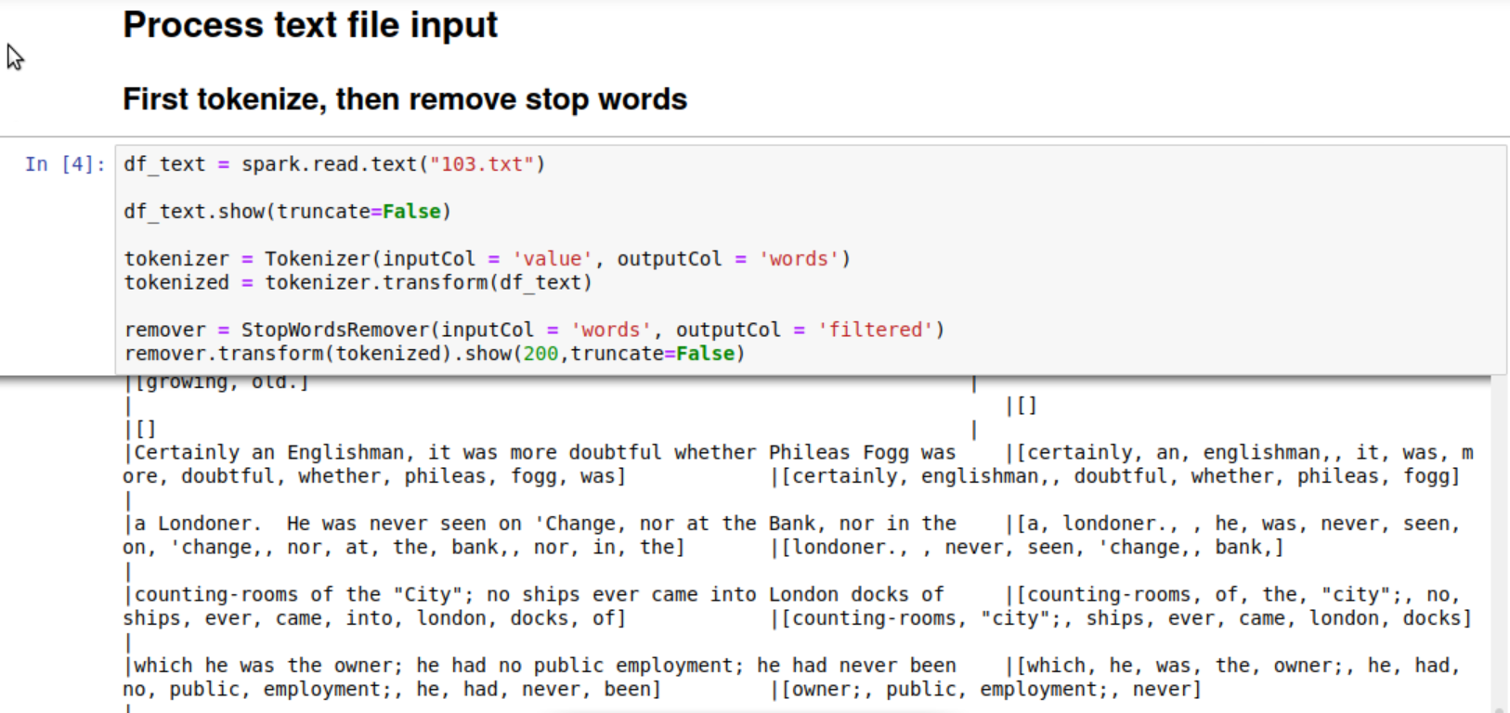

Then remove stop words by the built-in function

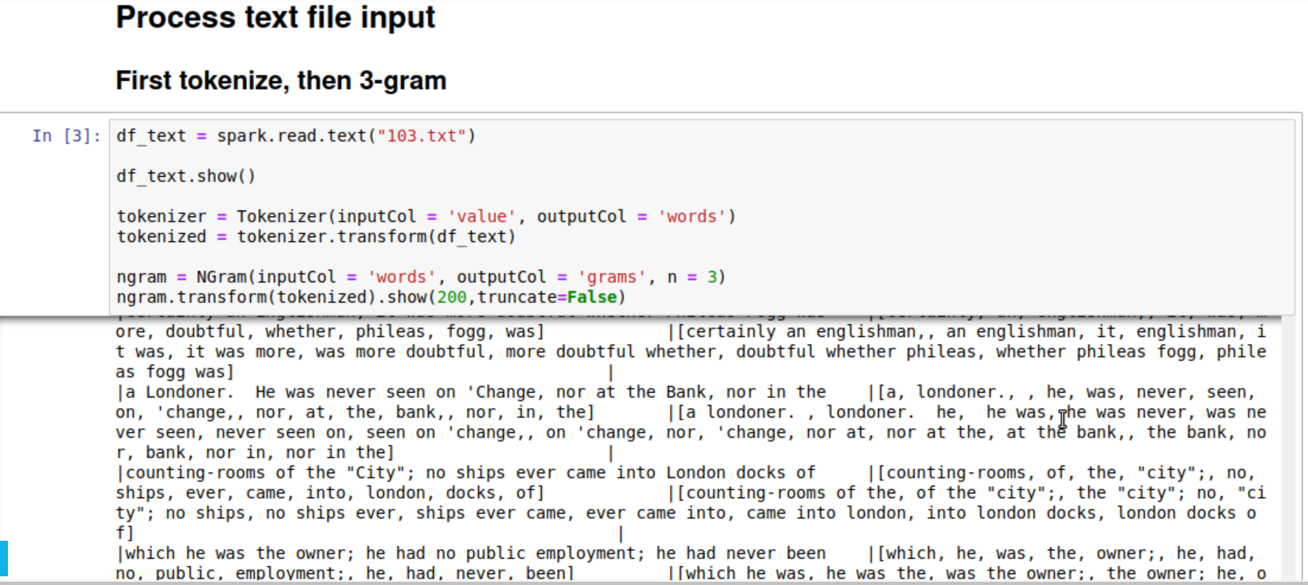

Get 3-gram of the text file