PS2
Submitted by: Roy Sarafov 209619477

Question 1

Question 1.1

Question 1.1.1
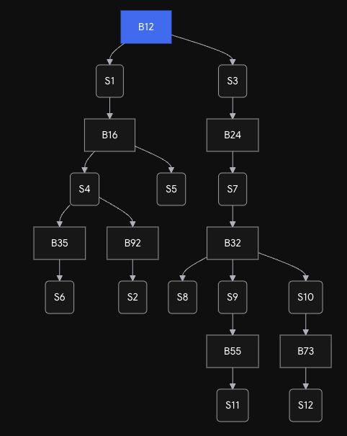

Question 1.1.2
• B12 (Root): Distance to root is 0. Root port: None.
• B16: Distance is 1. Root port is P2 (connects to S1).
• B24: Distance is 1. Root port is P2 (connects to S3).
• B32: Distance is 2 (via S7 -> B24). Root port is P1.
• B35: Distance is 2 (via S4 -> B16). Root port is P2.
• B92: Distance is 2 (via S4 -> B16). Root port is P1.
• B55: Distance is 3 (via S9 -> B32). Root port is P2.
• B73: Distance is 3 (via S10 -> B32). Root port is P2.

Question 1.1.3
• S1: B12-P2.
• S2: B92-P2.
• S3: B12-P1.
• S4: B16-P3.
• S5: B16-P1.
• S6: B35-P3.
• S7: B24-P1.
• S8: B32-P3 (B32 has a lower ID than B35, breaking the distance tie).
• S9: B32-P2.
• S10: B32-P4.
• S11: B55-P1 (B55 has a lower ID than B73).
• S12: B73-P3.
• Non-forwarding bridges: All bridges have at least one Designated Port (e.g., facing leaf segments), meaning no bridge completely stops forwarding frames.

Question 1.2
• If B32 broadcasts its ID as 12, the network experiences a split-root scenario.
• Bridges will calculate their shortest path to the nearest "B12".
• B55 and B73 will see B32 (Fake B12) as distance 1.
• B24 and B35 will receive conflicting BPDUs of equal distance and will fall back to port ID tiebreakers to choose between the real and fake B12 branches.
Because B24 blocks its connection to S7, and B35 blocks its connection to S4, the network is effectively severed into two isolated spanning trees. Traffic cannot cross between the "Real B12" tree and the "Fake B12" tree.
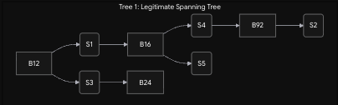
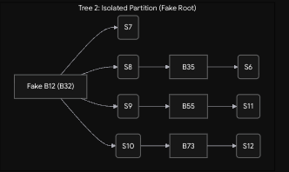
Each bridge selects the path with the lowest cost to an ID of 12. If costs are tied, it uses the sender's Bridge ID, and then the sender's Port ID to break the tie.
• Real B12: Distance 0. Root Port: None.
• Fake B12 (B32): Distance 0. Root Port: None.
• B16: Distance 1 (via S1 to Real B12). Root Port: P2.
• B24: Distance 1. It is 1 hop from Real B12 (via S3) and 1 hop from Fake B12 (via S7). Since both advertise ID 12 and cost 0, it falls back to the sender port ID. Assuming the real B12's P1 is lower than Fake B12's P2, B24 chooses Real B12. Root Port: P2 (on S3).
• B35: Distance 1 (via S8 to Fake B12). Root Port: P1. (Note: Its path to the real B12 via S4 -> B16 is Distance 2, so it prefers the Fake B12).
• B92: Distance 2 (via S4 -> B16 -> Real B12). Root Port: P1. (Note: Its path to Fake B12 via B35 is also Distance 2. It ties! It breaks the tie using the upstream bridge ID: B16 < B35, so it chooses the path to the Real B12).
• B55: Distance 1 (via S9 to Fake B12). Root Port: P2.
• B73: Distance 1 (via S10 to Fake B12). Root Port: P2.
Segments are claimed by the bridge advertising the lowest cost to "Root 12".
S1: Real B12-P2 (Distance 0).
S2: B92-P2.
S3: Real B12-P1 (Distance 0).
S4: B16-P3. Both B16 and B35 claim distance 1 to "Root 12". They tie on cost, so we check the sender Bridge ID. B16 < B35, so B16 wins the DP role. B35 blocks its port on S4.
S5: B16-P1.
S6: B35-P3.
S7: Fake B12 (B32)-P2. B24 claims distance 1, but Fake B12 claims distance 0. Fake B12 wins. B24 blocks its port on S7.
S8: Fake B12 (B32)-P3. (Distance 0 wins).
S9: Fake B12 (B32)-P1. (Distance 0 wins).
S10: Fake B12 (B32)-P4. (Distance 0 wins).
S11: B55-P1. Both B55 and B73 are distance 1 from Fake B12. B55 < B73, so B55 wins.
S12: B73-P3.

Question 2

Question 2.1
• Bridge i splits the line into two sets of segments:
left side (size i) and right side (size n - i + 1).
• Assuming bidirectional traffic x between any pair of segments, the total traffic crossing Bridge i per time unit is $2⋅ i⋅ \left(n - i + 1\right)⋅ x$.
• This amount is independent of which bridge is the root because a linear topology inherently lacks loops, meaning the spanning tree encompasses all links without blocking any.

Question 2.2
• Adding Bridge 0 between Segment 0 and Segment n creates a ring.
• Since Bridge 0 has the minimal ID (0), it becomes the root.
• To prevent loops, the Spanning Tree Protocol will block a port exactly opposite to the root (near segment $\frac{n}{2}$), effectively breaking the ring back into a folded line. The traffic through Bridge i will then depend on its new position relative to the blocked segment.

Question 3
• Cost Expression: In a 3-stage Clos architecture, the outer stages consist of $\frac{N}{c}$ switches of size $c × c$, and the middle stage consists of c switches of size $\frac{N}{c}$ times $\frac{N}{c}$. Given the cost of a crossbar is its dimension to the power of 1.5, the total cost C(c) is:
$$C\left(c\right)= 2N\sqrt{c} +\frac{N^{\frac{3}{2}}}{\sqrt{c}}$$
• Minimization: To find the optimal c, take the derivative with respect to c and set it to zero:
$$\frac{N}{\sqrt{c}}-\frac{N^{\frac{3}{2}}}{2C^{\frac{3}{2}}}=0$$

Solving this yields the cost-minimizing component size:
$$c =\frac{\sqrt{N}}{2}$$

Question 4

Question 4.1
• Scenario:
- t=1: Packet A arrives at Input 1, destined for Output 1. Packet B arrives at Input 2, destined for Output 1.
- t=2: Packet C arrives at Input 2, destined for Output 2.
• Why Output Queuing (OQ) works: OQ moves both A and B to Output 1 simultaneously at t=1. At t=2, C moves to Output 2, meaning A, B, and C can all depart unhindered at t=1, t=2, and t=2 respectively.
• Why CIOQ fails: At t=1, CIOQ can only move one packet (e.g., A) to Output 1, leaving B queued at Input 2. At t=2, Input 2 contains both B and C, but the fabric can only extract one packet per input per time unit, causing an unavoidable delay for either B or C.

Question 4.2
• A speedup of 2 grants two internal fabric cycles per external time unit.
• External t=1:
- Cycle 1.1: Move Packet A from Input 1 to Output 1.
- Cycle 1.2: Move Packet B from Input 2 to Output 1.
• External t=2:
- Cycle 2.1: Move Packet C from Input 2 to Output 2.
- Result: All packets reach their output queues in time to match the OQ departure schedule perfectly.

Question 5
The 16x16 switch requires decomposing the port permutation into 4 internal sub-steps (matchings) between the input lines (W, X, Y, Z) and output lines (A, B, C, D). Here is the valid schedule:
- Sub-step 1: $W→ B \left(Port 1→ 7\right), X→ D \left(Port 6→ 16\right), Y→ A \left(Port 9→ 2\right), Z→C (Port 13→ 9)$.
- Sub-step 2: $W→ C \left(Port 2→ 10\right), X→ D \left(Port 7→ 15\right), Y→ A \left(Port 11→ 4\right), Z→ B (Port 15→ 6)$.
- Sub-step 3: $W→ B \left(Port 3→ 5\right), X→ D \left(Port 8→ 14\right), Y→ C \left(Port 10→ 12\right), Z→ A (Port 14→ 3).$
- Sub-step 4: $W→ C \left(Port 4→ 11\right), X→ A \left(Port 5→ 1\right), Y→ D \left(Port 12→ 13\right), Z→ B (Port 16→ 8)$.

Question 6

Question 6.1
• The stream transmits 1000 bits in 1ms, resulting in an active rate of 1 Mbps.
• R(t) is a periodic function (period = 1 second) where R(t) = 1 Mbps during the 1ms transmission windows (e.g., $t∈ [0, 1 ms],$[2ms, 3ms], $…$, [18ms, 19ms]) and R(t) = 0 during the waiting periods.

Question 6.2
• Total data per cycle is 10,000 bits, and the drain rate is 20 kbps.
• The maximum buffer accumulation occurs at the end of the burst phase (t = 19ms).
• Data arrived: 10,000 bits. Data drained: $19ms × 20kbps = 380 bits$}.
• Minimum required buffer B = 10,000 - 380 = 9620 bits.

Question 6.3
• Data is processed in 2-byte (16-bit) quanta. We need minimal envelopes for peak and sustained rates:
• Peak Bucket: Rate $ρ_{1} = 1 Mbps, Burst σ_{1} = 16 bits$ (1 quantum).
• Average Bucket: Rate$ρ_{2} = 10 kbps$ (long-term average). The maximum burst above 10 kbps at t=19 ms is $10,000 - 19 ms × 10 kbps$) = 9810 bits. Rounding up to the nearest 16-bit group gives $σ_{2} = 9824 bits$.

