PS2
Roy Sarafov
209619477

1

1.1

1.1.1
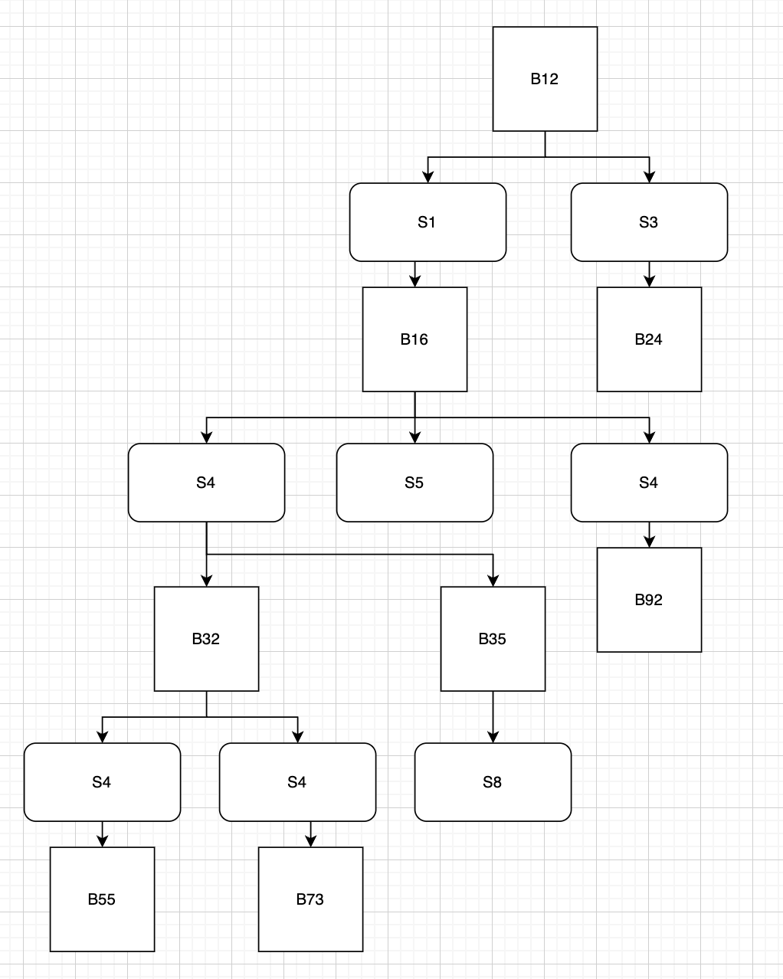

1.1.2
Bridge | Distance from Root | Root Port | Via Segment
B12 | 0 | — (root) | —
B16 | 1 | P2 | S1
B24 | 1 | P2 | S3
B32 | 2 | P3 | S4 (via B16)
B35 | 2 | P3 | S4 (via B16)
B92 | 2 | P1 | S4 (via B16)
B55 | 3 | P2 | S9 (via B32)
B73 | 3 | P2 | S10 (via B32)

1.1.3
Segment | Designated Port
S1 | B12-P2
S2 | B92-P2
S3 | B12-P1
S4 | B16-P3
S5 | B16-P1
S6 | B35-P3
S7 | B24-P1
S8 | B35-P1
S9 | B32-P1
S10 | B32-P4
S11 | B55-P1
S12 | B73-P3
Blocked ports: - B32-P2 (S7) and B73-P1 (S11), as neither won the root or designated port elections.
Non-forwarding bridges: Zero non-forwarding bridges (all possess one or more designated ports).

1.2

1.2.1
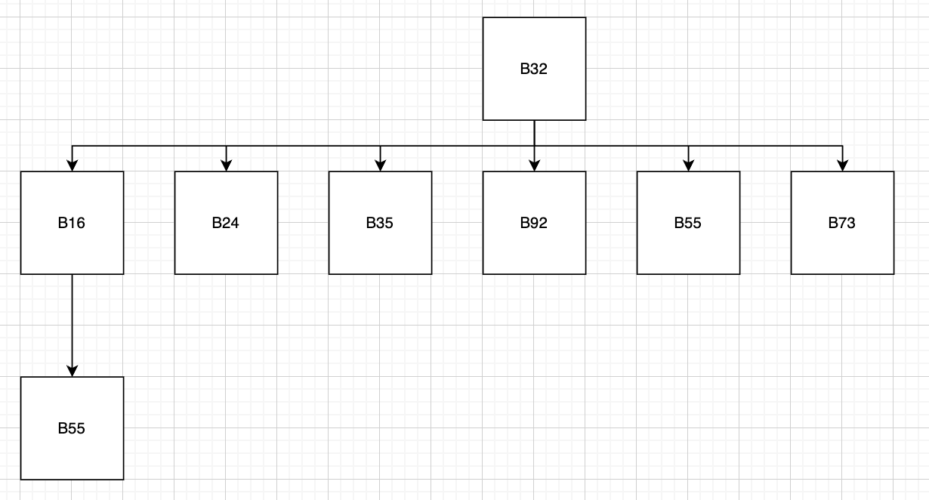

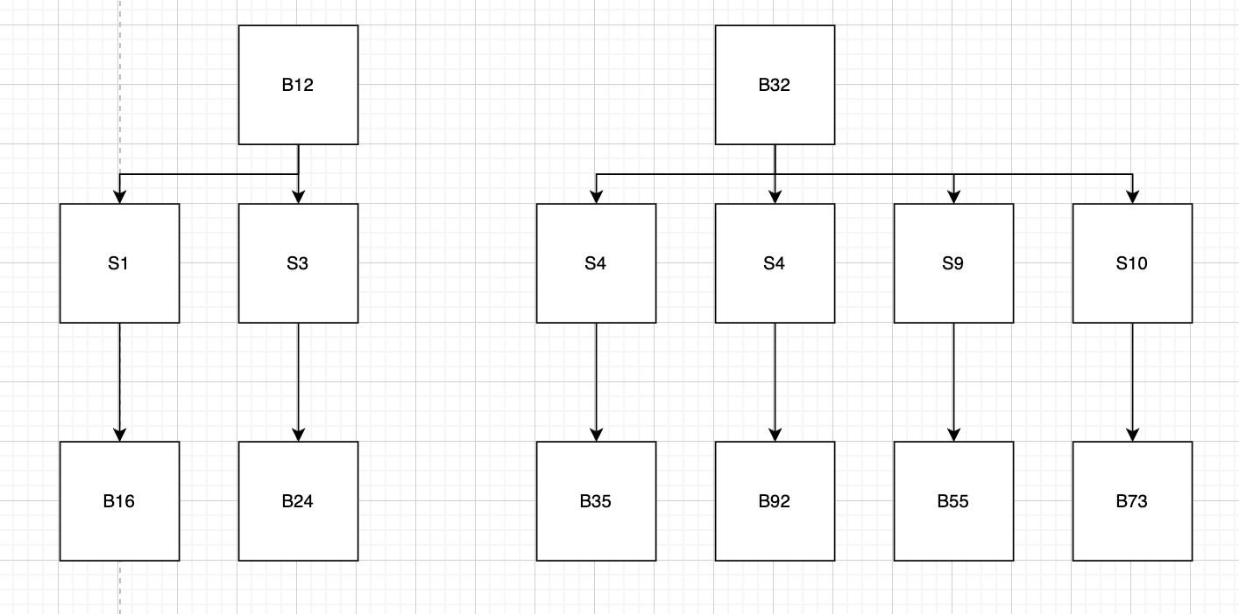

1.2.2
Bridge | Distance | Root Port
B12 | 0 | —
B32 | 0 | —
B16 | 1 | P2 (S1)
B24 | 1 | P2 (S3)
B55 | 1 | P2 (S9)
B73 | 1 | P2 (S10)
B35 | 1 | P3 (S4)
B92 | 1 | P1 (S4)

1.2.3
Segment | Designated Port
S1 | B12-P2
S2 | B92-P2
S3 | B12-P1
S4 | B32-P3
S5 | B16-P1
S6 | B35-P3
S7 | B32-P2
S8 | B35-P1
S9 | B32-P1
S10 | B32-P4
S11 | B55-P1
S12 | B73-P3

Blocked ports: - B16-P3 (on S4) , B24-P1 (on S7), B73-P1 (on S11)
Non-forwarding bridges: B24 does not forward traffic because it contains only a root port and zero designated ports.

2

2.1
In a linear chain there are no loops, so the spanning tree is the chain itself regardless of which bridge is root. No ports are blocked.
Bridge i carries all traffic that crosses it – i.e., traffic between segments {0, …, i−1} (left side, i segments) and segments {i, …, n} (right side, n+1−i segments).
Total traffic on bridge i:
$$\text{Traffic}(i)=2⋅i⋅(n+1-i)⋅x$$
(Factor 2 for both directions: left→right and right→left.)
Does it depend on root position? No. Since the topology is a simple line (no loops), the spanning tree equals the full topology regardless of which bridge has the minimum ID. No ports are ever blocked.

2.2
Bridge 0 connects segment 0 to segment n, forming a ring. Bridge 0 has the smallest ID → it is the root.
Since bridge 0 is root, both its ports (on seg 0 and seg n) are designated. Bridges route toward whichever side reaches bridge 0 faster: - Bridge i at distance min(i, n+1−i) from root - Bridges 1, …, ⌊n/2⌋ route leftward (toward seg 0) - Bridges ⌈n/2⌉+1, …, n route rightward (toward seg n)
If n is even, bridge n/2 has equal distance both ways; tie-break by lower bridge ID on the path (bridge 0 vs bridge n, bridge 0 wins → bridge n/2 routes leftward through seg n/2 − 1… Actually the tie-break is by the BPDU: bridge n/2 hears from bridge n/2−1 (dist n/2−1, going left) vs bridge n/2+1 (dist n/2−1, going right). The tie-break is on the bridge ID of the sender: lower ID wins. For simplicity, assume bridge n/2 routes leftward (toward lower-numbered bridges).
The spanning tree splits into two arms from bridge 0. The blocked port is on the segment where the two arms meet (approximately in the middle).
Traffic on bridge i:
For i ≤ ⌊n/2⌋ (left arm): bridge i separates segments {0,…,i−1} from segments {i,…,⌊n/2⌋} in its subtree direction. However, since the tree is now two arms from a single root:
Bridge i (left arm) carries traffic between: - All segments in the subtree “beyond” bridge i (segments {i, …, ⌊n/2⌋}) - All other segments ({0, …, i−1} ∪ {⌈n/2⌉+1, …, n})
$$\text{Traffic}(i)=2⋅(⌊n/2⌋-i+1)⋅(n+1-(⌊n/2⌋-i+1))⋅x$$
$$=2⋅(⌊n/2⌋+1-i)⋅(n-⌊n/2⌋+i)⋅x$$
By symmetry, for bridge i in the right arm (i > ⌈n/2⌉):
$$\text{Traffic}(i)=2⋅(i-⌈n/2⌉)⋅(n+1-(i-⌈n/2⌉))⋅x$$
Simplified (for large even n, split at n/2):
- Left arm bridge i (1 ≤ i ≤ n/2): Traffic = 2·(n/2 + 1 − i)·(n/2 + i)·x
- Right arm bridge i (n/2 + 1 ≤ i ≤ n): Traffic = 2·(i − n/2)·(n + 1 − i + n/2)·x
The maximum traffic is on bridges closest to root (i=1 and i=n), approximately n²/2 · x for large n. The middle bridges carry minimal traffic ≈ n·x.

3
For N×N switch with crossbar components of size c×c: - Stage 1: N/c switches, each c×c → cost per switch: c^(3/2) - Stage 2 (middle): c switches, each (N/c)×(N/c) → cost per switch: (N/c)^(3/2) - Stage 3: N/c switches, each c×c → cost per switch: c^(3/2)
(For rearrangeable non-blocking: number of middle switches m = c is sufficient.)

Total Cost
$$\text{Cost}(c)=2⋅\frac{N}{c}⋅c^{3/2}+c⋅{\left(\frac{N}{c}\right)}^{3/2}$$
$$=2N\sqrt{c}+\frac{N^{3/2}}{\sqrt{c}}$$

Optimization
Taking derivative and setting to zero:
$$\frac{d}{dc}\text{Cost}=\frac{N}{\sqrt{c}}-\frac{N^{3/2}}{2c^{3/2}}=0$$
$$\frac{N}{\sqrt{c}}=\frac{N^{3/2}}{2c^{3/2}}⟹2c=\sqrt{N}$$
$$\boxed{c^{*}=\frac{\sqrt{N}}{2}}$$

Minimum Cost (for large N)
Substituting c* = √N/2:
$${\text{Cost}}_{min}=2N⋅\frac{N^{1/4}}{\sqrt{2}}+\frac{N^{3/2}⋅\sqrt{2}}{N^{1/4}}=\frac{2N^{5/4}}{\sqrt{2}}+\sqrt{2}⋅N^{5/4}=2\sqrt{2}⋅N^{5/4}$$

4

4.1
Switch: 2×2
Time Slot | Arrivals
t = 1 | Pkt A: input 1 → output 1; Pkt B: input 2 → output 1
t = 2 | Pkt C: input 2 → output 2
With Output Queuing (OQ): - t=1: Fabric transfers both A and B to output 1’s queue (fabric speed = N × line speed). A departs output 1 at t=1. - t=2: B departs output 1 at t=2. C transfers to output 2 queue, departs at t=2. - Departure schedule: A@1, B@2, C@2. ✓ Feasible.
With CIOQ (no speedup): - t=1: Partial permutation – at most one packet to output 1. Transfer A (in1→out1). B stays at input 2. - t=2: Must transfer both B (in2→out1) and C (in2→out2). But both are at input 2 – a partial permutation allows at most one packet from each input port. Only one of B or C can cross the fabric. - If B crosses: B departs out1@t=2 ✓, but C delayed to t=3 ≠ t=2. ✗ - If C crosses: C departs out2@t=2 ✓, but B delayed to t=3 ≠ t=2. ✗ - Infeasible. ✗

4.2
With speedup 2, two partial permutations per time slot:
Time Slot | Permutation 1 | Permutation 2
t = 1 | in1 → out1 (A) | in2 → out1 (B)
t = 2 | in2 → out2 (C) | —
Result: A and B both reach output 1 by end of t=1. A departs t=1, B departs t=2. C reaches output 2 at t=2, departs t=2. Matches OQ schedule. ✓

5

Setup
- 4×4 crossbar running at 4× port speed (4 sub-steps per time slot)
- Input lines: W(ports 1–4), X(ports 5–8), Y(ports 9–12), Z(ports 13–16)
- Output lines: A(ports 1–4), B(ports 5–8), C(ports 9–12), D(ports 13–16)

Permutation
Input | 1 | 2 | 3 | 4 | 5 | 6 | 7 | 8 | 9 | 10 | 11 | 12 | 13 | 14 | 15 | 16
Output | 7 | 10 | 5 | 11 | 1 | 16 | 15 | 14 | 2 | 12 | 4 | 13 | 9 | 3 | 6 | 8

Traffic Matrix (connections per input-line/output-line pair)
Group connections by input line → output line: - W→A: none | W→B: 1→7, 3→5 | W→C: 2→10, 4→11 | W→D: none - X→A: 5→1 | X→B: none | X→C: none | X→D: 6→16, 7→15, 8→14 - Y→A: 9→2, 11→4 | Y→B: none | Y→C: 10→12 | Y→D: 12→13 - Z→A: 14→3 | Z→B: 15→6, 16→8 | Z→C: 13→9 | Z→D: none
Traffic matrix:
 | A | B | C | D
W | 0 | 2 | 2 | 0
X | 1 | 0 | 0 | 3
Y | 2 | 0 | 1 | 1
Z | 1 | 2 | 1 | 0
Each row and column sums to 4. ✓

Decomposition into 4 Permutation Matrices
Sub-step | Crossbar Config | Connections Realized
1 | W→B, X→D, Y→A, Z→C | 3→5, 6→16, 9→2, 13→9
2 | W→C, X→D, Y→A, Z→B | 2→10, 7→15, 11→4, 15→6
3 | W→C, X→A, Y→D, Z→B | 4→11, 5→1, 12→13, 16→8
4 | W→B, X→D, Y→C, Z→A | 1→7, 8→14, 10→12, 14→3
Verification: All 16 port-to-port connections are covered exactly once. ✓

Explanation of Computation
- Classify each of the 16 connections by (input line, output line) pair.
- Build the 4×4 traffic demand matrix.
- Decompose the matrix into 4 permutation matrices using iterative selection (each permutation = one valid crossbar configuration connecting each input line to exactly one output line).
- For each sub-step, assign specific port connections from the available pool for that (input line, output line) pair.

6

Flow Description
- 10 packets/second, each 1000 bits
- Packet transmission: 1 ms; gap between packets: 1 ms
- Burst duration: 19 ms (10 packets × 1ms + 9 gaps × 1ms)
- Idle period: 981 ms
- Pattern repeats every 1000 ms

6.1
R(t) is periodic with period T = 1 second = 1000 ms.
Within each period:
$$R(t)=\left\{\begin{matrix}1,000,000\text{ bps}=1\text{ Mbps} & t∈[0,1)∪[2,3)∪[4,5)∪⋯∪[18,19)\text{ ms} \\ 0 & \text{otherwise}\end{matrix}\right.$$
In other words: R(t) = 1 Mbps during ms intervals [2k, 2k+1) for k = 0, 1, …, 9 (mod 1000 ms), and R(t) = 0 elsewhere.

6.2
The buffer fills during the burst and drains during idle. We track maximum buffer occupancy.
At the end of the k-th packet (t = 2k−1 ms, for k = 1, …, 10): - Bits input: 1000k - Bits drained: 20,000 bps × (2k−1)/1000 s = 20(2k−1) = 40k − 20 bits
Buffer occupancy = 1000k − (40k − 20) = 960k + 20
Maximum at k = 10 (t = 19 ms):
$$σ_{min}=960×10+20=\boxed{9,620\text{ bits}}$$
Verification: After the burst, buffer drains at 20 kbps. Time to empty: 9620/20000 = 481 ms < 981 ms idle period. Buffer empties before next burst. ✓

6.3
Bits are written to the buffer in groups of 2 bytes (16 bits) at a time.
The dual leaky bucket constraint requires: for any time interval of length t, the cumulative bits sent ≤ min(σ₁ + ρ₁·t, σ₂ + ρ₂·t).
First bucket (average rate + burst tolerance): - ρ₁ = 10,000 bps (average rate = 10 packets × 1000 bits / 1 s) - σ₁ = max excess above average rate over any interval
At end of k-th packet (t = 2k−1 ms): Excess = bits_sent − ρ₁·t = 1000k − 10,000·(2k−1)/1000 = 1000k − 20k + 10 = 980k + 10
Maximum at k = 10: σ₁ = 9,810 bits
Buffer writes occur in discrete 2-byte increments, necessitating a bucket size rounded up to a 16-bit multiple .i.e 9824 bits
Second bucket (peak rate constraint): - ρ₂ = 1,000,000 bps (peak rate = 1 Mbps during transmission) - σ₂ = 16 bits (one 2-byte group — the minimum instantaneous burst unit)
Final parameters:
$$\boxed{ρ_{1}=10,000\text{ bps}, σ_{1}=9,824\text{ bits}, ρ_{2}=1,000,000\text{ bps}, σ_{2}=16\text{ bits}}$$

