LOS 06. The Time Value of Money
- interpret interest rates as required rates of return, discount rates, or opportunity costs.
- Interest rate 三种解释
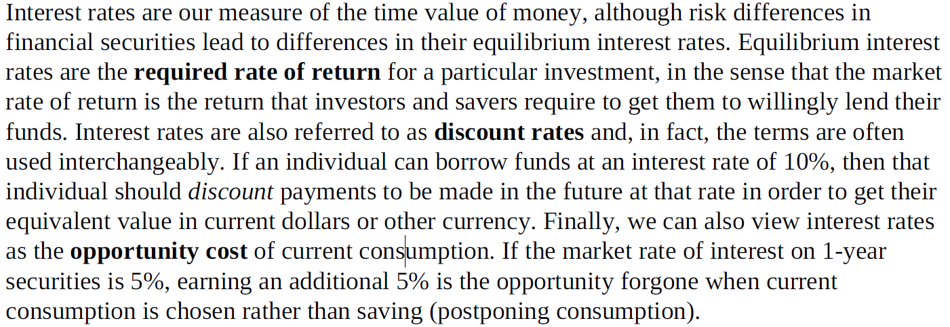

- explain an interest rate as the sum of a real risk-free rate and premiums that compensate investors for bearing distinct types of risk.
- 名义和实际无风险利率
- T-bills 代表名义利率
T-bill rates are nominal risk-free rates because they contain an inflation premium
- 证券还有些风险
Default risk. The risk that a borrower will not make the promised payments in a timely manner.
Liquidity risk. The risk of receiving less than fair value for an investment if it must be sold for cash quickly.
Maturity risk. As we will cover in detail in the section on debt securities, the prices of longer-term bonds are more volatile than those of shorter-term bonds. Longer maturity bonds have more maturity risk than shorter-term bonds and require a maturity risk premium.
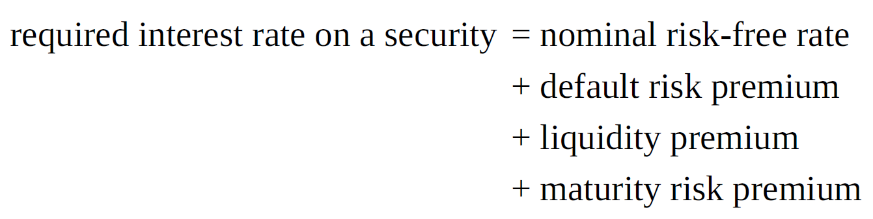
- 国债和个企债券区别
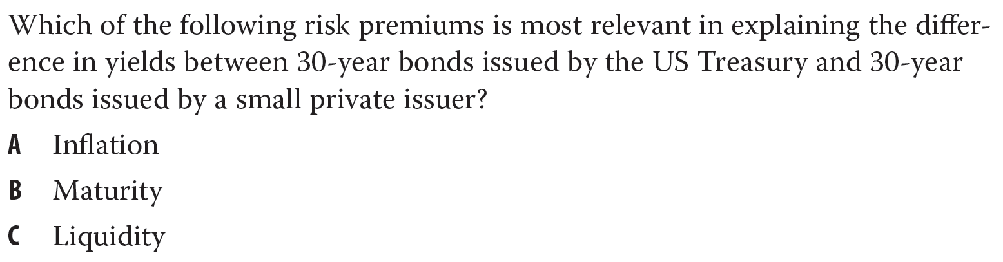
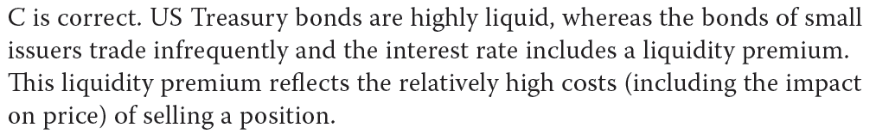

- calculate and interpret the effective annual rate, given the stated annual interest rate and the frequency of compounding
- 名义和实际利率的互换
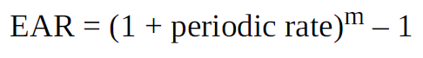

- solve time value of money problems for different frequencies of compounding.
- PV, FV, PMT, n, i 的计算
- Continuous compounding
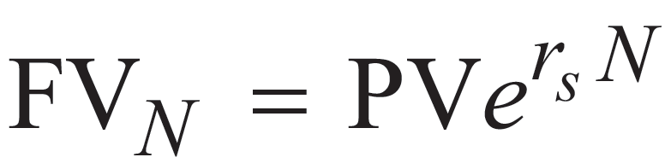
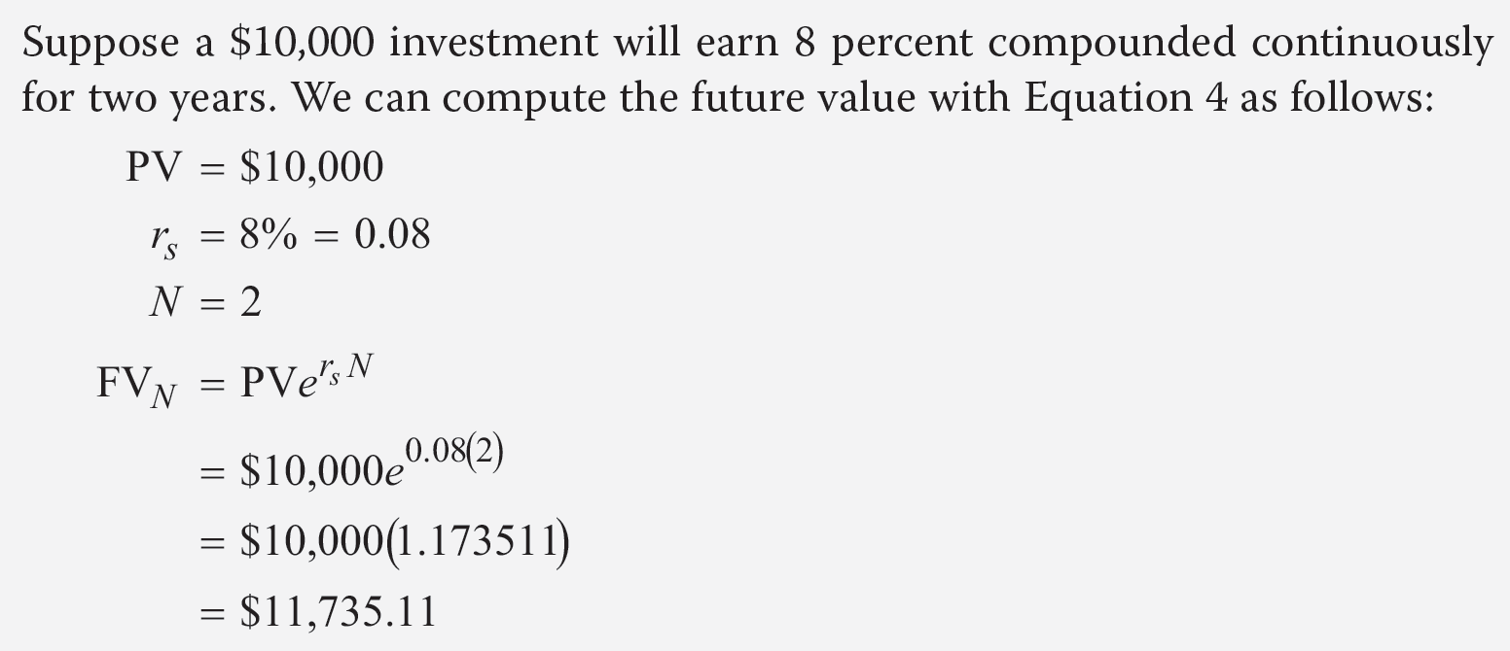

- calculate and interpret the future value (FV) and present value (PV) of a single sun of money, an ordinary annuity, an annuity due, a perpetuity (PV only), and a series of unequal cash flows
- [易错] 区分年初还是年末模式
- 永续年金，PMT=PV*i

- demonstrate the use of a time line in modeling and solving time value of money problems.
- 时间轴上移动，要注意年初年末模式

