Assignment-2

PROBLEM STATEMENT:
Create MFA for authentication.
Solution:
1.Log into AWS account and go to security credentials.
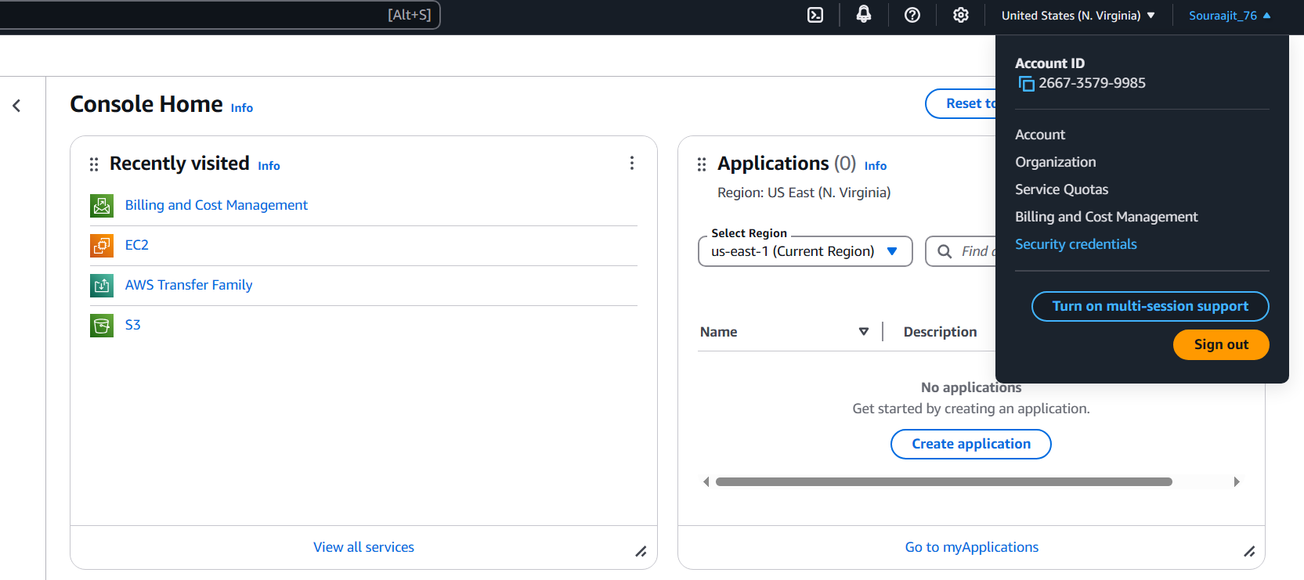
2.Add MFA device by clicking on ‘Assign MFA device’.
Enter a desired device name, MFA device and then click on ‘Next’.
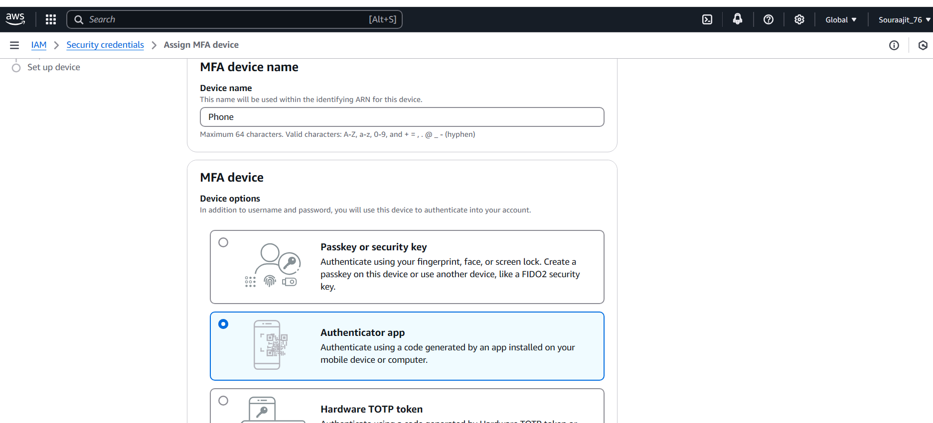

3.Enter code using authenticator app and click on ‘Add MFA’ to complete the process.
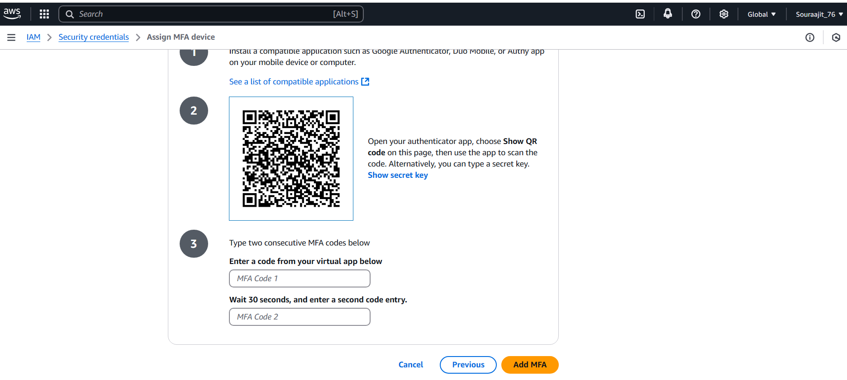

4.MFA device assigned successfully.

