Q. One card is drawn from a well-shuffled deck of 52 cards. Calculate the probability that the card will

(i) be an ace,  
(ii) not be an ace.

Q. Two students Anil and Ashima appeared in an examination. The probability that Anil will qualify the examination is 0.05 and that Ashima will qualify the examination is 0.10. The probability that both will qualify the examination is 0.02. Find the probability that

1. Both Anil and Ashima will not qualify the examination.
2. Atleast one of them will not qualify the examination and
3. Only one of them will qualify the examination.

Q. A piggy bank contains hundred 50p coins, fifty 1Re coins, twenty 2Rs coins and ten 5Rs coins. If it is equally likely that one of the coins will fall out when the bank is turned upside down, what is the probability that the coin (i) will be a 50p coin? (ii) will not be a 5 Rs coin?

Q. A and B are two events such that P(A)=0.54,P(B)=0.69 and P(A∩B)=0.35. Find (i)P(A∪B) (ii)P(A ́∩B ́) (iii)P(A∩B ́) (iv)P(B∩A ́)

Q. A missing helicopter is reported to have crashed somewhere in the rectangular region shown in Fig. 14.2. What is the probability that it crashed inside the lake shown in the figure?

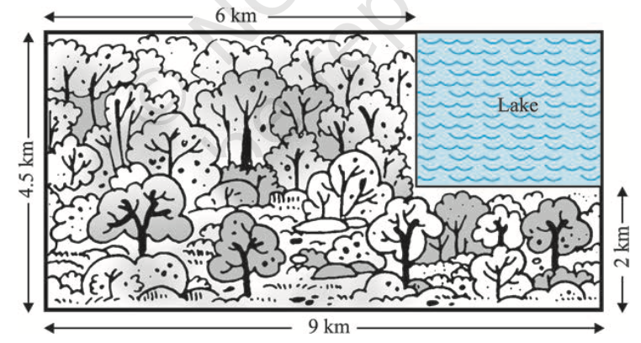

Q. The probability that a student will pass the final examination in both English and Hindi is 0.5 and the probability of passing neither is 0.1. If the probability of passing the English examination is 0.75, what is the probability of passing the Hindi examination?

Q. On her vacations Veena visits four cities (A, B, C and D) in a random order. What is the probability that she visits

(i) A before B? (ii) A before B and B before C? (iii) A first and B last? (iv) A either first or second? (v) A just before B?

Q. Find the probability that when a hand of 7 cards is drawn from a well shuffled deck of 52 cards, it contains (i) all Kings (ii) 3 Kings (iii) atleast 3 Kings.

Q. Three letters are dictated to three persons and an envelope is addressed to each of them, the letters are inserted into the envelopes at random so that each envelope contains exactly one letter. Find the probability that at least one letter is in its proper envelope.

Q. If 4-digit numbers greater than 5,000 are randomly formed from the digits 0, 1, 3, 5, and 7, what is the probability of forming a number divisible by 5 when, (i) the digits are repeated? (ii) the repetition of digits is not allowed?

Q. A box of oranges is inspected by examining three randomly selected oranges drawn without replacement. If all the three oranges are good, the box is approved for sale, otherwise, it is rejected. Find the probability that a box containing 15 oranges out of which 12 are good and 3 are bad ones will be approved for sale**.**

Q.Two balls are drawn at random with replacement from a box containing 10 black and 8 red balls. Find the probability that

(i) both balls are red.   
(ii) first ball is black and second is red.

(iii) one of them is black and other is red.

Q. The probability of obtaining an even prime number on each die, when a pair of dice is rolled is ?

Q. Let E and F be events with P(E) =3/5, P(F) = 3/10 and P(E∩F)= 1/5. Are E and F independent?

Q. Given that the events A and B are such that P(A)= 1/2, P(A∪B)= 3/5 and P (B) = p. Find p if they are (i) mutually exclusive (ii) independent.  Q. Events A and B are such that P(A)= 1/2,P(B)= 7/12 and P(notA or notB)= 1/4. State whether A and B are independent ?

Q . Two events A and B will be independent, if

(A) A and B are mutually exclusive  
(B) P(A′B′) = [1 – P(A)] [1 – P(B)]  
(C) P(A) = P(B)   
(D) P(A) + P(B) = 1

Q. A laboratory blood test is 99% effective in detecting a certain disease when it is in fact present. However, the test also yields a false positive result for 0.5% of the healthy person tested (i.e. if a healthy person is tested, then, with probability 0.005, the test will imply he has the disease). If 0.1 percent of the population actually has the disease, what is the probability that a person has the disease given that his test result is positive?

Q. Two groups are competing for the position on the Board of directors of a corporation. The probabilities that the first and the second groups will win are 0.6 and 0.4 respectively. Further, if the first group wins, the probability of introducing a new product is 0.7 and the corresponding probability is 0.3 if the second group wins. Find the probability that the new product introduced was by the second group.   
   
Q. A manufacturer has three machine operators A, B and C. The first operator A produces 1% defective items, where as the other two operators B and C pro- duce 5% and 7% defective items respectively. A is on the job for 50% of the time,B is on the job for 30% of the time and C is on the job for 20% of the time. A defective item is produced, what is the probability that it was produced by A?

Q. Probability that A speaks the truth is 4/5 . A coin is tossed. A reports that a head appears. The probability that actually there was a head is ?

Q. A and B throw a die alternatively till one of them gets a ‘6’ and wins the game. Find their respective probabilities of winning, if A starts first.

Q. If a machine is correctly set up, it produces 90% acceptable items. If it is incorrectly set up, it produces only 40% acceptable items. Past experience shows that 80% of the set ups are correctly done. If after a certain set up, the machine produces 2 acceptable items, find the probability that the machine is correctly set up.

Q. Suppose that 5% of men and 0.25% of women have grey hair. A grey haired person is selected at random. What is the probability of this person being male? Assume that there are an equal number of males and females.   
   
Q. Assume that the chances of a patient having a heart attack is 40%. It is also assumed that a meditation and yoga course reduce the risk of heart attack by 30% and prescription of certain drug reduces its chances by 25%. At a time a patient can choose any one of the two options with equal probabilities. It is given that after going through one of the two options the patient selected at random suffers a heart attack. Find the probability that the patient followed a course of meditation and yoga?

Q. If P(A|B) > P(A), then which of the following is correct :  
(A) P(B|A) < P(B)

(B) P(A ∩ B) < P(A) . P(B)

(C) P(B|A) > P(B)

(D) P(B|A) = P(B)

Q. If A and B are two events such that P(A)+P(B) – P(AandB) = P(A),then

(A) P(B|A) = 1

(B) P(A|B) = 1

(C) P(B|A) = 0

(D) P(A|B) = 0