VPC Setup & Resource Map

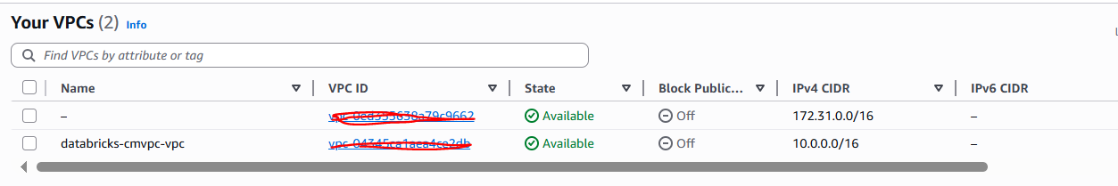
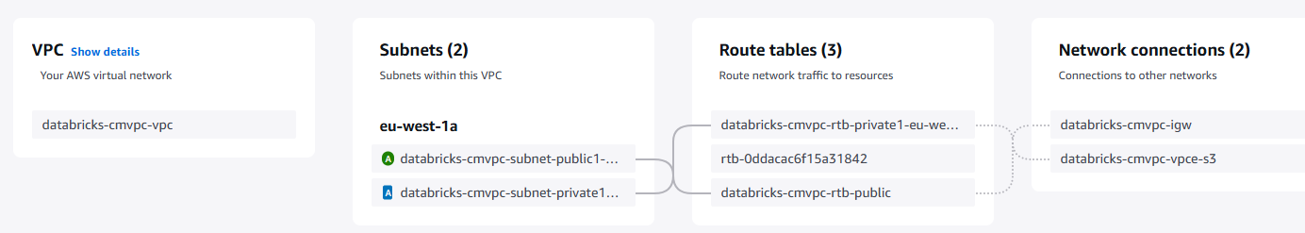

Subnets:
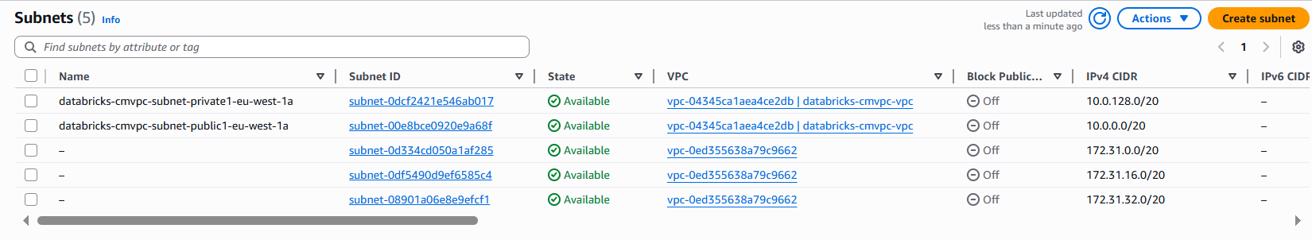

Internet gateway:

Tagged with VPC (Public Subnet)
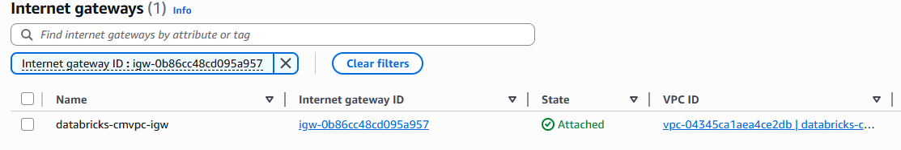

Network ACL(Public Subnet)
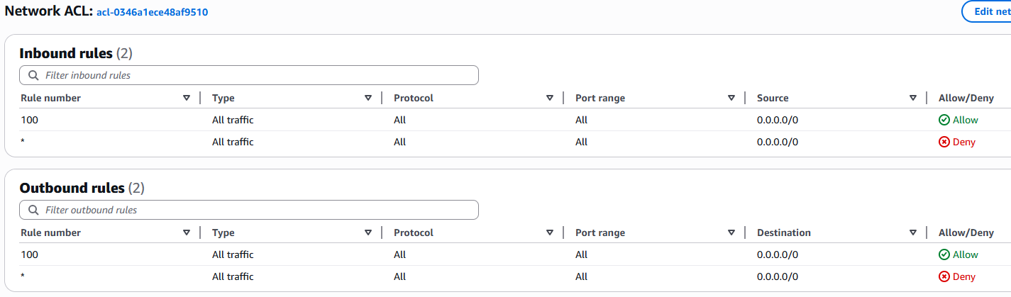

Route Table(Public Subnet)

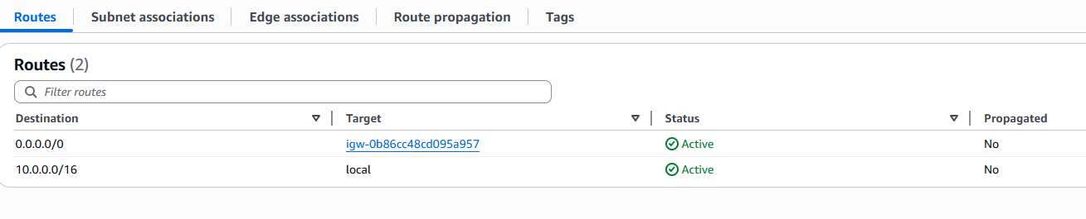

Instance (Public Subnet)
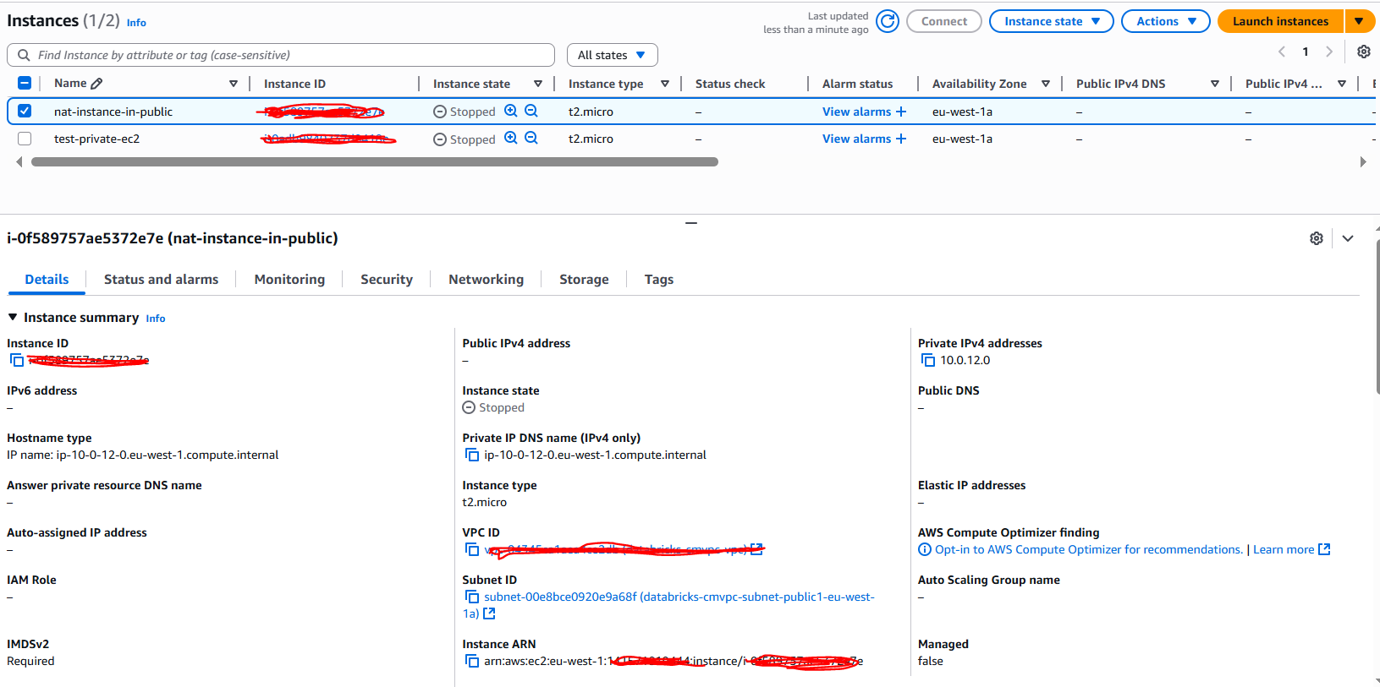

Route Table(Private Subnet)

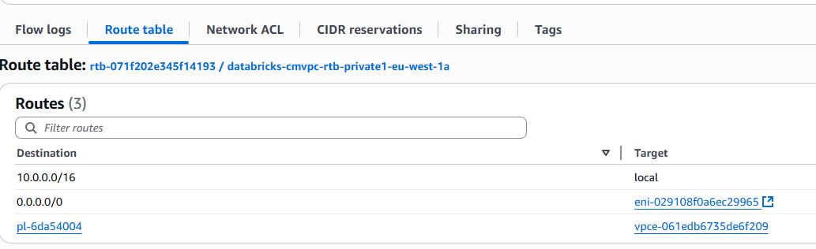
(3rd one is needed to access the S3 Gateway End point - discussed later)
eni-029108f0a6ec29965 - This is the Network Interface for Instance which resides in Public Subnet. Meaning only the request from this instance can accept the request into this private instance. And Private instance can talk with this public instance while talk to Internet.
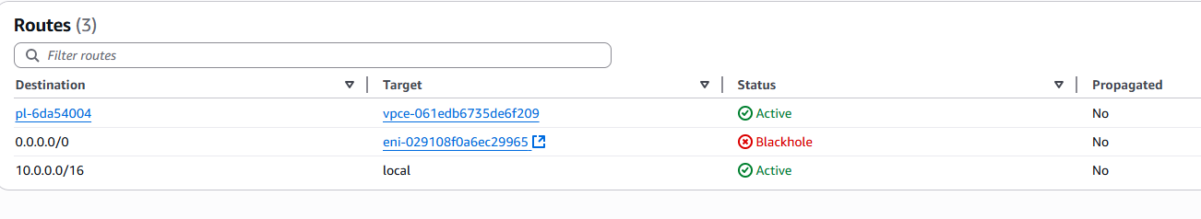
(** Its Balckhole as because I STOP my public instance temporarily)

Network ACL(Private Subnet)

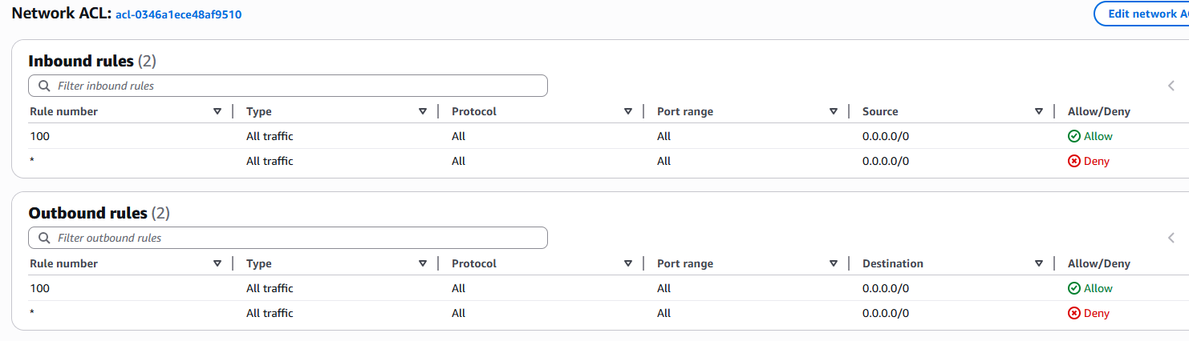

End Point Service (Gateway and Internet)
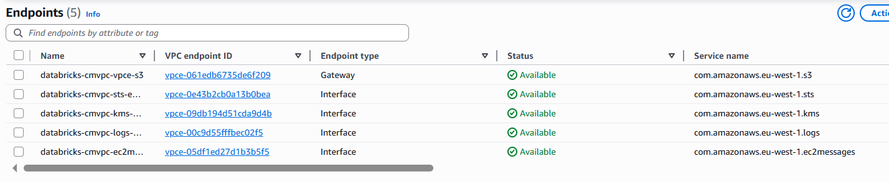
Special Note :
Gateway End Point service is FREE but the Interface End Point is chargeable based on hour (use or not use).
And also these are tagged with Private Subnet:
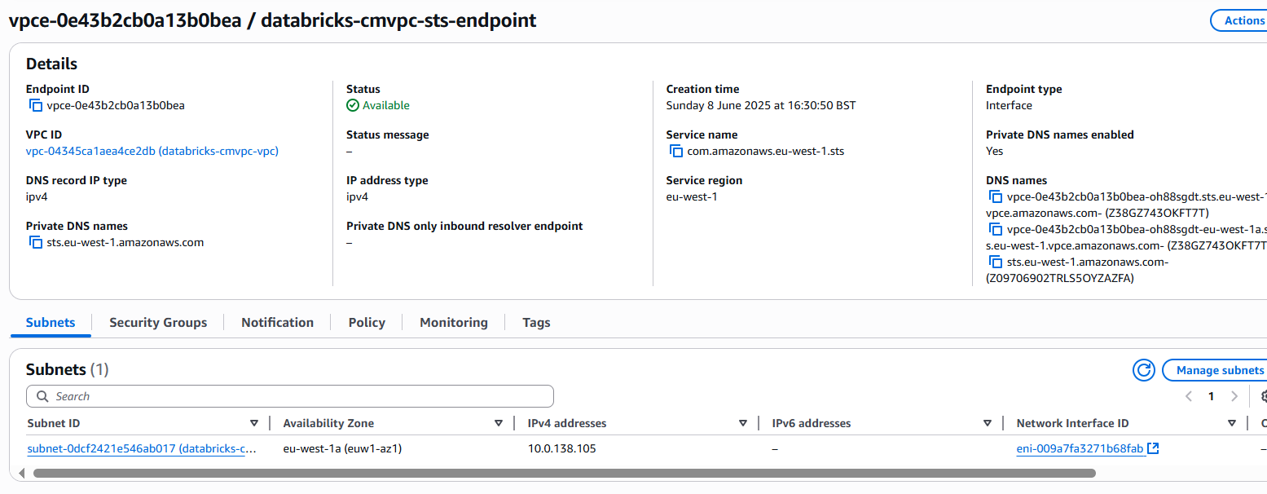
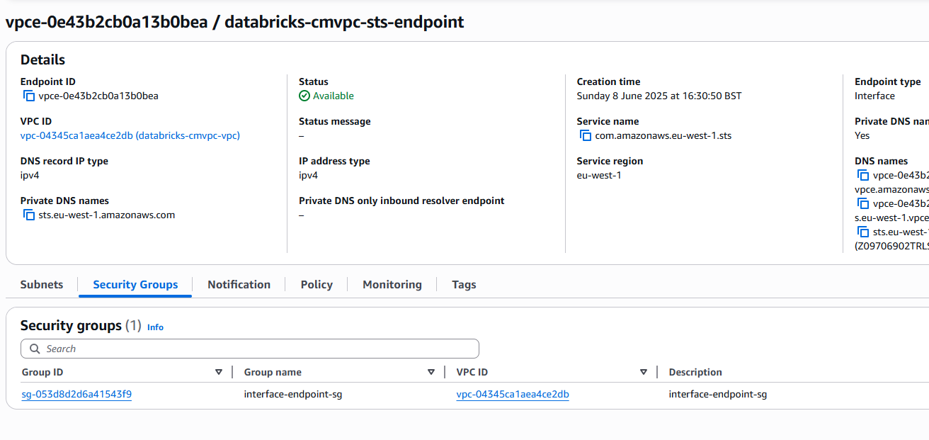
Policy:
{
"Statement": [
{
"Action": "*",
"Effect": "Allow",
"Principal": "*",
"Resource": "*"
}
]
}

Detailed Reasoning:
Interface endpoints (powered by AWS PrivateLink) enable private connectivity to AWS services (like S3, DynamoDB, Secrets Manager, etc.) within your VPC.
By placing them in a private subnet, you:
Avoid assigning public IPs to sensitive resources.
Prevent data from traversing the public internet.

No Need for Internet Access
- The whole point of interface endpoints is to replace public internet access for AWS APIs.
- Your private EC2s/Lambdas/etc. can talk to AWS services over the AWS internal network.

