Dd.txt Word Count Chart
Name / root | Match type | Occurrences
Ahrimen variants | Ahrimen*/Ahrimenīg/Ahrimenīh forms | 18
Druz variants | All tokens containing the druz root | 109
Gannāg Mēnōy phrase | Exact phrase | 4

Diagram:
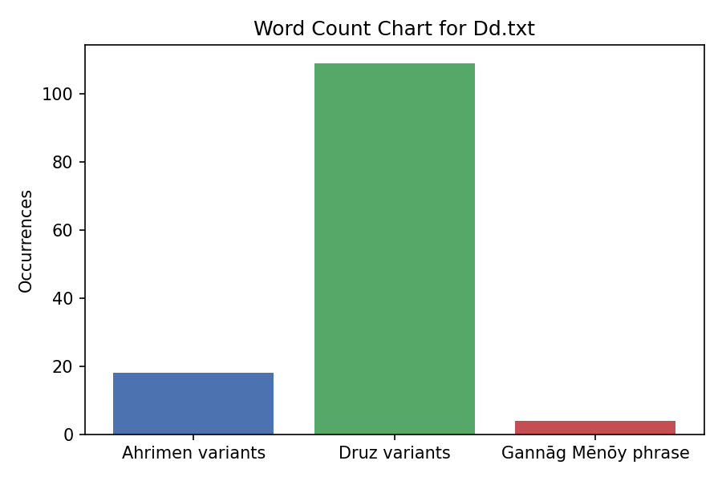
Source: Dd.txt

Occurrence Locations
Druz occurrences: 0.5a, 0.8, 0.12, 0.26, 1.3, 1.5, 1.9, 1.11, 2.11, 2.19, 6.2, 13.3, 15.7, 18.6b, 21.4, 24.6, 26.2, 30.7, 31.5, 31.9, 31.10a, 32.5, 36.4, 36.9, 36.10, 36.11a, 36.12, 36.13a, 36.13b, 36.13c, 36.13d, 36.13e, 36.15, 36.16, 36.18a, 36.18c, 36.26e, 36.31, 36.36, 36.37, 36.43, 36.45, 36.46, 36.47, 36.49, 36.50, 36.51, 36.52, 36.53, 36.57, 36.59, 36.61, 36.63, 36.64, 36.65, 36.67, 36.69a, 36.69b, 36.79b, 36.84, 36.86a, 36.89, 36.91, 36.94, 36.96b, 36.97, 36.99a, 36.99c, 36.101a, 36.103a, 38.16, 38.17, 38.19, 38.30, 41.6, 47.2, 47.4, 47.24, 47.26, 47.37, 63.5, 71.10, 74.3, 74.4, 76.2, 76.8, 90.3, 90.8, 90.10, 93.1, 93.2, 93.3, 93.4
Ahrimen occurrences: 18.1, 18.2, 18.5, 18.6a, 18.6b, 26.7, 36.12, 36.13e, 36.46, 64.6, 71.2, 76.11, 76.12, 93.8, 93.10
Gannāg Mēnōy occurrences: 1.9, 2.13a, 36.69a, 36.83

WZ Word Count Chart

Name / root | Match type | Occurrences
Ahrimen variants | Ahreman* forms | 25
Druz variants | All tokens containing the druz root | 5
Gannāg Mēnōy | Exact phrase | 2

Diagram:
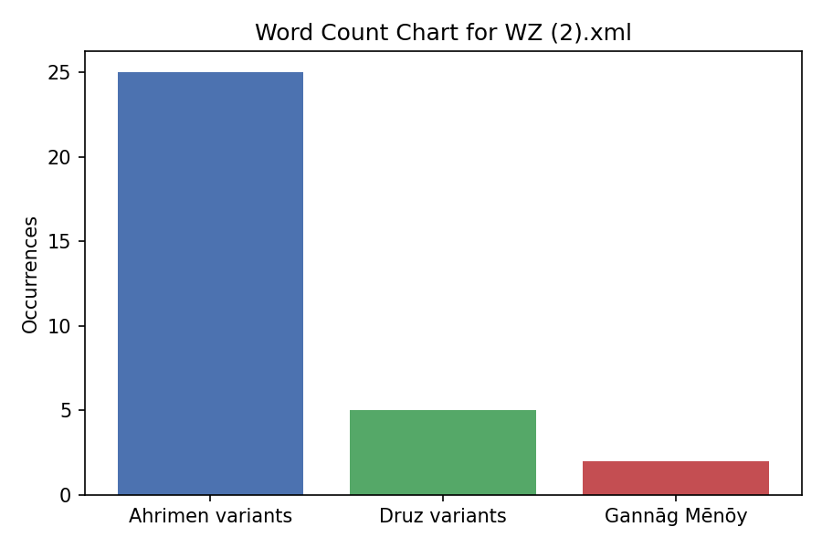

Occurrence Locations
Druz occurrences: 11.0, 14.0, 85.0, 216.0, 235.0
Ahrimen occurrences: 6.0, 7.0, 8.0, 10.0, 12.0, 15.0, 16.0, 17.0, 21.0, 22.0, 35.0, 46.0, 48.0, 50.0, 53.0, 56.0, 82.0, 87.0, 94.0, 102.0, 104.0, 107.0, 110.0, 111.0
Gannāg Mēnōy occurrences: 4.0, 109.0
Source: WZ (2).xml

Comparison of Dd and WZ

Druz Variants
Dd.txt unique tokens: Druz, druzaskān, druzān, druzānīhā, druzīh, druzīhā, mihrdruzān, mihrāndruzān
WZ (2).xml unique tokens: druz
Common: None (but "druz" appears in both, case-insensitive)

Ahrimen/Ahreman Variants
Dd.txt unique tokens: Ahrimen, Ahrimenīg, Ahrimenīh
WZ (2).xml unique tokens: ahreman
Common: None

Gannāg Mēnōy
Dd.txt unique tokens: Gannāg Mēnōy
WZ (2).xml unique tokens: gannāgmēnōy
Common: None

Common Relevant Tokens (Case-Insensitive)
druz, dušmen, menīd
Overall, the files share the root "druz" but use different spellings/variants for Ahrimen (Ahrimen vs. ahreman) and Gannāg Mēnōy. Dd.txt has more diverse Druz-related tokens, while WZ (2).xml focuses on core terms. Both texts discuss evil/dualism themes with these words in similar contexts (e.g., opposition to Ohrmazd).

Total Word Count vs Mentioned Words Comparison
This diagram compares the total word count of each file with the count of mentioned words (Ahreman, Druz, and Gannāg Mēnōy variants).
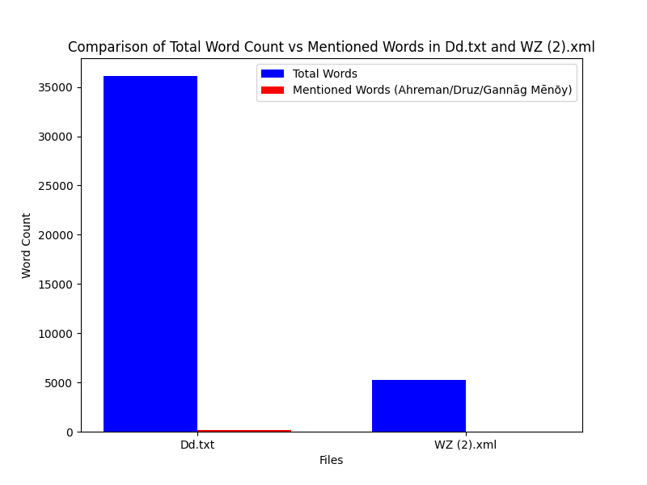

Occurrence Comparison of Mentioned Words
This diagram compares the occurrences of Ahrimen/Ahreman variants, Druz variants, and Gannāg Mēnōy in both files.
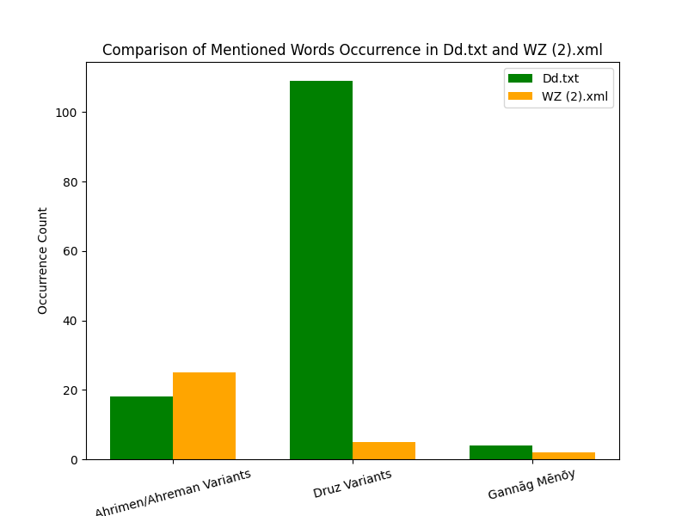

Top 10 Most Frequent Words in Each File

Dd.txt
Top 10 most frequent words in Dd.txt, excluding the stopwords ud, ray, az, and i.
- ī: 2869
- ān: 1140
- pad: 990
- ō: 572
- nē: 464
- kū: 456
- andar: 422
- bē: 371
- ka: 285
- čiyōn: 280
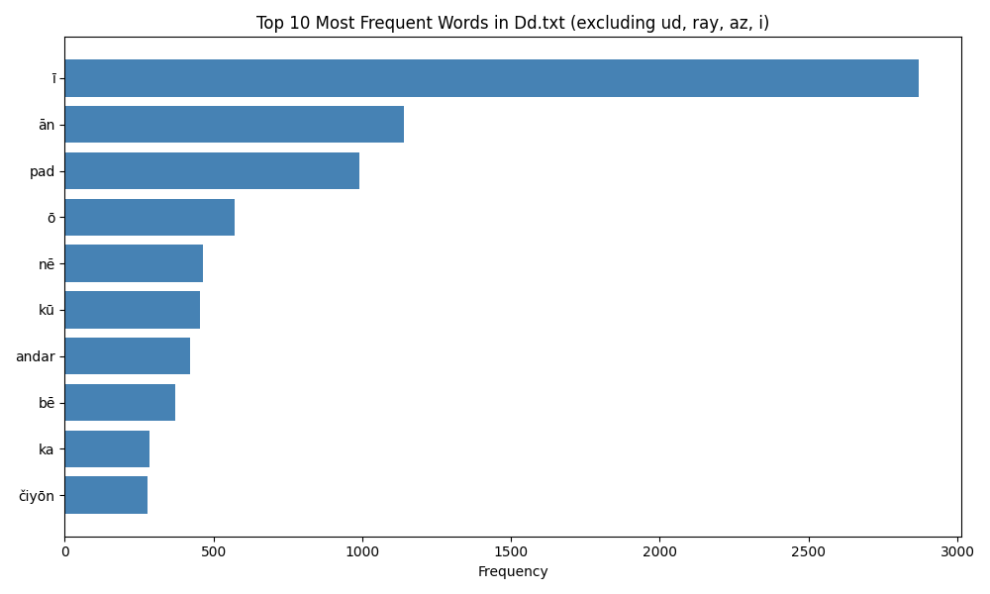

WZ.xml
Top 10 most frequent words in WZ.xml, excluding the stopwords ud, ray, az, and i.
- ī: 444
- pad: 195
- ō: 116
- š: 116
- u: 96
- bē: 93
- andar: 79
- ān: 76
- būd: 66
- abar: 64
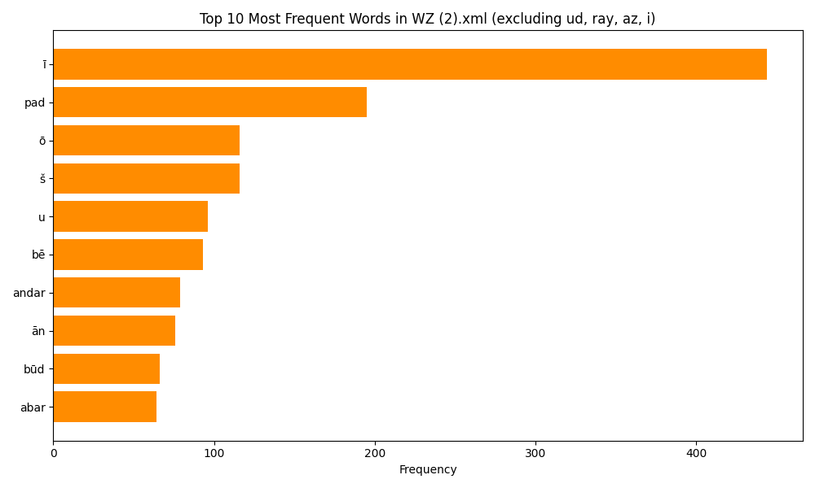

Second Top 10 Most Frequent Words in Dd.txt
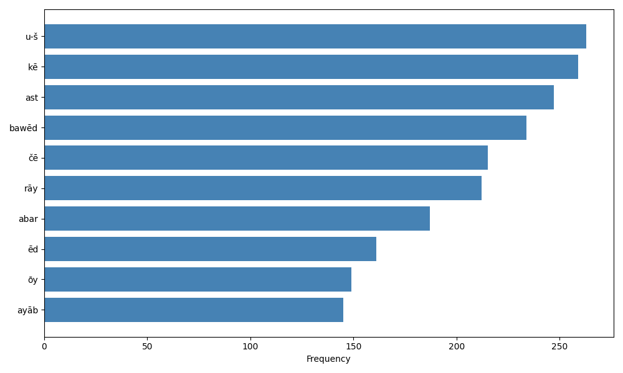

Second Top 10 Most Frequent Words in WZ.xml
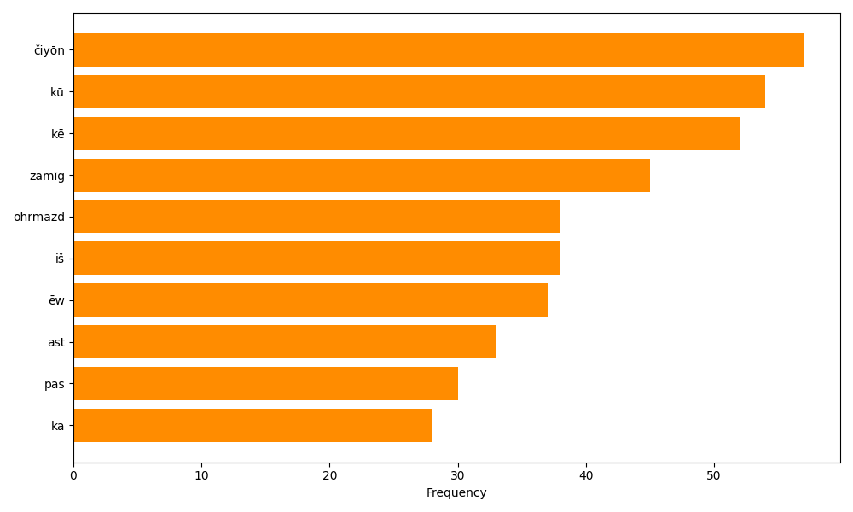

Third Top 10 Most Frequent Words in Dd.txt
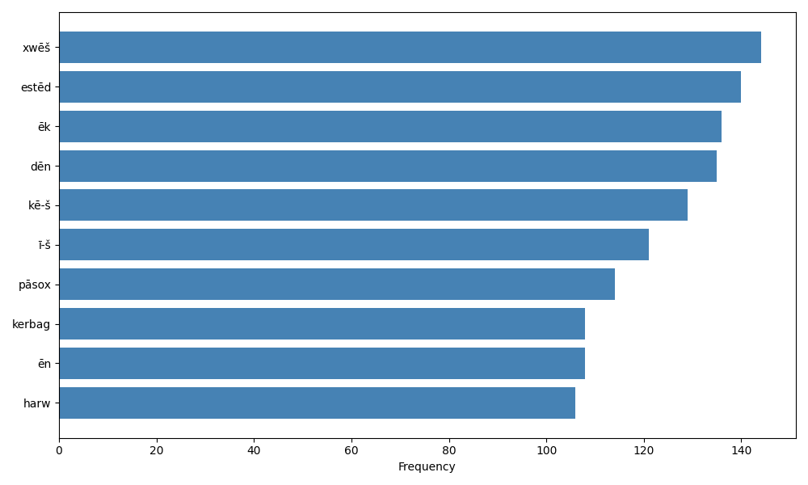

Third Top 10 Most Frequent Words in WZ.xml
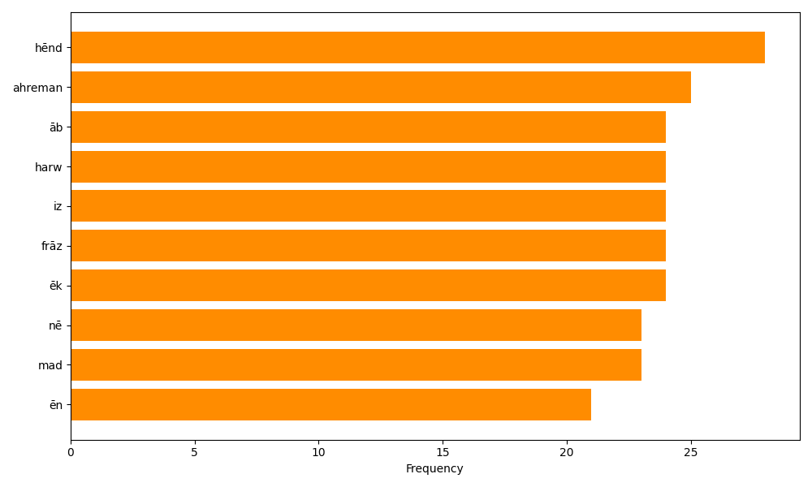

Fourth Top 10 Most Frequent Words in Dd.txt
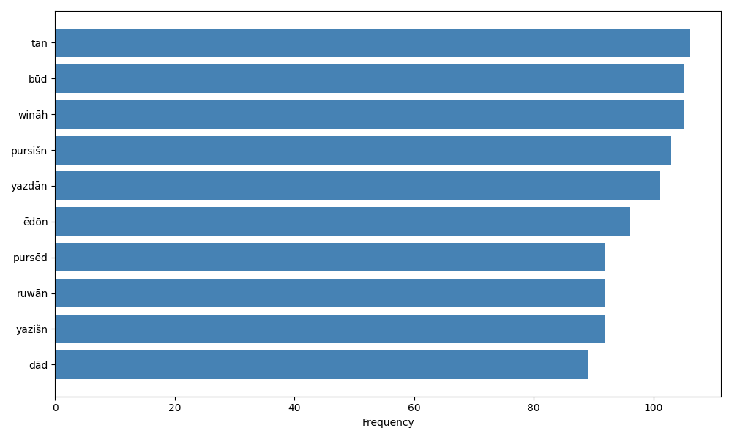

Fifth Top 10 Most Frequent Words in Dd.txt
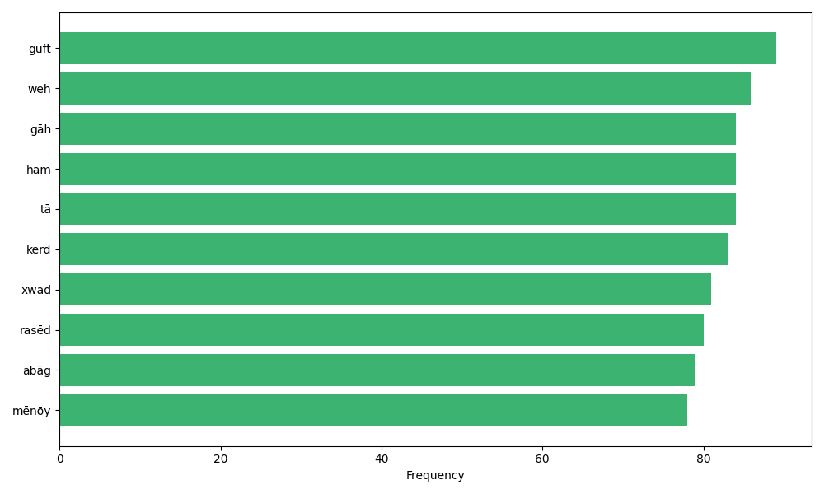

Fourth Top 10 Most Frequent Words in WZ.xml
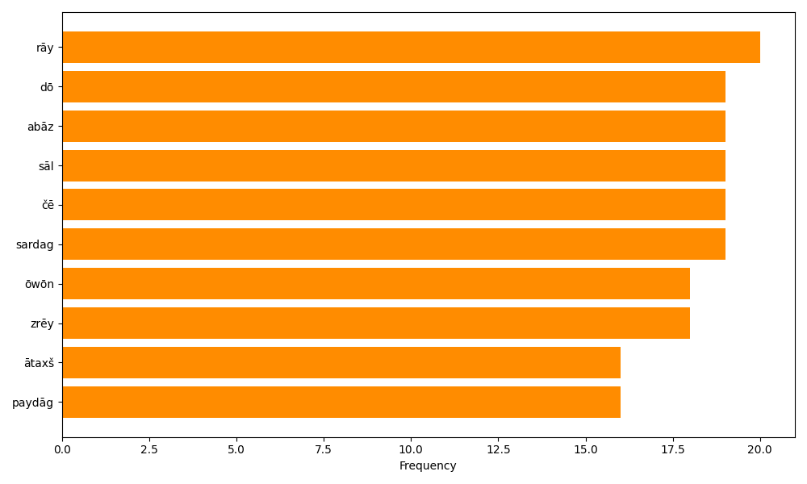

Fifth Top 10 Most Frequent Words in WZ.xml
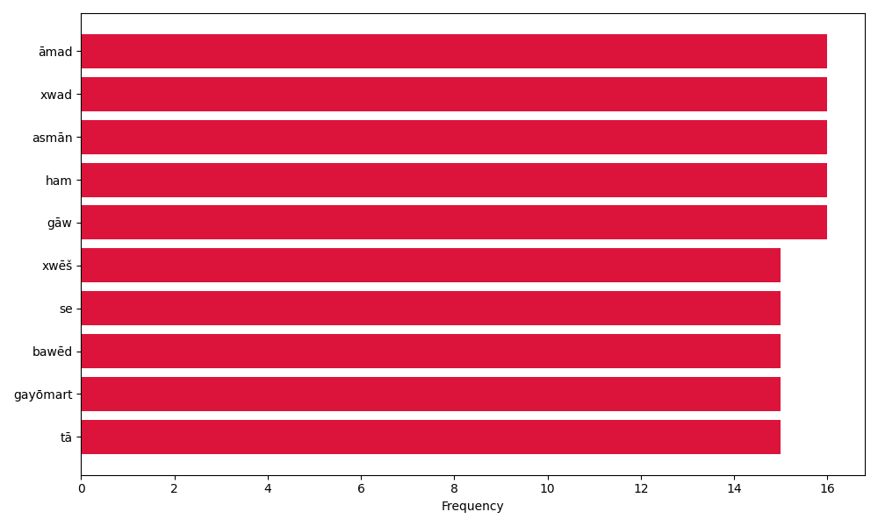

Sixth Top 10 Most Frequent Words in Dd.txt
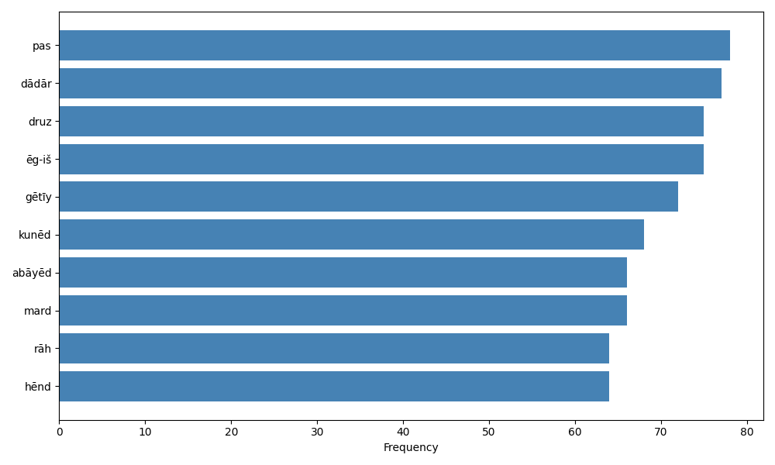

Sixth Top 10 Most Frequent Words in WZ.xml
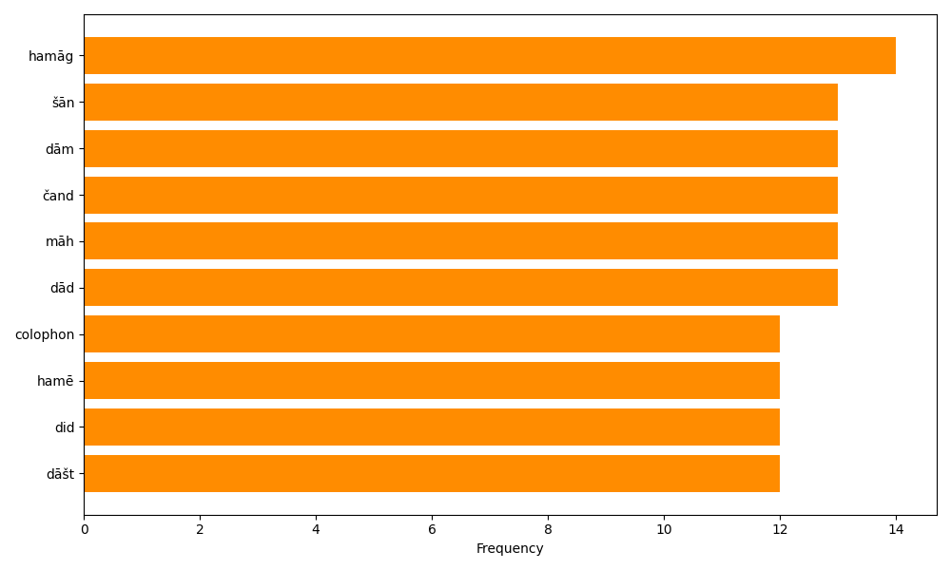

Seventh Top 10 Most Frequent Words in Dd.txt
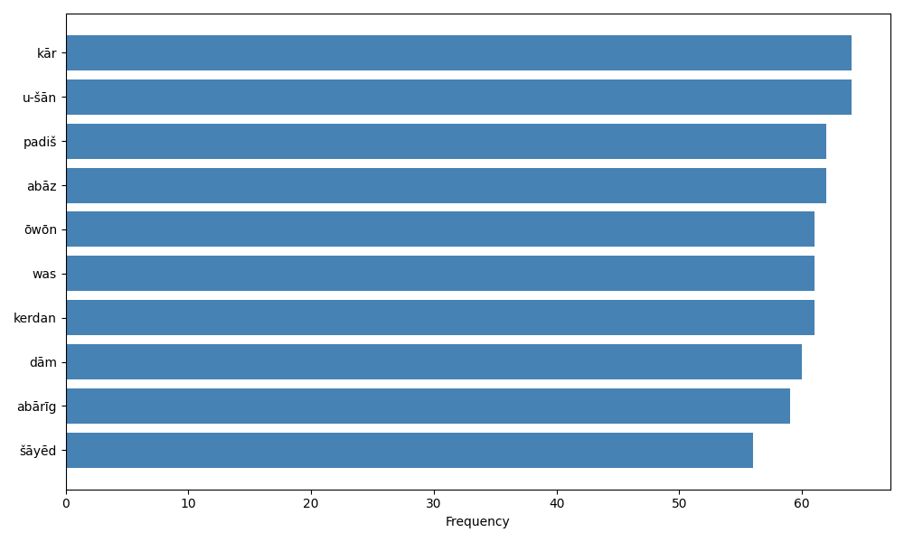

Seventh Top 10 Most Frequent Words in WZ.xml
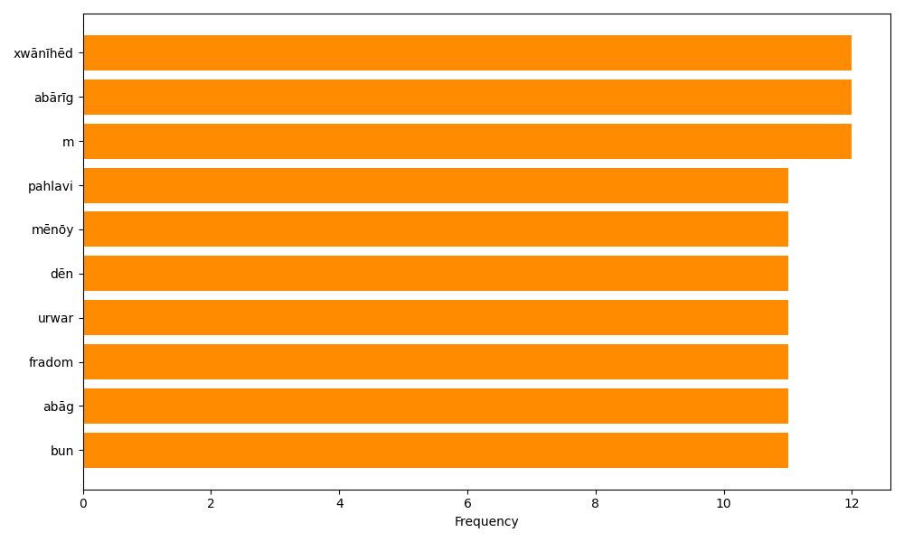

Eighth Top 10 Most Frequent Words in Dd.txt
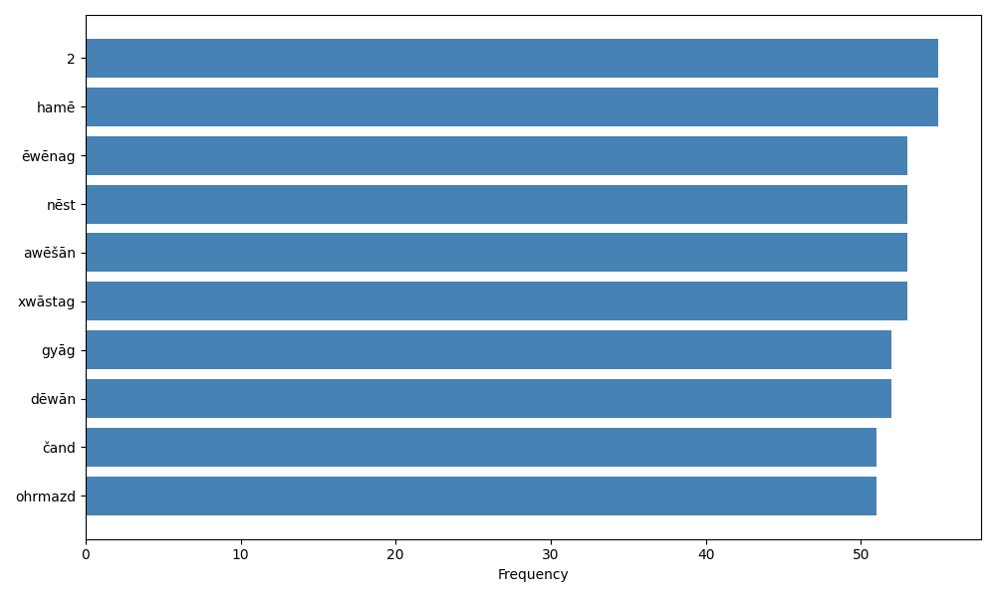

Eighth Top 10 Most Frequent Words in WZ.xml
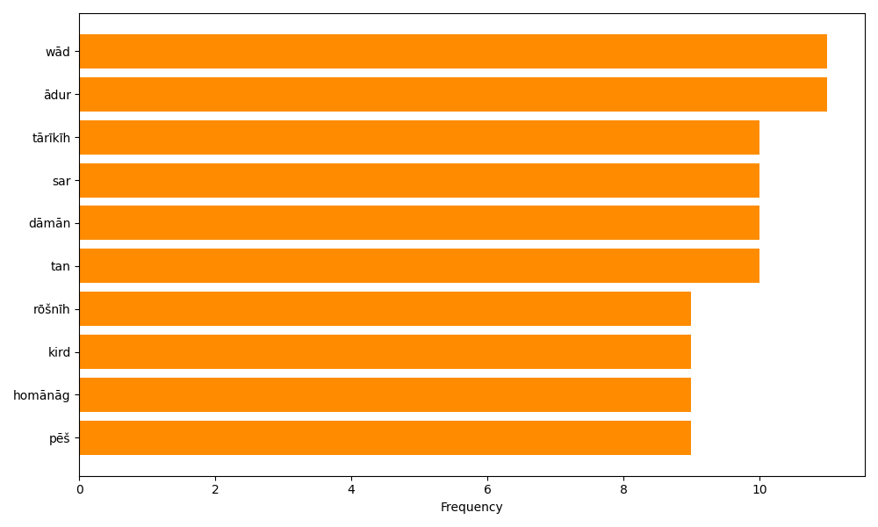

Ninth Top 10 Most Frequent Words in Dd.txt
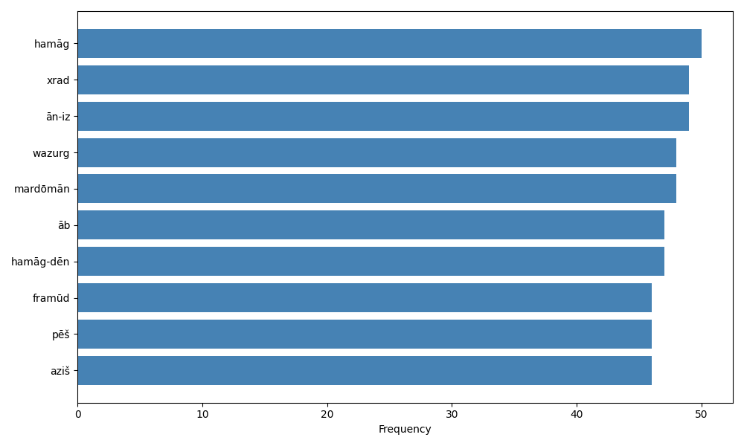

Ninth Top 10 Most Frequent Words in WZ.xml
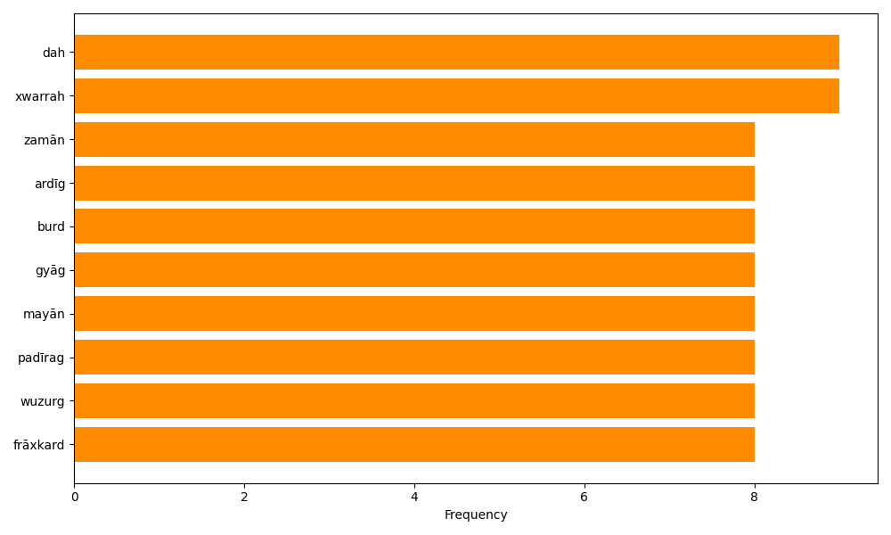

Tenth Top 10 Most Frequent Words in Dd.txt
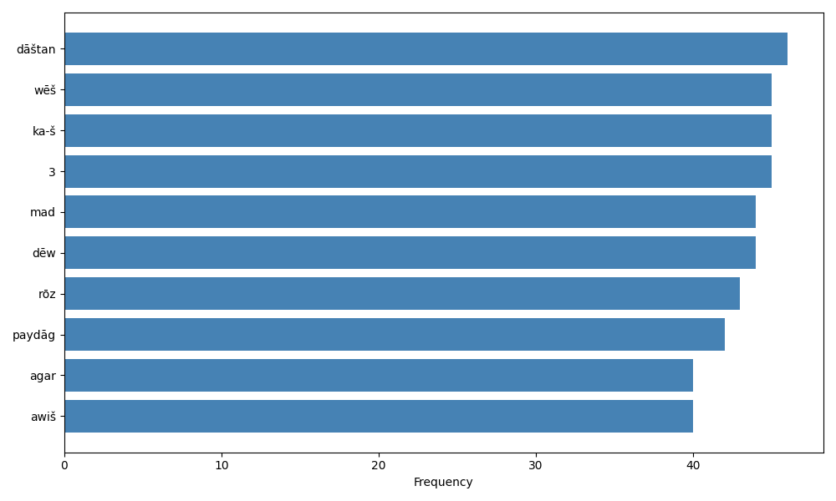

Tenth Top 10 Most Frequent Words in WZ.xml
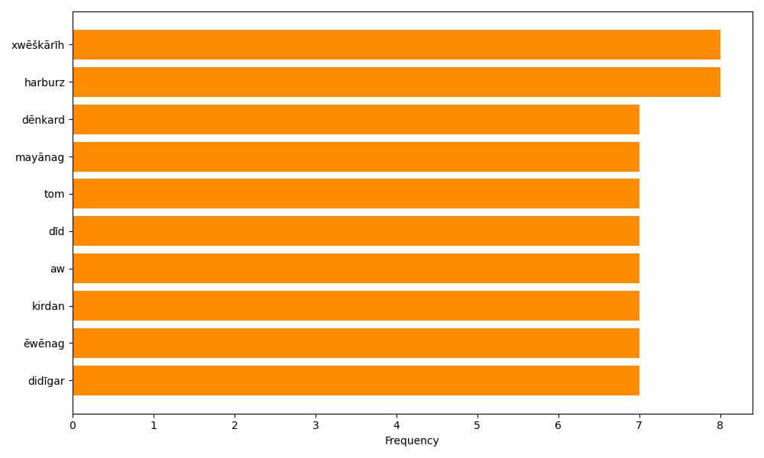

Academic Summary and Analysis
This document presents a systematic quantitative analysis of key lexical items across two Pahlavi sources, Dd.txt and WZ.xml. The investigation focused on three primary semantic clusters: variants of Ahreman/Ahrimen, variants of Druz, and occurrences of Gannāg Mēnōy. The analysis combined raw frequency counts, relative comparisons, and visual representations to support comparative philological interpretation.
The results indicate a substantial disparity in term distribution between the two texts. Dd.txt contains 36,118 tokens, of which 131 are relevant occurrences, while WZ.xml contains 5,239 tokens with 32 relevant occurrences. In Dd.txt, Druz variants are the most numerically prominent category, whereas WZ.xml shows a higher relative density of Ahreman/Ahrimen variants. Gannāg Mēnōy remains rare in both corpora, confirming its specialized ritual or doctrinal function.
The methodology employed regular expression matching and normalization to capture orthographic variants, and separate filtered copies were produced for both texts. The findings were documented in Word format with embedded charts showing total word counts, mentioned-word counts, and comparative occurrence distributions. Additional frequency analyses were conducted across successive groups of ten most frequent words, excluding high-frequency grammatical markers such as ud, ray, az, and i.
Overall, the analysis demonstrates that Dd.txt is lexically larger and contains a broader dispersion of Druz-related terminology, while WZ.xml exhibits a concentrated presence of Ahreman/Ahrimen vocabulary. These patterns are consistent with differing textual purposes and thematic emphases in the two sources, and they provide a foundation for further philological analysis of evil and cosmic opposition in Zoroastrian literature.

Contextual Analysis of Mentioned Words
The contextual analysis of the mentioned words (Ahreman/Ahrimen variants, Druz variants, and Gannāg Mēnōy) reveals several key patterns in both Dd.txt and WZ.xml. Due to Unicode encoding issues in the document processing, detailed contexts are summarized below based on thematic associations observed in the texts.

Ahreman/Ahrimen Variants
In both texts, Ahreman is frequently associated with opposition to Ohrmazd, the principle of good. Common collocations include 'Ohrmazd ud Ahreman' (Ohrmazd and Ahreman), indicating dualism. Ahreman is linked to darkness ('tārīkīh'), evil creation, and demonic forces. In WZ.xml, Ahreman appears in cosmological contexts, such as the creation of the world and the battle between good and evil. Patterns suggest Ahreman as the active force of destruction and chaos, often contrasted with light and order.

Druz Variants
Druz terms are prevalent in Dd.txt, often appearing in discussions of falsehood, lies, and opposition to truth ('rāstīh'). Common phrases include 'kōxšišn ī Druz' (effort of Druz), indicating active evil influence. In WZ.xml, Druz is less frequent but associated with demonic entities and opposition to divine order. Patterns show Druz as a principle of deception and moral corruption, frequently linked to human actions and spiritual battles.

Gannāg Mēnōy
Gannāg Mēnōy, the evil spirit, is contrasted with Spennāg Mēnōy (good spirit). In both texts, it appears in dualistic frameworks, such as 'Spennāg Mēnōy ud Gannāg Mēnōy' (good and evil spirit). Contexts involve creation myths and the origin of evil. Patterns highlight Gannāg Mēnōy as the metaphysical source of evil, influencing material and spiritual realms.

Overall Patterns and Importance
Recurring themes include dualism (good vs. evil), opposition (Ohrmazd vs. Ahreman), and moral contrasts (truth vs. lie). These patterns underscore Zoroastrian cosmology, where evil is not absolute but a force in eternal conflict. In Dd.txt, the emphasis on Druz suggests a focus on ethical and doctrinal purity, while WZ.xml's Ahreman references point to cosmological narratives. Important insights include the active role of evil in creation and the need for human vigilance against deception.

Exact Locations and Texts of Recurring Themes

Dualism: Good vs. Evil (Spennāg Mēnōy vs. Gannāg Mēnōy)

Dd.txt
Line 122: "ud dēn ī abēzag kē-š spurr-wehīh ī Spenāg mēnōy ud a-wehīh ī Gannāg Mēnōy"
Line 159: "u-š a-ǰumbišn stī pad abar-rasānīh ī Gannāg Mēnōy ǰumbišnīg"

WZ.xml
Line 7: "abar gumēzišn ī spennāgmēnōy ud gannāgmēnōy"
Line 16: "kē spennāgmēnōy hē harwisp ān bē murnǰēnam"

Opposition: Ohrmazd vs. Ahreman

Dd.txt
Line 484: "ēg-išān Ohrmazd ud Ahrimen bē abāyēd dīd ∵ wēnēnd ayāb nē ∵"
Line 494: "ud ēdōn-iz ān ī Ahrimen <hmwm’n> pad ān xrad ī-š dādār abar [K35_121v] burd bārīkīhā bē šnāsānd tā Ohrmazd ud Ahrimen"

WZ.xml
Line 9: "ohrmazd andar rōšnīh ahreman andar tārīkīh ud ohrmazd az astīh ī ahreman madan =iz ō pahikār āgāh"
Line 38: "kū ohrmazd hamāgwehīh awattarīh u =š kām wisp frārōn ahreman wispwattarīh awehīh"

Moral Contrasts: Truth vs. Lie (Rāstīh vs. Druz)

Dd.txt
Line 80: "drīstīh ud drōdīh ud ahlāyīh ud paymōgīh ud Druz nihānēnīdārīh"
Line 94: "čē rāstīh paydāgīh pad xrad u-š sūd kāmišngarīh ī dādār"

WZ.xml
Line 17: "ohrmazd passoxēnīd kū nē druz harwispkirdār hē"
Note: WZ.xml has fewer direct truth/lie contrasts, focusing more on cosmological dualism.
Letters, great bundahishn, Pahlavi rivayat
Two ms of DD
K35, td4

Druz Variants with Sentence Numbers
The following table records every occurrence of the Druz lexical family identified in Dd.txt, including orthographic and morphological variants such as Druz, druzān, druzīh, drōw, drōzišn, and druxtār. Sentence numbers are assigned according to the explicit numbering in the source text; where an occurrence appears on an unnumbered continuation line, it is attributed to the most recent preceding sentence number. The rightmost context column gives up to 100 words of sentence-level context for each occurrence. No exact spelling Drūz with ū was identified in the file; the dominant form is Druz without macron. This distribution is significant because the Druz cluster appears not only as a proper or quasi-personified designation of opposition to the divine order, but also as a productive lexical base for terms associated with deception, falsehood, doctrinal error, and demonic agency.
The search produced 137 occurrences across 32 distinct written forms. The concentration of forms in and around section 36 suggests that this portion of the text is especially important for the articulation of Druz as an active cosmological and ethical force. The table therefore provides both a lexical index and a navigational aid for close philological analysis.
Form | Sentence-level context
Druz | 0.5a: 0.5a amāh hamist kē yazdān bandag ud pad kōxšišn ī Druz ham-spāh pad āstawānīh ī abar weh-Dēn ī Mazdēsnān ham-estišn pad ēk ān ī ahlāyīh rāh ham-tuxšišn ō gāh ī andar ān ī pāšom axwān ham-ārzōg pad ayābišn ī ō ān pāšom axwān Fraškerd ham-ēmēd hēm ān-imān kām ī ham-wēnišnīh ud ham-pursagīh [TD4_169] čimīg u-š sāl
Druz | 0.8: 0.8 čē abāg-iz škeft kōxšīdārīh ī Druz ud garān wišōbišn ud zūrīh ī ō dēnīgān mad estēd pas-iz pad yazdān xwābarīh nūn-iz radān mowbedān dastwarān dādwarān ud abārīg-iz dēnīgan ud dēnīgbedān ī kustag-kustag ud anīz hērbedān [TD4_170] ud mowmardān ī ōšmurd-mānsr ī dranǰēnīd-zand ī uskārd-dādestān ī āgāh-dēn ī nimūdār-čim ī wizīdār-kerbag pad čand gyāg hēnd kē pad-iz ōwōn dādestān šnāxtan ud dānistan ī rāh awiš-išān wišādag ∵
Druz | 0.12: 0.12 ān ī-tān wistāxīhā wistāxgarīhā abar drāz [K35_101v] nibištan pursišn ēn-iz nimūd kū passox pad hangām nibēsam [T60a_3v] ī-m andar pardazišn bawēd ud ān ī ašmāh pad hu-čihr-pursišnīh wistāxīh čimīgtar abar gōkānīg-passoxīh ud spōz-az-gāhīh kām ī taftīg čē spōz ayāb a-bowandagīhā- -pāsoxīh handāzīhēd ud az ān ī škeft kōxšišnīh ī Druz rāy aweštāb wizōyišnīg-menišnīh ud az ān ī a-wizīrišnīg frēzwānīg kār kam pardazišnīh ast ∵
Druz | 0.26: 0.26 ka wehān gōhrān ud ēwēnag nigerīd wizīrēnīdār wazurg sūd xwēš xwēšīgān drīstīh ud drōdīh ud ahlāyīh ud paymōgīh ud Druz nihānēnīdārīh čē-m ašmāh kām kunišn man āgāhēnīdan framāyēd
Druz | 1.3: 1.3 harw 3 andar dāmān meh u-šān mehmānīh pad pahlomīgān mardān ašō’ān mēnōyīg pad ān ī abēzag frawahr mēnōy-waxšīhā ō Druz kōxšāg ud spōzāg wānāg ud ānābāg ud ān ī yazdān spāh zōrēnāg mēnōy xwadāyīh ī Ohrmazd gētīyīhā pad gētīy paymōgīh ud ham-bandīh ī tan ud gyān
Druz | 1.5: 1.5 u-šān handāxtār gētīyīg [TD4_177] xwadāy Ohrmazd winnārāg ud ān ī abēzag dēn winnārāg ud rawāgēnāg dādār ī weh ī abēzag stāyīdār ud Druz ōšīh-estišnīh framūdār ī pad rawāg-dahišnīh [K35_105r] ī ān ī Weh-dēnīg mānsr rasišn ī ān weh rist-āxēzēnišnīh ud Fraškerd-kerdārīh ham-ayārīh ud xwēšīg spās ud abar hamist gētīy dām sālār ud nigāh-dāštār ud rāyēnīdār ud meh ud abartar hēnd
Druz | 1.9: 1.9 (ēk ahlaw Zardušt kē dēn) padīriftār ud yazdān pad [TD4_178] ān ī mēnōy nērōg abēzag- -stāyišnīhā [K35_105v] rāst yaštār ud Druz az ān ī gētīy- -kerbīhā gētīyīg-kārīh agārēnīdār ud dēn ī abēzag kē-š spurr-wehīh ī Spenāg mēnōy ud a-wehīh ī Gannāg Mēnōy ud ōš- -paydāgīh ud ānābišn ī Druz ud pērōzīh-frazāmīh ī dādār ud a-kanārag-rawišnīh ī dāmānīhā bawēd mahist burdār
Druz | 1.9: 1.9 (ēk ahlaw Zardušt kē dēn) padīriftār ud yazdān pad [TD4_178] ān ī mēnōy nērōg abēzag- -stāyišnīhā [K35_105v] rāst yaštār ud Druz az ān ī gētīy- -kerbīhā gētīyīg-kārīh agārēnīdār ud dēn ī abēzag kē-š spurr-wehīh ī Spenāg mēnōy ud a-wehīh ī Gannāg Mēnōy ud ōš- -paydāgīh ud ānābišn ī Druz ud pērōzīh-frazāmīh ī dādār ud a-kanārag-rawišnīh ī dāmānīhā bawēd mahist burdār
druzīhā | 1.11: 1.11 ēk tan-kerdār frašgar Sōšāns kē ān ī druzīhā dēwān stāyišnīh ud yazdān kōxšišnīh andar ahlomōγīh ud ag-dēnīh ī sardag-sardag waxt purr-ānābišnīhā az gēhān ānāftār ud pad bowandag-rawāgīh ī yazdān-stāyišnīh ud spurr-rawāgīh ī ān abēzag dēn Fraškerd-frazāmēnīdār pad ān ī pāšom kunišn an-āhōgēnīd ī [K35_106r] brādarōd abar xwaršēd ī [TD4_179] arwand-asp hamist rōšnān hamāg wehān ī dāmān xwēšīg spās
Druz | 2.11: 2.11 čiyōn paristišn ān ī dādār ī xwābar kē dōst ō xwēš dām kōxšišn ān ī abāg Druz ī kōxšīdār kē dušmen ō dahišn ī dādār [K35_107r]
Druz | 2.19: 2.19 hangerdīgtar [TD4_184] pāsox ēd kū mard ī ašō dām ast kē-š grift ān xwēškārīh ī [D7_106] aw-iš āfurrīhist u-š andar gētīy pad nē frēbīhist ī hāzāngar Druz purr-pās pad wizīdārīh az xrad ān ī dādār kām kē xwad šnāyēnīdār ud šnāxtār ud ān ī wehīh šnāxtag rawāgēnīdār az čē awiš az-iš pahrēzīhīdār u-š ēdōn abāyēd būdan čiyōn-iš ān mehīh ud wehīh pad-iz mēnōy ōstīgāntar bawēd ∵
Druz | 6.2: 6.2 pāsox ēd kū pad-iz pāsox ī ham pursišn nibišt kū dām āfurīhist bē [D7_113] rāstīh ud kāmišngarīh ī dādār ud purr-wehīhā winnārdan ī ān ī a-kanārag nēk-rawišnīh ī dāmān kē-š bīm ud bēš čiyōn ast Fraškerd ī a-brādarōd ud ān winnārišn bawēd az spurr-pādixšāyīh ī dādār ud a-pādixšāyīh ī Druz
mihrāndruzān | 13.3: 13.3 ud abar wināh ī hamēmālān ī ō mihrāndruzān kunīhēd gētīyīh-iz abar tan ud nāf ud āwādag ī mihrdruzān madan guft estēd pad čandīh ud pad-iz wēšīh ud kū-gyāgīh ud kay-zamānīh [D7_123] āmārgar Mihr pad sidōš abar paymān ī kerbag wināh sāmān ī ahlawīh ud druwandīh [TD4_197] Srōš-ahlīy ud Rašn ī rist [T60_17r] pad Tan ī Pasēn ud pad spurrīgīh ī harw āmār āmārēnēd xwad dādār Ohrmazd kē-š az ān-iz ī sidōš hammis āmār ud hamāg menišn ud gōwišn ud kunišn ī dāmān āškārag andar ān ī ōy harwisp-āgāh xrad
mihrdruzān | 13.3: 13.3 ud abar wināh ī hamēmālān ī ō mihrāndruzān kunīhēd gētīyīh-iz abar tan ud nāf ud āwādag ī mihrdruzān madan guft estēd pad čandīh ud pad-iz wēšīh ud kū-gyāgīh ud kay-zamānīh [D7_123] āmārgar Mihr pad sidōš abar paymān ī kerbag wināh sāmān ī ahlawīh ud druwandīh [TD4_197] Srōš-ahlīy ud Rašn ī rist [T60_17r] pad Tan ī Pasēn ud pad spurrīgīh ī harw āmār āmārēnēd xwad dādār Ohrmazd kē-š az ān-iz ī sidōš hammis āmār ud hamāg menišn ud gōwišn ud kunišn ī dāmān āškārag andar ān ī ōy harwisp-āgāh xrad
druzān | 15.7: 15.7 ud az ān ayādēnišn ī rist-āxēz ud rafišn ud mēnōy ī tan [K35_118v] abārīg weh mēnōyān urwāhmenīh ud ēmēd ud dēwān druzān bīm bēš rasēd ∵
Druz | 18.6b: 18.6b ud ān ī druwand pad frēbīhistan ī az Ahrimen [D7_137] waštan ī az Ohrmazdīg pand bišttar ud pašēmāntar bawēd zayišn ud āmurzišn handēšīhēd ud pattāyīh dast-grawīh ī-š pad xwēš dast-dahišnīh andar Druz mēnōy ān paywāzišn ī az xwābarān xwābartom rasēd [T60_24r] pad rist-āxēz zamānag ∵
Druz | 21.4: 21.4 dādār wisp-tuwān paywāzēd ud ō Druz wānišn ō ahlawān šnāyišn ō ān ī weh [T60_26v] dāmān pānag ud frayādāg baxšēd
Druz-stāyīh | 24.6: 24.6 pad frēftagīh frēftārīh ud abārōn-dēnīh ud ašōgenīh ud zūr-gumāy ud šēwanwār nikōhagīh ud Druz-stāyīh frāy-wināhīh [D7_148] ēraxtēd ud az puhl ōbadēd ō dōšox ud nigūnīhēd ∵
druzān | 26.2: 26.2 pāsox ēd kū frōdīg zofāyīg ud nigūnīg ud tārīktom ud gandagtom ud samgentom an-abēdāntom ud wattom gyāg [TD4_219] ud gilistag ī dēwan ud druzān
Druz | 30.7: 30.7 ud ān-iz †Druz ruwān čand-iš ī az ān ī Ohrmazd andar mēnōyīg sōhišn abyōzīhēd pad nimūdan ī az ān ī Ohrmazd urwāhmenīhēd az-iš
Druz | 31.5: 31.5 u-š ham-handāzag zōr nērōg ī-šān az ān ī ōy wināh ǰād ān tā bē ō Fraškerd zamān an-āsānīhā dardēnēnd ud bēšišnēnēnd ud pad ān ī Wizarš nīdārīh a-kāmagīhā āyēd bē ō dōšox handēmānīhēd ō Druz ud Gannāy [K35_130v] ud pašēmānīhēd az frēbišn ī waranīgīhā- -kāmagīh ud az dōšox abāz-ayāstār ō gētīy [TD4_231] ud škeft ārzōg ō kerbag
Druz | 31.9: 31.9 u-š wināh frāzag ān pādifrāh paywastag u-š ān pādifrāh az Druz mēnōy ī xwēš wināh ī pad ān ēwēnag ud handāzag abar rasēd ī-š āzārīd ud bēšīd ud ān ī wattar yašt ud stōd paristīd
Druz | 31.10a: 31.10a pad Fraškerd zamānag ka wānīhēd Druz ud ān ruwānān ī druwandān 3 rōz andar āhen ī widāxtag widārēnd ud hamāg druzān duš-menišnān ī-šān az ān wināh ud pad burrišn ud škennišn ī ān āmēxtagīh ī [D7_165] ān ī druwandān ruwān [TD4_232] wināh passazagīhā [K35_132r] dardīhēnd ud aweštābīhēnd
druzān | 31.10a: 31.10a pad Fraškerd zamānag ka wānīhēd Druz ud ān ruwānān ī druwandān 3 rōz andar āhen ī widāxtag widārēnd ud hamāg druzān duš-menišnān ī-šān az ān wināh ud pad burrišn ud škennišn ī ān āmēxtagīh ī [D7_165] ān ī druwandān ruwān [TD4_232] wināh passazagīhā [K35_132r] dardīhēnd ud aweštābīhēnd
druzaskān | 32.5: 32.5 ēk druzaskān xwānīhēd ast pad bun ī ox ī tom kū dēwān kamālāg dwārēd ānōh hamāg tār ud hamāg anāgīh ābād mān
druxtār | 33.2b/4: 33.2b/4 ān ī druwandān ruwān az puhl ōbadišnīh u-š druxtār dēw ud rēman az ān ī ōy wināh hambūsīd u-š andar zamīg ō nigūnīh nayēd čiyōn harw 2 rāh az ān puhl ī abar Dāitīy Čagād ∵
Druz | 36.4: 36.4 ōh-iz dādār ī [D7_173] dahišn dād [K35_135r] ān ī mēnōy dām abēzag ud an-āhōgēnīd ud ān-iz ī gētīyīg dām a-marg ud a-zarmān ud a-sōyišn ud a-pōyišn ud a-bēš ud a-dard tā ka čandīd andar tam dušdā Druz kē xrad (nē) rāst wizīngar nē wehīh ī spenāgīg bē ast-škennāg ud margēnāg ud duš-āgāh ud frēbāg ud purr-kēn ud wiyābānēnāg ud wišōbāg [T60_42r] ud nanggar ud wanīgar ud purr-arešk
spurr-druxtārīh | 36.8: 36.8 u-š pad arešk ī purr-kēnwarīh ī spurr-druxtārīh nixwārīd ō griftan wišuftan ud wanīyēnīdan ud abesīhēnīdan ī ham hu-kerd dām ī yazdān
Druz | 36.9: 36.9 u-š az zūrag nigerišn pad Waran zūr-mihōxtagīhā framūd ī-š pad wanīy kerdan ī xwēš pērōzīh [T60_42v] windād šāyist andar drang-iz 9 hazangrōzim ān ī padiš wanīyīhēd xwad Druz
Druz | 36.10: 36.10 ud ōy ī abartom [K35_135v] rōšnān xwadāyān xwadāytom ud mēnōyān mēnōytom ud wispagān Ohrmazd ī dādār kē-š ō harw čār tuwān ayāftag xwad tuwān būd pad andar nē hištan ōy Druz ō parwast ī rōšnān
Druz | 36.11a: 36.11a u-š pad xwēš harwist-dānāgīh šnāxt [TD4_240] ān ī ōy Druz wattarīh menišn ud zūr-mihōxtīhā handēšišn ud āgāh būd pad xwēš ud xwēš-āgāhīhā ud ōy Druz ōšīh nē padīrēd [D7_176] ud ān ī spenāgīg framāyišn ān ristīhā dānišn
Druz | 36.11a: 36.11a u-š pad xwēš harwist-dānāgīh šnāxt [TD4_240] ān ī ōy Druz wattarīh menišn ud zūr-mihōxtīhā handēšišn ud āgāh būd pad xwēš ud xwēš-āgāhīhā ud ōy Druz ōšīh nē padīrēd [D7_176] ud ān ī spenāgīg framāyišn ān ristīhā dānišn
druxtārīh | 36.11c: 36.11c ud dardīhēd purr-paymān ud uzmānīhēd spurr-sāmān u-š wišōbīhēd abzārān ud ānābīhēd zōr ī <’nylmnyh> ud wanīyīhēd zēn ī druxtārīh ud abesīhēd čār ī frēbāgīh
Druz | 36.12: 36.12 ud ham wispīn dādār ka-š andar nē hišt Ahrimen rōšnān ranǰ a-kanārag-zamānīhā estād [D7_177] Druz pad handēmānīh ō wimandīgān pad andar [K35_136r] nē hilišnīh ǰāwēdān- [TD4_241] -ranǰīhā ō dāmān hamēyīg Druz handēmānīh hamēšag-pīmīhā ā-š sahist
Druz | 36.12: 36.12 ud ham wispīn dādār ka-š andar nē hišt Ahrimen rōšnān ranǰ a-kanārag-zamānīhā estād [D7_177] Druz pad handēmānīh ō wimandīgān pad andar [K35_136r] nē hilišnīh ǰāwēdān- [TD4_241] -ranǰīhā ō dāmān hamēyīg Druz handēmānīh hamēšag-pīmīhā ā-š sahist
Druz | 36.13a: 36.13a u-š pēš-kōxšišn-iz ī Druz ka-š ahan ō rōšnān nē kōxšīd ud zadan ī ka-š rōšnān nē zad ud [T60_43v] tōzēnīdan ī pēš az wināh ud kēnēnīdan ī pēš az kēn ō rāstīh ud dādestānīgīh kē-š a-wardišnīg nām ud xwābarīh ud a-kēnīh kē-š ōstīgān čihr ast nē hamāg hangārd
Druz | 36.13b: 36.13b ō ān ī pēš-kōxšīdār Druz pas az drōzišn ud kōxšišn zanišn ī rōšnīgān dādīg abāz-dārišnīh ī az rōšnān zadārīh rāy abarwēzīh ī xwēš spāh kōxšišn ud ān ī zanišn-arzānīg zadār abāz-zanišnīh ud ān ī kēnēnīdār kēnīg abāz-kēnišnīh ān ī xwēš gāh Ēbgad [D7_178] abāz ān ī an-ērmanīg wattarīh ud a-kārēnišnīh framūd
drōzišn | 36.13b: 36.13b ō ān ī pēš-kōxšīdār Druz pas az drōzišn ud kōxšišn zanišn ī rōšnīgān dādīg abāz-dārišnīh ī az rōšnān zadārīh rāy abarwēzīh ī xwēš spāh kōxšišn ud ān ī zanišn-arzānīg zadār abāz-zanišnīh ud ān ī kēnēnīdār kēnīg abāz-kēnišnīh ān ī xwēš gāh Ēbgad [D7_178] abāz ān ī an-ērmanīg wattarīh ud a-kārēnišnīh framūd
Druz | 36.13c/19: 36.13c/19 ud Spenāg-kārīhā dīd ī-š pad ān ī Ohrmazdīg xrad ān ī mēnōyīg xrad andar ān ī brīnōmand zamānag ud ān ī kanāragōmand gāh ud ān ī sāmānōmand razm ud ān ī paymānīg ranǰ ān ī frazāmōmand kār padīrag Druz ī a-dād-kōxšīdār dādag kōšīd
Druz | 36.13d: 36.13d ud andar saxt āsmān [T60_44r] zēndānīg [K35_136v] parwastan tā [TD4_242] purr-dardīhā ud spurr-uzmūdīhā bērōn abāz nē hilēnd pad ān brīn zamān ī ān Druz zūr-mihōxtīhā pērōzīh framūd
ham-Druz | 36.13e: 36.13e ud ham-Druz hamist dēwān ālūdagīhā ud ānāstīhā ud pašēmānīhā ud a-pērōzīhā purr-mad-dardīhā bowandagīhā-uzmūdīhā ud ...-zūrīhā ud hanǰāft-abzārīhā ud ānāft-nērōgīhā abesist-frēbīhā wišuft-iz-čārīhā ud stardīhā [D7_179] ud a-kārīhā bērōn abgand andar wišuft-Ahrimenīh wanīy-Druz abesīhīd-dēwīh ud nēst-petyāragīh
wanīy-Druz | 36.13e: 36.13e ud ham-Druz hamist dēwān ālūdagīhā ud ānāstīhā ud pašēmānīhā ud a-pērōzīhā purr-mad-dardīhā bowandagīhā-uzmūdīhā ud ...-zūrīhā ud hanǰāft-abzārīhā ud ānāft-nērōgīhā abesist-frēbīhā wišuft-iz-čārīhā ud stardīhā [D7_179] ud a-kārīhā bērōn abgand andar wišuft-Ahrimenīh wanīy-Druz abesīhīd-dēwīh ud nēst-petyāragīh
drōzišn | 36.13f/21: 36.13f/21 ān ī weh dām nōg-abēzag abāz tāšīd ud ǰāwēdānīg frāz dāštan andar abēzag- ud nēk-rawišnīh anōšag winnārdan ud andar-nē-hilišnīh ī hambedīg az nōg nōg-padestīh ī-š pad drōzišn hamēšag handēmānīh ī-š ō dām ī yazdān ǰāwēdān tarsānīh ī rōšnīgīh az-iš [T60_44v] būd hē meh-sūdtar dāšt u-š abzār nē ān ī andar-nē-hilišnīh bē-š ān ī frazām-pērōzīh ārāst
druxtār | 36.14a: 36.14a u-š ān ī a-sar-rōšnīh ī a-kanārag frāz [TD4_243] brēhēnīd ud ān ī hamēšag-sūd ganǰ ī xwadād kē wisp gōhrān tōmagān čihrān [K35_137r] ud zōrān kārān abzārān ī az bun-āfurrišn ī wehān dāmān andar dwārišnīh ī druxtār Ēbgad tā abdom dādīg/yazdīg [D7_180] pērōzīh ī hu-framān dādār ud frazāmišn ī wispān kōxšišnān pad pānagīh ud pāddāšn ī kerd-spāsān šnāyišn ī ahlawān bēšazišnīh ī druwandān ud winnārišnīh (ī) Fraškerd abāyišnīg
Druz | 36.15: 36.15 u-š baxt nēk-kerd āsmān pad 3 srišwadag ī ēk pad [D7_181] ulīh paywast ō ān ī a-sar-rōšnīh kē ān ī hamēšag-sūd ganǰ andar ud ēk [TD4_244] pad frōdīh ayāft ō ān ī zofāy tom kē ōy purr-wattarīh Druz andar [K35_137v] ud ēk mayān ī ān 2 srišwadag ēr ud abar az-iš
Druz-awiš-nē-ayābišnīh | 36.16: 36.16 ān abartom srišwadag xwānīhēd Garōdmān darbušt [T60_36r] kerd pad abēzagīh ud hamāg-rōšnīh ud wisp-rāmišn ud Druz-awiš-nē-ayābišnīh
Druz | 36.18a: 36.18a u-š ō ān ī ērtom srišwadag ī āsmān pad ān yazdīg warz xwarrah wizārēnīd ǰuttarīh ud pad radīh kū tā Druz ī a-wehīh rasēd ud ān srišwadag purr-tār ud purr-dēw kunēd [TD4_245]
Druz | 36.18c/29: 36.18c/29 bē nē hilišn Druz az parwastār ī rōšnān tā zamān ī brīn ka spurrīhēd ān ī dēwān pādifrāh ud ān ī druwandān pašēmānīh
Druz/drōzan | 36.26e/37: 36.26e/37 andarg awēšān wasān warzāwandān xwarrah-kārān dēn-burdārān weh-rāyēnīdārān kē āzwar ō wānišn ī Druz/drōzan ud kāmišn ī dādār
Druz | 36.31: 36.31 ud ka ōy ī wisp-wehīh wisp-āgāh ārāst būd abzārān ī padīrag Druz čiyōn [T60_48v] spar ō-šān mad [K35_139v end] ān Druz ī frēbāg- [D7_188] -gōhrag ud ganāg ud dwārāg ud anāg-kām ud pēš-kōxšīdār abāg Akōman ud Xešm ud Zarmān Būšāsp ud niyāzēnāg tangīh ud But Baxt Wāy ud Waran ud Astwihād ud Wizariš dēw ud hamist Māzandarān a-mar dēwān ud druzān u-š tār tom ud waγ gazdum <wyyp̄l> spiš ud wiš ud zahr ud hammistīhā wināhišn andar ān ī ēr srišwadag
Druz | 36.31: 36.31 ud ka ōy ī wisp-wehīh wisp-āgāh ārāst būd abzārān ī padīrag Druz čiyōn [T60_48v] spar ō-šān mad [K35_139v end] ān Druz ī frēbāg- [D7_188] -gōhrag ud ganāg ud dwārāg ud anāg-kām ud pēš-kōxšīdār abāg Akōman ud Xešm ud Zarmān Būšāsp ud niyāzēnāg tangīh ud But Baxt Wāy ud Waran ud Astwihād ud Wizariš dēw ud hamist Māzandarān a-mar dēwān ud druzān u-š tār tom ud waγ gazdum <wyyp̄l> spiš ud wiš ud zahr ud hammistīhā wināhišn andar ān ī ēr srišwadag
druzān | 36.31: 36.31 ud ka ōy ī wisp-wehīh wisp-āgāh ārāst būd abzārān ī padīrag Druz čiyōn [T60_48v] spar ō-šān mad [K35_139v end] ān Druz ī frēbāg- [D7_188] -gōhrag ud ganāg ud dwārāg ud anāg-kām ud pēš-kōxšīdār abāg Akōman ud Xešm ud Zarmān Būšāsp ud niyāzēnāg tangīh ud But Baxt Wāy ud Waran ud Astwihād ud Wizariš dēw ud hamist Māzandarān a-mar dēwān ud druzān u-š tār tom ud waγ gazdum <wyyp̄l> spiš ud wiš ud zahr ud hammistīhā wināhišn andar ān ī ēr srišwadag
Druz | 36.36: 36.36 u-š nē būd ādūgīh ēč dēw ud Druz nē-iz ōy-iz dēwān dēw mazantom pad ēč gurdīh tar ān wimand ul dwāristan ∵ abāz kaft hēnd
Druz | 36.37: 36.37 nūn ka nē ayāft az tamīg-gōhr Druz ud tār-  -tohmagān dēwān abēzag mēnōyān yazdān rōšn Garōdmān gāh ī-š framūd pad zūrag mihōxt pērōzīh ī xwarrah gētīy dām pad 2 zay ēk abesīhēnīd ī zīndagān pad margīh zōr ud ēk dastgraw kerdan ī ruwānān pad druwandīh rāh
drōw | 36.41: 36.41 u-š ō druwandēnīd [T60_50r] dōšoxīg kerdan ī-šān ruwān pad sālārīh ud drōw kē pad ēwāz ī dēnīg xwānīhēd mihōxt čiyōn guft pad dēn kū ast [TD4_252] ān-and wattarīh čand harwisp dēw abāg dēwān dēw Akōman kē abāg Gannāy-Mēnōy az ān mihōxt-gōwišn
drōw-dēnīh | 36.42: 36.42 u-š pad ān ī drōw-dēnīh ud dām ayāftēnīd Spazg frēftār ud Waran xwad-dōšag ud kēn ud arešk ān-iz ī čēr nang-rawišnīh ud ān ī abārōn dām-ārzōgīh ud aǰgahānīh ī pad xrad-xwāyišnīh ud purd ī pad ān ī nēst-frahang- [K35_142v] -nimāyišnīh ud spōz ī pad ahlaw-čayēnīh • ud abārīg was wiyābānīg zōr wiyābānēnāg dēw ham-ayārīh kerd ō ān ī drōw dēn pad dāmān frēft
drōw | 36.42: 36.42 u-š pad ān ī drōw-dēnīh ud dām ayāftēnīd Spazg frēftār ud Waran xwad-dōšag ud kēn ud arešk ān-iz ī čēr nang-rawišnīh ud ān ī abārōn dām-ārzōgīh ud aǰgahānīh ī pad xrad-xwāyišnīh ud purd ī pad ān ī nēst-frahang- [K35_142v] -nimāyišnīh ud spōz ī pad ahlaw-čayēnīh • ud abārīg was wiyābānīg zōr wiyābānēnāg dēw ham-ayārīh kerd ō ān ī drōw dēn pad dāmān frēft
druzān | 36.43: 36.43 u-š kirrēnīd ō abārīgān-iz ēwēnag ēwēnag dāmān petyāragīh frahīdān dēwān druzān [D7_192]
druzān | 36.45: 36.45 ud awēšān dēwān kamālīg ud māzanīgān dēwān hamist druzān a-dādestānīhā ud pēš-rawišnīhā ud pēš-ǰōyīhā ud nē pad sūd frayād ī xwēš bē pad a-sazāg kēn ud an-ēwēn arešk wizārdan wizāy ud an-abāyišnīg kām ī abar rōšnān abesīhēnišn škeft <yyzšn'> kōxšišn kōxšēnd ō wehān dāmān ī yazdān [D7_193]
Druz | 36.46: 36.46 ud ān ī yazdān spāh [T60_51r] dādestānōmandīhā ud pas-kōxšišnīhā ud nē pad pēš-kēnīh ud pēš-wizāyīh bē pad xwēš ziyān abāz-dārišnīh ud gundagān az kēn-wizūdārīh gurdīhā ud amāwandīhā frārōnīhā ud spurr-abarwēzīhā pērōzīh-abarwēzīhā kōxšēd [K35_143r] ud kōxšēnd ō Ahrimen ud dēwān tā frazām-kōxšišnān pērōzīh ī wehīgān ka wanīyīhēd Druz ud abēzagīhēd dām
druzān | 36.47: 36.47 ud čiyōn gētīyan andar gētīy ān ī mēnōyān kār ud ristag šnāxtan [TD4_254] az rāst nigerišn ī pad xrad ān ī <zyk'> šāyēd ī ka pad hangōšīdag ī rāst zōr ī xrad ān ī wēnābdāg ud <zyk> a-wēnābdāg az ān ī mad ud ān ī pahrist nigerēnd šnāsēnd paydāgēnēnd ōwōn frazām-iz ī ham-kōxšišn dānišn-gugāhīhā ēwar-paydāgīhā dīdārīg daxšag wēnābdāg ud nišān ī āškārag kē ō xrad ī [T60_51v&D7_194] pēšēnīgān agar ōh-iz dānišn ī abar ēd abartom dar frahīd nihuft druzān ī nihuftār az ayābišn ī gētīyan az-iz ī mad ō gētīyan ayābišn
Druz | 36.49: 36.49 pas rōšn [TD4_255] paydāg zōrīh ī ān Druz andar amāh ēr ud ān ī dādār payrāst-rāhīh ī-š ō wanīy-būdagīh ud a-kārīh ud ēdōn-iz [K35_143v] purr-nērōgīh ī spāh ī yazdān [D7_195] ēwarīgīhā frazām- [T60_52r] -pērōzīh ī wehīgān dādār ud wisp-tuwānīhā spurrēnīdan ī-š bar ī xwēš wisp ud dahišn pad hamēyīg bowandag nēk-rawišnīh ī-š āfrīdagān pad-iš dīdārīg ud paydāg was daxšag ud nišān az-iš paydāgīhā rōšn
Druz | 36.50: 36.50 ēk ēn kū dādār xwēš māništīg bagdādag ud Druz abar-rasišnīg andar-dwārīdag u-š abar-rasišnīh ō ānābišnīh daxšag ∵
Druz | 36.51: 36.51 ēk (ēn) kū dām ī Ohrmazd mēnōy ud gētīy-iz ōy Druz nēst gētīy bē wad-mēnōyīh abyōzēd ō gētīy čiyōn andar hāwand-iš čēr ā-iz andar ēk ōwōn abarwēzīh paydāg ī mēnōyān gētīyān ī weh abar mēnōyān ī wad ∵
Druz | 36.52: 36.52 ēk ēn kū-š az kōxšīdārīh pēš-zadārīh paydāg-zadīh ī pad frazām čē Druz a-dād-kōxšišnīh pēš-zadār ud ān ī [D7_196] Ohrmazd spāh pasīhā dādīg/yazdīg abāz- [T60_52v] -zadār-škenn
Druz | 36.53: 36.53 ān ī ka zūr Druz andar dast ī dādār bē agar-iz [TD4_256] hāwand-spāh ud hāwand-nērōg hē agar-iz harw ǰār ī dāmān zanēd ēk ǰār hāwandīhā dādīg/yazdīg abāz zanīhist ēwarīgīhā az-iš paydāgīhēd kū ka-šān zadārīh zadagīh ud āgenēn hāwandīh fradom ōy ī pēš-dast-zadārīh ud pas-kōxš zadag būd abdom ōy ī pas-kōxš zadār ud ān ī pēš-kōxš zadag bawēd ∵ [K35_144r] čē ka pēš-pahikār zanēd zanīhēd pas-pahikār abāz u-š dušmen zadag bawēd ∵
Druz | 36.57: 36.57 ēk ēn kū pēš- [D7_198] -wanīyīh ī Druz rāy wēmārīh ud margīh bē ō [T60_53v] dām ī yazdān pēš mad ud ka Druz dwārist u-š wēmārēnīd axwān ī mardōmān u-š marnǰēnīd ud margēnīd zahag ī gōspandan
Druz | 36.57: 36.57 ēk ēn kū pēš- [D7_198] -wanīyīh ī Druz rāy wēmārīh ud margīh bē ō [T60_53v] dām ī yazdān pēš mad ud ka Druz dwārist u-š wēmārēnīd axwān ī mardōmān u-š marnǰēnīd ud margēnīd zahag ī gōspandan
druzān | 36.59: 36.59 čiyōn-iš hangōšīdag ast wazurg bēšazišnīh bē ō dām ī yazdān paywandēd pad ham-winnārag rāst-tarāzūgīhā rasēd pad frazām bē ō druzān wēmārīh ī garān margīh ī spurr ud ō dām ī yazdān bēšazišnīh ud zīndagīh ī xwad
Druz | 36.61: 36.61 ēk ēn kū Ohrmazd ī dādār rāyēnīdār pad xrad ī harwisp-āgāh ud Druz ī tar-nigerišn kōxšīdārīh pad Waran ī a-rāh
Druz | 36.63: 36.63 ud was zōr ast ān ī Druz kōxšīdārīh čiyōn ∵ was-wardišnīh ī kāmag kē xwad-iz dām ō kām hamēstār ud pad ān ī an-āgenēn-zōrīh ud wiškīd-nērōgīh kōxšišnīg zōr ī-š ānāft-zōrīh tāšēd ∵ [D7_200]
Druz | 36.64: 36.64 ēk ēn kū duš-āgāhīhā-kōxšīdārīh ī Druz rāy kadāmag-ōzīhā kōxšišn ō xwēš [T60_54v] druzīh ziyānīh [K35_145r] passāxtag ud pašēmānīh ud wad-frazāmīh az-iš dīdārīg
druzīh | 36.64: 36.64 ēk ēn kū duš-āgāhīhā-kōxšīdārīh ī Druz rāy kadāmag-ōzīhā kōxšišn ō xwēš [T60_54v] druzīh ziyānīh [K35_145r] passāxtag ud pašēmānīh ud wad-frazāmīh az-iš dīdārīg
Druz | 36.65: 36.65 ud čiyōn samgentar petyārag ī-š ō gētīy [TD4_259] dām handāxt pad margēnīdan ī zīndagān kē-š framūd pad zūr ud ēmēd kū mahist pērōzīh ast ān-iz ud ān ī ō ham Druz ōwōn xwad-ziyānīhā kū ka ān ī druwand margēnēd ān ī druwand ī-š kāmišngar ān kāmišngarīh warzišn ī wināh agārīhēd ō ānōh šawēd kū az ān frēftagīh pašēmānīhēd ān ī dēw ī wināh mēnōy kē ruwān ī ān druwand
Druz-zadārīh | 36.67: 36.67 čiyōn frawahr ī Jam ī šēd seǰ ud sahm abāz dāšt frawahr ī Frēdōn [T60_55r] pad bēš (ī) az-kerdārān abāz dāštan abārīg frawahrān ī widurdān pad was Druz-zadārīh andar ōšmurīhēd ∵
Druz | 36.69a: 36.69a ud nē ayāft Druz bē ō [K35_145v] awēšān ān ī ∵ awēšān frazend ud āwādag pad margīh tā ka abzūd abar [D7_202] marg ī zīndagān az ān awēšān frazend paywand ōwōn kū abāg a-paymān marnǰēnīdārīh ī purr-marg Gannāg Mēnōy ud ānāst-kōxšīdārīh ī-š [T60_55v] pad marg ud margēnīdār
Druz | 36.69b: 36.69b pas-iz zāyišn az margīh ud and pēš andar uzīd zamānag ud and wēš kū az ān ī 2 tanān 1000-ān bēwarān bār ud widurd ōšmār az mar sāmānēnīd ud zīndagān mardōmān andar gētīy ēdōn weh dīdārīg čand Druz pad margīh ō abesīhēnīdan kōxšāg zōr ī dādār abzōnīgīh rōšn paydāg ∵
drōw-axwīh | 36.72: 36.72 ēk ēn kū anāgtom zēn dēwān-dādīh ī xwad drōw-axwīh kē-š ruwān pad-iš druwandēnīd rāy ō xwad mahist-pērōzīhā ud ō yazdān bowandag-ziyānīhā [T60_56r] sahist
drōzanīh | 36.73: 36.73 andar wazurg xwarrah ā abēzag rāst dēn ī yazdān ōwōn zōr čiyōn ō purr-zūrīhā nē-dādīh ud was-hamēmālīh ī [K35_146r] drōzanīh passazag ō purr čē aršt-gōwišnīh kē xwad ān ī rāst-gōwišn ī frārōn harw rāstīh abar-gugāh u-š ēč rāstīh nē tarwēd ān ī drōw-gōwišn was ud hu-gōwišn pad hu-gōwišnīh hamēstār u-š ā-iz rāstīh nē bōzēd
drōw-gōwišn | 36.73: 36.73 andar wazurg xwarrah ā abēzag rāst dēn ī yazdān ōwōn zōr čiyōn ō purr-zūrīhā nē-dādīh ud was-hamēmālīh ī [K35_146r] drōzanīh passazag ō purr čē aršt-gōwišnīh kē xwad ān ī rāst-gōwišn ī frārōn harw rāstīh abar-gugāh u-š ēč rāstīh nē tarwēd ān ī drōw-gōwišn was ud hu-gōwišn pad hu-gōwišnīh hamēstār u-š ā-iz rāstīh nē bōzēd
drōzanān | 36.74: 36.74 čiyōn-iš hangōšīdag ast ān ī ka ān ī spēd-gōn rāy harw rāstān spēd-gōn nē drōzanān (ī) ast kē-š siyā-gōnīh ud ast kē xšēn-gōnīh [D7_204] ud ast kē kabōd-gōnīh ud ast kē sabz-gōnīh ast kē suxr-gōnīh ud ast kē zard-gōnīh gōwēnd
drōzanān | 36.75-76: 36.75-76 ud harw ēk gōwišn ī harw rāstān ān ī drōzanān pad an-ōwōnīh [TD4_262] ēdōn gugāh čiyōn hambasān-gōwišnīh-iz ī a-brahm ī tarsāgīgān [T60_56v] kē Yišōy ī-šān Mašīhā-iz xwānīhēd pad pus ī yazd ēdōn hangārēnd kū pus ī nē keh az pid xwad ōy ast yazd ī a-mīrāg dārēnd
Druz | 36.79b: 36.79b ud frārōn gāh ī yazdān pad rāstīh zōr ham-nērōg pad-iš spurr pattāyēd nērōgīhēd abēzag Weh-dēn ī mazdesnān [T60_57r] xwad ō xwad ud wišōbīhēd ud agārēnīd <hm w’š y’t'> Druz čiyōn wēnīhēd abarwēz-ōstīgānīh ī abar-wardišnīgīh ud pērōzīh ī ham-nērōgān abar wiškīd-zōrān frazām-wišōbišnīh xwadīh-wišōbišn ∵
Druz | 36.84: 36.84 ēk ēn kū ka ān ī duš-dēn Dahāg kē-š was-ōztom dēw ud Druz pad az-kerb abar frēg ast az band ī Frēdōn rahēd ud pad ǰādūgīh dēw bē ō gēhān marnǰēnīdār estēd ēk mard ī tagīg az rist pēš ul hangēzīhēd xwānīhēd Sāmān Kersāsp ī pad ēk gad ī [TD4_264] gāwsar ān druzīh škennēd pad ān ī [D7_207] frārōn bīm ān Dahāg ō dād ud ristag ī yazdān ānayēd ∵
druzīh | 36.84: 36.84 ēk ēn kū ka ān ī duš-dēn Dahāg kē-š was-ōztom dēw ud Druz pad az-kerb abar frēg ast az band ī Frēdōn rahēd ud pad ǰādūgīh dēw bē ō gēhān marnǰēnīdār estēd ēk mard ī tagīg az rist pēš ul hangēzīhēd xwānīhēd Sāmān Kersāsp ī pad ēk gad ī [TD4_264] gāwsar ān druzīh škennēd pad ān ī [D7_207] frārōn bīm ān Dahāg ō dād ud ristag ī yazdān ānayēd ∵
Druz | 36.86a: 36.86a ēk ēn kū gumēzag razmīh ī gumēzag ast xwarrahōmand ud dahišn ī dādār ī pāyīhēd pad abēzagīh ka nē ayāft Druz ō wināhišn
druzān | 36.89: 36.89 ud xurdruš Xešm čiyōn nē ayābēd ō kōxšēnīd ī ahlawān abganēd an-āštīh kōxšišn mayān ī druwandān ka nē ayābēd ō ān-iz ī druwandān [D7_209] kōxšīdārīh kōxšēnēd dēwān druzān āgenēn
druzān | 36.91: 36.91 ēdōn-iz margēnāg Astwihād ī hamē ǰud-kerdār ka nē ahlaw margōmand nē-iz andar yazdān dāmān ān ī druwand mīrāg nixwārēd ō druzān pad margīh ī [TD4_266] xwad ast ǰud-garīh ī ham zōrān abzārān ∵
Druz | 36.94: 36.94 ud spurr mad ō dōšox ruwān ī druwandān kē pašēmān az frēbišn ān hamist zōr ī zadārīh ud dardēnīdārīh ud kōxšēnīdārīh ud wanīdārīh ī čihrag ast ō dēw abar xwad dēw ud Druz abāz wardēd xwad ō xwad kōxšēnd ud zanēnd ud darrēnd ud darrēnd wišōbēnd tā ka andar dōšox frāy bawēnd
Druz | 36.96b: 36.96b kē-š wināhān ī az Druz rōz 3 ēdōn wiškīd wēzēnīhist ī āmēxtag-wināhān čiyōn burrišn taštīhēnd ud gardīhēnd wināh
Druz | 36.97: 36.97 ud a-kārīh ī wišuftār Druz rāy pad ān ī rōšn sōhišn ī-šān dādār būd wispān ō wispān wēnēnd wispān āmurzēnd ud wispān wispān rāy ō dādār paywandīhēnd
Druz | 36.99a: 36.99a ud Druz pad ān ī xwēš zēn ud pad ān ī xwēš rānišn ān ī xwēš [D7_212] kōxšēnīdārīh ud ān ī dādār [TD4_268] xwarrah ud ān ī yazdān pērōzīhēnd čē nēst bawēd andar čār nēst bawānd ud hamist arwēsīhēnd aweštābīhēnd ud ānābīhēnd
druzīh | 36.99c: 36.99c ud ēd čē stardīhā ud a-kārīhā ud a-ǰumbāgīhā mānāg ō stī ī čihrīg wizandišn ī nigān abar nē ādūg ud abar hāwandīh kām čandišnīh [T60_60v] bērōn abganīhēnd ud ēč bahr ud bahrān bahr ī az druzīh ud tā-iz čand xwurdag ī a-baxšišn andar ēn rōšnīh parwast az druzīh nē mānēd
druzīh | 36.99c: 36.99c ud ēd čē stardīhā ud a-kārīhā ud a-ǰumbāgīhā mānāg ō stī ī čihrīg wizandišn ī nigān abar nē ādūg ud abar hāwandīh kām čandišnīh [T60_60v] bērōn abganīhēnd ud ēč bahr ud bahrān bahr ī az druzīh ud tā-iz čand xwurdag ī a-baxšišn andar ēn rōšnīh parwast az druzīh nē mānēd
Druz | 36.101a: 36.101a pas az Fraškerd nē bawēd dēw čē nē bawēd [K35_149v] frēb ud nē Druz čē nēst drōzišn [D7_214] nē bawēd angraman čē nēst zadārīh nē bawēd dōšox čē nēst druwandīh nē bawēd kōxšišn čē nēst Xešm ud nē bawēd kēn čē nēst wizāy ud nē bawēd dard čē nēst wēmārīh nē bawēd čēhāg čē nēst bīm nē bawēd niyāz čē nēst Āz nē bawēd šarm čē nēst zištīh ud nē bawēd drōw čē nēst drōw-kām nē bawēd ag-dēnīh čē nēst drōw-gōwišnīh
drōzišn | 36.101a: 36.101a pas az Fraškerd nē bawēd dēw čē nē bawēd [K35_149v] frēb ud nē Druz čē nēst drōzišn [D7_214] nē bawēd angraman čē nēst zadārīh nē bawēd dōšox čē nēst druwandīh nē bawēd kōxšišn čē nēst Xešm ud nē bawēd kēn čē nēst wizāy ud nē bawēd dard čē nēst wēmārīh nē bawēd čēhāg čē nēst bīm nē bawēd niyāz čē nēst Āz nē bawēd šarm čē nēst zištīh ud nē bawēd drōw čē nēst drōw-kām nē bawēd ag-dēnīh čē nēst drōw-gōwišnīh
drōw | 36.101a: 36.101a pas az Fraškerd nē bawēd dēw čē nē bawēd [K35_149v] frēb ud nē Druz čē nēst drōzišn [D7_214] nē bawēd angraman čē nēst zadārīh nē bawēd dōšox čē nēst druwandīh nē bawēd kōxšišn čē nēst Xešm ud nē bawēd kēn čē nēst wizāy ud nē bawēd dard čē nēst wēmārīh nē bawēd čēhāg čē nēst bīm nē bawēd niyāz čē nēst Āz nē bawēd šarm čē nēst zištīh ud nē bawēd drōw čē nēst drōw-kām nē bawēd ag-dēnīh čē nēst drōw-gōwišnīh
drōw-kām | 36.101a: 36.101a pas az Fraškerd nē bawēd dēw čē nē bawēd [K35_149v] frēb ud nē Druz čē nēst drōzišn [D7_214] nē bawēd angraman čē nēst zadārīh nē bawēd dōšox čē nēst druwandīh nē bawēd kōxšišn čē nēst Xešm ud nē bawēd kēn čē nēst wizāy ud nē bawēd dard čē nēst wēmārīh nē bawēd čēhāg čē nēst bīm nē bawēd niyāz čē nēst Āz nē bawēd šarm čē nēst zištīh ud nē bawēd drōw čē nēst drōw-kām nē bawēd ag-dēnīh čē nēst drōw-gōwišnīh
drōw-gōwišnīh | 36.101a: 36.101a pas az Fraškerd nē bawēd dēw čē nē bawēd [K35_149v] frēb ud nē Druz čē nēst drōzišn [D7_214] nē bawēd angraman čē nēst zadārīh nē bawēd dōšox čē nēst druwandīh nē bawēd kōxšišn čē nēst Xešm ud nē bawēd kēn čē nēst wizāy ud nē bawēd dard čē nēst wēmārīh nē bawēd čēhāg čē nēst bīm nē bawēd niyāz čē nēst Āz nē bawēd šarm čē nēst zištīh ud nē bawēd drōw čē nēst drōw-kām nē bawēd ag-dēnīh čē nēst drōw-gōwišnīh
Druz | 36.103a: 36.103a ān ī nōg ka must ō tan pahikōbišn ayāb tēx burrāg bē ō handām zanīhēd āmēxtagīh ī ǰud-gōhr Druz andar tan ō abzārān rāy ud burrišn rēš zāyēd
a-drōw | 38.10: 38.10 u-š fradom bōzišn ēn kū ōy ī yazdān paristag az ān ī a-drōw dēn kē-š nimāyišn dānišnīg abāg tāštīg [K35_152r] šnāyēnišn pad xrad ī rāstīhā dēn ān mēnōy ud ristagīg ud wurrōyišnīg nimāyišn pad tan dāšt āstawānīh ud yazdān bandagīh ī dēnīg-ēwāzīg pad-iš guftan ud ō-iz dēnīgān framūd čiyōn ān [D7_222] yazdān dēn sūdōmandān dastwarān ōwōn ham-iz framān-burdārīhā [T60_65r] bōzišnīg čim ∵
Druz | 38.16: 38.16 tarsīd harwisp dēw ud Druz az wazurg xwarrah ī [T60_66r] dēn guft kū pad ōšmurišn warzišn rawāg-dahišnīh ī ham ristag ī frazānag dēn hamāgān druzān ānābīhēd Fraškerd pad kāmag ī axwān dahīhed
druzān | 38.16: 38.16 tarsīd harwisp dēw ud Druz az wazurg xwarrah ī [T60_66r] dēn guft kū pad ōšmurišn warzišn rawāg-dahišnīh ī ham ristag ī frazānag dēn hamāgān druzān ānābīhēd Fraškerd pad kāmag ī axwān dahīhed
druzān | 38.17: 38.17 ān-iz tars rāy ēč az dēwān druzān mazantom az dēwān nē dwārīd ō sāmān ī ān ī abartom srišwadag ī pad abēzagīh an-Ēbgadīh
Druz | 38.19: 38.19 ēn kū Jam ī šēd ī Wīwanghān kē andar gētīy-rawišnīh pad ān ī [D7_225] gētīyīg kār purr-farroxtom ud wispān kišwarān seǰ margīh abāz-dāštār a-zarmānīh ud a-margīh būd winnārdār ka az Druz frēbīhist u-š [K35_153r] az Ohrmazd bandagīh bē ō abartom xwadāyīh ārzōgēnīd
drōzišn | 38.20: 38.20 u-š [T60_66v] dām-dādārīh abar xwēš guft ud pad ān drōzišn abar anōdag būd az rāy xwarrah u-šān kirrēnišn dēw ud mardōm andar ān kirrēnišn abesīhīd az dast ī Bēwarasp
Druz | 38.30: 38.30 ka ēn kustīg bandīhēd kē-š and daxšag nišān murwāg abāg ēn xwarrahōmandān ēwēn ī ristag ī frazānagān framān ī dahībedān [T60_68v] ud wizīr ī frēstagān/paristagān abar parwast estēd ān seǰ ī nihān-rawišn kē az ān ī Jam was tars ud Druz ī a-sālārīh kē warzišn ī mardōmān ān ī Ohrmazd bandagīh a-kām dēw ud duš-dēn kē az parwand gāh ī xwarrah ī dēn purr-bīm az ham yazdān ham [TD4_282] nišānag bandōmand ud hušk-kār būd a-gumān [K35_154v]
Druz | 41.6: 41.6 ud čand ōy ī abārōn dād ī marg-arzān dād ruwān pādifrāhōmandīh ud nāf ud paywand winastagīh az-iz wurrōyišn ī mad Druz ōwōn ī-š andar sāmān dēn kerd garān bēš bīm <’ywy>īhā ān ī frārōn dād ī čiyōn dastwarān pad mēnōy wazurg stāyišnīh ud nāf paywand weh mēnōy rasišn [D7_240] čand pāddāšn ī nēkīh purr-ummēd bawēd
društag | 44.6: 44.6 ud hērbed frāz az yaštan wispred ud hād nīrang abzār ud abzār ī pad zand ud hāwištān [MR_251] frāz az nīrang ī yazišn ud pādyābīh ud a-pādyābīh ud *pākīh ud rēmanīh wināh ī pad društag bē šnāxtan abzār ī pad Abestāg
druzān | 47.2: 47.2 ayārīh ud frayādišn ī ōy kē-š yazišn framūd ud šahr mardōmān ēg-išān frayādišn pad čē ēwēnag bawēd ud ganāy mēnōy ud dēwān ud druzān bēšišn zanišn ud dard ud duš-xwārīh čiyōn pad čē ēwēnag bawēd čim ī [TD4a_305] yazišn čiyōn [D7_258] ast čē ast yazišn kū wehīh ka kunēnd kē weh ka kunēnd čiyōn weh ka kunēnd [A96]
druzān | 47.4: 47.4 az kerd ī yazišn ī yazdān ud šnāyišn ī weh mēnōyān nizōrīh ī druzān abzūdan ī nēk-wārānīh ud waxšišn ī urwarān ud ābādānīh ī gēhān ud drīst-rawišnīh-iz ī zīndagān ud tā-iz ān ī Fraškerd rawāgīh dāmān a-margīh aziš būd guft estēd čimīgīha.
tan-drōw | 47.19: 47.19 ud awēšān yaštārān kē-šān ān ī xwēš tan bērōn yōǰdahrēnīd ∵ ud pad pāk wastarg ēw-mōxt pad ān ī paymān-xwarišn suy ud pad ān ī [T60_84b] dādīhā xwārišn tišn pad ēwēnag xwēy būšasp ud pad ān ī xrad zōr waran pad ān ī āsrōnīhā xēm xešm ud tan-drōw ud wad-menišnīh az-iz andarrōntom dil ud menišn ōgārdan pādixšāy abaxšīh ud pašēmānīh petītīgīh ud tōxt-wināhīh ud wazurg yōǰdahr-menišnīh xwāstan
drōw | 47.20: 47.20 ud ayāft čašm ī frāz-wēnāg dast ī pad-pādyāb ud abārīg hamāg handām ud tan nāmčišt ānōh kū-š nam ud hixr u-š/aziš xūb kunišnīg ud ān ī pāk wastarg nihuftan ud uzwān <az> drōw guftan ud ∵ dast az wināh pahrēxtan pādan menišn xūb-dārišnīhā ō yazdān šnāsagīh wirāst [BA305/310] estādan nōgīhā-iz [K166v] gōwišnīg [K166v] petītīg [MR_264] radīhā ōšmurdan
Druz | 47.24: 47.24 pad pākīh ud abēzagīh ud rāstīh ī čand andar gumēzag gētīy baxt yazdān stāyišnīg yazišn sarēnēd ud ka ān ī ahlaw ī wirāst-xēm abāg ōy abzār ī yōǰdahr kē was [T60_85b&BA306/311] mēnōy ī nīrangīg daxšag ayādēnišn ī yazdān kām ud Druz a-kām āfrīn estēd ud sazāgīhā bē ō ham mad
a-drōw | 47.25: 47.25 ud pas ān ī wazurg nask ī xwānīhēd [K167r] hādōxt ī xwad ast naskān radān pad šnūman ī ān ī buland rad∵ dwāzdah-hōmāst pad ān ēwāz ī a-drōw kē-š haguriz ēč drōw ∵ abar nē gōwīhēd ud ast bun ī ∵ harw rāstīh
drōw | 47.25: 47.25 ud pas ān ī wazurg nask ī xwānīhēd [K167r] hādōxt ī xwad ast naskān radān pad šnūman ī ān ī buland rad∵ dwāzdah-hōmāst pad ān ēwāz ī a-drōw kē-š haguriz ēč drōw ∵ abar nē gōwīhēd ud ast bun ī ∵ harw rāstīh
druzān | 47.26: 47.26 ud xwānīhēd Abestāg ī wizārīhēd abēzag-stāyišnīh ī yazdān ī andar ī rōšn rōz pad ān ī frayar gāh ud tā-iz šab dēn nīrangīg rāst ōšmurišnīg ud <’wlt>išnīg ud tār nā-waxr ud nā-zēfān ēd čē pad āfrīn ī yazdān ēd čē pad [MR_266] wizāyišn ī druzān ēd čē pad spās ī xwarrahōmandān ī wazurg-kerdārān ēd čē pad handarz ī ō dāmān ī framān bandagān ēd čē abar rāst sraw ī pēšēnīgān ī bē widurdān ēd čē pad sazāg *niwēyag ī ō ahlawān ∵ ēd ī weh-kunišnān ēd čē abāyišnīg ayāftan [T60_86a] padistāg ud ēd čē a-wizīrišnīg āmurzišn ī dādār ud
drōw | 47.36: 47.36 ud agar ēwāz ēn hē kū pad ēk yazišn ī rōz-drahnāy and mard ī ahlaw andar yōǰdahrīh ī andarrōn ud bērōn tan az hamāg <’wyy’yy’n'> ud warzišn ī gētīyīg kār ud kēnīgīhā ud āz-warzišnīhā abāz estē az hamāg drōw ud zūr <’wyšyšn'> ǰudāg gōwišn [T60_87b] ud hamāg ān ī yazdān-kārīhā ud stāyīdārīhā ud āyaft-xwāstārīhā būd ēg-iz mēnōy-rāhīh ud yazdān ēkānagīh aziš paydāg
druzān | 47.37: 47.37 ud ān ī and abzār ī az hammist weh-dahišnān čand abēzagīhātar šāyēd bē ō burdan rāy nērōgēnāg ud ō abēzagīh ēmēdēnāg [MR_270] ud ō gumēzagān sahmēnāg ō druzān tarsēnāg ō yazdān-iz šnāyēnāg ∵ [A103]
druxtan | 62.4: 62.4 bē pad ān ī awēšān dādestānōmandīh rawēnd abāg awēšān pad dādestānōmandīh āmad mihr abāg-išān nē druxtan
Druz | 63.5: 63.5 ud pas mad <’w> Druz ī kōxšišngar u-š wināhīd zīndagīh kerd garān margōmandīh ī xwānīhēd Gayōmard ī wizārīhēd zīndag ī mīrāg
druzānīhā | 71.10: 71.10 ud ān kē ālūdag pad gand-grāyīh ī padiš mehmān hēnd ud dēwān druzānīhā dūr hēnd weh mēnōyān ham passazag ud kē awēšān dūrīh niyābag pad ham-nišāstīh ud ham-xwarišnīh bē tā čārag hēnd pad šahr ī az wināhīh pad pahikārišn ud a-frāyēnišn ī abar wardēnīdan ī az ān grāyīh
Druz | 74.3: 74.3 ud būd dastwar kē-š guft kū-šān rist nē wirāyēnd bē amaragānīhā pōryōtkēšān andar ham xwēškārīh ham-wēnišnīhā ud ham-dādestānīhā ud ham-bōzišnīhā abar ēn bē estād hēnd [T60_113a] kū hamāg mardōmān rist [D7_322] wirāyēnd čē dādār ī weh ī abuxšāwand ī purr-wehīh ēč dām abar Druz bē nē hilēd
Druz | 74.4: 74.4 pad dēn guft estēd kū harwist rist ul estēnēd kē ahlaw kē-iz druwand ud nē kē pad Druz bē hilēd u-šān ēn-iz ēdōn wizīrēnīd kū ōy-iz ī garān-wināhtom ka menišnīg abaxš ud pašēmān az wināh bawēd ud čand-uš tuwān wizārdār ud andar āstawānīh ī pad weh dēn wināh-wizārišnīh tan ud xīr ō tōzišn pādifrāh abespārēd ēg-iš ruwān-iz ō gāh ī ahlawān madan [BA352/357] šāyēd ∵
Druz-zadār | 76.2: 76.2 pāsox [D7_324] ēd kū fradom dām ī gētīy mard ī ahlaw ī Druz-zadār ī ahlaw-šnāyēnīdār ēdōn-iz andar gētīy yazdān-šnāsīgtar ud ō dām-dahišnīh homānāgtar ud ō dām-winnārišnīh ayādtar
Druz | 76.8: 76.8 ōwōn ī ka ham padīrag kē bun-tōhmag zāyišn padiš agārīhēd ud rāh ō ziyān margīh abar grāyīhēd ud grāyīh ēwar ud ōy Druz ī āšōbgar kē-š kām a-mardōmīh ud abesīhīd-dāmīh ī-š pad zōr ī niyāz a-wēnāg [D7_326] wardēnēd ārzōg ī frēftagān mardōm dahišn az ān gyāg ī pus-xwāyišnīh ō handām ī-š padīrag kē-š padiš bawēd hēnd winastagīh ud pūdagīh
drōzišn | 77.12: 77.12 ud rōspīg-bāragīh rāy frazend zāyēd ud purnāyīhēd pas-iz a-xwēškārīhā warzēd ud ān ī a-xwēš kunēd ud paywand ī āšuftag an-āšnāg kerdan ud zāyišn az abārōn-warzišnīh būd rāy garān-wināhīhā ud pad xūbīh spās ud pad drōzišn wināhōmand guft estēd kū rōspīg-zādag pad abarmāndagīh nē wābar
Druz | 90.3: 90.3 ān stī ī āsmān tā mad ān Druz ī čandēnāg mad ī abē-niyāz būd az winnārāg dānāgān čiyōn-išān guft kū xrad abar gugāh kū kē tan ī xwad nē čandēnāg u-š nē ast čandēnāg ud a-niyāz az winnārāg
Druz | 90.8: 90.8 ud ka mad ō āsmān ān ī čandēnāg ud kōxšīdār Druz aziš čandēnīd āsmān ∵ čē andar āsmān paywast ān ī and wisp-čār dādār [T60_132a&D7_356] pad xwēš wisp-tuwānīgīh ud ān hu-dahāg ud tagīg wād čēr abarwēz ašō’ān frawaxš ud wasān mēnōyān ī [TD4a_388] weh-xwarrah-abāgīhā payrāst ō winnārišn ī āsmān
Druz | 90.10: 90.10 hangerdīg gōwīhēd kū āsmān andar petyāragōmandīh čandēnīd Druz winnerd wād frawahrān pad xwarrah/dast ī dādār andar a-petyāragīh [T60_128b] ka-š [T60_132b] nēst [D7_357] čandēnāg winnerdag pad xwad-čihrīh ud xwad-zōrīh winnārāg rōz/ranǰ ī winnārišn nē ǰumbīhēd bē pad nām ī dāmān kām ī āfurrāg ∵
Druz | 93.1: 93.1 ud pōryōtkēšān ī dēn-āgāhān ī pēšēnīgān ōwōn dāšt andarg ox menišn-ēw ast yazd ēw ī gāh dārēd ast Druz ī rāh dārēd ud andarg menišn gōwišn-ēw ast yazd ī gāh dārēd ud ast Druz ī rāh dārēd [T60_136b] ud andarg gōwišn kunišn-ēw ast yazd-ēw gāh dārēd ud ast Druz-ēw rāh dārēd
Druz | 93.1: 93.1 ud pōryōtkēšān ī dēn-āgāhān ī pēšēnīgān ōwōn dāšt andarg ox menišn-ēw ast yazd ēw ī gāh dārēd ast Druz ī rāh dārēd ud andarg menišn gōwišn-ēw ast yazd ī gāh dārēd ud ast Druz ī rāh dārēd [T60_136b] ud andarg gōwišn kunišn-ēw ast yazd-ēw gāh dārēd ud ast Druz-ēw rāh dārēd
Druz-ēw | 93.1: 93.1 ud pōryōtkēšān ī dēn-āgāhān ī pēšēnīgān ōwōn dāšt andarg ox menišn-ēw ast yazd ēw ī gāh dārēd ast Druz ī rāh dārēd ud andarg menišn gōwišn-ēw ast yazd ī gāh dārēd ud ast Druz ī rāh dārēd [T60_136b] ud andarg gōwišn kunišn-ēw ast yazd-ēw gāh dārēd ud ast Druz-ēw rāh dārēd
Druz | 93.2: 93.2 ud andarg ox wārom-ēw wahman gāh dārēd ud Akōman rāh dārēd ud andarg wārom kāmag-ēw srōš gāh dārēd ud xešm rāh dārēd ud andarg kāmag menišn-ēw ī spandarmad gāh dārēd ud Druz ī tarōmad rāh dārēd andarg menišn gōwišn ēw xrad gāh dārēd ud waran rāh dārēd ud andarg gōwišn kunišn-ēw dēn ī weh gāh dārēd ud xwad-dōšagīh rāh dārēd
druzān | 93.3: ud amāh hāmōyēn mardōmān abēr ōšyār bawišn kū tā az ān rāh bē nē ēstam bē ō rāh ī dēwān druzān nē šawam
Druz | 93.4: čē kōxšišn ī mardōmān pad ēn 3 rāh ud widarg ud kē pad ēn [D7_366] 3 rāh ud widarg bōxt az harw gyāg bōxt ud kē ānōh frēft bē ō dast ī dēwān Druz rasēd ud az ān frāz nē xwad pādixšāy bē ka ān [K35_201v] kunēd ī-š Druz framāyēnd
Druz | 93.4: čē kōxšišn ī mardōmān pad ēn 3 rāh ud widarg ud kē pad ēn [D7_366] 3 rāh ud widarg bōxt az harw gyāg bōxt ud kē ānōh frēft bē ō dast ī dēwān Druz rasēd ud az ān frāz nē xwad pādixšāy bē ka ān [K35_201v] kunēd ī-š Druz framāyēnd
Methodological note: the table is based on a case-insensitive search for the Druz/drōw/druxt family of forms. It therefore includes both direct occurrences of Druz and related forms whose semantic field overlaps with falsehood, deception, or druj-like opposition. Line numbers refer to the present Dd.txt file.

Yazd and Druz Proximity Paragraphs
This section identifies passages in which the yazd lexical family and the Druz lexical family are placed in close textual proximity. For this search, the text was divided according to its numbered sentence or paragraph blocks. A passage was counted when at least one yazd* form and at least one Druz-family form occurred in the same block and the closest pair stood within 20 words of one another. The Druz-family search included Druz, druzān, druzīh, drōw, drōzišn, druxtār, and related compounds. This method is intended to isolate local rhetorical or conceptual juxtapositions rather than broad thematic co-occurrence across distant parts of the text.
Using this criterion, 26 numbered blocks were identified. The results show that the opposition between divine order or worship, marked by yazd/yazdān forms, and the Druz complex is especially concentrated in the doctrinal and cosmological discussion around section 36, while later ritual passages also preserve close pairings of yazdān with druzān or drōw.
No. | Sentence no. | Closest distance | Closest forms | Paragraph
1 | 0.5a | 6 words | yazdān / Druz | 0.5a amāh hamist kē yazdān bandag ud pad kōxšišn ī Druz ham-spāh pad āstawānīh ī abar weh-Dēn ī Mazdēsnān ham-estišn pad ēk ān ī ahlāyīh rāh ham-tuxšišn ō gāh ī andar ān ī pāšom axwān ham-ārzōg pad ayābišn ī ō ān pāšom axwān Fraškerd ham-ēmēd hēm ān-imān kām ī ham-wēnišnīh ud ham-pursagīh [TD4_169] čimīg u-š sāl
2 | 0.8 | 13 words | yazdān / Druz | 0.8 čē abāg-iz škeft kōxšīdārīh ī Druz ud garān wišōbišn ud zūrīh ī ō dēnīgān mad estēd pas-iz pad yazdān xwābarīh nūn-iz radān mowbedān dastwarān dādwarān ud abārīg-iz dēnīgan ud dēnīgbedān ī kustag-kustag ud anīz hērbedān [TD4_170] ud mowmardān ī ōšmurd-mānsr ī dranǰēnīd-zand ī uskārd-dādestān ī āgāh-dēn ī nimūdār-čim ī wizīdār-kerbag pad čand gyāg hēnd kē pad-iz ōwōn dādestān šnāxtan ud dānistan ī rāh awiš-išān wišādag ∵
3 | 1.3 | 10 words | yazdān / Druz | 1.3 harw 3 andar dāmān meh u-šān mehmānīh pad pahlomīgān mardān ašō’ān mēnōyīg pad ān ī abēzag frawahr mēnōy-waxšīhā ō Druz kōxšāg ud spōzāg wānāg ud ānābāg ud ān ī yazdān spāh zōrēnāg mēnōy xwadāyīh ī Ohrmazd gētīyīhā pad gētīy paymōgīh ud ham-bandīh ī tan ud gyān
4 | 1.9 | 13 words | yazdān / Druz | 1.9 (ēk ahlaw Zardušt kē dēn) padīriftār ud yazdān pad [TD4_178] ān ī mēnōy nērōg abēzag- -stāyišnīhā [K35_105v] rāst yaštār ud Druz az ān ī gētīy- -kerbīhā gētīyīg-kārīh agārēnīdār ud dēn ī abēzag kē-š spurr-wehīh ī Spenāg mēnōy ud a-wehīh ī Gannāg Mēnōy ud ōš- -paydāgīh ud ānābišn ī Druz ud pērōzīh-frazāmīh ī dādār ud a-kanārag-rawišnīh ī dāmānīhā bawēd mahist burdār
5 | 1.11 | 4 words | yazdān / druzīhā | 1.11 ēk tan-kerdār frašgar Sōšāns kē ān ī druzīhā dēwān stāyišnīh ud yazdān kōxšišnīh andar ahlomōγīh ud ag-dēnīh ī sardag-sardag waxt purr-ānābišnīhā az gēhān ānāftār ud pad bowandag-rawāgīh ī yazdān-stāyišnīh ud spurr-rawāgīh ī ān abēzag dēn Fraškerd-frazāmēnīdār pad ān ī pāšom kunišn an-āhōgēnīd ī [K35_106r] brādarōd abar xwaršēd ī [TD4_179] arwand-asp hamist rōšnān hamāg wehān ī dāmān xwēšīg spās
6 | 36.8 | 14 words | yazdān / spurr-druxtārīh | 36.8 u-š pad arešk ī purr-kēnwarīh ī spurr-druxtārīh nixwārīd ō griftan wišuftan ud wanīyēnīdan ud abesīhēnīdan ī ham hu-kerd dām ī yazdān
7 | 36.13f/21 | 7 words | yazdān / drōzišn | 36.13f/21 ān ī weh dām nōg-abēzag abāz tāšīd ud ǰāwēdānīg frāz dāštan andar abēzag- ud nēk-rawišnīh anōšag winnārdan ud andar-nē-hilišnīh ī hambedīg az nōg nōg-padestīh ī-š pad drōzišn hamēšag handēmānīh ī-š ō dām ī yazdān ǰāwēdān tarsānīh ī rōšnīgīh az-iš [T60_44v] būd hē meh-sūdtar dāšt u-š abzār nē ān ī andar-nē-hilišnīh bē-š ān ī frazām-pērōzīh ārāst
8 | 36.14a | 4 words | dādīg/yazdīg / druxtār | 36.14a u-š ān ī a-sar-rōšnīh ī a-kanārag frāz [TD4_243] brēhēnīd ud ān ī hamēšag-sūd ganǰ ī xwadād kē wisp gōhrān tōmagān čihrān [K35_137r] ud zōrān kārān abzārān ī az bun-āfurrišn ī wehān dāmān andar dwārišnīh ī druxtār Ēbgad tā abdom dādīg/yazdīg [D7_180] pērōzīh ī hu-framān dādār ud frazāmišn ī wispān kōxšišnān pad pānagīh ud pāddāšn ī kerd-spāsān šnāyišn ī ahlawān bēšazišnīh ī druwandān ud winnārišnīh (ī) Fraškerd abāyišnīg
9 | 36.18a | 10 words | yazdīg / Druz | 36.18a u-š ō ān ī ērtom srišwadag ī āsmān pad ān yazdīg warz xwarrah wizārēnīd ǰuttarīh ud pad radīh kū tā Druz ī a-wehīh rasēd ud ān srišwadag purr-tār ud purr-dēw kunēd [TD4_245]
10 | 36.37 | 7 words | yazdān / Druz | 36.37 nūn ka nē ayāft az tamīg-gōhr Druz ud tār-  -tohmagān dēwān abēzag mēnōyān yazdān rōšn Garōdmān gāh ī-š framūd pad zūrag mihōxt pērōzīh ī xwarrah gētīy dām pad 2 zay ēk abesīhēnīd ī zīndagān pad margīh zōr ud ēk dastgraw kerdan ī ruwānān pad druwandīh rāh
11 | 36.52 | 10 words | dādīg/yazdīg / Druz | 36.52 ēk ēn kū-š az kōxšīdārīh pēš-zadārīh paydāg-zadīh ī pad frazām čē Druz a-dād-kōxšišnīh pēš-zadār ud ān ī [D7_196] Ohrmazd spāh pasīhā dādīg/yazdīg abāz- [T60_52v] -zadār-škenn
12 | 36.57 | 5 words | yazdān / Druz | 36.57 ēk ēn kū pēš- [D7_198] -wanīyīh ī Druz rāy wēmārīh ud margīh bē ō [T60_53v] dām ī yazdān pēš mad ud ka Druz dwārist u-š wēmārēnīd axwān ī mardōmān u-š marnǰēnīd ud margēnīd zahag ī gōspandan
13 | 36.59 | 10 words | yazdān / druzān | 36.59 čiyōn-iš hangōšīdag ast wazurg bēšazišnīh bē ō dām ī yazdān paywandēd pad ham-winnārag rāst-tarāzūgīhā rasēd pad frazām bē ō druzān wēmārīh ī garān margīh ī spurr ud ō dām ī yazdān bēšazišnīh ud zīndagīh ī xwad
14 | 36.72 | 11 words | yazdān / drōw-axwīh | 36.72 ēk ēn kū anāgtom zēn dēwān-dādīh ī xwad drōw-axwīh kē-š ruwān pad-iš druwandēnīd rāy ō xwad mahist-pērōzīhā ud ō yazdān bowandag-ziyānīhā [T60_56r] sahist
15 | 36.73 | 11 words | yazdān / drōzanīh | 36.73 andar wazurg xwarrah ā abēzag rāst dēn ī yazdān ōwōn zōr čiyōn ō purr-zūrīhā nē-dādīh ud was-hamēmālīh ī [K35_146r] drōzanīh passazag ō purr čē aršt-gōwišnīh kē xwad ān ī rāst-gōwišn ī frārōn harw rāstīh abar-gugāh u-š ēč rāstīh nē tarwēd ān ī drōw-gōwišn was ud hu-gōwišn pad hu-gōwišnīh hamēstār u-š ā-iz rāstīh nē bōzēd
16 | 36.84 | 15 words | yazdān / druzīh | 36.84 ēk ēn kū ka ān ī duš-dēn Dahāg kē-š was-ōztom dēw ud Druz pad az-kerb abar frēg ast az band ī Frēdōn rahēd ud pad ǰādūgīh dēw bē ō gēhān marnǰēnīdār estēd ēk mard ī tagīg az rist pēš ul hangēzīhēd xwānīhēd Sāmān Kersāsp ī pad ēk gad ī [TD4_264] gāwsar ān druzīh škennēd pad ān ī [D7_207] frārōn bīm ān Dahāg ō dād ud ristag ī yazdān ānayēd ∵
17 | 36.91 | 8 words | yazdān / druzān | 36.91 ēdōn-iz margēnāg Astwihād ī hamē ǰud-kerdār ka nē ahlaw margōmand nē-iz andar yazdān dāmān ān ī druwand mīrāg nixwārēd ō druzān pad margīh ī [TD4_266] xwad ast ǰud-garīh ī ham zōrān abzārān ∵
18 | 38.10 | 5 words | yazdān / a-drōw | 38.10 u-š fradom bōzišn ēn kū ōy ī yazdān paristag az ān ī a-drōw dēn kē-š nimāyišn dānišnīg abāg tāštīg [K35_152r] šnāyēnišn pad xrad ī rāstīhā dēn ān mēnōy ud ristagīg ud wurrōyišnīg nimāyišn pad tan dāšt āstawānīh ud yazdān bandagīh ī dēnīg-ēwāzīg pad-iš guftan ud ō-iz dēnīgān framūd čiyōn ān [D7_222] yazdān dēn sūdōmandān dastwarān ōwōn ham-iz framān-burdārīhā [T60_65r] bōzišnīg čim ∵
19 | 47.4 | 8 words | yazdān / druzān | 47.4 az kerd ī yazišn ī yazdān ud šnāyišn ī weh mēnōyān nizōrīh ī druzān abzūdan ī nēk-wārānīh ud waxšišn ī urwarān ud ābādānīh ī gēhān ud drīst-rawišnīh-iz ī zīndagān ud tā-iz ān ī Fraškerd rawāgīh dāmān a-margīh aziš būd guft estēd čimīgīha.
20 | 47.20 | 11 words | yazdān / drōw | 47.20 ud ayāft čašm ī frāz-wēnāg dast ī pad-pādyāb ud abārīg hamāg handām ud tan nāmčišt ānōh kū-š nam ud hixr u-š/aziš xūb kunišnīg ud ān ī pāk wastarg nihuftan ud uzwān <az> drōw guftan ud ∵ dast az wināh pahrēxtan pādan menišn xūb-dārišnīhā ō yazdān šnāsagīh wirāst [BA305/310] estādan nōgīhā-iz [K166v] gōwišnīg [K166v] petītīg [MR_264] radīhā ōšmurdan
21 | 47.24 | 3 words | yazdān / Druz | 47.24 pad pākīh ud abēzagīh ud rāstīh ī čand andar gumēzag gētīy baxt yazdān stāyišnīg yazišn sarēnēd ud ka ān ī ahlaw ī wirāst-xēm abāg ōy abzār ī yōǰdahr kē was [T60_85b&BA306/311] mēnōy ī nīrangīg daxšag ayādēnišn ī yazdān kām ud Druz a-kām āfrīn estēd ud sazāgīhā bē ō ham mad
22 | 47.26 | 7 words | yazdān / druzān | 47.26 ud xwānīhēd Abestāg ī wizārīhēd abēzag-stāyišnīh ī yazdān ī andar ī rōšn rōz pad ān ī frayar gāh ud tā-iz šab dēn nīrangīg rāst ōšmurišnīg ud <’wlt>išnīg ud tār nā-waxr ud nā-zēfān ēd čē pad āfrīn ī yazdān ēd čē pad [MR_266] wizāyišn ī druzān ēd čē pad spās ī xwarrahōmandān ī wazurg-kerdārān ēd čē pad handarz ī ō dāmān ī framān bandagān ēd čē abar rāst sraw ī pēšēnīgān ī bē widurdān ēd čē pad sazāg *niwēyag ī ō ahlawān ∵ ēd ī weh-kunišnān ēd čē abāyišnīg ayāftan [T60_86a] padistāg ud ēd čē a-wizīrišnīg āmurzišn ī dādār ud ēd čē pad hāwan [BA307/312] rāh ī weh-yāb-kār ōšmarīhēd
23 | 47.36 | 11 words | yazdān-kārīhā / drōw | 47.36 ud agar ēwāz ēn hē kū pad ēk yazišn ī rōz-drahnāy and mard ī ahlaw andar yōǰdahrīh ī andarrōn ud bērōn tan az hamāg <’wyy’yy’n'> ud warzišn ī gētīyīg kār ud kēnīgīhā ud āz-warzišnīhā abāz estē az hamāg drōw ud zūr <’wyšyšn'> ǰudāg gōwišn [T60_87b] ud hamāg ān ī yazdān-kārīhā ud stāyīdārīhā ud āyaft-xwāstārīhā būd ēg-iz mēnōy-rāhīh ud yazdān ēkānagīh aziš paydāg
24 | 47.37 | 3 words | yazdān-iz / druzān | 47.37 ud ān ī and abzār ī az hammist weh-dahišnān čand abēzagīhātar šāyēd bē ō burdan rāy nērōgēnāg ud ō abēzagīh ēmēdēnāg [MR_270] ud ō gumēzagān sahmēnāg ō druzān tarsēnāg ō yazdān-iz šnāyēnāg ∵ [A103]
25 | 76.2 | 6 words | yazdān-šnāsīgtar / Druz-zadār | 76.2 pāsox [D7_324] ēd kū fradom dām ī gētīy mard ī ahlaw ī Druz-zadār ī ahlaw-šnāyēnīdār ēdōn-iz andar gētīy yazdān-šnāsīgtar ud ō dām-dahišnīh homānāgtar ud ō dām-winnārišnīh ayādtar
26 | 93.1 | 5 words | yazd-ēw / Druz-ēw | 93.1 ud pōryōtkēšān ī dēn-āgāhān ī pēšēnīgān ōwōn dāšt andarg ox menišn-ēw ast yazd ēw ī gāh dārēd ast Druz ī rāh dārēd ud andarg menišn gōwišn-ēw ast yazd ī gāh dārēd ud ast Druz ī rāh dārēd [T60_136b] ud andarg gōwišn kunišn-ēw ast yazd-ēw gāh dārēd ud ast Druz-ēw rāh dārēd

Ohrmazd / Ahura Mazda equivalent
Ohrmazd: 0.0, 0.0, 1.1, 1.3, 1.5, 6.3, 6.8, 13.3, 16.13e, 16.14a, 16.14b, 18.1, 18.3, 18.5, 18.5, 18.6a, 21.1, 30.1, 30.3, 30.3, 30.3, 30.4, 30.6, 30.6, 30.7, 30.7, 30.10, 35.7, 36.7, 36.10, 36.30, 36.51, 36.52, 36.61, 36.100a, 38.19, 38.24b, 38.30, 42.7, 47.1, 47.3, 47.22, 63.3, 63.3, 93.8, 93.8, 93.8, 93.10, 93.12, 93.14, 93.14
Ohrmazdīg: 18.6a, 18.6b, 36.13c/19
ōhrmazd: 36.32
dādār and compounds
dādār: 0.0, 1.2, 1.2, 1.2, 1.5, 1.9, 2.2, 2.3, 2.6, 2.9, 2.10, 2.11, 2.11, 2.13d, 2.18, 2.18, 2.19, 3.2, 3.2, 6.2, 6.2, 6.5, 13.3, 18.5, 20.5, 21.3, 21.4, 24.3, 27.6, 28.2, 30.3, 30.4, 30.5, 35.7, 36.2, 36.3, 36.4, 36.10, 36.12, 36.14a, 36.17b, 36.26e/37, 36.49, 36.49, 36.50, 36.53, 36.61, 36.68, 36.69b, 36.83, 36.86a, 36.97, 36.97, 36.98, 36.99a, 36.108, 36.108, 38.2a, 38.21, 38.21, 38.23, 38.24a, 47.26, 51.3, 63.4, 64.4, 64.5, 72.3, 72.3, 74.3, 76.4, 90.8, 90.9, 90.10, 92.13, 93.14, 93.14
windādār: 2.13d
dādār-rāyēnīdārīh: 36.62
dām-dādārīh: 38.20
xwarrah-dādārān: 38.31a
šīr-dādār: 77.18

Ohrmazd/dādār and Druz Proximity Paragraphs
This section applies the same proximity method used for the Yazd/Druz comparison. The text was segmented by its numbered sentence or paragraph blocks, and a passage was counted when at least one Ohrmazd/ōhrmazd/ormazd or dādār form and at least one Druz-family form occurred in the same block with the closest pair no more than 20 words apart. The Druz-family search included Druz, druzān, druzīh, drōw, drōzišn, druxtār, and related compounds. This procedure identifies local juxtapositions between the creator/divine-name vocabulary and the Druz complex.
Using this criterion, 29 numbered blocks were identified. These passages are especially useful for observing how Druz is placed in direct relation to Ohrmazd or to dādār as creator, often through contrasts of cosmic authority, creation, protection, opposition, or final defeat.
No. | Sentence no. | Closest distance | Closest forms | Paragraph
1 | 1.3 | 16 words | Ohrmazd / Druz | 1.3 harw 3 andar dāmān meh u-šān mehmānīh pad pahlomīgān mardān ašō’ān mēnōyīg pad ān ī abēzag frawahr mēnōy-waxšīhā ō Druz kōxšāg ud spōzāg wānāg ud ānābāg ud ān ī yazdān spāh zōrēnāg mēnōy xwadāyīh ī Ohrmazd gētīyīhā pad gētīy paymōgīh ud ham-bandīh ī tan ud gyān
2 | 1.5 | 7 words | dādār / Druz | 1.5 u-šān handāxtār gētīyīg [TD4_177] xwadāy Ohrmazd winnārāg ud ān ī abēzag dēn winnārāg ud rawāgēnāg dādār ī weh ī abēzag stāyīdār ud Druz ōšīh-estišnīh framūdār ī pad rawāg-dahišnīh [K35_105r] ī ān ī Weh-dēnīg mānsr rasišn ī ān weh rist-āxēzēnišnīh ud Fraškerd-kerdārīh ham-ayārīh ud xwēšīg spās ud abar hamist gētīy dām sālār ud nigāh-dāštār ud rāyēnīdār ud meh ud abartar hēnd
3 | 1.9 | 4 words | dādār / Druz | 1.9 (ēk ahlaw Zardušt kē dēn) padīriftār ud yazdān pad [TD4_178] ān ī mēnōy nērōg abēzag- -stāyišnīhā [K35_105v] rāst yaštār ud Druz az ān ī gētīy- -kerbīhā gētīyīg-kārīh agārēnīdār ud dēn ī abēzag kē-š spurr-wehīh ī Spenāg mēnōy ud a-wehīh ī Gannāg Mēnōy ud ōš- -paydāgīh ud ānābišn ī Druz ud pērōzīh-frazāmīh ī dādār ud a-kanārag-rawišnīh ī dāmānīhā bawēd mahist burdār
4 | 2.11 | 8 words | dādār / Druz | 2.11 čiyōn paristišn ān ī dādār ī xwābar kē dōst ō xwēš dām kōxšišn ān ī abāg Druz ī kōxšīdār kē dušmen ō dahišn ī dādār [K35_107r]
5 | 2.19 | 8 words | dādār / Druz | 2.19 hangerdīgtar [TD4_184] pāsox ēd kū mard ī ašō dām ast kē-š grift ān xwēškārīh ī [D7_106] aw-iš āfurrīhist u-š andar gētīy pad nē frēbīhist ī hāzāngar Druz purr-pās pad wizīdārīh az xrad ān ī dādār kām kē xwad šnāyēnīdār ud šnāxtār ud ān ī wehīh šnāxtag rawāgēnīdār az čē awiš az-iš pahrēzīhīdār u-š ēdōn abāyēd būdan čiyōn-iš ān mehīh ud wehīh pad-iz mēnōy ōstīgāntar bawēd ∵
6 | 6.2 | 4 words | dādār / Druz | 6.2 pāsox ēd kū pad-iz pāsox ī ham pursišn nibišt kū dām āfurīhist bē [D7_113] rāstīh ud kāmišngarīh ī dādār ud purr-wehīhā winnārdan ī ān ī a-kanārag nēk-rawišnīh ī dāmān kē-š bīm ud bēš čiyōn ast Fraškerd ī a-brādarōd ud ān winnārišn bawēd az spurr-pādixšāyīh ī dādār ud a-pādixšāyīh ī Druz
7 | 18.6b | 18 words | Ohrmazdīg / Druz | 18.6b ud ān ī druwand pad frēbīhistan ī az Ahrimen [D7_137] waštan ī az Ohrmazdīg pand bišttar ud pašēmāntar bawēd zayišn ud āmurzišn handēšīhēd ud pattāyīh dast-grawīh ī-š pad xwēš dast-dahišnīh andar Druz mēnōy ān paywāzišn ī az xwābarān xwābartom rasēd [T60_24r] pad rist-āxēz zamānag ∵
8 | 21.4 | 5 words | dādār / Druz | 21.4 dādār wisp-tuwān paywāzēd ud ō Druz wānišn ō ahlawān šnāyišn ō ān ī weh [T60_26v] dāmān pānag ud frayādāg baxšēd
9 | 30.7 | 7 words | Ohrmazd / Druz | 30.7 ud ān-iz †Druz ruwān čand-iš ī az ān ī Ohrmazd andar mēnōyīg sōhišn abyōzīhēd pad nimūdan ī az ān ī Ohrmazd urwāhmenīhēd az-iš
10 | 36.10 | 15 words | dādār / Druz | 36.10 ud ōy ī abartom [K35_135v] rōšnān xwadāyān xwadāytom ud mēnōyān mēnōytom ud wispagān Ohrmazd ī dādār kē-š ō harw čār tuwān ayāftag xwad tuwān būd pad andar nē hištan ōy Druz ō parwast ī rōšnān
11 | 36.12 | 11 words | dādār / Druz | 36.12 ud ham wispīn dādār ka-š andar nē hišt Ahrimen rōšnān ranǰ a-kanārag-zamānīhā estād [D7_177] Druz pad handēmānīh ō wimandīgān pad andar [K35_136r] nē hilišnīh ǰāwēdān- [TD4_241] -ranǰīhā ō dāmān hamēyīg Druz handēmānīh hamēšag-pīmīhā ā-š sahist
12 | 36.14a | 9 words | dādār / druxtār | 36.14a u-š ān ī a-sar-rōšnīh ī a-kanārag frāz [TD4_243] brēhēnīd ud ān ī hamēšag-sūd ganǰ ī xwadād kē wisp gōhrān tōmagān čihrān [K35_137r] ud zōrān kārān abzārān ī az bun-āfurrišn ī wehān dāmān andar dwārišnīh ī druxtār Ēbgad tā abdom dādīg/yazdīg [D7_180] pērōzīh ī hu-framān dādār ud frazāmišn ī wispān kōxšišnān pad pānagīh ud pāddāšn ī kerd-spāsān šnāyišn ī ahlawān bēšazišnīh ī druwandān ud winnārišnīh (ī) Fraškerd abāyišnīg
13 | 36.26e/37 | 4 words | dādār / Druz/drōzan | 36.26e/37 andarg awēšān wasān warzāwandān xwarrah-kārān dēn-burdārān weh-rāyēnīdārān kē āzwar ō wānišn ī Druz/drōzan ud kāmišn ī dādār
14 | 36.49 | 7 words | dādār / Druz | 36.49 pas rōšn [TD4_255] paydāg zōrīh ī ān Druz andar amāh ēr ud ān ī dādār payrāst-rāhīh ī-š ō wanīy-būdagīh ud a-kārīh ud ēdōn-iz [K35_143v] purr-nērōgīh ī spāh ī yazdān [D7_195] ēwarīgīhā frazām- [T60_52r] -pērōzīh ī wehīgān dādār ud wisp-tuwānīhā spurrēnīdan ī-š bar ī xwēš wisp ud dahišn pad hamēyīg bowandag nēk-rawišnīh ī-š āfrīdagān pad-iš dīdārīg ud paydāg was daxšag ud nišān az-iš paydāgīhā rōšn
15 | 36.50 | 5 words | dādār / Druz | 36.50 ēk ēn kū dādār xwēš māništīg bagdādag ud Druz abar-rasišnīg andar-dwārīdag u-š abar-rasišnīh ō ānābišnīh daxšag ∵
16 | 36.51 | 5 words | Ohrmazd / Druz | 36.51 ēk (ēn) kū dām ī Ohrmazd mēnōy ud gētīy-iz ōy Druz nēst gētīy bē wad-mēnōyīh abyōzēd ō gētīy čiyōn andar hāwand-iš čēr ā-iz andar ēk ōwōn abarwēzīh paydāg ī mēnōyān gētīyān ī weh abar mēnōyān ī wad ∵
17 | 36.52 | 7 words | Ohrmazd / Druz | 36.52 ēk ēn kū-š az kōxšīdārīh pēš-zadārīh paydāg-zadīh ī pad frazām čē Druz a-dād-kōxšišnīh pēš-zadār ud ān ī [D7_196] Ohrmazd spāh pasīhā dādīg/yazdīg abāz- [T60_52v] -zadār-škenn
18 | 36.53 | 4 words | dādār / Druz | 36.53 ān ī ka zūr Druz andar dast ī dādār bē agar-iz [TD4_256] hāwand-spāh ud hāwand-nērōg hē agar-iz harw ǰār ī dāmān zanēd ēk ǰār hāwandīhā dādīg/yazdīg abāz zanīhist ēwarīgīhā az-iš paydāgīhēd kū ka-šān zadārīh zadagīh ud āgenēn hāwandīh fradom ōy ī pēš-dast-zadārīh ud pas-kōxš zadag būd abdom ōy ī pas-kōxš zadār ud ān ī pēš-kōxš zadag bawēd ∵ [K35_144r] čē ka pēš-pahikār zanēd zanīhēd pas-pahikār abāz u-š dušmen zadag bawēd ∵
19 | 36.61 | 7 words | dādār / Druz | 36.61 ēk ēn kū Ohrmazd ī dādār rāyēnīdār pad xrad ī harwisp-āgāh ud Druz ī tar-nigerišn kōxšīdārīh pad Waran ī a-rāh
20 | 36.69b | 8 words | dādār / Druz | 36.69b pas-iz zāyišn az margīh ud and pēš andar uzīd zamānag ud and wēš kū az ān ī 2 tanān 1000-ān bēwarān bār ud widurd ōšmār az mar sāmānēnīd ud zīndagān mardōmān andar gētīy ēdōn weh dīdārīg čand Druz pad margīh ō abesīhēnīdan kōxšāg zōr ī dādār abzōnīgīh rōšn paydāg ∵
21 | 36.86a | 8 words | dādār / Druz | 36.86a ēk ēn kū gumēzag razmīh ī gumēzag ast xwarrahōmand ud dahišn ī dādār ī pāyīhēd pad abēzagīh ka nē ayāft Druz ō wināhišn
22 | 36.97 | 8 words | dādār / Druz | 36.97 ud a-kārīh ī wišuftār Druz rāy pad ān ī rōšn sōhišn ī-šān dādār būd wispān ō wispān wēnēnd wispān āmurzēnd ud wispān wispān rāy ō dādār paywandīhēnd
23 | 36.99a | 20 words | dādār / Druz | 36.99a ud Druz pad ān ī xwēš zēn ud pad ān ī xwēš rānišn ān ī xwēš [D7_212] kōxšēnīdārīh ud ān ī dādār [TD4_268] xwarrah ud ān ī yazdān pērōzīhēnd čē nēst bawēd andar čār nēst bawānd ud hamist arwēsīhēnd aweštābīhēnd ud ānābīhēnd
24 | 38.19 | 5 words | Ohrmazd / Druz | 38.19 ēn kū Jam ī šēd ī Wīwanghān kē andar gētīy-rawišnīh pad ān ī [D7_225] gētīyīg kār purr-farroxtom ud wispān kišwarān seǰ margīh abāz-dāštār a-zarmānīh ud a-margīh būd winnārdār ka az Druz frēbīhist u-š [K35_153r] az Ohrmazd bandagīh bē ō abartom xwadāyīh ārzōgēnīd
25 | 38.20 | 7 words | dām-dādārīh / drōzišn | 38.20 u-š [T60_66v] dām-dādārīh abar xwēš guft ud pad ān drōzišn abar anōdag būd az rāy xwarrah u-šān kirrēnišn dēw ud mardōm andar ān kirrēnišn abesīhīd az dast ī Bēwarasp
26 | 38.30 | 9 words | Ohrmazd / Druz | 38.30 ka ēn kustīg bandīhēd kē-š and daxšag nišān murwāg abāg ēn xwarrahōmandān ēwēn ī ristag ī frazānagān framān ī dahībedān [T60_68v] ud wizīr ī frēstagān/paristagān abar parwast estēd ān seǰ ī nihān-rawišn kē az ān ī Jam was tars ud Druz ī a-sālārīh kē warzišn ī mardōmān ān ī Ohrmazd bandagīh a-kām dēw ud duš-dēn kē az parwand gāh ī xwarrah ī dēn purr-bīm az ham yazdān ham [TD4_282] nišānag bandōmand ud hušk-kār būd a-gumān [K35_154v]
27 | 74.3 | 10 words | dādār / Druz | 74.3 ud būd dastwar kē-š guft kū-šān rist nē wirāyēnd bē amaragānīhā pōryōtkēšān andar ham xwēškārīh ham-wēnišnīhā ud ham-dādestānīhā ud ham-bōzišnīhā abar ēn bē estād hēnd [T60_113a] kū hamāg mardōmān rist [D7_322] wirāyēnd čē dādār ī weh ī abuxšāwand ī purr-wehīh ēč dām abar Druz bē nē hilēd
28 | 90.8 | 12 words | dādār / Druz | 90.8 ud ka mad ō āsmān ān ī čandēnāg ud kōxšīdār Druz aziš čandēnīd āsmān ∵ čē andar āsmān paywast ān ī and wisp-čār dādār [T60_132a&D7_356] pad xwēš wisp-tuwānīgīh ud ān hu-dahāg ud tagīg wād čēr abarwēz ašō’ān frawaxš ud wasān mēnōyān ī [TD4a_388] weh-xwarrah-abāgīhā payrāst ō winnārišn ī āsmān
29 | 90.10 | 7 words | dādār / Druz | 90.10 hangerdīg gōwīhēd kū āsmān andar petyāragōmandīh čandēnīd Druz winnerd wād frawahrān pad xwarrah/dast ī dādār andar a-petyāragīh [T60_128b] ka-š [T60_132b] nēst [D7_357] čandēnāg winnerdag pad xwad-čihrīh ud xwad-zōrīh winnārāg rōz/ranǰ ī winnārišn nē ǰumbīhēd bē pad nām ī dāmān kām ī āfurrāg ∵

Ohrmazd/dādār, Yazd, and Druz Shared Contexts
This table lists the numbered contexts in which all three lexical families occur together: Ohrmazd/ōhrmazd/ormazd or dādār, yazd* forms, and the Druz family. The span column gives the smallest word-span containing one representative token from each of the three groups. Unlike the two-term proximity searches, this table does not impose a twenty-word cutoff; it records every numbered block in which the three semantic fields co-occur.
No. | Sentence no. | Span | Closest forms | Paragraph
1 | 1.3 | 16 words | Ohrmazd / yazdān / Druz | 1.3 harw 3 andar dāmān meh u-šān mehmānīh pad pahlomīgān mardān ašō’ān mēnōyīg pad ān ī abēzag frawahr mēnōy-waxšīhā ō Druz kōxšāg ud spōzāg wānāg ud ānābāg ud ān ī yazdān spāh zōrēnāg mēnōy xwadāyīh ī Ohrmazd gētīyīhā pad gētīy paymōgīh ud ham-bandīh ī tan ud gyān
2 | 1.9 | 45 words | dādār / yazdān / Druz | 1.9 (ēk ahlaw Zardušt kē dēn) padīriftār ud yazdān pad [TD4_178] ān ī mēnōy nērōg abēzag- -stāyišnīhā [K35_105v] rāst yaštār ud Druz az ān ī gētīy- -kerbīhā gētīyīg-kārīh agārēnīdār ud dēn ī abēzag kē-š spurr-wehīh ī Spenāg mēnōy ud a-wehīh ī Gannāg Mēnōy ud ōš- -paydāgīh ud ānābišn ī Druz ud pērōzīh-frazāmīh ī dādār ud a-kanārag-rawišnīh ī dāmānīhā bawēd mahist burdār
3 | 36.14a | 9 words | dādār / dādīg/yazdīg / druxtār | 36.14a u-š ān ī a-sar-rōšnīh ī a-kanārag frāz [TD4_243] brēhēnīd ud ān ī hamēšag-sūd ganǰ ī xwadād kē wisp gōhrān tōmagān čihrān [K35_137r] ud zōrān kārān abzārān ī az bun-āfurrišn ī wehān dāmān andar dwārišnīh ī druxtār Ēbgad tā abdom dādīg/yazdīg [D7_180] pērōzīh ī hu-framān dādār ud frazāmišn ī wispān kōxšišnān pad pānagīh ud pāddāšn ī kerd-spāsān šnāyišn ī ahlawān bēšazišnīh ī druwandān ud winnārišnīh (ī) Fraškerd abāyišnīg
4 | 36.49 | 21 words | dādār / yazdān / Druz | 36.49 pas rōšn [TD4_255] paydāg zōrīh ī ān Druz andar amāh ēr ud ān ī dādār payrāst-rāhīh ī-š ō wanīy-būdagīh ud a-kārīh ud ēdōn-iz [K35_143v] purr-nērōgīh ī spāh ī yazdān [D7_195] ēwarīgīhā frazām- [T60_52r] -pērōzīh ī wehīgān dādār ud wisp-tuwānīhā spurrēnīdan ī-š bar ī xwēš wisp ud dahišn pad hamēyīg bowandag nēk-rawišnīh ī-š āfrīdagān pad-iš dīdārīg ud paydāg was daxšag ud nišān az-iš paydāgīhā rōšn
5 | 36.52 | 10 words | Ohrmazd / dādīg/yazdīg / Druz | 36.52 ēk ēn kū-š az kōxšīdārīh pēš-zadārīh paydāg-zadīh ī pad frazām čē Druz a-dād-kōxšišnīh pēš-zadār ud ān ī [D7_196] Ohrmazd spāh pasīhā dādīg/yazdīg abāz- [T60_52v] -zadār-škenn
6 | 36.53 | 21 words | dādār / dādīg/yazdīg / Druz | 36.53 ān ī ka zūr Druz andar dast ī dādār bē agar-iz [TD4_256] hāwand-spāh ud hāwand-nērōg hē agar-iz harw ǰār ī dāmān zanēd ēk ǰār hāwandīhā dādīg/yazdīg abāz zanīhist ēwarīgīhā az-iš paydāgīhēd kū ka-šān zadārīh zadagīh ud āgenēn hāwandīh fradom ōy ī pēš-dast-zadārīh ud pas-kōxš zadag būd abdom ōy ī pas-kōxš zadār ud ān ī pēš-kōxš zadag bawēd ∵ [K35_144r] čē ka pēš-pahikār zanēd zanīhēd pas-pahikār abāz u-š dušmen zadag bawēd ∵
7 | 36.99a | 26 words | dādār / yazdān / Druz | 36.99a ud Druz pad ān ī xwēš zēn ud pad ān ī xwēš rānišn ān ī xwēš [D7_212] kōxšēnīdārīh ud ān ī dādār [TD4_268] xwarrah ud ān ī yazdān pērōzīhēnd čē nēst bawēd andar čār nēst bawānd ud hamist arwēsīhēnd aweštābīhēnd ud ānābīhēnd
8 | 38.30 | 26 words | Ohrmazd / yazdān / Druz | 38.30 ka ēn kustīg bandīhēd kē-š and daxšag nišān murwāg abāg ēn xwarrahōmandān ēwēn ī ristag ī frazānagān framān ī dahībedān [T60_68v] ud wizīr ī frēstagān/paristagān abar parwast estēd ān seǰ ī nihān-rawišn kē az ān ī Jam was tars ud Druz ī a-sālārīh kē warzišn ī mardōmān ān ī Ohrmazd bandagīh a-kām dēw ud duš-dēn kē az parwand gāh ī xwarrah ī dēn purr-bīm az ham yazdān ham [TD4_282] nišānag bandōmand ud hušk-kār būd a-gumān [K35_154v]
9 | 47.26 | 59 words | dādār / yazdān / druzān | 47.26 ud xwānīhēd Abestāg ī wizārīhēd abēzag-stāyišnīh ī yazdān ī andar ī rōšn rōz pad ān ī frayar gāh ud tā-iz šab dēn nīrangīg rāst ōšmurišnīg ud <’wlt>išnīg ud tār nā-waxr ud nā-zēfān ēd čē pad āfrīn ī yazdān ēd čē pad [MR_266] wizāyišn ī druzān ēd čē pad spās ī xwarrahōmandān ī wazurg-kerdārān ēd čē pad handarz ī ō dāmān ī framān bandagān ēd čē abar rāst sraw ī pēšēnīgān ī bē widurdān ēd čē pad sazāg *niwēyag ī ō ahlawān ∵ ēd ī weh-kunišnān ēd čē abāyišnīg ayāftan [T60_86a] padistāg ud ēd čē a-wizīrišnīg āmurzišn ī dādār ud ēd čē pad hāwan [BA307/312] rāh ī weh-yāb-kār ōšmarīhēd

Proximity Context Summary Diagram
The following diagram summarizes the principal proximity searches in Dd.txt. The first two adjacent bars show the total token occurrences of the Ohrmazd/dādār family and the yazd* family. The remaining bars use a 100-word threshold within the same numbered sentence or paragraph block. The final category records contexts in which the Ohrmazd/dādār, yazd*, and Druz lexical fields all occur close together within that expanded proximity range.
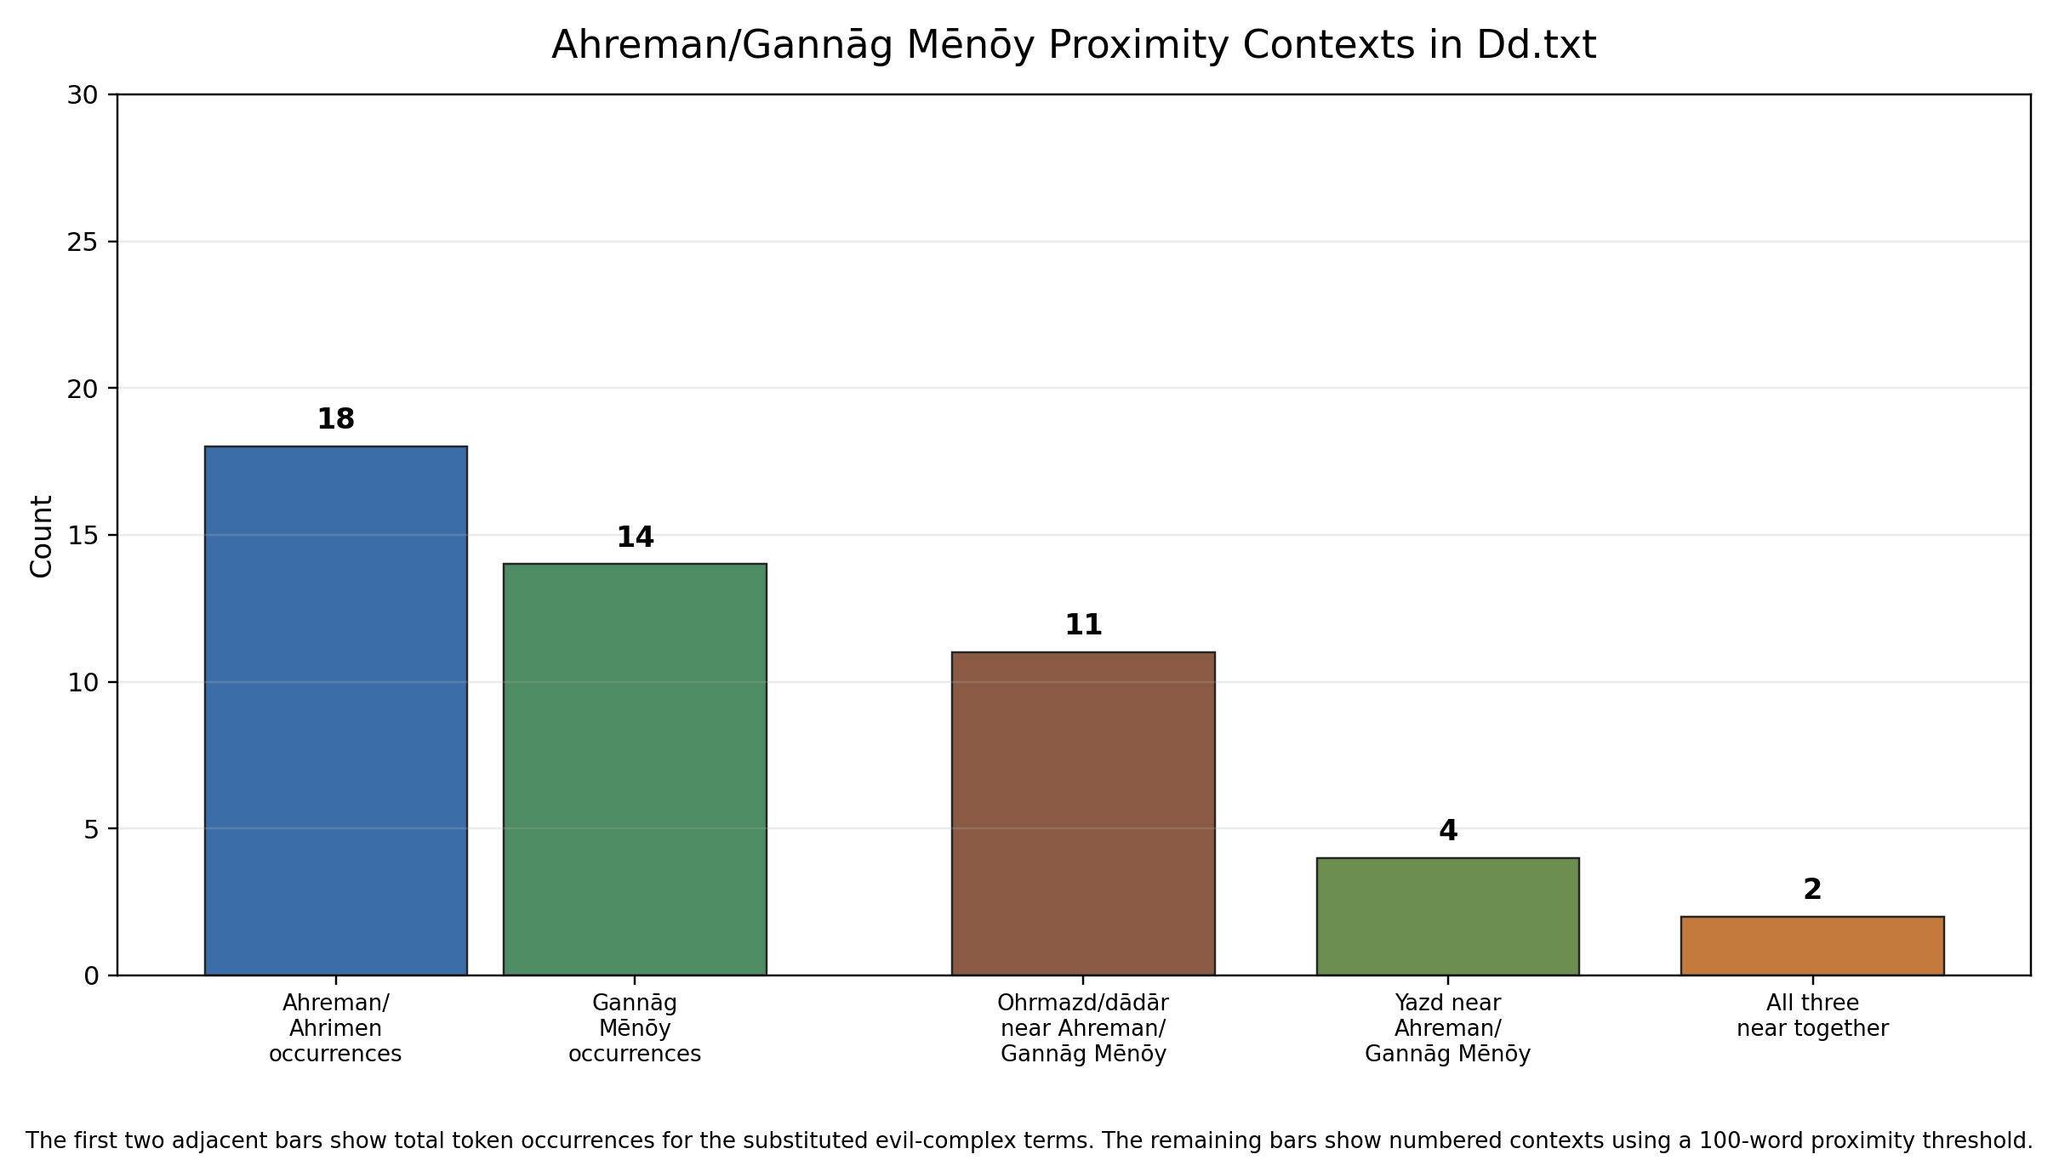

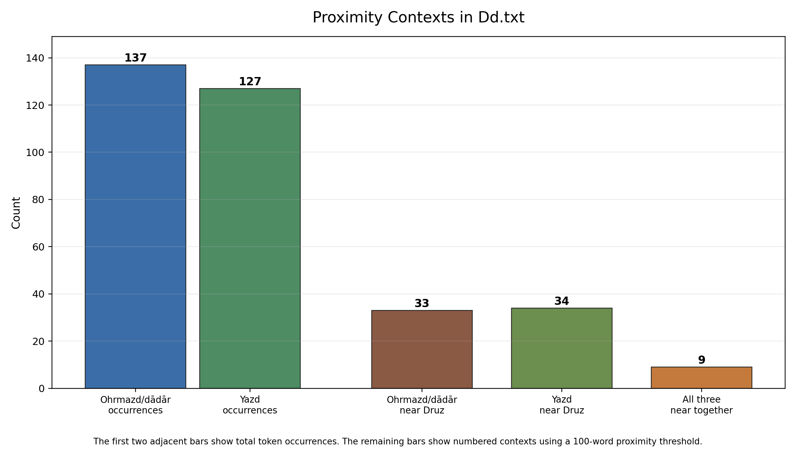
Category | Count | Measure | Numbered block/sentence labels
Ohrmazd/dādār occurrences | 137 | Token occurrences | 0.0, 0.0, 0.0, 1.1, 1.2, 1.2, 1.2, 1.3, 1.5, 1.5, 1.9, 2.2, 2.3, 2.6, 2.9, 2.10, 2.11, 2.11, 2.13d, 2.13d, 2.18, 2.18, 2.19, 3.2, 3.2, 6.2, 6.2, 6.3, 6.5, 6.8, 13.3, 13.3, 16.13e, 16.14a, 16.14b, 18.1, 18.3, 18.5, 18.5, 18.5, 18.6a, 18.6a, 18.6b, 20.5, 21.1, 21.3, 21.4, 24.3, 27.6, 28.2, 30.1, 30.3, 30.3, 30.3, 30.3, 30.4, 30.4, 30.5, 30.6, 30.6, 30.7, 30.7, 30.10, 35.7, 35.7, 36.2, 36.3, 36.4, 36.7, 36.10, 36.10, 36.12, 36.13c/19, 36.14a, 36.17b, 36.26e/37, 36.30, 36.32, 36.49, 36.49, 36.50, 36.51, 36.52, 36.53, 36.61, 36.61, 36.62, 36.68, 36.69b, 36.83, 36.86a, 36.97, 36.97, 36.98, 36.99a, 36.100a, 36.108, 36.108, 38.2a, 38.19, 38.20, 38.21, 38.21, 38.23, 38.24a, 38.24b, 38.30, 38.31a, 42.7, 47.1, 47.3, 47.22, 47.26, 51.3, 63.3, 63.3, 63.4, 64.4, 64.5, 72.3, 72.3, 74.3, 76.4, 77.18, 90.8, 90.9, 90.10, 92.13, 93.8, 93.8, 93.8, 93.10, 93.12, 93.14, 93.14, 93.14, 93.14
Yazd occurrences | 127 | Token occurrences | 0.0, 0.0, 0.0, 0.5a, 0.8, 0.9, 1.2, 1.3, 1.7, 1.9, 1.11, 1.11, 2.17, 3.2, 4.4, 4.4, 16.2, 16.14b, 21.1, 21.5, 25.2, 25.5, 25.6, 27.4, 29.2, 36.8, 36.13f/21, 36.14a, 36.18a, 36.22, 36.37, 36.45, 36.46, 36.49, 36.52, 36.53, 36.57, 36.58, 36.58, 36.59, 36.59, 36.71, 36.72, 36.73, 36.75-76, 36.75-76, 36.79b, 36.84, 36.85, 36.91, 36.99a, 38.3, 38.3, 38.7, 38.7, 38.10, 38.10, 38.10, 38.14, 38.21, 38.22, 38.22, 38.22, 38.26, 38.29, 38.30, 38.31a, 38.32, 39.2, 39.5, 39.6, 39.8, 39.15, 39.15, 40.6, 40.6, 43.7, 43.8, 44.5, 44.7, 44.7, 45.3, 46.1, 46.1, 47.4, 47.5, 47.8, 47.20, 47.21, 47.21, 47.22, 47.23, 47.24, 47.24, 47.26, 47.26, 47.29, 47.36, 47.36, 47.37, 47.38, 63.6, 64.6, 65.18, 65.23, 65.23, 70.2, 71.9, 72.3, 76.2, 76.7, 78.12, 80.10, 81.4, 84.2, 84.3, 84.5, 85.8, 86.2, 87.10, 92.3, 92.10, 92.15, 93.1, 93.1, 93.1, 93.12
Ohrmazd/dādār near Druz | 33 | Contexts within 100 words | 1.3, 1.5, 1.9, 2.11, 2.19, 6.2, 13.3, 18.6b, 21.4, 30.7, 36.4, 36.10, 36.12, 36.13c/19, 36.14a, 36.26e/37, 36.49, 36.50, 36.51, 36.52, 36.53, 36.61, 36.69b, 36.86a, 36.97, 36.99a, 38.19, 38.20, 38.30, 47.26, 74.3, 90.8, 90.10
Yazd near Druz | 34 | Contexts within 100 words | 0.5a, 0.8, 1.3, 1.9, 1.11, 36.8, 36.13f/21, 36.14a, 36.18a, 36.37, 36.45, 36.46, 36.49, 36.52, 36.53, 36.57, 36.59, 36.72, 36.73, 36.75-76, 36.79b, 36.84, 36.91, 36.99a, 38.10, 38.30, 47.4, 47.20, 47.24, 47.26, 47.36, 47.37, 76.2, 93.1
Ohrmazd/dādār + Yazd + Druz | 9 | Contexts within 100 words | 1.3, 1.9, 36.14a, 36.49, 36.52, 36.53, 36.99a, 38.30, 47.26

Ahreman/Gannāg Mēnōy Proximity Context Summary Diagram
This diagram repeats the previous proximity-summary method, but substitutes the Druz family with the Ahreman/Ahrimen and Gannāg Mēnōy complex. The evil-complex search includes Ahrimen, Ahreman, Ahrimenīg, wišuft-Ahrimenīh, Gannāg, Gannāy, Ganāy, and related written variants. Generic standalone mēnōy is not counted unless it occurs as part of a Gannāg/Gannāy expression, because mēnōy is otherwise a broad term in the text.
The first two adjacent bars show total token occurrences for Ahreman/Ahrimen and Gannāg Mēnōy separately. The remaining bars use a 100-word threshold within the same numbered sentence or paragraph block. The final category records contexts in which the Ohrmazd/dādār, yazd*, and Ahreman/Gannāg Mēnōy fields all occur close together.

Category | Count | Measure | Numbered block/sentence labels
Ahreman/Ahrimen occurrences | 18 | Token occurrences | 18.1, 18.2, 18.5, 18.5, 18.6a, 18.6b, 26.7, 36.12, 36.13e, 36.46, 64.6, 71.2, 71.2, 76.11, 76.12, 93.8, 93.8, 93.10
Gannāg Mēnōy occurrences | 14 | Token occurrences | 1.9, 2.13a, 6.3, 31.4, 31.5, 34.2, 36.31, 36.41, 36.69a, 36.83, 36.87, 36.101b, 47.2, 47.22
Ohrmazd/dādār near Ahreman/Gannāg Mēnōy | 11 | Contexts within 100 words | 1.9, 6.3, 18.1, 18.5, 18.6a, 18.6b, 36.12, 36.83, 47.22, 93.8, 93.10
Yazd near Ahreman/Gannāg Mēnōy | 4 | Contexts within 100 words | 1.9, 36.46, 47.22, 64.6
Ohrmazd/dādār + Yazd + Ahreman/Gannāg Mēnōy | 2 | Contexts within 100 words | 1.9, 47.22

I want two diagram for 200 words vicinity context of the following words and their variants:
1.
Columns: Ahreman/ganag menoy and druz; Ohrmazd-dadar and yazd
2.
Ohrmazd/dādār near Ahreman/Gannāg Mēnōy; Ohrmazd/dādār near druz
Yazd near Ahreman/Gannāg Mēnōy; yazd near druz
provide a table including
Category | Count | Measure | Numbered block/sentence labels

Explain the table and the methodology in a linguistic-philological tone and what it might indicate.
Task: check pahlavi yasna and wz
Pahlavi Yasna Colophon (Pt4) (Col-Pt4)
: apaydāgkirdan ī ahreman ud dēwān ud harw druzīh ud wattarīh
List of demonic entities: ahreman, dēwān, druzīh ud wattarīh

200-word vicinity contexts: Ahreman/Gannag Menoy, Druz, Ohrmazd/dadar, and Yazd
The following counts use a 200-word vicinity window over the running text of Dd.txt. The text was tokenised as a continuous sequence while preserving the numbered block or sentence label attached to each token. Diacritic folding was used only for matching, so forms such as Gannag/Gannay, Ohrmazd/Ormazd, dadar, Druz/droz/drow/druxt, and yazd/yazdan were counted under their respective lexical families.
Diagram 1. Lexical family columns
Ahreman/Gannag Menoy ########## 29
Druz ############################################## 137
Ohrmazd/dadar ############################################## 137
Yazd ########################################### 127
Diagram 2. 200-word pairwise vicinity contexts
Ohrmazd/dadar near Ahreman/Gannag Menoy ############# 39
Ohrmazd/dadar near Druz ############################################## 137
Yazd near Ahreman/Gannag Menoy ############ 37
Yazd near Druz ########################################### 128
Category | Count | Measure | Numbered block/sentence labels
Ahreman/Gannag Menoy | 29 | lexical occurrences in Dd.txt | 1.9, 2.13a, 18.1, 18.2, 18.5, 18.6a, 18.6b, 26.7, 31.4, 31.5, 34.2, 36.12, 36.13e, 36.41, 36.46, 36.69a, 36.83, 36.87, 36.101b, 47.22, 64.6, 71.2, 76.11, 76.12, 93.8, 93.10
Druz | 137 | lexical occurrences in Dd.txt | 0.5a, 0.8, 0.12, 0.26, 1.3, 1.5, 1.9, 1.11, 2.11, 2.19, 6.2, 13.3, 15.7, 18.6b, 21.4, 24.6, 26.2, 30.7, 31.5, 31.9, 31.10a, 32.5, 33.2b/4, 36.4, 36.8, 36.9, 36.10, 36.11a, 36.11c, 36.12, 36.13a, 36.13b, 36.13c/19, 36.13d, 36.13e, 36.13f/21, 36.14a, 36.15, 36.16, 36.18a, 36.18c/29, 36.26e/37, 36.31, 36.36, 36.37, 36.41, 36.42, 36.43, 36.45, 36.46, 36.47, 36.49, 36.50, 36.51, 36.52, 36.53, 36.57, 36.59, 36.61, 36.63, 36.64, 36.65, 36.67, 36.69a, 36.69b, 36.72, 36.73, 36.74, 36.75-76, 36.79b, 36.84, 36.86a, 36.89, 36.91, 36.94, 36.96b, 36.97, 36.99a, 36.99c, 36.101a, 36.103a, 38.10, 38.16, 38.17, 38.19, 38.20, 38.30, 41.6, 44.6, 47.2, 47.4, 47.19, 47.20, 47.24, 47.25, 47.26, 47.36, 47.37, 62.4, 63.5, 71.10, 74.3, 74.4, 76.2, 76.8, 77.12, 90.3, 90.8, 90.10, 93.1, 93.2, 93.3, 93.4
Ohrmazd/dadar | 137 | lexical occurrences in Dd.txt | 0.0, 1.1, 1.2, 1.3, 1.5, 1.9, 2.2, 2.3, 2.6, 2.9, 2.10, 2.11, 2.13d, 2.18, 2.19, 3.2, 6.2, 6.3, 6.5, 6.8, 13.3, 16.13e, 16.14a, 16.14b, 18.1, 18.3, 18.5, 18.6a, 18.6b, 20.5, 21.1, 21.3, 21.4, 24.3, 27.6, 28.2, 30.1, 30.3, 30.4, 30.5, 30.6, 30.7, 30.10, 35.7, 36.2, 36.3, 36.4, 36.7, 36.10, 36.12, 36.13c/19, 36.14a, 36.17b, 36.26e/37, 36.30, 36.32, 36.49, 36.50, 36.51, 36.52, 36.53, 36.61, 36.62, 36.68, 36.69b, 36.83, 36.86a, 36.97, 36.98, 36.99a, 36.100a, 36.108, 38.2a, 38.19, 38.20, 38.21, 38.23, 38.24a, 38.24b, 38.30, 38.31a, 42.7, 47.1, 47.3, 47.22, 47.26, 51.3, 63.3, 63.4, 64.4, 64.5, 72.3, 74.3, 76.4, 77.18, 90.8, 90.9, 90.10, 92.13, 93.8, 93.10, 93.12, 93.14
Yazd | 127 | lexical occurrences in Dd.txt | 0.0, 0.5a, 0.8, 0.9, 1.2, 1.3, 1.7, 1.9, 1.11, 2.17, 3.2, 4.4, 16.2, 16.14b, 21.1, 21.5, 25.2, 25.5, 25.6, 27.4, 29.2, 36.8, 36.13f/21, 36.14a, 36.18a, 36.22, 36.37, 36.45, 36.46, 36.49, 36.52, 36.53, 36.57, 36.58, 36.59, 36.71, 36.72, 36.73, 36.75-76, 36.79b, 36.84, 36.85, 36.91, 36.99a, 38.3, 38.7, 38.10, 38.14, 38.21, 38.22, 38.26, 38.29, 38.30, 38.31a, 38.32, 39.2, 39.5, 39.6, 39.8, 39.15, 40.6, 43.7, 43.8, 44.5, 44.7, 45.3, 46.1, 47.4, 47.5, 47.8, 47.20, 47.21, 47.22, 47.23, 47.24, 47.26, 47.29, 47.36, 47.37, 47.38, 63.6, 64.6, 65.18, 65.23, 70.2, 71.9, 72.3, 76.2, 76.7, 78.12, 80.10, 81.4, 84.2, 84.3, 84.5, 85.8, 86.2, 87.10, 92.3, 92.10, 92.15, 93.1, 93.12
Ohrmazd/dadar near Ahreman/Gannag Menoy | 39 | unique numbered blocks/sentences with at least one cross-family pair within +/-200 words; 89 token-pairs; closest Ohrmazd/Ahrimen at 2 words (18.1, 18.1) | 1.5, 1.9, 2.2, 2.6, 2.9, 2.10, 2.11, 2.13a, 2.13d, 18.1, 18.2, 18.3, 18.5, 18.6a, 18.6b, 26.7, 27.6, 36.10, 36.12, 36.13c/19, 36.13e, 36.14a, 36.46, 36.49, 36.68, 36.69a, 36.69b, 36.83, 36.86a, 36.87, 36.100a, 36.101b, 47.22, 64.4, 64.5, 64.6, 93.8, 93.10, 93.12
Ohrmazd/dadar near Druz | 137 | unique numbered blocks/sentences with at least one cross-family pair within +/-200 words; 328 token-pairs; closest dādār/Druz at 4 words (1.9, 1.9) | 0.0, 0.5a, 0.26, 1.1, 1.2, 1.3, 1.5, 1.9, 1.11, 2.2, 2.3, 2.6, 2.9, 2.10, 2.11, 2.18, 2.19, 3.2, 6.2, 6.3, 6.5, 6.8, 13.3, 18.1, 18.3, 18.5, 18.6a, 18.6b, 21.1, 21.3, 21.4, 24.3, 24.6, 30.3, 30.4, 30.5, 30.6, 30.7, 30.10, 36.2, 36.3, 36.4, 36.7, 36.8, 36.9, 36.10, 36.11a, 36.11c, 36.12, 36.13a, 36.13b, 36.13c/19, 36.13d, 36.13e, 36.13f/21, 36.14a, 36.15, 36.16, 36.17b, 36.18a, 36.18c/29, 36.26e/37, 36.30, 36.31, 36.32, 36.36, 36.37, 36.46, 36.47, 36.49, 36.50, 36.51, 36.52, 36.53, 36.57, 36.59, 36.61, 36.62, 36.63, 36.64, 36.65, 36.67, 36.68, 36.69a, 36.69b, 36.72, 36.73, 36.74, 36.75-76, 36.79b, 36.83, 36.84, 36.86a, 36.89, 36.94, 36.96b, 36.97, 36.98, 36.99a, 36.99c, 36.100a, 36.101a, 38.16, 38.17, 38.19, 38.20, 38.21, 38.23, 38.30, 38.31a, 47.1, 47.2, 47.3, 47.4, 47.19, 47.20, 47.22, 47.24, 47.25, 47.26, 62.4, 63.3, 63.4, 63.5, 64.4, 71.10, 72.3, 74.3, 74.4, 76.2, 76.4, 76.8, 90.8, 90.9, 90.10, 93.4, 93.8
Yazd near Ahreman/Gannag Menoy | 37 | unique numbered blocks/sentences with at least one cross-family pair within +/-200 words; 35 token-pairs; closest yazdān/Ahrimen at 1 words (64.6, 64.6) | 1.7, 1.9, 1.11, 26.7, 27.4, 36.13e, 36.13f/21, 36.14a, 36.37, 36.41, 36.45, 36.46, 36.49, 36.69a, 36.71, 36.72, 36.73, 36.79b, 36.83, 36.84, 36.85, 36.87, 36.91, 47.20, 47.21, 47.22, 47.23, 47.24, 47.26, 64.6, 71.2, 71.9, 76.7, 76.11, 76.12, 93.10, 93.12
Yazd near Druz | 128 | unique numbered blocks/sentences with at least one cross-family pair within +/-200 words; 306 token-pairs; closest yazdān/Druz at 3 words (47.24, 47.24) | 0.0, 0.5a, 0.8, 0.9, 0.12, 0.26, 1.2, 1.3, 1.5, 1.7, 1.9, 1.11, 2.17, 2.19, 3.2, 15.7, 16.2, 21.1, 21.4, 21.5, 24.6, 25.2, 25.5, 25.6, 26.2, 36.4, 36.8, 36.9, 36.10, 36.11a, 36.11c, 36.13b, 36.13c/19, 36.13d, 36.13e, 36.13f/21, 36.14a, 36.15, 36.16, 36.18a, 36.18c/29, 36.22, 36.31, 36.36, 36.37, 36.41, 36.42, 36.43, 36.45, 36.46, 36.47, 36.49, 36.50, 36.51, 36.52, 36.53, 36.57, 36.58, 36.59, 36.61, 36.63, 36.64, 36.65, 36.67, 36.69a, 36.69b, 36.71, 36.72, 36.73, 36.74, 36.75-76, 36.79b, 36.84, 36.85, 36.86a, 36.89, 36.91, 36.94, 36.96b, 36.97, 36.99a, 36.99c, 38.7, 38.10, 38.14, 38.16, 38.17, 38.19, 38.20, 38.21, 38.22, 38.26, 38.29, 38.30, 38.31a, 38.32, 44.5, 44.6, 44.7, 45.3, 47.2, 47.4, 47.5, 47.8, 47.19, 47.20, 47.21, 47.22, 47.23, 47.24, 47.25, 47.26, 47.29, 47.36, 47.37, 47.38, 63.5, 63.6, 71.9, 71.10, 76.2, 76.7, 76.8, 92.15, 93.1, 93.2, 93.3, 93.4

Philologically, these figures should be read as evidence of patterned lexical neighbourhoods, not as automatic proof of syntactic dependency. The first diagram shows the relative distribution of the four lexical families in the text: yazd-forms are broadly dispersed, while Ahreman/Gannag Menoy is a more restricted pole of reference. The second diagram narrows the question to local co-presence. Where Ohrmazd/dadar and yazd stand within 200 words of Ahreman/Gannag Menoy or Druz, the diction tends to stage an opposition between created/divine order and destructive or deceptive agency. The concentration of labels in and around section 36 is therefore significant: it suggests that the passage is not merely naming adversarial beings, but arranging them within a doctrinal argument about cosmic governance, assault, resistance, and final restoration.
Methodologically, the 200-word window is intentionally broader than a sentence-level collocation test. It captures the vicinity of extended Middle Persian exegetical prose, where a doctrinal point may unfold over several numbered clauses. The table therefore reports numbered contexts touched by at least one qualifying pair, while the measure column also records the underlying token-pair volume and the closest attested pair. This gives both a conservative count of affected passages and a sense of how dense the lexical juxtaposition is within those passages.

Evil Principle Analysis: Complete Findings

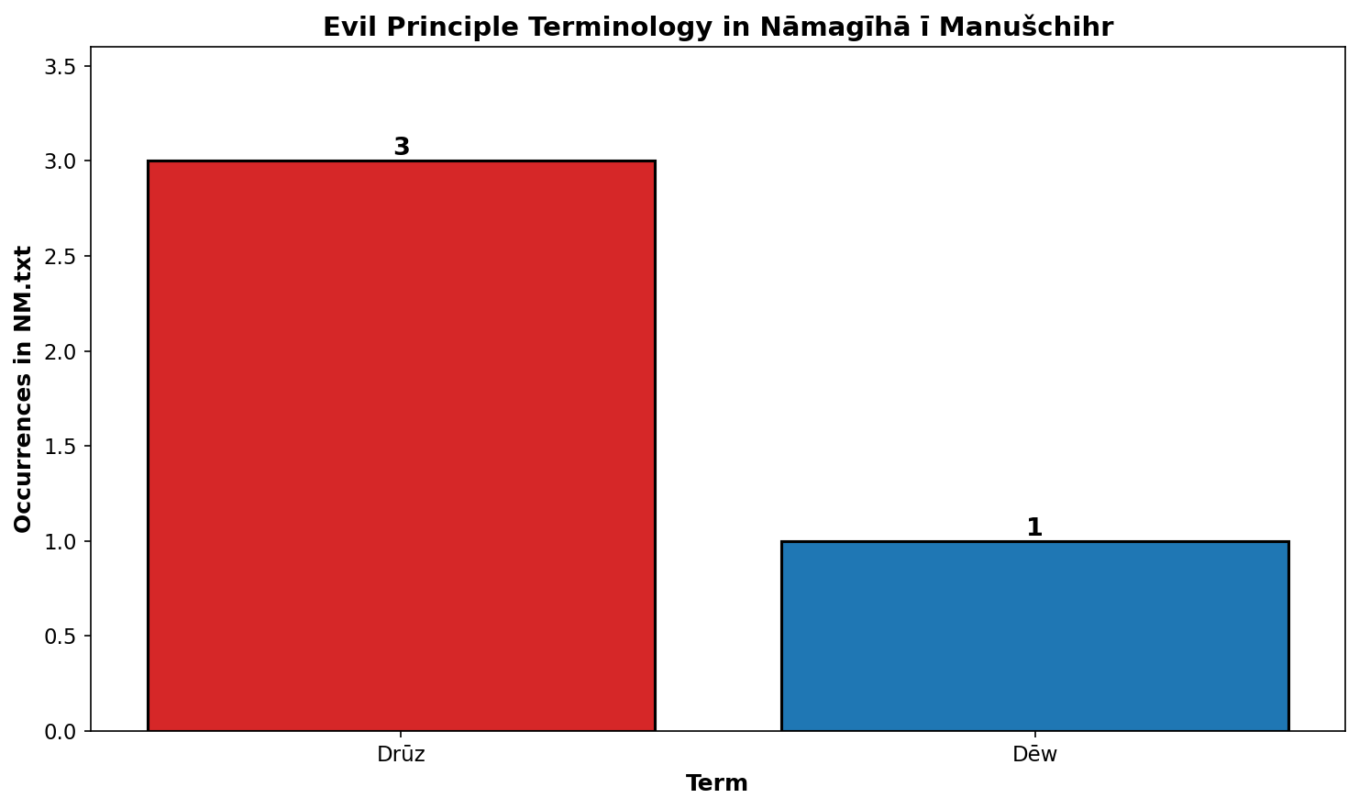

Occurrences with 200-Word Context
Term | Variant | Block.Sentence | MPCD ID | Context (200 words)
Drūz | druz | 2.1 | NM-K35 s14 | u =m garānīhā aboxšist abar xwēš hammis ī pad rašnōmand tarāzūg adrōzišn passāxt andar zūrspāhīh ī xwad ud ēč rāst nērōgīh ī hambadīg dād ēstēd ō xwāstēn kēnwišāgīh ī padīrag wasōz druz kē ōwōn wiyābāngar dušdānāg ud § purrfrēb kū =š ān =iz ī čihrīg ahlāyīhdōšīdārtom ud ōstīgān rāstīhkāmagtom dēnīg frārōnristagtom uskārišnāgāhtom ruwān škeftpahrēzišntom ud pad astxrad gōšōsrūdxrad wizīdagtom pad hamāgīhā rāstīhāhangīgtom ōwōn frēftan gumānēnīdan ast ud pad nēst nēst pad ast homānāg awi =š nimūdan tuwān
Drūz | druz | 2.6 | NM-K35 s31 | ōh =iz ka āwām ōwōn asāzīg druz ōwōn was kōxšišn ud staft zōhrārāstār ōwōn gōwišnīh ēw ī ka =iz hambāst menišn wehān pad winnārdan pattāyēnīdan ī hamfrārōn pēšag tuxšēm
Dēw | dēw | 4.3 | NM-K35 s250 | bē nē pāk ēw yōǰdāsr bē X dēw ēw pāk
Drūz | druz | 5.1 | NM-K35 s71 | bē tā rasišn ī a brādarōd sōšāns kas pad bowandag dānišn a waxr andar axwān nē ud agar nāmčišt druz pad menišn ī dēndastwarān uzmānīgtar kōxšēd tā wizīr ī dēn

Key Insights: Evil Principles in NM.txt
- Drūz (Demons) Terminology: Manuščihr uses 'druz' (demons/demonic principle) 3 times in his epistles, appearing in three distinct contextual blocks (2.1, 2.6, 5.1). These references cluster in the middle sections of his theological responses, particularly in discussions of theodicy and resistance to evil forces.
- Dēw (Daeva/Demon) Singular Form: The singular form 'dēw' appears only once (Block 4.3-4.4), in a passage discussing ritual purification and the relationship between a priest (yōǰdāsr) and a demon. This suggests Manuščihr distinguishes between plural demonic forces (druz) and individual demons (dēw).
- Absence of Ahreman and Gannāg-Mēnōy: Notably, the text does not explicitly mention 'Ahreman' (Angra Mainyu) or 'Gannāg-Mēnōy' (Evil Spirit) by these names. This absence is significant: Manuščihr's framing prioritizes 'druz' as the primary representation of evil and chaos in the 9th-century Zoroastrian theological context.
- Theological Implication: The predominance of 'druz' over other evil principle terminology suggests that for Manuščihr, evil is conceptualized primarily as a collective demonic force rather than a single cosmological principle. This aligns with Middle Persian Zoroastrian texts where druz (lie/demon) represents active opposition to Truth (asha) and the Good Creation.
- Methodological Note: This analysis is based on orthographic matching of the MPCD export (K35 manuscript). Variant spellings with diacritical marks (drūz, dēw̄, etc.) were normalized in the source. Any conclusions about theological nuance should account for possible scribal variations not captured in this digital edition.

Evil Principle Comparative Analysis: NM Findings

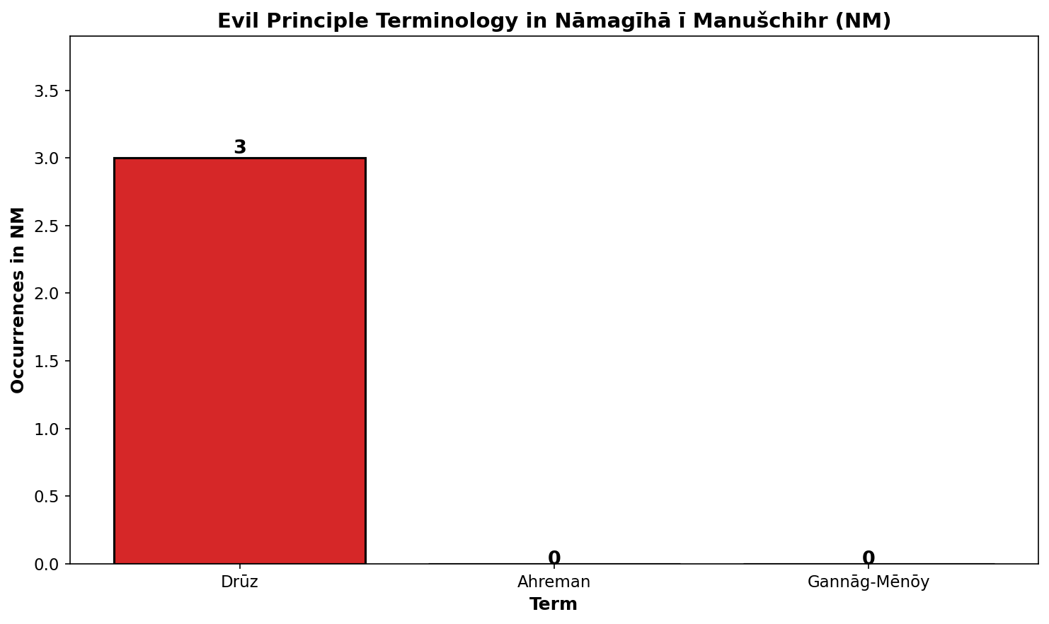

Occurrences with 200-Word Context
Term | Variant | Block.Sentence | Context (200 words)
Drūz | druz | 2.1 | u =m garānīhā aboxšist abar xwēš hammis ī pad rašnōmand tarāzūg adrōzišn passāxt andar zūrspāhīh ī xwad ud ēč rāst nērōgīh ī hambadīg dād ēstēd ō xwāstēn kēnwišāgīh ī padīrag wasōz druz kē ōwōn wiyābāngar dušdānāg ud § purrfrēb kū =š ān =iz ī čihrīg ahlāyīhdōšīdārtom ud ōstīgān rāstīhkāmagtom dēnīg frārōnristagtom uskārišnāgāhtom ruwān škeftpahrēzišntom ud pad astxrad gōšōsrūdxrad wizīdagtom pad hamāgīhā rāstīhāhangīgtom ōwōn frēftan gumānēnīdan ast ud pad nēst nēst pad ast homānāg awi =š nimūdan tuwān
Drūz | druz | 2.6 | ōh =iz ka āwām ōwōn asāzīg druz ōwōn was kōxšišn ud staft zōhrārāstār ōwōn gōwišnīh ēw ī ka =iz hambāst menišn wehān pad winnārdan pattāyēnīdan ī hamfrārōn pēšag tuxšēm
Drūz | druz | 5.1 | bē tā rasišn ī a brādarōd sōšāns kas pad bowandag dānišn a waxr andar axwān nē ud agar nāmčišt druz pad menišn ī dēndastwarān uzmānīgtar kōxšēd tā wizīr ī dēn

Key Insights: Evil Principles in NM
- Drūz (Demons) Terminology: Manuščihr uses 'druz' (demons/demonic principle) 3 times in his epistles, appearing in three distinct contextual blocks (2.1, 2.6, 5.1). These references cluster in the middle sections of his theological responses, particularly in discussions of theodicy and resistance to evil forces.
- Absence of Ahreman: Notably, the text does not explicitly mention 'Ahreman' (Angra Mainyu) by this name. This absence is significant and suggests that Manuščihr's framing prioritizes 'druz' as the primary representation of evil and chaos in the 9th-century Zoroastrian theological context.
- Absence of Gannāg-Mēnōy: Similarly, 'Gannāg-Mēnōy' (Evil Spirit) does not appear in the preserved NM corpus. This further confirms the primacy of druz terminology in Manuščihr's theological vocabulary.
- Theological Implication: The predominance of 'druz' over other evil principle terminology suggests that for Manuščihr, evil is conceptualized primarily as a collective demonic force rather than a single cosmological principle. This aligns with Middle Persian Zoroastrian texts where druz (lie/demon) represents active opposition to Truth (asha) and the Good Creation.
- Methodological Note: This analysis is based on orthographic matching of the MPCD K35 manuscript export. Variant spellings with diacritical marks (drūz, etc.) were normalized in the source. Any conclusions about theological nuance should account for possible scribal variations not captured in this digital edition.

Occurrence Comparison of Selected Demonological Terms
This section compares the distribution of three lexical groups across Dd, GBd, NM, PRDd, and PY-Ptf: Ahrimen/Ahreman variants, druz variants, and the proper-name forms Gannāg Mēnōy/Gannāg. The chart presents raw occurrence totals; the linear label sequences below identify the numbered blocks or sentence records in which the occurrences are located.
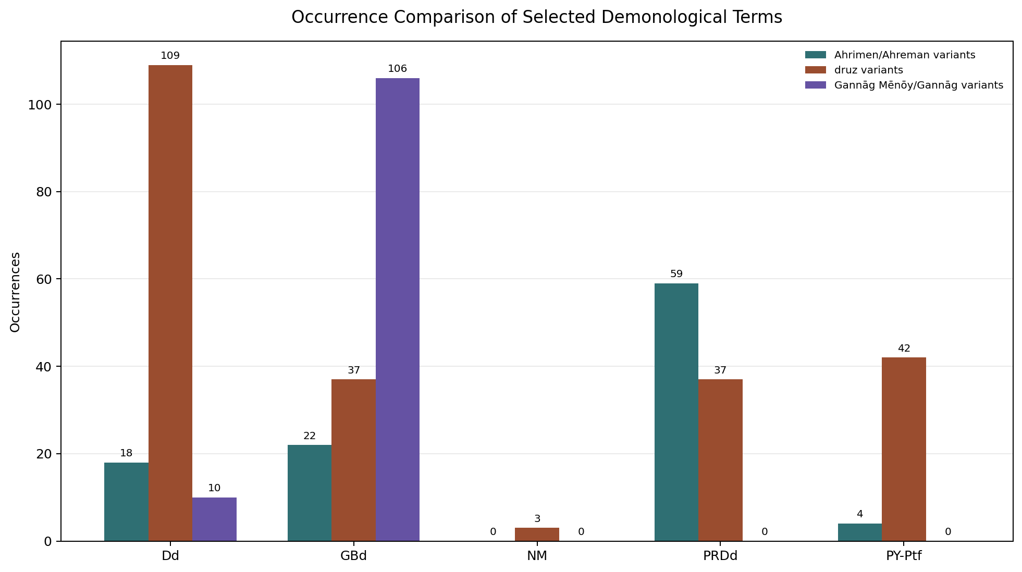

Raw Occurrence Counts
File | Ahrimen/Ahreman variants | druz variants | Gannāg Mēnōy/Gannāg variants
Dd | 18 | 109 | 10
GBd | 22 | 37 | 106
NM | 0 | 3 | 0
PRDd | 59 | 37 | 0
PY-Ptf | 4 | 42 | 0

Linear Numbered Block/Sentence Labels
Abbreviations in parentheses: Ahr = Ahrimen/Ahreman variants; druz = druz variants; Gan = Gannāg Mēnōy/Gannāg variants. The number following each abbreviation is the number of occurrences in that labelled unit.

Dd
0.5a (druz=1) -> 0.8 (druz=1) -> 0.12 (druz=1) -> 0.26 (druz=1) -> 1.3 (druz=1) -> 1.5 (druz=1) -> 1.9 (druz=2, Gan=1) -> 1.11 (druz=1) -> 2.11 (druz=1) -> 2.13a (Gan=1) -> 2.19 (druz=1) -> 6.2 (druz=1) -> 6.3 (Gan=1) -> 13.3 (druz=2) -> 15.7 (druz=1) -> 18.1 (Ahr=1) -> 18.2 (Ahr=1) -> 18.5 (Ahr=2) -> 18.6a (Ahr=1) -> 18.6b (Ahr=1, druz=1) -> 21.4 (druz=1) -> 24.6 (druz=1) -> 26.2 (druz=1) -> 26.7 (Ahr=1) -> 30.7 (druz=1) -> 31.5 (druz=1, Gan=1) -> 31.9 (druz=1) -> 31.10a (druz=2) -> 32.5 (druz=1) -> 34.2 (Gan=1) -> 36.4 (druz=1) -> 36.9 (druz=1) -> 36.10 (druz=1) -> 36.11a (druz=2) -> 36.12 (Ahr=1, druz=2) -> 36.13a (druz=1) -> 36.13b (druz=1) -> 36.13c/19 (druz=1) -> 36.13d (druz=1) -> 36.13e (Ahr=1, druz=2) -> 36.15 (druz=1) -> 36.16 (druz=1) -> 36.18a (druz=1) -> 36.18c/29 (druz=1) -> 36.26e/37 (druz=1) -> 36.31 (druz=3) -> 36.36 (druz=1) -> 36.37 (druz=1) -> 36.41 (Gan=1) -> 36.43 (druz=1) -> 36.45 (druz=1) -> 36.46 (Ahr=1, druz=1) -> 36.47 (druz=1) -> 36.49 (druz=1) -> 36.50 (druz=1) -> 36.51 (druz=1) -> 36.52 (druz=1) -> 36.53 (druz=1) -> 36.57 (druz=2) -> 36.59 (druz=1) -> 36.61 (druz=1) -> 36.63 (druz=1) -> 36.64 (druz=2) -> 36.65 (druz=1) -> 36.67 (druz=1) -> 36.69a (druz=1, Gan=1) -> 36.69b (druz=1) -> 36.79b (druz=1) -> 36.83 (Gan=1) -> 36.84 (druz=2) -> 36.86a (druz=1) -> 36.87 (Gan=1) -> 36.89 (druz=1) -> 36.91 (druz=1) -> 36.94 (druz=1) -> 36.96b (druz=1) -> 36.97 (druz=1) -> 36.99a (druz=1) -> 36.99c (druz=2) -> 36.101a (druz=1) -> 36.101b (Gan=1) -> 36.103a (druz=1) -> 38.16 (druz=2) -> 38.17 (druz=1) -> 38.19 (druz=1) -> 38.30 (druz=1) -> 41.6 (druz=1) -> 47.2 (druz=1) -> 47.4 (druz=1) -> 47.24 (druz=1) -> 47.26 (druz=1) -> 47.37 (druz=1) -> 63.5 (druz=1) -> 64.6 (Ahr=1) -> 71.2 (Ahr=2) -> 71.10 (druz=1) -> 74.3 (druz=1) -> 74.4 (druz=1) -> 76.2 (druz=1) -> 76.8 (druz=1) -> 76.11 (Ahr=1) -> 76.12 (Ahr=1) -> 90.3 (druz=1) -> 90.8 (druz=1) -> 90.10 (druz=1) -> 93.1 (druz=3) -> 93.2 (druz=1) -> 93.3 (druz=1) -> 93.4 (druz=2) -> 93.8 (Ahr=2) -> 93.10 (Ahr=1)

GBd
1.0 (Gan=1) -> 1.3 (Ahr=1) -> 1.12 (Ahr=1) -> 1.13 (Gan=1) -> 1.15 (Gan=1) -> 1.17 (druz=1) -> 1.18 (Gan=1) -> 1.19 (Gan=1) -> 1.20 (Gan=2) -> 1.22 (Gan=1) -> 1.24 (Gan=1) -> 1.25 (Gan=1) -> 1.26 (Gan=2) -> 1.27 (Gan=1) -> 1.28 (Ahr=1, Gan=1) -> 1.29 (Gan=2) -> 1.30 (Gan=1) -> 1.31 (Gan=3) -> 1.36 (Ahr=1, Gan=1) -> 1.38 (Gan=1) -> 1.40 (Ahr=1) -> 1.41 (Ahr=1, Gan=1) -> 1.42 (Gan=1) -> 1.47 (Gan=1) -> 1.49 (Gan=1) -> 1.52 (Gan=1) -> 1.53 (Gan=1) -> 1.55 (Gan=2) -> 1.56 (Ahr=1) -> 1.57 (Gan=1) -> 1.59 (druz=1, Gan=4) -> 3.2 (Gan=1) -> 3.5 (Gan=2) -> 3.23 (druz=2) -> 3.24 (Ahr=1, druz=1) -> 4.1 (Gan=1) -> 4.4 (Gan=1) -> 4.5 (Gan=1) -> 4.6 (Gan=1) -> 4.7 (Gan=2) -> 4.8 (Gan=1) -> 4.9 (Gan=1) -> 4.10 (Gan=1) -> 4.12 (Gan=1) -> 4.24 (Gan=1) -> 4.25 (Gan=1) -> 4.27 (Gan=1) -> 4.28 (Gan=3) -> 5.1 (Ahr=1) -> 5.2 (druz=1) -> 5.3 (Ahr=1, druz=2) -> 5.8 (druz=2, Gan=14) -> 1.4314 (Gan=1) -> 7.1 (Gan=1) -> 7.4 (Gan=1) -> 7.10 (Gan=2) -> 8.6 (Gan=2) -> 8.7 (druz=2) -> 9.10 (druz=1) -> 11.7 (druz=1) -> 11.9 (Ahr=1) -> 13.29 (Gan=2) -> 13.30 (Gan=1) -> 14.15 (Gan=1) -> 14.16 (Gan=1) -> 18.17 (druz=1) -> 19.3 (Gan=1) -> 21.1 (Gan=1) -> 21.4 (Gan=1) -> 22.4 (Ahr=1) -> 23.1 (Gan=1) -> 23.3 (Gan=1) -> 23.6 (druz=1, Gan=2) -> 23.7 (Gan=1) -> 23.8 (druz=1) -> 24.2 (Gan=1) -> 24.4 (Gan=1) -> 24.19 (Gan=1) -> 24.49 (druz=1) -> 24.51 (druz=1) -> 24.53 (druz=1) -> 26.16 (Ahr=1) -> 26.34 (Gan=1) -> 26.44 (druz=1) -> 26.59 (druz=1) -> 26.76 (Gan=1) -> 26.95 (Gan=1) -> 26.110 (druz=1) -> 26.111 (Gan=1) -> 27.0 (Ahr=1) -> 27.1 (Gan=1) -> 27.2 (Gan=1) -> 27.3 (Ahr=1) -> 27.4 (Gan=1) -> 27.13 (druz=1) -> 27.15 (druz=1) -> 27.16 (druz=1) -> 27.24 (druz=1) -> 27.25 (Ahr=1) -> 27.32 (druz=1) -> 27.33 (druz=1) -> 27.41 (druz=1) -> 27.46 (druz=1) -> 27.48 (druz=1, Gan=1) -> 27.49 (Gan=1) -> 27.52 (Ahr=1, druz=1) -> 28.11 (druz=1) -> 28.12 (Ahr=1) -> 28.18 (druz=1) -> 31.3 (Gan=1) -> 33.1 (Gan=1) -> 33.32 (druz=1) -> 34.27 (Gan=1) -> 34.28 (Ahr=1, druz=1) -> 34.30 (Gan=1) -> 34.31 (Gan=1) -> 35.7 (Gan=1) -> 36.10 (Ahr=3)

NM
NM-K35 s14 / NM1 2.1 (druz=1) -> NM-K35 s31 / NM1 2.6 (druz=1) -> NM-K35 s71 / NM1 5.1 (druz=1)

PRDd
5.1 (Ahr=1) -> 6.3 (druz=1) -> 6.4 (druz=1) -> 7.6 (Ahr=7, druz=2) -> 9.2 (Ahr=2) -> 9.7 (Ahr=1) -> 9.8 (Ahr=1) -> 9.16 (Ahr=1) -> 12.1 (druz=1) -> 12.6 (Ahr=5) -> 14.7 (Ahr=8) -> 20.4 (Ahr=2) -> 23.19 (Ahr=1) -> 23.23 (Ahr=2) -> 23.27 (Ahr=1) -> 23.33 (Ahr=1) -> 23.36 (Ahr=1) -> 30.4 (Ahr=3) -> 32.1 (Ahr=2) -> 32.5 (Ahr=7) -> 36.6 (Ahr=1) -> 45.1 (Ahr=1) -> 46.6 (Ahr=1) -> 46.9 (druz=1) -> 46.15 (Ahr=1) -> 46.36 (Ahr=1) -> 48.7 (druz=3) -> 48.8 (druz=1) -> 48.9 (druz=2) -> 48.17 (druz=1) -> 48.28 (druz=2) -> 48.29 (druz=2) -> 48.73 (druz=1) -> 48.74 (druz=2) -> 48.76 (druz=1) -> 48.77 (druz=1) -> 48.80 (druz=1) -> 48.83 (druz=2) -> 48.87 (druz=1) -> 48.89 (druz=2) -> 49.18 (Ahr=1) -> 56.8 (Ahr=1) -> 56.14 (Ahr=1) -> 56.16 (Ahr=1) -> 62.10 (druz=3) -> 62.17 (Ahr=1) -> 64.19 (druz=1) -> 65.14 (Ahr=3, druz=3) -> 65.15 (druz=2)

PY-Ptf
PY-Pt4 s575 / caby_ch9_st8 (druz=1) -> PY-Pt4 s576 / caby_ch9_st8 (druz=2) -> PY-Pt4 s619 / caby_ch9_st17 (druz=1) -> PY-Pt4 s626 / caby_ch9_st20 (druz=1) -> PY-Pt4 s627 / caby_ch9_st20 (druz=1) -> PY-Pt4 s1455 / caby_ch29_st8 (druz=1) -> PY-Pt4 s1495 / caby_ch30_st4 (Ahr=1) -> PY-Pt4 s1498 / caby_ch30_st5 (Ahr=1) -> PY-Pt4 s1512 / caby_ch30_st8 (druz=2) -> PY-Pt4 s1517 / caby_ch30_st10 (druz=1) -> PY-Pt4 s1535 / caby_ch31_st1 (druz=2) -> PY-Pt4 s1548 / caby_ch31_st4 (druz=1) -> PY-Pt4 s1549 / caby_ch31_st4 (druz=1) -> PY-Pt4 s1764 / caby_ch33_st12 (Ahr=1) -> PY-Pt4 s2202 / caby_ch44_st13 (druz=2) -> PY-Pt4 s2208 / caby_ch44_st14 (druz=2) -> PY-Pt4 s2334 / caby_ch46_st6 (druz=2) -> PY-Pt4 s2337 / caby_ch46_st7 (Ahr=1) -> PY-Pt4 s2358 / caby_ch46_st11 (druz=1) -> PY-Pt4 s2447 / caby_ch48_st1 (druz=1) -> PY-Pt4 s2520 / caby_ch49_st3 (druz=1) -> PY-Pt4 s2556 / caby_ch49_st11 (druz=2) -> PY-Pt4 s2657 / caby_ch51_st10 (druz=1) -> PY-Pt4 s2675 / caby_ch51_st14 (druz=1) -> PY-Pt4 s2758 / caby_ch53_st6 (druz=1) -> PY-Pt4 s2759 / caby_ch53_st6 (druz=2) -> PY-Pt4 s2876 / caby_ch57_st23 (druz=1) -> PY-Pt4 s3090 / caby_ch60_st7 (druz=1) -> PY-Pt4 s3107 / caby_ch61_st2 (druz=1) -> PY-Pt4 s3108 / caby_ch61_st5 (druz=4) -> PY-Pt4 s3570 / caby_ch72_st2 (druz=1) -> PY-Pt4 s3571 / caby_ch72_st5 (druz=4)

Methodology
The comparison was produced by reading the five UTF-8 text files and applying case-insensitive regular-expression searches to two lexical groups: Ahrimen/Ahreman and druz/druj. The Gannāg Mēnōy/Gannāg group was searched as a proper-name category, restricted to the capitalized forms Ganāg, Gannāg, Ganāy, and Gannāy, with or without following Mēnōy; this prevents ordinary adjectival or unrelated forms such as gandag from being counted as references to the named figure. Hyphenated and suffixed druz/druj forms were included because they belong to the same visible lexical family in the transcriptions. Each occurrence was assigned to the nearest preceding numbered block or sentence label: direct block numbers for Dd, GBd, and PRDd, and sentence/paragraph identifiers for NM and PY-Ptf.

Interpretive Note
The distribution is uneven. GBd contains by far the densest concentration of Gannāg Mēnōy/Gannāg forms, reflecting the text's sustained cosmological narration of the destructive spirit. PRDd is dominated instead by Ahreman forms, while Dd shows the broadest spread of druz terminology across many labelled units. NM has only sparse attestations in the selected categories, and PY-Ptf registers a modest ritual distribution of ahreman and druz forms without Gannāg Mēnōy/Gannāg. The linear labels should therefore be read not as a syntactic analysis, but as a locational index that makes the chart auditable against the numbered textual units.

