Assignment 17

CREATE TABLE EMPLOYEE3 (EMP_ID INT PRIMARY KEY,EMP_DEP VARCHAR(20),BASIC_SALARY INT,CONSALARY INT,BONUS INT,TAX INT,NET_SALARY INT);

INSERT INTO EMPLOYEE3 (EMP_ID,EMP_DEP,BASIC_SALARY) VALUES (1,'CSE',78100);

INSERT INTO EMPLOYEE3 (EMP_ID,EMP_DEP,BASIC_SALARY) VALUES (2,'AI',18145);

INSERT INTO EMPLOYEE3 (EMP_ID,EMP_DEP,BASIC_SALARY) VALUES (3,'ML',30000);

INSERT INTO EMPLOYEE3 (EMP_ID,EMP_DEP,BASIC_SALARY) VALUES (4,'CSE',20000);

INSERT INTO EMPLOYEE3 (EMP_ID,EMP_DEP,BASIC_SALARY) VALUES (5,'ECE',38000);

SELECT *FROM EMPLOYEE3 ORDER BY EMP_ID;

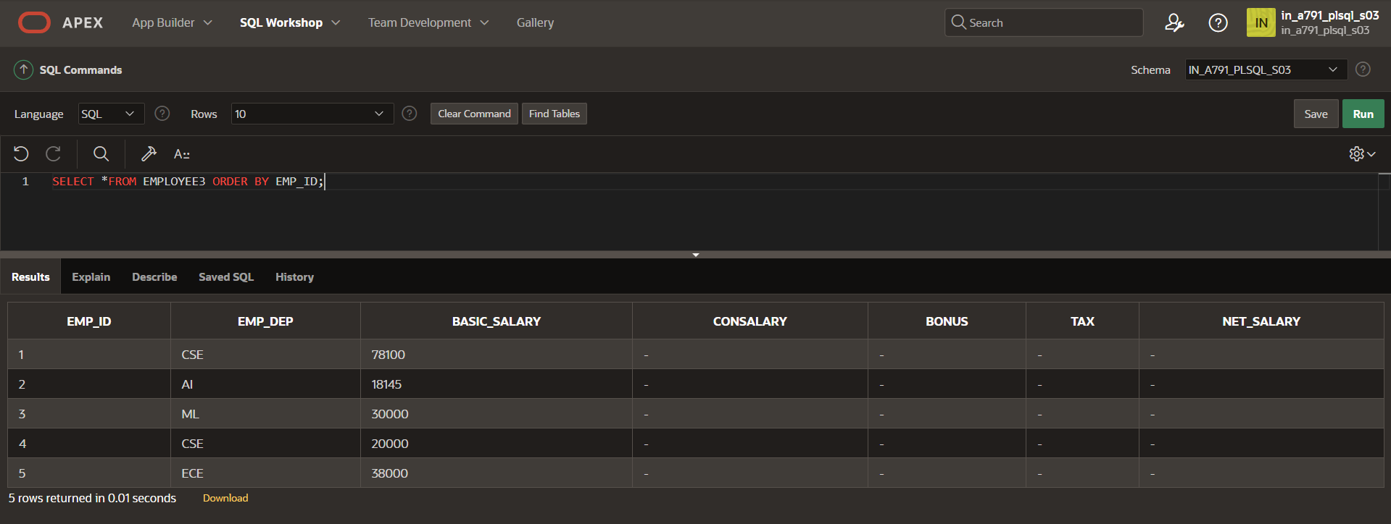

UPDATE EMPLOYEE3 SET BONUS=BASIC_SALARY*0.25 where EMP_DEP = 'CSE';

UPDATE EMPLOYEE3 SET BONUS=0 where EMP_DEP != 'CSE';

SELECT *FROM EMPLOYEE3 ORDER BY EMP_ID;

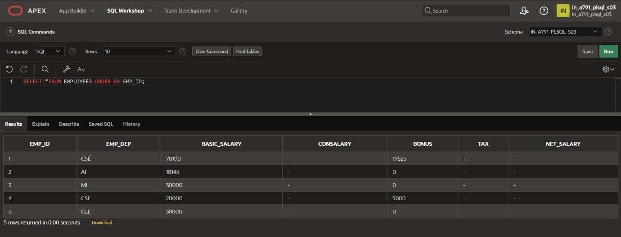

DECLARE

CURSOR cemp IS SELECT EMP_ID, BASIC_SALARY, BONUS FROM EMPLOYEE3;

v_emp_id EMPLOYEE3.EMP_ID%TYPE;

v_basic_salary EMPLOYEE3.BASIC_SALARY%TYPE;

v_bonus EMPLOYEE3.BONUS%TYPE;

v_tax EMPLOYEE3.TAX%TYPE;

v_consalary EMPLOYEE3.CONSALARY%TYPE;

v_net_salary EMPLOYEE3.NET_SALARY%TYPE;

BEGIN

OPEN cemp;

LOOP

FETCH cemp INTO v_emp_id, v_basic_salary, v_bonus;

EXIT WHEN cemp%NOTFOUND;

IF v_basic_salary < 20000 THEN

v_tax := 0.1 * v_basic_salary;

v_consalary := 0.12 * v_basic_salary;

ELSIF v_basic_salary >= 20000 AND v_basic_salary < 50000 THEN

v_tax := 0.2 * v_basic_salary;

v_consalary := 0.16 * v_basic_salary;

ELSE

v_tax := 0.3 * v_basic_salary;

v_consalary := 0.21 * v_basic_salary;

END IF;

v_net_salary := v_basic_salary + v_consalary + v_bonus - v_tax;

UPDATE EMPLOYEE3

SET TAX = v_tax,

CONSALARY = v_consalary,

NET_SALARY = v_net_salary

WHERE EMP_ID = v_emp_id;

END LOOP;

CLOSE cemp;

END;

/

SELECT *FROM EMPLOYEE3 ORDER BY EMP_ID;

