DIMENSIONALITY REDUCTION
& UNSUPERVISED CLUSTERING
PCA • K-Means • DBSCAN • Hierarchical Clustering
Project Report | Reproducible analysis using the Scikit-learn Wine dataset

1. Executive Summary
This project applies Principal Component Analysis (PCA) and three unsupervised clustering methods to the 13 numerical measurements in the Scikit-learn Wine dataset (178 observations). Features were standardized before PCA and clustering. PCA retained 10 components to preserve at least 95% of total variance (96.17%). K-Means was evaluated for k=2 through 10 using inertia and silhouette score; the highest tested silhouette occurred at k=3 (0.299). DBSCAN and Ward-linkage hierarchical clustering were also evaluated. The analysis demonstrates both the usefulness and limitations of clustering: results depend on representation, distance metric, and hyperparameters, and clusters should not automatically be interpreted as true classes.

2. Objectives and Requirements
- Standardize high-dimensional numerical features and perform PCA.
- Plot the explained variance ratio scree plot and select a defensible number of components.
- Apply K-Means and determine k using the Elbow Method and Silhouette Score.
- Apply DBSCAN and Hierarchical (agglomerative/Ward) clustering.
- Visualize cluster projections in 2D and 3D using Seaborn/Matplotlib; provide Plotly visualization code in the notebook.
- Compare methods, interpret findings, and document limitations.

3. Dataset and Preprocessing
The Wine dataset bundled with Scikit-learn contains 178 samples, 13 continuous chemical measurements, and a three-class reference target. The target labels are not used to fit PCA or the clustering models; they are used only after fitting for optional external validation. This prevents supervised labels from influencing the unsupervised assignments.
All 13 input columns are numerical. The notebook checks missing values, applies median imputation as a defensive preprocessing step, and standardizes each feature using z-scores (mean 0, standard deviation 1). Scaling is essential because measurements have different units and ranges, and PCA/K-Means use variance or distance calculations that are scale-sensitive.
Dataset dimensions: 178 rows × 13 features. Missing values in the supplied dataset: 0.

4. Principal Component Analysis
PCA was fitted to the standardized feature matrix. Components are orthogonal linear combinations of the original variables, ordered by the amount of variance they explain. The scree plot shows individual and cumulative explained variance. The selection rule used here is the smallest number of components reaching at least 95% cumulative explained variance: 10 components (96.17%). For context, 8 components reach 90% variance.
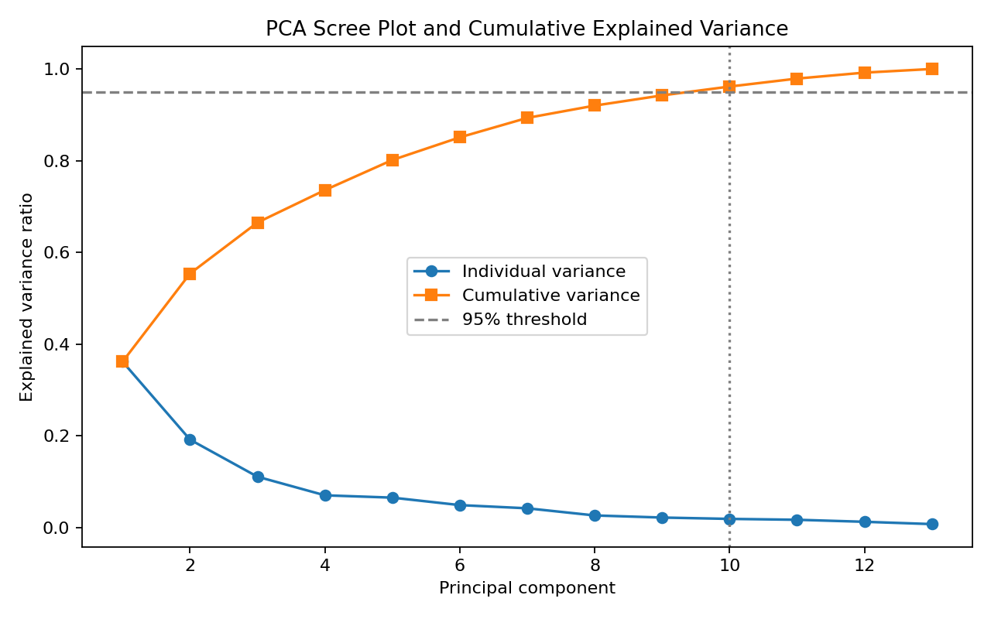
Figure 1. Individual and cumulative PCA explained variance.

5. K-Means Clustering and Selection of k
K-Means was run on the first 10 PCA components, with k ranging from 2 to 10. Each fit used k-means++ initialization, 20 initializations, and a fixed random seed for reproducibility. Inertia measures within-cluster squared distances and generally decreases as k increases; the elbow plot is used to look for diminishing returns. Silhouette score measures separation and cohesion, with higher values generally indicating better-defined clusters.
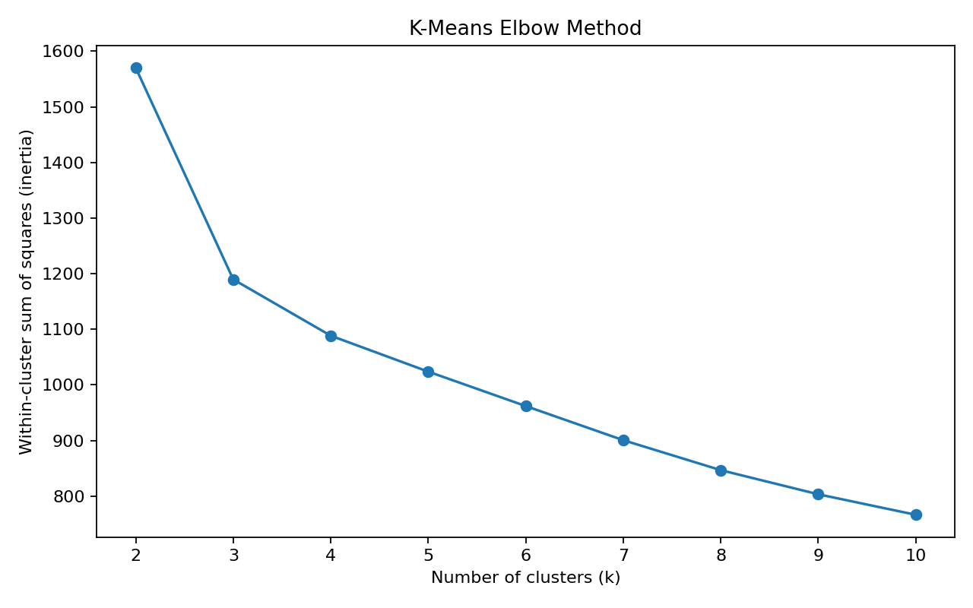
Figure 2. K-Means elbow curve.
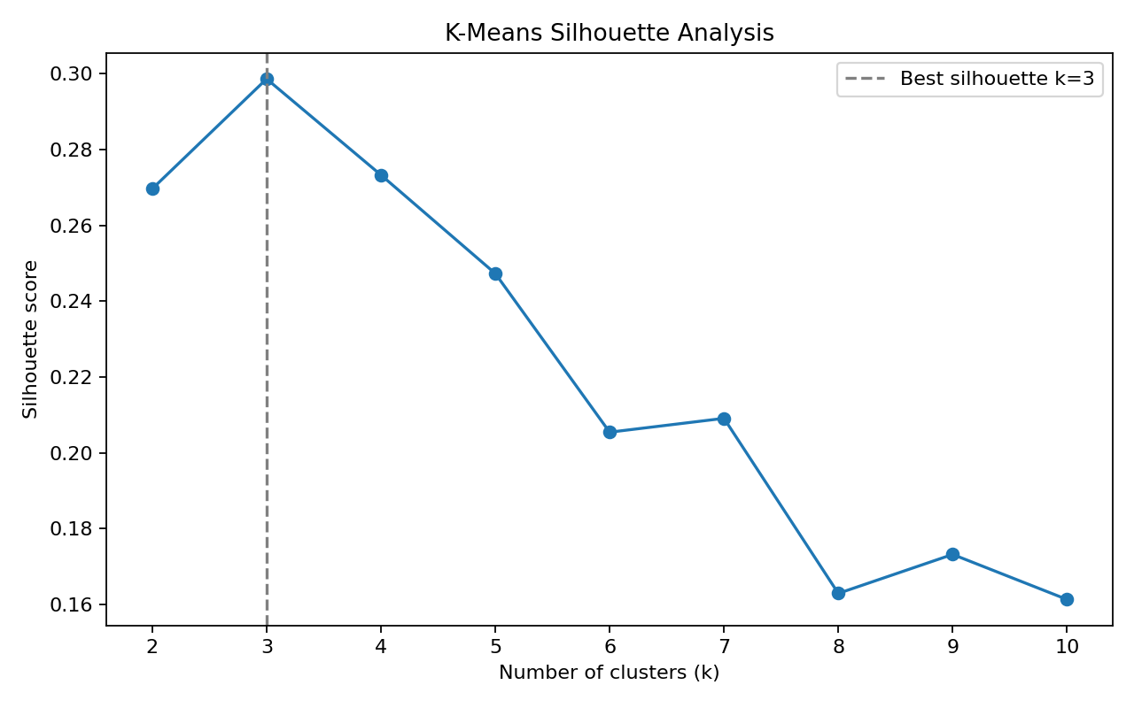
Figure 3. Silhouette score across candidate k values.
The highest silhouette among tested values was at k=3, score=0.299. This is a data-driven selection within the tested range, not proof that this is the uniquely correct number of natural groups. The elbow curve should be inspected alongside the silhouette results.
Final K-Means internal metrics: silhouette=0.299, Davies–Bouldin=1.336, Calinski–Harabasz=76.2. Higher silhouette and Calinski–Harabasz are generally preferable; lower Davies–Bouldin is generally preferable.

6. DBSCAN Clustering
DBSCAN is a density-based algorithm that can identify irregularly shaped groups and mark low-density observations as noise (-1). It does not require a preset cluster count. The notebook tests eps values from 1.0 to 3.0 with min_samples=5 on the same PCA representation. The scan is reported rather than hiding the sensitivity of the result to eps.
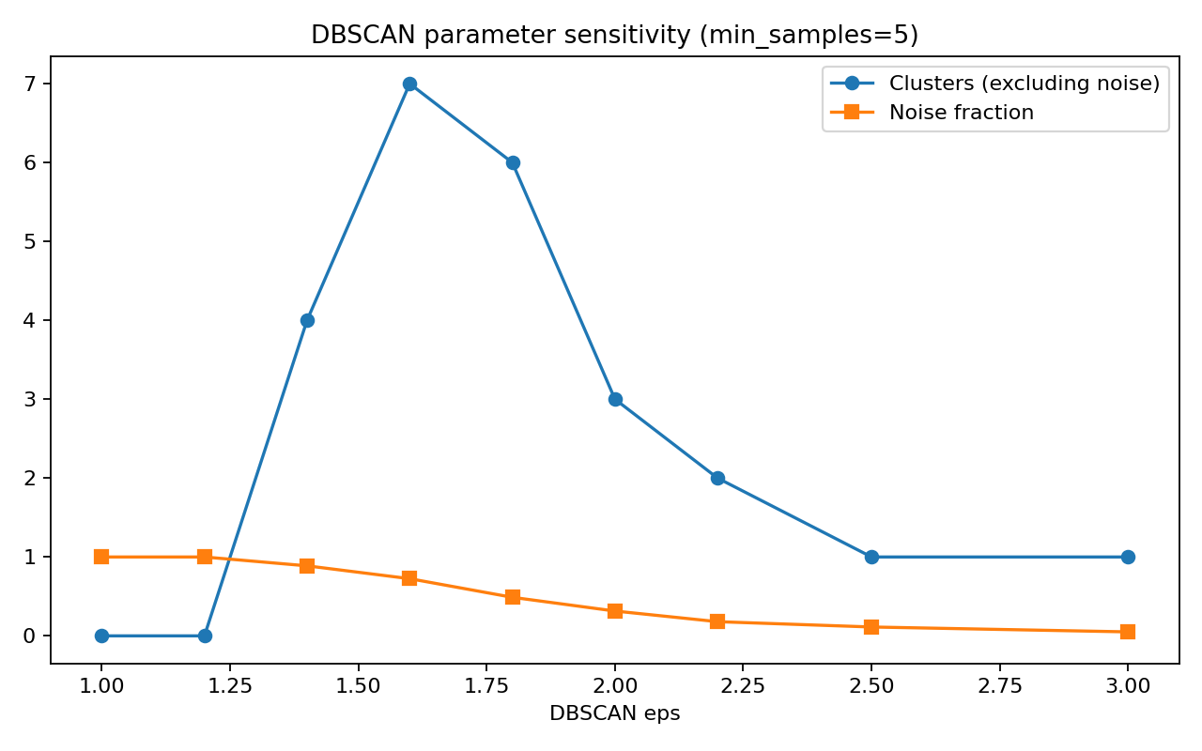
Figure 4. DBSCAN cluster count and noise fraction across eps values.
At eps=1.4, DBSCAN produced 4 clusters excluding noise, with 88.8% of observations marked as noise; silhouette on non-noise points was 0.557. This parameter choice maximizes the reported non-noise silhouette among tested settings that produced at least two clusters, but its high noise fraction makes it unsuitable as a blanket best solution. Density-based results should be judged using both cluster quality and coverage.

7. Hierarchical Clustering
Agglomerative hierarchical model with Ward linkage was fitted to the PCA representation and cut into 3 clusters to allow a like-for-like cluster-count comparison with the selected K-Means solution. Ward linkage greedily merges groups while minimizing the increase in within-cluster variance. A dendrogram is included in the notebook to inspect the merge structure and alternative cut levels.
Adjusted Rand Index against the reference labels (post-hoc only): K-Means=0.897; Hierarchical=0.759. These external scores are descriptive comparisons, not training targets.

8. Cluster Visualizations
The following plots show K-Means assignments projected onto the first two and first three principal components. PCA projections are useful for visual inspection but can hide separation that exists in the full retained component space. The notebook also contains interactive Plotly 2D and 3D scatter plots.
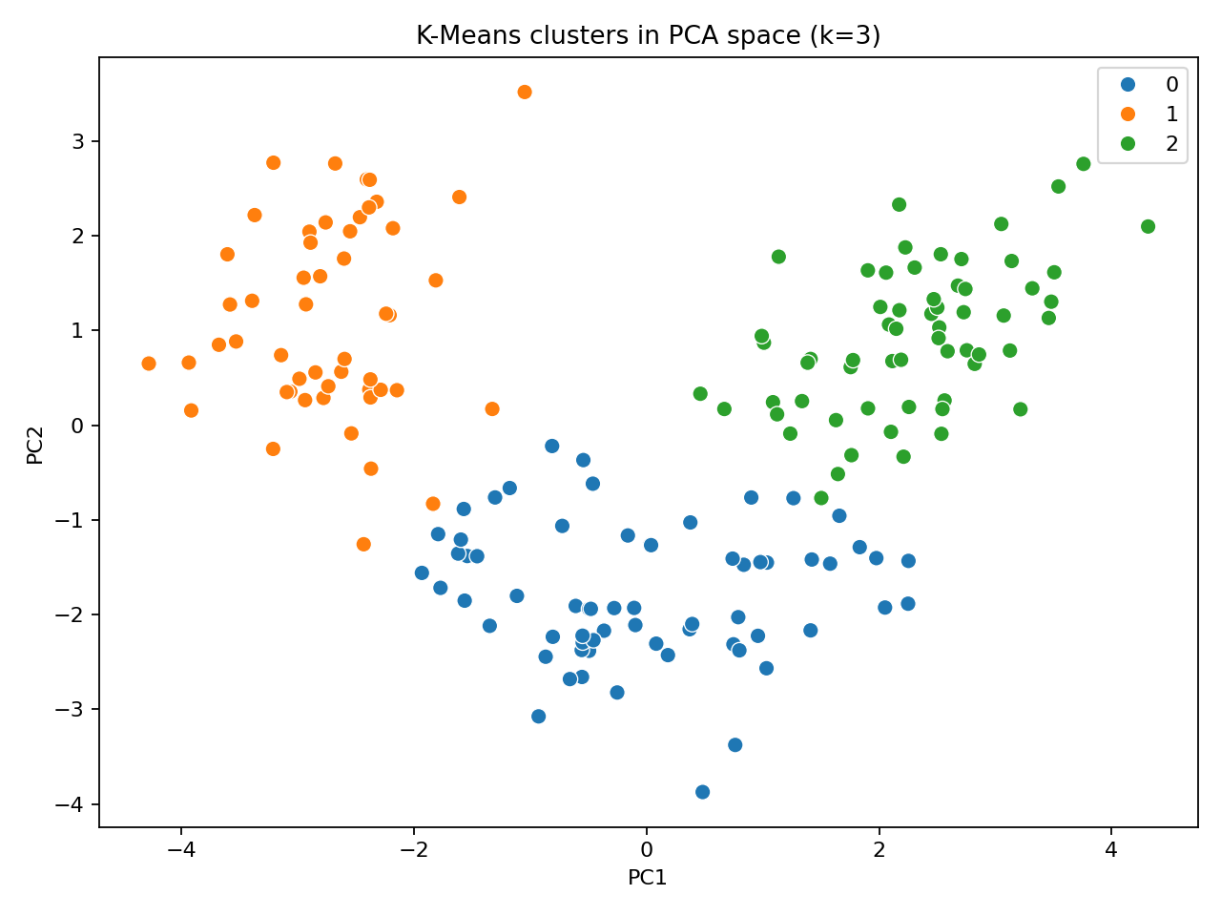
Figure 5. K-Means assignments in the first two principal components.
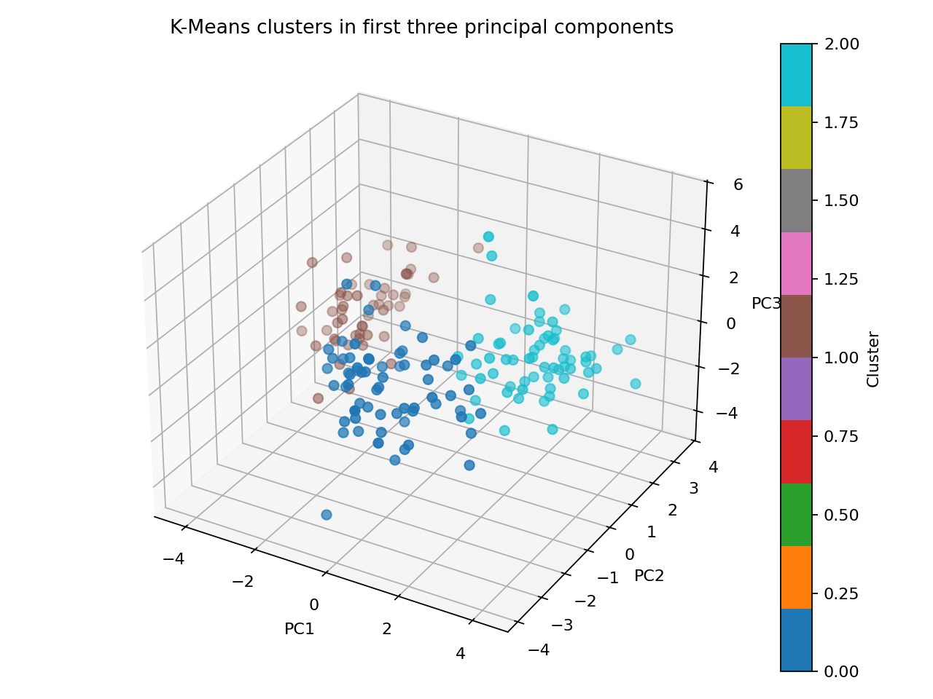
Figure 6. K-Means assignments in the first three principal components.

9. Comparison and Interpretation
Method | Cluster setup | Strength | Main caution
K-Means | k=3 | Simple, scalable; compact groups | Needs k; favors roughly spherical clusters
DBSCAN | eps=1.4, min_samples=5 | Finds dense groups; labels noise | Sensitive to eps and density variation
Hierarchical | Ward; cut to k=3 | Nested merge structure; dendrogram | Choice of cut and linkage affects result
K-Means gives a complete partition, while DBSCAN can leave many points unassigned as noise. Hierarchical clustering provides a multi-level view of similarity. No single method is universally superior: the choice depends on whether the application expects complete assignments, noise detection, compact clusters, or a hierarchical structure.

10. Conclusion
The workflow successfully standardizes the 13-dimensional data, compresses it to 10 principal components while retaining at least 95% of variance, and evaluates K-Means, DBSCAN, and hierarchical clustering. K-Means selection is supported by both elbow and silhouette diagnostics; DBSCAN demonstrates density-based discovery but also illustrates the trade-off between cluster separation and noise coverage. The 2D/3D projections make the assignments interpretable, while the numerical metrics provide a more complete assessment than plots alone.

11. Limitations and Future Work
- Results are specific to the Wine dataset and may differ substantially on the user's own dataset.
- The 95% PCA threshold is a practical heuristic; task-specific predictive or reconstruction goals may justify another threshold.
- K-Means and DBSCAN use Euclidean distance in the selected PCA space; alternative metrics or representations may change results.
- DBSCAN uses a small, transparent eps grid and fixed min_samples; a k-distance plot and broader parameter search may improve tuning.
- Silhouette can favor compact separated groups and may be misleading for non-convex or density-based clusters.
- Reference class labels are used only for post-hoc ARI/NMI checks; unsupervised clusters need not match the known classes.

12. Reproducibility and Submission Files
The accompanying Jupyter Notebook contains executable code, package imports, data loading, preprocessing, PCA, scree plot, K-Means elbow and silhouette analysis, DBSCAN parameter scan, hierarchical clustering, 2D/3D visualizations, Plotly interactive charts, evaluation metrics, and interpretation prompts. Run all cells from top to bottom in a Python environment with scikit-learn, pandas, numpy, scipy, matplotlib, seaborn, and plotly installed.
Random state: 42. Dataset: sklearn.datasets.load_wine. All clustering is performed without the target labels.

