COMPUTER NETWORKING

Communication b/w 2 or more interfaces

Every device runs on the network will have IP address assigned to its network interface like laptops,mobiles.

Components

2 or more computers/devices

Cables as links b/n the comps

Network interfacing card(NIC) on each

Computer

Switches

Routers

Software called operating system(OS)

OSI model

Ppl around the world uses comp network to communicate with each other and for that systems must be developed which are compatible to communicate.

There should be standard communication methods & devices and ISO (International org of standardization) has developed this standard which is OSI

ISO-OSI model is a 7layer architecture developed in 1984

7layers

Basic elements of a layered model are

Service is a set of actions that a layer offers to another layer

Protocol set of rules that a layer uses to exchange information

Interfaces communication between the layers.

Application – info is in data

Presentation—info is in data

Session – info is in data --- web server , mail server, browser, client

Transport—info is in segments , end-end connections & reliability--gateway

Network—1 node to another , info is in packets—router,firewall layer 3 switch

Datalink – info is in frames(mac , LLC)--bridge

Physical – cables , info is in bits(1,0) --hubs

Classification

LAN –local area network – n/w devices r very close to each other through cables

WAN – wide area network --internet

MAN – metropolitan area network – n/w that connects computers within a metropolitan area could be a single large city

CAN –campus area network like offices,colleges

PAN – personal area network like mobile hotspot

Devices

Switches

Routers is a networking device that forwards data packets b/w computer networks, it sends n receives data on computer networks

A traffic that is getting generated on laptop goes to switch>> router>>modem internet

Every device has its own IP address

Home network

IP addresses

Class A 10.0.0.0 to 10.255.255.255

Class B 172.16.0.0 to 172.31.255.255

Class C 192.168.0.0 to 192.168.255.255

Protocols

Format specification that defines the procedures that must be followed when transmitting or receiving the data.

Defines the format, timing, sequence, error checking used on the network.

TCP UDP

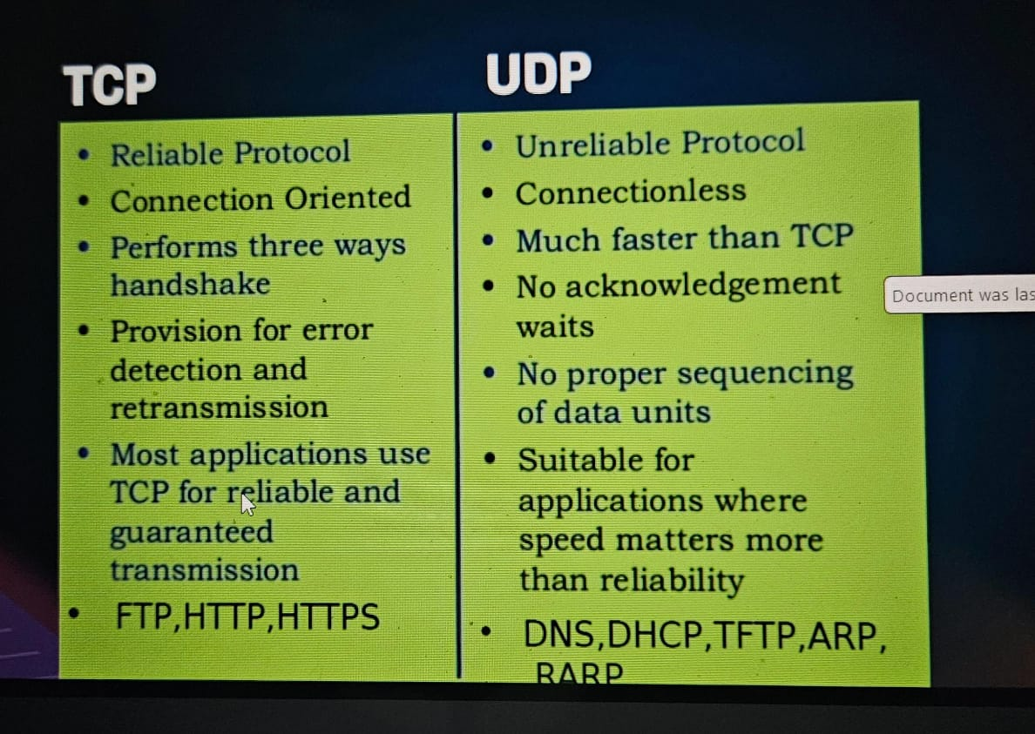

DNS & DHCP

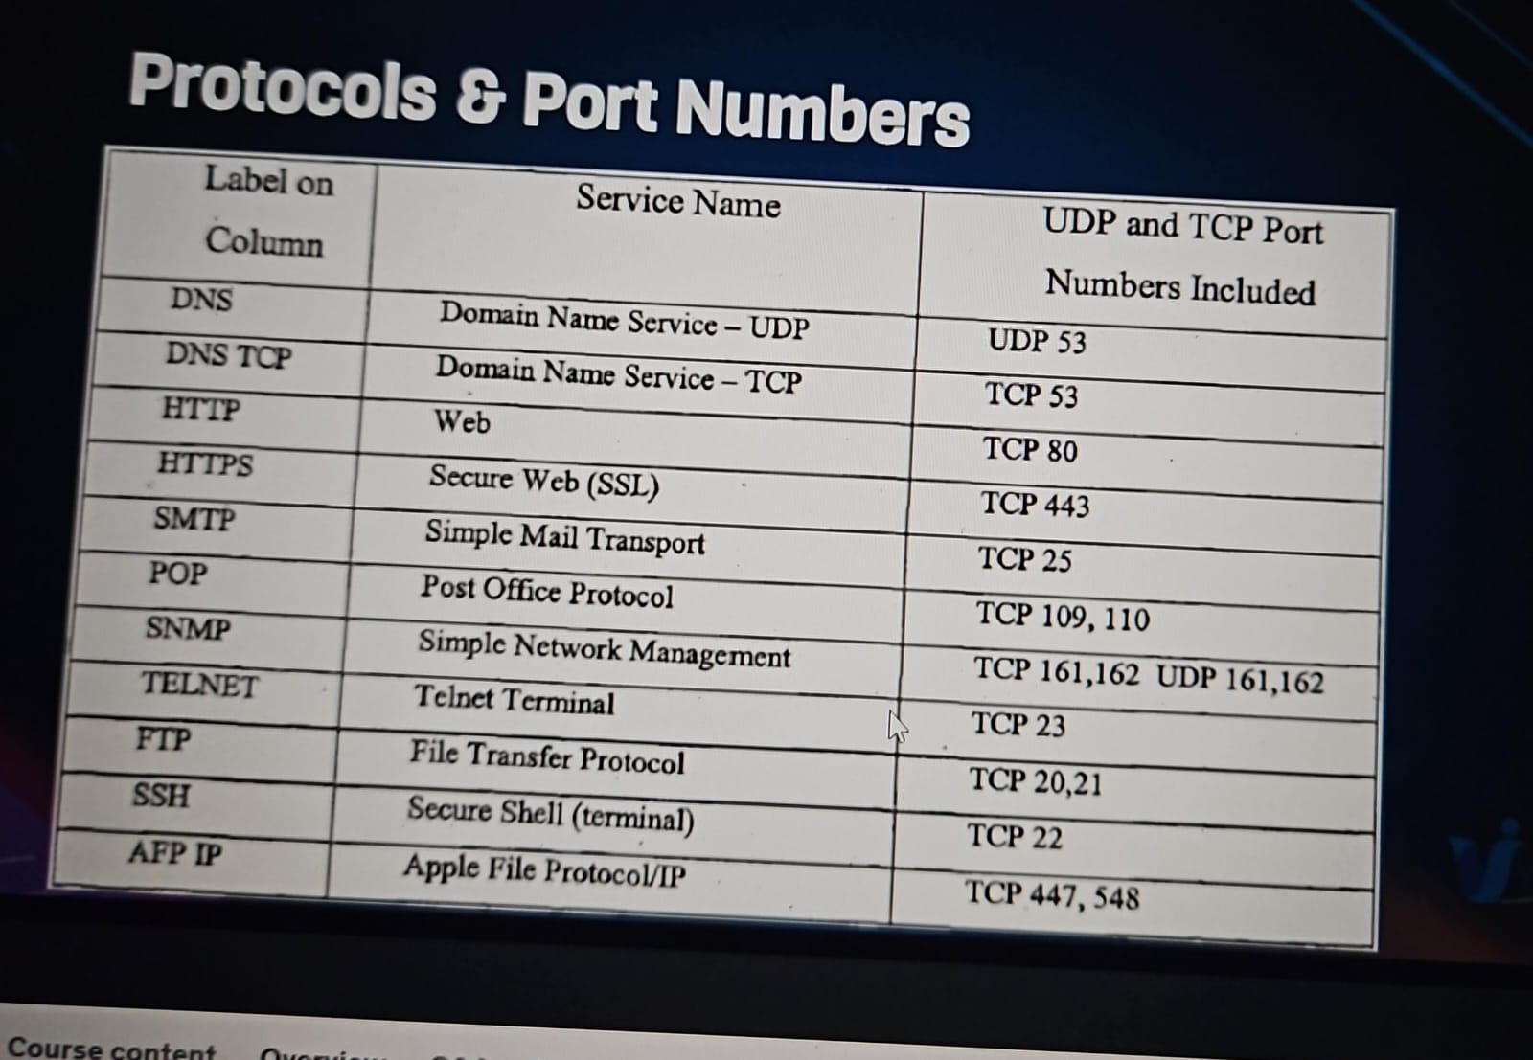

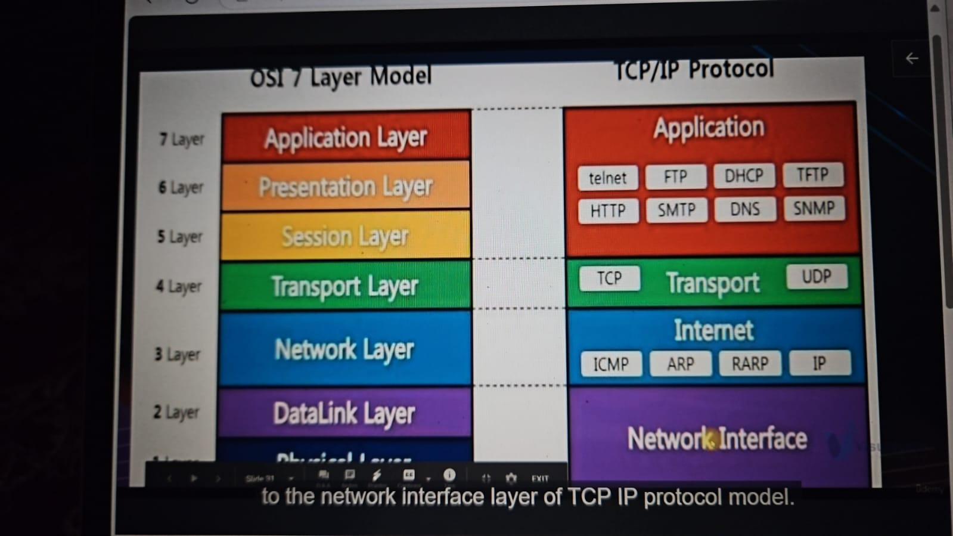

Network cmds