**Name : Vishal Thakor**

**Date : 18-06-2025…**

**Edit Custom Tables in Orca**

1. **What is msi :-** An MSI file (Microsoft Installer file) is a special type of installation package used on Windows to install, update, or uninstall software. It uses the Windows Installer service (msiexec.exe) to manage the process.

Msi file contains Files to be installed,Installation instructions,Registrychanges,

Shortcuts,Custom actions and Uninstall information

1. **What is a file associations :** A file association links a file extension (like .txt, .jpg, or .mp4) with a default program that can open it.

For example:

**.txt →** opens with Notepad

**.jpg →** opens with Photos

**.mp4 →** opens with Movies & TV (or VLC, if installed)

1. **Goal :** Main goal of this project is to edit custom tables in msi file and perform actions automatically like,

Create environment variable

Create/delete/modify Registry.

You can download firefox msi from [here](https://www.exemsi.com/downloads/packages/Firefox/Firefox%20Setup%2014.0.1.msi).

1. **Tool used :** there are many ways and tools available in the market for Edit Custom table,

Like : Advance installer GUI,Orca Tool, instead.but o have used orca for msi file association.

**Orca Tool :** Orca is a free Windows Installer package editor from Microsoft. It lets you directly view and edit the internal database tables of .msi including setting file associations, modifying components, registry entries, shortcuts, and more.

You can download orca sdk tool from [link](https://go.microsoft.com/fwlink/?linkid=2320455).

After download you will see a **winsdksetup.exe** file.



1. **open Orca tool :**  click on start menu and searchfor orca tool and open it.

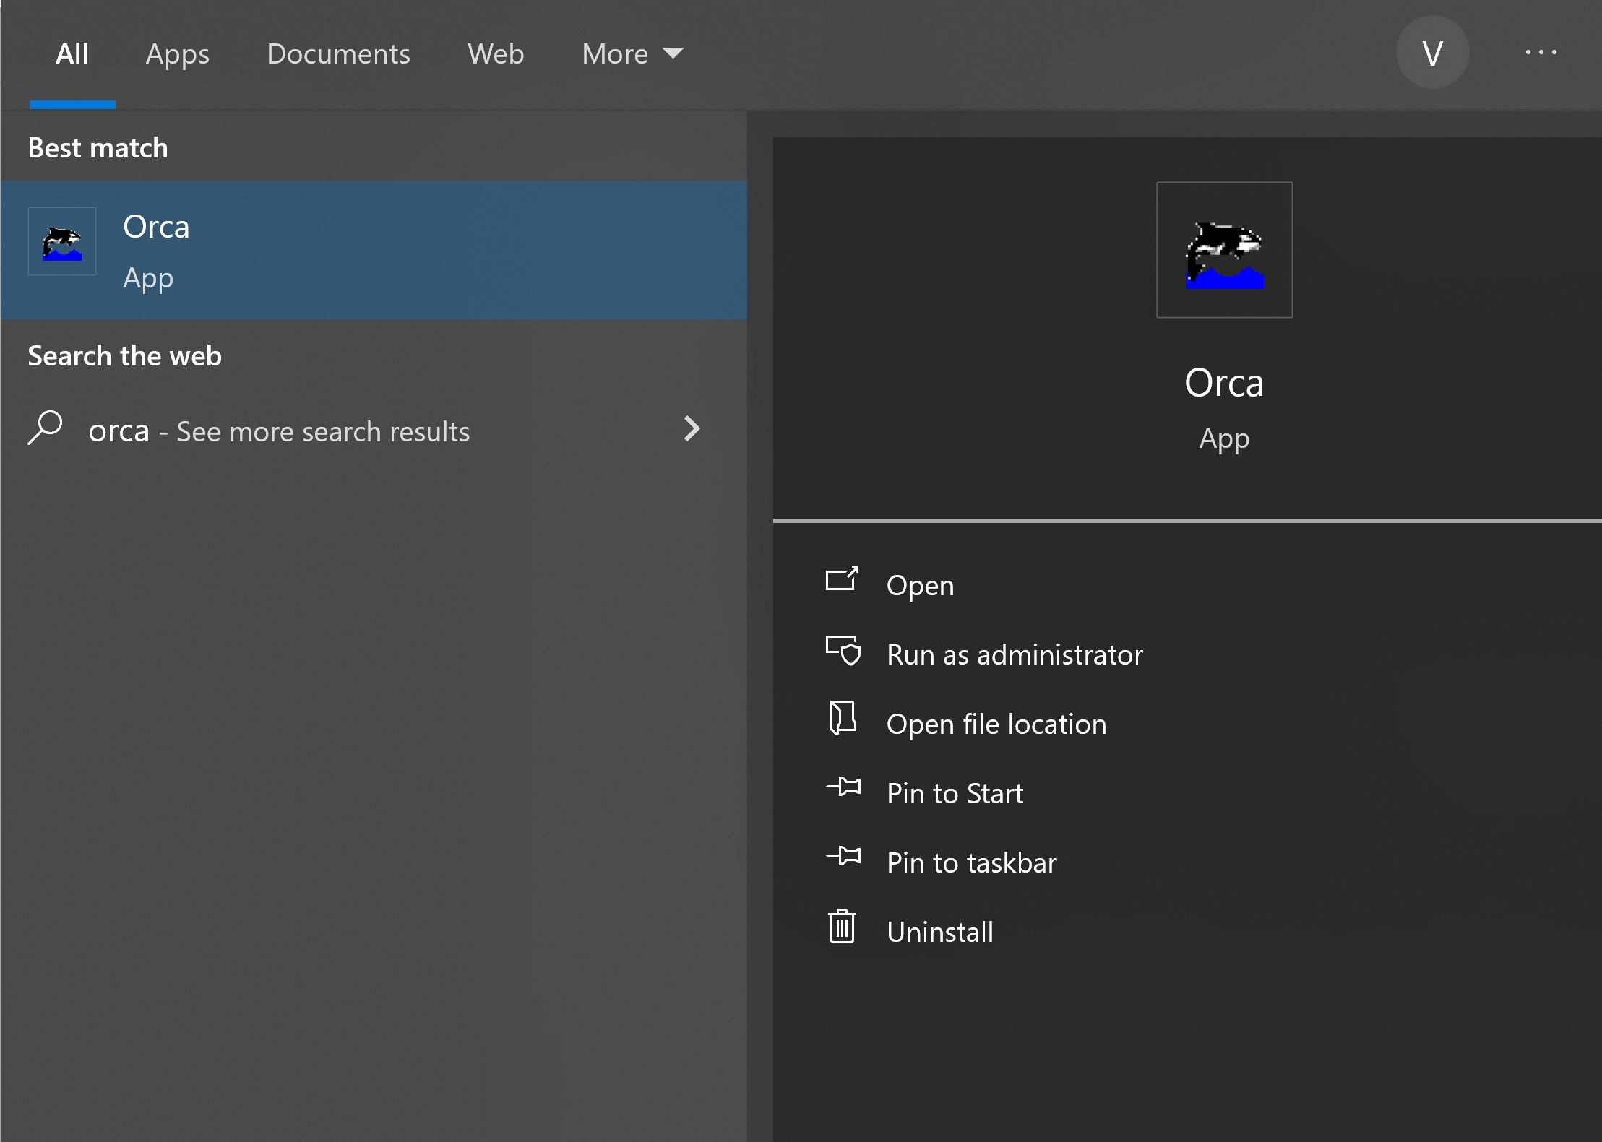

1. **Open firefox msi file :**

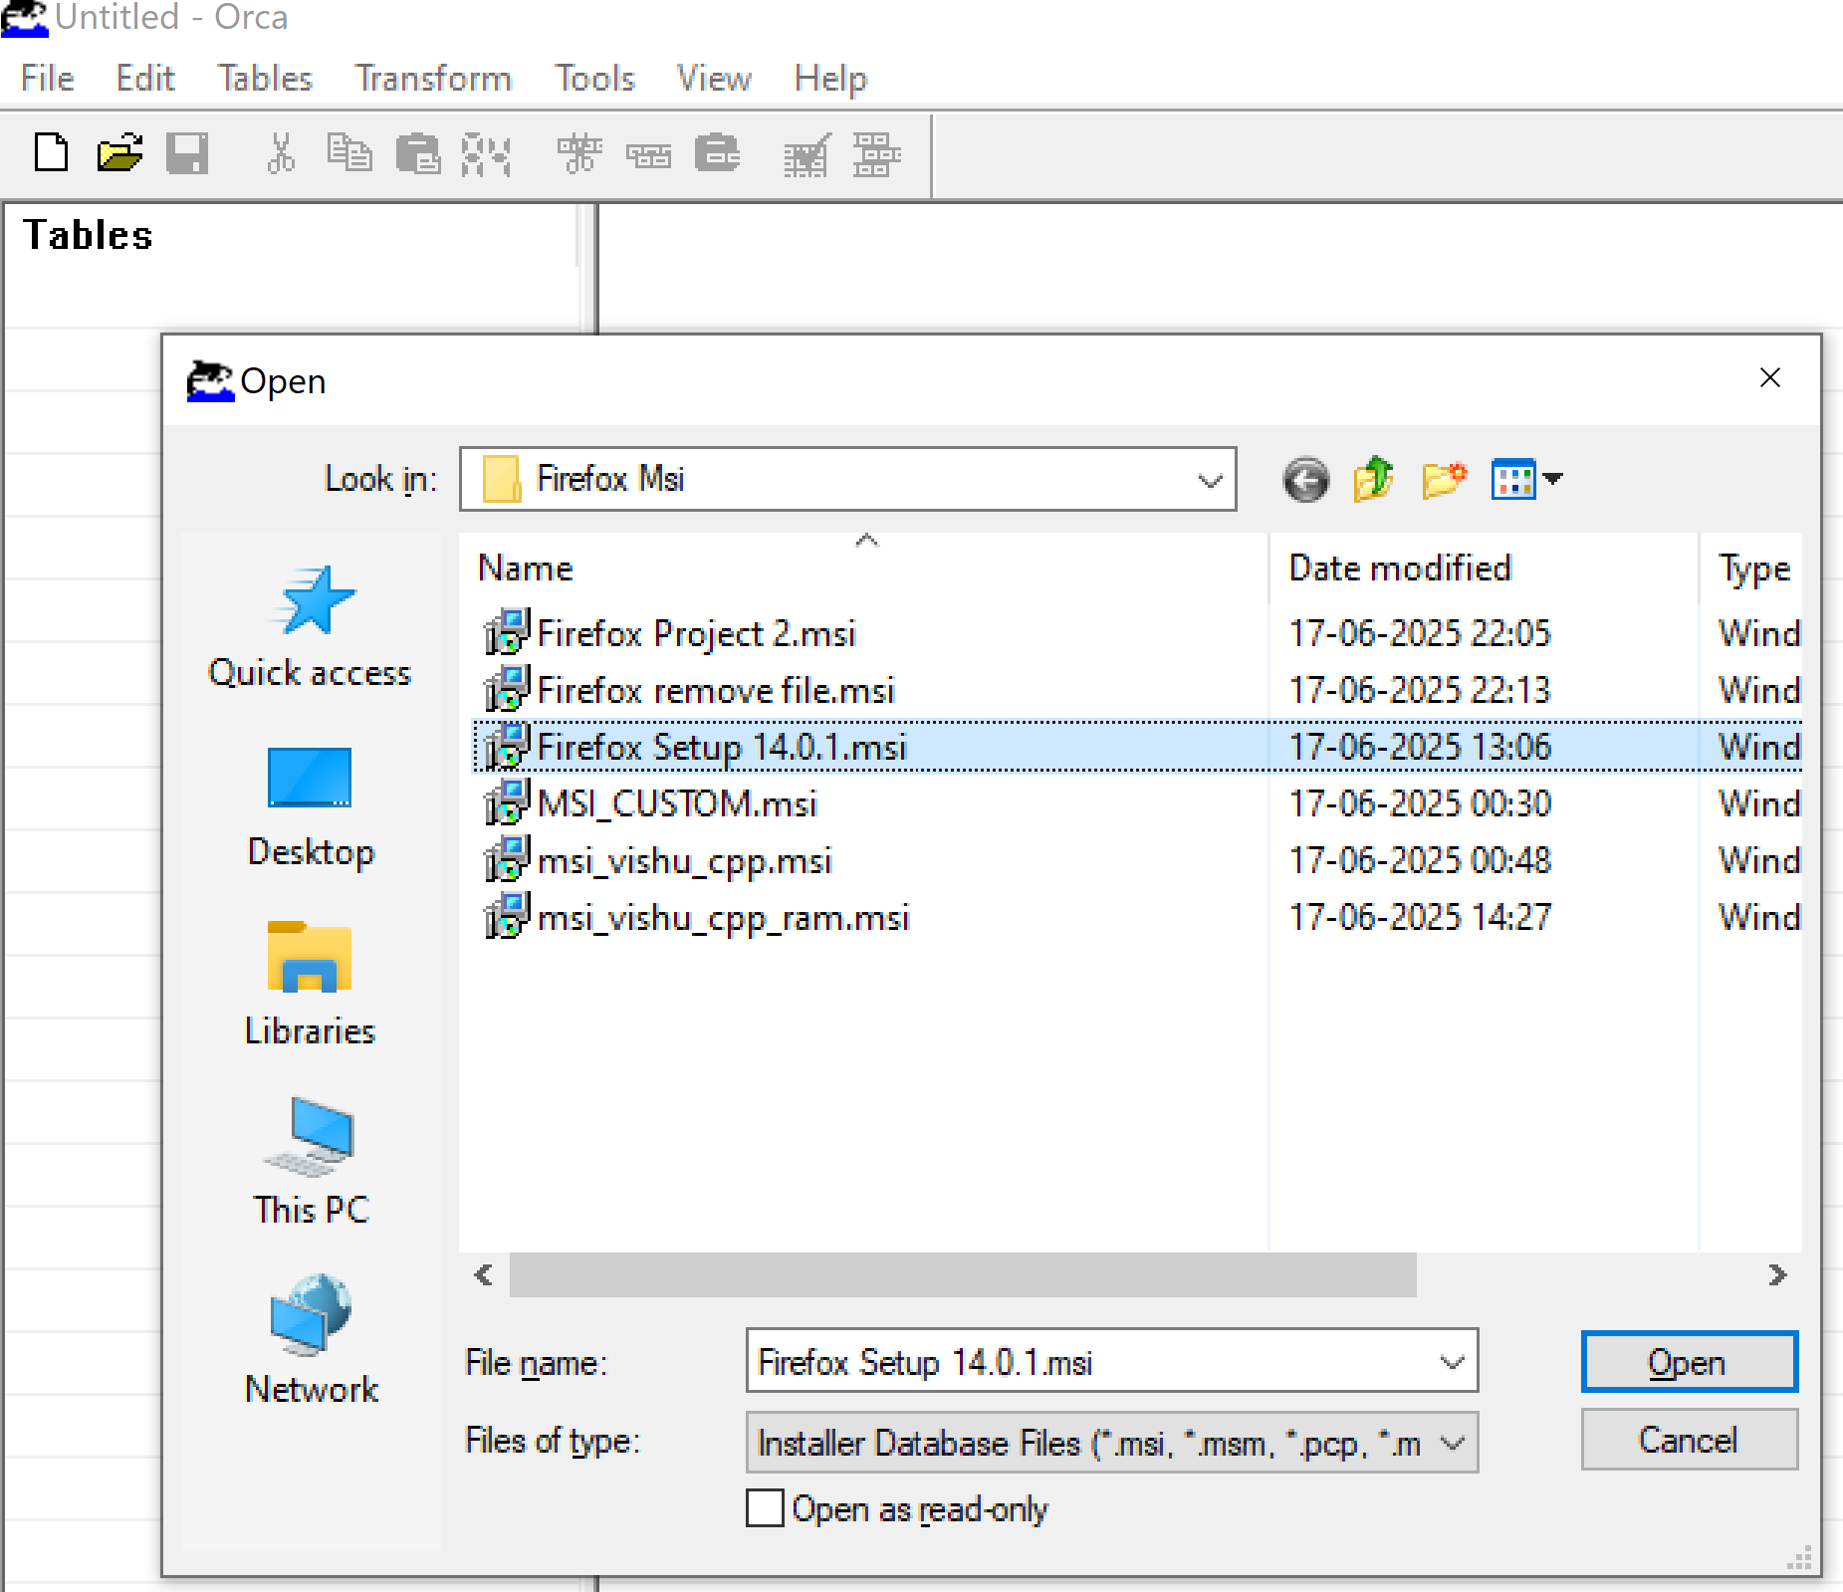

1. **Add Missing tables :** click on table meny andthen click on **Menu->table->new**  to add new table.

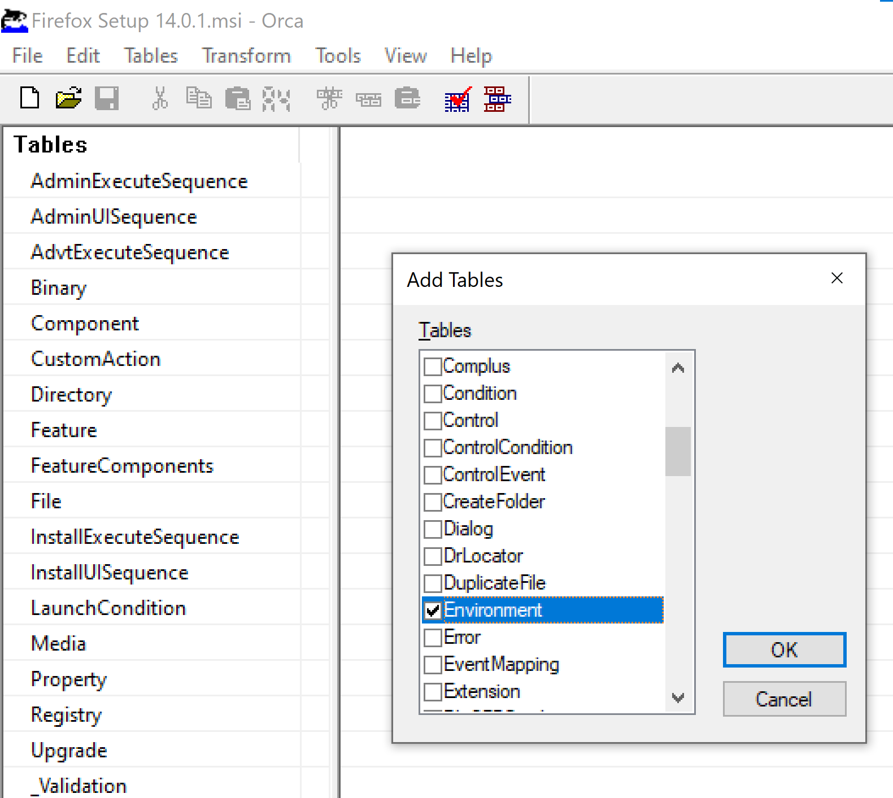

The **Environment Table** in an **MSI** package is used to create, modify, or remove environment variables during the installation or uninstallation of an application.

Add the following values to add custom environment variable.

|  |  |  |  |
| --- | --- | --- | --- |
| **Enviroment** | **Name** | **Vakue** | **Component_** |
| FIREFOX_HOME="C:\Program Files (x86)\Mozilla Firefox" | FIREFOX_HOME | C:\Program Files (x86)\Mozilla Firefox | bz.ProductComponent |

This creates a environment variable as: FIREFOX_HOME= C:\Program Files (x86)\Mozilla Firefox

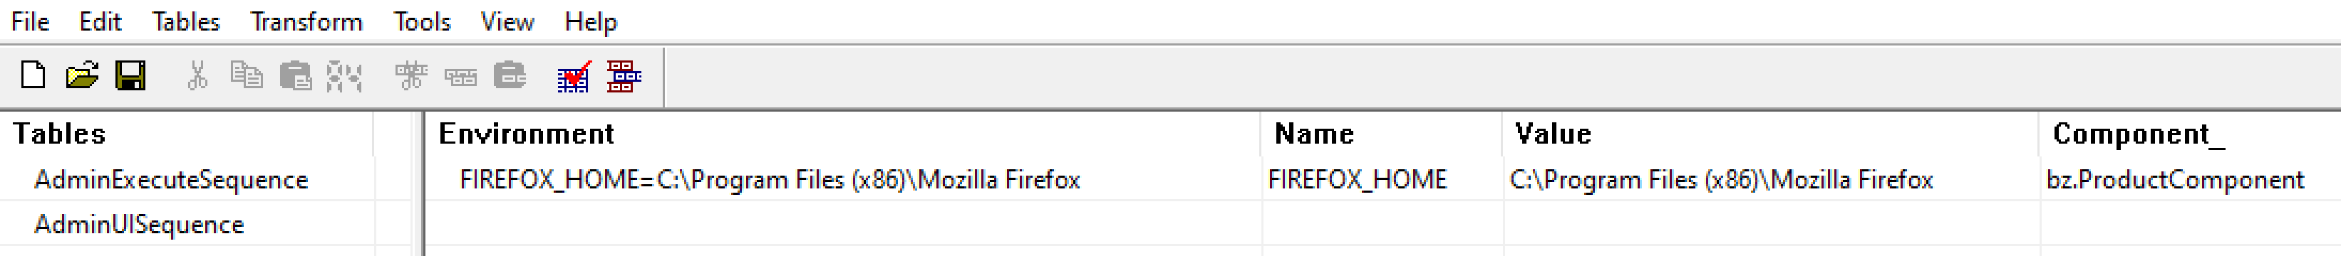

1. **Create custom Registry:**  to create a custom registry navigate to the **Registry** Table. And click on add row ,then add following values

|  |  |  |  |  |  |
| --- | --- | --- | --- | --- | --- |
| **Registry** | **Root** | **Key** | **Name** | **Value** | **Component_** |
| CustomRegistry | 2 | SOFTWARE\MyKey | VishalKey | Wipro | bz.ProductComponent |



This creates a custom registry at : Computer\HKEY_LOCAL_MACHINE\SOFTWARE\MyKey

With value wipro.

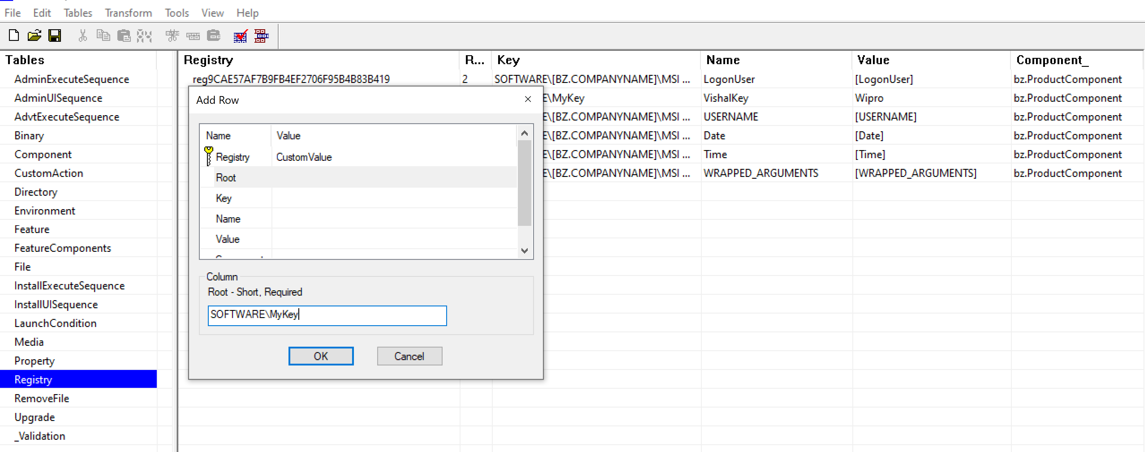

1. **Add Entries to RemoveFile Table:**

This table removes files/folders on install or uninstall

Click on table menu->add table then select RemoveFile table to add tabe.

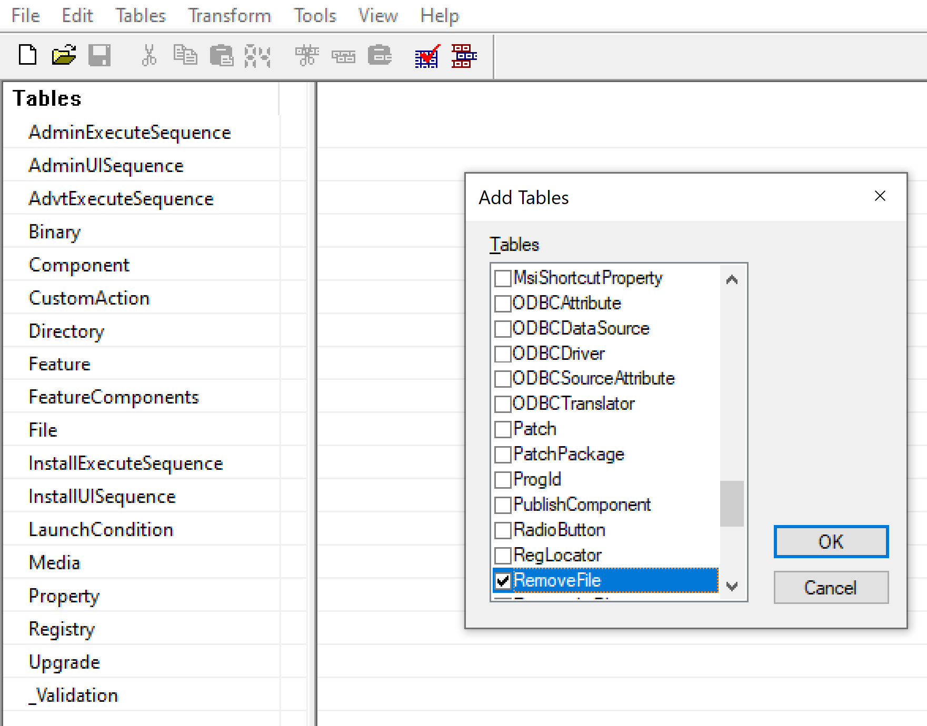

**Add values in RemoveFile table as below :**

|  |  |  |  |  |
| --- | --- | --- | --- | --- |
| **FileKey** | **Compnent_** | **Name** | **DirProperty** | **InstallMode** |
| RemoveSampleFile | bz.ProductComponent | Sample.txt | BZ.INSTALLFOLDER | 2 |

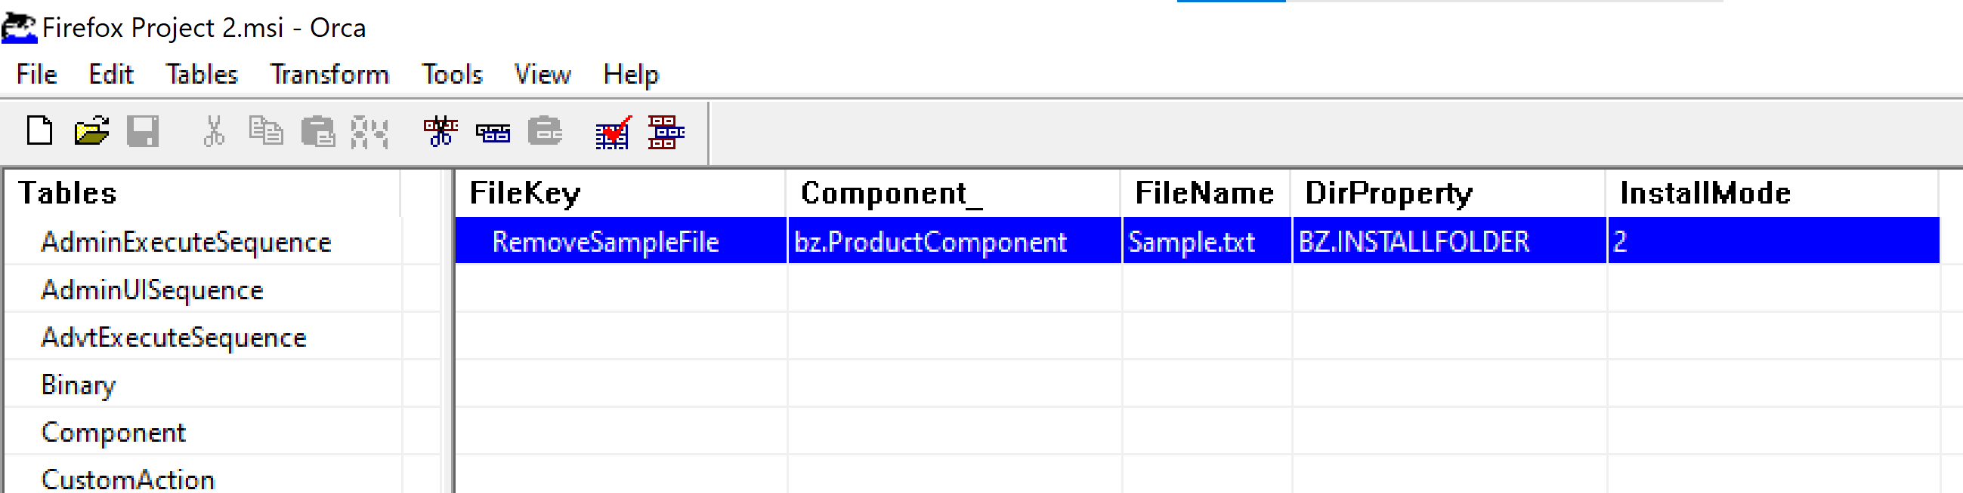

It will remove Saple.txt file from installer directry,when we uninstall application.

1. **Save the msi file and install application:**

my msi installer file is saved at location : D:\wipro\Capstone-project\Resources\Firefox Msi\Firefox Project 2.msi. go to that path in run installer file,

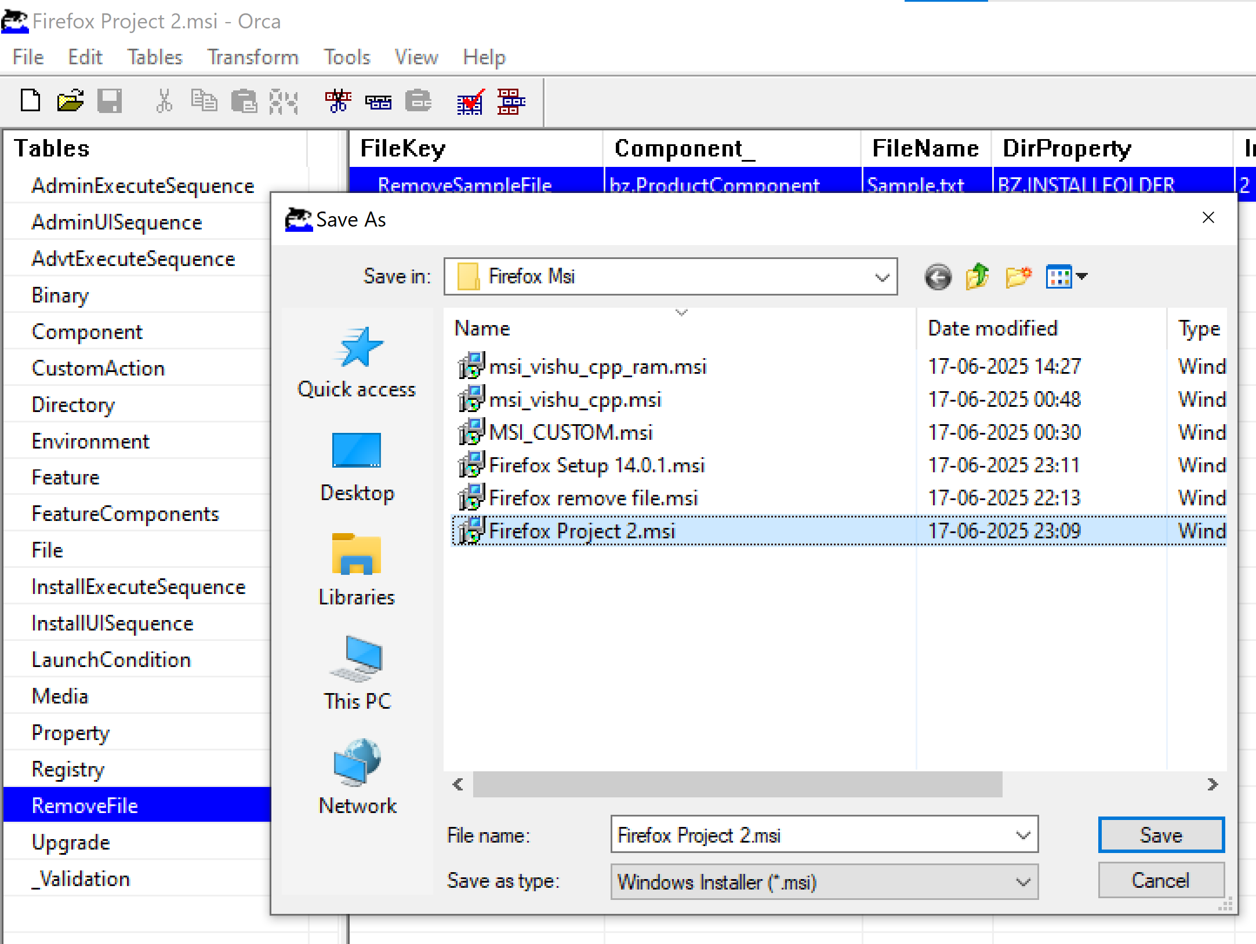

**After the file installation check the Enviroment Variable,Registry keys etc**

**Enviroment Variables :**

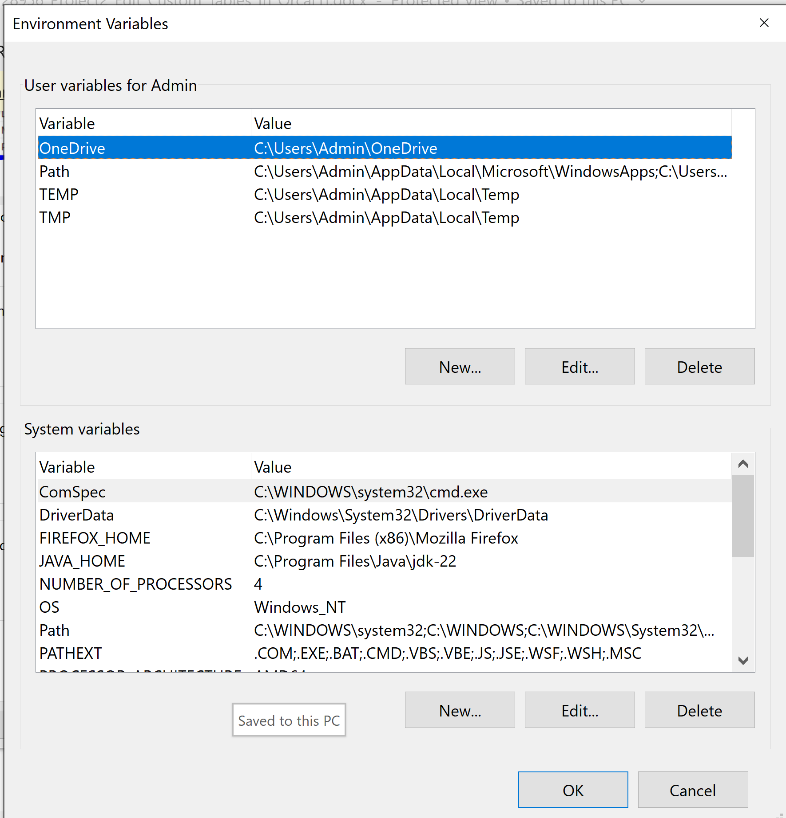



**Registry Editor :**

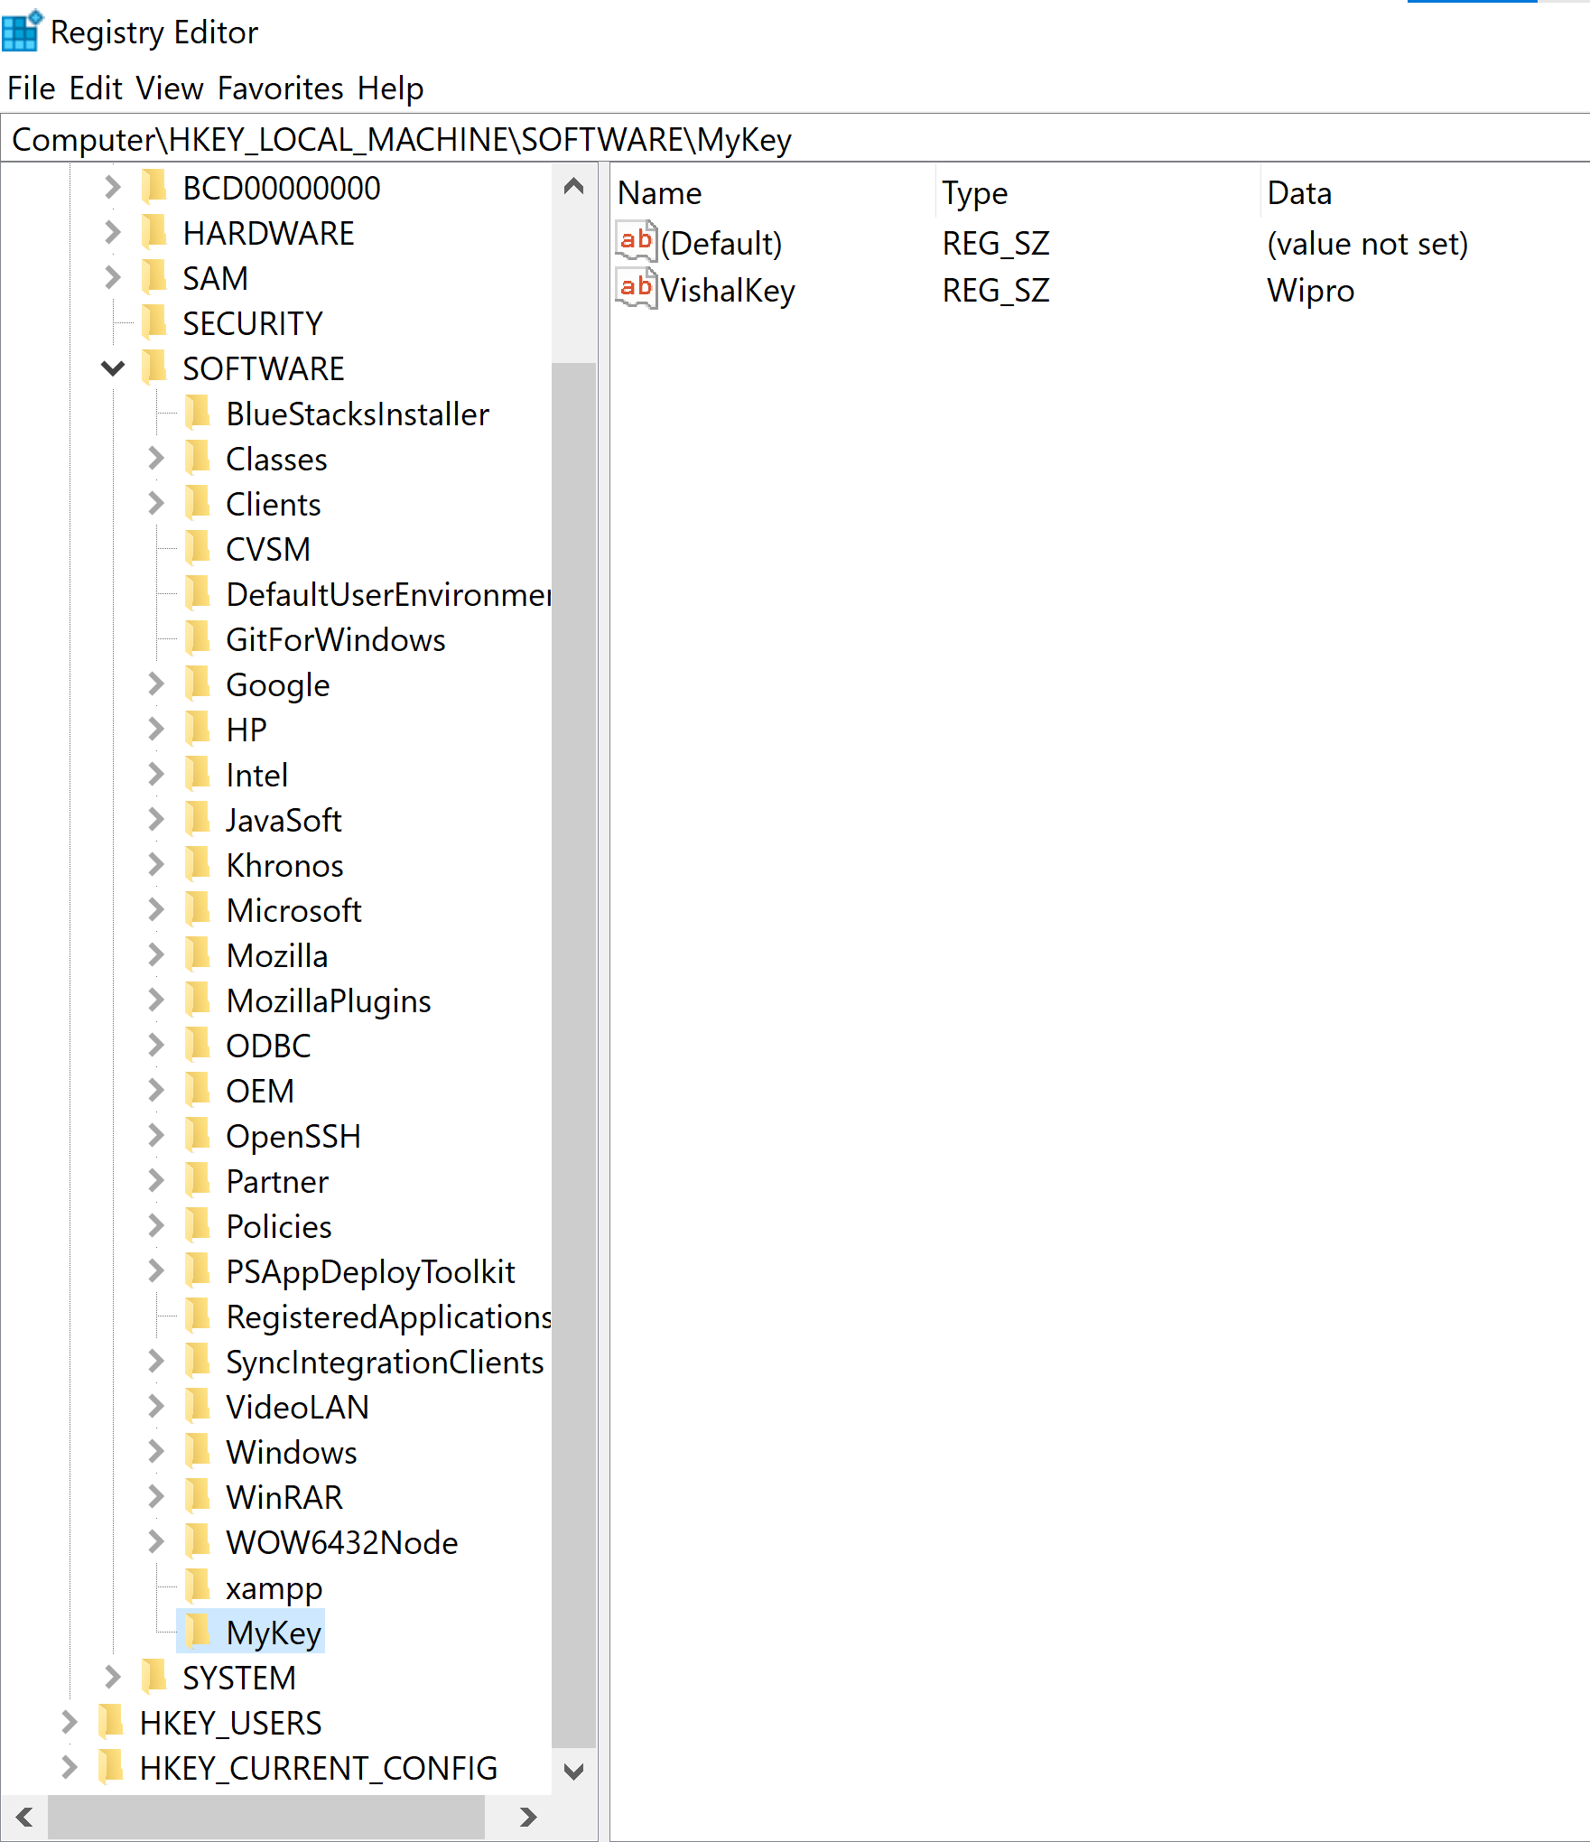



1. **Conclusion :**

**in conclusion.**

* Orca allows powerful **customization** of MSI behavior
* By manually editing **Environment**, **RemoveFile**, and **Registry** tables, we can Set environment variables, Clean up unnecessary files, Configure registry entries, etc
* These techniques are **valuable** for software packaging, enterprise deployment, and system integration.