PART -2 WINDOWS FORMS

AIM 1:Create a Windows Form to Convert following currency conversion.
Rupees to dollar, frank, euro.

PROGRAM:

using System;
using System.Collections.Generic;
using System.ComponentModel;
using System.Data;
using System.Drawing;
using System.Linq;
using System.Text;
using System.Windows.Forms;

namespace GDI_
{
public partial class Practical1 : Form
{
public Practical1()
{
InitializeComponent();
}

private void doller_Click(object sender, EventArgs e)
{
double doller_price = Convert.ToDouble(textBox1.Text) * 0.014;
label1.Text = Convert.ToString(doller_price)+" $";
}

private void Practical1_Load(object sender, EventArgs e)
{
textBox1.Focus();
}

private void frank_Click(object sender, EventArgs e)
{
double doller_price = Convert.ToDouble(textBox1.Text) * 0.014;
label1.Text = Convert.ToString(doller_price)+" Franc";
}

private void euro_Click(object sender, EventArgs e)
{
double doller_price = Convert.ToDouble(textBox1.Text) * 0.012;
label1.Text = Convert.ToString(doller_price)+" Euro";
}
}
}

OUTPUT:
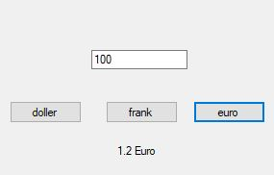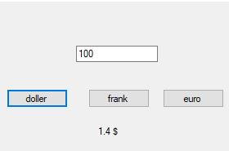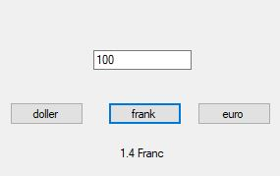

2 : Create a Windows Form to convert infix notation to postfix

notation. Ex: a+b-c =>ab+c-

PROGRAM:

using System;
using System.Collections.Generic;
using System.ComponentModel;
using System.Data;
using System.Drawing;
using System.Linq;
using System.Text;
using System.Windows.Forms;

namespace Practical_2_2
{
public partial class Form1 : Form
{
public Form1()
{
InitializeComponent();
}

private void button1_Click(object sender, EventArgs e)
{
string infix=textBox1.Text;
string postfix = convert(infix);
label1.Text = postfix;
}
static string convert( string infix )
{
string postfix;
int prio = 0;
postfix = "";
Stack<Char> s1 = new Stack<char>();
for (int i = 0; i < infix.Length; i++)
{
char ch = infix[i];
if (ch == '+' || ch == '-' || ch == '*' || ch == '/')
{
if (s1.Count <= 0)
s1.Push(ch);
else
{
if (s1.Peek() == '*' || s1.Peek() == '/')
prio = 1;
else
prio = 0;
if (prio == 1)
{
if (ch == '+' || ch == '-')
{
postfix += s1.Pop();
i--;
}
else
{
postfix += s1.Pop();
i--;
}
}
else
{
if (ch == '+' || ch == '-')
{
postfix += s1.Pop();
s1.Push(ch);

}
else
s1.Push(ch);
}
}
}
else
{
postfix += ch;
}
}
int len = s1.Count;
for (int j = 0; j < len; j++)
postfix += s1.Pop();
return postfix;
}
}
}

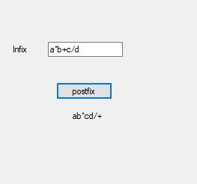
OUTPUT:

AIM 3 : Create a Windows Form to convert digits to words Ex: 123 =>One Hundred and Twenty-three.

PROGRAM:

using System;
using System.Collections.Generic;
using System.ComponentModel;
using System.Data;
using System.Drawing;
using System.Linq;
using System.Text;
using System.Windows.Forms;

namespace WindowsFormsApplication1
{
public partial class Form1 : Form
{
int a = 0;
int number;
int num;
int[] dg = new int[4]{0,0,0,0};
string str;
string[] digits = new
string[10]{"zero","one","two","three","four","five","six","seven","eight","nine"};
public Form1()
{
InitializeComponent();
}

private void textBox1_TextChanged(object sender, EventArgs e)
{

}

private void button1_Click(object sender, EventArgs e)
{
int i=3;
number = Convert.ToInt32(textBox1.Text);

num = number;
while (num != 0)
{
dg[i] = num%10;
num = num / 10;
i--;
}
for (; a < 4; a = a + 1)
{
if (a == 0)
{

str = digits[dg[a]] + " thousand ";
}
if (a == 1)
{
str = str + digits[dg[a]] + " hundred and ";
}
if (a == 2)
{
str = str + digits[dg[a]] + "ty-";
}
if (a == 3)
{
str = str + digits[dg[a]];
}

}
textBox2.Text = str;
}

private void label2_Click(object sender, EventArgs e)
{

}

private void textBox2_TextChanged(object sender, EventArgs e)
{

}
}
}
OUTPUT:
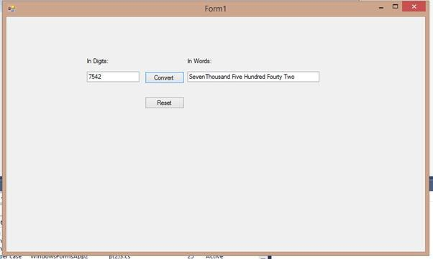

AIM 4 : Create a Windows Form to implement Calculator Application

PROGRAM:

using System;
using System.Collections.Generic;
using System.ComponentModel;
using System.Data;
using System.Drawing;
using System.Linq;
using System.Text;
using System.Windows.Forms;

namespace cal
{
public partial class Form1 : Form
{
Double result = 0;
String operation = "";
bool enter_value = false;

public Form1()
{
InitializeComponent();
}

private void standardToolStripMenuItem_Click(object sender, EventArgs e) {

this.Width = 250;
textBox1.Width = 218;
}

private void scToolStripMenuItem_Click(object sender, EventArgs e) {

this.Width = 581;
textBox1.Width = 475;
}

private void Form1_Load(object sender, EventArgs e)
{
this.Width = 250;
textBox1.Width = 218;
}

private void button_Click(object sender, EventArgs e)
{
if ((textBox1.Text == "0") || (enter_value))
{
textBox1.Clear();

}
enter_value = false;

Button button = (Button)sender;
if (button.Text == ".")
{
if (!(textBox1.Text.Contains(".")))
{
textBox1.Text = textBox1.Text + button.Text;
}
}
else
textBox1.Text = textBox1.Text + button.Text;
}

private void button2_Click(object sender, EventArgs e)
{
textBox1.Text = "0";
label1.Text = "";
}

private void button3_Click(object sender, EventArgs e)
{
textBox1.Text = "0";
label1.Text = "";
result = 0;
}

private void button1_Click(object sender, EventArgs e)
{
if (textBox1.Text.Length > 0)
{
textBox1.Text = textBox1.Text.Remove(textBox1.Text.Length-1,1);
}
if (textBox1.Text== "0")
{
textBox1.Text = "0";
}
}

private void operator_click(object sender, EventArgs e)
{
Button button = (Button)sender;
if (result != 0)
{
EQUAL.PerformClick();
operation = button.Text;
label1.Text = result + "" + operation;
enter_value= true;
}

else
{
operation = button.Text;
result = Convert.ToDouble(textBox1.Text);
label1.Text = result + "" + operation;
enter_value = true;
}
}

private void button18_Click(object sender, EventArgs e)
{
label1.Text = "";
switch (operation)
{

case "+":

textBox1.Text = Convert.ToString(result + Convert.ToDouble(textBox1.Text));

break;
case "-":

textBox1.Text = Convert.ToString(result - Convert.ToDouble(textBox1.Text));

break;
case "*":

textBox1.Text = Convert.ToString(result * Convert.ToDouble(textBox1.Text));

break;
case "/":

textBox1.Text = Convert.ToString(result / Convert.ToDouble(textBox1.Text));

break;
case "Mod":

textBox1.Text = Convert.ToString(result % Convert.ToDouble(textBox1.Text));

break;
case "Exp":
double i=Convert.ToDouble(textBox1.Text);
double q;
q = (result);

textBox1.Text = Convert.ToString(Math.Exp(i * Math.Log(q * 4))); break;

default:
break;
}
result = Convert.ToDouble(textBox1.Text);
label1.Text = "";
}

private void button40_Click(object sender, EventArgs e)
{
textBox1.Text = "3.141592653589976323";

}

private void button39_Click(object sender, EventArgs e)
{
double ilog = Convert.ToDouble(textBox1.Text);

label1.Text = Convert.ToString("log " + "( " + (textBox1.Text) + " )"); ilog= Math.Log10(ilog);

textBox1.Text = Convert.ToString(ilog);
}

private void button38_Click(object sender, EventArgs e)
{
double sq = Convert.ToDouble(textBox1.Text);

label1.Text = Convert.ToString("sqrt " + "( " + (textBox1.Text) + " )"); sq = Math.Sqrt(sq);

textBox1.Text = Convert.ToString(sq);
}

private void button36_Click(object sender, EventArgs e)
{
double sinh = Convert.ToDouble(textBox1.Text);

label1.Text = Convert.ToString("Sinh " + "( " + (textBox1.Text) + " )"); sinh = Math.Sinh(sinh);

textBox1.Text = Convert.ToString(sinh);
}

private void button35_Click(object sender, EventArgs e)
{
double sin = Convert.ToDouble(textBox1.Text);

label1.Text = Convert.ToString("Sin " + "( " + (textBox1.Text) + " )"); sin = Math.Sin(sin);

textBox1.Text = Convert.ToString(sin);
}

private void button32_Click(object sender, EventArgs e)
{
double cosh = Convert.ToDouble(textBox1.Text);
label1.Text = Convert.ToString("Cosh " + "( " + (textBox1.Text) + " )");
cosh = Math.Cosh(cosh);
textBox1.Text = Convert.ToString(cosh);

}

private void button31_Click(object sender, EventArgs e)
{
double cos = Convert.ToDouble(textBox1.Text);

label1.Text = Convert.ToString("Cos " + "( " + (textBox1.Text) + " )"); cos = Math.Cos(cos);

textBox1.Text = Convert.ToString(cos);
}

private void button28_Click(object sender, EventArgs e)
{
double tanh = Convert.ToDouble(textBox1.Text);

label1.Text = Convert.ToString("Tanh " + "( " + (textBox1.Text) + " )"); tanh = Math.Tanh(tanh);

textBox1.Text = Convert.ToString(tanh);
}

private void button27_Click(object sender, EventArgs e)
{
double tan = Convert.ToDouble(textBox1.Text);

label1.Text = Convert.ToString("Tan " + "( " + (textBox1.Text) + " )"); tan = Math.Tan(tan);

textBox1.Text = Convert.ToString(tan);

}

private void button30_Click(object sender, EventArgs e)
{
int a = Convert.ToInt32(textBox1.Text);
textBox1.Text = Convert.ToString(a, 2);
}

private void button26_Click(object sender, EventArgs e)
{
int a = Convert.ToInt32(textBox1.Text);
textBox1.Text = Convert.ToString(a, 16);
}

private void button22_Click(object sender, EventArgs e)
{
int a = Convert.ToInt32(textBox1.Text);
textBox1.Text = Convert.ToString(a, 8);
}

private void button34_Click(object sender, EventArgs e)
{
int a = Convert.ToInt32(textBox1.Text);
textBox1.Text = Convert.ToString(a);
}

private void button37_Click(object sender, EventArgs e)
{
double a;

a = Convert.ToDouble(textBox1.Text) * Convert.ToDouble(textBox1.Text); textBox1.Text = Convert.ToString(a);

}

private void button33_Click(object sender, EventArgs e)
{
double a;

a = Convert.ToDouble(textBox1.Text) * Convert.ToDouble(textBox1.Text) *
Convert.ToDouble(textBox1.Text);
textBox1.Text = Convert.ToString(a);
}

private void button29_Click(object sender, EventArgs e)
{
double a;

a = Convert.ToDouble(1.0 / Convert.ToDouble(textBox1.Text)); textBox1.Text = Convert.ToString(a);
}

private void button25_Click(object sender, EventArgs e)
{

double ln = Convert.ToDouble(textBox1.Text);

label1.Text = Convert.ToString("ln " + "( " + (textBox1.Text) + " )"); ln = Math.Log(ln);

textBox1.Text = Convert.ToString(ln);
}

private void button21_Click(object sender, EventArgs e)
{
double a;

a = Convert.ToDouble(textBox1.Text) * Convert.ToDouble(100); textBox1.Text = Convert.ToString(a);

}
}
}
OUTPUT:
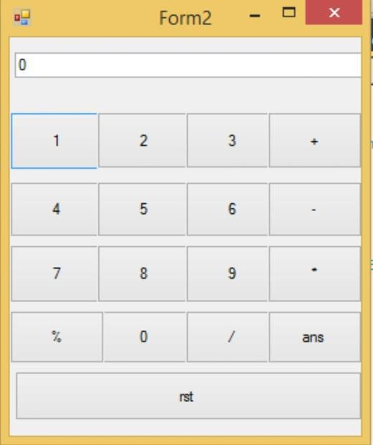

AIM 5 : To drag and drop item from one textbox to other textbox.

PROGRAM:

using System;

using System.Collections.Generic;

using System.ComponentModel;

using System.Data;

using System.Drawing;

using System.Linq;

using System.Text;

using System.Windows.Forms;

namespace WindowsFormsApplication1

{

public partial class Windows5 : Form

{

int index;

public Windows5()

{

InitializeComponent();

}

private void Windows5_Load(object sender, EventArgs e)

{

listBox1.Items.Add("Apple");

listBox1.Items.Add("Orange");

listBox1.Items.Add("Pineapple");

listBox1.Items.Add("Kiwi");

listBox2.Items.Add("Red Rose");

listBox2.Items.Add("Sunflower");

listBox2.Items.Add("White Rose");

listBox2.Items.Add("Tulips");

}

private void button1_Click(object sender, EventArgs e)

{

for(int i = 0; i < listBox1.SelectedItems.Count; i++)

{

listBox2.Items.Add(listBox1.SelectedItems[i].ToString());

}

for(int i = listBox1.SelectedItems.Count-1; i>=0; i--)

{

if (listBox1.GetSelected(i) == true)

{

listBox1.Items.RemoveAt(i);

}

}

}

private void button2_Click(object sender, EventArgs e)

{

for (int i = 0; i < listBox2.SelectedItems.Count; i++)

{

listBox1.Items.Add(listBox2.SelectedItems[i].ToString());

}

for (int i = listBox2.Items.Count - 1; i >= 0; i--)

{

if (listBox2.GetSelected(i) == true)

{

listBox2.Items.RemoveAt(i);

}

}

}

private void listBox1_MouseDown(object sender, MouseEventArgs e) {

ListBox listbox = (ListBox)sender;

index = listbox.IndexFromPoint(e.X, e.Y); listbox.DoDragDrop(listbox.Items[index], DragDropEffects.Move);

}

private void listBox1_DragOver(object sender, DragEventArgs e)

{

if (e.Data.GetDataPresent(DataFormats.StringFormat))

{

e.Effect = DragDropEffects.Move;

}

else

{

e.Effect = DragDropEffects.None;

}

}

private void listBox1_DragDrop(object sender, DragEventArgs e)

{

ListBox listBox = (ListBox)sender;

listBox.Items.Add(e.Data.GetData(DataFormats.StringFormat).ToString());

if (listBox.Name == "listBox1")

{

listBox2.Items.RemoveAt(index);

}

else

{

listBox1.Items.RemoveAt(index);

}

}

}

}

OUTPUT:
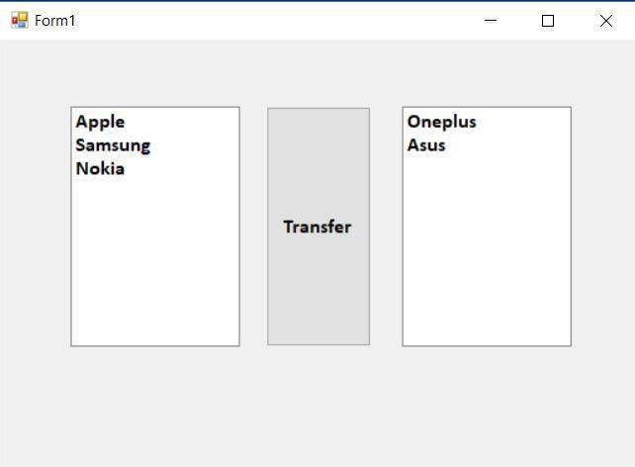

AIM 6 : Create a windows form which implements Menus (File, Color) and a Text Box. File menu item has 4 options Fonts, Open, Save, Print (Print Preview and Print), Exit. Color menu opens a Color Dialog box. Clicking on the colors sets the background of the form with respective color. Open menu item opens a file, reads the contents and displays in the TextBox while Save menu items saves the content of Text Box in to a file.

PROGRAM:

using System;
using System.Collections.Generic;
using System.ComponentModel;

using System.Data;
using System.Drawing;
using System.Linq;
using System.Text;
using System.IO;
using System.Windows.Forms;

namespace WindowsFormsApplication1
{
public partial class Form1 : Form
{
public Form1()
{
InitializeComponent();
}
private void Form1_Load(object sender, EventArgs e)
{

}
private void newToolStripMenuItem_Click(object sender, EventArgs e)
{
richTextBox1.Clear();
}
private void openToolStripMenuItem_Click(object sender, EventArgs e)
{
if (openFileDialog1.ShowDialog() == DialogResult.OK)

{

StreamReader sr = new StreamReader(openFileDialog1.FileName); richTextBox1.Text = sr.ReadToEnd(); sr.Close();

}
}
private void saveToolStripMenuItem_Click(object sender, EventArgs e)
{

saveFileDialog1.FileName = "unknown.txt"; saveFileDialog1.Filter = "text file(*.txt)|*.txt|All files(*.*)|*.*";

if (saveFileDialog1.ShowDialog()== DialogResult.OK)
{
StreamWriter sw = new StreamWriter(saveFileDialog1.FileName)
{
sw.WriteLine(richTextBox1.Text);
}
}
}
private void printToolStripMenuItem_Click(object sender, EventArgs e)
{
printDialog1.Document = printDocument1;
if (printDialog1.ShowDialog() == DialogResult.OK)
{
printDocument1.Print();

}
}
private void printPreviewToolStripMenuItem_Click(object sender, EventArgs
e)
{

printPreviewDialog1.Document = printDocument1; printPreviewDialog1.ShowDialog();
}
private void fontToolStripMenuItem_Click(object sender, EventArgs e)
{
if (richTextBox1.SelectedText != "")
{
richTextBox1.Select();
if (fontDialog1.ShowDialog() == DialogResult.OK)
{
richTextBox1.Font = fontDialog1.Font;
}
}
}
private void exitToolStripMenuItem_Click(object sender, EventArgs e)
{
Application.Exit();
}
private void colorToolStripMenuItem_Click(object sender, EventArgs e)
{
ColorDialog cd = new ColorDialog();

ColorDialog cd1 = new ColorDialog();
if (cd.ShowDialog() == DialogResult.OK)
{
BackColor = cd.Color;
}
if (cd1.ShowDialog() == DialogResult.OK)
{
richTextBox1.ForeColor = cd1.Color;
}}}}

OUTPUT:
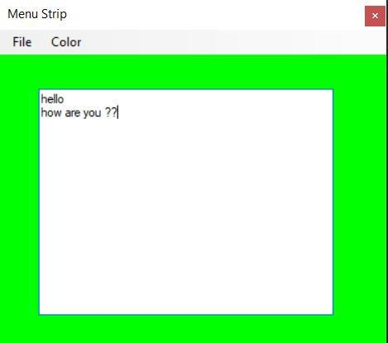

AIM 7 : Implement an MDI form with Menu item “Add”, clicking on
Add generates a new childform(blank). And Menu item “Child Forms” which contains sub menu for implementingError Provider, Tool tip, Panel and Group Box controls each on a separate form.

PROGRAM:

using System;

using System.Collections.Generic;

using System.ComponentModel;

using System.Data;

using System.Drawing;

using System.Linq;

using System.Text;

using System.Windows.Forms;

namespace Prac7

{

public partial class Form1 : Form

{

public Form1()

{

InitializeComponent();

}

private void addChildToolStripMenuItem_Click(object sender, EventArgs e)

{

Form f = new Form();

f.Text = "Child";

f.MdiParent = this;

f.Show();

}

private void errorProviderToolStripMenuItem_Click(object sender, EventArgs e)

{

Form f = new error();

f.MdiParent = this;

f.Show();

}

private void groupBoxToolStripMenuItem_Click(object sender, EventArgs e)

{

Form f = new GB();

f.MdiParent = this;

f.Show();

}

private void panelDemoToolStripMenuItem_Click(object sender, EventArgs e)

{

Form f = new panel();

f.MdiParent = this;

f.Show();

}

private void toolTipToolStripMenuItem_Click(object sender, EventArgs e)

{

Form f = new tooltip();

f.MdiParent = this;

f.Show();

}

}

}

//Error Provider

using System;

using System.Collections.Generic;

using System.ComponentModel;

using System.Data;

using System.Drawing;

using System.Linq;

using System.Text;

using System.Windows.Forms;

namespace Prac7

{

public partial class error : Form

{

public error()

{

InitializeComponent();

}

private void textBox1_TextChanged(object sender, EventArgs e)

{

if (textBox1.Text.Length > 10)

{

errorProvider1.SetError(textBox1, "Error");

}

}

}

}

//Group Box

using System;

using System.Collections.Generic;

using System.ComponentModel;

using System.Data;

using System.Drawing;

using System.Linq;

using System.Text;

using System.Windows.Forms;

namespace Prac7

{

public partial class GB : Form

{

public GB()

{

InitializeComponent();

}

private void GroupBox_Load(object sender, EventArgs e)

{

groupBox1.Text = "Select Color : ";

this.BackColor = Color.AliceBlue;

radioButton1.Text = "Red";

radioButton2.Text = "Blue";

radioButton3.Text = "Green";

}

private void radioButton1_CheckedChanged(object sender, EventArgs e)

{

this.BackColor = Color.Red;

}

private void radioButton2_CheckedChanged(object sender, EventArgs e) {

this.BackColor = Color.Blue;

}

private void radioButton3_CheckedChanged(object sender, EventArgs e) {

this.BackColor = Color.Green;

}

}

}

//Panel

using System;

using System.Collections.Generic;

using System.ComponentModel;

using System.Data;

using System.Drawing;

using System.Linq;

using System.Text;

using System.Windows.Forms;

namespace Prac7

{

public partial class panel : Form

{

public panel()

{

InitializeComponent();

}

private void panel_Load(object sender, EventArgs e)

{

checkBox1.Text = "RED";

checkBox2.Text = "GREEN";

checkBox3.Text = "BLUE";

checkBox4.Text = "YELLOW";

}

private void checkBox1_CheckedChanged(object sender, EventArgs e)

{

if (checkBox1.Checked)

{

BackColor = Color.Red;

}

}

private void checkBox2_CheckedChanged(object sender, EventArgs e)

{

if (checkBox2.Checked)

{

BackColor = Color.Green;

}

}

private void checkBox3_CheckedChanged(object sender, EventArgs e)

{

if (checkBox3.Checked)

{

BackColor = Color.Blue;

}

}

private void checkBox4_CheckedChanged(object sender, EventArgs e) {

if (checkBox4.Checked)

{

BackColor = Color.Yellow;

}

}

}

}

//ToolTip

using System;

using System.Collections.Generic;

using System.ComponentModel;

using System.Data;

using System.Drawing;

using System.Linq;

using System.Text;

using System.Windows.Forms;

namespace Prac6

{

public partial class tooltip : Form

{

public tooltip()

{

InitializeComponent();

}

private void tooltip_Load(object sender, EventArgs e)

{

ToolTip buttonToolTip = new ToolTip(); buttonToolTip.ToolTipTitle = "Button Tooltip"; buttonToolTip.ShowAlways = true; buttonToolTip.SetToolTip(button1, "Click me to execute..");

ToolTip textboxToolTip = new ToolTip(); textboxToolTip.ToolTipTitle = "Text Box Tooltip"; textboxToolTip.SetToolTip(textBox1, "Enter something..");

}

}

}

OUTPUT:
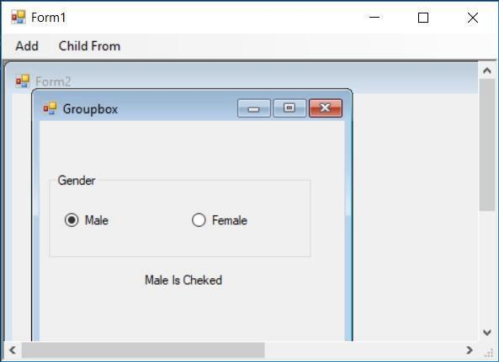

AIM 8 : Create a custom control for calculating Simple Interest and Compound Interest.

PROGRAM:

Program.cs

using System;
using System.Collections.Generic;
using System.ComponentModel;
using System.Drawing;
using System.Data;
using System.Linq;
using System.Text;
using System.Windows.Forms;

namespace Intrest
{
public partial class UserControl1 : UserControl
{
public UserControl1()
{
InitializeComponent();
}

private void button1_Click(object sender, EventArgs e)
{
double amount, per, month;
amount = Convert.ToDouble(text_amount.Text);
per = Convert.ToDouble(text_per.Text);
month = Convert.ToDouble(text_month.Text);
double intrest;
intrest = amount * per * month / (100*12);
label4.Text = "Simple Intrest :- " + intrest.ToString();
}

private void button2_Click(object sender, EventArgs e)
{
double amount, per, month;
amount = Convert.ToDouble(text_amount.Text);
per = Convert.ToDouble(text_per.Text);
month = Convert.ToDouble(text_month.Text);
double cintrest;
cintrest=amount;
for (int i = 0; i < month/12; i++)
{
amount+=(double)amount*per*month/(100*12);
}
cintrest = amount - cintrest;
label4.Text = "Compound Intrest :- " + cintrest.ToString();
}
}
}
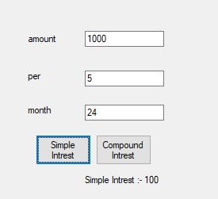
OUTPUT:

AIM 9 : Implement Paint application to draw various shapes using GDI+. Use menu to provide various options. Free Hand Drawing should also be implemented.

PROGRAM:

using System;

using System.Collections.Generic;

using System.ComponentModel;

using System.Data;

using System.Drawing;

using System.Linq;

using System.Text;

using System.Windows.Forms;

namespace P9

{

public partial class Form1 : Form

{

Pen pen;

Graphics g;

float x, y;

int flag=0;

public Form1()

{

InitializeComponent();

g = this.CreateGraphics();

}

private void button1_Click(object sender, EventArgs e)

{

Graphics g = this.CreateGraphics();

pen = new Pen(Color.Blue, 2);

g.DrawEllipse(pen, 50, 100, 50, 50);

}

private void button2_Click(object sender, EventArgs e)

{

pen = new Pen(Color.Red, 2);

g.DrawRectangle(pen, 120, 100, 50, 100);

}

private void button3_Click(object sender, EventArgs e)

{
Pen = new Pen(Color.Green, 2);

PointF pt1 = new PointF(220, 100);

PointF pt2 = new PointF(180, 200);

PointF pt3 = new PointF(260, 200);

PointF[] ptsArray =

{

pt1, pt2, pt3

};

g.DrawPolygon(pen, ptsArray);

}

private void button4_Click(object sender, EventArgs e)

{

flag = 1;

pen = new Pen(Color.Yellow, 3);

}

private void Form1_MouseMove(object sender, MouseEventArgs e)

{

if (e.Button == MouseButtons.Left&& flag==1)

{

g.DrawLine(pen, x, y, e.X, e.Y);

x = e.X;

y = e.Y;

}

}

private void Form1_MouseDown(object sender, MouseEventArgs e)

{

x = e.X;

y = e.Y;

}

private void Form1_MouseUp(object sender, MouseEventArgs e)

{

flag = 0;

}

}

}

OUTPUT:
