ASSIGNMENT-1

1)E-Book:

<html>
<head>
<title>Assignment 1 & 2</title>
<h1><center>ASSIGNMENT-1 & 2</center></h1>
</head>
<body bgcolor=cyan text=blue>
<a href="#Chapter-1">Chapter-1: Introduction</a><br>
<a href="#Chapter-2">Chapter-2: What is HTML?</a><br>
<a href="#Chapter-3">Chapter-3: What is Javascript?</a><br>
<br><br><br><br><br><br><br><br><br><br><br><br><br><br>
<h1 id="Chapter-1">Chapter-1: Introduction</h1>
<p>
In order to make websites look and function a certain way, web developers utilize different languages. The three core languages that make up the World Wide Web are HTML5, CSS, and JavaScript.
In the IT world, the internet is an essential platform, whether its for developing or for consumer use. When developing a website, typically three main languages come into play. These languages are JavaScript, CSS, and HTML. HTML is the backbone of most webpages. Essentially, it is used to create the structure of how a specific website would look like, from the headings, to the paragraphs, the body, links, and even images.
</p>
<a href="#Chapter-2">Chapter-2: What is HTML?</a><br>
<a href="#Chapter-3">Chapter-3: What is Javascript?</a><br>
<br><br><br><br><br><br><br><br><br><br><br><br><br><br>
<h1 id="Chapter-2">Chapter-2: What is HTML?</h1>
<p>
HTML is the conventional markup language used to create and edit web pages and web applications. HTML is used for creating the basic structure of a website. HTML consists of different elements preceded by an opening tag, <tag>, and a closing tag, </tag>. The content between the tags, <html> and </html>, is the content of the webpage. The content between the tags, <head> and </head>, is the title of the webpage. This text is displayed between the <title> and </title> tags. The content between the tags, <body> and </body>, is the main content of the webpage. The content can include links , paragraphs, headings, and various other elements.
</p>
<a href="#Chapter-1">Chapter-1: Introduction</a><br>
<a href="#Chapter-3">Chapter-3: What is Javascript?</a><br>
<br><br><br><br><br><br><br><br><br><br><br><br><br><br>
<h1 id="Chapter-3">Chapter-3 What is Javascript?</h1>
<p>
JavaScript is a scripting language that is used along with HTML and CSS as the three core components of the World Wide Web. JavaScript has first-class functions and is used in most websites. JavaScript does not have any I/O which means that it has to be embedded in the host environment. JavaScript is also used in PDF documents, game development, and desktop and mobile applications. JavaScript is most commonly used to make DHTML by adding client-side behavior to HTML pages.
</p>
<a href="#Chapter-1">Chapter-1: Introduction</a><br>
<a href="#Chapter-2">Chapter-2: What is HTML?</a><br>
</body>
</html>

OUTPUT:

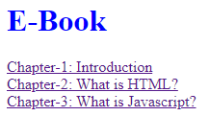

2)IMAGEMAP:

<html>
<body>
<p>Click on the shapes to watch it closer:</p>
<img src="parent.png" width="255" height="185" alt="Geometry" usemap="#planetmap">

<map name="planetmap">
<area shape="poly" coords="167,113,198,92,233,122,195,152" alt="Circle" href="circle.html">
<area shape="poly" coords="127,10,196,11,196,76,131,77" alt="Rectangle" href="rectangle.html">

<area shape="poly" coords=" 17,98,152,96,151,149,17,148" alt="Rectangle" href="rectangle.html">
<area shape="poly" coords="30,76,67,12,106,75" alt="Triangle" href="triangle.html">
<area shape="poly" coords="258,4,285,43,261,109,241,55" alt="Ellipse" href="ellipse.html">
</map>

</body>
</html>

Assignment 3
Create your class time table using HTML.

<html>
<head>
<title>Time Table</title>
</head>
<body >
<h3 align="center">SARVAJANIK COLLEGE OF ENGINEERING & TECHNOLOGY, SURAT (042) <br>
CLASS TIME TABLE(REVISED-7-1-2019)</h3>
<p align=center>
<b>BE :</b>III CO(SHIFT-1) &nbsp;&nbsp;&nbsp;
<b>SEMESTER:</b>VI &nbsp;&nbsp;&nbsp;
<b>YEAR:</b>2018-2019 &nbsp;&nbsp;&nbsp;
<b>CLASS ROOM:</b>C-203
</p>
<table border="1px" ALIGN="center">
<tr>
<th>PERIODS <br>&amp; TIME</th>
<th>1<br>08:30-09:30</th>
<th>2<br>09:30-10:30</th>
<th rowspan="11">&nbsp;&nbsp;R&nbsp;&nbsp;<br>&nbsp;&nbsp;e&nbsp;&nbsp;<br>&nbsp;&nbsp;c&nbsp;&nbsp;<br>&nbsp;&nbsp;e&nbsp;&nbsp;<br>&nbsp;&nbsp;s&nbsp;&nbsp;<br>&nbsp;&nbsp;s&nbsp;&nbsp;</th>
<th>3<br>10:45-11:45</th>
<th>4<br>11:45-12:45</th>
<th rowspan="11" >&nbsp;&nbsp;R&nbsp;&nbsp;<br>&nbsp;&nbsp;e&nbsp;&nbsp;<br>&nbsp;&nbsp;c&nbsp;&nbsp;<br>&nbsp;&nbsp;e&nbsp;&nbsp;<br>&nbsp;&nbsp;s&nbsp;&nbsp;<br>&nbsp;&nbsp;s&nbsp;&nbsp;</th>
<th>5<br>01:30-02:30</th>
<th>6<br>02:30-03:30</th>
</tr>
<tr>
<td rowspan="2">MON<br></td>
<td>AJ</td>
<td>.NET/CG</td>
<td colspan="2">.NET (ALL) (JC, VU)</td>
<td>WT</td>
<td>SE</td>
</tr>
<tr>
<td>BP</td>
<td>VU/UD</td>
<td colspan="2">CG (ALL) (UD,BKS)</td>
<td>KD</td>
<td>SG</td>
</tr>
<tr>
<td rowspan="2">TUE<br></td>
<td>AJ</td>
<td>.NET/CG</td>
<td colspan="2">WT (A) (UD, KD)</td>
<td>TOC</td>
<td rowspan="2">DE(NN,FV,RO)</td>
</tr>
<tr>
<td>VJ</td>
<td>VU/BK</td>
<td colspan="2">AJ (B) (KP,VJ)</td>
<td>BK</td>
</tr>
<tr>
<td rowspan="2">WED<br></td>
<td>SE</td>
<td>WT</td>
<td colspan="2">WT (B) (UD, KD)</td>
<td>SE</td>
<td rowspan="2"></td>
</tr>
<tr>
<td>KD</td>
<td>UD</td>
<td colspan="2">SE (A) (SG,UM)</td>
<td>SG</td>
</tr>
<tr>
<td rowspan="2">THU</td>
<td>TOC</td>
<td>.NET/CG</td>
<td colspan="2">AJ (A) (BP,NK)</td>
<td>SE</td>
<td>AJ</td>
</tr>
<tr>
<td>MK</td>
<td>VU/UD</td>
<td colspan="2">SE (B) (SG,KD)</td>
<td>KD</td>
<td>BP</td>
</tr>
<tr>
<td rowspan="2">FRI</td>
<td rowspan="2">DE(KP,VU,UM)</td>
<td rowspan="2">DE(KP,VU,UM)</td>
<td >WT<br></td>
<td>AJ</td>
<td>TOC</td>
<td>.NET/CG</td>
</tr>
<tr>
<td>UD</td>
<td>VJ</td>
<td>BK</td>
<td>JC/BKS</td>
</tr>
</table>
<br><br>
<TABLE BORDER="1" ALIGN="center">
<TR>
<TH ROWSPAN="3"><CENTER>FACULTY<BR>CODE:</BR></CENTER></TH>
<TD><CENTER>VU:PROF.VASUNDHARA UCHHULA</CENTER></TD>
<TD><CENTER>VJ:PROF.VANDANA JOSHI</CENTER></TD>
<TD><CENTER>BKS:PROF.BHUMIKA SHAH</CENTER></TD>
<TD><CENTER>SG:PROF.SNEHAL GANDHI</CENTER></TD>
</TR>
<TR>
<TD><CENTER>MK:PROF.MEHUL KHATIWALA</CENTER></TD>
<TD><CENTER>BP:PROF.BHAVESH PATEL</CENTER></TD>
<TD><CENTER>UD:PROF.URMI DESAI</CENTER></TD>
<TD><CENTER>UM:PROF.URVASHI MISTRY</CENTER></TD>
</TR>
<TR>
<TD><CENTER>JC:PROF.JAYESH CHAUDHARI</CENTER></TD>
<TD><CENTER>KD:PROF.KRISHNA DALASANIYA</CENTER></TD>
<TD><CENTER>KP:PROF.KARUNA PATEL</CENTER></TD>
<TD><CENTER>NK:NITYA KOMALAN</CENTER></TD>
</TR>
</table>
<TABLE BORDER="1" ALIGN="center">
<tr>
<TH><CENTER>Name of class teacher:</CENTER></TH>
<td>PROF.VASUNDHARA UCHHULA</td>
<TD>PROF.JYDEEP BARAD</TD>
<TD>PROF.KRISHNA DALASANIYA</TD>
</tr>
</TABLE>
<BR>
<TABLE ALIGN="center">
<tr>
<TH><CENTER>Time table Coordinator&nbsp;&nbsp;</CENTER></TH>
<th><CENTER>Head Of the Department</CENTER></th>
<Th><CENTER>Dean-Academic</CENTER></Th>
<Th><CENTER>Principal,SCET</CENTER></Th>
</tr>
<tr>
<td></td>
<td><center>Prof.(Dr.)Keyur Rana</center></td>
<td><center>Prof.(Dr.)Niteen Patel</center></td>
<td><center>&nbsp;&nbsp;Dr.Vaishali Mungurwadi</center></td>
</tr>
</TABLE>
</body>
</html>

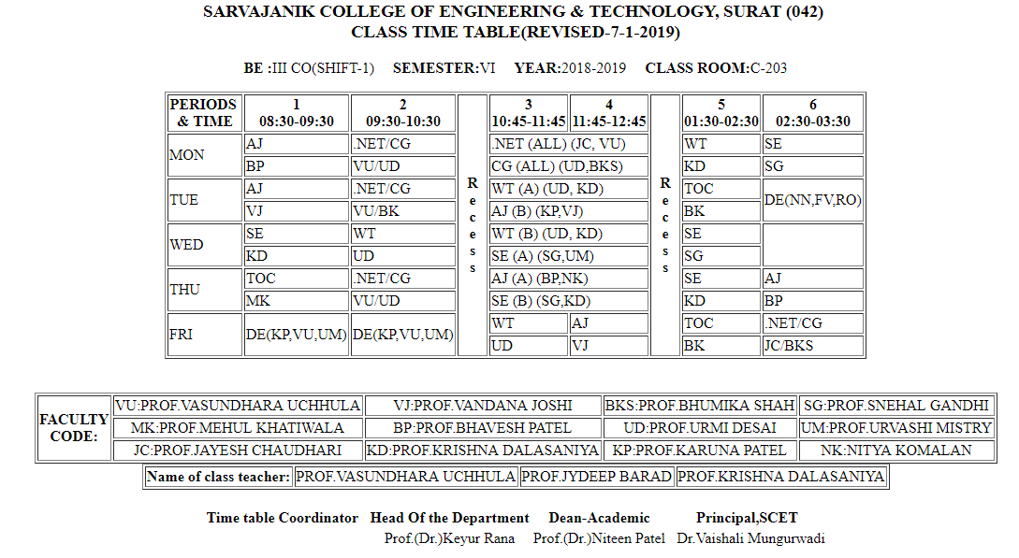

• Assignment 4
Create our co-intra page layout with three different frame. Top frame,left frame and right frame. On leftside frame put links for different subjects of your class in this semester. by clicking on these links syllabus of relevant subject will open on right side frame. use FRAMESET and FRAME tag.

Top.html
<html>
<head>
<title>Top</title>
</head>
<body bgcolor=#05718e>
<center><h1><font color=white>Syllabus of Semester-6</font></h1></center>
</body>
</html>

Left_frame.html
<html>
<head>
<title>Subjects</title>
</head>
<body bgcolor=#05718e>
<a href="http://gtu-info.com/Subject/2160701/SE/Software-Engineering/Syllabus" target=display><strong><font color=white>Software Engineering</font></a></strong><br>
<a href="http://gtu-info.com/Subject/2160707/AJAVA/Advanced-Java/Syllabus" target=display><strong><font color=white>Advanced Java</font></a></strong><br>
<a href="http://gtu-info.com/Subject/2160708/WT/Web-Technology/Syllabus" target=display><strong><font color=white>Web Technology</font></a></strong><br>
<a href="http://gtu-info.com/Subject/2160704/TOC/Theory-of-Computation/Syllabus" target=display><strong><font color=white>Theory Of Computation</font></a></strong><br>
<a href="http://gtu-info.com/Subject/2160711/.NET/Net-Technology/Syllabus" target=display><strong><font color=white>.Net</font></a></strong><br>
<a href="http://gtu-info.com/Subject/2151603/CG/Computer_Graphics/Syllabus" target=display><strong><font color=white>Computer Graphics</font></a></strong><br>
</body>
</html>

Main.html

<html>
<head>
<title>Assignment-4</title>
<frameset rows="20%,*">
<frame name = "top" src="top.html">
<frameset cols = "20%,80%">
<frame name = "subjects" src="subjects.html">
<frame name = "display" src="">
</frameset>
</frameset>
</head>
<body>
</body>
</html>

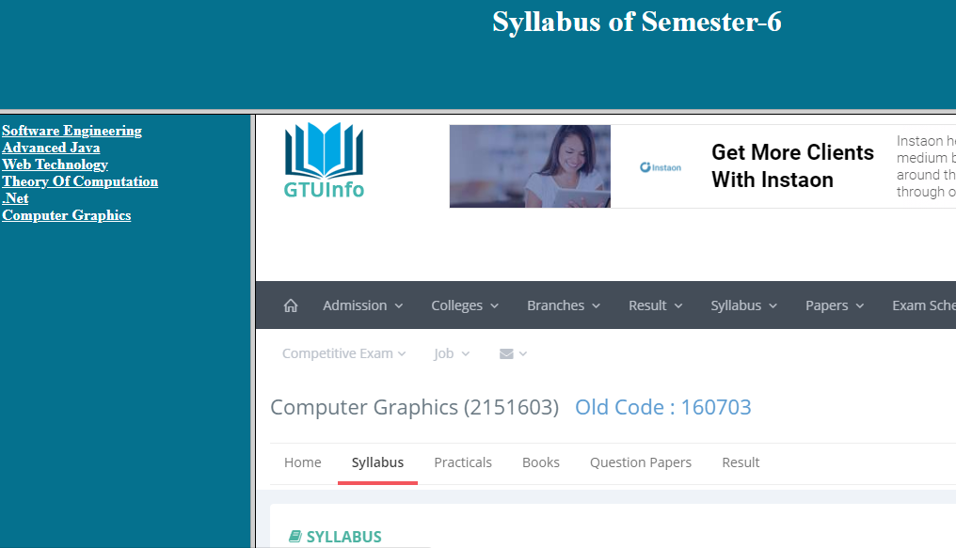
• Assignment 5
Create webpage as follow
<html>
<head>
<title>Registration Page</title>
</head>
<body bgcolor=#012d4c>
<form>
<table align=center border=5px bgcolor=#ed9cde bordercolor=#012660>
<tr>
<th colspan=2 height=50>Registration Page</th>
</tr>
<tr>
<td>Registration_Id:</td>
<td><input type=text></td>
</tr>
<tr>
<td>Username:</td>
<td><input type=text></td>
</tr>
<tr>
<td>Password:</td>
<td><input type=password></td>
</tr>
<tr>
<td>First Name:</td>
<td><input type=text></td>
</tr>
<tr>
<td>Last Name:</td>
<td><input type=text></td>
</tr>
<tr>
<td>Gender:</td>
<td><input type=radio name="gender" value="male" checked>Male
<input type=radio name="gender" value="female">Female</td>
</tr>
<tr>
<td>Date of Birth:</td>
<td>
<select>
<option value=day>Day</option>
<option value=1>1</option>
<option value=2>2</option>
<option value=3>3</option>
<option value=4>4</option>
<option value=5>5</option>
<option value=6>6</option>
<option value=7>7</option>
<option value=8>8</option>
<option value=9>9</option>
<option value=10>10</option>
<option value=11>11</option>
<option value=12>12</option>
<option value=13>13</option>
<option value=14>14</option>
<option value=15>15</option>
</select>
<select>
<option value=month>Month</option>
<option value=1>1</option>
<option value=2>2</option>
<option value=3>3</option>
<option value=4>4</option>
<option value=5>5</option>
<option value=6>6</option>
<option value=7>7</option>
<option value=8>8</option>
<option value=9>9</option>
<option value=10>10</option>
<option value=11>11</option>
<option value=12>12</option>
</select>
<select>
<option value=year>Year</option>
<option value=1>2010</option>
<option value=2>2011</option>
<option value=3>2012</option></option>
<option value=4>2013</option>
<option value=5>2014</option>
<option value=6>2015</option>
<option value=7>2016</option>
<option value=8>2017</option>
<option value=9>2018</option>
<option value=10>2019</option>
</select>
</td>
</tr>
<tr>
<td >Address:</td>
<td ><textarea rows=2></textarea></td>
</tr>
<tr>
<td>City:</td>
<td>
<select>
<option value=visnagar>Visnagar</option>
<option value=surat>Surat</option>
<option value=ahmedabad>Ahmedabad</option>
</select>
</td>
</tr>
<tr>
<td>State:</td>
<td>
<select>
<option value=gujarat>Gujarat</option>
<option value=maharashtra>Maharashtra</option>
<option value=goa>Goa</option>
</select>
</td>
</tr>
<tr>
<td>Country:</td>
<td>
<select>
<option value=india>India</option>
<option value=us>US</option>
<option value=uk>UK</option>
</select>
</td>
</tr>
<tr>
<td>Hobbies:</td>
<td>
<input type=checkbox name=hobbies value=reading>Reading
<input type=checkbox name=hobbies value=writing>Writing
<input type=checkbox name=hobbies value=singing>Singing
</td>
</tr>
<tr>
<td>Mobile No.:</td>
<td><input type=text></td>
</tr>
<tr>
<td>Attach C.V.:</td>
<td><button>Choose File</button>No file chosen</td>
</tr>
<tr>
<td colspan=2><center><button>Submit</button><button>Reset</button></center></td>
</tr>
</table>
</form>
</body>
</html>

OUTPUT:

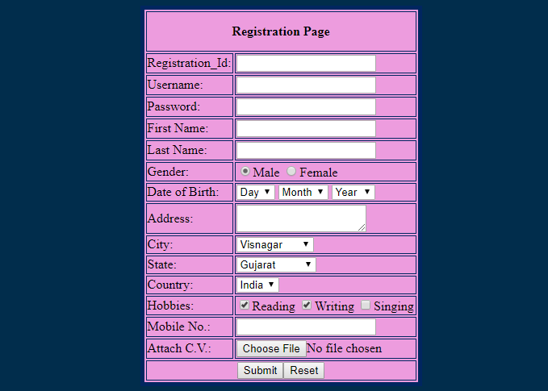

JAVA SCRIPT PRACTICAL LIST
1. Write a javascript program to display “hello world” using internal javascript and external
javascript.

PROGRAM:
<html>
<head>
<title>Internal and External JS</title>
<script type="text/javascript" src="External.js ">
</script>
</head>
<body>
<br>Output of Internal Javascript<br>
<script>document.write("Hello World");</script>
</body>
</html>
External.js
var s = "Output of External Javascript";
var str = "Hello World";
document.write(s+str);

OUTPUT:
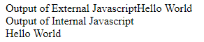

2. Write a javascript program to demo of local and global variables.
PROGRAM:
<html>
<head>
<title>Javscript Local and Global variables</title>
</head>
<body>
<script type="text/javascript">
var global = "Global variable";
myfunction();
function myfunction() {
var local = "Local variable<br>";
document.write(local);
document.write(global);
}
</script>
</body>
</html>

OUTPUT:
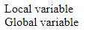
3. Write a javascript program to demo alert box,conditional box and prompt box.

PROGRAM:
<html>
<head>
<title>Javascript alert box</title>

<script type="text/javascript">
function warn(){
alert("Warning");
document.write("This is a warning message");
}
function confirmation() {
var x = confirm("Do u want to continue?");
if(x){
document.write("user wants to continue");
return tue;
}
else{
document.write("User doesn't want to continue");
return false;
}
}
function js_prompt(){
var x = prompt("Enter your name", "Your name here");
document.write("You entered: " + x);
}

</script>
</head>
<body>
<form>
<input type="button" value="Alert Box" onclick="warn();" >
<input type="button" value="Prompt Box" onclick="js_prompt();">
<input type="button" value="Confirm Box" onclick="confirmation();">
</form>
</body>
</html>

OUTPUT:
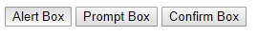
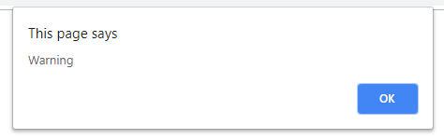
4. Write a javascript program to take user input as integer from user and find out that number is prime or not.
PROGRAM:
<html>
<head><title>Prime or not</title></head>
<body><script type="text/javascript">
var n = parseInt(prompt("Enter n:"));
var i,f = 0;
for(i=2;i<=n/2;i++){
if (n%i==0){
f=1;
break;
}
}
if (f==0)document.write("Prime");
else document.write("Not Prime");
</script></body>
</html>

OUTPUT:
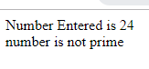

5. Write a javascript program to calculate of a person age. Take user's birthdate from user and current date from system.

PROGRAM:
<html>
<head><title>JS5</title></head>
<body><script type="text/javascript">
var date = prompt("Enter your birthdate (Jan 1 1999):","");
var ddate = new Date(date);
var cdate = new Date();
var x = cdate.getFullYear() - ddate.getFullYear();
document.write("<br>Your age: "+ x);
</script>
</body>
</html>

OUTPUT:
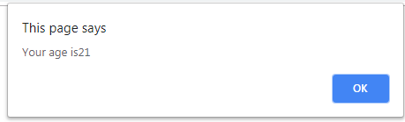
6. Write a javascript program to print Fibonacci series using function.

PROGRAM:
<html>
<head><title>Fibonacci Series</title></head>
<body><script type="text/javascript">
var n = parseInt(prompt("Enter n:",""));
var i,a=0,b=1,c;
function fibo(){
document.write(a +" "+b);
for(i=0;i<n-2;i++){
c=a+b;
document.write(" "+c);
a=b;
b=c;
}
}
fibo();
</script>
</body>
</html>
OUTPUT:
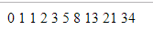

7. Write a javascript function to find factorial of a given number and return the answer.

PROGRAM:
<html>
<head><title>Factorial</title></head>
<body><script type="text/javascript">
var n = parseInt(prompt("Enter n:",""));
var i;
function fact(){
var ans=1;
for(i=0;i<n;i++){
ans *= (i+1);
}
return ans;
}
document.write("Answer: " +fact());
</script>
</body>
</html>
OUTPUT:
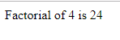
8. Create different variables of Array and string objects. And use all the functions related to that.
PROGRAM:
<html>
<head><title>Array & String</title>
<script input="text/javascript">
var subject=["wt","se","aj","cg","toc"];
var name="Darshit Akbari";
var le=name.length;
document.write(subject[0]);
subject.push(" pushed element : de <br>");
document.write(subject[5]);
subject.pop();
document.write("element popped");
document.write("<br>");
document.write("join method<br>");
document.write(subject.join("****"));
document.write("<br>Strings methods");
document.write("length ",le)
le=name.indexOf("Akbari");
document.write("<br>index of method Darshit",le);
le=name.search("Darshit");
document.write("<br>search index Darshit:",le);
var sl=name.slice(3,9);
document.write("<br> slice method 3-9",sl);
var n=sr.replace("Darshit","king");
document.write("<br>method replace",n);
</script>
</head>
</html>
OUTPUT:
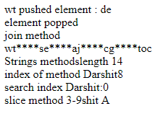
9. Create javascript that scroll some message in Status window of browser.
PROGRAM:
<html><head>
<title>Scroll Message</title>
<script input="text/javascript">
msg="Hi… How are you?";
window.status=msg;
var pos=0;
function scroll(){
window.status=msg.substring(pos,ms.length)+msg.substring(0,pos);
pos++;
if(pos>msg.length)
pos==0;
window.setTimeout(scroll(),500);
}
</script>
</head>
</html>
10. Write a javascript program to change the background color of web page repeatedly.

PROGRAM:
<html>
<head><title>Background Colour</title>
<script input="text/javascript">
i=0;color=["red","green","blue","pink","black"];
function bgchange(){
document.bgColor=color[i];
i++;
if(i>6){
i=0;}
window.setTimeout("bgchange()",500);
}bgchange();
</script></head>
</html>

OUTPUT:

11. Create a webpage containing one button. clicking on this button change the size of the window & position.

PROGRAM:
<html><body>
<script>
var win = window.open("","","weight=200,height=100");
setTimeout(()=>{
win.resizeTo(500,500);
},2000);
</script></body>
</html>

OUTPUT:
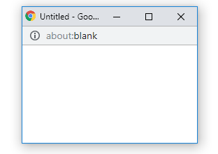

12. Put three button “OPEN NEW WINDOW”,”CLOSE CHILD WINDOW”,”CLOSE MAIN WINDOW” in main HTML page, on click of first button, execute some JavaScript code that will open one child window. Clicking on second button child window will close and third button main html page will close.

PROGRAM:
<html>
<head><title>Put three button</title>
<h5>Put three button “OPEN NEW WINDOW”,”CLOSE CHILD WINDOW”,”CLOSE MAIN
WINDOW” in main HTML page, on click of first button, execute some JavaScript code that
will open one child window. Clicking on second button child window will close and third
button main html page will close.</h5>
<script input="text/javascript">
function mynewin(){
var myWindow = window.open("", "myWindow", "width=200, height=100");
}
function myclosewin(){
myWindow.close();}
function myclosemain(){
window.close();
}
</script></head><body>
<button onclick="mynewin()">
click for new window</button>
<button onclick="myclosewin()">
Click here for closing child window onclick</button>
<button onclick="myclosemain() ">
Click here to close main window</button>
</body>
</html>

OUTPUT:
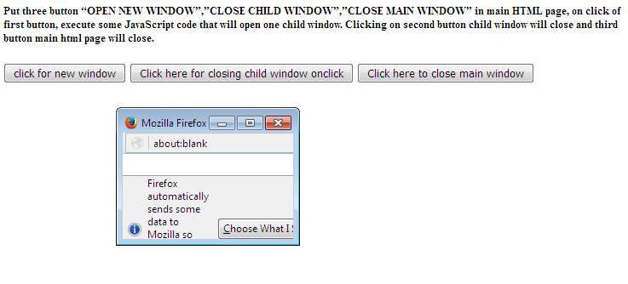

13. Write a javascript to get details from visitors browser.

PROGRAM:
<html>
<body><script>
document.write("Browser : " + navigator.appCodeName+"<br>");
document.write("Agent : " + navigator.userAgent);
</script></body>
</html>
OUTPUT:
14. Write a javascript program to rotate images.

PROGRAM:
<html><body>
<canvas id="myCanvas" width="300" height="150" style="border:1px solid #d3d3d3;">
</canvas><script>
var c = document.getElementById("myCanvas");
var ctx = c.getContext("2d");
ctx.rotate(20 * Math.PI / 180);
ctx.fillRect(100, 50, 100, 50);
</script></body>
</html>
OUTPUT:


15. Write a javascript program to zoom out the image. use mouseover event for the same.
PROGRAM:
<html><body>
<img onmouseover="bigImg(this)" onmouseout="normalImg(this)" border="0" src="http://www.asianage.com/sites/default/files/images/SHIVAJI.jpg" alt="Smiley" width="64" height="64">
<script>
function bigImg(x) {
x.style.height = "256px";
x.style.width = "256px";
}function normalImg(x) {
x.style.height = "64px";
x.style.width = "64px";
}
</script></body></html>

OUTPUT:



