# PRACTICAL-1

# Preprocessing of missing values. Replace the missing values for given automobile dataset “imports-85.data” with user specified global constant.

# Program :

package a;

import java.io.BufferedReader;

import java.io.BufferedWriter;

import java.io.File;

import java.io.FileNotFoundException;

import java.io.FileReader;

import java.io.FileWriter;

import java.io.IOException;

import java.util.ArrayList;

public class DM_Practical_1 {

FileReader fin;

FileWriter fout;

BufferedReader bin;

BufferedWriter bout;

String[] cols;

ArrayList<String[]> dataList;

String initalData[];

String line = null;

// ArrayList<String> col;

public DM_Practical_1() throws IOException {

intialData();

fileRead();

fillMissing();

fileWrite();

}

private void fileRead() throws IOException {

int i = 0;

dataList = new ArrayList<>();

fin = new FileReader(new File("assets/imports-85.data"));

bin = new BufferedReader(fin);

while ((line = bin.readLine()) != null) {

cols = line.split(",");

dataList.add(cols);

}

// TODO Auto-generated method stub

}

private void fileWrite() throws IOException {

fout=new FileWriter(new File("assets/imports-85-1.data"));

bout=new BufferedWriter(fout);

for(String[]rows : dataList)

{

line=String.join(",",rows);

bout.write(line+"\n");

}

bout.close();

bin.close();

fin.close();

fout.close();

// TODO Auto-generated method stub

}

private void fillMissing() {

int j = 0;

for (String[] rows : dataList) {

int i = 0;

for (String cols : rows) {

//System.out.print(i + "\t" + cols);

if (cols.contains("?"))

dataList.get(j)[i] = initalData[i];

i++;

}

//System.out.println();

j++;

}

}

private void intialData() {

initalData = new String[26];

initalData[1] = 46 + "";

initalData[5] = "three";

initalData[18] = 4.6f + "";

initalData[19] = 4.6f + "";

initalData[21] = 46 + "";

initalData[22] = 46000 + "";

initalData[25] = 46000 + "";

}

public static void main(String arg[]) throws IOException {

new DM_Practical_1();

}

}

**Output :-**

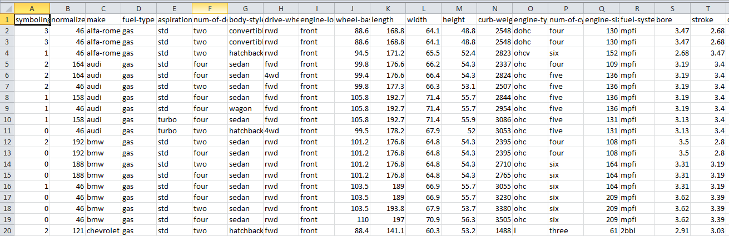

# PRACTICAL-2

* **Preprocessing of missing values. Replace the missing values for given automobile dataset “imports-85.data” with mean, median and mode value of numeric attribute.**

**Program :-**

package a;

import java.io.BufferedReader;

import java.io.BufferedWriter;

import java.io.File;

import java.io.FileReader;

import java.io.FileWriter;

import java.io.IOException;

import java.util.ArrayList;

import java.util.Enumeration;

import java.util.Hashtable;

import java.util.Scanner;

import java.util.Set;

public class DM_Practical_2 {

int choice = 0;

FileReader fin;

FileWriter fout;

BufferedReader bin;

BufferedWriter bout;

String[] cols;

ArrayList<String[]> dataList;

Double initalData[][];

String line = null;

int missingCol[];

public DM_Practical_2() throws IOException {

initalData = new Double[26][3];

fileRead();

Scanner s = new Scanner(System.in);

System.out.println("Menu\n1 : Mean\n2 : Meaden\n3 : Mode\n0 : Exit\n");

choice = s.nextInt();

while (true) {

if (choice == 0)

break;

fillMissing();

printIntialData();

fillMissingDatawithMean();

// printData();

fileWrite();

choice = s.nextInt();

}

}

public static void main(String[] args) throws IOException {

// TODO Auto-generated method stub

new DM_Practical_2();

}

private void printIntialData() {

for (Double a[] : initalData)

System.out.println("Sum : " + a[0] + "\t NO :" + a[1] + " Mean : " + a[2]);

}

private void printData() {

for (String[] a : dataList) {

for (String cols : a) {

System.out.println(cols);

}

}

}

private void fileRead() throws IOException {

int i = 0;

dataList = new ArrayList<>();

fin = new FileReader(new File("assets/imports-85.data"));

bin = new BufferedReader(fin);

while ((line = bin.readLine()) != null) {

cols = line.split(",");

dataList.add(cols);

}

}

private void fileWrite() throws IOException {

fout = new FileWriter(new File("assets/imports-85-2.data"));

bout = new BufferedWriter(fout);

for (String[] rows : dataList) {

line = String.join(",", rows);

bout.write(line + "\n");

}

bout.close();

bin.close();

fin.close();

fout.close();

// TODO Auto-generated method stub

}

private void fillMissing() {

missingCol = new int[26];

int j = 0;

for (String[] rows : dataList) {

int i = 0;

for (String cols : rows) {

// System.out.print(i + "\t" + cols);

if (cols.contains("?"))

missingCol[i] = 1;

// dataList.get(j)[i] = initalData[i];

i++;

}

// System.out.println();

j++;

}

for (int i = 0; i < missingCol.length; i++) {

if (missingCol[i] == 1) {

calculateMissingData(i);

}

}

}

private void calculateMissingData(int i) {

String mode[][] = null;

//if (choice == 1 || choice == 2)

if (i == 5)

return;

int j = 0;

System.out.println("cols : " + i);

double sum = 0, n = 0;

for (String[] rows : dataList) {

if (!rows[i].contains("?"))

try {

if (choice == 1)

sum = sum + Double.parseDouble(rows[i]);

n++;

j++;

} catch (Exception e) {

e.printStackTrace();

}

}

intialData(i, sum, (double) n);

}

private void intialData(int index, double sum, double cnt) {

if (choice == 1) {

initalData[index][0] = sum;

initalData[index][1] = cnt;

initalData[index][2] = sum / cnt;

}

}

private void fillMissingDatawithMean() {

int j = 0;

for (String[] rows : dataList) {

int i = 0;

for (String cols : rows) {

// System.out.print(i + "\t" + cols);

if (cols.contains("?"))

if (initalData[i][2] != null)

dataList.get(j)[i] = String.valueOf(initalData[i][2]);

i++;

}

// System.out.println();

j++;

}

}

}

**Output :-**

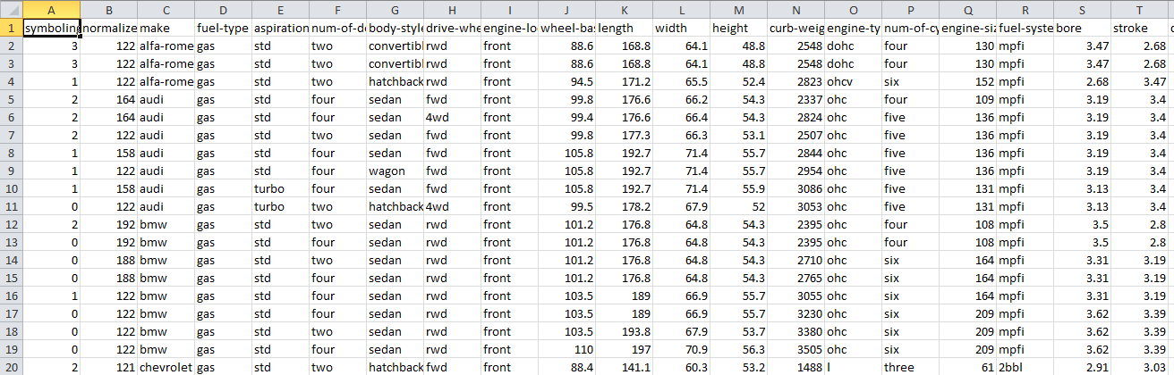

# PRACTICAL-3

* **Preprocessing of missing values. Replace the missing values for given automobile dataset “imports-85.data” with mean value of each attribute class. (Consider no. of doors as the class attribute - 6th attribute)**

**Program :-**

import java.io.*;

public class Practical_3 {

public static void main(String[] atr) throws Exception

{

FileReader fr=new FileReader("imports-85.csv");

BufferedReader br= new BufferedReader(fr);

FileWriter fw=new FileWriter("output.csv");

String line =br.readLine();

line=br.readLine();

int total1=0,total2=0,total3=0,b[],i,j=0,k=0,l=0;

b=new int[164];

while(line!=null)

{

String[] arr=line.split(",");

//When no.of doors are four

if(arr[5].equals("four"))

{

if(!arr[1].equalsIgnoreCase("?"))

{

total1=total1+Integer.parseInt(arr[1]);

b[j]=Integer.parseInt(arr[1]);

j++;

}}

if(arr[5].equals("two"))

{

if(!arr[1].equalsIgnoreCase("?"))

{

total2=total2+Integer.parseInt(arr[1]);

b[k]=Integer.parseInt(arr[1]);

k++;

}

}

if(arr[5].equals("?"))

{

if(!arr[1].equalsIgnoreCase("?"))

{

total3=total3+Integer.parseInt(arr[1]);

b[l]=Integer.parseInt(arr[1]);

l++;

}}

line=br.readLine();

}

double mean1=0.0,mean2=0.0,mean3=0.0;

mean1=(double)total1/j; //When no.of doors are four

mean2=(double)total2/k; //When no.of doors are two

mean3=(double)total3/l; //When no.of doors are ?

System.out.println("Mean1 is: "+ mean1+"\nMean2 is: "+ mean2+"\nMean3 is: "+ mean3+"\n");

FileReader fr1=new FileReader("imports-85.csv");

BufferedReader br1= new BufferedReader(fr1);

String line1=br1.readLine();

line1=br1.readLine();

while(line1!=null)

{

String arr[]=line1.split(",");

for(i=0;i<arr.length;i++)

{

if(arr[5].equals("four"))

{

if(arr[i].equals("?"))

{

arr[i]=String.valueOf(mean1);

}}

if(arr[5].equals("two"))

{

if(arr[i].equals("?"))

{

arr[i]=String.valueOf(mean2);

}}

if(arr[5].equals("?"))

{

if(arr[i].equals("?"))

{

arr[i]=String.valueOf(mean1);

}}

fw.write(arr[i]+",");

}

fw.write("\n");

line1=br1.readLine();

}

br.close();

fw.close();

br1.close(); }}

**Input:**

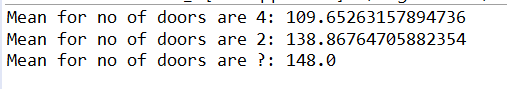

**Output:**

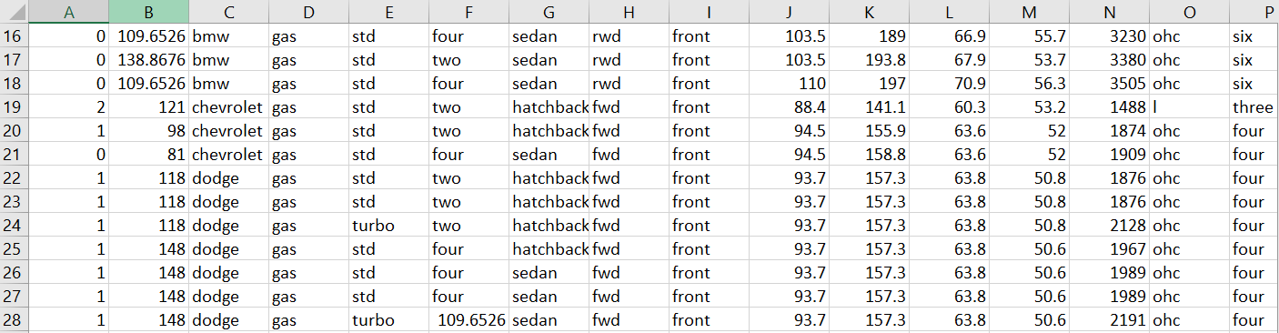

# PRACTICAL-4

* **Preprocessing of Noisy Data. Consider the following values for age attribute of total 21 records : 13, 52, 15, 16, 45, 19, 20, 21, 22, 25, 30, 33, 35, 36, 40, 46, 70, 16, 25, 22, 33. Implement smoothing by bin means to smooth these data, using a suitable bin depth.**

**Program :-**

package a;

import java.io.*;

import java.lang.reflect.Array;

import java.util.ArrayList;

import java.util.Arrays;

import java.util.Collection;

import java.util.Collections;

public class DM_Practical_4 {

FileInputStream fin;

FileOutputStream fout;

BufferedReader buffIn;

BufferedOutputStream buffOut;

String data;

ArrayList<String> dataArray;

int binSize, nobin;

public DM_Practical_4() {

try {

fin = new FileInputStream(new File("assets/input.data"));

buffIn = new BufferedReader(new InputStreamReader(fin));

String[] cols;

dataArray = new ArrayList<>();

while ((data = buffIn.readLine()) != null) {

cols = data.split(", ");

dataArray.addAll(Arrays.asList(cols));

// System.out.println(data);

}

/*

* for (String d : dataArray) { System.out.println(d); }

*/

System.out.println("With Sorted");

{

ArrayList<Integer> dta = new ArrayList<>();

for (String d : dataArray)

dta.add(Integer.valueOf(d));

Collections.sort(dta);

dataArray.clear();

for (Integer i : dta) {

dataArray.add(String.valueOf(i));

}

}

// Collections.sort(dataArray);

for (String d : dataArray) {

System.out.println(d);

}

buffIn.close();

fin.close();

} catch (Exception e) {

e.getMessage();

}

calculateBinSize();

nobin = dataArray.size() / binSize;

System.out.println("Total Size :" + dataArray.size() + "Bin Size :" + binSize);

normlizeBins(0);

}

private void normlizeBins(int choice) {

// ArrayList<Integer> meanArray = new ArrayList<>();

int sum = 0;

if (choice == 0) {

for (int i = 0; i < nobin; i++) {

for (int j = 0; j < binSize; j++) {

// meanArray.add(Integer.valueOf(dataArray.get(i + j)));

sum += Integer.valueOf(dataArray.get(i * binSize + j));

}

for (int k = 0; k < binSize; k++) {

dataArray.set(i * binSize + k, String.valueOf((double) sum / (double) binSize));

}

sum = 0;

}

}

for (String d : dataArray) {

System.out.println(d);

}

// TODO Auto-generated method stub

}

private void calculateBinSize() {

int min = dataArray.size();

for (int i = 1; i < dataArray.size() / 2; i++) {

if (dataArray.size() % i == 0) {

if (min > Math.abs(dataArray.size() / i - i)) {

min = Math.abs(dataArray.size() / i) - i;

System.out.println("bin : " + binSize + "min : " + (Math.abs(dataArray.size() / i) - i));

binSize = i;

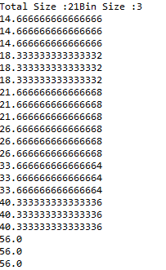 }

}

}

}

public static void main(String[] args) {

new DM_Practical_4();

}

}

**Output :-**

# PRACTICAL-5

* **Preprocessing of Noisy Data. Consider the following values for age attribute of total 21 records : 13, 52, 15, 16, 45, 19, 20, 21, 22, 25, 30, 33, 35, 36, 40, 46, 70, 16, 25, 22, 33. Implement smoothing by bin medians to smooth these data, using a suitable bin depth.**

**Program :-**

package a;

import java.io.*;

import java.lang.reflect.Array;

import java.util.ArrayList;

import java.util.Arrays;

import java.util.Collection;

import java.util.Collections;

public class DM_Practical_5 {

FileInputStream fin;

FileOutputStream fout;

BufferedReader buffIn;

BufferedOutputStream buffOut;

String data;

ArrayList<String> dataArray;

int binSize, nobin;

public DM_Practical_5() {

try {

fin = new FileInputStream(new File("assets/input.data"));

buffIn = new BufferedReader(new InputStreamReader(fin));

String[] cols;

dataArray = new ArrayList<>();

while ((data = buffIn.readLine()) != null) {

cols = data.split(", ");

dataArray.addAll(Arrays.asList(cols)); }

System.out.println("With Sorted");

{

ArrayList<Integer> dta = new ArrayList<>();

for (String d : dataArray)

dta.add(Integer.valueOf(d));

Collections.sort(dta);

dataArray.clear();

for (Integer i : dta) {

dataArray.add(String.valueOf(i));

}

}

for (String d : dataArray) {

System.out.println(d);

}

buffIn.close();

fin.close();

} catch (Exception e) {

e.getMessage();

}

calculateBinSize();

nobin = dataArray.size() / binSize;

System.out.println("Total Size :" + dataArray.size() + "Bin Size :" + binSize);

normlizeBins(1);

}

private void normlizeBins(int choice) {

// ArrayList<Integer> meanArray = new ArrayList<>();

int sum = 0;

if (choice == 1) {

for (int i = 0; i < nobin; i++) {

if (binSize % 2 == 0) {

sum=Integer.valueOf(dataArray.get(i*binSize+binSize/2))+Integer.valueOf(dataArray.get(i*binSize+((binSize/2)-1)));

sum=sum/2;

} else {

sum=Integer.valueOf(dataArray.get(i*binSize+binSize/2));

}

for (int k = 0; k < binSize; k++) {

dataArray.set(i * binSize + k, String.valueOf(sum));

// System.out.print(dataArray.get(i*binSize+k)+" ");

}

sum = 0;

}

}

for (String d : dataArray) {

System.out.println(d);

}

}

private void calculateBinSize() {

int min = dataArray.size();

for (int i = 1; i < dataArray.size() / 2; i++) {

if (dataArray.size() % i == 0) {

if (min > Math.abs(dataArray.size() / i - i)) {

min = Math.abs(dataArray.size() / i) - i;

System.out.println("bin : " + binSize + "min : " + (Math.abs(dataArray.size() / i) - i));

binSize = i;

} }

}

}

public static void main(String[] args) {

new DM_Practical_5();

}

}

**Output :-**

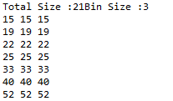

# PRACTICAL-6

* **Preprocessing of Noisy Data. Consider the following values for age attribute of total 21 records : 13, 52, 15, 16, 45, 19, 20, 21, 22, 25, 30, 33, 35, 36, 40, 46, 70, 16, 25, 22, 33. Implement smoothing by bin boundaries to smooth these data, using a suitable bin depth.**

**Program :-**

package a;

import java.io.*;

import java.lang.reflect.Array;

import java.util.ArrayList;

import java.util.Arrays;

import java.util.Collection;

import java.util.Collections;

public class DM_Practical_6 {

FileInputStream fin;

FileOutputStream fout;

BufferedReader buffIn;

BufferedOutputStream buffOut;

String data;

ArrayList<String> dataArray;

int binSize, nobin;

public DM_Practical_6() {

try {

fin = new FileInputStream(new File("assets/input.data"));

buffIn = new BufferedReader(new InputStreamReader(fin));

String[] cols;

dataArray = new ArrayList<>();

while ((data = buffIn.readLine()) != null) {

cols = data.split(", ");

dataArray.addAll(Arrays.asList(cols));

// System.out.println(data);

}

System.out.println("With Sorted");

{

ArrayList<Integer> dta = new ArrayList<>();

for (String d : dataArray)

dta.add(Integer.valueOf(d));

Collections.sort(dta);

dataArray.clear();

for (Integer i : dta) {

dataArray.add(String.valueOf(i));

}

}

for (String d : dataArray) {

System.out.println(d);

}

buffIn.close();

fin.close();

} catch (Exception e) {

e.getMessage();

}

calculateBinSize();

nobin = dataArray.size() / binSize;

System.out.println("Total Size :" + dataArray.size() + "Bin Size :" + binSize);

normlizeBins(2);

}

private void normlizeBins(int choice) {

// ArrayList<Integer> meanArray = new ArrayList<>();

int sum = 0;

if (choice == 2) {

int a = 0, min = 0, max = 0;

for (int i = 0; i < nobin; i++) {

min = Integer.valueOf(dataArray.get(i * binSize + 0));

max = Integer.valueOf(dataArray.get(i * binSize + (binSize-1)));

System.out.print(dataArray.get(i*binSize)+" ");

for (int j = 1; j < binSize-1; j++) {

a = Integer.valueOf(dataArray.get(i * binSize + j));

if (Math.abs(a - min) < Math.abs(a - max))

dataArray.set(i * binSize + j, dataArray.get(i * binSize + 0));

else

dataArray.set(i * binSize + j, dataArray.get(i * binSize + (binSize-1)));

System.out.print(dataArray.get(i*binSize+j)+" ");

}

System.out.println(dataArray.get(i*binSize+(binSize-1))+" ");

}

}

}

private void calculateBinSize() {

int min = dataArray.size();

for (int i = 1; i < dataArray.size() / 2; i++) {

if (dataArray.size() % i == 0) {

if (min > Math.abs(dataArray.size() / i - i)) {

min = Math.abs(dataArray.size() / i) - i;

System.out.println("bin : " + binSize + "min : " + (Math.abs(dataArray.size() / i) - i));

binSize = i;

}

}

}

}

public static void main(String[] args) {

new DM_Practical_6();

}

}

**Output :-**

