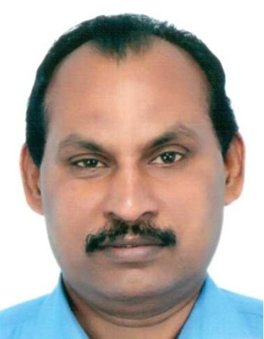

**Resume Summary**

|  |  |  |  |  |  |  |  |  |  |  |  |  |  |  |  |  |  |  |  |  |
| --- | --- | --- | --- | --- | --- | --- | --- | --- | --- | --- | --- | --- | --- | --- | --- | --- | --- | --- | --- | --- |
| |  |  |  |  |  |  |  |  |  |  |  |  |  |  |  |  |  |  |  |  | | --- | --- | --- | --- | --- | --- | --- | --- | --- | --- | --- | --- | --- | --- | --- | --- | --- | --- | --- | --- | | ***Contact details: -***  **Email:** [rkkpillai4@gmail.com](mailto:rkkpillai4@gmail.com); **Mobile:** +919840256843  **Current Location:** Cochin Kerala  Address: - PetroNest Apartment, No 44/39668, Flat No 7C, Stadium Link Road, Opposite to IMA House, Kaloor, Cochin-682025, Kerala.  **Date of Birth**   17 Nov 1961 **Gender**  Male **Nationality**  India  ***Professional and work experiences: -***   |  |  | | --- | --- | | **Work experience** | Over 33 years | | **Skills** | Heavy Equipment & Engines Maintenance and its management, technical communicator, technical training and spare parts and unit sales marketing & management. | | **Industry** | Heavy earth moving equipment’s [ CAT & JCB ] , Engine , Heavy Commercial vehicles [Mercedes Benz & Bharat Benz ] , Ancillaries, Automotive/ Ancillaries, Construction and Mining etc. | | **Category** | Product Support - Construction, Production , Marketing etc. | | **Last assignments** | Dy General Manager – Product Support for Mercedes Benz & Bharat Benz Heavy Commercial Vehicles (Mining trucks) vertical. | | **Roles & Responsibilities** | Responsible for recruiting service & parts personals, Training & development , Setting up of Branch office, Parts depot , Warranty administrations , Coordination with Principle ( Daimler India ) , Establishing Main & Satellite workshops, Site operations etc . | | **Previous Employers** | 1. L& T (1981-1985) with Caterpillar Division as Apprentice trainee and service engineer, 2. TIL Limited Kolkata (1985-1989) as parts sales service supervisor. 3. Gmmco Ltd (1989 – 2005) as Parts Manager, branch manager and Regional Service Manager. 4. Muscat Overseas at Oman- Muscat (2005-2012) As National Service Manager for JCB, STILL, Volvo Penta engines and Generator 5. Gmmco Ltd (2012 – 2021) as Product Support Head responsible for Service & Parts Operations and implementing CRM | | **Highest Degree Held** | B-TECH (Mech) and Diploma in Business Management | |  | Presently working as, a consultant with Falcon Synergy Engineers to manage their machineries maintenances and asset management. |   **Core competencies: -**  Mechanical Engineer having 33 years of experience in handling progressive responsibilities {Spare Parts & Services} from Aftermarket technical solution to Leadership roles. >Knowledge of Products & Markets on Hydraulics, Materials Handling & Construction Equipment in India & Middle East. >Specialized in after sales, new business development and International market expansion. >Adept at technical sales, after sales support, procurement, product & project management >Experience in combining entrepreneurial drive with business-management skills to drive gains in revenue, market share and profits. >Cultivate & maintain excellent relationships with all stake holders. >Awareness about Project Management.  Above information’s are in best of my knowledge.  **R Kutty Krishna Pillai** |  | |