**RESUME**

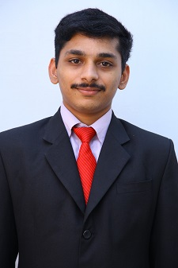

**CIBIN MATHEW**

KOZHIKOTTU (H)

NEYYASSERY (P.O)

KARIMANNOOR

THODUPUZHA

IDUKKI

Kerala -685581

Mob: 9562774406

9961193259

Email- cibinm14@gmail.com

**CAREER OBJECTIVE**

To work in a challenging and healthy work environment that provides me satisfaction and self development and helps me to achieve organizational goal.

**PERSONAL DETAILS:-**

Age : 32

Date of Birth : 14-10-1990

Gender : Male

Nationality : India

Marital Status : Single

Religion : Christian

Mother Tongue : Malayalam

Languages Known : Malayalam, English ,

**Educational Qualifications**

|  |  |  |
| --- | --- | --- |
| Qualification | University / Board | Percentage of marks |
| SSLC | Board of Public Examinations, Kerala | 60% |
| Plus Two | Board of Public Examinations, Kerala | 62% |
| B. Com | M.G. University, Kottayam, Kerala | 58% |
| M.B.A | M.G. University, Kottayam, Kerala | 63.2% |
| M.Com | M.G. University, Kottayam, Kerala | PASS |
| TALLY ERP.9 |  | A |

**EXPERIENCE**

|  |  |
| --- | --- |
| **INSTITUTE** | **EXPERIENCE** |
| Poly John and Company , Charterd Accountant | 7 Month |
| Mini Muthoottu Nidhi Kerala LTD | 3 Years |
| Essar Lab Mate | 6 Month |

**DECLARATION**

I hereby declare that the above furnished details are true and correct to the best of my knowledge and belief.

Place : Thodupuzha CIBIN MATHEW

Date : 12-05-2023