**CURRICULAM VITAE**

**ABHIRAM C**

**Chaliyil House**

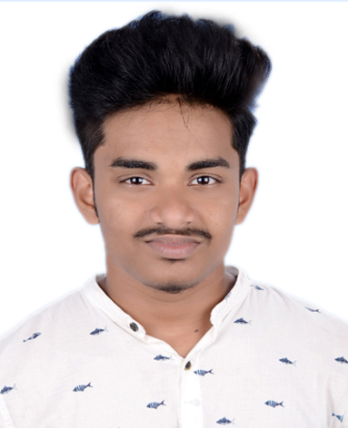

**East Karad**

**Karadparmba po**

**Malappuram**

**Pin-673632**

**Mob-7510171218**

**Email:abhiramarnold@gmail.com**

**------------------------------------------------------------------------------------------------------------------------------**

**CAREER OBJECTIVE:**

To work I a healthy , innovative and challenging environment extracting the best out of me, which is conducive to learn and grow at professional as well as personal level thereby directing me future endeavors as an asset to the organization.

**ACADEMIC QUALIFICATIONS:**

|  |  |  |  |  |
| --- | --- | --- | --- | --- |
| COURSE | BRANCH/SUBJECTS | UNIVERSITY/ BOARD | PERCENTAGE | YEAR OF PASS |
| 10th | Physics, Chemestry, Maths, General | STATE BOARD EDUCATION KERALA | 69% | 2017 |
| ITI | Elecronic Mechanical | NCVT | Passed | 2021 |
|  | Automobile Electrical and Electronic Asseceries | KERALA | Passed | 2022 |

**WORK EXPERIENCE:**

Automobile Electrical and Electronics Asseceries working in 1 year experience

**PERSONAL QUALITIES:**

Hard Working

Willing to learn new things

Sincere

Positive attitude

**SKILLS:**

Computer Basic Knowledge

Creative thinking

**HOBBIES & INTERESTS:**

Body Building

Music

Cinema

**PERSONAL DETAILS:**

Fater Name : Anil Kumar C

Date of Birth : 16-03-2002

Gender : Male

Nationality : Indian

Language Known : English, Malayalam, Hindi

Maritual Status : Single

**DECLARATION**

Ihereby declare that the above written particulars and true and correct to the best of my knowledge and belief.

Place :Karadparamba

Date: 09-12-2021 Abhiram C