### Steps to setup and build DataCollection project

Prerequisites

**Installed Visual Studio 2015 or 2017 (Community Edition is free), with C# language support and .NET Framework SDK v4.5**

1. Extract “DataCollection.zip” into any folder, let’s say, Project
2. Inside the Project folder you will see 2 folders: **DataCollection** and **OpenScrapping. DataCollection** folder contains main source files, and **OpenScrapping** contains the web-scrapping DLL source code– this is necessary to build DataCollection app.

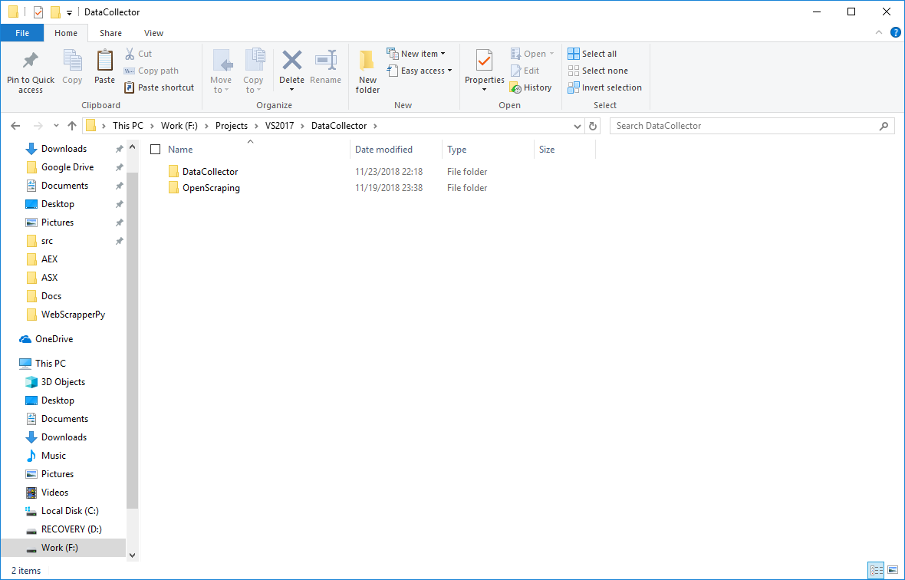

1. Open DataCollection folder. You will see source files and subfolders:

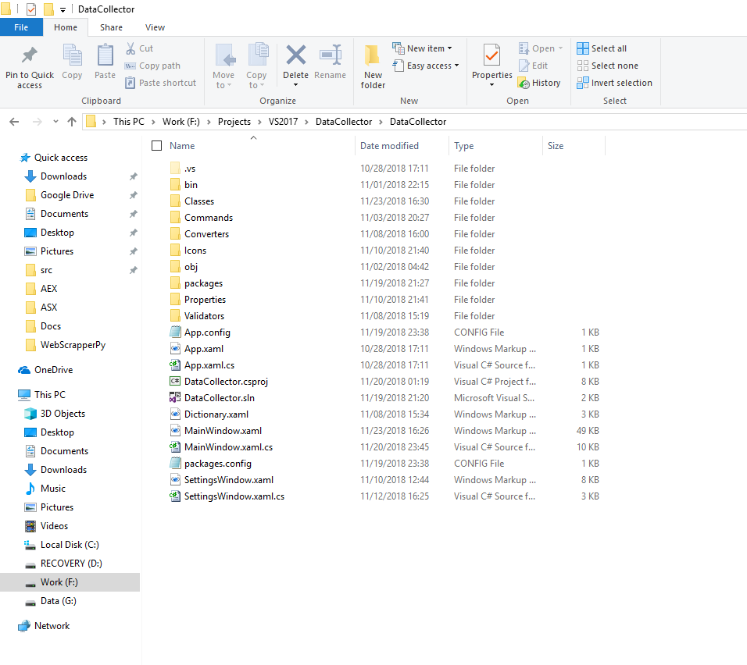

1. Open Visual Studio 2015 or 2017
2. From the main menu choose **File->Open->Project/Solutions. “**Open Project” dialog should appear

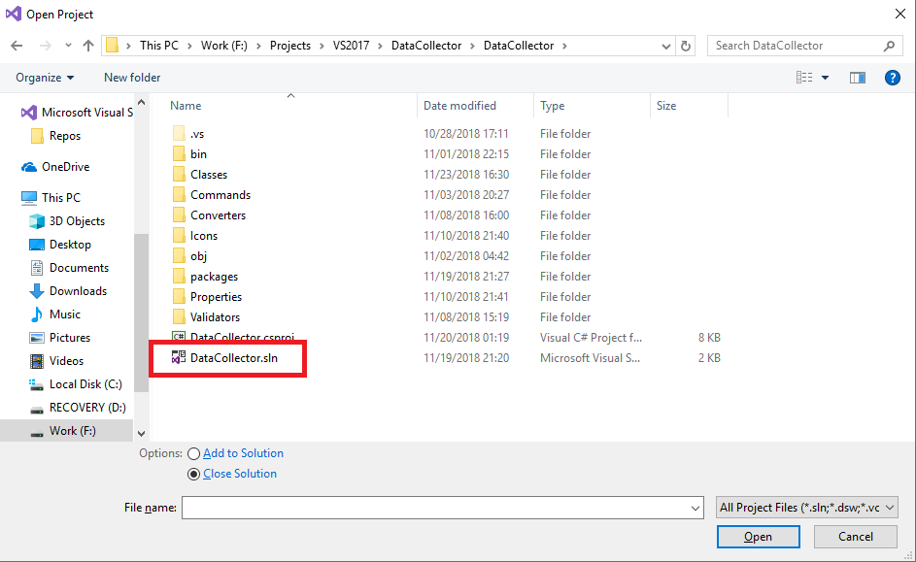

1. Navigate to the **DataCollection** directory and open file **DataCollection.sln –** this is the solution file, which contains setup configuration of project.
2. When solution is opened, you must see the following inside the Visual Studio (inner windows layout may differ, but inside the **Solution Explorer** window you will find the tree structure of the solution)

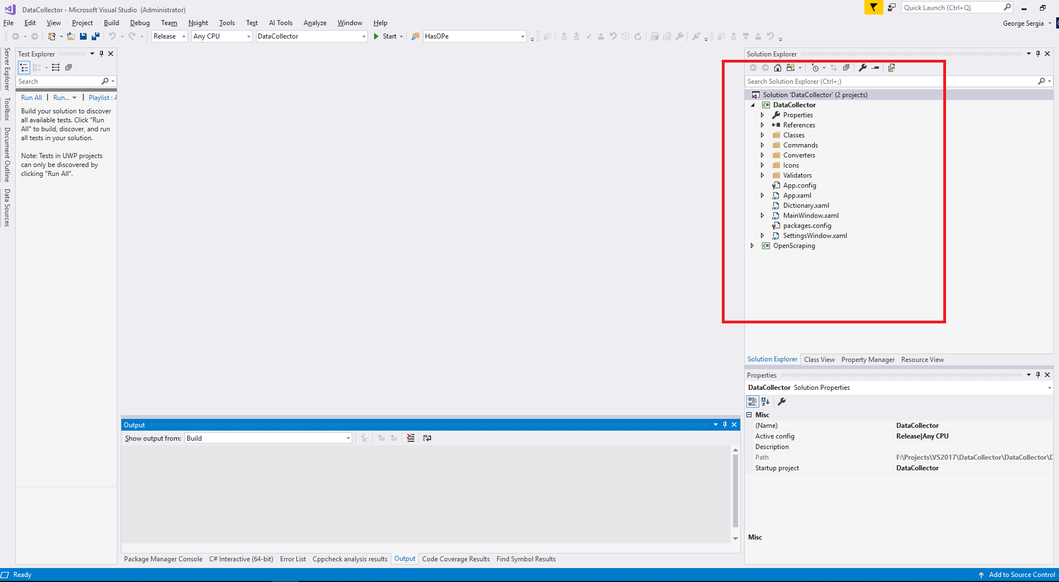

1. From the main menu, select **Build->Rebuild Solution** - this will clean previous build files and rebuild**,** or **Build->Build Solution** – this will just build solution, if source is changed

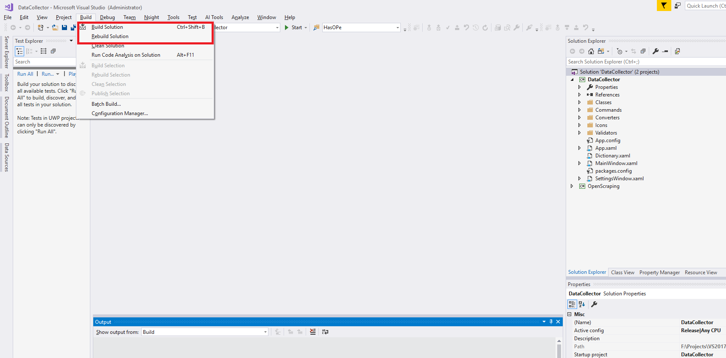

1. Before you build the solution, you can chose project configuration, **Debug/Release** from the configurations list:

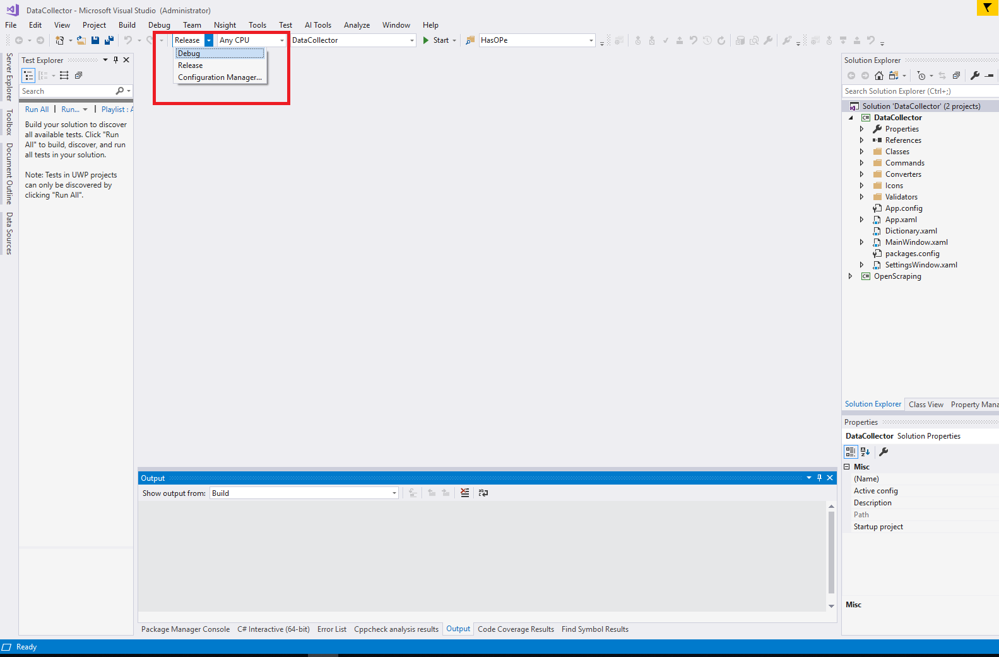

1. Based on the chosen configuration, output files are generated inside **DataCollection/Bin/Debug**, or **DataCollection/Bin/Release** folders:

