SOCIAL MEDIA AUTOMATION

Project Roadmap
Phases 1-8
ROYAL GLASS | BLUE HAVEN

Document control | Value
Status | Project Roadmap
Version | 1.0
Effective date | 24 August 2026
Scope | Royal Glass and Blue Haven; project phases 1-8
Current execution horizon | Phases 1-4 - Foundation & Data
Future growth horizon | Phases 5-8 - Intelligence, Execution & Growth
Purpose | Govern phase sequence, boundaries, hand-offs and change control

Authority of this document
This roadmap is the governing source for the project sequence and phase boundaries. Phase-specific Source of Truth documents govern the detailed configuration inside their own phase. If work begins to conflict with this roadmap, update and approve the roadmap first rather than allowing scope to drift silently.

Project objective
Turn collected market and performance data into better marketing decisions, stronger content and more qualified enquiries, while keeping human control over final actions.

1. Purpose and Boundaries
This document prevents the project from drifting as new tools, ideas and AI capabilities are introduced. It defines what each phase is for, what it should hand to the next phase, and what must wait until later.

1.1 This roadmap includes
- The approved order and business purpose of Phases 1 through 8.
- The boundary between foundation/data work and future intelligence/execution work.
- The primary deliverable and exit gate for each phase.
- The operating rules that later phase documents and implementation work must follow.
- The current role of external tools without making any one vendor the permanent source of truth.

1.2 This roadmap does not include
- Detailed implementation design, code architecture or database schemas.
- Fixed vendor commitments, subscription plans or permanent tool choices.
- Fixed development estimates or budgets; these should be approved separately when a phase is ready to start.
- Automatic publishing without human approval.
- New brands, regions or services that have not first been approved through the governing upstream phase.
Operating principle
Build in sequence, prove value before scaling, and keep business rules upstream. Later phases may enrich the system, but they must not silently redefine the brands, priorities, competitor rules or success measures established earlier.

2. Shared Project Rules
1. Phase gates: Do not treat a downstream phase as approved until the required upstream inputs exist and are accepted.
2. Business outcomes first: Optimise toward qualified traffic, enquiries and useful decisions, not activity for its own sake.
3. Brand separation: Royal Glass and Blue Haven may share infrastructure, but relevance, competitors, recommendations and reporting remain brand-specific.
4. Own the useful data: External tools can collect or publish information, but the reusable business history should remain available to Royal Glass.
5. Evidence before recommendation: Recommendations should be traceable to current, relevant information rather than generic AI output.
6. Human approval: AI or automation may recommend and prepare work, but final publishing remains a human-controlled action unless a later policy explicitly changes this.
7. Prove before expanding: New intelligence or automation layers begin as a controlled test before broader rollout.

3. Roadmap at a Glance
The approved roadmap has two horizons. Phases 1-4 establish the foundation and data discipline. Phases 5-8 turn that trusted data into intelligence, recommendations, approved content and measurable business outcomes.
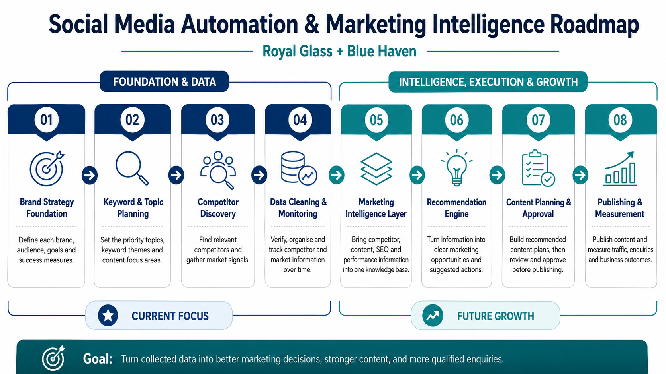
Roadmap visual - reference view. The written phase definitions below are authoritative if a visual is later edited.
Phase | Name | Business purpose | Roadmap status
1 | Brand Strategy Foundation | Define each brand, audience, goals and success measures. | Established
2 | Keyword & Topic Planning | Set priority topics, keyword themes and content focus areas. | Established
3 | Competitor Discovery | Find relevant competitors and gather market signals. | CURRENT
4 | Data Cleaning & Monitoring | Verify, organise and track competitor and market information over time. | Next
5 | Marketing Intelligence Layer | Bring competitor, content, SEO and performance information into one knowledge base. | Future
6 | Recommendation Engine | Turn information into clear marketing opportunities and suggested actions. | Future
7 | Content Planning & Approval | Build recommended content plans, then review and approve before publishing. | Future
8 | Publishing & Measurement | Publish approved content and measure traffic, enquiries and business outcomes. | Future

Current versus future scope
Phases 1-4 are the active foundation/data horizon. Phases 5-8 are approved future direction, not permission to skip the data foundation. The intelligence layer should start only when the competitor and market data is clean enough to trust.

4. Phase Definitions - Foundation & Data

4.1. Phase 1 - Brand Strategy Foundation
Business purpose | Define what Royal Glass and Blue Haven are, who they serve, which commercial priorities matter, and how success is judged.
Required inputs | Approved business information and current brand/service direction.
Includes | Brand profiles; audiences; service/topic priorities; positioning; conversion goals; KPI hierarchy; relevance rules; cross-brand separation rules.
Primary deliverable | Phase 1 Brand Profiles & Strategy - Source of Truth.
Exit / gate | Brand definitions, priorities, KPI logic and relevance rules are approved and can be consumed by later phases without inventing new assumptions.
Boundary | No competitor discovery, scaled keyword expansion, social scraping, content generation, scheduling or publishing.

4.2. Phase 2 - Keyword & Topic Planning
Business purpose | Translate the brand strategy into a structured keyword, topic and discovery plan that can serve competitor research, SEO and later content intelligence.
Required inputs | Approved Phase 1 brand strategy and relevance rules.
Includes | Topic maps; keyword matrices; P1/P2/P3 priorities; customer journey and content-pillar mapping; discovery query subsets; competitor discovery cadence; SEO review cadence.
Primary deliverable | Phase 2 Keyword Matrix & Topic Map - Source of Truth.
Exit / gate | The keyword/topic configuration and smaller Phase 3 discovery set are accepted as the governing input for discovery.
Boundary | No competitor scraping results, business classification, social monitoring, website rewrites or publishing.

4.3. Phase 3 - Competitor Discovery
Business purpose | Build the raw candidate universe for each brand using the approved discovery queries and sources.
Required inputs | Phase 1 brand scope plus the active Phase 2 discovery query set and cadence.
Includes | Run approved discovery sources; collect candidate businesses and source records; preserve the exact query/source that found each candidate; identify discovery gaps for targeted re-runs.
Primary deliverable | Raw competitor candidate dataset with query and source provenance for Royal Glass and Blue Haven.
Exit / gate | Discovery has adequate coverage of known direct competitors and strategic adjacent businesses, and the raw dataset is ready for structured cleaning and validation.
Boundary | A search result is not automatically a competitor. Normalisation, deduplication, final classification and ongoing monitoring belong to Phase 4.

4.4. Phase 4 - Data Cleaning & Monitoring
Business purpose | Turn raw discovery output into a trusted, maintainable competitor and market dataset that can be tracked over time.
Required inputs | Phase 3 raw candidate datasets with provenance.
Includes | Normalise names/URLs/contact fields; deduplicate entities; verify relevance; classify Direct, Adjacent, Supplier/Ecosystem, Needs Validation or Irrelevant; establish approved competitor master lists; collect/refresh market and competitor signals on an agreed cadence; retain history and last-verified dates.
Primary deliverable | Clean competitor master data plus monitoring rules and historical snapshots suitable for later analysis.
Exit / gate | The data is clean enough that business users can understand who is being monitored, why they are relevant, when they were last verified, and where the information came from.
Boundary | Do not allow later AI recommendations to treat unverified or irrelevant candidates as authoritative evidence.

5. Phase Definitions - Intelligence, Execution & Growth

5.1. Phase 5 - Marketing Intelligence Layer
Business purpose | Make trusted competitor, content, SEO and performance information easy to retrieve together so the business can ask useful marketing questions against its own accumulated knowledge.
Required inputs | Clean Phase 4 competitor/market data plus approved brand, keyword, content and performance sources as they become available.
Includes | Create a unified knowledge layer; preserve brand context and source provenance; make historical information searchable/retrievable; support a controlled Royal Glass-first proof of concept before wider rollout.
Primary deliverable | Marketing Intelligence knowledge base / proof of concept with a defined set of business questions and source-backed answers.
Exit / gate | The proof of concept demonstrates useful, traceable answers that save research effort or improve decision quality enough to justify further investment.
Boundary | This phase provides evidence and context. It does not autonomously decide what to publish.

5.2. Phase 6 - Recommendation Engine
Business purpose | Convert trusted information into prioritised marketing opportunities and suggested next actions.
Required inputs | Phase 5 knowledge layer plus the approved brand goals, topic priorities and measurement rules.
Includes | Identify opportunities/gaps; rank recommended actions; explain why an action is recommended; distinguish evidence from recommendation; apply brand-specific relevance rules; support recurring business briefs.
Primary deliverable | Recommendation outputs such as competitor insights, SEO/content opportunities and suggested priorities with supporting evidence.
Exit / gate | Recommendations are relevant, explainable and consistently useful enough for a human reviewer to make faster, better decisions.
Boundary | Recommendations are advisory. They do not bypass business review or automatically publish content.

5.3. Phase 7 - Content Planning & Approval
Business purpose | Turn approved opportunities into usable content plans while keeping brand voice, commercial priorities and human approval intact.
Required inputs | Approved Phase 6 recommendations plus brand assets, content rules and campaign priorities.
Includes | Content calendars; briefs; draft themes/captions; channel selection; creative requirements; review workflow; approval state; Royal Glass/Blue Haven separation.
Primary deliverable | Approved content plan and publish-ready assets/drafts for the selected channels.
Exit / gate | Every item scheduled for execution has an owner/approval state and aligns to the correct brand, objective and source recommendation.
Boundary | No unapproved automated publishing. Content generation is not a substitute for approval or brand governance.

5.4. Phase 8 - Publishing & Measurement
Business purpose | Execute approved marketing activity and measure whether it creates useful downstream business outcomes.
Required inputs | Approved Phase 7 content plus connected publishing and measurement channels.
Includes | Schedule/publish approved content; capture reach, engagement, website traffic and conversion signals; measure enquiries and business outcomes where attribution exists; feed performance learnings back into future planning.
Primary deliverable | Published campaigns/content, performance reporting and a feedback loop into the intelligence system.
Exit / gate | The team can connect activity to agreed KPIs and use results to improve future recommendations rather than merely reporting vanity metrics.
Boundary | Publishing tools are execution channels, not the permanent source of business strategy or historical intelligence.

6. Phase Gates and Hand-offs
Gate | Required hand-off | Rule
1 -> 2 | Approved brand scope, audiences, topic tiers, positioning, conversions and KPIs | Keyword/topic system must reflect Phase 1 rather than inventing a new strategy.
2 -> 3 | Approved discovery query subset, priority and cadence | Discovery should use the approved query plan and preserve provenance.
3 -> 4 | Raw candidates with source/query lineage | Cleaning and classification must be able to explain where each candidate came from.
4 -> 5 | Trusted competitor master data and monitoring history | Do not build intelligence on top of noisy/unverified data.
5 -> 6 | Source-backed knowledge responses that are demonstrably useful | Only recommend from information that can be retrieved and explained.
6 -> 7 | Prioritised recommendations with rationale/evidence | Content planning begins from approved opportunities, not arbitrary posting volume.
7 -> 8 | Human-approved publish-ready content | Only approved items move to execution.
8 -> feedback loop | Performance and business outcome data | Use measured results to improve future intelligence, recommendations and content decisions.

No silent phase skipping
Work may be explored early for learning, but it must not be treated as a production dependency until the upstream gate is satisfied. A prototype is allowed; a hidden change of scope is not.

7. Tool Roles - Business View
Tools may change over time. Their role in the business process matters more than the vendor name.
Role / current example | Business job | Boundary
Apify / discovery collectors | Collect search, maps, website or social signals | Input source only; not the source of truth for strategy or final competitor status.
Owned data store / master datasets | Retain clean competitor, content and historical records | Preserve reusable business knowledge even if a collector changes.
Marketing Intelligence layer | Bring relevant stored information together for questions and analysis | Must retain source context and brand separation.
Recommendation layer | Suggest what may deserve attention or action | Advisory; human decision remains the gate.
Metricool / publishing platform | Schedule and publish approved social content | Execution tool; not the owner of strategy or historical intelligence.
Website / analytics / lead systems | Capture traffic, conversions, enquiries and later business outcomes | Provide feedback on whether marketing activity created value.

8. Governance and Change Control
Governance ensures that new tools, ideas and requests are evaluated against the approved sequence instead of changing the project scope informally.
Roadmap authority: This document governs phase names, sequence, high-level boundaries and hand-offs.
Phase 1 authority: Phase 1 governs brand identity, market, audiences, commercial priorities, conversions, KPIs and relevance rules.
Phase 2 authority: Phase 2 governs approved keywords/topics, discovery-query priorities and review/discovery cadence.
Later phase authority: Each later Source of Truth document will govern the detailed rules inside that phase once approved.
Change propagation: If a brand, service, audience, target region or core objective changes, update the earliest affected source first and propagate the change downstream.
Versioning: Material changes require a new version number, effective date and change-log entry.
Tool changes: Changing a vendor does not automatically change the roadmap. Update the roadmap only if the business role, phase boundary or operating rule changes.
Conflict rule
For phase sequence and boundaries, this roadmap wins. For brand strategy, Phase 1 wins. For keyword/topic configuration, Phase 2 wins. Implementation notes and tool configurations must conform to those governing documents rather than replacing them.

9. Roadmap Acceptance Criteria
- The eight phase names and sequence are accepted.
- Phases 1-4 are recognised as the foundation/data horizon and Phases 5-8 as future intelligence/execution/growth.
- Phase 3 remains discovery; Phase 4 owns cleaning, validation, classification and monitoring.
- The Marketing Intelligence layer is a future addition after the data foundation is trustworthy.
- Recommendation outputs remain advisory and human approval remains required before publishing.
- Tool roles are understood as replaceable components rather than the project strategy itself.
- Future phase documents must align with this roadmap and upstream Sources of Truth.
Roadmap decision
Once accepted, this document becomes the project-level reference used to check whether new requests belong in the current phase, a later phase, or require a formal roadmap change. The goal is controlled evolution, not scope drift.

10. Governing References
Source | Location | Purpose
Internal - Phase 1 Source of Truth | Phase1_Brand_Profile.docx | Governs brand profiles, goals, topic tiers, KPIs, relevance and cross-brand separation.
Internal - Phase 2 Source of Truth | Phase_2_Keyword_Matrix_Topic.docx | Governs keyword/topic matrices, discovery query subsets, priority and cadence.
Internal - Updated roadmap visual | social_media_marketing_roadmap.png | Presentation view of the approved eight-phase roadmap; written definitions in this document govern if the image is edited.
External - architecture inspiration | github.com/jamwithai/production-agentic-rag-course | Reference for the future intelligence/recommendation direction only; it is not a governing project source.

11. Version History
Version | Date | Change
1.0 | 24 Aug 2026 | Initial project-level Source of Truth defining the updated eight-phase roadmap, current/future horizons, phase gates, business tool roles and change-control rules.

