Report for



By: Intellij System Solution Sdn. Bhd.

**1.0 Introduction**

|  |  |
| --- | --- |
| **General Information** | **Response** |
| Name of Candidate: | Mohammad Abu Naser |
| Apply Position: | Dot Net / DBA / Big Data Analytics |
| Date of Submission : | 25/06/2017 |
| Github repository link: |  |

**2.0 How it Works**

1. First Create a database in SQL Server and name it “SystemDB” and restore the data SystemDB_Backup file.
2. Open the ASP.Net solution file.
3. Find “Web.Config” file and open it.
4. Change the “ConnectionString” parameter as per Database local host name.
5. Run the package file and open it in a browser.
6. Now WORK following the below screen shots.
7. It will work in a web browser.
8. It is developed in ASP.Net 2012, HTML, MySql Server 2012

**3.0 Screenshots**

1. **Create Task**

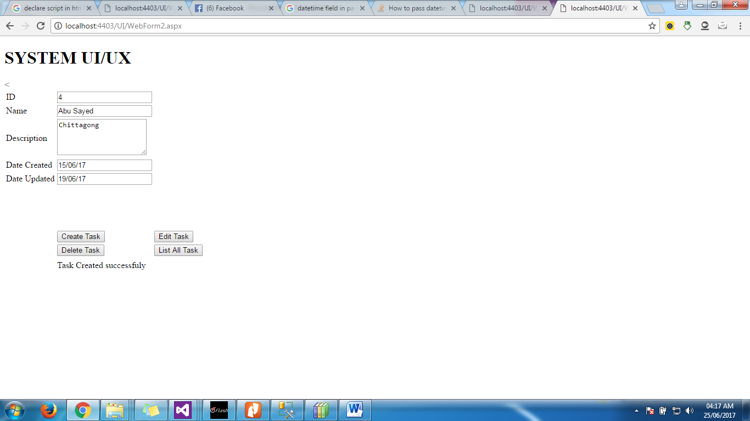

1. **Delete a Task**

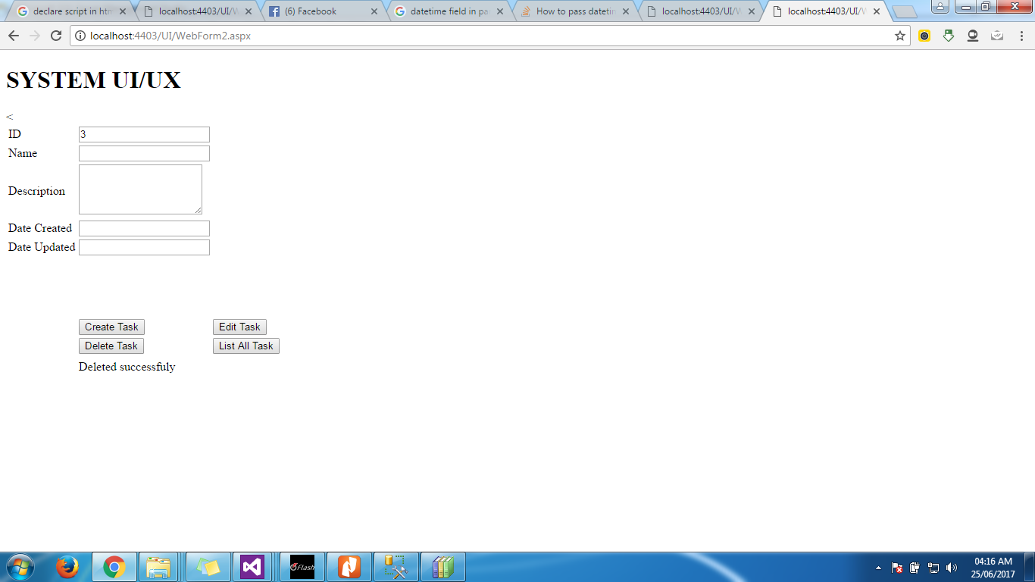

1. **Edit Task**

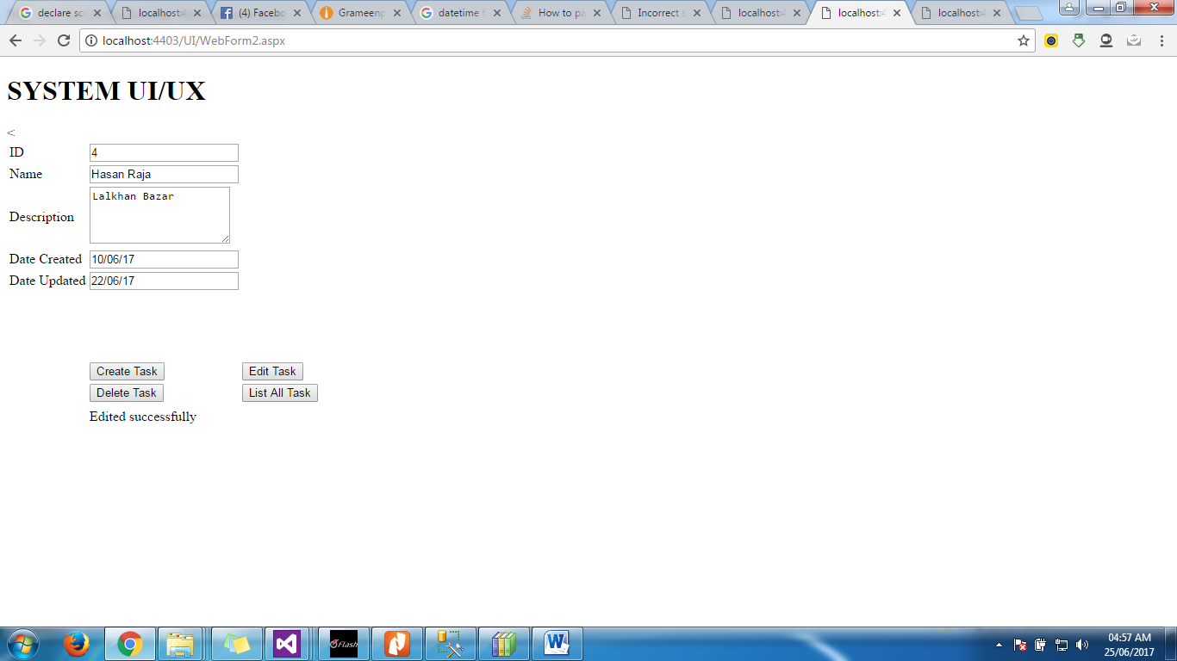

1. **Edit (if Id not exists)**

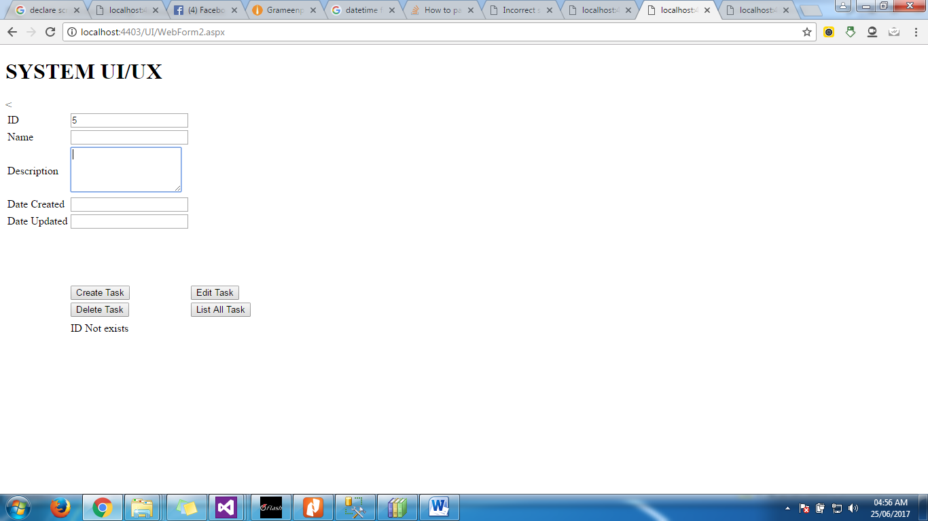

1. **List all tasks**

