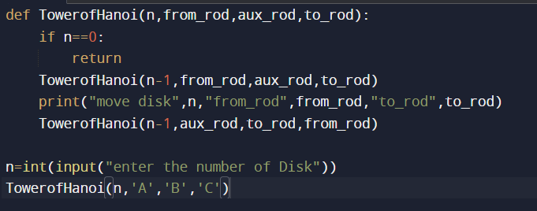#implement solutions for Tower of hanoi

INPUT=

def TowerofHanoi(n,from_rod,aux_rod,to_rod):

if n==0:

return

TowerofHanoi(n-1,from_rod,aux_rod,to_rod)

print("move disk",n,"from_rod",from_rod,"to_rod",to_rod)

TowerofHanoi(n-1,aux_rod,to_rod,from_rod)

n=int(input("enter the number of Disk"))

TowerofHanoi(n,'A','B','C')