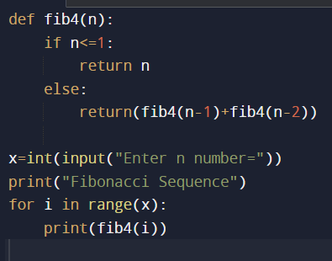#program to demonstrate recursive operations(Fibonacci series)

Output=

def fib4(n):

if n<=1:

return n

else:

return(fib4(n-1)+fib4(n-2))

x=int(input("Enter n number="))

print("Fibonacci Sequence")

for i in range(x):

print(fib4(i))