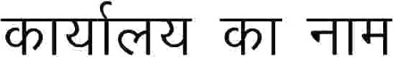JODHPUR (Zilla Panchaya

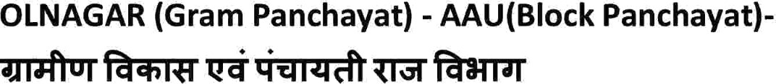

—

SIYOLNAGAR

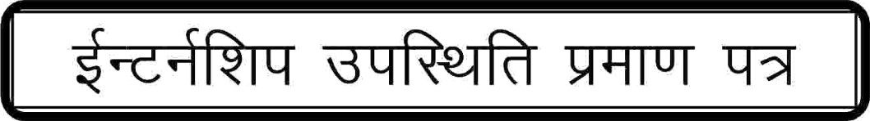

— 12023

