**Display Restraunts:**

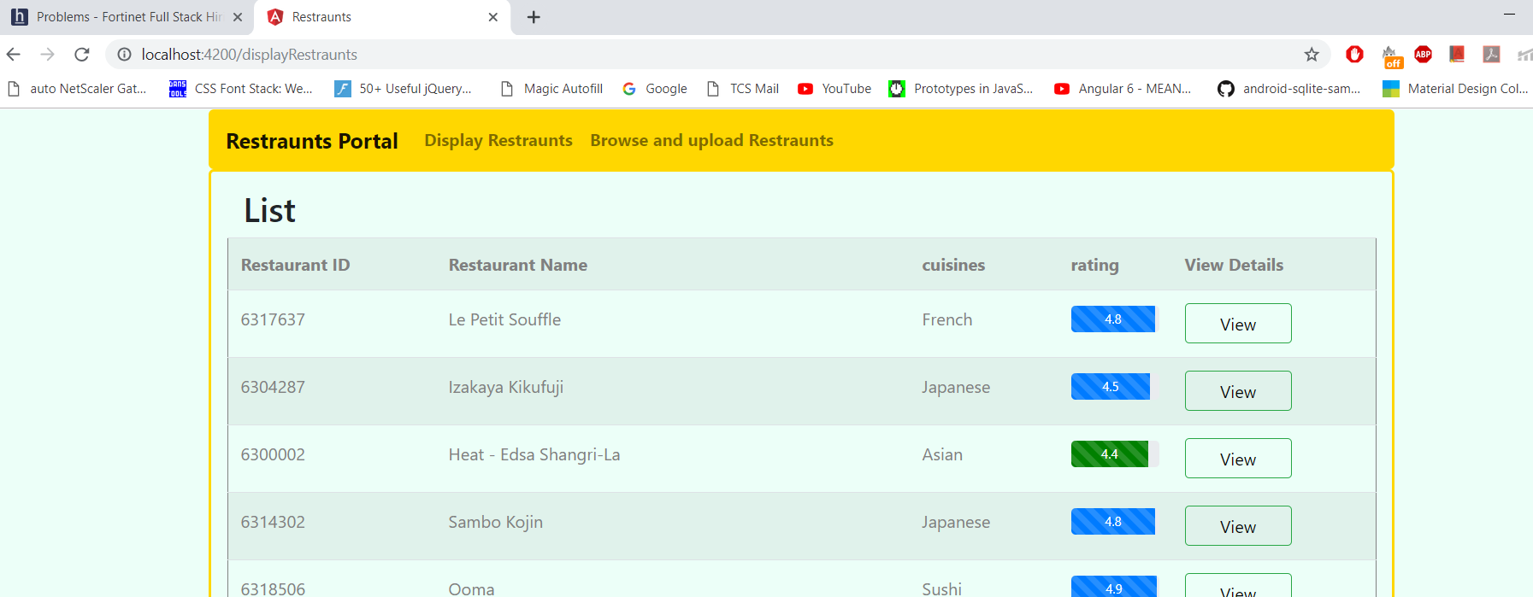

**View Restraunt details**

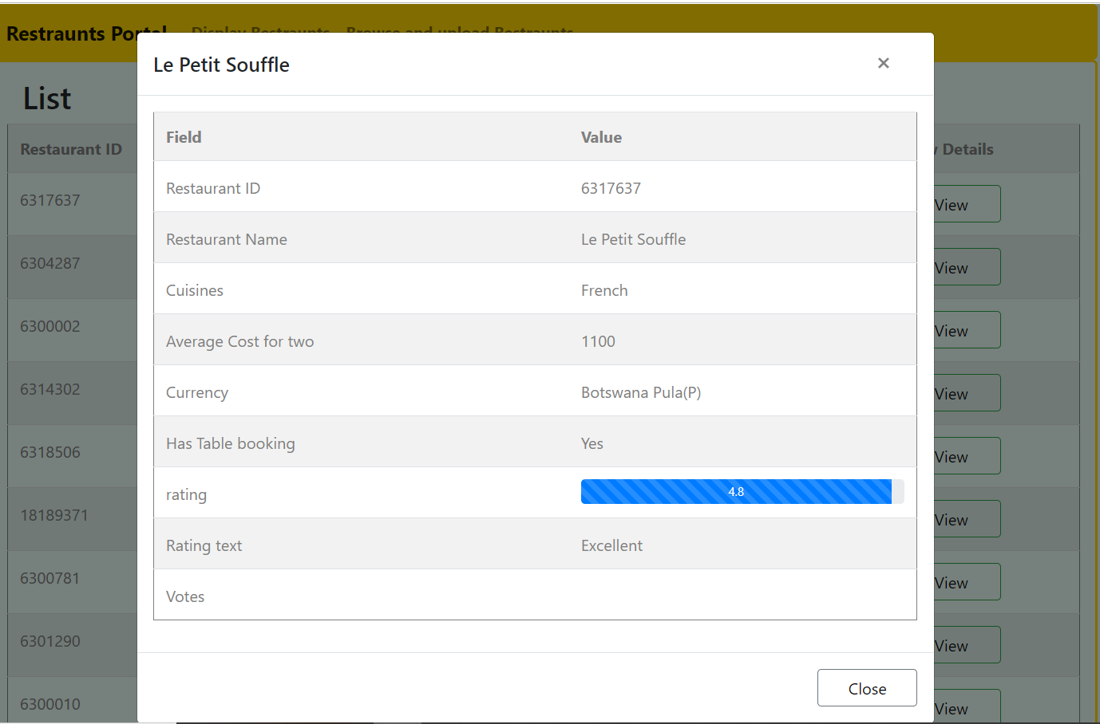

**Upload Restraunts**

