PCA (timeOmics)

## PCA analysis for timeOmics data at time 1

I just wanted to compare the PCA results at one time point for timeOmics package data

# A tibble: 6 × 7

PatID time c0 c1.0 c1.1 c1.2 c1.3 1 A _1 0.681 -0.168 -0.134 0.120 0.446 2 A _2 1.48 0.431 1.12 -0.0818 0.459 3 A _3 0.945 1.47 1.61 -0.110 1.58 4 A _4 0.740 1.12 1.77 0.175 1.41 5 A _5 0.929 1.24 1.83 -0.0378 1.27 6 A _6 1.04 2.31 2.53 0.231 2.11

Importance of components: PC1 PC2 PC3 PC4 PC5 PC6 PC7 Standard deviation 3.5135 2.6694 0.99679 0.42425 0.33302 0.26369 0.23584 Proportion of Variance 0.5878 0.3393 0.04731 0.00857 0.00528 0.00331 0.00265 Cumulative Proportion 0.5878 0.9272 0.97446 0.98303 0.98831 0.99162 0.99427 PC8 PC9 PC10 PC11 PC12 PC13 PC14 Standard deviation 0.15838 0.12599 0.11689 0.11002 0.10496 0.09309 0.09067 Proportion of Variance 0.00119 0.00076 0.00065 0.00058 0.00052 0.00041 0.00039 Cumulative Proportion 0.99547 0.99622 0.99687 0.99745 0.99797 0.99839 0.99878 PC15 PC16 PC17 PC18 PC19 PC20 PC21 Standard deviation 0.08044 0.06924 0.06123 0.05612 0.05380 0.04951 0.04663 Proportion of Variance 0.00031 0.00023 0.00018 0.00015 0.00014 0.00012 0.00010 Cumulative Proportion 0.99909 0.99931 0.99949 0.99964 0.99978 0.99990 1.00000 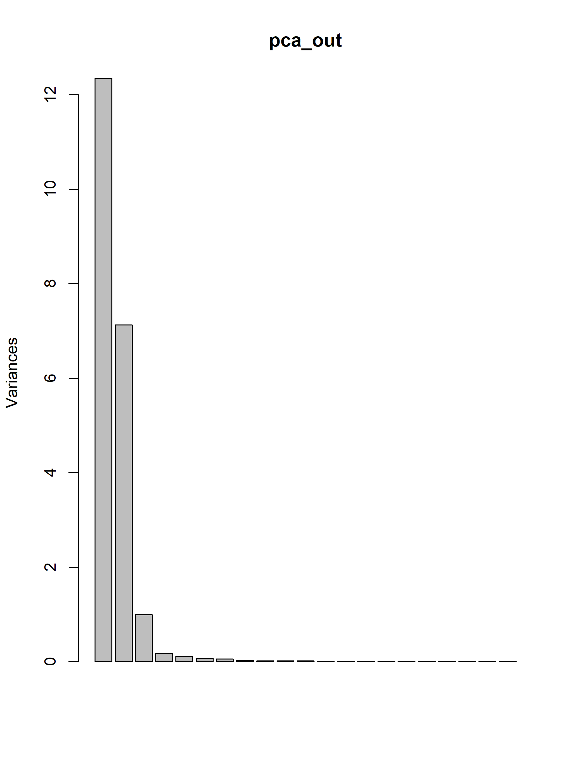 PC1 PC2 PC3 PC4 PC5 c0 0.008171982 0.05115184 -0.992935864 0.058847963 -0.007486662 c1.0 -0.224507281 0.22675907 0.027514486 -0.039903518 -0.024074105 c1.1 -0.222863834 0.23079837 0.015133025 0.001363713 0.036056657 c1.2 -0.222288939 0.20738469 -0.017972987 -0.023972556 0.803942943 c1.3 -0.220950544 0.23091024 0.032416886 0.026968529 -0.178260257 c1.4 -0.224572414 0.22800681 0.021191688 0.026038521 -0.015835816 c2.0 0.223645058 -0.22769776 -0.008006748 0.061630205 0.014821792 c2.1 0.226778948 -0.22454754 -0.024015584 -0.003717985 -0.048782944 c2.2 0.232843327 -0.19133404 0.022100774 -0.012105940 0.473365368 c2.3 0.227506017 -0.22109334 0.017945486 -0.043383465 0.108238606