Costs of production

The short run and the long run:
The short-run can be defined as a period which is long enough to permit any desired change of output technologically possible without altering the scale of plant but which is not long enough to permit any adjustment of scale of plant.
On the other hand, the long run is a period which is sufficiently long enough to permit any desired change of output technologically possible altering the scale of plant and which is long enough to permit any adjustment of scale of plant.

Fixed costs:
Fixed costs are the costs of all those factors of production whose amount can’t be altered quickly in the short-run. The fixed costs are mainly those costs of the fixed plant and equipment of the firm. The clearest way to define fixed costs is to say that they are costs that continue it the firm temporarily shut down producing nothing at all. Fixed costs include such items as interest on investment in the plant and equipment, most kinds of insurance, property taxes, depreciation and maintenance etc. and wages of those people who continue to be employed even in a temporary shut-down.

Variable costs:
Variable costs are those costs that vary with the volume of output. They must necessarily rise as the firms output increase, since larger output require larger quantities of variable resources and hence, larger cost obligations. They include wages, payment for raw materials and other goods bought by the firm, payment for fuel, interest on short-term loans etc.

SHORT-RUN TOTAL COST CURVES
Cost curves show the minimum cost of producing various levels of output. In the short run, one or two factors of production are fixed in quantity. Total fixed costs (TFC) refer to the total obligations incurred by the firm per unit of time for all fixed inputs. Total variable costs (TVC) are the total obligations incurred by the firm per unit of time for all the variable inputs it uses. Total costs (TC) equal TFC plus TVC.

Table 1.1 presents hypothetical TFC, TVC, and TC schedules. These schedules are plotted in fig. 1-1.

Table 1.1

Quantity of output | Total fixed cost | Total variable cost | Total cost
0 | 60 | 0 | 60
1 | 60 | 30 | 90
2 | 60 | 40 | 100
3 | 60 | 45 | 105
4 | 60 | 55 | 115
5 | 60 | 75 | 135
6 | 60 | 120 | 180

Cost ($)

.
.
.
.
.
.
.
.
.
.
.
.
.
.
.
.
180

160

140

120

100

80

60

40

20

0
1 2 3 4 5 6 Q
TC
TVC
TFC
Fig. 1-1

Suppose an entrepreneur has a fixed plant that can be used to produce a certain commodity. Further suppose this plant cost $ 60. Total fixed cost is, therefore, $ 60 – it is constant irrespective of the level of output. This is reflected in Table/ Schedule 1.1 by the column of $ 60 entries labeled “Total fixed cost.” It is also shown by the horizontal line labeled TFC in Figure 1-1. Both table and graph emphasize that fixed cost is indeed fixed.
Variable inputs must also be used if production exceeds zero. The greater the level of variable input the greater the total variable cost of production. This is shown in column 3 of table 1.1 and by the curve labeled TVC in Fig 1-1.
Summing total fixed and total variable cost gives total cost, the entries in the last column of table 1.1 and the curve labeled TC in Figure 1-1. From the figure, we see that TC and TVC move together and are, in a sense, parallel. That is to say, the slopes of the two curves are the same at every output point; and at each point, the two curves are separated by a vertical distance of $ 60, the total fixed cost.

SHORT-RUN PER-UNIT COST CURVES:

Although total cost curves are very important, per-unit cost curves are even more important in the short-run analysis of the firm. The short-run per-unit cost curves that we will consider are the average fixed cost, the average variable cost, the average cost, and the marginal cost curves.

Average Fixed Cost: Average fixed cost (AFC) equals total fixed costs divided by output. So

AFC =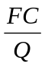

Average variable Cost: Average variable cost (AVC) equals total variable costs divided
by output. Thus

AVC = 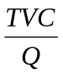

Average Cost: Average cost (AC) equals total costs divided by output. AC also equals AFC plus AVC. So

AC = 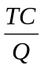 and AC = AFC + AVC

Marginal Cost: Marginal cost (MC) equals the change in TC or the change in TVC per unit change in output. So

MC = 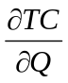

Table 1.2 presents Average and marginal cost calculations

(1)  Quantity of output | (2)  Total fixed cost | (3)  Total variable cost | (4)  Total cost | (5)  Average fixed cost | (6)  Average variable cost | (7)  Average Total cost | (8)  Marginal cost
1 | $60 | $ 30 | $ 90 | $ 60 | $ 30.00 | $ 90.00 | ..
2 | 60 | 40 | 100 | 30 | 20.00 | 50.00 | 10
3 | 60 | 45 | 105 | 20 | 15.00 | 35.00 | 5
4 | 60 | 55 | 115 | 15 | 13.75 | 28.75 | 10
5 | 60 | 75 | 135 | 12 | 15.00 | 27.00 | 20
6 | 60 | 120 | 180 | 10 | 20.00 | 30.00 | 45
.
.

90

80

70

60

50

40

30

20

10

0
1 2 3 4 5 6 Q
.
.
.
.
.
.
.
.
.
.
.
.
.
.
.
.
.
.
.
.
AC
AFC
AVC
MC
AVC
MC
AFC
AC
COSTS ($)
Fig. 1-2

The AFC, AVC, AC and MC schedules of table 1.2 are plotted in Fig. 1-2. Note that while the AFC curve falls continuously as output is expanded, the AVC, AC, and MC curves are U-shaped. The MC curve reaches its lowest point at a lower level of output than either the AVC curve or the AC curve. Also, the rising portion of the MC curve intersects the AVC and AC curve at their lowest point.
From The following cost functions calculate AC, MC, AVC, AFC functions and also calculate the output when the MC will be minimum.

i) C = Q³ ─ 61.25 Q² + 1528.5Q + 2000
ii) C = Q³ ─ 7Q² + 111Q + 50

LONG-RUN COSTS OF THE TRADITIONAL THEORY: THE 'ENVELOPE' CURVE

In the long run all factors are assumed to become variable. We said that the long-run cost curve is a planning curve, in the sense that it is a guide to the entrepreneur in his decision to plan the future expansion of his output.

The long-run average-cost curve is derived from short-run cost curves. Each point on the LAC corresponds to a point on a short-run cost curve, which is tangent to the LAC at that point. Let us examine in detail how the LAC is derived from the SRC curves.

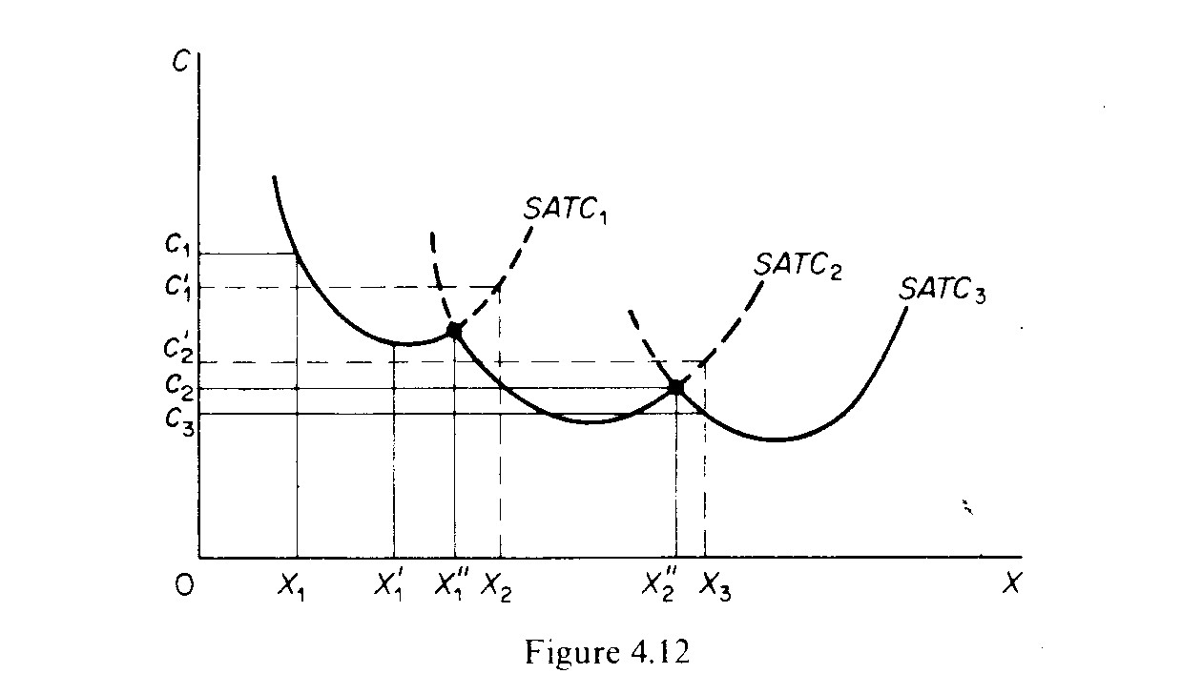

Assume, as a first approximation, that the available technology to the firm at a particular point of time includes three methods of production, each with a different plant size: a small plant, medium plant and large plant. The small plant operates with costs denoted by the curve SAC₁, the medium-size plant operates with the costs on SAC₂ and the large-size plant gives rise to the costs shown on SAC₃, (figure 4.12). If the firm plans to produce output X₁, it will choose the small plant. If it plans to produce X ₂ it will choose the medium plant. If it wishes to produce X₃ it will choose the large size plant.
If the firm starts with the small plant and its demand gradually increases, it will produce at lower costs (up to level X₁). Beyond that point costs start increasing. If its demand reaches the level X"₁; the firm can either continue to produce with the small plant or it can install the medium-size plant. The decision at this point depends not on costs but on the firm's expectations about its future demand. If the firm expects that the demand will expand further than X"₁; it will install the medium plant, because with this plant outputs larger than X"₁, are produced with a lower cost. Similar considerations hold for the decision of the firm when it reaches the level X"₂.

If it expects its demand to stay constant at this level, the firm will not install the large plant, given that it involves a larger investment which is profitable only if demand expands beyond X"₂ For example, the level of output X₃ is produced at a cost C₃, with the large plant, while it costs C'₂ if produced with the medium-size plant (C'₂ > C₃).

Now if we relax the assumption of the existence of only three plants and assume that the available technology includes many plant sizes, each suitable for a certain level of output, the points of intersection of consecutive plants (which are the crucial points for the decision of whether to switch to a larger plant) are more numerous. In the limit, if we assume that there is a very large number (infinite number) of plants, we obtain a continuous curve, which is the planning LAC curve of the firm. Each point of this curve shows the minimum (optimal) cost for producing the corresponding level of output.
The LAC curve is the locus of points denoting the least cost of producing the corresponding output. It is a planning curve because on the basis of this curve the firm decides what plant to set up in order to produce optimally (at minimum cost) the expected level of output. The firm chooses the short-run plant which allows it to produce the anticipated (in the long run) output at the least possible cost. In the traditional theory of the firm the LAC curve is U-shaped and it is often called the `envelope curve' because it 'envelopes' the SRC curves (figure 4.13).
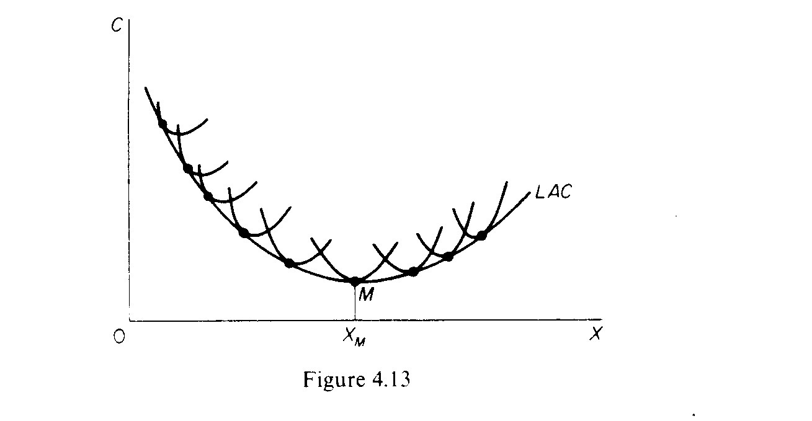

Let us examine the U shape of the LAC. This shape reflects the laws of returns to scale According to these laws the unit costs of production decrease as plant size increases, due to the economies of scale which the larger plant sizes make possible.
The traditional theory of the firm assumes that economies of scale exist only up to a certain size of plant, which is known as the optimum plant size, because with this plant size all possible economies of scale are fully exploited. If the plant increases further than this optimum size there are diseconomies of scale, arising from managerial inefficiencies. It is argued that management becomes highly complex, managers are overworked and the decision making process becomes less efficient. The turning-up of the LAC curve is due to managerial diseconomies of scale, since the technical diseconomies can be avoided by duplicating the optimum technical plant size.
A serious implicit assumption of the traditional U-shaped cost curves is that each plant size is designed to produce optimally a single level of output (e.g. 1000 units of X). Any departure from that X, no matter how small (e.g. an increase by 1 unit of X) leads to increased costs. The plant is completely inflexible. There is no reserve capacity, not even to meet seasonal variations in demand.

As a consequence of this assumption the LAC curve `envelopes' the SRAC. Each point of the LAC is a point of tangency with the corresponding SRAC curve. The point of tangency occurs to the falling part of the SRAC curves for points lying to the left of the minimum point of the LAC: since the slope of the LAC is negative up to M (figure 4.13) the slope of the SRAC curves must also be negative, since at the point of their tangency the two curves have the same slope. The point of tangency for outputs larger than X_{M} occurs to the rising part of the SRAC curves: since the LAC rises, the SAC must rise at the point of their tangency with the LAC. Only at the minimum point M of the LAC is the corresponding SAC also at a minimum. Thus at the falling part of the LAC the plants are not worked to full capacity; to the rising part of the LAC the plants are overworked; only at the minimum point M is the (short-run) plant optimally employed.

- A manufacturer has a fixed cost of $120,000 and a variable cost of $20 per unit made and sold. Selling price is $50 per unit.
- Find the revenue, cost and profit functions using q for the number of units.
- Compute profit if 10000 units are made and sold.
- Compute profit if 1000 units are made and sold
- Find the break-even quantity.
- Find the break-even dollar volume of sales.
- Construct the break-even chart. Label the cost and revenue lines, the fixed cost line, and the break-even point.

