Thesis Addendum
Required Additions and Corrections
Continual Learning Section · References · Front Matter

This is a companion document, not a replacement chapter. It lists exactly what to add to or fix in Thesis_Report_2021E123_2021E015.docx, with ready-to-paste text, real tables, and the actual charts already built for the journal paper. Nothing here asks you to rewrite what's already there — only to add the missing continual-learning results section and fix a short list of concrete errors (a placeholder citation, a duplicate reference, a blank contribution table, and a few mismatched citation numbers).
Loosely-matched citations that are still topically reasonable are left alone throughout this document — they're flagged as optional only, on the view that a thesis shouldn't read as suspiciously perfect.

Priority at a glance
# | What | Type | Where
1 | Add the missing Continual Learning results section (EWC / Replay / Isolation / Hybrid, 3 init. cases, real tables + 3 charts) | MUST ADD | Chapter 4
2 | Fill the blank member-contribution table | MUST FIX | Front matter, after Declaration
3 | Fix placeholder reference [19] (fake DOI/volume/pages) | MUST FIX | Reference list
4 | Remove duplicate reference (Zhao et al. appears twice) | MUST FIX | Reference list
5 | Fix “Dataset Authors” placeholder name → real names | MUST FIX | Reference list
6 | Add the missing PlantVillage dataset citation | MUST FIX | Reference list
7 | Fix 4 citation numbers pointing at the wrong / wrong-domain paper | MUST FIX | Ch.1 & Ch.2 body
8 | Broaden the CL methodology (3.6) beyond EWC-only | SUGGESTED | Chapter 3
9 | Update List of Figures numbering to match the body | SUGGESTED | Front matter
10 | Update List of Tables once new tables are inserted | SUGGESTED | Front matter
11 | Broaden Objective 1.2.2 wording (EWC-only → multi-method) | OPTIONAL | Chapter 1
12 | Chapter 4.4/4.5/4.6 phase-label drift (existing content) | OPTIONAL | Chapter 4

Part 1 — Front Matter and Content Page

1.1 Member contribution table — currently blank
[MUST FIX] The table on the page right after DECLARATION (“CONTRIBUTION TO THE PROPOSAL BY THE MEMBERS IN GROUP”) has a column for each of you (2021/E/015, 2021/E/123) against every chapter/section, and every single cell is empty — no ticks, no percentages, nothing filled in. If your department requires this declaration (most do for group theses), an examiner will notice a blank table immediately.
Fill in each cell — a checkmark, a percentage split, or “Joint”, whatever your department's convention is. This document can't fill it in for you since only you two know who actually did what.
Separately, and lower priority: that same table still lists the proposal-stage chapter structure (“CHAPTER 4: RESULTS AND DISCUSSION”, “CHAPTER 5: CONCLUSION AND FUTURE WORKS” with 5.1/5.2/5.3), which doesn't match your final 9-chapter structure (Progress & Results / Timeline / Budget / Ethical Considerations / Limitations / Discussion & Conclusion as separate chapters 4–9). This is cosmetic — leave it if you're short on time.

1.2 List of Figures — numbering doesn't match the body
[SUGGESTED] The “LIST OF FIGURES” page numbers the dataset/results figures as “Figure 4.1” through “Figure 4.11”, but the actual captions in the body call them “Figure 6” through “Figure 17” (plain sequential numbers, continuing from Figures 1–5 in the Literature Review). Right now the two don't line up at all.
Easiest fix: keep the body captions as they are (Figure 6–Figure 17) and just retype the List of Figures entries to use the same plain numbers instead of the 4.x style. That's an 8-line edit, not a renumbering of the whole document.
e.g. change “Figure 4.1: Sample images collected from turmeric greenhouse…” → “Figure 7: Sample images collected from turmeric greenhouse…” (matching the actual caption at the point it appears in Chapter 4).
Once you add the new Continual Learning section (Part 3 below), append its 3 new figures to this list too — continuing the numbering as Figure 18, 19, 20.

1.3 List of Tables — will need 5–6 new entries
[SUGGESTED] Currently lists only Table 1 (YOLO comparison), Table 2 (segmentation comparison), Table 3 (Timeline), Table 4 (Budget). Once the Continual Learning tables from Part 3 are inserted, add entries for Tables 5–10 (or renumber to fit wherever you insert them) with their page numbers filled in after you finalize placement.

1.4 Table of Contents page numbers
[SUGGESTED] Adding the new section will shift every page number after it (Timeline, Budget, Ethical Considerations, Limitations, Discussion & Conclusion, Reference). Regenerate/update the TOC page numbers as the very last step, after all content is final.

Part 2 — Chapter 1: Objectives (optional)
[OPTIONAL] Objective 3 (section 1.2.2) currently reads only: “To develop a continual learning system for adapting the model to new data over time using Elastic Weight Consolidation (EWC)…” — but your actual work (and your own Abstract) evaluates four methods (EWC, Experience Replay, Parameter Isolation, Hybrid) and finds Replay wins on accuracy while EWC wins on efficiency. As written, the objective undersells the study. This is optional — the current wording isn't wrong, just narrower than what you actually did.
▶ SUGGESTED REPLACEMENT (optional)
“To develop and rigorously evaluate a continual learning framework for adapting the model to new data over time, comparing Elastic Weight Consolidation (EWC), Experience Replay, and Parameter Isolation across same-class and new-class learning scenarios. This ensures the model can learn from new observations without catastrophic forgetting, and identifies which strategy is preferable for different deployment constraints (accuracy versus retraining cost).”

Part 3 — Chapter 3: Methodology — broaden Section 3.6
[MUST ADD] Section 3.6 (“Continual Learning with Elastic Weight Consolidation (EWC)”) currently describes only EWC's Fisher Information Matrix penalty — three sentences. It doesn't mention Experience Replay, Parameter Isolation, the three initialization strategies (scratch / ImageNet / PlantVillage), or the layer-wise training strategy — all of which your own Abstract and Literature Review already describe as central to the work, and all of which the new Chapter 4 results (Part 4 below) depend on. Right now a reader hits results for methods the Methodology chapter never introduced.
Keep the existing EWC paragraph exactly as it is, and add the following four short subsections directly after it.
▶ READY TO PASTE

3.6.1 Experience Replay
Experience Replay is a data-level alternative to EWC's weight-level penalty. A stratified buffer of prior-class exemplars (a minimum floor per class, drawn only from the initial training pool) is stored and mixed 50/50 with incoming stream data in every training batch. Unlike EWC, Replay applies no penalty term to the loss; instead, the classifier head receives direct gradient correction from both old and new samples simultaneously, which prevents the output layer from drifting toward the new classes at the expense of the old.

3.6.2 Parameter Isolation
Parameter Isolation avoids forgetting by construction: all existing weights are frozen, and only a small amount of new capacity is trained for incoming data. For same-class learning, this is a lightweight bottleneck adapter (96→24→96 channels, identity-initialized, ≈ 18,000 parameters — about 1.2% of the backbone) inserted after the penultimate feature block. Because old weights are mathematically untouched, forgetting is zero by definition; the trade-off is that all new learning is confined to this small adapter's capacity.

3.6.3 Initialization Strategy as an Experimental Factor
Continual learning outcomes depend heavily on how the backbone was initialized before continual updates begin, so three initialization strategies are evaluated side by side rather than fixing one:
- Case 1 — Scratch: random initialization, no pretrained features.
- Case 2 — ImageNet: MobileNetV3-Small initialized from standard ImageNet weights.
- Case 3 — In-domain (PlantVillage): the backbone is first pretrained on the broader PlantVillage classes before continual learning begins, encoding plant-domain features (venation, lesion morphology, leaf texture) in advance.
Each of the four CL methods is evaluated under all three cases, so that the comparison isolates the effect of the CL method itself from the effect of the starting representation.

3.6.4 Layer-Wise Training Strategy
Rather than applying continual updates uniformly across the network, the backbone is partitioned into four functional groups by feature type and forgetting sensitivity, and a different learning-rate policy is applied to each:
Group | Layers | Role
G1 (Early) | features[0–3] | Edges, colour gradients — universal; always frozen
G2 (Mid) | features[4–8] | Venation, texture — plant-domain; frozen in same-class CL
G3 (Late) | features[9–12] | Lesion shape, discolouration — primary forgetting site
G4 (Head) | classifier[0–3] | Class probabilities — always task-specific

Confining plasticity to the late layers (G3) and the classifier head (G4) concentrates the EWC penalty and the replay gradient on the parameters that actually drift, rather than diluting them across early layers that never move. When new classes are added, the classifier head additionally uses a split learning rate — old-class output neurons are updated an order of magnitude more slowly than new-class neurons, so the network can quickly learn the new class without erasing what it already knew.

Part 4 — Chapter 4: The Missing Continual Learning Results

4.0 What's actually happening in the current 4.4 / 4.5 / 4.6
[OPTIONAL — diagnosis only, see verdict below] Read closely, the text under these three headings is one phase behind its own heading and figure captions:
Heading says | Text under it actually describes | Figures under it
4.4 — MobileNetV3 Base Training (Phase 1) | The Decision Tree environmental risk model (a different topic entirely) | Figure 12/13, captioned “Phase 1” — these look like the real Phase-1 figures, just missing their matching paragraph
4.5 — Transfer Learning to Turmeric (Phase 2) | Phase 1 results (97.58% across 15 classes, “foundation for turmeric adaptation”) | Figure 14/15, captioned “Phase 2”
4.6 — Incremental Learning with EWC (Phase 3) | Phase 2 results (89.81% turmeric transfer accuracy) | Figure 16/17, captioned “Phase 3”

Net effect: the real Phase 3 — the actual continual learning results (EWC / Replay / Isolation / Hybrid comparison) — has no section and no content anywhere in Chapter 4. That is the gap this Part fills.
Fixing the paragraph drift above is optional and left to your judgement — it's confusing on close reading, but not the kind of error an AI-similarity check would flag, and fixing it means re-checking exactly which figure belongs where. If you have time, the simplest correct fix is: move the Decision Tree paragraph out of 4.4 (it doesn't have a proper home in the current outline — easiest is to fold it into 3.7 in the Methodology chapter, since that's where the Decision Tree is introduced), then shift the 97.58%-paragraph up into 4.4 and the 89.81%-paragraph up into 4.5. If you don't have time, leave it as is and just add the new section below as 4.7.
──────────────────────────────────────────────────────────────────────────────────────────

4.7 Incremental Learning: Comparative Evaluation of Continual Learning Strategies (Phase 3)
▶ READY TO PASTE — insert as a new section after the existing 4.6
Having established the base classifier (Phase 1) and its transfer to turmeric disease classification (Phase 2), this section presents the core continual learning evaluation: a systematic comparison of four adaptation strategies — Elastic Weight Consolidation (EWC), Experience Replay, Parameter Isolation, and a Hybrid EWC+Replay scheme — across three backbone initialization strategies (Section 3.6.3) and two incremental scenarios: same-class streaming (Category A, where the model sees more data for the same five disease classes over time) and new-class expansion (Category B, where two additional classes are introduced, expanding the classifier from five to seven outputs). Naive fine-tuning, which applies no forgetting protection, is included throughout as a reference lower bound, not as a valid continual learning method.

4.7.1 Category A: Same-Class Continual Learning
Table 5 reports accuracy and F1-score for every case/method combination across two continual learning cycles, together with training time.
Case / Method | Cycle 1 Acc | Cycle 2 Acc | Avg. Acc | Time
Case 1 — EWC | 97.89% | 97.45% | 97.67% | 337 s
Case 1 — Replay | 97.45% | 97.19% | 97.32% | 482 s
Case 1 — Isolation | 96.31% | 96.57% | 96.44% | 232 s
Case 1 — Naive* | 97.63% | 97.54% | 97.58% | 322 s
Case 2 — EWC | 97.98% | 98.24% | 98.21% | 171 s
Case 2 — Replay (best) | 98.07% | 98.42% | 98.25% | 620 s
Case 2 — Isolation | 97.19% | 97.27% | 97.23% | —
Case 2 — Naive* | 97.63% | 99.21% | 98.42% | 322 s
Case 3 — EWC | 97.63% | 97.45% | 97.54% | 339 s
Case 3 — Replay | 97.80% | 98.50% | 98.15% | 482 s
Case 3 — Isolation | 96.48% | 96.66% | 96.57% | 232 s
Case 3 — Naive* | 96.48% | 98.24% | 97.36% | —
Table 5: Category A results — same-class continual learning. *Naive fine-tuning uses the full data history and is shown for reference only; it is not a valid continual learning method under the storage constraint.

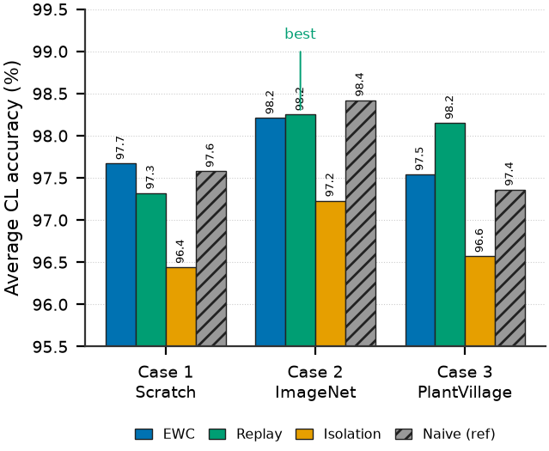
Figure 18: Category A average accuracy across initialization cases and continual learning methods.
Experience Replay with ImageNet initialization (Case 2) reaches the highest average accuracy at 98.25%, but the margin over EWC in the same case (98.21%) is only 0.04 percentage points, while EWC trains in 171 seconds against Replay's 620 seconds — a 3.6× difference. For a device that must retrain periodically under a limited power budget, this is a meaningful practical trade-off: EWC reaches essentially the same accuracy for a fraction of the training cost, since it only requires one additional forward pass over the buffer to estimate parameter importance.
The three methods show distinct behaviour. EWC is stability-dominant, holding accuracy nearly constant across cycles. Replay is plasticity-dominant, achieving the best Cycle-2 accuracy in every case, because mixing old exemplars into every batch gives the classifier head direct correction from both old and new data. Isolation is consistency-dominant, varying the least across cycles since old weights are never touched — at the cost of roughly a one-point accuracy deficit, because its small bottleneck adapter is the only part of the network allowed to learn.

4.7.2 EWC Regularization Strength (Lambda) Tuning
EWC's penalty strength, λ, trades stability against plasticity: too small offers insufficient protection, too large prevents the model from adapting at all. Table 6 shows a grid search over six values of λ on Case 2.
λ | Cycle 1 Acc | Cycle 2 Acc | Assessment
1,000 | 97.71% | 98.15% | Under-regularized
3,000 | 97.80% | 98.24% (best for Cycle 2) | Optimal for Cycle 2
5,000 | 97.63% | 98.24% | Marginal over-regularization
8,000 | 97.89% | 98.07% | Slight plasticity loss
10,000 | 97.98% (best for Cycle 1) | 98.24% | Optimal for Cycle 1
15,000 | 97.89% | 98.15% | Over-regularized
Table 6: EWC lambda grid search (Case 2, Category A).

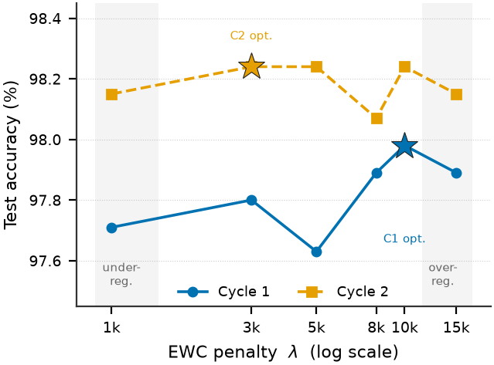
Figure 19: EWC accuracy versus regularization strength across two cycles.
The optimal λ is cycle-dependent: 10,000 maximizes Cycle 1 accuracy, but 3,000 is preferable by Cycle 2. This is interpreted as follows: Cycle 1 must protect a freshly transferred representation against the first distribution shift, whereas by Cycle 2 the model has already adapted once, and further regularization only suppresses plasticity without adding retention. A schedule of λ = 10,000 for the first cycle and λ = 3,000 for subsequent cycles is adopted for all reported EWC results.

4.7.3 Category B: New-Class Expansion
Table 7 reports both dimensions that matter under class expansion — new-class accuracy on the two newly introduced disease classes, and old-class retention on the original five classes — since a method can trivially maximize one at the expense of the other.
Case / Method | Avg. New-Class Acc. | Old-Class Retention | Time
Case 1 — EWC | 82.79% | 87.34% | 1,048 s
Case 1 — Replay | 92.85% | 84.78% | 1,268 s
Case 1 — Naive* | 93.91% | 87.07% | 743 s
Case 1 — Hybrid | 84.43% | 92.44% | 1,741 s
Case 2 — EWC | 94.20% | 95.95% | 797 s
Case 2 — Replay (best) | 98.07% | 97.19% | 1,181 s
Case 2 — Isolation | 50.87% | ~100% | —
Case 2 — Naive* | 95.74% | 87.51% | 351 s
Case 2 — Hybrid | 95.26% | 98.24% | 1,659 s
Case 3 — EWC | 90.62% | 95.78% | 1,128 s
Case 3 — Replay | 96.42% | 96.92% | 1,220 s
Case 3 — Isolation | 15.38% | ~100% | —
Case 3 — Naive* | 96.91% | 94.72% | 668 s
Case 3 — Hybrid | 92.84% | 97.54% | 1,691 s
Table 7: Category B results — new-class expansion (5→7 classes). Old-class retention measured at Cycle 2 on the original five classes. *Reference only, not a valid CL method.

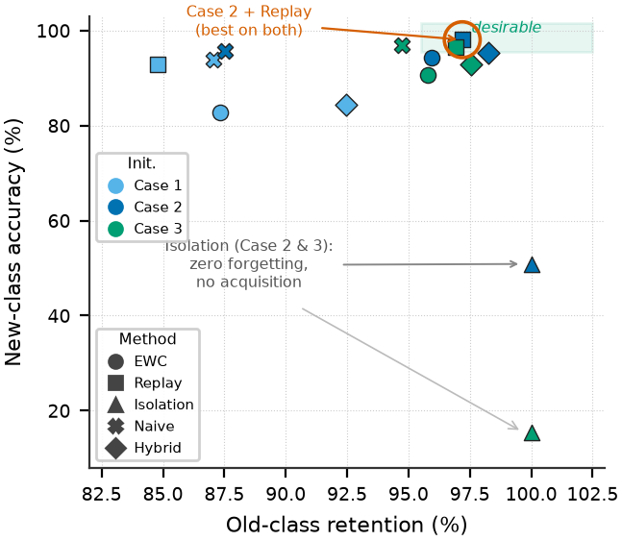
Figure 20: Stability–plasticity trade-off under new-class expansion. Only ImageNet-initialized Experience Replay is strong on both axes at once.
Case 2 with Experience Replay is the clear winner on both dimensions simultaneously: 98.07% new-class accuracy with 97.19% old-class retention. No other configuration exceeds 96% on both at once. Naive fine-tuning's apparent competitiveness in Category A (Section 4.7.1) disappears here: old-class retention falls to 87.07–87.51%, confirming that its earlier good behaviour was only because the same five classes kept recurring in every stream, which acted as accidental replay — not because naive fine-tuning is actually robust to forgetting.

4.7.4 Why Parameter Isolation Fails on New Classes
Parameter Isolation, which was within about one point of the best method in Category A, collapses when new classes are introduced: 50.87% average new-class accuracy in Case 2 and just 15.38% in Case 3 — close to chance level for a two-class decision. The cause is architectural: the isolation branch for new classes is trained entirely from scratch, receiving no feature information from the pretrained backbone, so it must learn disease-discriminative features from a few hundred images per class with no shared representation to build on. Notably, the stronger the frozen backbone (Case 3's in-domain PlantVillage pretraining), the worse this failure becomes — because a stronger backbone widens the representational gap between itself and the untrained new branch. The conclusion is that Parameter Isolation should not be used in any deployment scenario where new disease classes may appear; it remains a reasonable choice only for same-class streaming under strict memory constraints.

4.7.5 Does Combining EWC and Replay Help?
A Hybrid scheme applying both the EWC penalty and the replay buffer simultaneously was tested on the hypothesis that weight-level and data-level protection would reinforce each other. Table 8 shows they do not.
Case | Hybrid New-Class | Replay New-Class | Hybrid Old Retention | Time Overhead
Case 1 | 84.43% | 92.85% (+8.4) | 92.44% | +37%
Case 2 | 95.26% | 98.07% (+2.8) | 98.24% | +40%
Case 3 | 92.84% | 96.42% (+3.6) | 97.54% | +39%
Table 8: Hybrid (EWC+Replay) versus Replay alone, Category B.

The Hybrid method underperforms Replay alone by 2.8–8.4 percentage points on new-class accuracy while costing 37–40% more training time. The explanation is that the two mechanisms compete rather than cooperate: EWC's penalty constrains exactly the late layers and classifier head that need to move to learn the new classes, partially cancelling the replay gradient's benefit. Combining methods is not automatically better — it depends on whether the mechanisms act on the same parameters with the same or opposing intent.

4.7.6 Resource Utilization
Table 9 summarizes the memory footprint relevant to on-device deployment.
Method / Scenario | Peak VRAM (MB) | Model Size (MB) | Note
Isolation — Cat. A | 122.63 | 5.81 | Lowest VRAM
Replay — Cat. A | 155.58 | 5.81 | Best accuracy
EWC — Cat. A | 169.51 | 5.81 | Fastest (171 s)
Naive — Cat. A/B | 161–162 | 5.81 | Reference
Replay — Cat. B | 325.39 | 5.82 | Head expansion
EWC — Cat. B | 383–601 | 5.82 | Fisher matrix at Cycle 2
Hybrid — Cat. B | 384–601 | 5.82 | Highest; no accuracy gain
Table 9: Resource utilization by method and scenario.

Every trained model remains within 5.82 MB, comfortably inside the storage budget of an edge device, and adding two new classes costs only 0.01 MB. Peak memory during retraining — not model size — is the actual constraint on device: same-class scenarios fit within 170 MB, while Category B Replay needs 325 MB and Category B EWC peaks at 601 MB when its Fisher matrix is held alongside activations.

4.7.7 Section Summary
Across both scenarios: Experience Replay with ImageNet initialization is the strongest overall configuration, EWC is the preferred choice when training time or power budget is constrained (equivalent Category-A accuracy at 3.6× lower cost), Parameter Isolation is usable only when no new classes will ever be introduced, and combining EWC with Replay is not worthwhile — it costs more and performs worse than Replay alone. These findings directly determined the choice of Case 2 + Experience Replay as the recipe carried forward to the turmeric-specific validation in Section 4.8.
──────────────────────────────────────────────────────────────────────────────────────────

4.8 Continual Learning Validation on Turmeric Data
▶ READY TO PASTE — insert directly after 4.7
Sections 4.4–4.6 established a base turmeric classifier (Phase 2, 89.81% accuracy). Having identified Case 2 + Experience Replay as the strongest general-purpose recipe in Section 4.7, this configuration is applied to the turmeric model itself, across two further continual learning cycles, to confirm the recipe transfers to the actual target crop and not only to the benchmark data. Because the turmeric test set is much smaller (107 images) than the benchmark dataset, results are averaged over three random seeds and reported as mean ± standard deviation.
Stage | Accuracy | Macro F1
Base (Case 2, ImageNet) | 89.10 ± 2.35% | 89.18 ± 2.16%
Replay, Cycle 1 | 92.52 ± 3.37% | 92.29 ± 3.76%
Replay, Cycle 2 (adopted) | 90.03 ± 3.54% | 89.93 ± 3.73%
Naive fine-tuning, Cycle 2* | 87.85 ± 2.47% | 87.72 ± 2.68%
Table 10: Turmeric continual learning validation. Five classes: healthy, leaf blotch, leaf spot, dry, aphid damage. Test set n = 107. *Reference condition only.

The recipe transfers successfully: Experience Replay is the only configuration that ends above its own starting point (+0.93 percentage points over the base model), while naive fine-tuning ends 1.25 points below it. Given the small test set, a single misclassified image is worth roughly one percentage point, so these differences should be read as evidence that the recipe is stable and transfers correctly to turmeric — not as a precise ranking between methods on this crop specifically. A larger turmeric test set would be needed to state that more strongly.

Part 5 — Reference and Citation Fixes
Split into two groups. The first group are concrete errors — a placeholder left unfilled, a reference listed twice, a placeholder author name, a missing foundational citation, and a few citation numbers that point at a paper from a completely different field. These are worth fixing regardless of how strict the marking is. The second group are just loosely-matched topical citations, which are common in real theses and are fine to leave exactly as they are.

5.1 Must fix
[MUST FIX — #1] Reference [19] (Alharbi, Khan & Tayyaba, “Wheat Disease Classification using Continual Learning”) still has placeholder bibliographic data: “vol. X, no. X, pp. X-X” and DOI “10.1109/ACCESS.2023.xxxxxxx”. This reads as an unfinished citation, not a real one.
Either look up the real IEEE Access volume/issue/page numbers and DOI for this paper before submitting, or replace it with a different, fully-verifiable reference on wheat/crop disease continual learning.
[MUST FIX — #2] “Zhao, Y. et al. (2023), ‘Identification of plant disease based on multi-task continual learning,’ Agronomy, vol. 13, no. 12” appears twice in the reference list — once as an early entry and again later, with identical wording both times.
Delete the second occurrence, and check whether any in-text citation was pointing at the second (now-removed) number — if so, repoint it at the first occurrence's number instead.
[MUST FIX — #3] Reference for the turmeric Mendeley dataset lists the author as literally “Dataset Authors” — a placeholder, not a real name.
▶ VERIFIED REPLACEMENT
A. K. M. F. K. Siam, M. A. S. Nirob, and P. Bishshash, “Turmeric Plant Disease Dataset: Advancing AI for Agricultural Sustainability,” Mendeley Data, 2025, DOI: 10.17632/g46dvrcvwn.1.
Note: your thesis currently cites DOI version “.2”; the verified record found during the companion journal paper's reference audit was version “.1” with these author names — worth a quick check on Mendeley that .2 is the same dataset with the same authors before submitting, in case the version was updated after your original citation.
[MUST FIX — #4] PlantVillage is used repeatedly — in the Available Databases section, the Phase 1 foundation training, and the Ethical Considerations chapter (“38 disease classes”) — but the original PlantVillage dataset paper is never actually cited anywhere in the 29-entry reference list.
▶ SUGGESTED ADDITION
D. P. Hughes and M. Salathé, “An open access repository of images on plant health to enable the development of mobile disease diagnostics,” arXiv:1511.08060, 2015.
[MUST FIX — #5] Four specific citation numbers point at the wrong paper — not just loosely related, but actually a different paper than the one the sentence is about:
Location | Claim | Currently cites | Should cite
Ch.2, §2.2 (Forecasting Models) | “SerpensGate-YOLOv8…demonstrates 12% improvement over baseline YOLOv8” | [12] (Zhang et al., lettuce growth CNN) | [5] (Miao, Meng & Zhou — the actual SerpensGate-YOLOv8 paper)
Ch.2, §2.2 | “MobileNetV3 implementations achieving 94% accuracy in varietal classification” | [13] (Nazeer et al., Jetson Nano object detection) | [8] (Saha, Mangukia & Manickavasagan — the actual MobileNetV3 chickpea varietal paper)
Ch.2, §2.2 | “LSTM networks with attention mechanisms demonstrate 88% accuracy in predicting disease-conducive microclimate conditions” | [14] (Tan & Le, EfficientNet — not an LSTM paper at all) | Needs a real LSTM/microclimate source, or reword to remove the specific attribution if none is available
Ch.2, §2.2 | “fusion of visual and environmental data streams…reducing combined prediction error by 23%” | [16] (Jiang et al., “Autosurv” — a cancer survival-analysis paper, unrelated field) | Needs a real agricultural multimodal-fusion source, or reword as your own hypothesis rather than a cited external finding

The first two are simple citation-number corrections (the correct paper is already in your reference list, just under the wrong number). The last two don't have an obviously correct reference already in your list — either find a real agricultural source for each specific number, or rephrase the sentence so it isn't attributed to a source that doesn't support it.

5.2 Optional — loosely matched, fine to leave
[OPTIONAL] Several other citations ([1], [2][3], [4], [6], [8][9], [10][11]) are topically in the right area (turmeric/plant disease/AIoT/YOLO) without being a precise match to the exact sentence they're attached to. This is common in real theses and not the kind of error that stands out — leave these as they are unless you have spare time.

Final Checklist
- Fill in the blank member-contribution table (front matter)
- Add Section 4.7 — Continual Learning comparative results (Tables 5–9, Figures 18–20)
- Add Section 4.8 — Turmeric-specific CL validation (Table 10)
- Add Section 3.6.1–3.6.4 — Replay / Isolation / initialization / layer-wise strategy
- Fix reference [19] placeholder data
- Remove duplicate Zhao et al. reference
- Fix “Dataset Authors” → real names (Siam, Nirob, Bishshash)
- Add the missing PlantVillage citation
- Fix the 4 wrong-paper citation numbers in §2.2
- Update List of Figures numbering to match the body; add Figures 18–20
- Update List of Tables; add Tables 5–10
- Update Table of Contents page numbers (do this last)
- (Optional) broaden Objective 1.2.2 wording
- (Optional) fix the 4.4/4.5/4.6 phase-label drift

