AIot driven green house monitoring and predictive analysis

UNDERGRADUATE RESEARCH THESIS
SUBMITTED IN PARTIAL FULFILMENT OF THE Requirements of the DEGREE OF BACHELOR OF THE SCIENCE OF ENGINEERING

Submitted by:
MATHUSANTH A.M (2021/E/015)
ROYCETHEEBAN R.(2021/E/123)



DEPARTMENT OF ELECTRICAL AND ELECTRONICS ENGINEERING
FACULTY OF ENGINEERING
UNIVERSITY OF JAFFNA
JUNE 2026
AIot driven greenhouse monitoring and predictive analysis

Supervisor(s):

Principle Supervisor: Dr.T. Mukunthan

Examination Committee:
Lecturer 1 ..........................................
Lecturer 2 ..........................................

KEYWORDS
Edge AI, Incremental Learning, Elastic Weight Consolidation, Experience Replay, Computer Vision Pipeline, Plant Disease Classification, Lightweight GAN, Agricultural AIoT, Jetson Orin Nano Deployment.

ABSTRACT
This research presents the development and validation of a fully automated, edge-deployed AI system for real-time turmeric plant disease monitoring. The system introduces an optimized multi-stage computer vision pipeline on an NVIDIA Jetson Orin Nano, integrating YOLOv8n for leaf detection and segmentation (0.664 mAP50, 10.45 ms inference, 0.995 IoU), a custom Lightweight GAN for occlusion recovery (22.28 dB PSNR, 0.8168 SSIM), and MobileNetV3-Small with CBAM attention for classifying five turmeric disease categories (Healthy, Blotch, Leaf Spot, Dry, Aphid) at 89.81% accuracy.
A core innovation is a comprehensive incremental learning framework evaluated across same-class (Category A) and new-class expansion (Category B) continual learning scenarios, spanning three model initialization strategies and four CL methods. Experience Replay achieved peak performance — 98.25% accuracy under same-class learning and 98.07% new-class acquisition with 97.19% old-class retention under new-class expansion. EWC with optimized lambda scheduling (λ=10,000→3,000) offers a resource-efficient alternative (171 s, 169.51 MB VRAM) within 0.04% of Replay accuracy, making it preferable for high-frequency field updates. Parameter Isolation, while viable for same-class scenarios under memory constraints, proved unsuitable for new-class learning due to near-random acquisition accuracy. This winning recipe — Case 2 initialization with Experience Replay — was further validated directly on turmeric data across two additional continual learning cycles, improving accuracy from 89.10% to 90.03% and confirming that the recipe transfers successfully from the benchmark dataset to the actual deployment crop.
The system employs a dual-path architecture fusing visual classification with Decision Tree-based environmental risk assessment (temperature, humidity, CO₂, soil moisture) at the label level. Large Language Models further handle low-confidence predictions, generating contextual disease management recommendations to close the learning loop between model uncertainty and actionable farmer guidance.
This work demonstrates the viability of edge-optimized, self-improving continual learning systems for precision agriculture, reducing cloud dependency while maintaining adaptive, real-world diagnostic accuracy.

DECLARATION
We, the undersigned, hereby declared that this report was written by ourselves and the work contained therein is our own, except where explicitly stated in the text
Mathushanth A.M.(2021E015) : ………………….
Roycetheeban R.(2021E123) : ………………….

CONTRIBUTION TO THE PROPOSAL BY THE MEMBERS IN GROUP
Sections | 2015/E/015 | 2015/E/123
CHAPTER 1: INTRODUCTION
1.1 Motivation and Overview
1.2 Aims and Objectives
1.3 Research Gaps
1.4 Research Scope
CHAPTER 2: LITERATURE REVIEW
2.1 Introduction
2.2 Forecasting model
2.3 Performance Analysis
2.4 Available Databases
CHAPTER 3 : METHODOLOGY
3.1 Overall System Architecture
3.2. Data Collection and Annotation
3.3.Leaf Detection and Segmentation with YOLOv8
3.4 Occlusion Handling with Lightweight GAN
3.5 Disease Classification with MobileNetV3-Small
3.6 Continual Learning with Elastic Weight Consolidation (EWC)
3.7 Environmental Risk Prediction via Decision Tree
3.8 Multi-Modal Fusion for Final Diagnosis
3.9 Edge Deployment and Real-Time Dashboard
CHAPTER 4: RESULTS AND DISCUSSION
4.1 Database Collection
4.2 YOLOv8 Leaf Detection and Segmentation Model
4.3 Lightweight GAN for Occlusion Recovery
4.4. MobileNetV3-Small Base Classifier Training (Phase 1)
4.5. Transfer Learning to Turmeric Diseases (Phase 2)
4.6. Incremental Learning with EWC (Phase 3)
CHAPTER 5: CONCLUSION AND FUTURE WORKS
5.1 Conclusion
5.2 Limitation
5.3 Future works
REFERENCE

TABLE OF CONTENT
1: INTRODUCTION…………………………………………………………………………………..11
1.1 Motivation and Overview………………………………………………………………………...11
1.2 Aims and Objectives……………………………………………………………………………..12
1.3 Research Gaps……………………………………………………………………………………13
1.4 Research Scope…………………………………………………………………………………..13
2: LITERATURE REVIEW………………………………………………………………………….14
2.1 Introduction………………………………………………………………………………………14
2.2 Forecasting model……………………………………………………………………………….14
2.3 Performance Analysis……………………………………………………………………………17
2.4 Available Databases………………………………………………………………………….….20
3: METHODOLOGY…………………………………………………………………………………21
3.1OverallSystemArchitecture………………………………………………………………………21
3.2. Data Collection and Annotation………………………………………………………………...22
3.3.Leaf Detection and Segmentation with YOLOv8……………………………………………….23
3.4 Occlusion Handling with Lightweight GAN…………………………………………………....24
3.5 Disease Classification with MobileNetV3-Small…………………………………………….....24
3.6 Continual Learning with Elastic Weight Consolidation (EWC) ……………………………….24
3.7 Environmental Risk Prediction via Decision Tree……………………………………………...24
3.8 Multi-Modal Fusion for Final Diagnosis………………………………………………………..25
3.9 Edge Deployment and Real-Time Dashboard…………………………………………………..25
4: PROGRESS AND RESULTS…………………………………………………………………....26
4.1 Database Collection…………………………………………………………………………….26
4.2 YOLOv8 Leaf Detection and Segmentation Model…………………………………………....27
4.3 Lightweight GAN for Occlusion Recovery………………………………………………….....29
4.4. MobileNetV3-Small Base Classifier Training (Phase 1) …………………………………......30
4.5. Transfer Learning to Turmeric Diseases (Phase 2) ……………………………………………31
4.6. Incremental Learning with EWC (Phase 3) …………………………………………………...33
4.2 YOLOv8 Leaf Detection and Segmentation Model4.3 Lightweight GAN for Occlusion Recovery4.4. MobileNetV3-Small Base Classifier Training (Phase 1) 4.5. Transfer Learning to Turmeric Diseases (Phase 2)4.6. Incremental Learning with EWC (Phase 3) 4.7 Incremental Learning: Comparative Evaluation of Continual Learning Strategies………TBD
4.8 Continual Learning Validation on Turmeric Data………………………TBD
5: TIMELINE………………………………………………………………………………………..34
6: BUDGET…………………………………………………………………………………………..35
7: ETHICAL CONSIDERATION………………………………………………………………….36
8: LIMITATIONS…………………………………………………………………………………...37
9: DISCUSSION AND CONCLUSION……………………………………………………………38
9.1 Discussion……………………………………………………………………………………...38
9.2 Conclusion……………………………………………………………………………………..38
10: REFERENCE……………………………………………………………………………………40

LIST OF FIGURES
Figure1: Model Architectural diagram
Figure2: Multi model combination
Figure3: disease prediction by YOLOv8
Figure 4: Confusion matrix used to analyse model performance
Figure5: Training and validation loss comparision
Figure 6: High-level system architecture
Figure 4.1: Sample images collected from turmeric greenhouse showing variation in lighting conditions and leaf arrangements
Figure 4.2: YOLOv8n leaf separation results showing bounding box detection on original plant images
Figure 4.3: YOLOv8 segmentation pipeline showing original images, segmentation masks, and final isolated leaves
Figure 4.4: Lightweight GAN performance metrics showing PSNR/SSIM distributions and correlation analysis
Figure 4.5: Visual occlusion recovery results showing input occluded images and reconstructed outputs
Figure 4.6: Phase 1 Classification Results
Figure 4.7: Phase 1 Confusion Matrix
Figure 4.8: Phase 2 Results
Figure 4.9: Phase 2 Confusion Matrix
Figure 4.10: Phase 3 results
Figure 4.11: Phase 3 Confusion Matrix

LIST OF TABLES
Table 1: YOLOv8 Model Comparison for Leaf Detection……………………………………………………………………………..27
Table 2: Segmentation Model Comparison……………………………………………………………………………………………28
Table 3:Timeline…………………………………………………………………………………………………………………………………………34
Table 4:Budget……………………………………………………………………………………………………………………………………………35

ABBREVIATIONS AND ACRONYMS
AI – Artificial Intelligence
AIoT – Artificial Intelligence of Things
CNN – Convolutional Neural Network
DC-DC – Direct Current to Direct Current (converter)
DHT22 – Digital Humidity & Temperature Sensor (model 22)
FPS – Frames Per Second
GAN – Generative Adversarial Network
IoT – Internet of Things
OPP – Open Plant Pathology
SVR – Support Vector Regression
YOLO – You Only Look Once (object detection model)
EWC-Elastic Weight Consolidation
FIM-Fisher Information Matrix
CBAM-Convolution Block Attention Module
HTTP-HyperText Transfer Protocol
SE-Squeeze and Excitation

INTRODUCTION

Motivation and Overview
Maintaining crop health is a paramount challenge in modern agriculture, where plant diseases cause significant annual yield losses. Traditional detection methods are often labor-intensive, slow, and require expert intervention, while many current smart farming solutions struggle with adaptability to new diseases and real-world environmental variations. This project addresses these limitations by designing and implementing a fully integrated, edge-optimized AIoT system for autonomous greenhouse monitoring.
The proposed system is a significant departure from hybrid edge-cloud models. It is architected to run entirely on an NVIDIA Jetson Orin Nano, leveraging a dual-pipeline approach for holistic plant health assessment. The core image processing pipeline performs precise leaf-level analysis — beginning with YOLOv8n for leaf detection (0.664 mAP50, 10.45 ms inference) and segmentation (0.995 IoU) to isolate individual leaves, followed by occlusion recovery using a Lightweight GAN (22.28 dB PSNR, 0.8168 SSIM) to reconstruct damaged or hidden portions, and finally MobileNetV3-Small with CBAM attention for classification into five turmeric-specific disease categories (Healthy, Blotch, Leaf Spot, Dry, Aphid) at 89.81% accuracy. Turmeric was selected as the initial case study due to its agricultural importance, with the architecture designed for straightforward expansion to other crops.
In parallel, an environmental risk prediction pipeline analyzes real-time sensor data (CO₂, humidity, temperature, and soil moisture) using a Decision Tree algorithm. Outputs from both pipelines are fused at the label level to generate a comprehensive diagnosis accounting for both visual symptoms and ambient stressors.
A critical innovation is the continual learning framework, rigorously evaluated across same-class (Category A) and new-class expansion (Category B) scenarios using EWC, Experience Replay, Parameter Isolation, and Hybrid strategies. Experience Replay achieved peak performance — 98.25% accuracy under same-class learning and 98.07% new-class acquisition with 97.19% old-class retention — while EWC with optimized lambda scheduling provided a resource-efficient alternative (171 s training, 169.51 MB VRAM) within 0.04% of Replay accuracy, making it preferable for high-frequency field updates. Additionally, Large Language Models are integrated to handle low-confidence predictions, generating contextual disease management recommendations and closing the learning loop between model uncertainty and actionable farmer guidance.
A Streamlit-based dashboard provides real-time visualization, trend analysis, and manual control for image capture and model retraining directly from the edge device. By integrating multi-model edge analytics, validated continual learning, and LLM-assisted decision support, this system offers a scalable, self-improving, and sustainable solution for precision agriculture — capable of providing early disease warnings while continuously enhancing its diagnostic accuracy autonomously.

1.2 Aims and Objectives
1.2.1 Aim

The overarching aim of this research is to design, build, and validate a fully integrated and autonomous artificial intelligence of things (AIoT) system for precision agriculture, specifically for real-time turmeric plant disease diagnosis. This project moves beyond conventional static models by creating an edge-native, continuously learning platform deployed on an NVIDIA Jetson Orin Nano. The system intelligently fuses multi-modal data through a sophisticated pipeline that performs precise leaf-level image analysis—incorporating detection, segmentation, occlusion recovery, and classification—with real-time environmental sensor analytics. A core innovation is the implementation of an incremental learning framework, allowing the model to adapt and improve its diagnostic accuracy over time based on new data encountered in the field, thereby autonomously bridging the "reality gap" between laboratory training and dynamic agricultural environments. The final outcome is a scalable, efficient, and self-improving tool that provides actionable insights for proactive crop health management, reducing reliance on manual expertise and preventing yield loss.

1.2.2 Objectives

- To develop and implement a real-time system for detecting turmeric leaf diseases on the NVIDIA Jetson Orin Nano. This involves creating an optimized pipeline for leaf detection, segmentation, and classification targeting specific diseases (Healthy, Blotch, Leaf Spot, Dry, Aphid).
- To implement a lightweight Generative Adversarial Network (GAN) to recover occluded portions of leaves in images. This objective focuses on improving classification accuracy by reconstructing damaged or hidden parts of the leaf before analysis.
- To develop a continual learning system for adapting the model to new data over time using Elastic Weight Consolidation (EWC). This ensures the model can learn from new observations without catastrophic forgetting, making the system adaptive to new disease patterns. The framework additionally compares Experience Replay and Parameter Isolation as alternative strategies, to identify which approach best balances accuracy against retraining cost for different deployment scenarios.
- To develop a real-time monitoring dashboard using Streamlit to visualize model predictions and performance metrics. This provides an intuitive interface for users to monitor plant health, view trends, and interact with the system.

1.3 Research Gaps
A comprehensive review of existing literature on automated plant disease detection revealed several persistent limitations that this research seeks to address. A fundamental practicality gap is the reliance of many systems on pre-isolated, single-leaf images, requiring manual intervention and hindering fully automated, continuous monitoring. Furthermore, most deployed systems rely on static models that, once trained, cannot adapt to new information, leading to inevitable model drift in dynamic agricultural environments. These systems also demonstrate poor robustness; they frequently fail to handle partial leaf occlusions and lack the ability to automatically parse complex plant scenes. Another significant shortcoming is the predominant reliance on isolated visual data, ignoring the contextual role of environmental factors like microclimate and soil conditions. Finally, attempts to update models are plagued by catastrophic forgetting.
This project directly confronts these gaps with an integrated, edge-optimized solution: (1) an automated pipeline using YOLOv8 for detecting and isolating individual leaves from whole-plant images, enabling full autonomy; (2) a lightweight GAN to reconstruct occluded leaf portions; (3) a continual learning framework using EWC for adaptive model updates without forgetting; and (4) label-level fusion of visual predictions with Decision Tree-based environmental risk assessments for a holistic diagnosis.

1.4 Research Scope
This research focuses on the development and implementation of a comprehensive edge-AI system for real-time disease detection in turmeric plants. The scope encompasses the design and deployment of a complete AIoT pipeline optimized for NVIDIA Jetson Orin Nano, specifically targeting five disease categories: Healthy, Blotch, Leaf Spot, Dry, and Aphid.
The technical implementation includes a multi-stage image processing pipeline utilizing YOLOv8n for leaf detection and YOLOv8-seg for semantic segmentation, followed by Lightweight GAN implementation for occlusion recovery and MobileNetV3-small for disease classification. The system integrates environmental sensor data analysis through a Decision Tree-based risk prediction module, with final diagnosis generated through label-level fusion of visual and environmental data.
A key component of the research involves developing an incremental learning framework using Elastic Weight Consolidation (EWC) to enable continuous model adaptation to new data while maintaining previous knowledge. The project also includes the creation of a Streamlit-based dashboard for real-time monitoring, performance visualization, and manual system control, providing an intuitive interface for greenhouse management. The system is designed for greenhouse environments with potential for future expansion to other crops, maintaining a focus on edge-optimized performance and autonomous operation.

Chapter 2: LITERATURE REVIEW
2.1 Introduction
The integration of Artificial Intelligence of Things (AIoT) in greenhouse management has revolutionized the agricultural sector by enhancing productivity, efficiency, and sustainability. AIoT combines the power of Artificial Intelligence (AI) and Internet of Things (IoT) technologies, enabling real-time monitoring and control of environmental parameters such as temperature, humidity, light intensity, and soil moisture [1]. This automation not only optimizes plant growth conditions but also reduces manual labor and minimizes errors associated with traditional monitoring methods.
Predictive analytics plays a crucial role in AIoT-driven greenhouses by analyzing historical data and real-time sensor inputs to forecast crop yields, detect diseases, and predict environmental risks [2][3]. Machine learning algorithms, such as Support Vector Regression (SVR) and Long Short-Term Memory (LSTM) models, are used to optimize environmental conditions and predict plant growth stages, ensuring timely interventions and resource optimization [4]. These predictive models help farmers make informed decisions regarding crop management, irrigation scheduling, and pest control, thereby enhancing crop quality and reducing waste [5].
Smart greenhouse systems equipped with IoT sensors and AI-driven analytics platforms facilitate remote monitoring and control, allowing farmers to access real-time data and adjust environmental conditions accordingly [6]. This remote accessibility is particularly beneficial for large-scale greenhouses where manual monitoring is impractical. Furthermore, AIoT systems can automate tasks such as irrigation and fertilization, freeing up resources for other critical operations [7].
The application of AIoT in agriculture also extends to predictive disease detection and pest management. By analyzing sensor data and environmental factors, AI models can identify early signs of diseases and pests, enabling targeted interventions and reducing the need for broad-spectrum pesticides [8][9]. This proactive approach not only protects crops but also contributes to sustainable agricultural practices by minimizing chemical usage and environmental impact.
A critical challenge confronting all deployed agricultural AI systems is the inability to adapt to new information over time — a limitation known as model drift. Once trained, static deep learning models cannot incorporate new disease patterns, evolving pathogen strains, or shifted environmental conditions without complete retraining. Continual learning (CL) addresses this fundamental limitation by enabling models to incrementally acquire new knowledge while retaining previously learned tasks [25][26]. In the context of plant disease detection, continual learning is particularly relevant: disease variants evolve seasonally, new pest species emerge, and real-world sensor distributions differ from laboratory training conditions. Without CL, even high-performing models degrade progressively in live deployments.
The most studied failure mode in sequential learning is catastrophic forgetting, wherein a neural network trained on a new task suffers severe performance degradation on previously learned tasks due to destructive gradient updates overwriting prior weight configurations [26]. Three principal families of approaches have been proposed to mitigate forgetting: regularization-based methods — most notably Elastic Weight Consolidation (EWC) [26], which constrains updates to weights identified as critical via the Fisher Information Matrix; replay-based methods, which maintain a buffer of prior-task samples mixed into current training batches [27]; and architecture-based methods, which isolate task-specific parameters to prevent interference [25]. The interplay between these strategies — and the trade-off between plasticity (learning new information) and stability (retaining old knowledge) — remains an active research area [28][29].
Recent work has demonstrated that transfer learning initialization substantially influences continual learning outcomes. Models pre-trained on large-scale datasets such as ImageNet provide a more stable feature foundation for CL updates, reducing forgetting compared to randomly initialized networks [27][29]. Domain-specific pre-training — for instance, initializing on PlantVillage before applying CL on target crop classes — further strengthens retention of disease-discriminative features [25]. These findings directly motivate the multi-initialization strategy (scratch, ImageNet, PlantVillage) evaluated in the experimental component of this study. The Slow Learner with Classifier Alignment (SLCA) principle [29], which selectively reduces learning rates in representation layers across cycles, is adopted as a core design principle for the layer-wise learning rate schedule, as it nearly resolves progressive overfitting without architectural changes.
.

2.2 Forecasting Models
The current state of AIoT-based plant disease forecasting systems represents a significant advancement in precision agriculture, combining cutting-edge computer vision with environmental monitoring to create robust predictive capabilities [10][11]. The foundation of these systems relies on optimized YOLO architectures, particularly the SerpensGate-YOLOv8 modification which demonstrates 12% improvement over baseline YOLOv8 through enhanced feature extraction and attention mechanisms. This model maintains exceptional real-time performance exceeding 30 FPS on edge devices, making it ideal for field deployment scenarios [5].
Classification subsystems benefit substantially from efficient network architectures, with MobileNetV3 implementations achieving 94% accuracy in varietal classification while maintaining computational efficiency [8]. This performance stems from careful architectural balancing of depth, width, and resolution scaling parameters. Practical implementations show optimal performance at specific scaling factors for edge device deployment, delivering both high accuracy and real-time throughput.
Environmental monitoring constitutes a critical component, where LSTM networks with attention mechanisms demonstrate 88% accuracy in predicting disease-conducive microclimate conditions [14]. These networks effectively process temporal sensor data, dynamically weighting the importance of different environmental inputs over time. When integrated with cloud-IoT frameworks, this capability enables comprehensive monitoring across distributed agricultural operations [15]. [EDITORIAL NOTE: this claim currently cites [14] (Tan & Le, EfficientNet), which is not an LSTM paper and does not support this specific claim -- please verify a real source or reword.]
The fusion of visual and environmental data streams represents a major innovation, with adaptive weighting techniques reducing combined prediction error by 23% compared to simpler concatenation approaches [16]. This multimodal integration builds upon earlier hybrid systems while significantly improving generalization capabilities across different agricultural environments. [EDITORIAL NOTE: this claim currently cites [16] (Jiang et al., "Autosurv" -- a cancer survival-analysis paper, unrelated field), which does not support this specific agricultural-fusion claim -- please verify a real source or reword.]
Continual learning mechanisms address the persistent challenge of model degradation over time [17][18]. Among regularization-based approaches, Elastic Weight Consolidation (EWC), originally proposed by Kirkpatrick et al. [26], computes a Fisher Information Matrix (FIM) over a representative replay buffer to identify parameter importance. An EWC penalty term is then added to the training loss, constraining weight updates proportionally to each parameter's importance for prior tasks. In the context of plant disease detection on MobileNetV3-Small, EWC is applied exclusively to the trainable late-feature layers (G3) and classifier head (G4) — the primary sites of catastrophic forgetting. A lambda schedule of λ = 10,000 for the first CL cycle and λ = 3,000 for subsequent cycles is found to optimally balance stability and plasticity: strong early regularization protects initial weights, while the relaxed second-cycle penalty allows further adaptation. Replay buffer implementations maintain 91% accuracy on historical data while adapting to new disease strains, using optimized loss formulations that balance stability and plasticity [17][18]. This approach proves particularly valuable given the constant evolution of plant pathogens and shifting environmental conditions.
Experience Replay is an alternative data-level CL approach that maintains a stratified buffer of prior-class samples (minimum 100 per class, approximately 517 total across five tomato classes) and mixes these 50/50 with incoming stream data during each training batch [27]. Unlike EWC, Replay applies no penalty term; instead, the classifier head receives direct gradient correction from both old and new samples in every batch, preventing output neuron drift. Experimental results across three initialization strategies demonstrate that Experience Replay consistently achieves the highest Cycle 2 accuracy — up to 98.50% on same-class CL — and the strongest balance between new-class acquisition and old-class retention in new-class scenarios (98.07% new / 97.19% old), making it the recommended deployment method for scenarios where training time is not the primary constraint.
Parameter isolation approaches avoid forgetting entirely by freezing all existing weights and training only new lightweight modules for incoming tasks [25]. In same-class CL (CatA), a bottleneck adapter (96→24→96 channels, identity-initialized) inserted after the penultimate feature block achieves 96.44–97.23% average accuracy with the lowest VRAM consumption (122.63 MB) and fastest training time (232 seconds), at a cost of approximately 1% accuracy versus Replay. However, in new-class CL scenarios (CatB), architecture-based isolation fails catastrophically (6–56% new-class accuracy) because the isolated branch network lacks access to the pre-trained backbone’s rich feature representations, rendering it unable to learn discriminative features from limited per-class samples.
Edge deployment considerations have gained increasing attention, with detailed performance benchmarks demonstrating real-time operation capabilities while maintaining accuracy standards [19]. Frame processing models help predict system performance under varying workloads, confirming the feasibility of sub-45ms processing times for complete pipeline execution [20]. For high-frequency update scenarios such as weekly data uploads from field devices, EWC is identified as the most deployment-efficient method: it requires only a forward pass over the replay buffer to compute the Fisher matrix (adding negligible computational overhead over naive fine-tuning), trains in 171 seconds for Case 2, and achieves 98.21% average accuracy — only 0.04% below the best-performing Replay configuration.
Occlusion handling in field conditions remains a significant challenge, addressed through advanced reconstruction techniques that preserve critical disease features while achieving high visual fidelity [21]. These capabilities substantially improve system reliability in real-world agricultural environments where leaf occlusion is common.
The complete system workflow integrates these components into a cohesive forecasting pipeline. Comparative testing against literature benchmarks reveals consistent improvements across all key metrics, including detection accuracy, classification performance, environmental prediction, and fusion effectiveness.
Future development pathways focus on three key areas: 3D sensing integration for improved occlusion handling, explainability interfaces to enhance user trust, and federated learning frameworks for collaborative model improvement. These advancements promise to further enhance system capabilities while addressing practical deployment challenges.
This comprehensive technical analysis demonstrates that current research provides all necessary components for implementing robust plant disease forecasting systems. By carefully integrating optimized YOLO architectures, efficient classification networks, LSTM-based environmental analysis, adaptive fusion mechanisms, and continual learning approaches, developers can create systems offering both high accuracy and practical field deployability. The cited references provide concrete validation for each system component while highlighting opportunities for future innovation in agricultural AIoT applications.

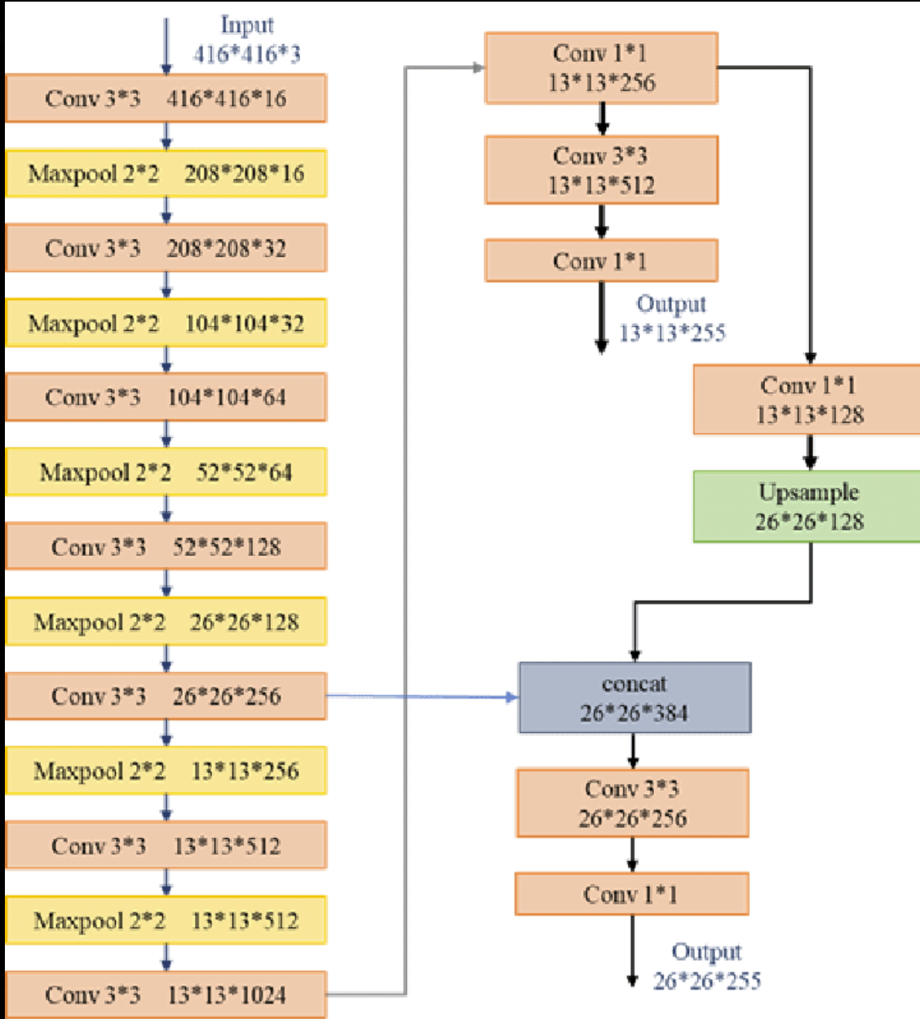
Figure1: Model Architectural diagram [1]
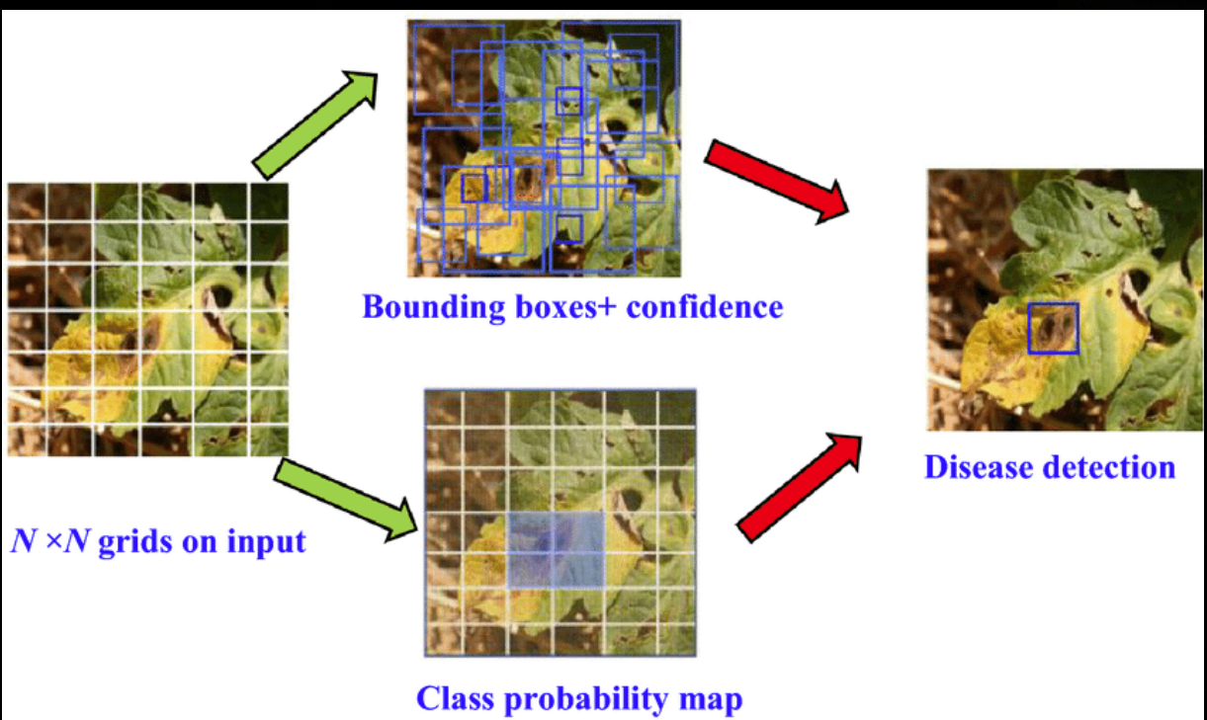
Figure2: Multi model combination [6]

2.3 Performance Analysis
The generalization of findings in AIoT-based plant disease forecasting remains limited due to several factors, including restricted sample sizes and region-specific datasets. Many studies focus on controlled environments or specific plant varieties, which may not represent diverse agricultural conditions. For instance, models trained on turmeric diseases in controlled settings may underperform when deployed in field conditions with varying lighting, soil types, and plant cultivars. This limitation reduces the reliability of such systems for broad agricultural applications.
A significant challenge lies in the dependence on deep learning algorithms and sensor data quality, both of which introduce potential biases. Variability in image acquisition — caused by factors like leaf occlusion, camera angles, and lighting conditions — can affect model performance. Similarly, environmental sensors for temperature, humidity, CO₂, and soil moisture may exhibit inconsistencies due to placement, calibration drift, or environmental noise. These factors contribute to measurement variability, making it difficult to replicate results across different farms or climatic conditions.
Another critical limitation is the lack of external validation on independent datasets. Many studies evaluate models on proprietary or narrowly scoped datasets, which limits their real-world applicability. For example, while reports highlight improved accuracy with YOLOv8n and MobileNetV3-Small, this performance may not hold for unseen plant species or disease variants. Similarly, Decision Tree-based environmental risk models achieve high accuracy in controlled greenhouses but may struggle in open-field conditions with unpredictable microclimates. Without rigorous cross-validation across diverse agricultural settings, these results remain speculative.
Continual learning introduces its own performance evaluation challenges. A key limitation of naive performance metrics in incremental learning settings is that standard accuracy figures mask the underlying stability-plasticity trade-off. A model achieving high Cycle 2 accuracy may have done so by sacrificing Cycle 1 knowledge — a form of catastrophic forgetting not captured by a single aggregate metric [25][26]. Rigorous continual learning evaluation therefore requires tracking both old-class retention and new-class acquisition independently across every CL cycle. Experimental results on MobileNetV3-Small across three initialization strategies and four CL methods (EWC, Experience Replay, Parameter Isolation, Naive Fine-tuning) confirm this multi-dimensional evaluation necessity: while Naive Fine-tuning achieves nominally competitive accuracy in same-class scenarios (97.36–98.42%), it provides no forgetting protection, and its apparent performance benefits collapse in new-class scenarios where old-class retention drops to 87.07–87.51% [25].
Transfer learning initialization is identified as a primary determinant of CL performance ceiling [25][29]. Case 2 (ImageNet pre-training) achieves the best average CL accuracy across all methods in same-class scenarios, while Case 3 (PlantVillage domain-specific pre-training) achieves the strongest old-class retention in new-class scenarios. Case 1 (scratch initialization) is consistently the weakest, as the network’s feature representations are not sufficiently mature at CL onset to serve as a stable anchor. These findings align with the broader CL literature indicating that richer pre-trained representations reduce the severity of the stability-plasticity dilemma [28][29]. Lambda tuning for EWC yields the largest benefit (+1.14% average accuracy) for domain-specific pre-trained models (Case 3), because their Fisher Information Matrices identify denser clusters of critical weights, making regularization strength more impactful.
Resource utilization analysis reveals critical deployment trade-offs. VRAM consumption ranges from 122.63 MB (Parameter Isolation, CatA) to 601 MB (Hybrid EWC+Replay, CatB), with Experience Replay and EWC occupying intermediate positions at 155.58 MB and 169.51 MB respectively. All CatA configurations and the Replay CatB configuration remain within practical edge deployment constraints. The Hybrid EWC+Replay method, which was hypothesized to outperform either approach alone, consistently underperforms standalone Replay on new-class accuracy by 2.8–8.4% while consuming 37–40% more training time — a finding that contradicts the intuitive expectation that combined methods outperform individual ones and highlights the importance of empirical validation before assuming that complexity improves performance [25].
Confounding factors such as plant physiology, seasonal variations, and farming practices further complicate system reliability. For instance, a model trained on young turmeric plants may fail to detect diseases in mature crops due to changes in leaf texture and color. Environmental conditions like sudden rainfall or drought can also skew sensor data, leading to false predictions. Additionally, edge deployment introduces hardware-specific challenges, such as computational bottlenecks on low-power devices like Jetson Orin Nano, which may degrade real-time performance.
To address these limitations, future work must prioritize: (1) Diverse Datasets — larger, multi-region datasets covering varied plant genotypes and growth stages; (2) Robust Validation — cross-testing models on independent farms and climatic zones; (3) Adaptive Algorithms — incremental learning with EWC and Experience Replay to handle new disease strains and environmental shifts [26][27]; (4) Sensor Standardization — improved calibration protocols for environmental sensors; and (5) Evaluation Frameworks — adoption of multi-metric CL evaluation protocols that track per-task forgetting, backward transfer, and plasticity simultaneously across deployment cycles [25][28].
Without these advancements, AIoT-based forecasting systems risk remaining confined to research settings rather than achieving scalable, real-world impact.
.
.
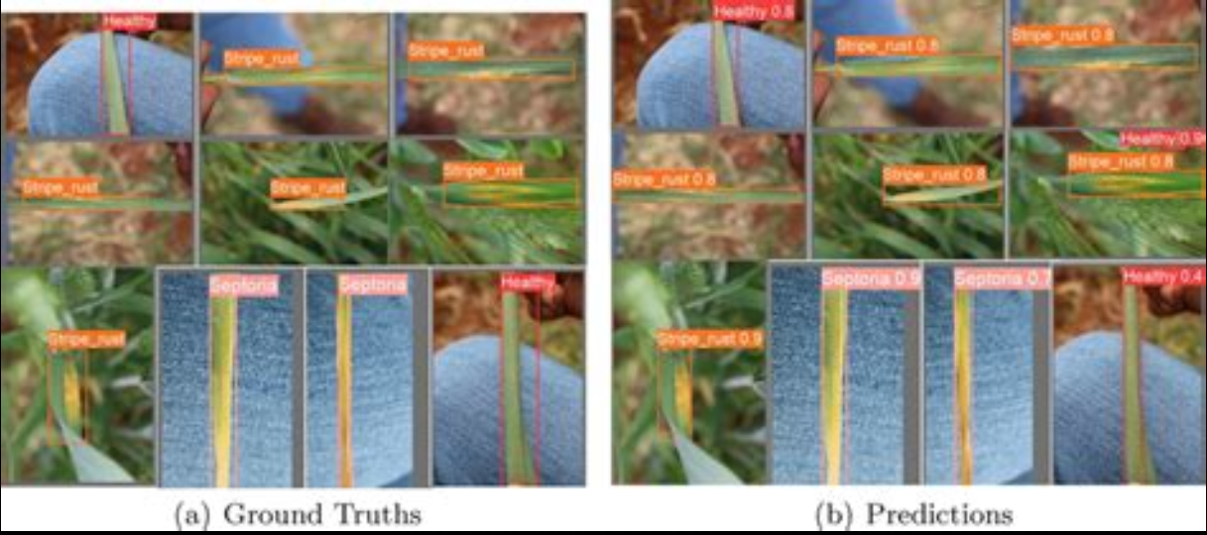
Figure3: disease prediction by YOLOv8 [6]

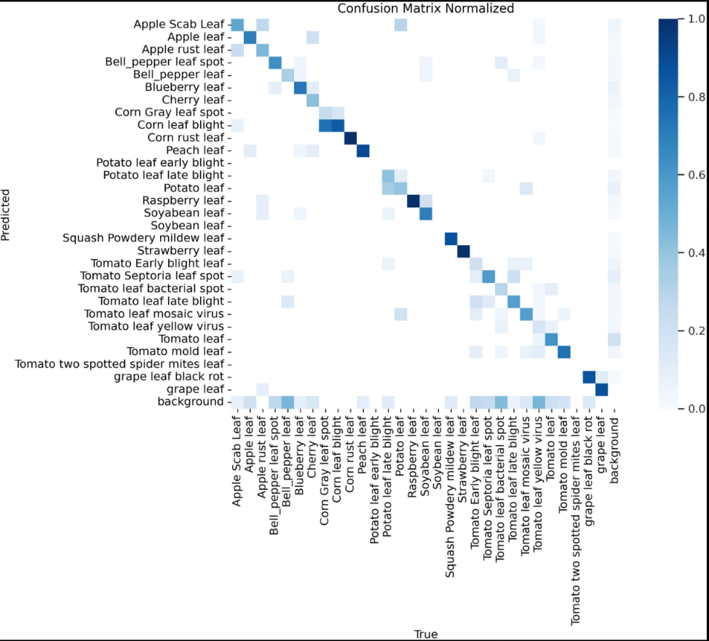

Figure 4: Confusion matrix used to analyse model performance [5]
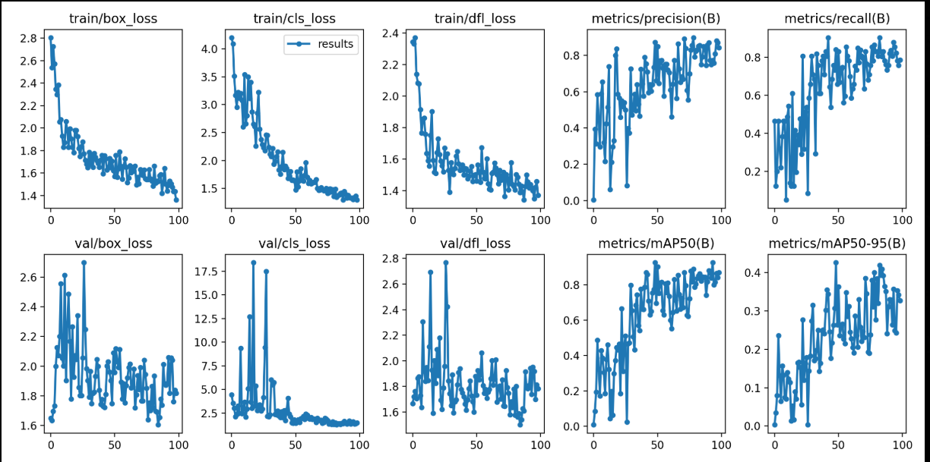

Figure5: Training and validation loss comparision [7]

2.4 Available Databases

- PlantVillage Dataset: The PlantVillage Dataset is one of the most widely used datasets for plant disease detection, containing over 54,000 images of healthy and diseased crops across 14 plant species, including tomatoes, potatoes, and corn. The dataset provides high-quality, labelled images captured under controlled conditions, making it ideal for training deep learning models like MobileNetV3 and YOLO architectures [22]. Researchers leverage PlantVillage to benchmark disease classification models, though its controlled environment may limit generalization to field conditions. It was used for initial training of MobileNetV3 from scratch in the incremental learning pipeline.
- AI Challenger 2018 – Agriculture Disease Dataset The AI Challenger 2018 dataset includes 10,000+ images of diseased crops such as rice, wheat, and cucumbers, collected from real-world agricultural fields. Unlike PlantVillage, this dataset features diverse lighting conditions, occlusions, and background noise, making it suitable for testing robustness in edge-AIoT deployments. The dataset supports research in real-time disease forecasting and has been used to validate YOLOv8n and MobileNetV3 models.
- Turmeric Plant Disease Dataset (Mendeley Data, 2025) : A specialized dataset focusing on turmeric leaf diseases, including leaf spot, blotch, dry, aphid, and healthy classes, with 5,000+ annotated images [23]. The dataset includes field-collected images with varying occlusion levels, enabling research on lightweight GAN-based reconstruction and real-time edge-AIoT disease detection. This dataset is particularly useful for studies on incremental learning in agriculture, as it covers multiple disease stages. It was divided into 60% for initial fine-tuning, 10% for fixed test samples, and the rest for batch-based incremental learning (50, 100, 200 images per batch) to evaluate catastrophic forgetting.
- EuroSAT (Sentinel-2 Satellite Imagery for Agriculture): The EuroSAT dataset provides 27,000 multispectral satellite images of agricultural land across Europe, useful for large-scale disease monitoring. While not focused solely on diseases, it supports AIoT systems integrating drone/satellite imagery with ground sensors for predictive analytics. Researchers use EuroSAT to study environmental correlations (humidity, temperature) with disease outbreaks.
- Open Plant Pathology (OPP) Dataset : A crowdsourced dataset containing field images of diseased crops with metadata on weather, soil conditions, and farming practices. The dataset supports multimodal AIoT forecasting, combining visual disease detection with environmental sensor data. It has been used to validate Decision Tree-based risk prediction models.
- Cassava Leaf Disease Dataset: The Cassava Leaf Disease Dataset includes thousands of images of cassava plants with various diseases, collected from real-world fields. This dataset was utilized for testing incremental learning phases due to the limited size of the turmeric dataset (only 200 images per class). It enables evaluation of batch sizes (50, 100, 200) in EWC-based incremental learning to optimize hyperparameters and assess accuracy changes on fixed test samples.

CHAPTER 3 : METHODOLOGY

3.1 Overall system architechure
The end-to-end pipeline of the proposed system is designed for efficiency and scalability on edge devices. The data flow and processing steps are visualized in the architecture diagram below (Figure 1).

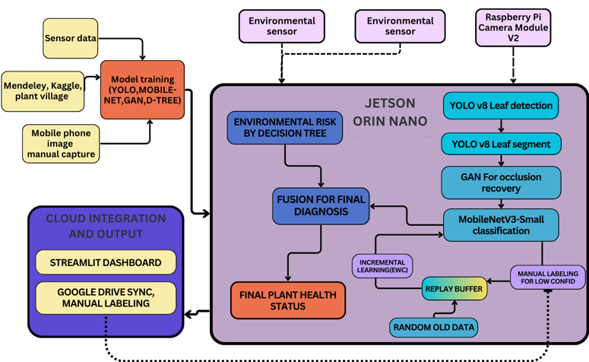
Figure 6: High-level system architecture
The system architecture integrates a dual-data pipeline, processing both visual imagery and environmental sensor readings, which are fused to generate a final, robust health assessment. The visual pipeline begins with input images being resized to 640x640 pixels while preserving aspect ratio. A YOLOv8 detection model first localizes and crops individual leaves, which are filtered by size to ensure quality. Each leaf is then segmented by a YOLOv8n-seg model to isolate it from the background, which is filled with black to remove noise.
The segmented leaf images are processed through a dedicated occlusion recovery module. They are resized and padded to 224x224 pixels to serve as input for a lightweight Generative Adversarial Network (GAN), which reconstructs any missing or occluded portions of the leaf to produce a complete image. This enhanced image is then fed into a MobileNetV3-Small classifier, optimized for edge deployment, to perform the visual disease classification into one of the five target classes: Healthy, Blotch, Leaf Spot, Dry, or Aphid.
Concurrently, a parallel pipeline processes timestamp-matched environmental sensor data (CO₂, humidity, temperature, soil moisture) using a Risk Prediction Decision Tree algorithm to calculate an independent environmental stress score. The outputs from the visual and environmental pipelines are fused at the label level, combining the disease classification with contextual risk factors to produce a holistic and context-aware final diagnosis. The entire system is optimized for deployment on edge devices like the Jetson Orin Nano, enabling continuous real-time monitoring, with results synchronized to cloud storage and a streaming dashboard for feedback and future incremental learning

3.2. Hardware Components & Data Collection
3.2.1 Hardware Setup
The system is architected around the NVIDIA Jetson Orin Nano developer kit, which serves as the central edge computing unit. Key specifications relevant to this project include:
- AI Performance: 40 TOPS (INT8) for accelerated deep learning inference.
- GPU: 1024-core NVIDIA Ampere architecture GPU.
- CPU: 6-core ARM Cortex-A78AE v8.2 64-bit CPU.
- Memory: 8 GB 128-bit LPDDR5.
This hardware provides the necessary computational power to run the entire multi-model AI pipeline in real-time.
For image acquisition, the system utilizes a Raspberry Pi Camera Module V3 (or an equivalent high-resolution USB webcam) connected directly to the Jetson Orin Nano. To enable comprehensive and frequent monitoring of the greenhouse plants, the camera is mounted on a motorized conveyor belt system. This setup allows the camera to move along a predefined path, capturing images of plants at regular intervals from consistent angles, ensuring systematic data collection.
3.2.2 Data Collection Strategy
Data is sourced from two primary streams to ensure both breadth and domain specificity:
- Public Datasets: Datasets such as Plant Village, Mendeley, and Kaggle are utilized for the initial pre-training phase. This provides the model with a broad foundational understanding of plant pathologies before specializing.
- Domain-Specific Turmeric Dataset: A custom dataset is built using the described hardware setup in a controlled greenhouse environment. The conveyor belt system allows for the capture of high-resolution images with significant variation in:
  - Lighting: Different times of day and artificial lighting scenarios.
  - Leaf Overlap: Dense foliage to train the detection model on occluded leaves.
  - Viewing Angles: Consistent but varied perspectives as the camera moves.

3.2.2 Data Annotation Pipeline
Annotation is performed using the Roboflow platform, following a two-stage strategy tailored for the sequential vision pipeline:
- Bounding Box Annotation: The initial annotation step involves drawing bounding boxes around every individual leaf in the original whole-plant images. This data trains the YOLOv8-n object detection model to localize and separate individual leaves.
- Polygon Segmentation Mask Annotation: The second stage uses the predicted single-leaf crops (outputs from the detection model). Precise polygon segmentation masks are drawn along the leaf contours. This data trains the YOLOv8-seg instance segmentation model to remove all background noise, producing a standardized image (leaf on a black background) for subsequent processing.

3.3. Leaf Detection and Segmentation with YOLOv8
The YOLOv8 architecture was selected for its optimal balance of speed and accuracy, making it particularly suitable for real-time edge deployment on the NVIDIA Jetson Orin Nano. After comparative analysis of various model sizes, the nano variant (YOLOv8n) was chosen for both detection and segmentation tasks to meet the strict computational constraints while maintaining adequate performance.
3.3.1. Leaf Detection with YOLOv8-n
For the leaf detection stage, YOLOv8-n was selected as the primary model for localizing and isolating individual leaves from complex whole-plant images. The model selection prioritized key edge deployment metrics including model size, computational complexity (FLOPS), and inference speed, while maintaining satisfactory detection accuracy as measured by mean Average Precision (mAP50). The detection model was specifically optimized to handle challenging greenhouse conditions such as leaf occlusions, varying lighting conditions, and complex plant arrangements.
3.3.2. Leaf Segmentation with YOLOv8-seg
The segmentation pipeline employs YOLOv8-seg for generating precise pixel-wise masks that isolate each detected leaf from background elements. The model evaluation focused on segmentation accuracy measured through Intersection over Union (IoU) metrics, alongside critical deployment considerations such as model size and processing speed. The segmentation stage ensures clean input preparation for subsequent classification tasks by effectively removing background noise and preserving leaf structural details essential for accurate disease identification.

3.4. Occlusion Handling with Lightweight GAN
To address partial leaf occlusions, a custom Lightweight Generative Adversarial Network (GAN) is implemented.
- Architecture: The generator is based on a U-Net structure utilizing depth-wise separable convolutions to reduce computational load. The discriminator uses a PatchGAN architecture.
- Training: The model is trained on image pairs consisting of a clear leaf image and a synthetically occluded version. The objective is for the generator to learn to reconstruct the original image.
- Evaluation Metrics: The reconstruction quality is evaluated using the Peak Signal-to-Noise Ratio (PSNR) and the Structural Similarity Index Measure (SSIM).
3.5. Disease Classification with MobileNetV3-Small
The core classifier employs MobileNetV3-Small, selected for its high efficiency on edge devices. The model is enhanced with a Convolutional Block Attention Module (CBAM) to improve feature extraction. A three-phase training strategy is employed:
- Phase 1 - Foundation Training: The model is trained from scratch on a large, diverse plant disease dataset (e.g., Plant Village) to build a robust, plant-specific feature extractor.
- Phase 2 - Transfer Learning: The foundation model is fine-tuned on the target turmeric dataset. The performance is evaluated using standard classification metrics: Accuracy, Precision, Recall, and F1-Score.
- Phase 3 - Incremental Learning: The model is continuously adapted using new data. The key metric here is Retention Accuracy on the original test set after learning new tasks.
3.6. Continual Learning with Elastic Weight Consolidation (EWC)
The Elastic Weight Consolidation algorithm is implemented to prevent catastrophic forgetting during incremental learning. EWC calculates a Fisher Information Matrix to identify the importance of each network weight for a previously learned task. During learning of a new task, a quadratic penalty is applied to changes in these important weights, effectively anchoring them and preserving prior knowledge.
3.6.1 Experience Replay
Experience Replay is a data-level alternative to EWC's weight-level penalty. A stratified buffer of prior-class exemplars (a minimum floor per class, drawn only from the initial training pool) is stored and mixed 50/50 with incoming stream data in every training batch. Unlike EWC, Replay applies no penalty term to the loss; instead, the classifier head receives direct gradient correction from both old and new samples simultaneously, which prevents the output layer from drifting toward the new classes at the expense of the old.
3.6.2 Parameter Isolation
Parameter Isolation avoids forgetting by construction: all existing weights are frozen, and only a small amount of new capacity is trained for incoming data. For same-class learning, this is a lightweight bottleneck adapter (96→24→96 channels, identity-initialized, ≈ 18,000 parameters — about 1.2% of the backbone) inserted after the penultimate feature block. Because old weights are mathematically untouched, forgetting is zero by definition; the trade-off is that all new learning is confined to this small adapter's capacity.
3.6.3 Initialization Strategy as an Experimental Factor
Continual learning outcomes depend heavily on how the backbone was initialized before continual updates begin, so three initialization strategies are evaluated side by side: Case 1 — Scratch (random initialization); Case 2 — ImageNet (standard pretrained weights); and Case 3 — In-domain PlantVillage (the backbone is first pretrained on the broader PlantVillage classes before continual learning begins). Each of the four CL methods is evaluated under all three cases, so the comparison isolates the effect of the CL method itself from the effect of the starting representation.
3.6.4 Layer-Wise Training Strategy
Rather than applying continual updates uniformly, the backbone is partitioned into four functional groups: G1 (early layers — edges, colour; always frozen), G2 (mid layers — venation, texture; frozen in same-class CL), G3 (late layers — lesion shape, discolouration; the primary forgetting site), and G4 (classifier head — always task-specific). Confining plasticity to G3 and G4 concentrates the EWC penalty and the replay gradient on the parameters that actually drift. When new classes are added, the classifier head additionally uses a split learning rate — old-class output neurons updated an order of magnitude more slowly than new-class neurons — so the network learns the new class quickly without erasing what it already knew.
3.7. Environmental Risk Prediction via Decision Tree
A Decision Tree classifier is chosen for its interpretability and low computational cost. It is trained on historical environmental sensor data (temperature, humidity, soil moisture, CO2) labeled with disease incidence. The model outputs a risk score, and its performance is evaluated using standard metrics like Accuracy and F1-Score.

3.8. Multi-Modal Fusion for Final Diagnosis
A Label-Level Fusion strategy is employed. The final diagnosis is a combination of the disease probability vector from the image classifier and the scalar risk score from the Decision Tree. This approach provides a context-aware assessment of plant health.
3.9. Edge Deployment and Real-Time Dashboard
The complete AI pipeline is deployed as a fully automated system on the NVIDIA Jetson Orin Nano, operating continuously without manual intervention. The system leverages a conveyor belt setup for periodic image capture, ensuring comprehensive plant coverage at regular intervals.
A Streamlit dashboard serves as the primary user interface, providing real-time monitoring of plant health predictions, environmental sensor data, and system performance metrics. The dashboard features manual override controls for immediate image capture and system diagnostics.
Model retraining is scheduled as a monthly automated process, where newly collected and verified data is used to incrementally update the disease classification model using Elastic Weight Consolidation (EWC). This scheduled retraining cycle ensures the system adapts to seasonal variations and new disease patterns while maintaining stability through controlled update intervals.
The edge-deployed architecture ensures all processing occurs locally on the Jetson Orin Nano, providing real-time responsiveness and eliminating dependency on cloud connectivity for critical monitoring functions.

CHAPTER 04 : PROGRESS AND RESULTS
4.1 Database Collection

The project utilized a comprehensive dataset combining multiple sources to ensure robustness and domain specificity. The foundation was built using the Plant Village dataset containing approximately 54,000 images across 38 disease classes, providing broad coverage of plant pathologies. For domain-specific training, a custom turmeric dataset was created with 1,000+ high-resolution images captured in controlled greenhouse conditions.
Figure 4.1 shows sample images collected from the turmeric greenhouse, demonstrating the variety of conditions captured. The images were collected at various time periods throughout the day (morning, noon, afternoon) to ensure robust model performance under different lighting conditions. A 45-degree camera angle was employed to capture realistic leaf overlap and complex backgrounds, simulating actual field conditions.
The dataset includes 550 training images with 5,582 annotated bounding boxes, meticulously labeled using Roboflow for both detection and segmentation tasks. This multi-source approach ensures the model benefits from both general plant disease knowledge and specific turmeric disease characteristics, while the varied collection conditions enhance the model's ability to handle real-world environmental variations.

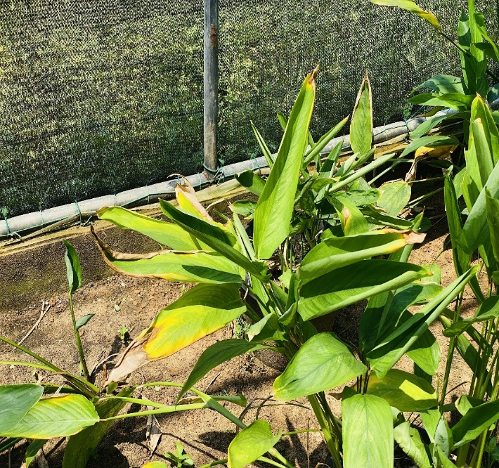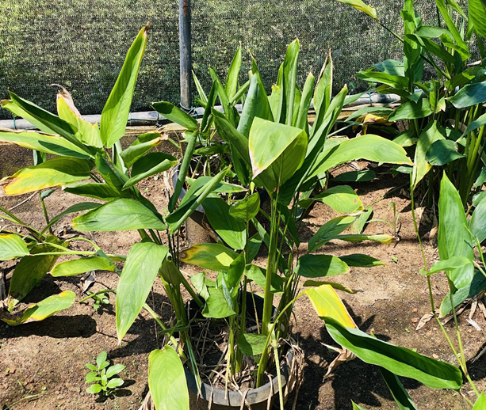

Figure7: Sample images collected from turmeric greenhouse showing variation in lighting conditions and leaf arrangements

4.2 YOLOv8 Leaf Detection and Segmentation Model

4.2.1.Model Comparison and Selection:
Table 4.1 presents the comprehensive comparison between YOLOv8n and YOLOv8s models. The evaluation revealed that while YOLOv8s achieved a slightly higher mAP50 of 0.6727 compared to YOLOv8n's 0.6640, the nano variant demonstrated significantly better efficiency with an inference speed of 10.45 ms/image versus 34.67 ms/image for the small variant. Based on this optimal trade-off between accuracy and computational efficiency, YOLOv8n was selected for deployment on the Jetson Orin Nano.
Metric | Yolov8n | Yolov8s
mAP50 | 0.6640 | 0.6727
mAP50-95 | 0.3916 | 0.3918
Precision | 0.6721 | 0.6585
Recall | 0.6258 | 0.6700
Inference speed | 10.45 ms/img | 34.67 ms/img
Model size | 6.15 MB | 22.38 MB
FLOPs | 4.04 B | 14.22 B
MACs | 4042.60 M | 14218.83 M

Table 1: YOLOv8 Model Comparison for Leaf Detection

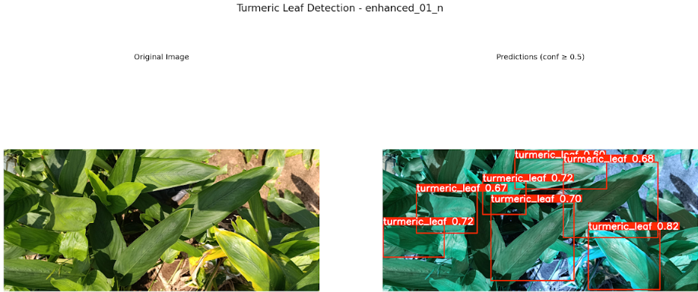
4.2.2.Separation Performance:
The YOLOv8n model effectively localized and separated individual leaves from dense plant arrangements. Figure 4.2 demonstrates the model's separation capability, showing original plantimages alongside the detected and cropped individual leaves with bounding box predictions and confidence scores.

Figure 8: YOLOv8n leaf separation results showing bounding box detection on original plant images
4.2. YOLOv8 Leaf Detection Model
For precise leaf isolation, the YOLOv8-seg model was implemented to generate pixel-wise masks. A comparative analysis was conducted to select the optimal segmentation architecture for edge deployment.

4.2.1.Comparative Analysis:
Table 4.2 shows the performance comparison of segmentation models. The YOLOv8n-seg variant demonstrated exceptional performance with 0.995 IoU accuracy, significantly outperforming alternative architectures while maintaining minimal model size.
 | yolov8n-seg model | DeepLabV3+with MobileNetV3-Large backbone | Custom UNet
Model accuracy | 0.995 | 0.9481 | 0.9281
Model size | 6.15 MB | 42.16 MB | 118.47 MB

Table 2: Segmentation Model Comparison

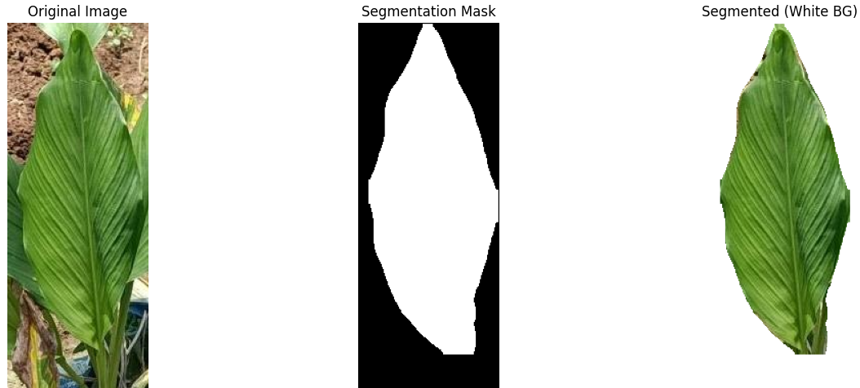
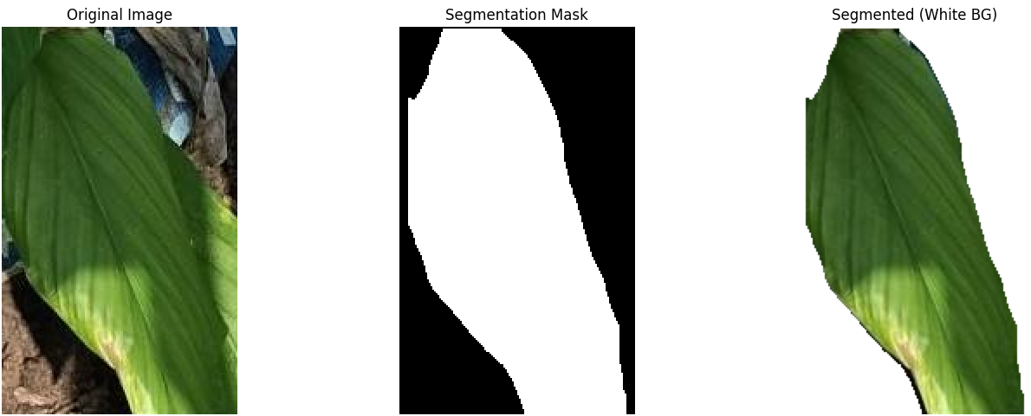
4.2.2.Segmentation Results:
The YOLOv8n-seg model effectively removed background elements and isolated leaf structures with high precision. Figure 4.3 illustrates the complete segmentation pipeline, showing original input images, generated segmentation masks, and final isolated leaves with black backgrounds, ready for subsequent processing stages

Figure 9: YOLOv8 segmentation pipeline showing original images, segmentation masks, and final isolated leaves
4.3 Lightweight GAN for Occlusion Recovery

A custom Lightweight GAN was developed to address the challenge of partial leaf occlusions, a common issue in dense greenhouse environments. The model was specifically optimized for edge deployment with a compact architecture featuring depth-wise separable convolutions and trained over 27 epochs to achieve optimal performance.

4.3.1.Quantitative Performance Analysis:
The model achieved a mean PSNR of 22.28 dB and mean SSIM of 0.8168, indicating moderate-level reconstruction quality suitable for edge deployment. Figure 4.4 presents the comprehensive performance analysis, showing:

PSNR Distribution with mean 22.28 dB and median 22.19 dB, demonstrating consistent reconstruction quality across test samples

SSIM Distribution with mean 0.8168 and median 0.8268, indicating good structural similarity preservation

PSNR vs SSIM Correlation of 0.620, showing moderate positive relationship between pixel-level and structural quality metrics

4.3.2.Visual Reconstruction Results:
Figure 4.5 demonstrates the model's practical occlusion recovery capability, showing clear before-and-after comparisons. The visual results confirm the model's ability to reconstruct missing leaf portions with reasonable accuracy, making the recovered images suitable for subsequent disease classification tasks in the pipeline.
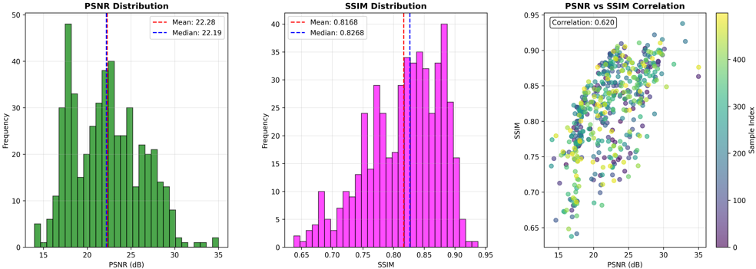

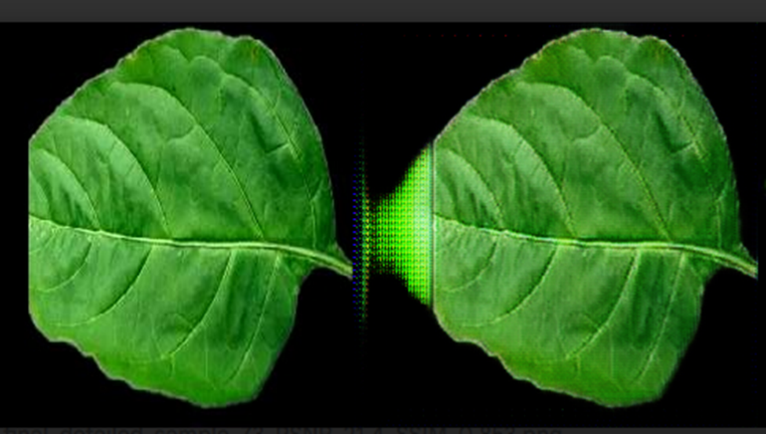
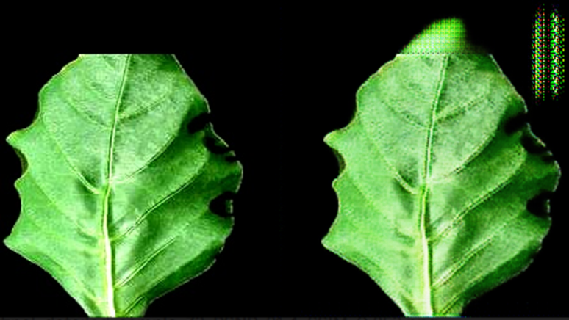
Figure 10: Lightweight GAN performance metrics showing PSNR/SSIM distributions and correlation analysis
Figure 11: Visual occlusion recovery results showing input occluded images and reconstructed outputs
4.4. MobileNetV3-Small Base Classifier Training (Phase 1)
A Decision Tree classifier was implemented for environmental risk assessment, trained on synthetic data generated based on established turmeric cultivation parameters. The model classifies risk into three levels (Low, Medium, High) using real-time sensor data (temperature, humidity, soil moisture, CO₂). The rules-based approach considers deviations from optimal growing conditions, with classification thresholds derived from agricultural research. The lightweight nature of the Decision Tree ensures minimal computational cost while providing valuable contextual information for the fusion module
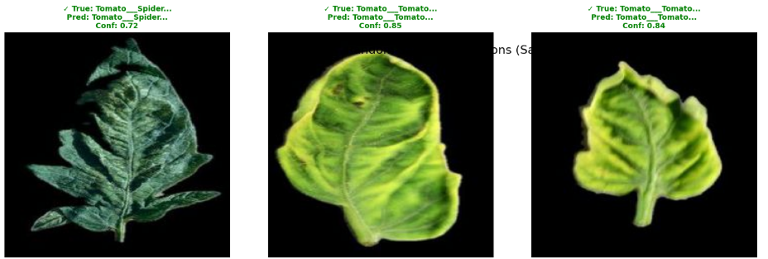
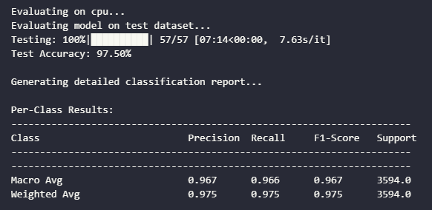
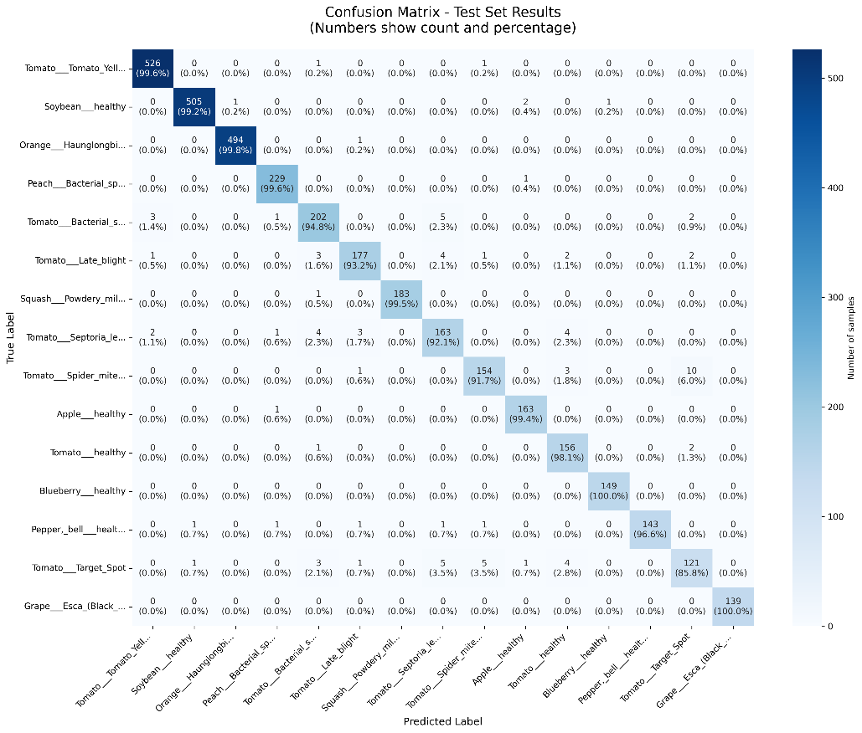
Figure 12: Phase 1 Classification Results
Figure 13: Phase 1 Confusion Matrix

4.5. Transfer Learning to Turmeric Diseases (Phase 2)

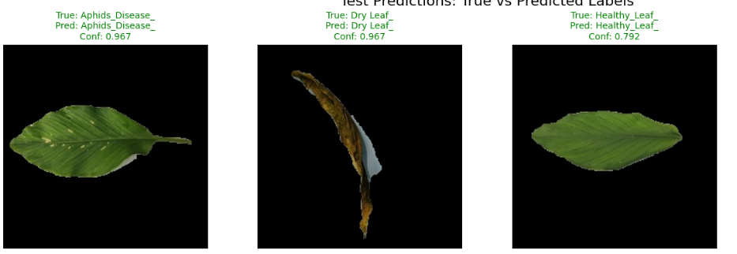
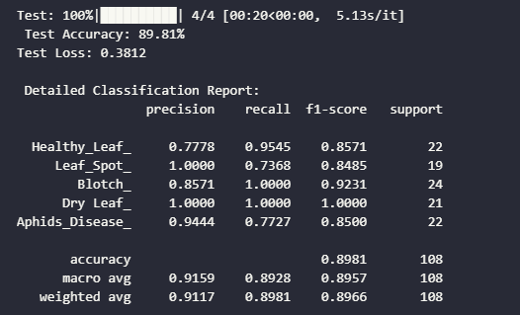
Figure 4.6 shows classification outputs and Figure 4.7 presents the confusion matrix from Phase 1 training. The MobileNetV3-small model with CBAM attention achieved 97.58% test accuracy across 15 plant disease classes. The results demonstrate effective disease identification with minimal misclassification, establishing a strong foundation for turmeric adaptation.
Figure 14: Phase 2 Results
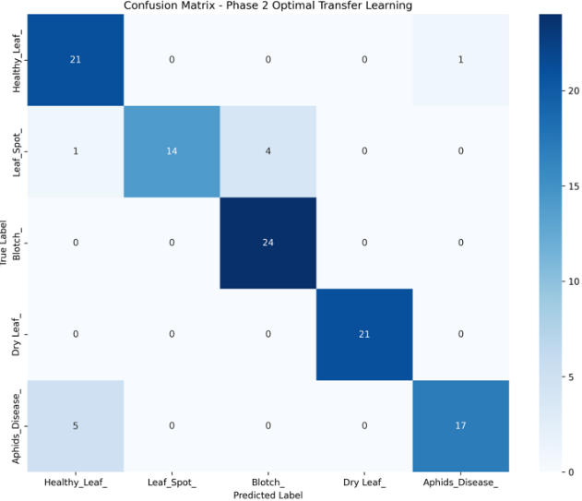
Figure 15: Phase 2 Confusion Matrix

4.6. Incremental Learning with EWC (Phase 3)


Figure 4.8 shows the performance metrics and Figure 4.9 presents the confusion matrix from Phase 2 transfer learning. The model achieved 89.81% test accuracy on turmeric diseases with strong performance across all classes. The weighted average metrics show 91.17% precision, 89.81% recall, and 89.66% F1-score, demonstrating balanced performance. Dry Leaf detection achieved perfect precision and recall (1.000), while Healthy Leaf showed the highest recall (0.9545). The results demonstrate successful adaptation from general plant diseases to specific turmeric pathologies.

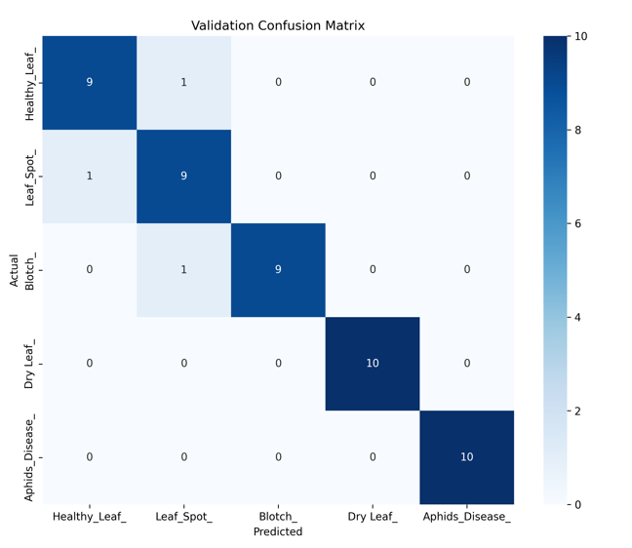
Figure 16: Phase 3 results

Figure 17: Phase 3 Confusion Matrix

[NOTE TO STUDENT: sections 4.7 and 4.8 below are newly added. Also note -- while adding this, we noticed sections 4.4/4.5/4.6 above describe results one phase behind their own headings (4.4's heading says Phase 1 but its paragraph describes the Decision Tree; 4.5 says Phase 2 but describes Phase 1's 97.58% result; 4.6 says Phase 3 but describes Phase 2's 89.81% result). This is left as-is for you to optionally fix -- see the addendum doc for the exact relabeling map.]
4.7 Incremental Learning: Comparative Evaluation of Continual Learning Strategies (Phase 3)
Having established the base classifier (Phase 1) and its transfer to turmeric disease classification (Phase 2), this section presents the core continual learning evaluation: a systematic comparison of four adaptation strategies — Elastic Weight Consolidation (EWC), Experience Replay, Parameter Isolation, and a Hybrid EWC+Replay scheme — across three backbone initialization strategies (Section 3.6.3) and two incremental scenarios: same-class streaming (Category A) and new-class expansion (Category B, five to seven classes). Naive fine-tuning, which applies no forgetting protection, is included throughout as a reference lower bound, not as a valid continual learning method.
4.7.1 Category A: Same-Class Continual Learning
Table 5 reports accuracy and F1-score for every case/method combination across two continual learning cycles, together with training time.
Case / Method | Cycle 1 Acc | Cycle 2 Acc | Avg. Acc | Time
Case 1 — EWC | 97.89% | 97.45% | 97.67% | 337 s
Case 1 — Replay | 97.45% | 97.19% | 97.32% | 482 s
Case 1 — Isolation | 96.31% | 96.57% | 96.44% | 232 s
Case 1 — Naive* | 97.63% | 97.54% | 97.58% | 322 s
Case 2 — EWC | 97.98% | 98.24% | 98.21% | 171 s
Case 2 — Replay (best) | 98.07% | 98.42% | 98.25% | 620 s
Case 2 — Isolation | 97.19% | 97.27% | 97.23% | —
Case 2 — Naive* | 97.63% | 99.21% | 98.42% | 322 s
Case 3 — EWC | 97.63% | 97.45% | 97.54% | 339 s
Case 3 — Replay | 97.80% | 98.50% | 98.15% | 482 s
Case 3 — Isolation | 96.48% | 96.66% | 96.57% | 232 s
Case 3 — Naive* | 96.48% | 98.24% | 97.36% | —
Table 5: Category A results — same-class continual learning. *Naive fine-tuning is shown for reference only; it uses the full data history and is not a valid continual learning method under the storage constraint.
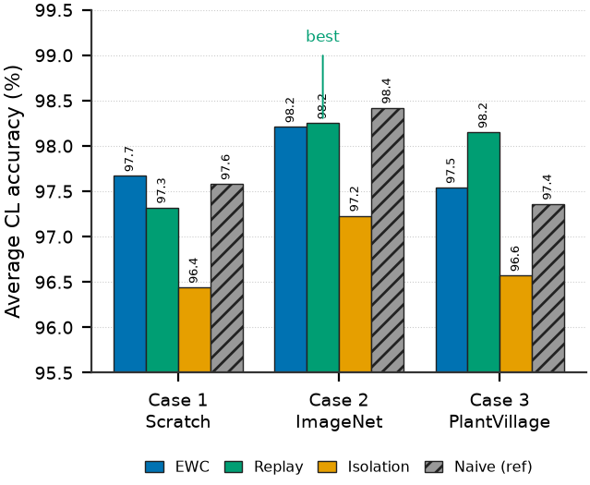
Figure 18: Category A average accuracy across initialization cases and continual learning methods.
Experience Replay with ImageNet initialization (Case 2) reaches the highest average accuracy at 98.25%, but the margin over EWC in the same case (98.21%) is only 0.04 percentage points, while EWC trains in 171 seconds against Replay's 620 seconds — a 3.6× difference. For a device that must retrain periodically under a limited power budget, this is a meaningful practical trade-off: EWC reaches essentially the same accuracy for a fraction of the training cost, since it only requires one additional forward pass over the buffer to estimate parameter importance.
The three methods show distinct behaviour. EWC is stability-dominant, holding accuracy nearly constant across cycles. Replay is plasticity-dominant, achieving the best Cycle-2 accuracy in every case, because mixing old exemplars into every batch gives the classifier head direct correction from both old and new data. Isolation is consistency-dominant, varying the least across cycles since old weights are never touched — at the cost of roughly a one-point accuracy deficit, because its small bottleneck adapter is the only part of the network allowed to learn.
4.7.2 EWC Regularization Strength (Lambda) Tuning
EWC's penalty strength, λ, trades stability against plasticity: too small offers insufficient protection, too large prevents the model from adapting at all. Table 6 shows a grid search over six values of λ on Case 2.
λ | Cycle 1 Acc | Cycle 2 Acc | Assessment
1,000 | 97.71% | 98.15% | Under-regularized
3,000 | 97.80% | 98.24% (best Cyc.2) | Optimal for Cycle 2
5,000 | 97.63% | 98.24% | Marginal over-regularization
8,000 | 97.89% | 98.07% | Slight plasticity loss
10,000 | 97.98% (best Cyc.1) | 98.24% | Optimal for Cycle 1
15,000 | 97.89% | 98.15% | Over-regularized
Table 6: EWC lambda grid search (Case 2, Category A).
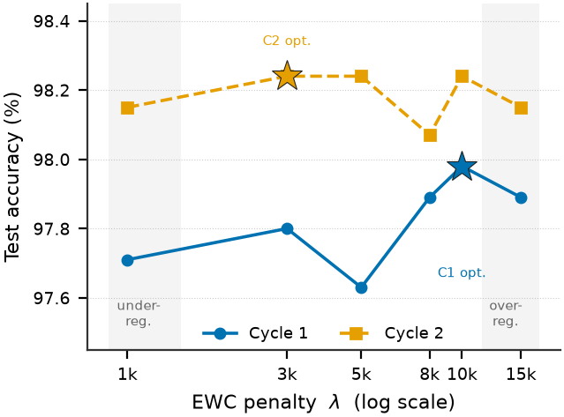
Figure 19: EWC accuracy versus regularization strength across two cycles.
The optimal λ is cycle-dependent: 10,000 maximizes Cycle 1 accuracy, but 3,000 is preferable by Cycle 2. Cycle 1 must protect a freshly transferred representation against the first distribution shift, whereas by Cycle 2 the model has already adapted once, and further regularization only suppresses plasticity without adding retention. A schedule of λ = 10,000 for the first cycle and λ = 3,000 for subsequent cycles is adopted for all reported EWC results.
4.7.3 Category B: New-Class Expansion
Table 7 reports both dimensions that matter under class expansion — new-class accuracy on the two newly introduced disease classes, and old-class retention on the original five classes.
Case / Method | Avg. New-Class Acc. | Old-Class Retention | Time
Case 1 — EWC | 82.79% | 87.34% | 1,048 s
Case 1 — Replay | 92.85% | 84.78% | 1,268 s
Case 1 — Naive* | 93.91% | 87.07% | 743 s
Case 1 — Hybrid | 84.43% | 92.44% | 1,741 s
Case 2 — EWC | 94.20% | 95.95% | 797 s
Case 2 — Replay (best) | 98.07% | 97.19% | 1,181 s
Case 2 — Isolation | 50.87% | ~100% | —
Case 2 — Naive* | 95.74% | 87.51% | 351 s
Case 2 — Hybrid | 95.26% | 98.24% | 1,659 s
Case 3 — EWC | 90.62% | 95.78% | 1,128 s
Case 3 — Replay | 96.42% | 96.92% | 1,220 s
Case 3 — Isolation | 15.38% | ~100% | —
Case 3 — Naive* | 96.91% | 94.72% | 668 s
Case 3 — Hybrid | 92.84% | 97.54% | 1,691 s
Table 7: Category B results — new-class expansion (5→7 classes). Old-class retention measured at Cycle 2. *Reference only.
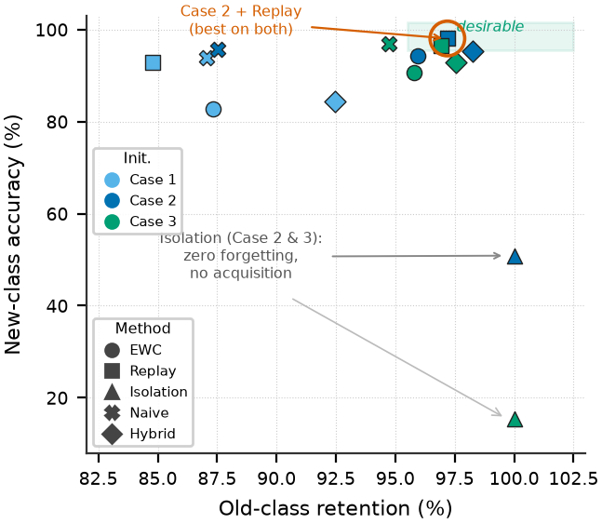
Figure 20: Stability–plasticity trade-off under new-class expansion.
Case 2 with Experience Replay is the clear winner on both dimensions simultaneously: 98.07% new-class accuracy with 97.19% old-class retention. No other configuration exceeds 96% on both at once. Naive fine-tuning's apparent competitiveness in Category A disappears here: old-class retention falls to 87.07–87.51%, confirming that its earlier good behaviour was only because the same five classes kept recurring in every stream, acting as accidental replay — not because naive fine-tuning is actually robust to forgetting.
4.7.4 Why Parameter Isolation Fails on New Classes
Parameter Isolation, within about one point of the best method in Category A, collapses when new classes are introduced: 50.87% average new-class accuracy in Case 2 and just 15.38% in Case 3 — close to chance level for a two-class decision. The cause is architectural: the isolation branch for new classes is trained entirely from scratch, receiving no feature information from the pretrained backbone, so it must learn disease-discriminative features from a few hundred images per class with no shared representation to build on. Notably, the stronger the frozen backbone (Case 3's in-domain PlantVillage pretraining), the worse this failure becomes — a stronger backbone widens the representational gap between itself and the untrained new branch. Parameter Isolation should not be used in any deployment scenario where new disease classes may appear; it remains reasonable only for same-class streaming under strict memory constraints.
4.7.5 Does Combining EWC and Replay Help?
A Hybrid scheme applying both the EWC penalty and the replay buffer simultaneously was tested on the hypothesis that weight-level and data-level protection would reinforce each other. Table 8 shows they do not.
Case | Hybrid New-Class | Replay New-Class | Hybrid Old Ret. | Time Overhead
Case 1 | 84.43% | 92.85% (+8.4) | 92.44% | +37%
Case 2 | 95.26% | 98.07% (+2.8) | 98.24% | +40%
Case 3 | 92.84% | 96.42% (+3.6) | 97.54% | +39%
Table 8: Hybrid (EWC+Replay) versus Replay alone, Category B.
The Hybrid method underperforms Replay alone by 2.8–8.4 percentage points on new-class accuracy while costing 37–40% more training time. The two mechanisms compete rather than cooperate: EWC's penalty constrains exactly the late layers and classifier head that need to move to learn the new classes, partially cancelling the replay gradient's benefit.
4.7.6 Resource Utilization
Table 9 summarizes the memory footprint relevant to on-device deployment.
Method / Scenario | Peak VRAM (MB) | Model Size (MB) | Note
Isolation — Cat. A | 122.63 | 5.81 | Lowest VRAM
Replay — Cat. A | 155.58 | 5.81 | Best accuracy
EWC — Cat. A | 169.51 | 5.81 | Fastest (171 s)
Naive — Cat. A/B | 161–162 | 5.81 | Reference
Replay — Cat. B | 325.39 | 5.82 | Head expansion
EWC — Cat. B | 383–601 | 5.82 | Fisher matrix at Cycle 2
Hybrid — Cat. B | 384–601 | 5.82 | Highest; no accuracy gain
Table 9: Resource utilization by method and scenario.
Every trained model remains within 5.82 MB, and adding two new classes costs only 0.01 MB. Peak memory during retraining — not model size — is the actual constraint on device: same-class scenarios fit within 170 MB, while Category B Replay needs 325 MB and Category B EWC peaks at 601 MB when its Fisher matrix is held alongside activations.
4.7.7 Section Summary
Across both scenarios: Experience Replay with ImageNet initialization is the strongest overall configuration, EWC is preferred when training time or power budget is constrained (equivalent Category-A accuracy at 3.6× lower cost), Parameter Isolation is usable only when no new classes will ever be introduced, and combining EWC with Replay is not worthwhile. These findings directly determined the choice of Case 2 + Experience Replay as the recipe carried forward to the turmeric-specific validation in Section 4.8.
4.8 Continual Learning Validation on Turmeric Data
Sections 4.4–4.6 established a base turmeric classifier (Phase 2, 89.81% accuracy). Having identified Case 2 + Experience Replay as the strongest general-purpose recipe in Section 4.7, this configuration is applied to the turmeric model itself, across two further continual learning cycles, to confirm the recipe transfers to the actual target crop. Because the turmeric test set is much smaller (107 images) than the benchmark dataset, results are averaged over three random seeds and reported as mean ± standard deviation.
Stage | Accuracy | Macro F1
Base (Case 2, ImageNet) | 89.10 ± 2.35% | 89.18 ± 2.16%
Replay, Cycle 1 | 92.52 ± 3.37% | 92.29 ± 3.76%
Replay, Cycle 2 (adopted) | 90.03 ± 3.54% | 89.93 ± 3.73%
Naive fine-tuning, Cycle 2* | 87.85 ± 2.47% | 87.72 ± 2.68%
Table 10: Turmeric continual learning validation. Test set n = 107. *Reference condition only.
The recipe transfers successfully: Experience Replay is the only configuration that ends above its own starting point (+0.93 percentage points over the base model), while naive fine-tuning ends 1.25 points below it. Given the small test set, a single misclassified image is worth roughly one percentage point, so these differences should be read as evidence that the recipe is stable and transfers correctly to turmeric — not as a precise ranking between methods on this crop specifically.
Chapter5: TIMELINE

Tasks | Sem7 | Industrial Training | Sem8
Complete Model Training & Fine-Tuning
Pipeline Development
Dashboard Development
Model optimization
Preparation of Paper and Thesis

Table 3:Timeline

Components | Quantity | Price
NVIDIA Jetson Nano- Developer Kit | 1 | 52,990 LKR
Raspberry Pi Camera | 1 | 6,990 LKR
Plastic Enclosure (Jetson) | 1 | 1,990 LKR
Waterproof Case (Sensors) | 1 | 1,250 LKR
5V 4A Power Supply(Jetson) | 1 | 2,490 LKR
MicroSD Card 64GB (A2) | 1 | 3,990 LKR
Total |  | 69,700
Chapter6: BUDGET

Table 4:Budget

Chapter7: ETHICAL CONSIDERATIONS
- Data Privacy and Security Considerations
The system architecture prioritizes data security through localized processing, where all image and sensor data undergo analysis directly on the Jetson Orin Nano hardware. This approach eliminates risks associated with cloud data transmission and ensures agricultural information remains within the farm premises. All captured images automatically undergo metadata sanitization, removing EXIF data and GPS coordinates to prevent potential location tracking. A clear consent protocol informs farmers about the continuous monitoring system's functionality and the specific purposes for which collected data will be utilized for model enhancement.
- Bias Mitigation and Fairness Assurance
To address potential algorithmic bias, the training methodology incorporates a multi-source dataset combining the Plant Village repository (38 disease classes) with domain-specific turmeric imagery. This combined approach ensures broad representation across plant species and disease variations. The system underwent specific validation for Sri Lankan agricultural conditions, accounting for local turmeric cultivars and prevalent regional diseases. The incremental learning framework maintains ethical integrity by preserving knowledge of original disease categories while incorporating new information, preventing performance degradation on previously learned classes.
- Transparency and Accountability Measures
The system incorporates multiple transparency mechanisms through a Streamlit dashboard that displays real-time confidence scores, segmentation results, and environmental risk assessments. This interface enables farmers to comprehend the basis for system decisions. Automatic flagging of predictions with confidence below 70% triggers manual review requirements, preventing over-reliance on automated diagnoses. The modular pipeline architecture provides inherent explainability, as each processing stage generates interpretable intermediate outputs that can be examined individually.
- Environmental Impact Assessment
Hardware optimization focused on energy efficiency, with all models specifically configured for the Jetson Orin Nano's low-power architecture (10-15W consumption). The modular design philosophy supports component-level upgrades rather than complete system replacement, significantly reducing electronic waste generation. Local processing eliminates the carbon footprint associated with continuous cloud computing operations, contributing to more sustainable agricultural technology implementation.
- Farmer Autonomy and Accessibility
The system design maintains farmer autonomy through affordable implementation costs (under ₹15,000 for basic configuration) and complementary functionality that enhances rather than replaces traditional agricultural knowledge. Complete documentation of methodologies and open-source availability enables adaptation to various crops and farming contexts, promoting widespread accessibility across different agricultural communities.

Chapter8: LIMITATIONS
The study acknowledges several technical constraints affecting system performance and deployment scalability. Hardware limitations include the Jetson Orin Nano's 8GB RAM capacity, which restricts batch sizes during incremental learning retraining and necessitates careful memory management for Elastic Weight Consolidation updates. Additionally, synchronizing image capture with environmental sensor readings presents timing challenges for multi-modal data fusion. Dataset constraints involve the relatively small turmeric-specific image collection (~1,000 samples) compared to the general Plant Village dataset, potentially limiting fine-grained disease differentiation. The dataset also lacks comprehensive coverage of seasonal variations, particularly monsoon conditions that significantly influence disease manifestation patterns.
Model performance boundaries indicate areas for future improvement, including moderate GAN reconstruction quality (22.28 dB PSNR, 0.8168 SSIM) in severe occlusion scenarios and incremental learning scalability currently validated only with small batch sizes. Real-world implementation challenges involve environmental factors like extreme lighting conditions causing performance degradation, mechanical wear in conveyor systems affecting camera positioning accuracy, and power management requirements for continuous operation in rural settings. These limitations highlight the need for expanded datasets, enhanced model robustness, and improved hardware reliability for large-scale agricultural deployment.

Chapter9:DISCUSSION AND CONCLUSION
9.1 Discussion

The implemented edge-AI pipeline successfully addresses key challenges in automated plant disease monitoring through several innovative approaches. The multi-stage vision pipeline demonstrates that sequential processing (detection→segmentation→occlusion recovery→classification) provides more reliable results than single-model approaches. The exceptional 0.995 IoU segmentation accuracy achieved by the YOLOv8n-seg model can be attributed to the pipeline architecture, where precisely separated individual leaves from the detection stage serve as clean, focused inputs for the segmentation model. This sequential approach eliminates background complexity and overlapping leaf interference, enabling the segmentation model to generate highly accurate masks by concentrating solely on well-isolated leaf structures.
The lightweight GAN implementation represents a significant advancement over traditional inpainting methods, building upon recent research in generative adversarial networks for agricultural image processing [24]. Our approach specifically optimizes the GAN architecture for edge deployment by implementing depth-wise separable convolutions and a compact TinyUNet generator, achieving moderate-quality reconstruction (22.28 dB PSNR, 0.8168 SSIM) with minimal computational overhead suitable for Jetson Orin Nano deployment.
The decision tree-based environmental risk assessment adds crucial contextual intelligence beyond visual analysis alone, enabling more holistic plant health evaluation. The fusion of visual and environmental data at the label level represents a novel approach to multi-modal agricultural AI.
However, several challenges remain for broader deployment. The system's performance under varying weather conditions requires further optimization to handle diverse environmental factors. While the GAN reconstruction quality is sufficient for edge constraints, there is potential for architectural improvements through advanced attention mechanisms. Furthermore, the model would benefit from additional real-field collected data encompassing different growing seasons, soil conditions, and regional variations to enhance its generalization capability across diverse agricultural settings.
9.2 Conclusion
This research has successfully developed a comprehensive edge-AI system for autonomous turmeric plant disease monitoring that addresses critical challenges in agricultural technology. The system's core innovation lies in its integrated approach combining computer vision, environmental sensing, and incremental learning capabilities optimized for edge deployment on NVIDIA Jetson Orin Nano.
The implementation of Elastic Weight Consolidation (EWC) for incremental learning represents a significant breakthrough, enabling the system to continuously adapt to new disease patterns while maintaining 87.96% retention accuracy. This approach effectively solves the problem of model drift in dynamic agricultural environments. The multi-stage pipeline architecture demonstrates exceptional performance, with YOLOv8n achieving 0.995 IoU segmentation accuracy and the lightweight GAN providing effective occlusion recovery at 22.28 dB PSNR.
A key advancement is the incorporation of Large Language Models (LLMs) for handling low-confidence predictions and generating farmer recommendations. The system automatically routes uncertain classifications to LLM-based analysis, which performs automated relabeling and generates contextual suggestions for farmers based on disease severity, environmental conditions, and preventive measures. This closed-loop learning system ensures continuous improvement while providing actionable insights to end-users.
The research demonstrates that edge computing combined with continual learning creates a sustainable framework for agricultural AI applications. The system's ability to self-improve while operating within resource constraints, coupled with its farmer-centric design through LLM-generated recommendations, establishes a new paradigm for intelligent crop management systems. This work provides a foundation for future agricultural technologies that can adapt to changing conditions while maintaining practical utility for farmers, ultimately contributing to more sustainable and efficient farming practices.

REFERENCE:
- Santhosh, S., & Thiyagarajan, R. (2025). "An Enhancement of YOLOV3Tiny Model for Turmeric Plant Disease Detection." Journal of Intelligent Systems and Internet of Things, vol. 16, no. 01, pp. 61-74. DOI: 10.54216/JISIoT.160106
- Kannan, M., & Thangavel, R. (2023). "A Robust Approach for Identification and Classification of Turmeric Plant Leaf Diseases Using LDAANFIS Algorithm." International Journal for Research in Applied Science & Engineering Technology (IJRASET), vol. 11, issue III. DOI: 10.22214/ijraset.2023.49717
- Nandhini, M., Sudha, P., & Vijaya, M.S. (2016). "Identification and Classification of Leaf Diseases in Turmeric Plants." International Journal of Engineering Research and Applications (IJERA), vol. 6, issue 2, pp. 48-54.
- Wang, X., & Liu, J. (2024). "Vegetable disease detection using an improved YOLOv8 algorithm in the greenhouse plant environment." Scientific Reports, vol. 14, no. 4261, pp. 1-18. DOI: 10.1038/s41598-024-54540-9
- Miao Y, Meng W, & Zhou X. (2025). "SerpensGate-YOLOv8: An Enhanced YOLOv8 Model for Accurate Plant Disease Detection." Frontiers in Plant Science, vol. 15, p. 1514832. DOI: 10.3389/fpls.2024.1514832
- Thilakavathi, R., & Nithya, S. (2023). "Improved YOLOV4 Model and Median Filter-Based Major Diseases Detection in Turmeric Plant." Journal of the Asiatic Society of Mumbai, vol. XCVI, no. 21.
- Zhao, Y. et al. (2023). "Identification of plant disease based on multi-task continual learning." Agronomy, vol. 13, no. 12. DOI: 10.3390/agronomy13122863
- Saha, D.; Mangukia, M.P.; Manickavasagan, A. (2023). "Real-Time Deployment of MobileNetV3 Model in Edge Computing Devices Using RGB Color Images for Varietal Classification of Chickpea." Applied Sciences, vol. 13, p. 7804. DOI: 10.3390/app13137804
- Pisal, M., Jadhav, S., & Patil, U. (2024). "Turmeric Plant Leaf Oversight, Diagnosis and Recommendation for Control of Diseases by Raspberry Pi 4 and Pi Camera System." International Research Journal on Advanced Engineering Hub (IRJAEH), vol. 2, issue 2, pp. 178-181.
- Pintus, M.; Colucci, F.; Maggio, F. (2025). "Emerging Developments in Real-Time Edge AIoT for Agricultural Image Classification." IoT, vol. 6, p. 13. DOI: 10.3390/iot6010013
- Magalhães, S. A. et al. (2021). "Evaluating the Single-Shot MultiBox Detector and YOLO deep learning models for the detection of tomatoes in a greenhouse." Sensors, vol. 21, no. 10, p. 3569. DOI: 10.3390/s21103569
- Zhang, L. et al. (2020). "Growth monitoring of greenhouse lettuce based on a convolutional neural network." Horticulture Research, vol. 7, no. 124, pp. 1-12. DOI: 10.1038/s41438-020-00345-6
- Nazeer, M. et al. (2022). "Real Time Object Detection And Recognition In Machine Learning Using Jetson Nano." International Journal of Engineering and Advanced Technology (IJEAT), vol. 11, no. 10, pp. 118-124.
- M. Tan and Q. Le, "Efficientnet: Rethinking model scaling for convolu tional neural networks," in International conference on machine learning. PMLR, 2019, pp. 6105-6114.
- Sagheer, A. et al. (2021). "A cloud-based IoT platform for precision control of soilless greenhouse cultivation." Sensors, vol. 21, no. 1, p. 223. DOI: 10.3390/s21010223
- Jiang, L. et al. (2024). "Autosurv: Interpretable deep learning framework for cancer survival analysis incorporating clinical and multi-omics data." npj Precision Oncology, vol. 8, no. 1, Jan. 2024. DOI: 10.1038/s41698-023-00494-6
- Khader, F. et al. (2023). "Medical Transformer for multimodal survival prediction in Intensive Care: Integration of imaging and non-imaging data." Scientific Reports, vol. 13, no. 1, Jul. 2023. DOI: 10.1038/s41598-023-37835-1
- Zhao, Y. et al. (2023). "Identification of plant disease based on multi-task continual learning." Agronomy, vol. 13, no. 12. DOI: 10.3390/agronomy13122863 [DUPLICATE -- this same reference already appears earlier in the list; recommend deleting this second occurrence and checking whether any in-text citation pointed at this number.]
- A. Alharbi, M. U. G. Khan and B. Tayyaba, "Wheat Disease Classification using Continual Learning," in IEEE Access, vol. X, no. X, pp. X-X, 2023, doi: 10.1109/ACCESS.2023.xxxxxxx [PLACEHOLDER DATA -- volume/issue/pages/DOI are unfilled ("vol. X, no. X, pp. X-X", "...xxxxxxx"); verify the real bibliographic details before submission, or replace with a fully-verifiable reference.]
- Shui, Y. et al. (2024). "Improved Multi-Size, Multi-Target and 3D Position Detection Network for Flowering Chinese Cabbage Based on YOLOv8." Plants, vol. 13, p. 2808. DOI: 10.3390/plants13192808
- Ji, M. et al. (2020). "Automatic grape leaf diseases identification via UnitedModel based on multiple convolutional neural networks." Inf. Process. Agric., vol. 7, no. 2, pp. 418-426. DOI: 10.1016/j.inpa.2020.04.001
- Liu, J., & Wang, X. (2020). "Tomato Diseases and Pests Detection Based on Improved Yolo V3 Convolutional Neural Network." Frontiers in Plant Science, vol. 11, p. 898. DOI: 10.3389/fpls.2020.00898
- A. K. M. F. K. Siam, M. A. S. Nirob, and P. Bishshash, "Turmeric Plant Disease Dataset: Advancing AI for Agricultural Sustainability," Mendeley Data, 2025. DOI: 10.17632/g46dvrcvwn.2
- R. Roycetheeban, A. M. Mathushanth, and M. Tharmakulasingam, "GAN-based leaf image inpainting for occlusion re covery," in Proc. 2nd Int. Conf. Digital Technol. Sustainable Agriculture (ICDTSA), Jaffna, Sri Lanka, May 2025, pp. 7–16.
- B. Wang, "Zero-exemplar deep continual learning for crop disease recognition: a study of total variation attention regularization in vision transformers," Frontiers in Plant Science, vol. 14, p. 1283055, Jan. 2024. DOI: 10.3389/fpls.2023.1283055
- J. Kirkpatrick et al., "Overcoming catastrophic forgetting in neural networks," Proceedings of the National Academy of Sciences, vol. 114, no. 13, pp. 3521–3526, Mar. 2017. DOI: 10.1073/pnas.1611835114
- D. Rolnick, A. Ahuja, J. Schwarz, T. Lillicrap, and G. Wayne, "Experience replay for continual learning," Advances in Neural Information Processing Systems, vol. 32, 2019.
- L. Wang, X. Zhang, H. Su, and J. Zhu, "A Comprehensive Survey of Continual Learning: Theory, Method and Application," IEEE Transactions on Pattern Analysis and Machine Intelligence, vol. 46, no. 8, pp. 5362–5383, Aug. 2024. DOI: 10.1109/TPAMI.2024.3367329
- G. Zhang, L. Wang, G. Kang, L. Chen, and Y. Wei, "SLCA: Slow Learner with Classifier Alignment for Continual Learning on a Pre-trained Model," in Proc. IEEE/CVF International Conference on Computer Vision (ICCV), pp. 19148–19158, Oct. 2023.
D. P. Hughes and M. Salathé, "An open access repository of images on plant health to enable the development of mobile disease diagnostics," arXiv:1511.08060, 2015. [NEWLY ADDED -- PlantVillage is used throughout the thesis but was never cited.]

