Muhammad Roychan Meliaz
FSDO001ONL021

OCBC – Hacktiv8 Bootcamp
Assignment_3

Kesulitan:
Swagger error, failed to load API definition. Sudah dicoba berbagai solusi masih belum teratasi.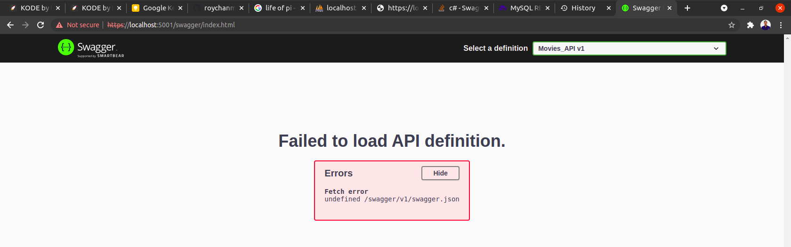

GET API
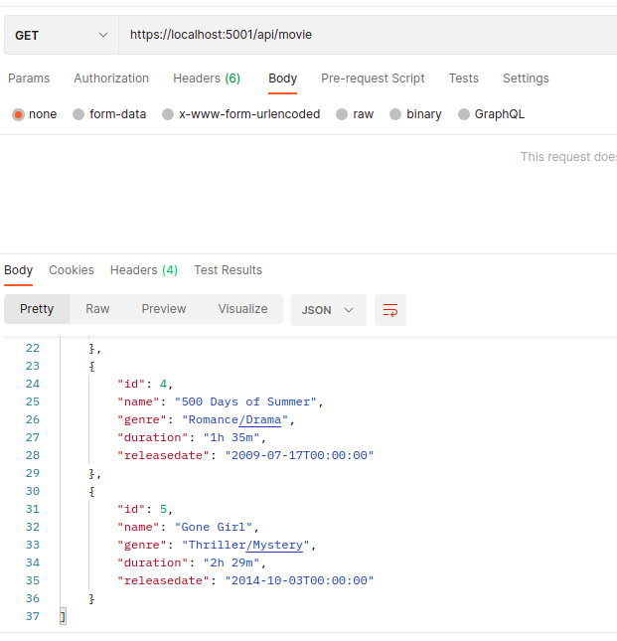

POST API
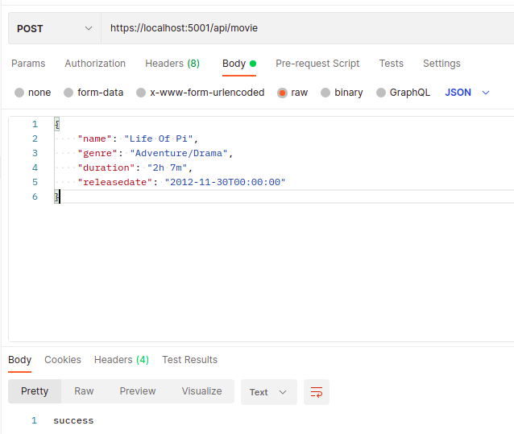

POST API Result
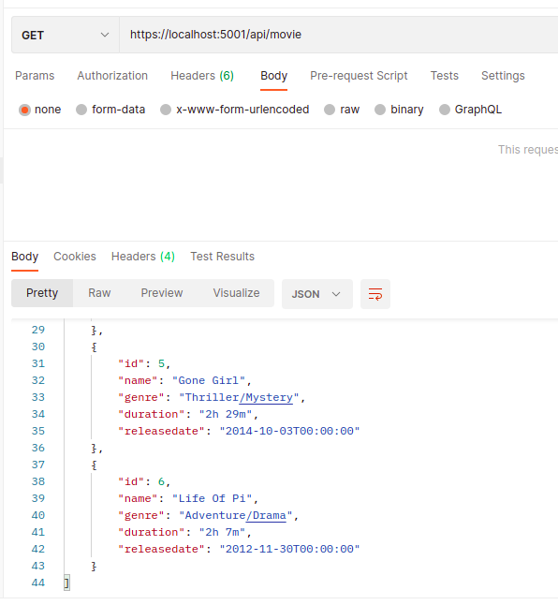

PUT API
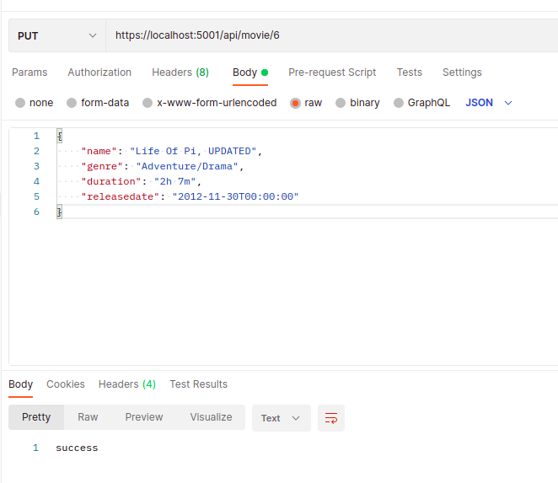

PUT API Result
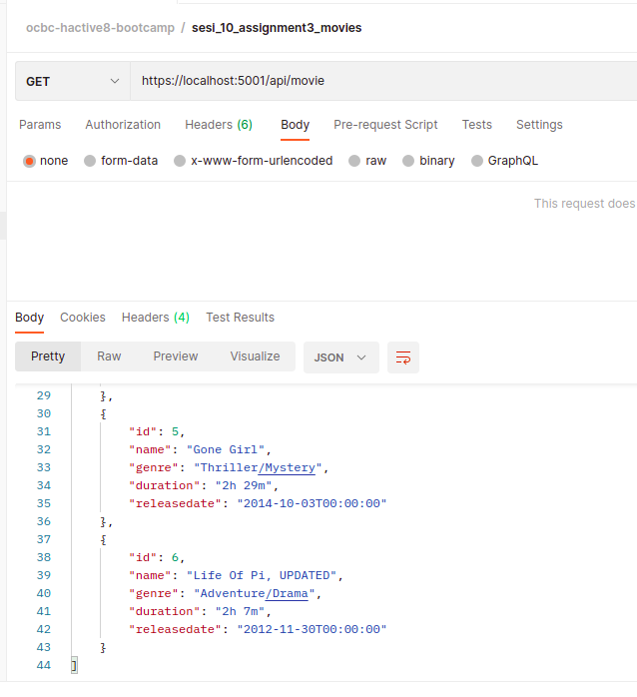

DELETE API
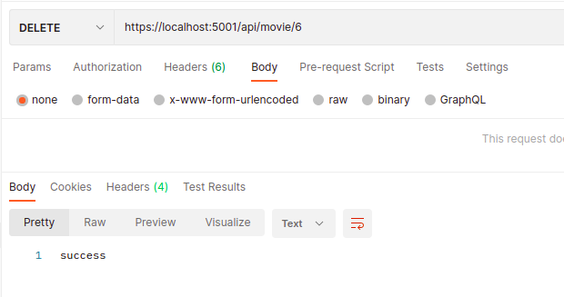

DELETE API RESULT
