Muhammad Roychan Meliaz
FSDO001ONL021

OCBC – Hacktiv8 Bootcamp
Final Project
CRUD PaymentDetail with JWT Authentication running lokal

AuthManagement APIs

GET API /api/PaymentDetail without Authorization → 401 Unauthorized
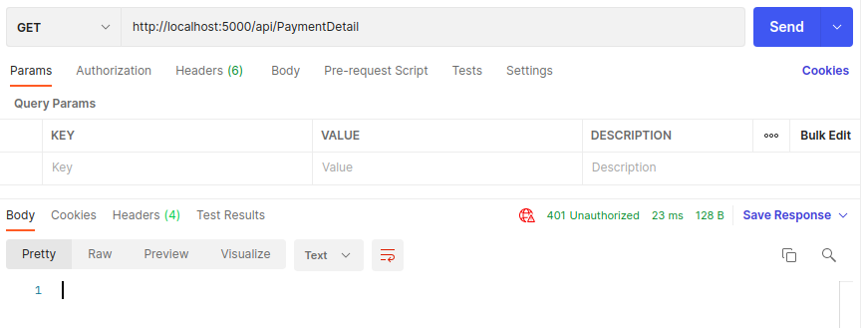

POST /api/AuthManagement/Register
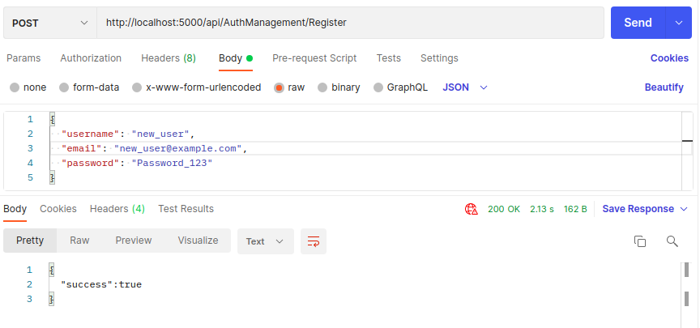

POST /api/AuthManagement/Login
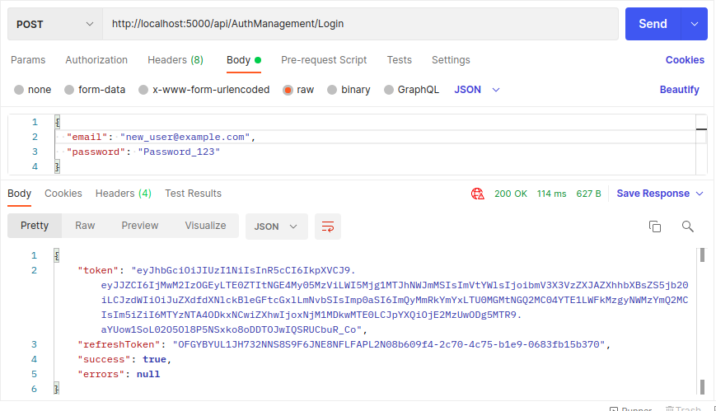

POST /api/AuthManagement/refreshToken (1)
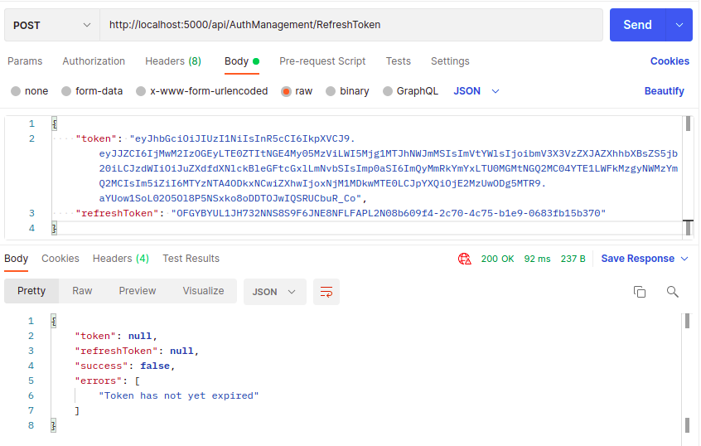

POST /api/AuthManagement/refreshToken (2) (Token Expired after 20 minutes)
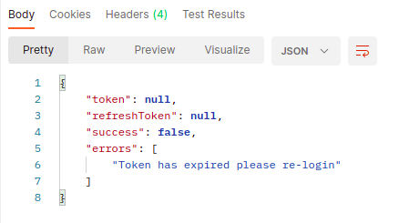

PaymentDetail APIs

Set Authorization

GET http://localhost:5000/api/PaymentDetail
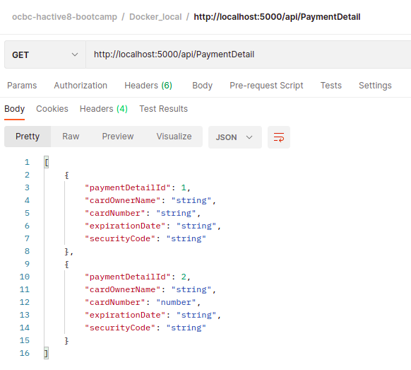
POST http://localhost:5000/api/PaymentDetail
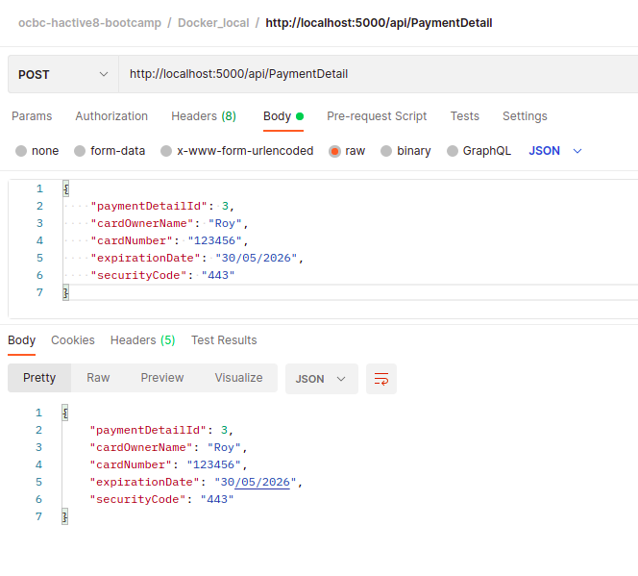

POST API Result
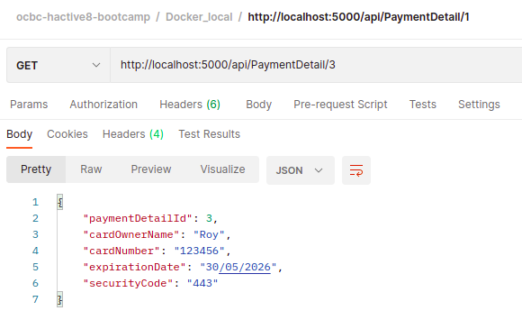
PUT http://localhost:5000/api/PaymentDetail
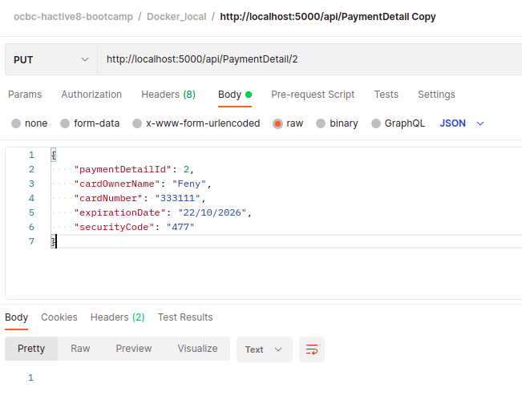

PUT API Result
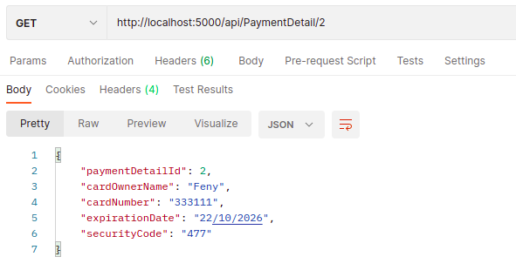

DELETE http://localhost:5000/api/PaymentDetail
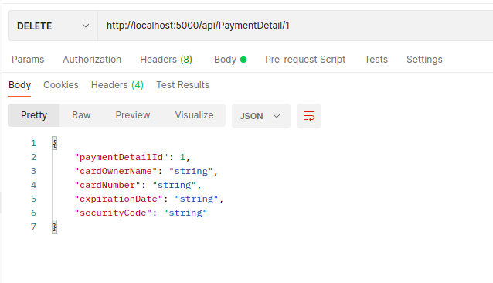

DELETE API RESULT
